***Imp/Export Smoke Testing  
AUTOPIPE 11.0.0.12***

**DXF**

|  |  |
| --- | --- |
| **Test Scope** | DXF Export |
| **Performed By** | Shafqat Farooq |
| **Date** | 14 of Nov, 2016 |
| **OS** | Win7-64-sp1 |
| **Description** | Covers the smoke test scenarios executed on DXF export module. |
| **Models** | QA323 |
| **Testing Status** | Failed |
| **AutoPIPE version** | 11.0.0.12 |
| **Benchmark** | 9.6.1.7 |
| **AutoCAD version** | 2016 |

**Procedure:**

* Open benchmark QA323.DAT model in AutoPIPE latest version
* Analyze the model (Analyze>Analyze All)
* Export to AutoCAD (*. dxf)
* Generate *.rpt report (Tools>Model Input Listing)
* Open/Import *. dxf in AutoCAD
* Verify all DXF files shall be readable by AutoCAD
* Examine the graphic and textural information passed through the DXF file to AutoCAD

**Feature Tested:**

* Settings in AutoPIPE: [**Tools**]/[**Settings**]/[**DXF Export Drawing Border**]

The model should be exported 4 times with the following settings:

* A = all AP2DXF.CNF defaults
* B = metric AutoCAD units, drawing size A3
* C = drawing size D, line width = 0.125”, text height = .250”
* D = drawing size A, include 3D model = No

**Result:** (Benchmark: 9.6.1.17)

|  |  |  |  |  |  |
| --- | --- | --- | --- | --- | --- |
| **Model** | **Setting** | **RPT generated** | **Graphical behavior compared**  **(model exported in AutoPIPE with model in AutoCAD)** | **Drawing Border**  **compared**  **((model exported in AutoPIPE with model in AutoCAD)** | **Pass/Fail** |
| **QA323** | A | OK | Not OK | OK | Fail |
| **QA323** | B | OK | Not OK | OK | Fail |
| **QA323** | C | OK | Not OK | OK | Fail |
| **QA323** | D | OK | Not OK | OK | Fail |

Following observations were made during testing in comparison with the models:

**QA323 (Setting: A)**

* **Graphical behavior comparison:** [Not OK]
  + At point A07, Number of hangers: 2 which graphically show 2 supports fixed at the same point. In AutoCAD Only 1 support can be seen at point A07. (Figure 1)
  + The orientation of the frame is incorrectly being shown in the AutoCAD, which is in horizontal position in contrast to vertical position. (Figure 2)
  + The support at point A12 is not restricted from the upward direction in the AutoCAD. Furthermore, A12 label lines are being shown doubled. (Figure 3)
  + In AutoCAD, Direction of concentrated forces at point A10 is towards negative X direction instead of X Positive direction. (Figure 4)
  + The Imposed support displacement arrows in the AutoCAD should be elongated as much as in AutoPIPE. (Figure 5)

Graphical View in AutoPIPE

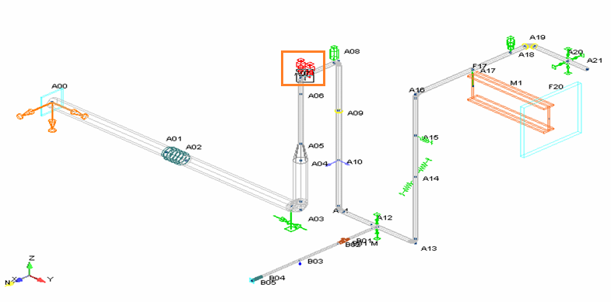 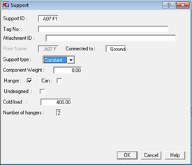

Graphical View in AutoCAD

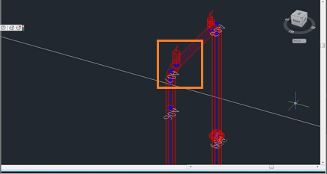

Figure 1

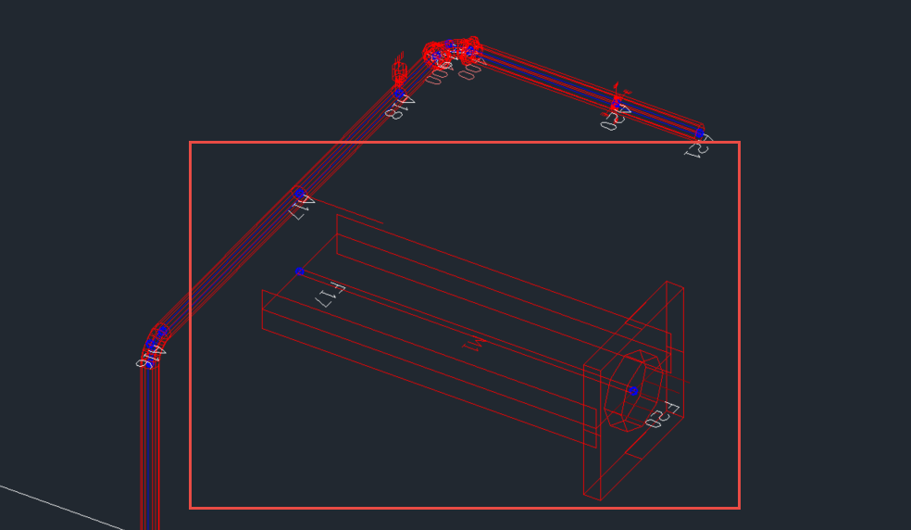

Figure 2

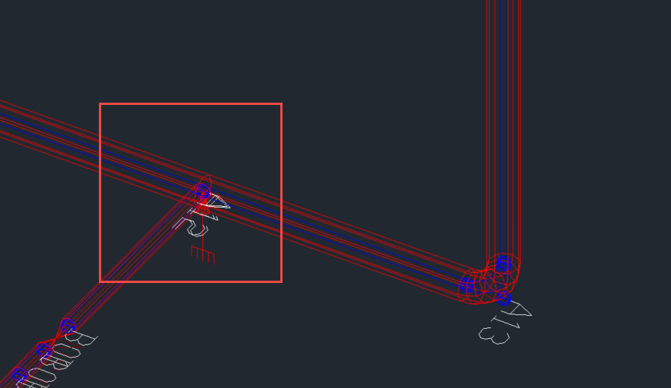

Figure 3

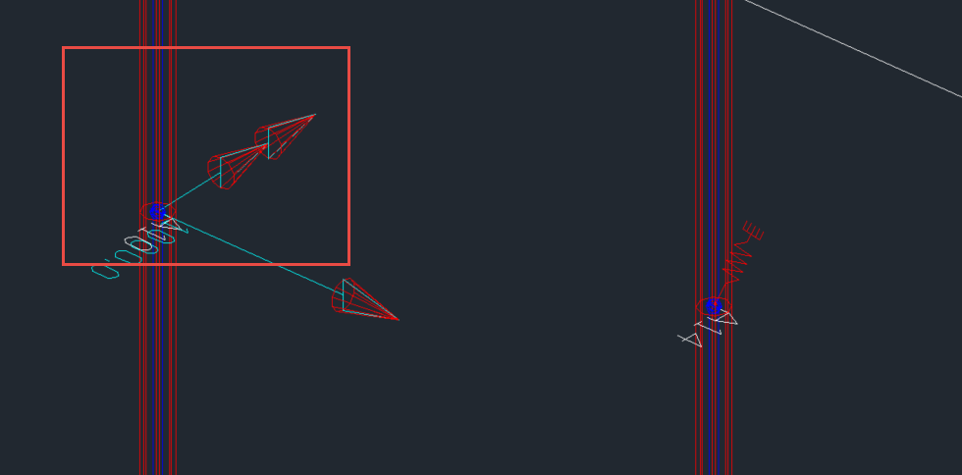

Figure 4

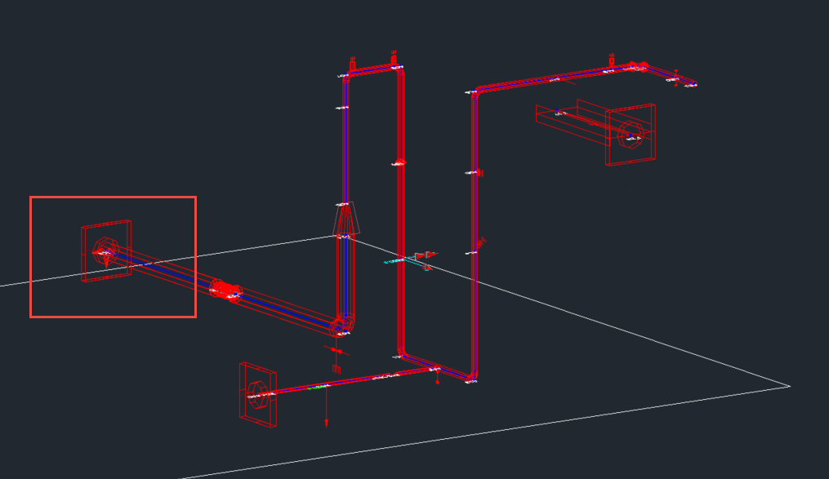

Figure 5

* **Drawing Border comparison: (defaults)** [OK]

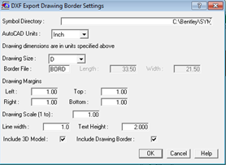 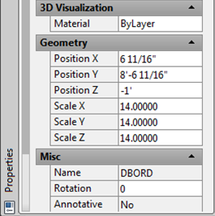

**QA323 (Setting: B)**

* **Graphical behavior comparison:** [Not OK]

Same as Setting A

* **Drawing Border comparison: (drawing size A3)** [OK]

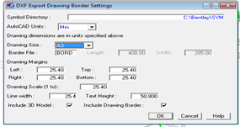 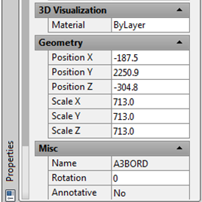

**QA323 (Setting: C)**

* **Graphical behavior comparison:** [Not OK]

Same as Setting A

* **Drawing Border comparison: (drawing size D) [**OK]

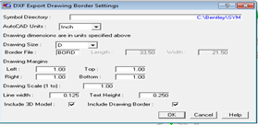 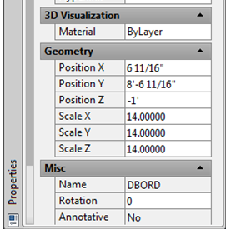

**QA323 (Setting: D)**

* **Graphical behavior comparison:** [Not OK]

Same as Setting A

* **Drawing Border comparison: (drawing size A, no 3D model)** [OK]

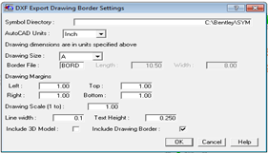 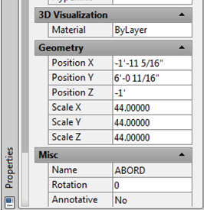

* **Drawing Border comparison: (no 3D model)** [OK]

