***Imp/Export Smoke Testing  
AUTOPIPE 10.1.0.2***

**CAESAR**

|  |  |
| --- | --- |
| **Test Scope** | Caesar Export |
| **Performed By** | Shafqat Farooq |
| **Date** | 8-February-2016 |
| **OS** | Win7-64-sp1 |
| **Description** | Covers the smoke test scenarios executed on Caesar export module. |
| **Models** | QA333A,QA333B,QA333C,QA333D |
| **Testing Status** | FAIL |
| **AutoPIPE version** | 10.1.0.2 |
| **Benchmark** | 9.6.1.7 |

**Procedure:**

Caesar II Neutral

DAT

DAT

RPT

COMPARE

RPT

1. Open benchmark DAT model in AutoPIPE latest version
2. Analyze the model (Analyze>Analyze All)
3. Generate *.rpt report (Tools>Model Input Listing)
4. SaveAs Caesar II Neutral (Export DAT to *.cii)
5. Open new instance of AutoPIPE and Import the *.cii (created in Step 4) and Analyze the model (Analyze>Analyze All)
6. Generate *.rpt report (Tools>Model Input Listing)
7. Use test case matrix sheet QA333-AP2CII-Export_0.xls for further test case execution, instructions and listing of the specific feature attributes to evaluate.
8. Also, compare the RPTs generated in Step 3 and Step 6.

**Relative comparisons between Model Input Listing reports (before export and after export) and, Scenarios were performed following Test Case Matrix QA333-AP2CII-Export_0 in AutoPIPE (before export and after export) for finding the point of matter. Test Case Matrix QA333-AP2CII-Export_0 has been used as an instructor for the test plan to verify that input data from an AutoPIPE DAT model is exported correctly as CII neutral file.**

**QA333A**

**“Caesar II Neutral (*.cii)”** option has not been added to the selection list under the **“File/Save As”** menu

**System Dialog:**

* Project ID and Prepared by: field empty after export
* Edition: 2004, after export 2012
* Material: B313-4, after export B313-12

**Pipe Data:**

|  |  |  |  |
| --- | --- | --- | --- |
| **Change in Pipe ids** | | **Change in Pipe properties** | |
| **Pipe** **ID**  **before export** | **Pipe ID**  **after export** | **Pipe properties before export** | **Pipe properties after export** |
| 2"NS | PIPE1 | Schedule: STD  Insul Material: AMOSITE ASBESTOS  Shear Modulus: 11.0000 | Schedule: NS  Insul Material: Other  Shear Modulus: 11.5385 |
| 6"API5LA | PIPE3 | Schedule: 40  Insul Material: CALCIUM SILICATE | Schedule: NS  Insul Material: Other |
| 10"A3331 | PIPE5 | Schedule: 40S  Insul Material: FIBERGLASS | Schedule: NS  Insul Material: Other |
| 16"A135A | PIPE8 | Schedule: 80; Insul Material: PERLITE | Schedule: NS; Insul Material: Other |
| 12"A105 | PIPE10 | Schedule: 120 | Schedule: NS |
| 20A335P2 | PIPE6 | Schedule: XS | Schedule: NS |
| 22A240-3 | PIPE11 | Schedule: STD  Pipe Material: A240-317  Composition: Austenitic  Min yield: 30000; Ultimate:75000  Long & Hoop modulus: 28.3  Shear modulus: 10.88; Density: 501 | Schedule: NS  Pipe Material: CS  Composition: Carbon  Mini yield: 36000; Ultimate: 0.00  Long & Hoop modulus: 29.5  Shear modulus: 11.34; Density:489 |
| 8A335-P1 | PIPE13 | Schedule: 80 | Schedule: NS |
| 24A333-1 | PIPE15 | Schedule: 100; Insul Material: Perl | Schedule: NS; Insul Material: Other |
| 28A285-B | PIPE17 | Schedule: STD | Schedule: NS |
| 36A135-B | PIPE19 | Schedule: XS | Schedule: NS |

* Value of Schedule and insulation material is showing under Pipe listing Data but not under Pipe data except for 2"NS.

**Operating Temperature and Pressure Data:**





**Component Data:**

* **Bends**

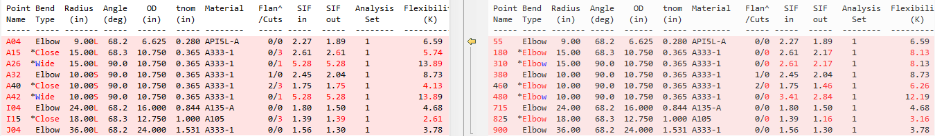



* **Tees**

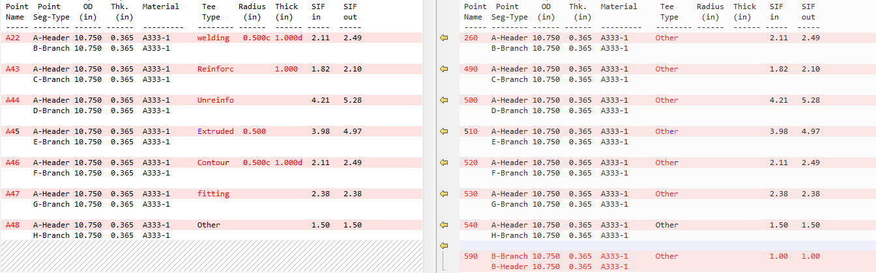



**After export an additional Tee has been added at point B02 -> 590**

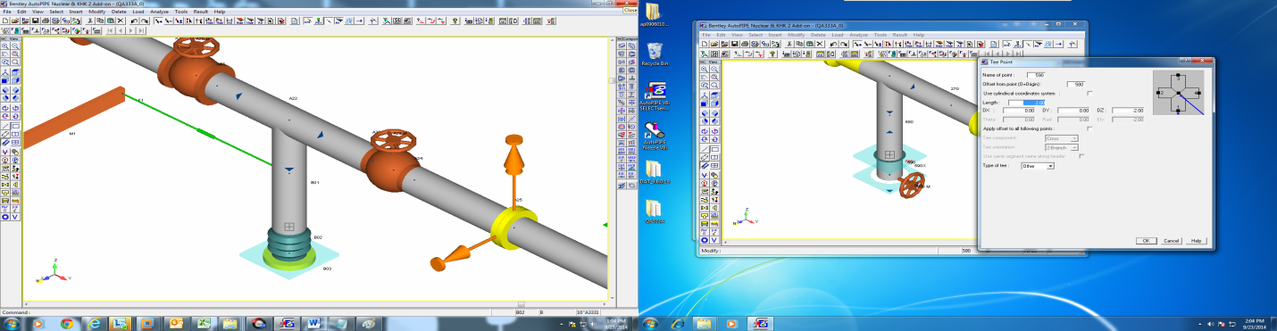

* **Flanges**

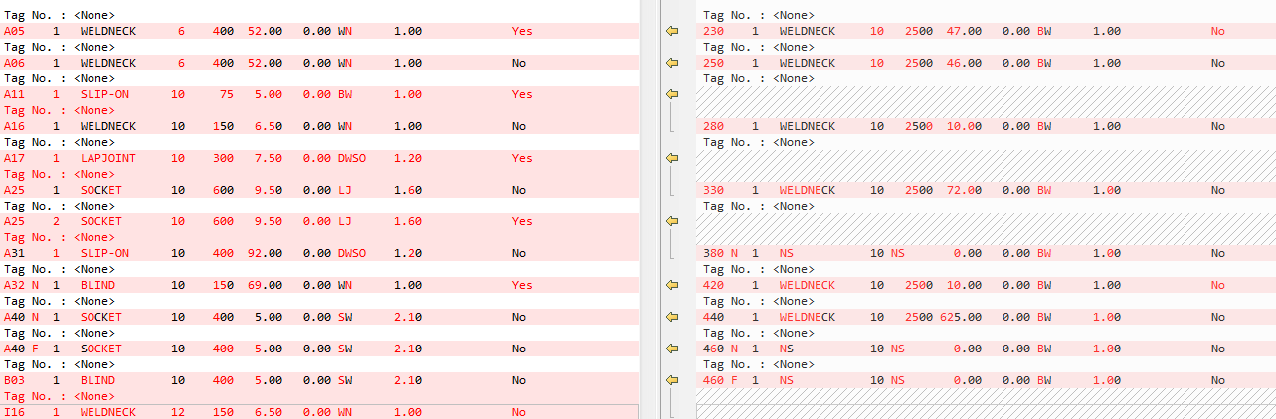

* **Valves**

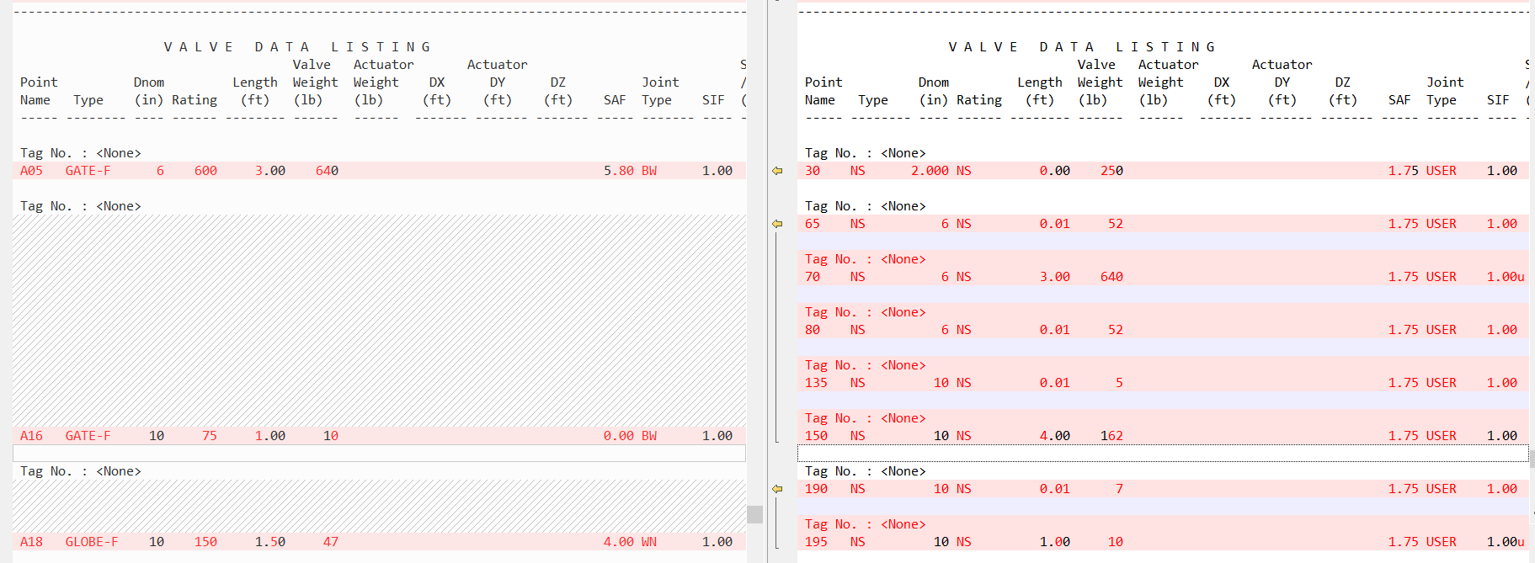

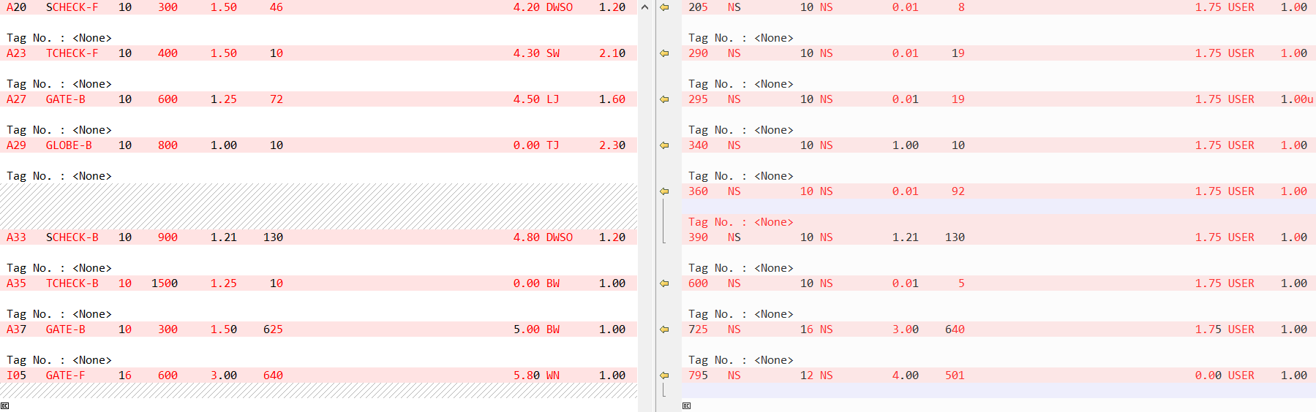

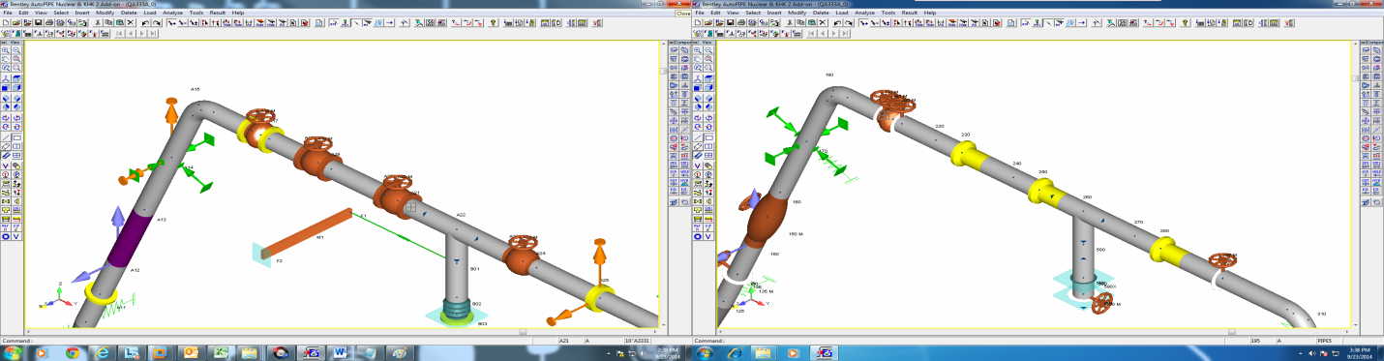

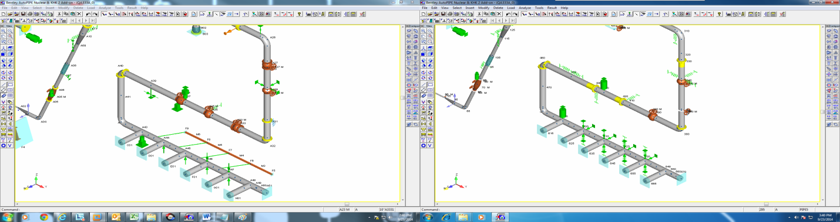

* **Flexible joint:**
* **A07** -> Y-shear, Z-shear stiffness changes from Rigid to 0.1000E+11 and Weight 10.0 to 0.00
* **I07** -> Y-shear, Z-shear stiffness changes from Rigid to 0.1000E+11 and Weight 10.0 to 0.00

**Center of gravity report:**

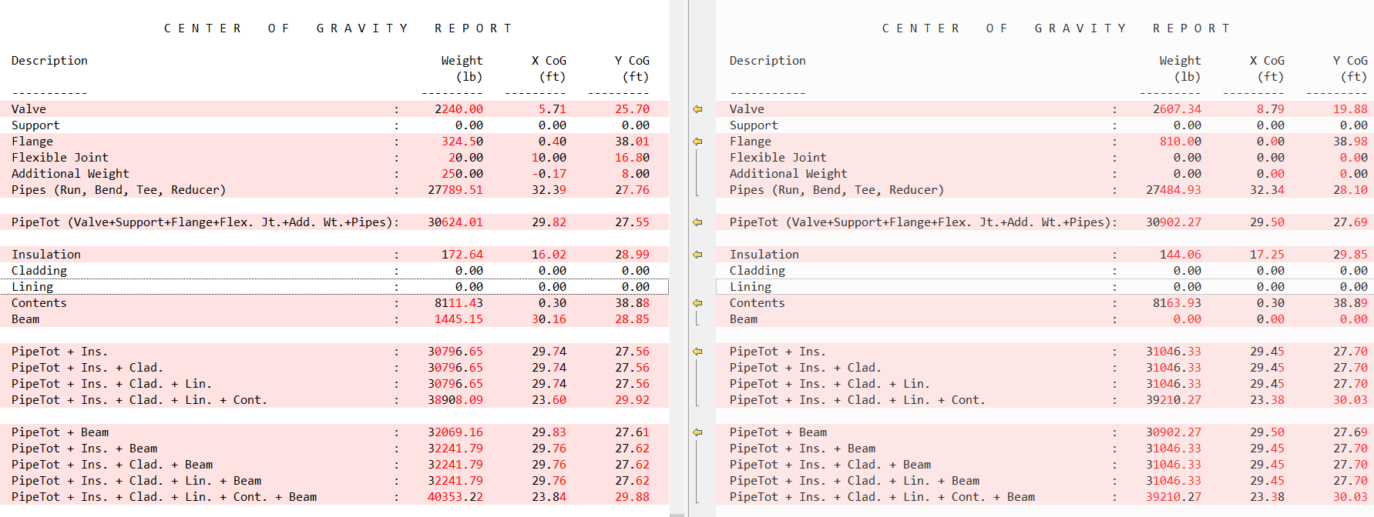

**Reducer Data Listing:**



**Support data:**

Issue in Supports and their type

**User SIF:**

Issue In user SIF.

**Beam Point data listing:**

Beam point data listing is not showing after export and beam is deleted after export.

**Forces and Displacements:**

Issue in Forces and Displacements values

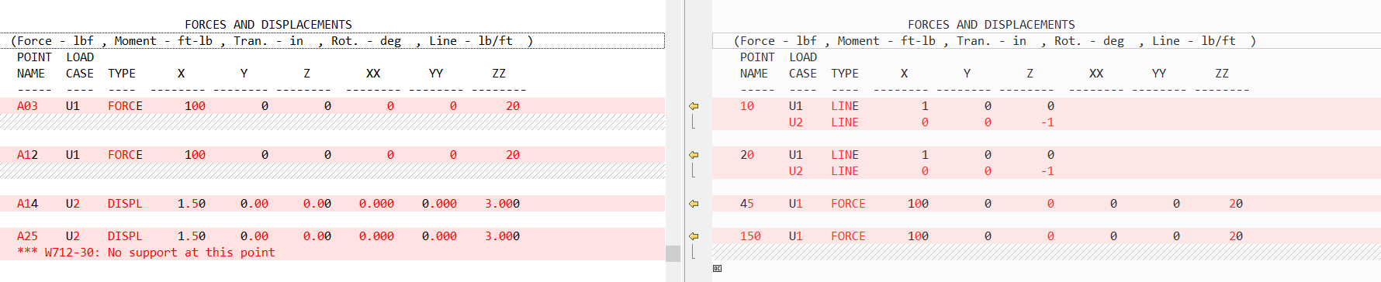

**Loads:**

After export, Load Summary cannot be found

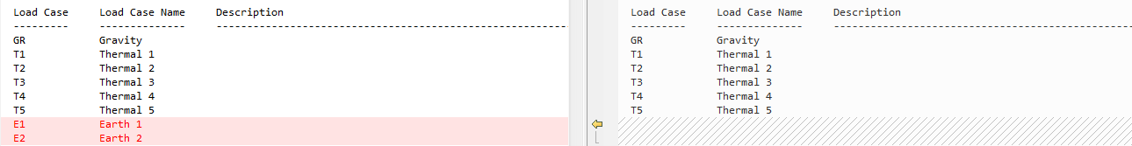

**Xtra data > Additonal Weight**

A02, after export additional weight at the point is replaced by a valve

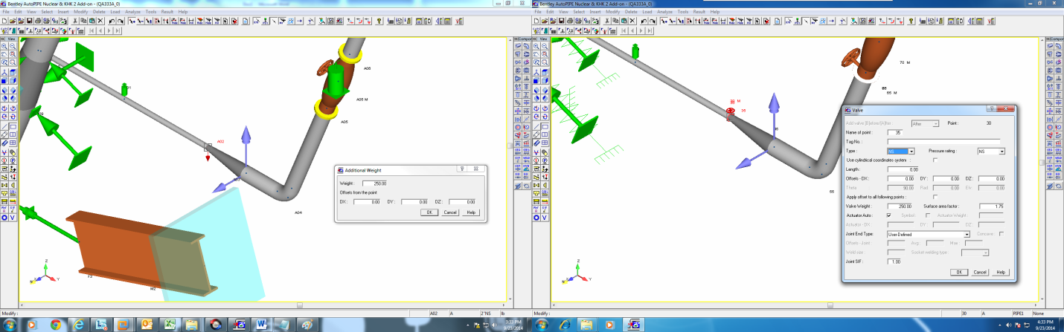

**Xtra data > Imposed Support Displacements**

A14 and A25, imposed support displacements missing after export

**QA333B**

Model was successfully exported to Caesar II Neutral, but on importing *.cii file the model failed to open. An error message was delivered.

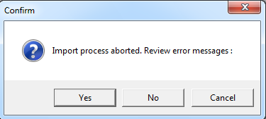

**QA333C**

**“Caesar II Neutral (*.cii)”** option has not been added to the selection list under the **“File/Save As”** menu

**System Dialog:**

* Project ID and Prepared by: field empty after export
* Edition: 2004, after export 2014
* Material: B313-4, after export B313-12

**Pipe Data:**

|  |  |  |  |
| --- | --- | --- | --- |
| **Change in Pipe ids** | | **Change in Pipe properties** | |
| **Pipe** **ID**  **before export** | **Pipe ID**  **after export** | **Pipe properties before export** | **Pipe properties after export** |
| 22A240-3 | PIPE1 | Schedule: STD; Pipe Material: A240-317  Composition: Austenitic  Min yield: 2109.21; Ultimate:5273.02  Long Weld W factor=1  Long & Hoop modulus: 1.9897  Shear modulus: 0.7653; Density: 8025.2  Pipe Unit Wgt=131.91 | Schedule: NS; Pipe Material: CS  Composition: Carbon  Min yield: 2812.28; Ultimate: 0.00  Long Weld W factor is missing  Long & Hoop modulus: 2.0741  Shear modulus: 0.7977; Density:7833.0  Pipe Unit Wgt=128.75 |
| 8A335-P1 | PIPE3 | Schedule: 80 | Schedule: NS |
| 24A333-1 | PIPE5 | Schedule: 100  Insul Material: Perl | Schedule: NS  Insul Material: Other |
| 28A285-B | PIPE7 | Schedule: STD | Schedule: NS |
| 36A135-B | PIPE9 | Schedule: XS | Schedule: NS |

* Value of Schedule is showing under Pipe listing Data but not under Pipe data except for 22a240-3

**Operating Temperature and Pressure Data:**

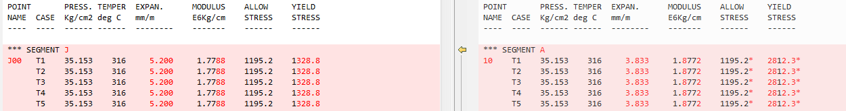

**Reducer data listing:**



**Bend data listing:**



**Center of gravity report:**

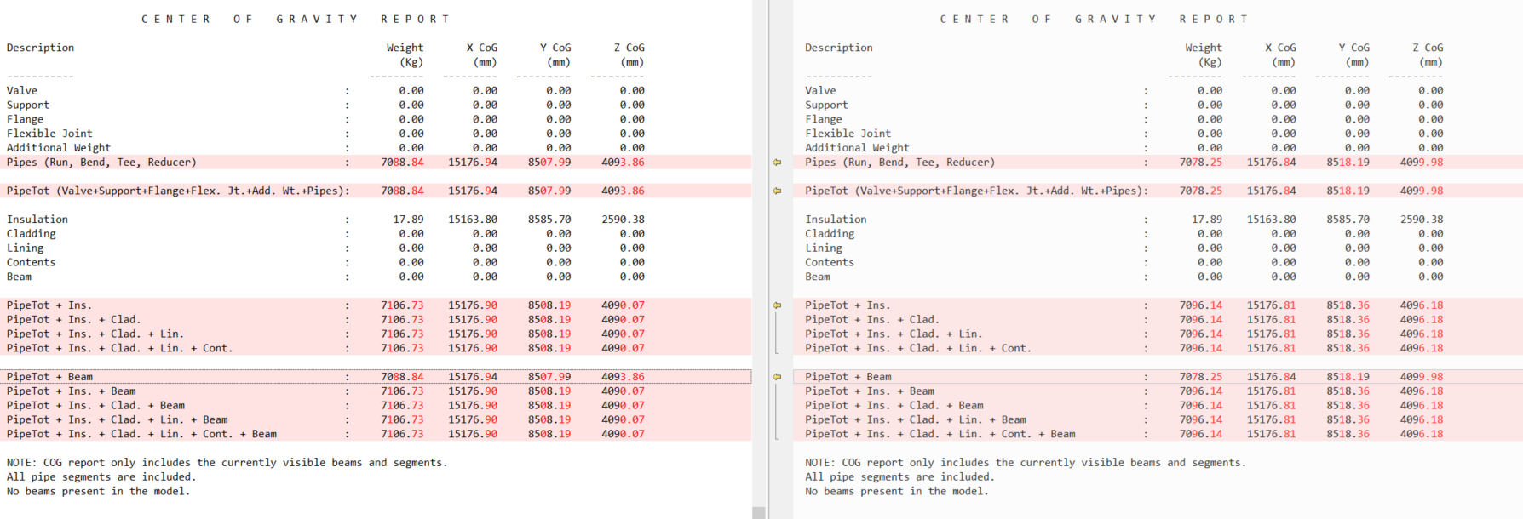

**Loads:**

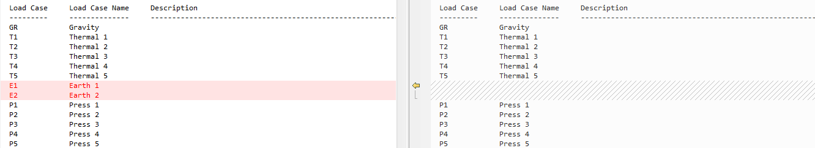

* Load summary is not shown after export

**Support Data:**

Similar Issue in support data for different points. Example is shown below as value of KTX and others are changed from rigid to .1000*10^11.



**QA333D**

**“Caesar II Neutral (*.cii)”** option has not been added to the selection list under the **“File/Save As”** menu

**System Dialog:**

* Project ID and Prepared by: field empty after export
* Component Library: AUTODIN, after export autopipe

**Pipe Data:**

|  |  |  |  |
| --- | --- | --- | --- |
| **Change in Pipe ids** | | **Change in Pipe properties** | |
| **Pipe** **ID**  **before export** | **Pipe ID**  **after export** | **Pipe properties before export** | **Pipe properties after export** |
| 2"NS | PIPE1 | Schedule: 1.4; Insul Material: Asb  Pipe Material: SW-AU3  Composition: Austenitic; Min yield: 137.90  Long & Hoop modulus: 0.19493  Shear modulus: 0.07497; Density: 8025 | Schedule: NS; Insul Material: Other  Pipe Material: CS  Composition: Carbon; Min yield: 275.79  Long & Hoop modulus: 0.20293  Shear modulus: 0.07805; Density: 7833 |
| 6"API5LA | PIPE3 | Schedule: 3.2; Insul Material: Calc  Pipe Material: SW-MA  Min yield: 206.84; Ultimate: 330.95  Long & Hoop modulus: 0.20993  Shear modulus: 0.08074 | Schedule: NS; Insul Material: Other  Pipe Material: CS  Min yield: 275.79; Ultimate: 0.00  Long & Hoop modulus: 0.20293  Shear modulus: 0.07805 |
| 10"A3331 | PIPE5 | Schedule: 4.5; Insul Material: Fib  Pipe Material: ST45.8  Min yield: 0.00; Ultimate: 320  Long & Hoop modulus: 0.21190  Shear modulus: 0.08150; Density: 7850  Pipe unit wgt=292.27 | Schedule: NS; Insul Material: Other  Pipe Material: CS  Min yield: 275.79; Ultimate: 0.00  Long & Hoop modulus: 0.20293  Shear modulus: 0.07805; Density: 7833  Pipe unit wgt=291.63 |
| 16"A135A | PIPE8 | Schedule: 5.0; Insul Material: Perl  Pipe Material: SW-UA1  Min yield: 206.84; Ultimate: 330.95  Long & Hoop modulus: 0.20593  Shear modulus: 0.07920 | Schedule: NS; Insul Material: Other  Pipe Material: CS  Min yield: 275.79; Ultimate: 0.00  Long & Hoop modulus: 0.20293  Shear modulus: 0.07805 |
| 12"A105 | PIPE10 | Schedule: 14.2; Pipe Material: SW-AU2  Composition: Austenitic  Min yield: 248.21; Ultimate: 482.63  Long & Hoop modulus: 0.19993  Shear modulus: 0.07690; Density: 8025  Pipe unit Wgt=1087.11 | Schedule: NS; Pipe Material: CS  Composition: Carbon  Min yield: 275.79; Ultimate: 0.00  Long & Hoop modulus: 0.20293  Shear modulus: 0.07805; Density: 7833  Pipe unit Wgt=1061.10 |
| 20A335P2 | PIPE6 | Schedule: 11; Pipe Material: SW-CU2  Composition: Other; Min yield: 206.84  Ultimate: 379.21  Long & Hoop modulus: 0.12494  Shear modulus: 0.04806; Density: 8940  Pipe Unit Wgt=1505.76 | Schedule: NS; Pipe Material: CS  Composition: Carbon, Min yield: 275.79  Ultimate: 0.00  Long & Hoop modulus: 0.20293  Shear modulus: 0.07805; Density: 7833  Pipe Unit Wgt=1319.31 |
| 22A240-3 | PIPE11 | Schedule: 6.3; Pipe Material: SW-AU1  Composition: Austenitic  Min yield: 206.84; Ultimate: 379.21  Long & Hoop modulus: 0.19993  Shear modulus: 0.07690; Density: 8025  Pipe Unit Wgt=860.57 | Schedule: NS ; Pipe Material: CS  Composition: Carbon  Minimum yield: 275.79; Ultimate: 0.00  Long & Hoop modulus: 0.20293  Shear modulus: 0.07805; Density: 7833  Pipe Unit Wgt=839.98 |
| 8A335-P1 | PIPE13 | Schedule: 22.2; Pipe Material: SW-CU3  Composition: Other; Min yield: 206.84  Long & Hoop modulus: 0.15197  Shear modulus: 0.05845; Density: 8940  Pipe Unit Wgt=2659.82 | Schedule: NS; Pipe Material: CS  Composition: Carbon; Min yield: 275.79  Long & Hoop modulus: 0.20293  Shear modulus: 0.07805; Density: 7833  Pipe Unit Wgt=2330.46 |
| 24A333-1 | PIPE15 | Schedule: 11.0; Pipe Material: SW-AL2  Composition: Other; Min yield: 206.84  Ultimate: 330.95  Long & Hoop modulus: 0.06997  Shear modulus: 0.02691; Density: 2707  Pipe Unit Wgt=549.15 | Schedule: NS; Pipe Material: CS  Composition: Carbon; Min yield: 275.79  Ultimate: 0.00  Long & Hoop modulus: 0.20293  Shear modulus: 0.07805; Density: 7833  Pipe Unit Wgt=1589.02 |
| 28A285-B | PIPE17 | Schedule: 14.2; Pipe Material: ST45.8  Min yield: 186.16; Ultimate: 482.63  Long & Hoop modulus: 0.21190  Shear modulus: 0.08150; Density: 7850  Pipe Unit Wgt=2393.65 | Schedule: NS; Pipe Material: CS  Min yield: 275.79; Ultimate: 0.00  Long & Hoop modulus: 0.20293  Shear modulus: 0.07805; Density: 7833  Pipe Unit Wgt=2388.47 |
| 36A135-B | PIPE19 | Schedule: 16.0; Pipe Material: SW-CM1  Min yield: 241.32; Ultimate: 482.63  Long & Hoop modulus: 0.20993  Shear modulus: 0.08074 | Schedule: NS; Pipe Material: CS  Min yield: 275.79; Ultimate: 0.00  Long & Hoop modulus: 0.20293  Shear modulus: 0.07805 |

**Coordinates Data listing:**

Some differences were observed in X, Y, Z coordinates.

**Operating Temperature and Pressure Data:**

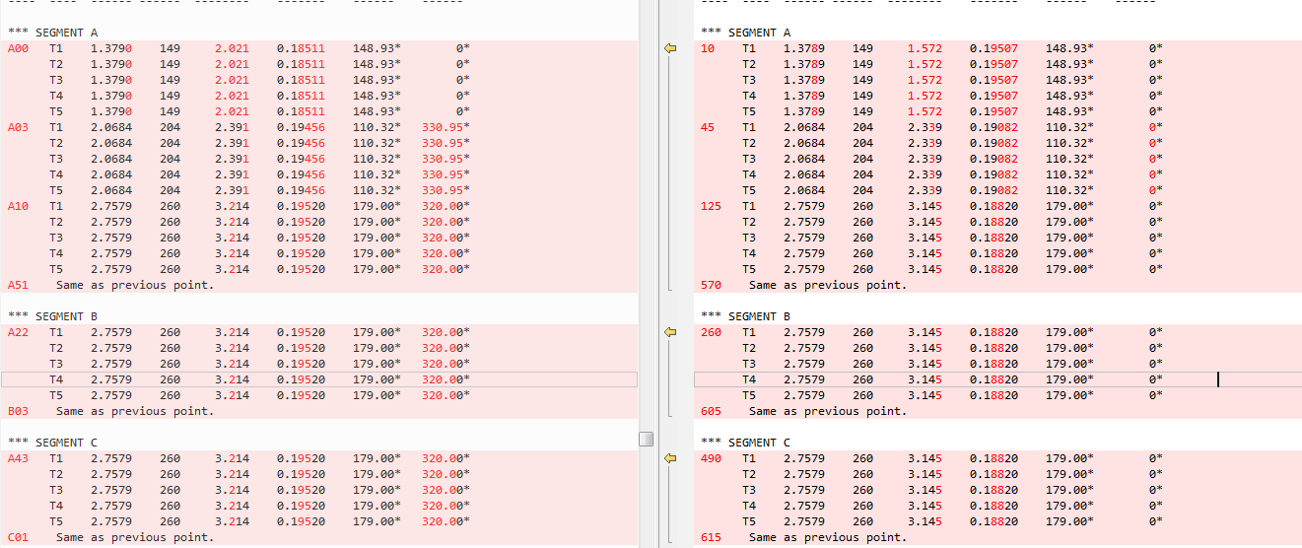

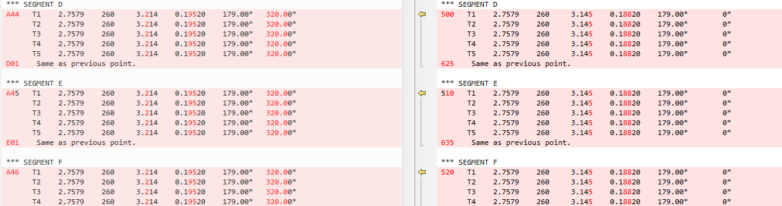

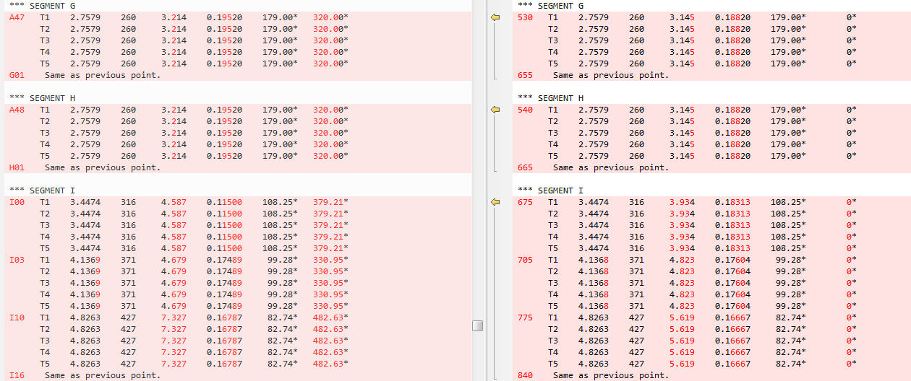

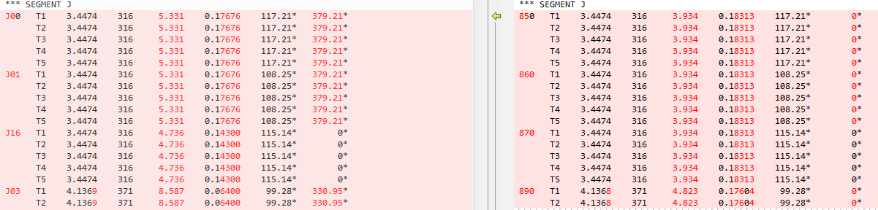

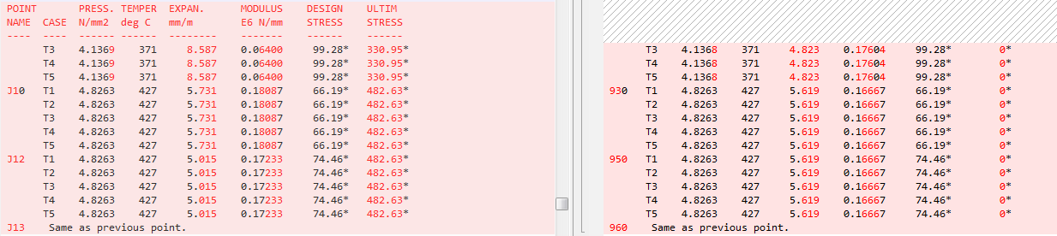

**Forces and Displacements:**

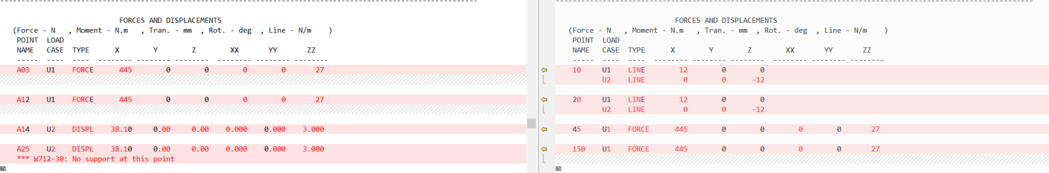

**Component Data:**

* 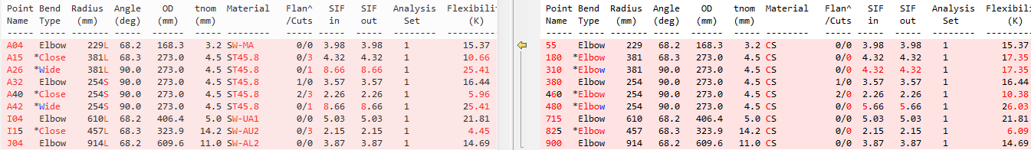**Bends**



* **Multiport component > Tee:** For all the Tees the type of tee and material has changed

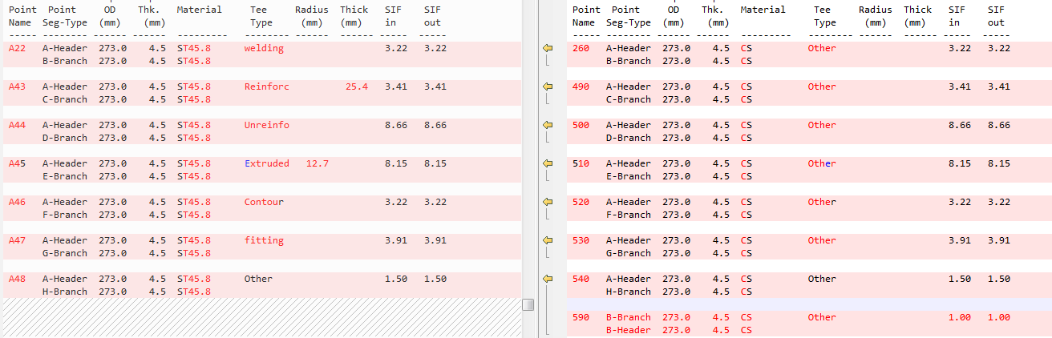

* After export an additional Tee is found at B02 -> 590

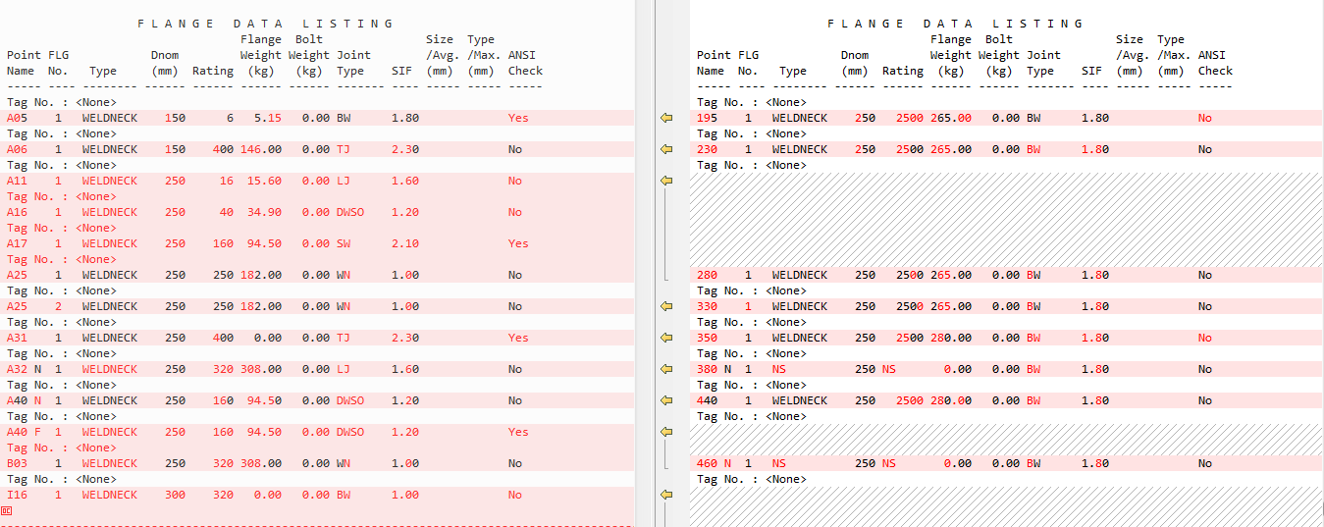**Flanges**

There are 13 flanges before exporting and 9 flanges after exporting. Also there is difference in values.

**Valves**

Issue in valves and their placement. Also there are 11 valves before exporting and 16 valves after exporting.

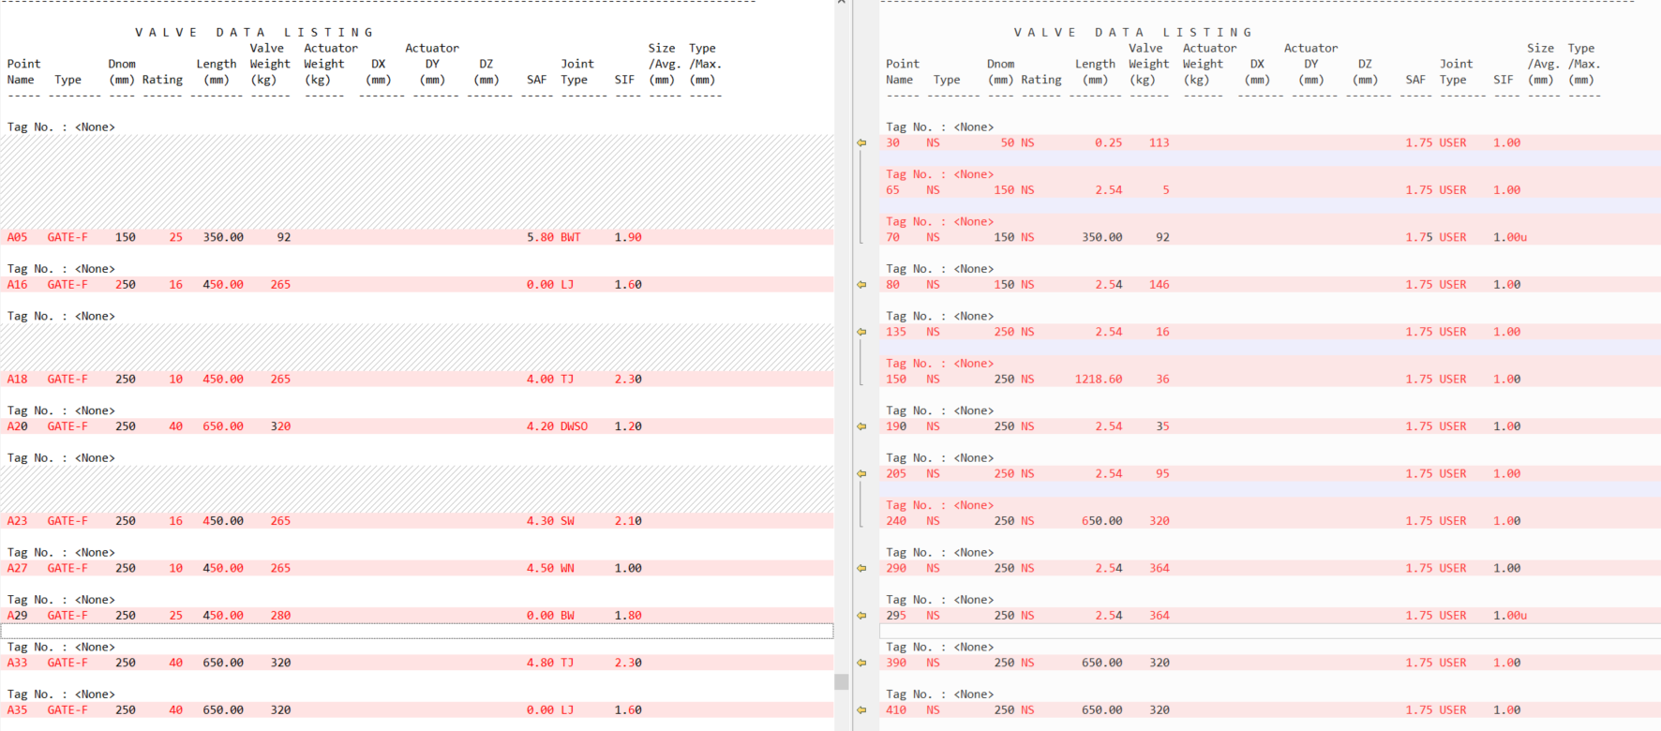

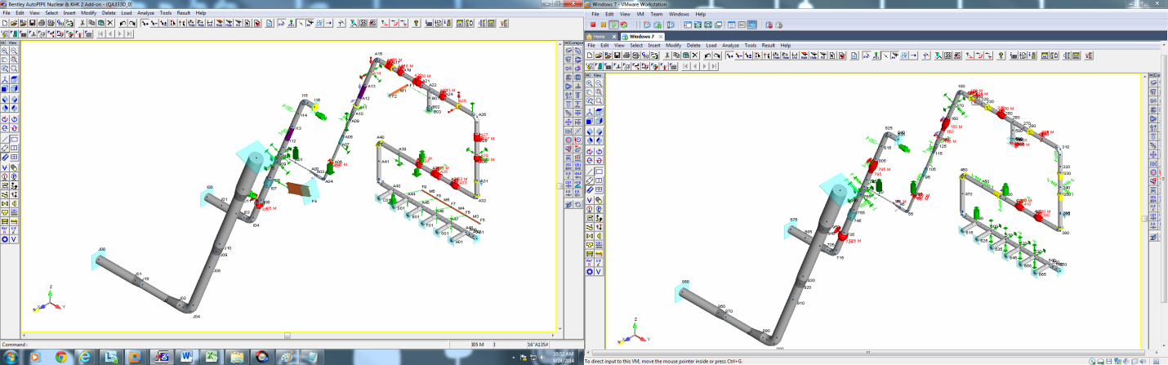

**Flexible Joints**

**A08 -> 105,** weight changes from 4.54 to 0.00

**Beam Point data listing:**

Beam point data listing is not showing after export and beam is deleted after export

**Support data:**

* Issue in Supports and their type
* Extra supports are present after export

**Reducer data listing:**

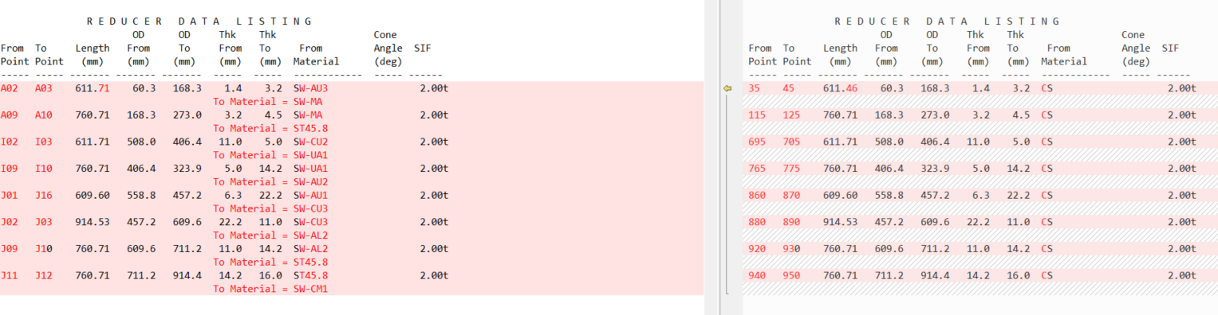

**Rigid pipe data listing:**

After export, rigid pipe data cannot be found

**Center of gravity report:**

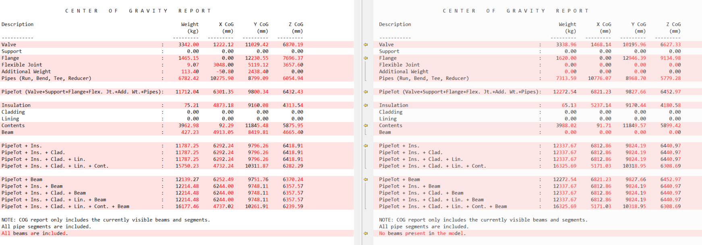

**Loads:**

After export, Loads Summary cannot be found

**Xtra data > Additional Weight**

A02, after export additional weight at the point is replaced by a valve

**Xtra data > Imposed Support Displacements**

A14 and A25, imposed support displacements missing after export