***Imp/Export Smoke Testing  
AUTOPIPE 10.1.0.2***

**Caesar:**

|  |  |
| --- | --- |
| **Test Scope** | Caesar Import |
| **Performed By** | Shafqat Farooq |
| **Date** | 4th Feb, 2016 |
| **Module** | Caesar |
| **Description** | Covers the smoke test scenarios executed on Caesar Import module |
| **Machine** | WIN-7,64-SP1 |
| **Models** | QA327A, QA327B, QA327C, QA327D, QA327E, QA327F, QA327G, QA327H, QA327 |
| **Testing Status** | Pass |
| **AutoPIPE version** | 10.1.0.2 |
| **Benchmark** | 9.6.1.7 |

**Feature Tested:**

Smoke testing was carried out on *CII format. The features tested during smoke are:

* Import *.cii file in AutoPIPE latest version. An NTL file will also be created in the working directory.
* Analyze the model (Analyze>Analyze All)
* Generate *.rpt report (Tools>Model input Listing)
* Compare the *.ntl generated(10.1.0.2) in latest build against the benchmark model *.ntl(9.6.1.7)

**Result:**

|  |  |  |  |
| --- | --- | --- | --- |
| **Model** | **NTL Generated** | **NTL compared**  **(latest against benchmark)** | **Pass/Fail** |
| QA327A | OK | OK | PASS |
| QA327B | OK | OK | PASS |
| QA327C | OK | OK | PASS |
| QA327D | OK | OK | Pass |
| QA327E | OK | OK | PASS |
| QA327F | OK | OK | PASS |
| QA327G | OK | OK | PASS |
| QA327H | OK | OK | PASS |
| QA327I | OK | OK | PASS |

**RPT comparison issues:**

**QA327A**

* **Component Data Listing**:
* Point data: Change in insulation material name
* Observation: This was an error in 9.6.1.7 and is now fixed in 10.1.0.2

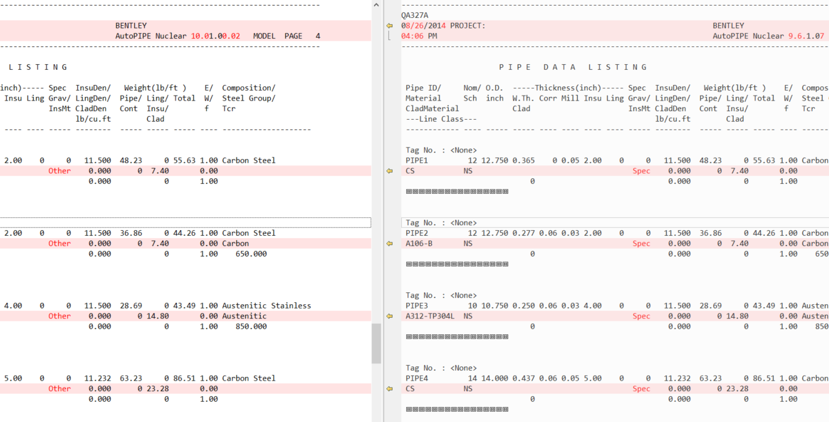

**QA327B**

* No *rpt file was generated for benchmark (9.6.1.7) so *rpt for 10.1.0.2 could not be compared with the benchmark

**QA327C**

* **No difference**

**QA327D**

* **Component Data Listing**:

Some minor differences observed.

* + Value of SIF for Unreinforced tee was 5.60 in 9.6.1.7 and now it is 5.59 in 10.1.0.2
  + Value of Mill in PIPE data was 0.062 in 9.6.1.7 and now it is 0.063 in 10.1.0.2.
  + Supports were connected to point 43 in 9.6.1.7 but now in 10.1.0.2 that point is removed and is connected to ground.
  + **Observations:**

While analyzing QA327D model, Errors occurred: These errors are due to absence of anchor.

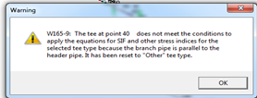 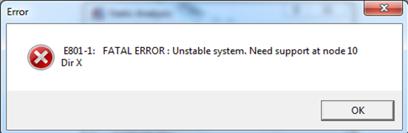

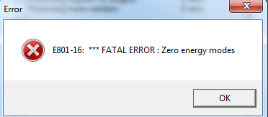

**QA327E**

* **Component Data Listing**:
* Point data: Change in Insulation material
* Observation: This was an error in 9.6.1.7 and is now fixed in 10.1.0.2

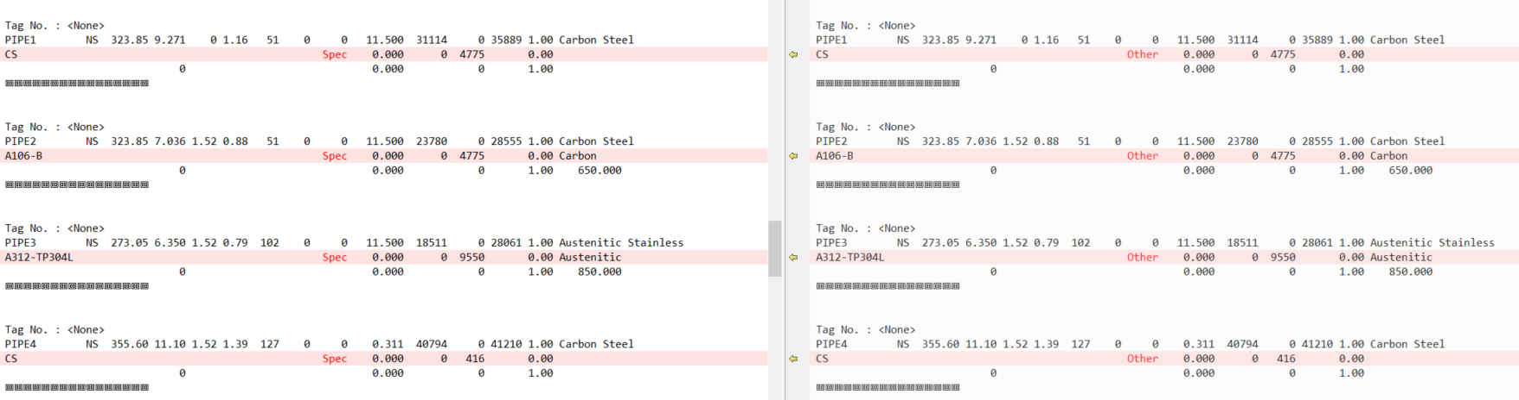

**QA327F**

* No *rpt file was generated for benchmark (9.6.1.7) so *rpt for 10.1.0.2 could not be compared with the benchmark

**QA327G**

* **Component Data Listing**:
* Point data: Change in Insulation material
* Observation: This was an error in 9.6.1.7 and is now fixed in 10.1.0.2

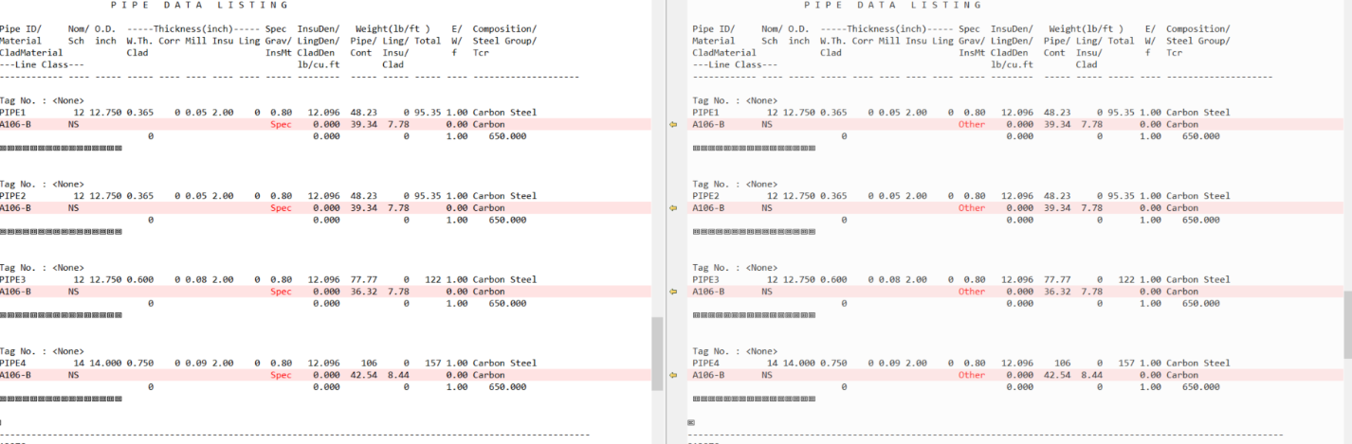

**QA327H**

* **Component Data Listing**:
* Support data: Value of Preload has changed.



* Point data: Change in Insulation material
* Observation: This was an error in 9.6.1.7 and is now fixed in 10.1.0.2

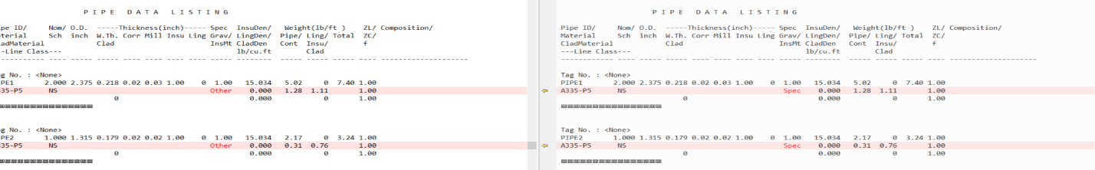**QA327I**

* **No difference**