***Imp/Export Smoke Testing  
AUTOPIPE 11.0.0.15***

**PXF**

|  |  |
| --- | --- |
| **Test Scope** | PXF Export |
| **Performed By** | Shafqat Farooq |
| **Date** | 29th November 2016 |
| **Machine** | WIN-64-SP1 |
| **Description** | Covers the smoke test scenarios executed on PXF Import module. |
| **Models** | QA325A, QA325B |
| **Testing Status** | Issues in supports |
| **AutoPIPE version** | 11.0.0.15 |
| **Benchmark** | 9.6.0.19 |
| **AutoPlant** | 8.11.13.620 |

**Procedure:**

* Open DAT model in AutoPIPE latest version.
* Analyze the model (Analyze>Analyze All)
* Generate *.rpt report (Tools>Model Input Listing)
* Export the model to AutoPLANT(*.pxf)
* Import/Open the *.pxf file in AutoPLANT
* Examine the following features in AutoPLANT

**Feature Tested:**

* Export PXF file and check that the export is done without errors
* Check vertical axis
* Check result units.
* Open QA325A model with English units in AutoPLANT
* Open QA325B model with Metric units in AutoPLANT
* Compare *.pxf in AutoPLANT and *.dat in AutoPIPE with geometric perspective

**Result:** (Benchmark: 9.6.0.19)

|  |  |  |
| --- | --- | --- |
| **Comparison** | **QA325A** | **QA325B** |
| **Geometry(length and coordinates)** | OK | OK |
| **Pipe run points starting or ending a segment** | OK | OK |
| **Pipe run points not connected to components** | OK | OK |
| **Bend Tangent intersection points (CP of bend in AutoPLANT)** | OK | OK |
| **Tee points** | OK | OK |
| **Flange** | Considered OK | Considered OK |
| **Reducer** | OK | OK |
| **Valve** | OK | OK |
| **Nozzle** | OK | OK |
| **Flexible joint** | OK | OK |
| **Anchors** | Considered OK | Considered OK |
| **Supports** | Not OK | Not OK |

Same issues were found for both the models i.e. QA325A and QA325B

**Issues in Supports:**

* Point **A03N** (X=10 Y=23 Z=0) Line Stop Support is missing at the point of a bend **[Not OK]**

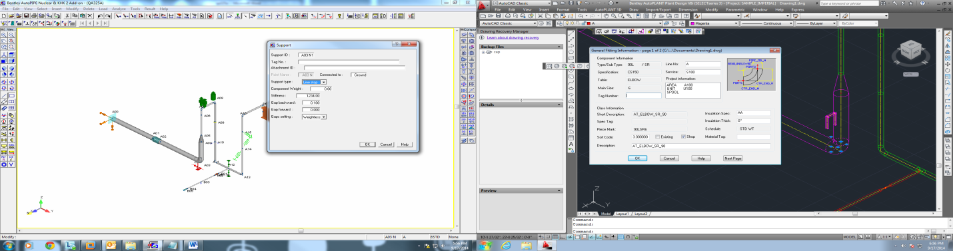

* Between Point A03 and A04, Shoe Channel Support was found in AutoPLANT at Pipe point: X=3048 Y=6858 Z=0 **[Not OK]**

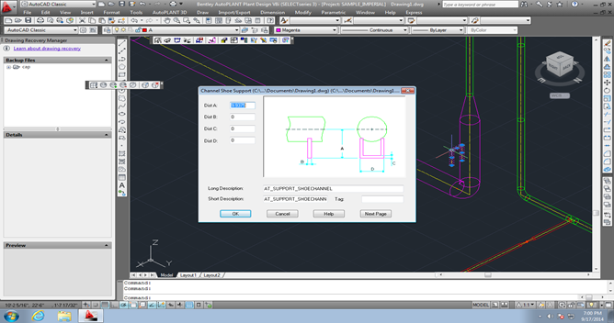

* Point **A0F** (X=9.75 Y=23 Z=8) Constant Support with 2 hangers has been replaced by Spring Support

(Considered OK, after viewing HELP DESK and PXFout.map file for Mapping)

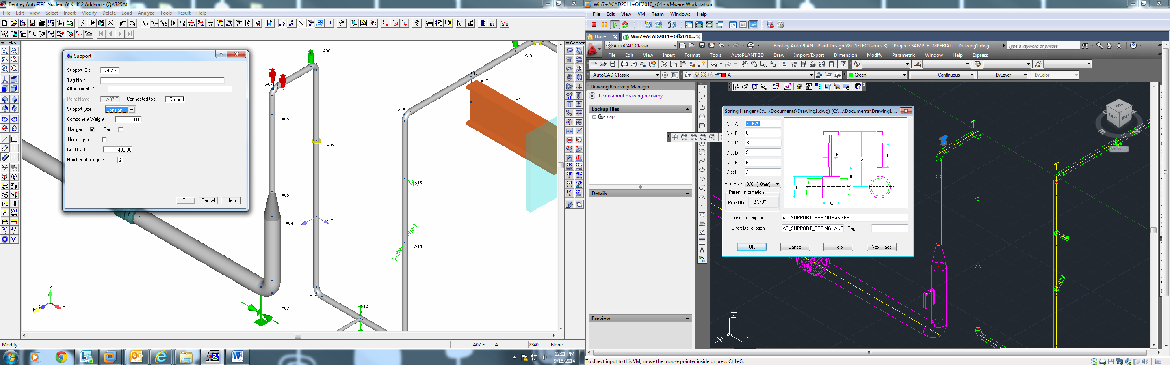

* Point **A12** (X=8 Y=25 Z=-1) V Stop Support missing at the point in AutoPLANT **[Not OK]**

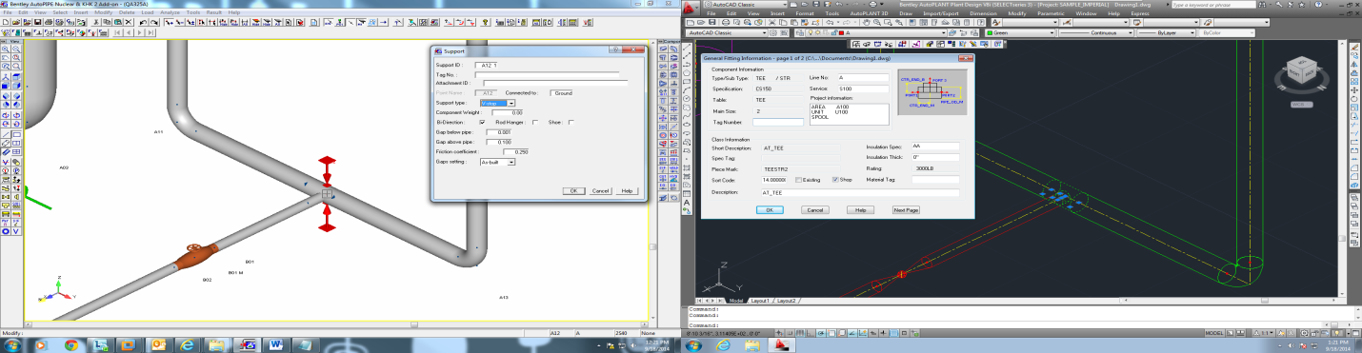

* Point **A16** (X=8 Y=27 Z=8) **[Not OK]**
* Spring Hanger Support additionally found at the point in AutoPLANT

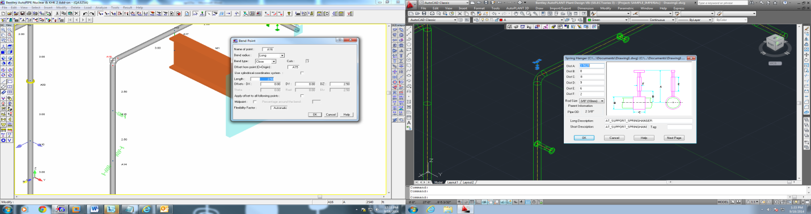

* Point **A17** (X=5 Y=27 Z=8) Tie Link Support is replaced by Base Support. In AutoPIPE a beam section is drawn from point F17 to F20 (Considered OK, after viewing HELP DESK and PXFout.map file for Mapping)

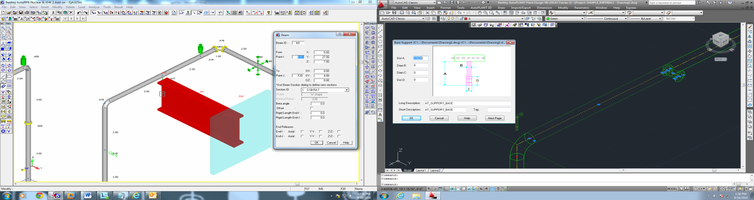

**Issues in Flanges:** (Considered OK, after viewing HELP DESK for Mapping)

* Point **A09** (X=8 Y=23 Z=5) Slip On Flange is missing at the point in AutoPLANT
* Point **A19N** (X=2.25 Y=27 Z=8) and Point A19F (X=2 Y=27.25 Z=8) No flanges found at these two points in AutoPLANT

**Issues in Anchors:** (Considered OK, after viewing HELP DESK and PXFout.map for Mapping)

* Point **A00** (X=10 Y=10 Z=0) Rigid anchor is replaced by Angle Guide Support
* Point **A21** (X=2 Y=30 Z=8) Rigid Anchor replaced by Angle Rigid Support
* Point **B05** (X=14 Y=25 Z=-1) Flexible Anchor has been replaced by Angle Guide Support