***Imp/Export Smoke Testing  
AUTOPIPE 11.0.0.12***

**NTL**

|  |  |
| --- | --- |
| **Test Scope** | NTL Import and Export |
| **Performed By** | Bilal Tahir |
| **Date** | 16 Nov, 2016 |
| **OS** | Win7-32-sp1 |
| **Description** | Covers the smoke test scenarios executed on NTL Import module. |
| **Models** | Earthquake, Force Spectrum, Harmonic, Oper Loads P-T, Response Spectrum, SAM, Time History, User, Wind, QA321A , QA321B, QA321C, QA321D, QA321E |
| **Testing Status** | FAIL |
| **AutoPIPE version** | 11.0.0.12 |
| **Benchmark** | 9.6.1.7 |

**Procedure:**

DAT

NTL

DAT

RPT

COMPARE

RPT

1. Open benchmark DAT model in AutoPIPE latest version
2. Analyze the model (Analyze>Analyze All)
3. Generate *.rpt report (Result>Input Listing) and *.out reports (Result>Results Report)
4. SaveAs NTL(Export DAT to NTL)
5. Import the NTL (created in Step 4) and Analyze the model (Analyze>Analyze All)
6. Generate *.rpt report (Result>Model Input Listing) and *.out report (Result>Results Report)
7. Compare the RPTs generated in Step 3 and Step 4.

**Feature Tested:**

Input listing Report (*.rpt) file

* Input dialogs
  + - “Analysis Set” dialog
    - “Static Analysis Load Cases” dialog
    - “Result Model Option” dialog
    - “Wind” dialog
    - “Static Earthquake” dialog

**Result:** (Benchmark: 9.6.0.19)

|  |  |  |  |  |  |
| --- | --- | --- | --- | --- | --- |
| **Model** | **NTL generated** | **RPT generated** | **OUT**  **generated** | **RPT compared**  **(latest against benchmark)** | **Pass/Fail** |
| **Earthquake** | OK | OK | OK | OK | PASS |
| **Force Spectrum** | OK | OK | OK | OK | PASS |
| **Harmonic** | OK | OK | OK | OK | PASS |
| **Oper Loads P-T** | OK | OK | OK | OK | PASS |
| **Response Spectrum** | OK | OK | OK | OK | PASS |
| **SAM** | OK | OK | OK | OK | PASS |
| **Time History** | OK | OK | OK | OK | PASS |
| **User** | OK | OK | OK | Not OK | FAIL |
| **Wind** | OK | OK | OK | OK | PASS |
| **QA327A** | OK | OK | OK | Not OK | FAIL |
| **QA327B** | OK | OK | OK | Not OK | FAIL |
| **QA327C** | OK | OK | OK | Not OK | FAIL |
| **QA327D** | OK | OK | OK | Not OK | FAIL |
| **QA327E** | OK | OK | OK | Not OK | FAIL |

Following observations were made during testing in comparison with the models:

**LOADCASES:**

**Earthquake**

1. “Model Input Listing Report” dialog: [OK]
2. “Result Model Option” dialog (Tools>Model>Results) : [Not OK]

After export Result Model Option dialog had **2 options** checked, which were unchecked before export

* **User normal thickness**
* **Include Max Range comb**

1. “Analysis Set” dialog (Load>Static Analysis Sets) : [OK]
2. “Static Analysis Load Cases” dialog (Load>Static Analysis Sets>Modify) : [OK]
3. Model Input Listing Report(*.rpt): [OK]

* **Model Revision Number:** After exportvaries from ‘2’ to ‘1’
* **Component Data Listing**:
* Point data: After export **Rating** varies from ‘16’ to ‘Nonstandard’, **ANSI check** varies from ‘No’ to ‘Yes’, (From A02 to A03) data for points ‘A02 N’ and ‘A02 F’ missing, (From A04 to A05) data not given and, (From A06 to A07) data not given
* Number of points in the system: After export decreases from **23** to **21**
* Weight of Empty Pipes: After export decreases from **1906.7 lb** to **1906.5 lb**
* **Flange Data Listing:**

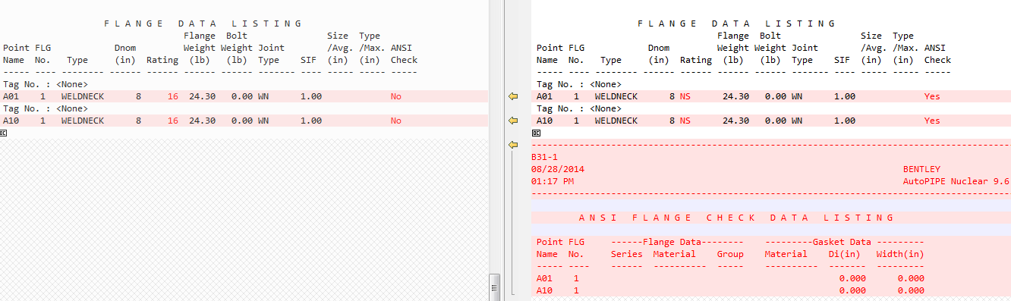

**Force Spectrum**

1. “Model Input Listing Report” dialog: [OK]
2. “Result Model Option” dialog (Tools>Model>Results): [Not OK]

After export Result Model Option dialog had **2 options** checked, which were unchecked before export

* **User normal thickness**
* **Include Max Range comb**

1. “Analysis Set” dialog (Load>Static Analysis Sets): [OK]
2. “Static Analysis Load Cases” dialog (Load>Static Analysis Sets>Modify): [OK]
3. Model Input Listing Report(*.rpt): [OK]

* **Model Revision Number:** After exportvaries from ‘2’ to ‘1’
* **Component Data Listing**:
* Point data: After export **ANSI check** varies from ‘No’ to ‘Yes’

**Harmonic**

1. “Model Input Listing Report” dialog: [OK]
2. “Result Model Option” dialog (Tools>Model>Results): [Not OK]

After export Result Model Option dialog had **1 option** checked, which was unchecked before export

* **User normal thickness**

1. “Analysis Set” dialog (Load>Static Analysis Sets): [OK]
2. “Static Analysis Load Cases” dialog (Load>Static Analysis Sets>Modify): [OK]
3. Model Input Listing Report(*.rpt): [OK]

* **Model Revision Number:** After exportvaries from ‘2’ to ‘1’
* **Component Data Listing**:
* Point data: After export **ANSI check** varies from ‘No’ to ‘Yes’

**Oper Loads P-T**

1. “Model Input Listing Report” dialog: [OK]
2. “Result Model Option” dialog (Tools>Model>Results): [OK]
3. “Analysis Set” dialog (Load>Static Analysis Sets): [OK]
4. “Static Analysis Load Cases” dialog (Load>Static Analysis Sets>Modify): [OK]
5. Model Input Listing Report(*.rpt): [OK]

* **Model Revision Number:** After exportvaries from ‘2’ to ‘1’
* **Table of Contents:** After export Coordinates page no shifted from 5 to 6
* **Component Data Listing**:
* Pipe data: After export **Shear Modulus** increased from **10.88461** E6 psi to **10.88462** E6 psi
* Point data: : After export **SIF** varies from 0 to 1 and **ANSI check** varies from ‘No’ to ‘Yes’
* **Flange Data Listing:**

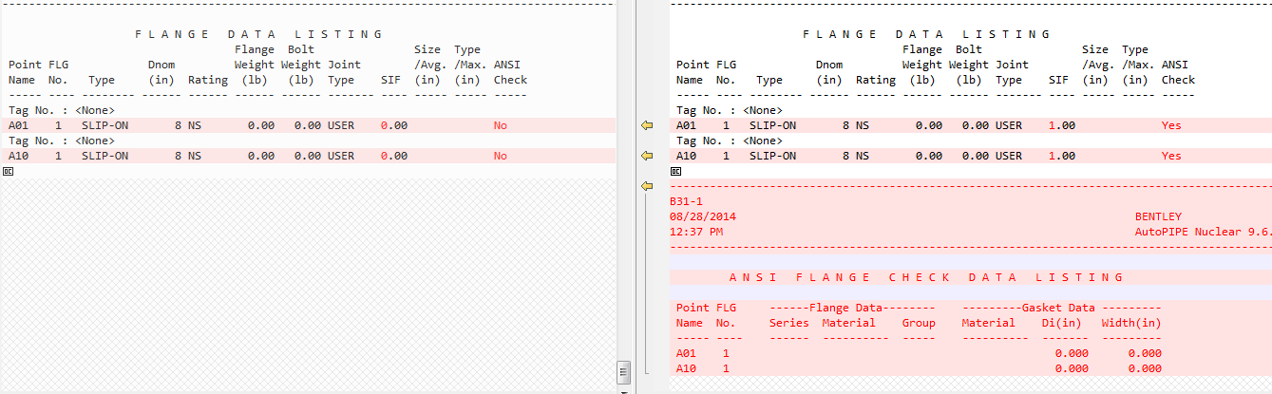

**Response Spectrum**

1. “Model Input Listing Report” dialog: [OK]
2. “Result Model Option” dialog (Tools>Model>Results): [OK]
3. “Analysis Set” dialog (Load>Static Analysis Sets) : [OK]
4. “Static Analysis Load Cases” dialog (Load>Static Analysis Sets>Modify): [OK]
5. Model Input Listing Report(*.rpt): [OK]

* **Model Revision Number:** After exportvaries from ‘2’ to ‘1’
* **Component Data Listing**:
* Pipe data: After export **Shear Modulus** increased from **10.88461** E6 psi to **10.88462** E6 psi
* Point data: : After export **SIF** varies from 0 to 1 and **ANSI check** varies from ‘No’ to ‘Yes’
* **Flange Data Listing:**

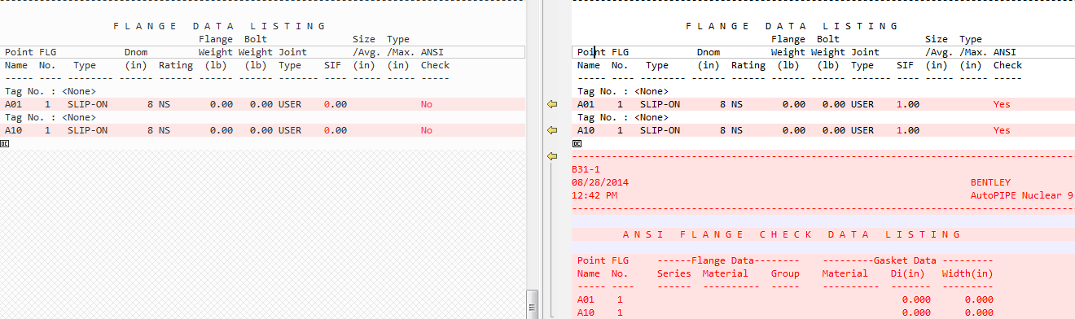

**SAM**

1. “Model Input Listing Report” dialog: [OK]
2. “Result Model Option” dialog (Tools>Model>Results) [Not OK]

* After export **Sustain margin** shifts from ‘Y’ to ‘E’

1. “Analysis Set” dialog (Load>Static Analysis Sets): [OK]
2. “Static Analysis Load Cases” dialog (Load>Static Analysis Sets>Modify): [OK]
3. Model Input Listing Report(*.rpt) [OK]

* **Model Revision Number:** After exportvaries from ‘2’ to ‘1’
* **Component Data Listing**:
* Point data: **ANSI check** varies from ‘No’ to ‘Yes’
* **Flange Data Listing:**



**Time History**

1. “Model Input Listing Report” dialog: [OK]
2. “Result Model Option” dialog (Tools>Model>Results): [Not OK]

* After export **Sustain margin** shifts from ‘Y’ to ‘E’

1. “Analysis Set” dialog (Load>Static Analysis Sets): [OK]
2. “Static Analysis Load Cases” dialog (Load>Static Analysis Sets>Modify): [OK]
3. Model Input Listing Report(*.rpt) [OK]

* **Model Revision Number:** After exportvaries from ‘2’ to ‘1’
* **Component Data Listing**:
* Point data: **ANSI check** varies from ‘No’ to ‘Yes’
* **Flange Data Listing:**



* After exporting NTL and then opening it in AutoPIPE an error occurred while analyzing

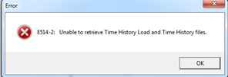

**User**

1. “Model Input Listing Report” dialog: [OK]
2. “Result Model Option” dialog (Tools>Model>Results): [OK]
3. “Analysis Set” dialog (Load>Static Analysis Sets): [Not OK]

* After export Load case **U140** was missing in Analysis set no: 1

1. “Static Analysis Load Cases” dialog (Load>Static Analysis Sets>Modify): [Not OK]

* Change in use cases for Analysis set no:1

**Comparison of Static Analysis Load Cases dialog for Analysis set no: 1**

**(Before export view and after export view)**

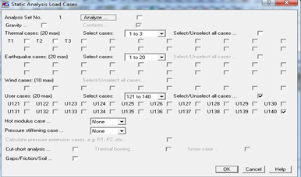 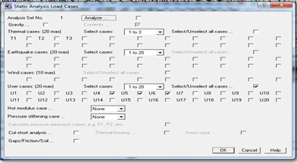

* Change in use cases for Analysis set no:3

**Comparison of Static Analysis Load Cases dialog for Analysis set no: 3**

**(Before export view and after export view)**

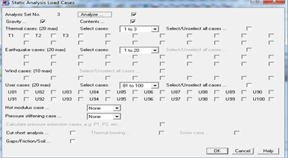 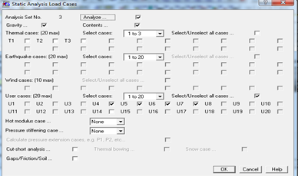

1. Model Input Listing Report(*.rpt) [Not OK]

* **Model Revision Number:** After exportvaries from ‘3’ to ‘1’
* **Component Data Listing**:
* Pipe data: After export **Shear Modulus** increased from **10.88823** E6 psi to **10.88824** E6 psi
* Point data: After export **Rating** varies from ‘16’ to ‘Nonstandard’, **ANSI check** varies from ‘No’ to ‘Yes’, Load varies from **U140** to **U14**
* **Flange Data Listing:**



**Wind**

1. Model Input Listing Report” dialog: [OK]
2. “Result Model Option” dialog (Tools>Model>Results) [Not OK]

* **User normal thickness**: checked after export

1. “Analysis Set” dialog (Load>Static Analysis Sets): [OK]
2. “Static Analysis Load Cases” dialog (Load>Static Analysis Sets>Modify): [OK]
3. Model Input Listing Report(*.rpt): [OK]

* **Model Revision Number:** After exportvaries from ‘2’ to ‘1’
* **Component Data Listing**:
* Point data: After export **Rating** varies from ‘16’ to ‘Nonstandard’, **ANSI check** varies from ‘No’ to ‘Yes’, Load varies from **U140** to **U14**
* **Flange Data Listing:**

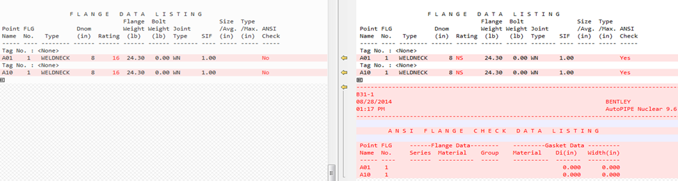

**QA321A**

1. “Model Input Listing Report” dialog: [OK]
2. “Result Model Option” dialog (Result>Model>Results): [OK]
3. “Analysis Set” dialog (Load>Static Analysis Sets): [OK]
4. “Static Analysis Load Cases” dialog (Load>Static Analysis Sets>Modify): [OK]
5. Model Input Listing Report(*.rpt) [Not OK]

* **Component DATA(Valve)**: Manufacturer data found missing.
* **Catalog Valve Data Listing**: Information missing

**QA321B**

1. “Model Input Listing Report” dialog: [OK]
2. “Result Model Option” dialog (Tools>Model>Results): [OK]
3. “Analysis Set” dialog (Load>Static Analysis Sets): [OK]
4. “Static Analysis Load Cases” dialog (Load>Static Analysis Sets>Modify): [OK]
5. Model Input Listing Report(*.rpt) [Not OK]



* **Table of Contents:** Support page no shifted from 23 to 22
* **Component Data Listing**:
* Point data: For Point A00 and A01 Id = 6, after export Id =710
* Support data: (From A01 to A02) For Point A01 Stiffness= 168 lb/in, Preload= 436 lbf, after export Stiffness= FREE, Preload= 0 lbf
* Support data: (From A02 to B01) For Point A02, Preload= 576 lbf, after export Preload= 0 lbf

(From B02 to B03) For Point B02, Support Id= B02, after export Support Id= B02 **1**

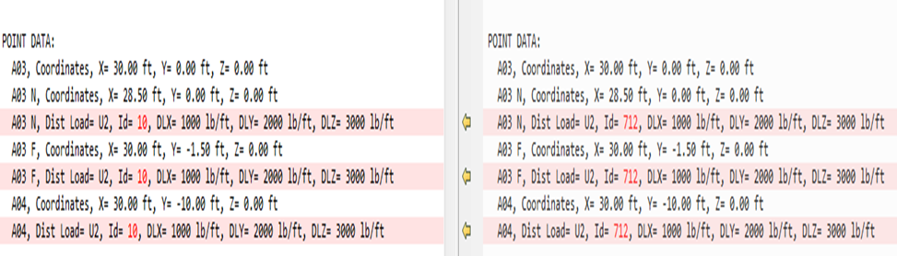

* **Beam Cross Section Listing:**

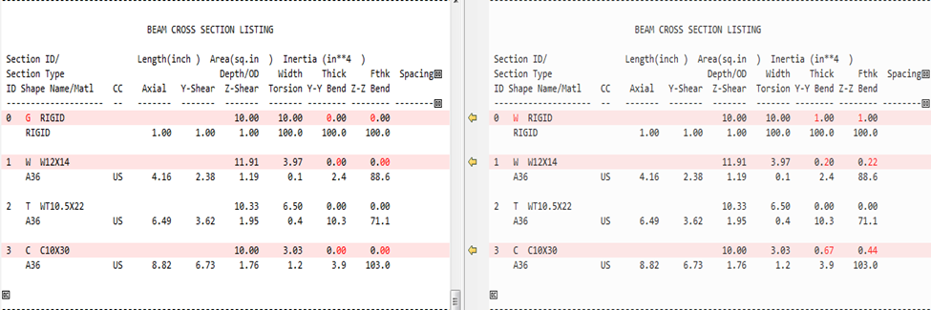

* **Soil Data Listing:**
* High Stiffness: Auto = ‘N’, after export Auto = ‘Y’
* Low Stiffness: Auto = ‘N’, after export Auto = ‘Y’
* **Load Summary Data Listing:** Load Case:1 Direction was set ‘Global Z-axis’, after export Direction X=0.000, y=0.000 and z=1.000
* **Fluid Transient Input Data:** Section not exported.
* **Load Summary Data Listing:** ‘Title’ for Spectrum varies before and after export changed
* **Support Data Listing:**
* For point A01 Stiff = 168.000 and Preload= 436, after export Stiff= 0.000 and Preload= 0
* For point A02 Preload= 576, after export Preload= 0
* Opening DAT in AutoPIPE errors occurred while analyzing

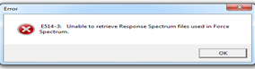 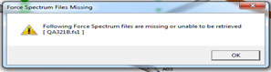

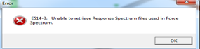 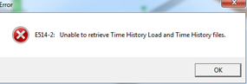

**QA321C**

1. “Model Input Listing Report” dialog: [OK]
2. “Result Model Option” dialog (Tools>Model>Results): [Not OK]

* **User normal thickness:** checked after export

1. “Analysis Set” dialog (Load>Static Analysis Sets): [OK]
2. “Static Analysis Load Cases” dialog (Load>Static Analysis Sets>Modify): [OK]
3. Model Input Listing Report(*.rpt) [Not OK]



* **Table of Contents:** Pipe properties page no shifted from 12 to 13
* **Point Data Listing**:
* Description: End Flanges and Sif changes for bends B3, D3,L3, N3 and P5
* For Segment O, 05 Run z= -0.99, after export z= -1.00
* For Segment N, N4, N5 Valve: Rating value missing
* For Segment P, Point name ‘P4’ Run, after export ‘P5’ N Near
* Weight of Empty Pipes= 1973.4 lb, after export its values changes to 1973.3 lb
* **Component Data Listing:**
* For Segment C, D ANSI check= No, after export ANSI check= Yes
* For Segment L, L4 M: z= -25.60, after export its value changes to -25.59
* For Segment M, M1 M: x= -9.67, after export its value changes to -9.68
* For Segment O,

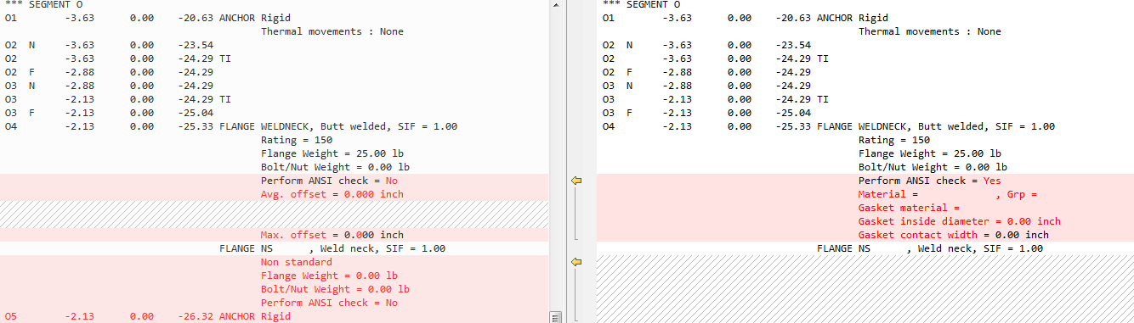

* Additional data after export
* Number of points in the system (Pipe + Frame + Soil): 156 + 0 + 0 = 156, after export Number of points in the system (Pipe + Frame + Soil): 155 + 0 + 0 = 155
* **Operating Temperature and Pressure Data:** Segment P, Point name ‘P4’, after export ‘P5 N’
* **Bend Data Listing:**

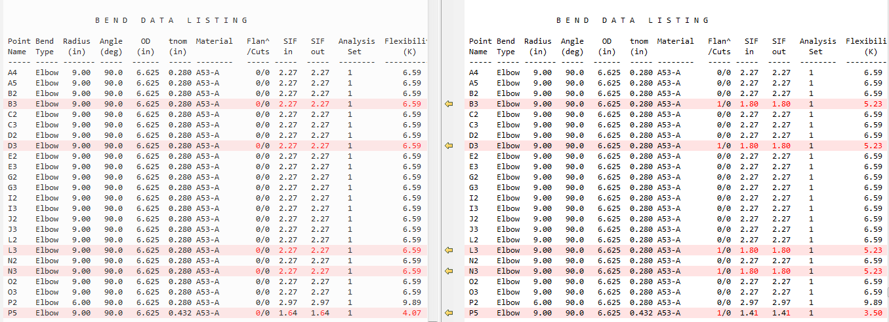

* **Flange Data Listing:** ANSI check varies from ‘No’ to ‘Yes’
* **CATALOG VALVE DATA LISTING:** Point Name L4,L6,M1, M2,N4,N5 data missing
* **ANSI Flange Check Data listing:** Additional data found after export
* After exporting NTL and then opening it in AutoPIPE an error occurred while analyzing

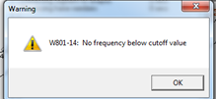

**QA321D**

1. “Model Input Listing Report” dialog: [OK]
2. “Result Model Option” dialog (Result>Result Options > Model [Not OK]

* **Include results desc:** unchecked after export

1. “Analysis Set” dialog (Load>Static Analysis Sets): [OK]
2. “Static Analysis Load Cases” dialog (Load>Static Analysis Sets>Modify): [OK]
3. Model Input Listing Report(*.rpt) [Not OK]



* **Component Data Listing:**
* Operating data:

‘Kfac1’ value changes from 0.800 to 0.850

‘Exp1’ value changes from 1.44000 mm/m to 1.53000 mm/m

* Component data:

Data for SIFI Circ, SIFO Circ, SIFI Long and SIFO Long is unmatched

* Operating data: Kfac1= 0.850, missing after export
* **Co-ordinates Data Listing:** Segment A, for point A18N x= 38575.74, after export x= 38575.73
* **Pipe Data Listing: ‘**PIPE05’ data not given after export
* **Material Data Listing:**

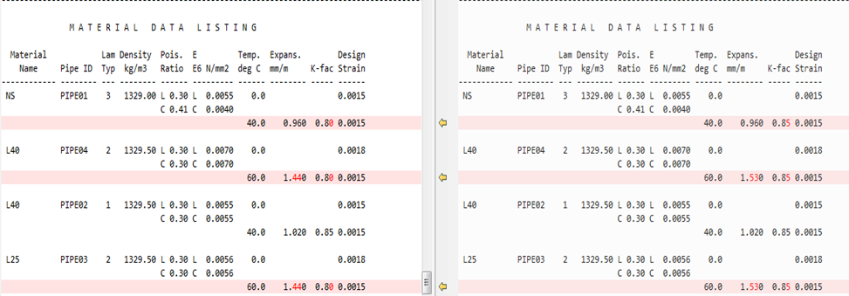

* **Operating Temperature And Pressure Data:**

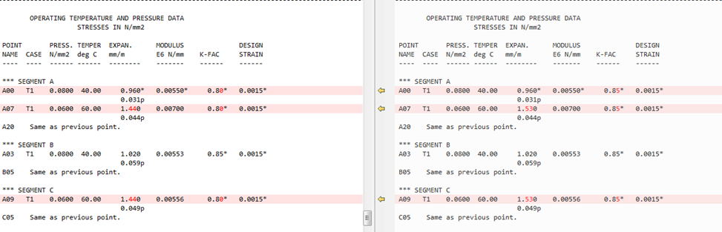

* **Loads Summary Data Listing:** Load case 1- W1 Direction= Global Z-axis, after export Direction is set X= 0.000 Y= 0.000 Z= 1.000
* **Support Data Listing:** Spring Manufacturer: ‘Anvil/Grinnell’ missing after export

**QA321E**

1. “Model Input Listing Report” dialog: [OK]
2. “Result Model Option” dialog (Tools>Model>Results): [Not OK]

* **User normal thickness:** checked after export
* **Include Max Range comb:** checked after export

1. “Analysis Set” dialog (Load>Static Analysis Sets): [OK]
2. “Static Analysis Load Cases” dialog (Load>Static Analysis Sets>Modify): [OK]
3. Model Input Listing Report(*.rpt) [Not OK]



* **Model Revision Number:** After exportvaries from ‘2’ to ‘1’
* **Component Data Listing:** Pipe data in Segment A, From point A00 TO A01: ‘Syc’ value changes from 0 psi to 40000.0 psi.
* **Material Allowable Data Listing: For** Material NS, ‘Yield psi’ value changes from 0.0 to 40000.0 psi
* **Soil Stiffness Properties (Soil):**
* High Stiffness: Auto = ‘N’, after export Auto = ‘Y’
* Low Stiffness: Auto = ‘N’, after export Auto = ‘Y’
* **Soil Properties:**

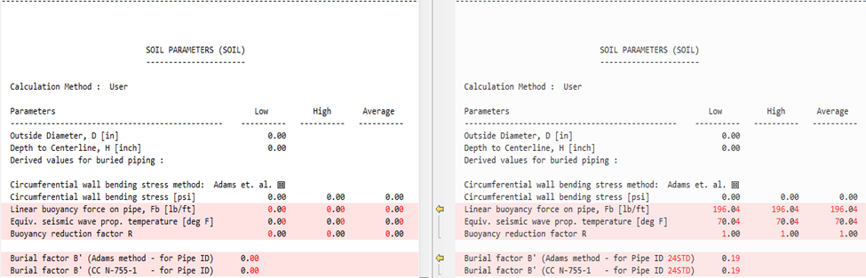

* After exporting NTL and then opening it in AutoPIPE an error occurred while analyzing

