**Insomnia**

**Concept Document**

**V. 2.0**

Professor Tim Samoff

Game Development Studio 1

Fall 2019

**Abstract:**

Insomnia is a 2d Adventure game with a lot of suspenseful . The main character(you) go to bed like any other ordinary day. However, the player is awakon to an almost life-like setting, however, the player does not know he is asleep still just captured in a harsh dream that seems like reality. The player then the player must then take multiple steps to wake up again, however, if he fails to wake himself before sunrise he will die permanently living in this cruel reality.

**Goal:**

In total Insomnia is a 5 room game with multiple “keys” that will allow the player to unlock the path to the roof where the player will jump from the top of his house only to wake up the next morning. The player must find clues and find these keys to unlock the next rooms in order to find the exit key, however, if the steps are done wrong you can die permanently when jumping off the roof.

**Design Statement:**

The reason I wanted to do an adventure game with a slower development was to build the suspense of the player as they get the clues and open new rooms. I feel many games often throw too much at the player at once. So for me having a game with a slower development was what I was shooting for.

**Audience & Context:**

My game is targeted towards players who enjoy action-packed but also a bit of suspense. Overall my game is not very complex and in all can be enjoyed by all ages but teenagers will appeal to it more as it requires a bit of more attention when it comes to understanding clues.

**Core Gameplay:**

Insomnia is built off of uncovering clues as well as applying them to the end goal. From the very begging of the game, you will be given important information that will play a role in the late game. Problem-solving but also being able to solve it under the stress of the player's life being on the line are key to being efficient and successful in Insomnia.

**Look and Feel:**

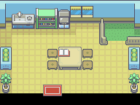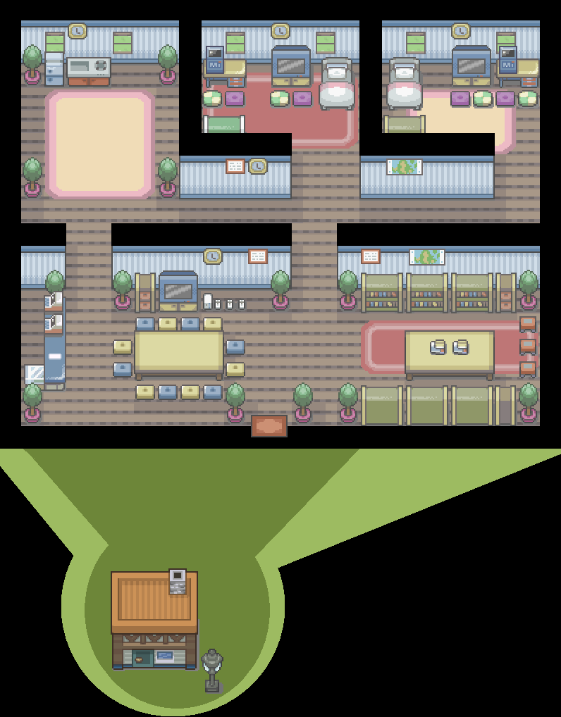

I wanted my maps to have a simplistic feel like that of the older pokemon games nothing very crazy just very homey feeling.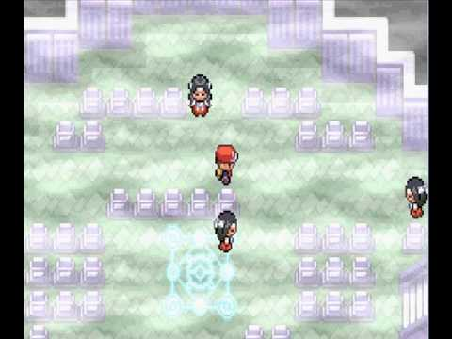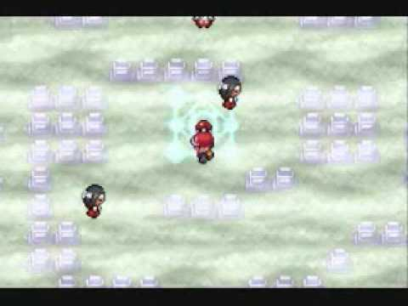

I wanted to go for a more spooky feel in my game to help build the suspense(if GB studios can pull this off)

**Game Flow:**

The player will start in their bedroom right after they have just finished homework going to the kitchen to eat with his family not knowing that in a couple hours he will be awoken to a harsh dream not finding any clue of where his family has gone. One the character eats he will then go to sleep only to wake up in the middle of the night to a deserted house the player must manevior and search for clue to the rooms that lay open to the player.

Room 1:

Room 1 or the Bedroom is where the player will spawn and will find clues scattered and helpful; things the player will need to remember for late game. The player is free to move around the room and leave it whenever they see fit and come back as they please.

room 2:

Can be whatever the next room the player chooses to decide. If the player decides to go to the room across them they will be in their parents room where they must again find clues in order to find the key in which will unlock the roof

Room 3:

The family room and kitchen by far has the most hints but also hints that can give you the wrong theory and get you kind instead of unlocking the true ending of the game

Room 4:

The roof is the end game the player depending on the choices and things the player has picked up will be forced to choose whether to jump off the roof or go down the chimney only to be trapped in the reality

**Final Gameplay Scenes:**

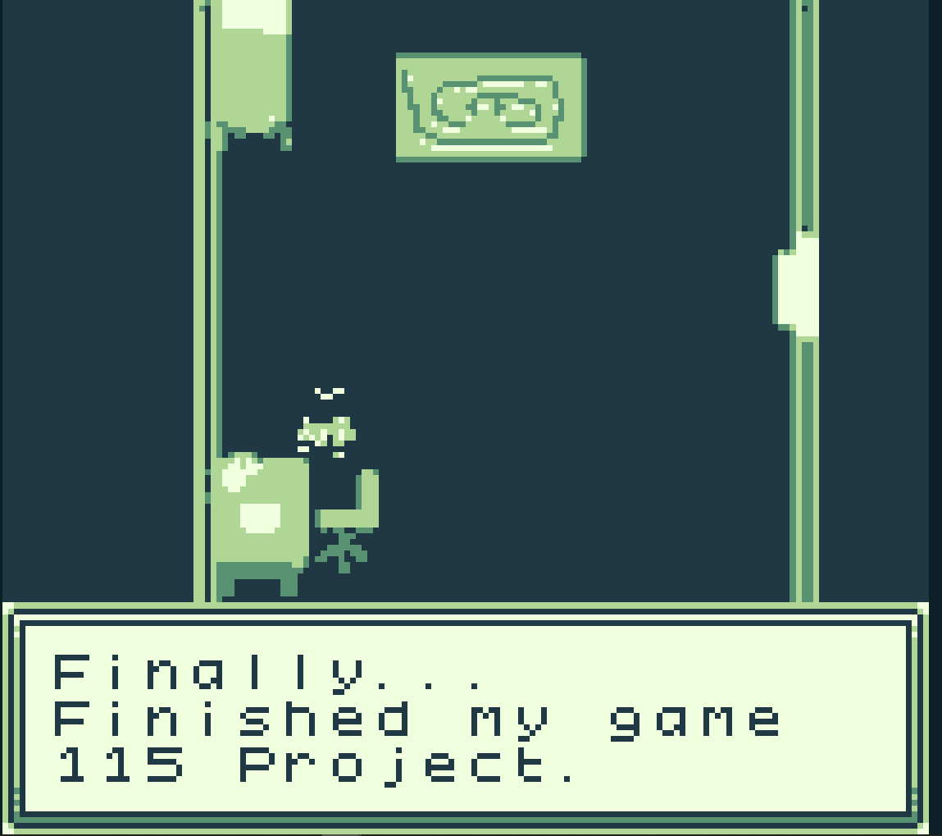

Intro Scene before our main character falls asleep.

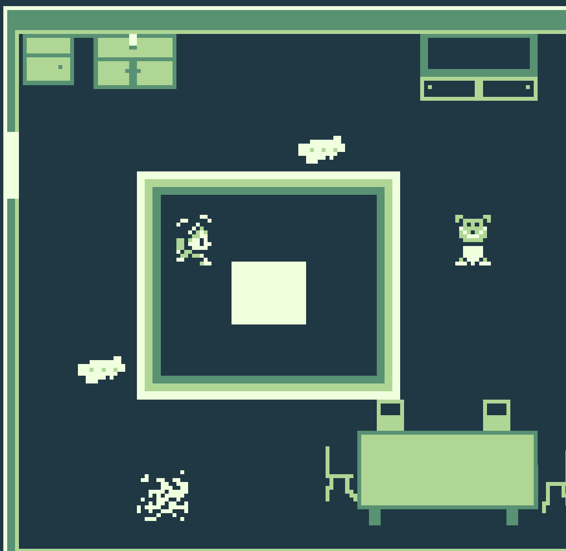

Our first scene in the dream world, here we are in the kitchen.

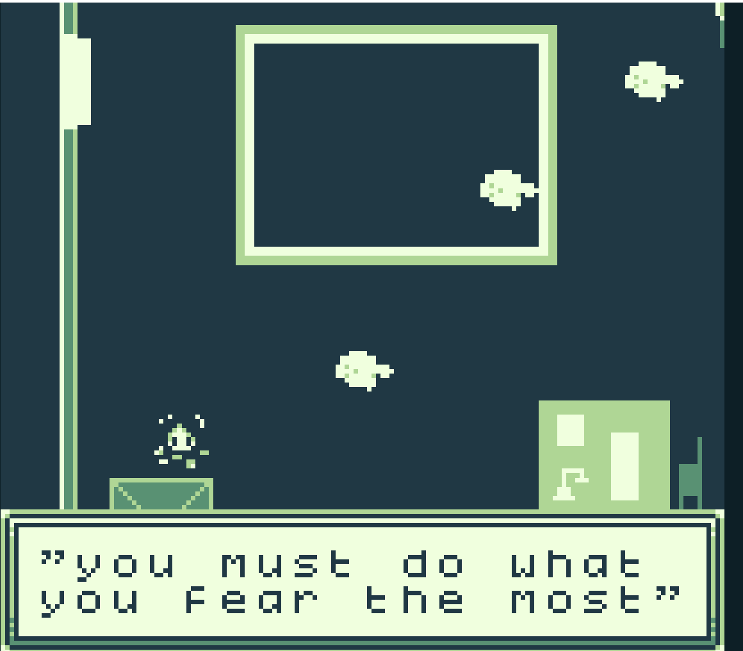

Here our main character is discovering clues about what he must do.

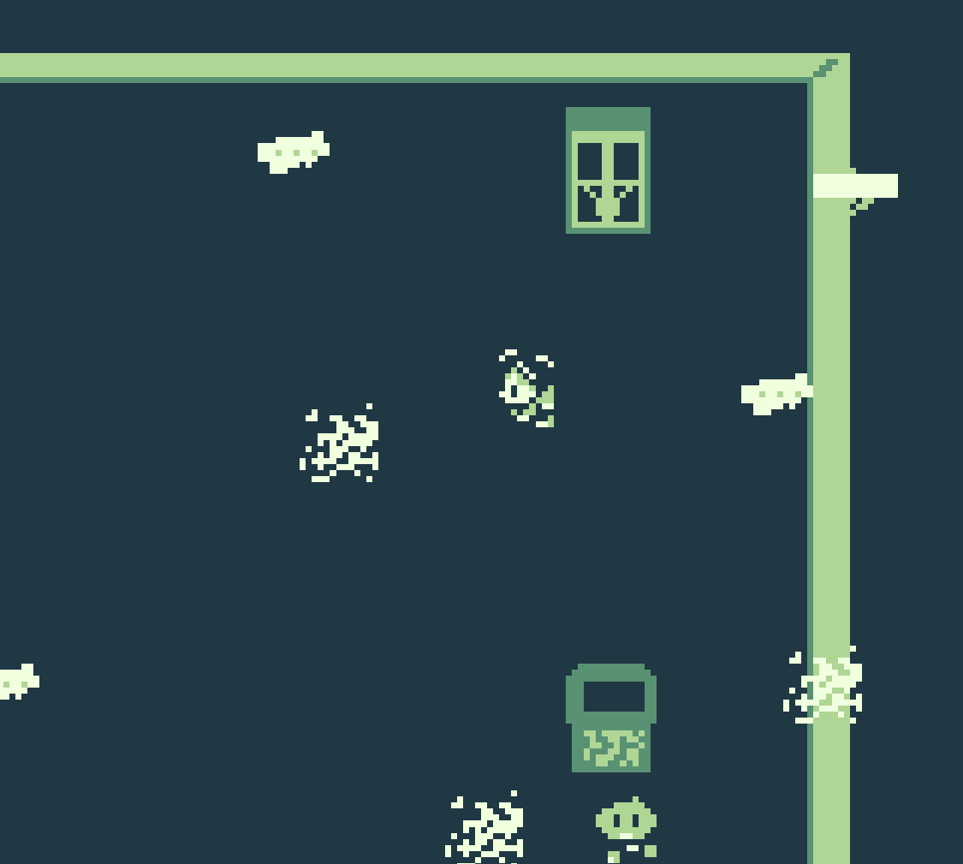

Here our main character has made it to near to end of the game.

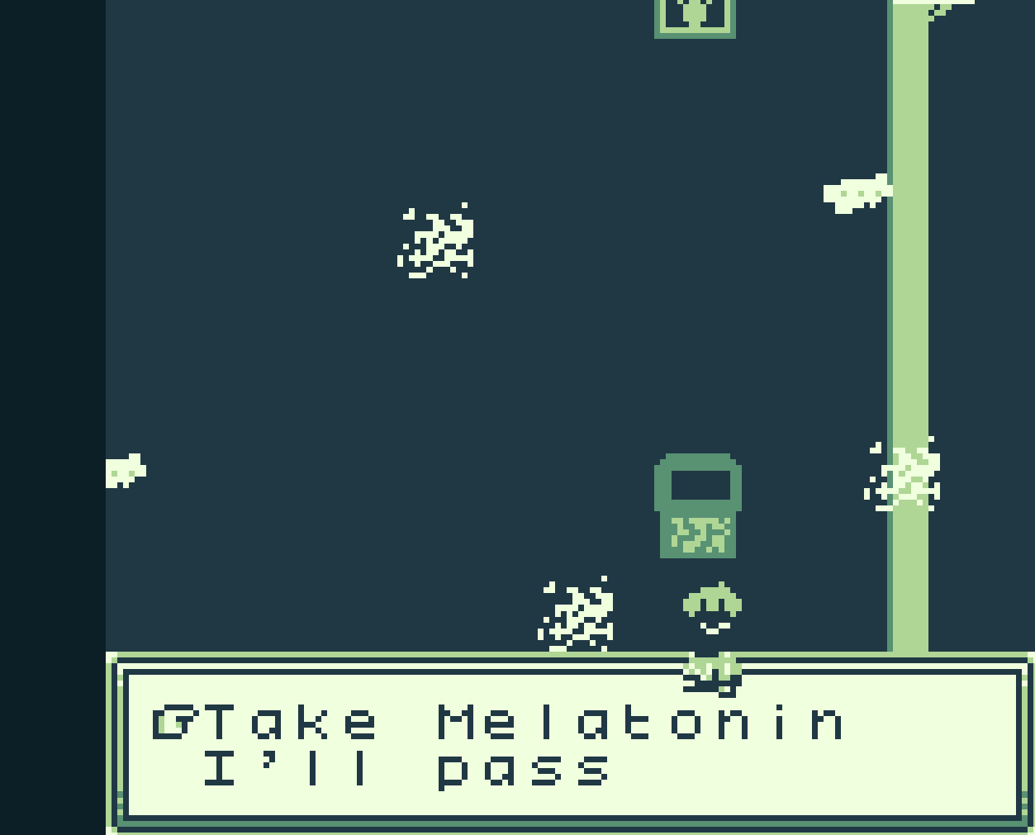

Here our character has made it to a key decision in the game that will decide his faith.

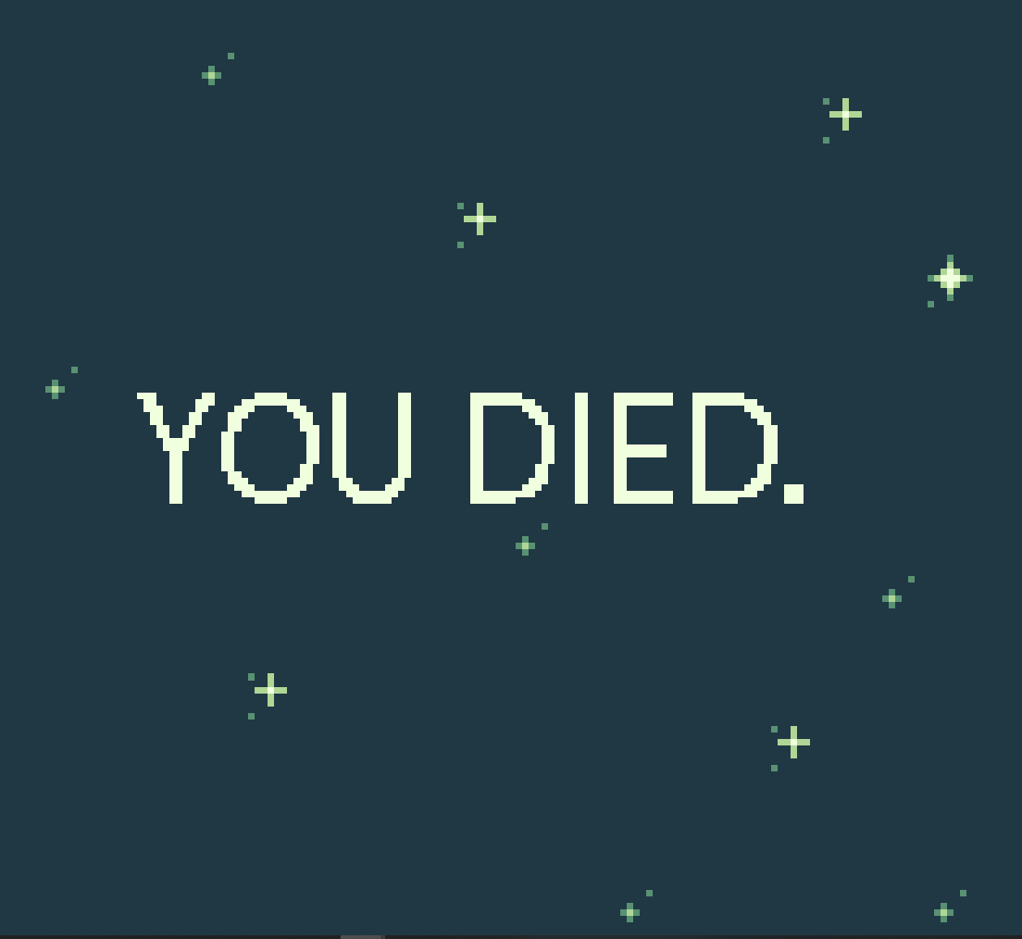

Here is a screen of what you can expect when choosing the wrong decision.

**Post Mortem:**

In all my game design did not come completely to life as to how I envisioned it. Maybe in the beginning some of my goals and ambitions for the game were “too big” for GB Studio. For beginners this was overall a huge learning curve for me to design and develop the game that I described above. I faced numerous challenges when designing the game. One challenge I faced was the narrative aspect of the game. This was a huge struggle for me as I wanted to include as much human interaction as possible but still with a good narrative flow to it. I will admit I failed in some aspects of this. My game was originally was supposed to have choices that would affect the outcome of the game depending on the playstyle the character chosen. This turned out to be too ambitious in the end due to time constraints and a very poor understanding of the software I had to settle for one defining choice that chose the fate of the player. Which made my game feel more narrative driven rather than choice driven. I completely had to cut out a whole side of interactive options and had to rewrite the story. It may not have been how I originally envisioned it but I still am quite pleased with what the end result turned out to be given having to self teach myself how GB studio works as well as other variables.

As I stated above, my game became very narrative driven with very few options for players to choose from. One place I struggled was filling in space with my game. At times my game feels quite empty and feels although as its missing something. I struggled here and resulted in placing more dialogue in the empty places.