Contents

Requirements for executing Pytest using Python 1

Steps to install pip & pipenv for project setup 1

Execute selenium tests 2

Execute API tests 4

PyCharm environment setup [Only If you already have the tool] 5

# Requirements for executing Pytest using Python

* Python 3.6+ (Download 3.7 preferably)
* Jet Brains PyCharm (Preferred) [Below steps are easy if we have PyCharm setup]

# Steps to install pip & pipenv for project setup

* Download Python executable from “<https://www.python.org/downloads/windows/>” and custom install to C drive for easy usage. (**Verify 32/64 bit executable for your system**)
* After you have downloaded & installed python in your local system you will find pip executable in “Scripts” folder under installed python folder.

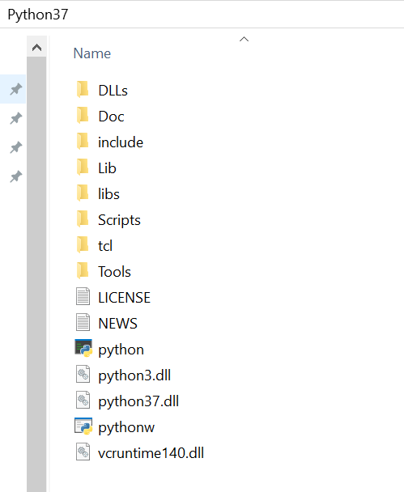 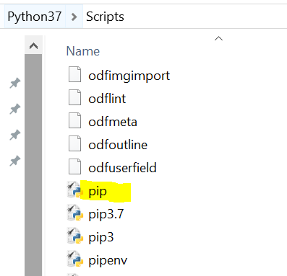

* Navigate to Scripts folder and execute **“pip install pipenv”** in command line.
* After successful installation pipenv executable will be installed in same “Scripts” folder.
* Navigate to project folder and you will find **pipenv file** which contains all dependent libraries for installation.

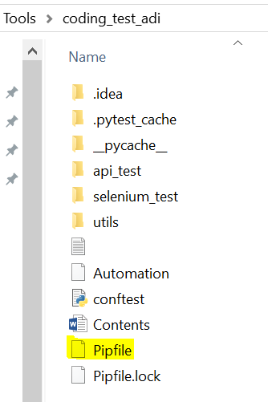

* **Add pipenv executable path or Scripts path** of your python installation into system variables for easy activation of project environment
* To generate/install a project environment use below command in your project directory,

“**python_installation_path/Scripts/pipenv install**”

Or

“**pipenv install”**

* Above command run should successfully install all dependent libraries and lock the files and new environment should be created.
* You will find your project environment in “C:\\users\\your_username\\.virtualenvs\\project_name_randomID”



# Execute selenium tests

* Run following command in project directory to activate pipenv shell in command line,
  + pipenv shell
  + Above command will open an environment specific subshell



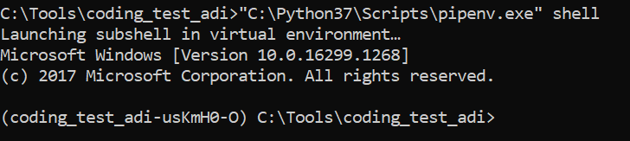

* Run **"C:\\Python37\\Scripts\\pipenv.exe" run python -m pytest "selenium_test\\tests\\test_wikitionary.py" --alluredir "selenium_test\\resources\\results"**

**Or (If pipenv is added to system path)**

“**pipenv run python -m pytest "selenium_test\\tests\\test_wikitionary.py" --alluredir "selenium_test\\resources\\results"**

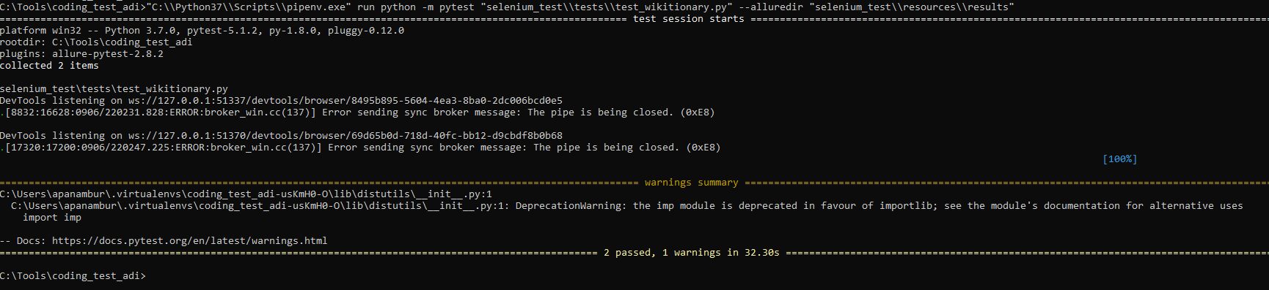

* Above command will start execution of selenium tests and results will be dumped into results folder for allure reporting

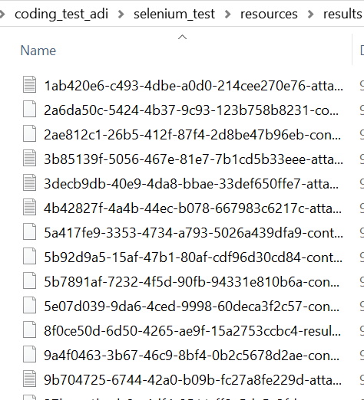

* For generating reports you have to download allure from below link,
  + <https://github.com/allure-framework/allure2/releases>
* After unzipping allure tool navigate to bin directory of allure, you will find allure/allure.bat for generating reports

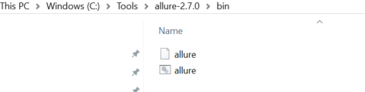

* + Using above tool, run below command
    - “path_to_allure\bin\allure serve C:\Tools\coding_test_adi\selenium_test\results”

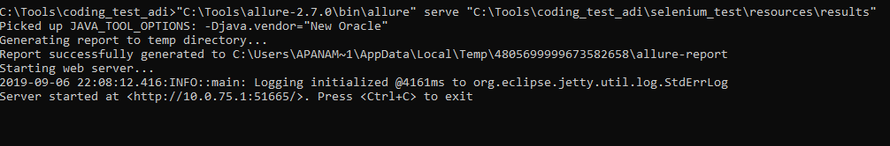

* + - Allure will generate and serve the results dynamically in a URL.

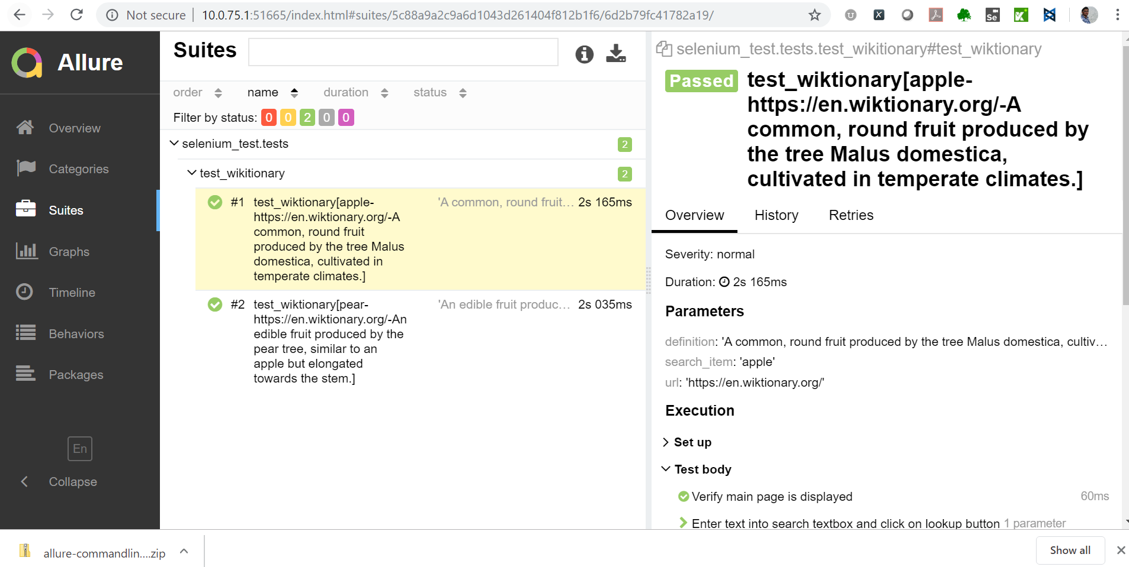

# Execute API tests

* Run following command in project directory to activate pipenv shell in command line,
  + pipenv shell
  + Above command will open an environment specific subshell





* Run **"C:\\Python37\\Scripts\\pipenv.exe" run python -m pytest "api_test\\tests\\test_weatherapi.py" --alluredir "api_test\\resources\\results"**

**Or (If pipenv is added to system path)**

“**pipenv run python -m pytest " api_test\\tests\\test_weatherapi.py" --alluredir " api_test\\resources\\results "**

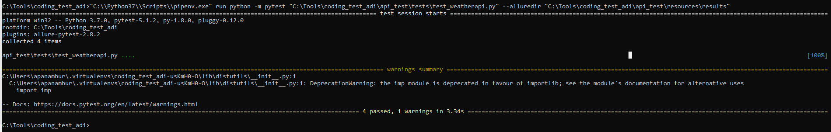

* After unzipping allure tool navigate to bin directory of allure, you will find allure/allure.bat for generating reports



* + Using above tool, run below command
    - “path_to_allure\bin\allure serve C:\Tools\coding_test_adi\selenium_test\results”

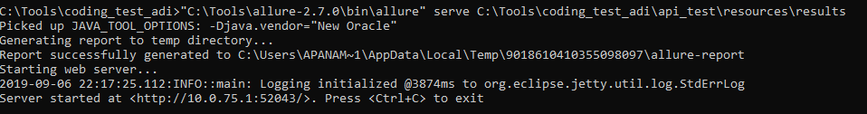

* + - Allure will generate and serve the results dynamically in a URL.

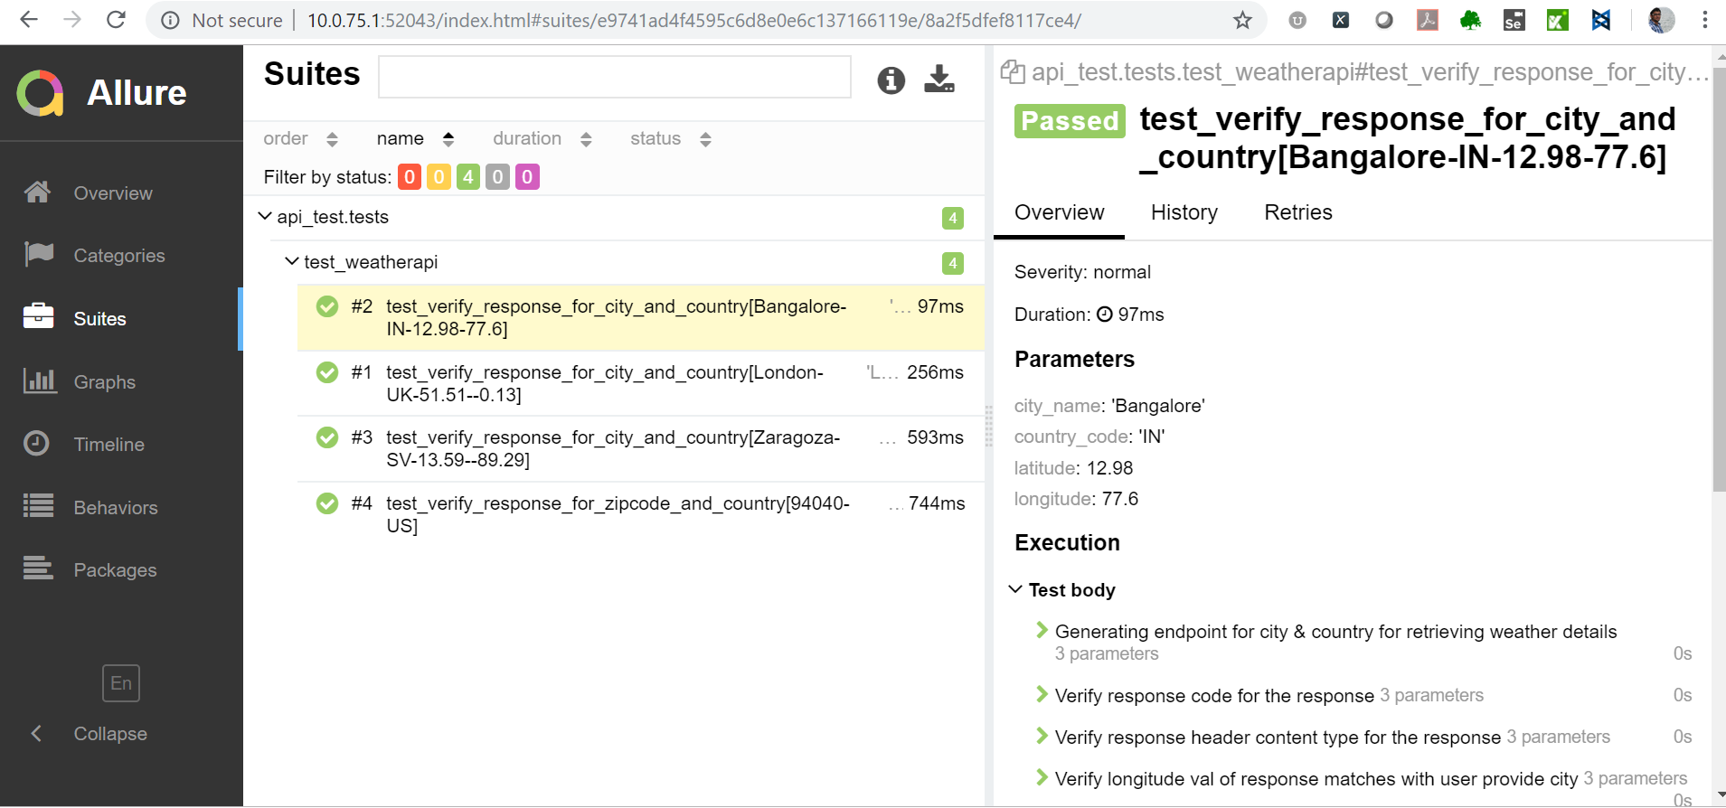

# PyCharm environment setup [Only If you already have the tool]

* Open the project in IDE
* IDE will request to setup pipenv environment
* Navigate to File->Setting->Project->Project Interpreter->Click on gear icon in top right and select “Add”

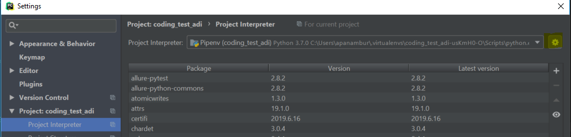

* Select “Pipenv Environment” to generate project environment

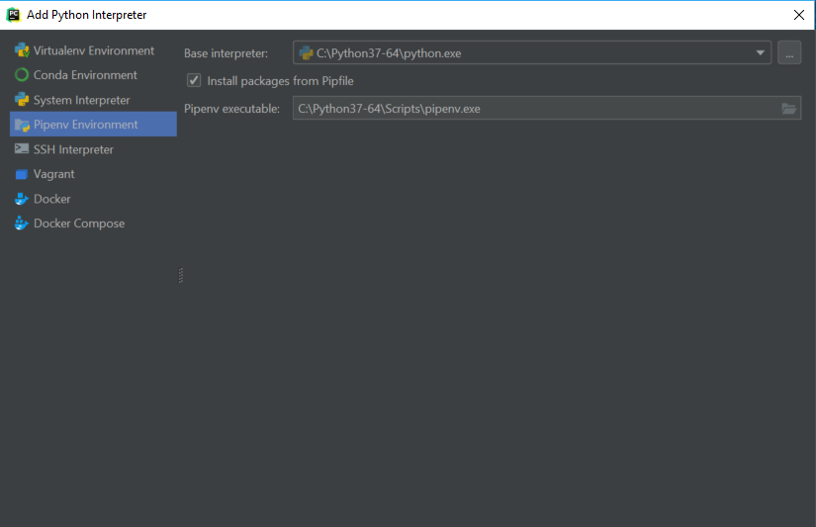

* After setting up, project environment will be ready for use.