Short WASH Assessment Report

Project: Household WASH Survey
Tool: KoboToolbox
Date: 2025

1. Overview
A household survey was conducted using KoboToolbox to assess water, sanitation, and hygiene (WASH) services. The data was exported and analyzed in Excel.

2. Key Indicators
Improved Water Source
- 60% of households use an improved water source
(e.g., piped water, borehole, protected well, rainwater).
Average Time to Water Source
- Average one-way travel time: 15.4 minutes
Indicates accessibility of water within the community.
Improved Sanitation
- 53% of households have improved sanitation facilities
(e.g., flush toilets, VIP latrines, septic systems).
Handwashing with Soap
- 67% of households have a dedicated handwashing facility.
- Among them, 67% have soap available, an important hygiene indicator.

Primary Water Source Types
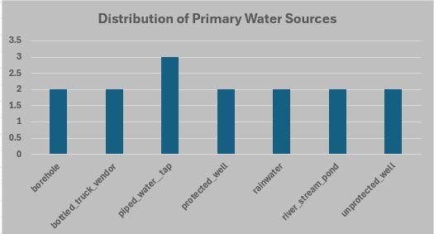

3. Summary of Findings
- Most households appear to have access to improved water.
- Travel time to water varies, indicating differing levels of access.
- Sanitation remains a key area for improvement if improved sanitation < 80%.
- Soap availability highlights gaps in hygiene behavior.

4. Recommendations
- Increase access to improved water sources.
- Improve household sanitation facilities.
- Promote handwashing practices and ensure soap availability.
- Reduce water collection time by installing new water points.

