1. 存储到kafka中的数据样式

{

"metrics": [

{"fields": {

"cpu_count":999

},

"name":"mem_available",

"tags":{

"cluster":"thanos",

"domain":"instance-b40760ec-756e-435a-a93d-c78813f4593e",

"flavorName":"openstack.cpu-1-ram-2048-disk-0",

"host":"nm02-compute-10e0e136e224",

"idc":"neimeng05",

"instance":"10.0.136.224",

"instanceId":"b40760ec-756e-435a-a93d-c78813f4593e",

"instanceName":"33953008",

"job":"libvirt_linux",

"projectId":"6e2df3c8806b49bcaceb48d6b836c490",

"projectName":"ct_06f57377bb064ac8b4484fc4f81da003",

"source_file":"ab49c9f1-99ee-4acd-9229-bc0bb8c3f81a",

"target_device":"vdb",

"userId":"07b147ae969349a3a76cd88c337279a4",

"userName":"ct_141e59ee1a54490db6440a452d70d3b5"

},

"timestamp":1661150739

}]

}

1. 存储到hive中的数据样式

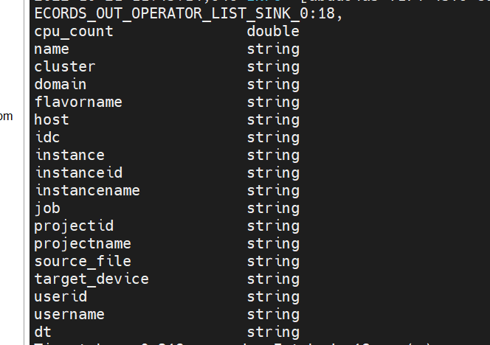

1. 存入mysql中的数据样式

