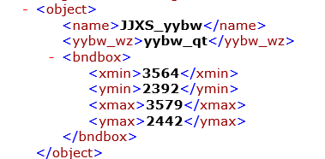

1. Name是大区域类别。

yybw_wz是什么？

1. 这些名称是大区域的类别吗？

这些名称和xlsx中的对不上。

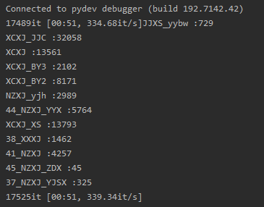

按照xlsx

38_XXXJ :1462

41_NZXJ :4257

45_NZXJ_ZDX :45

37_NZXJ_YJSX :325

44_NZXJ_YYX :5764

XCXJ_JJC :32058

XCXJ :13561

JJXS_yybw

XCXJ_BY3 :2102

XCXJ_BY2 :8171

NZXJ_yjh :2989

XCXJ_XS :13793

1. 按什么规则把这些名称加入

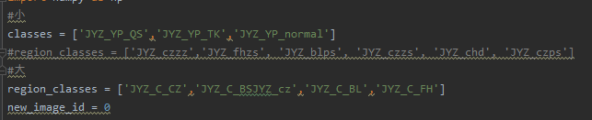

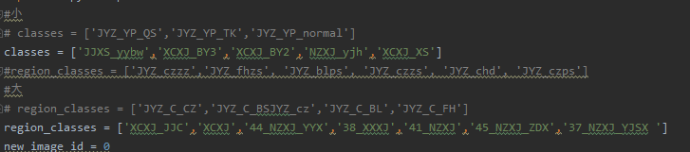

1. Train.py中cfg的参数

cfg为

Config (path: /home/igi/media/yhy/casecade/bin/configs/rcnn_region.py): {'optimizer': {'weight_decay': 0.0001, 'lr': 0.01, 'momentum': 0.9, 'type': 'SGD'}, 'log_level': 'INFO', 'gpus': 1, 'work_dir': '/home/igi/media/yhy/casecade/bin/..//model_output/region', 'root': '/home/igi/media/yhy/casecade/bin/../', 'os': <module 'os' from '/usr/local/python3.5/lib/python3.5/os.py'>, 'optimizer_config': {'grad_clip': {'max_norm': 35, 'norm_type': 2}}, 'test_pipeline': [{'type': 'LoadImageFromFile'}, {'type': 'MultiScaleFlipAug', 'transforms': [{'type': 'Resize', 'keep_ratio': True}, {'type': 'RandomFlip'}, {'type': 'Normalize', 'std': [58.395, 57.12, 57.375], 'mean': [123.675, 116.28, 103.53], 'to_rgb': True}, {'size_divisor': 32, 'type': 'Pad'}, {'type': 'ImageToTensor', 'keys': ['img']}, {'type': 'Collect', 'keys': ['img']}], 'img_scale': (1200, 800), 'flip': False}], 'img_norm_cfg': {'std': [58.395, 57.12, 57.375], 'mean': [123.675, 116.28, 103.53], 'to_rgb': True}, 'data': {'val': {'pipeline': [{'type': 'LoadImageFromFile'}, {'type': 'MultiScaleFlipAug', 'transforms': [{'type': 'Resize', 'keep_ratio': True}, {'type': 'RandomFlip'}, {'type': 'Normalize', 'std': [58.395, 57.12, 57.375], 'mean': [123.675, 116.28, 103.53], 'to_rgb': True}, {'size_divisor': 32, 'type': 'Pad'}, {'type': 'ImageToTensor', 'keys': ['img']}, {'type': 'Collect', 'keys': ['img']}], 'img_scale': (1200, 800), 'flip': False}], 'type': 'RegionDataset', 'img_prefix': '/home/igi/media/yhy/casecade/bin/..//train_data/', 'ann_file': '/home/igi/media/yhy/casecade/bin/..//train_data/test.txt'}, 'train': {'pipeline': [{'type': 'LoadImageFromFile'}, {'with_bbox': True, 'type': 'LoadAnnotations'}, {'type': 'Resize', 'img_scale': (1200, 800), 'keep_ratio': True}, {'flip_ratio': 0.5, 'type': 'RandomFlip'}, {'type': 'Normalize', 'std': [58.395, 57.12, 57.375], 'mean': [123.675, 116.28, 103.53], 'to_rgb': True}, {'size_divisor': 32, 'type': 'Pad'}, {'type': 'DefaultFormatBundle'}, {'type': 'Collect', 'keys': ['img', 'gt_bboxes', 'gt_labels']}], 'type': 'RegionDataset', 'img_prefix': '/home/igi/media/yhy/casecade/bin/..//train_data/', 'ann_file': '/home/igi/media/yhy/casecade/bin/..//train_data/train.txt'}, 'test': {'pipeline': [{'type': 'LoadImageFromFile'}, {'type': 'MultiScaleFlipAug', 'transforms': [{'type': 'Resize', 'keep_ratio': True}, {'type': 'RandomFlip'}, {'type': 'Normalize', 'std': [58.395, 57.12, 57.375], 'mean': [123.675, 116.28, 103.53], 'to_rgb': True}, {'size_divisor': 32, 'type': 'Pad'}, {'type': 'ImageToTensor', 'keys': ['img']}, {'type': 'Collect', 'keys': ['img']}], 'img_scale': (1200, 800), 'flip': False}], 'type': 'RegionDataset', 'test_mode': True, 'img_prefix': '/home/igi/media/yhy/casecade/bin/..//train_data/', 'ann_file': '/home/igi/media/yhy/casecade/bin/..//train_data/test.txt'}, 'imgs_per_gpu': 3, 'workers_per_gpu': 2}, 'log_config': {'hooks': [{'type': 'TextLoggerHook'}], 'interval': 50}, 'load_from': None, 'model': {'type': 'CascadeRCNN', 'bbox_head': [{'num_fcs': 2, 'in_channels': 256, 'target_means': [0.0, 0.0, 0.0, 0.0], 'type': 'SharedFCBBoxHead', 'num_classes': 8, 'roi_feat_size': 7, 'loss_bbox': {'beta': 1.0, 'type': 'SmoothL1Loss', 'loss_weight': 1.0}, 'target_stds': [0.1, 0.1, 0.2, 0.2], 'fc_out_channels': 1024, 'reg_class_agnostic': True, 'loss_cls': {'type': 'CrossEntropyLoss', 'use_sigmoid': False, 'loss_weight': 1.0}}, {'num_fcs': 2, 'in_channels': 256, 'target_means': [0.0, 0.0, 0.0, 0.0], 'type': 'SharedFCBBoxHead', 'num_classes': 8, 'roi_feat_size': 7, 'loss_bbox': {'beta': 1.0, 'type': 'SmoothL1Loss', 'loss_weight': 1.0}, 'target_stds': [0.05, 0.05, 0.1, 0.1], 'fc_out_channels': 1024, 'reg_class_agnostic': True, 'loss_cls': {'type': 'CrossEntropyLoss', 'use_sigmoid': False, 'loss_weight': 1.0}}, {'num_fcs': 2, 'in_channels': 256, 'target_means': [0.0, 0.0, 0.0, 0.0], 'type': 'SharedFCBBoxHead', 'num_classes': 8, 'roi_feat_size': 7, 'loss_bbox': {'beta': 1.0, 'type': 'SmoothL1Loss', 'loss_weight': 1.0}, 'target_stds': [0.033, 0.033, 0.067, 0.067], 'fc_out_channels': 1024, 'reg_class_agnostic': True, 'loss_cls': {'type': 'CrossEntropyLoss', 'use_sigmoid': False, 'loss_weight': 1.0}}], 'neck': {'type': 'FPN', 'in_channels': [256, 512, 1024, 2048], 'out_channels': 256, 'num_outs': 5}, 'num_stages': 3, 'rpn_head': {'type': 'RPNHead', 'feat_channels': 256, 'target_means': [0.0, 0.0, 0.0, 0.0], 'target_stds': [1.0, 1.0, 1.0, 1.0], 'anchor_strides': [4, 8, 16, 32, 64], 'in_channels': 256, 'anchor_scales': [8], 'loss_bbox': {'beta': 0.1111111111111111, 'type': 'SmoothL1Loss', 'loss_weight': 1.0}, 'anchor_ratios': [0.5, 1.0, 2.0], 'loss_cls': {'type': 'CrossEntropyLoss', 'use_sigmoid': True, 'loss_weight': 1.0}}, 'bbox_roi_extractor': {'type': 'SingleRoIExtractor', 'roi_layer': {'out_size': 7, 'type': 'RoIAlign', 'sample_num': 2}, 'out_channels': 256, 'featmap_strides': [4, 8, 16, 32]}, 'pretrained': 'open-mmlab://resnext101_64x4d', 'backbone': {'type': 'ResNeXt', 'frozen_stages': 1, 'style': 'pytorch', 'num_stages': 4, 'out_indices': (0, 1, 2, 3), 'depth': 101, 'groups': 64, 'base_width': 4}}, 'workflow': [('train', 1)], 'checkpoint_config': {'meta': {'config': '# model settings\nimport os\n\ncfg_root = os.path.abspath(os.path.dirname(__file__))\n#cfg_root = os.path.abspath(os.path.dirname(__file__))\nsec_root = os.path.dirname(cfg_root)\nroot =os.path.join(os.getcwd(),\'../\')# os.path.dirname(sec_root)\nprint("#################%s,###########################%s#############################%s"%(os.path.abspath(os.path.dirname(__file__)),\n

1. 模型保存

runner.run为模型训练，但是模型在哪里保存呢？

Github上查到save_checkpoint是保存模型的函数，但是这个函数在哪里调用呢

cfg.checkpoint_config的值为存储模型的间隔epoch

1. 训练精度

Epoch [1][4350/4389] lr: 0.01000, eta: 2 days, 19:56:38, time: 1.124, data_time: 0.007, memory: 9358, s0.loss_bbox: 0.0759, s2.loss_bbox: 0.0747, loss_rpn_bbox: 0.0094, s0.acc:

94.9414, s2.loss_cls: 0.0357, loss_rpn_cls: 0.0175, s1.loss_bbox: 0.1003, s1.acc: 94.6006, s2.acc: 94.5802, s1.loss_cls: 0.0708, s0.loss_cls: 0.1371, loss: 0.5214

Epoch [2][4350/4389] lr: 0.01000, eta: 2 days, 17:48:17, time: 1.117, data_time: 0.007, memory: 9358, s0.loss_bbox: 0.0565, s2.loss_bbox: 0.0614, loss_rpn_bbox: 0.0068, s0.acc:

96.3789, s2.loss_cls: 0.0278, loss_rpn_cls: 0.0098, s1.loss_bbox: 0.0773, s1.acc: 95.9582, s2.acc: 95.7154, s1.loss_cls: 0.0533, s0.loss_cls: 0.1028, loss: 0.3956

Epoch [3][2950/4389] lr: 0.01000, eta: 2 days, 16:52:42, time: 1.126, data_time: 0.008, memory: 9358, s0.loss_bbox: 0.0555, s2.loss_bbox: 0.0590, loss_rpn_bbox: 0.0089, s0.acc:

96.2598, s2.loss_cls: 0.0263, loss_rpn_cls: 0.0092, s1.loss_bbox: 0.0742, s1.acc: 96.0698, s2.acc: 95.8190, s1.loss_cls: 0.0490, s0.loss_cls: 0.0974, loss: 0.3794

Epoch [18][2300/4389] lr: 0.00010, eta: 1 day, 20:51:44, time: 1.153, data_time: 0.010, memory: 9358, s0.loss_bbox: 0.0195, s2.loss_bbox: 0.0278, loss_rpn_bbox: 0.0031, s0.acc: 97.9102, s2.loss

_cls: 0.0127, loss_rpn_cls: 0.0011, s1.loss_bbox: 0.0293, s1.acc: 97.8086, s2.acc: 97.9176, s1.loss_cls: 0.0245, s0.loss_cls: 0.0482, loss: 0.1662

Epoch [20][2950/4389] lr: 0.00010, eta: 1 day, 17:49:44, time: 1.133, data_time: 0.008, memory: 9358, s0.loss_bbox: 0.0185, s2.loss_bbox: 0.0261, loss_rpn_bbox: 0.0031, s0.acc: 98.4590, s2.loss

_cls: 0.0105, loss_rpn_cls: 0.0013, s1.loss_bbox: 0.0283, s1.acc: 98.4429, s2.acc: 98.3659, s1.loss_cls: 0.0197, s0.loss_cls: 0.0388, loss: 0.1462