**LAB 2 REPORT**

Name: Jiasen Zhou

Student No: 491302

Screenshot of email from Zapier:



Screenshot of the graphs on ThingSpeak:

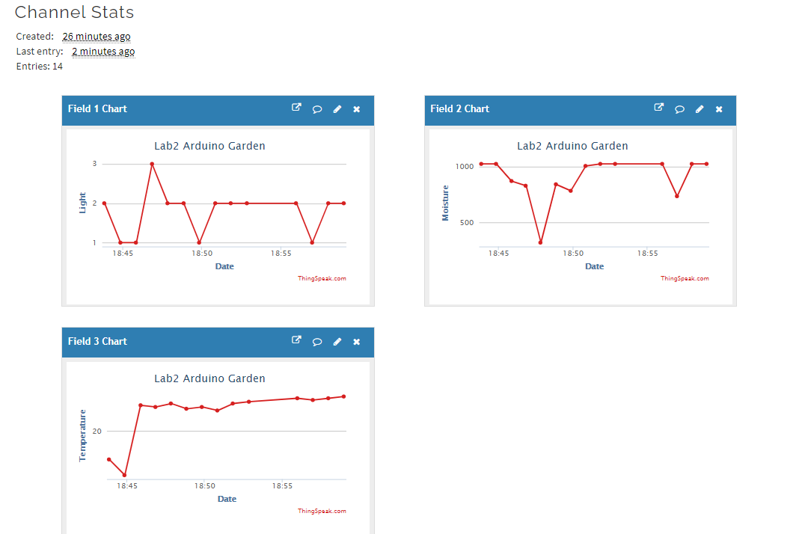

Circuit:

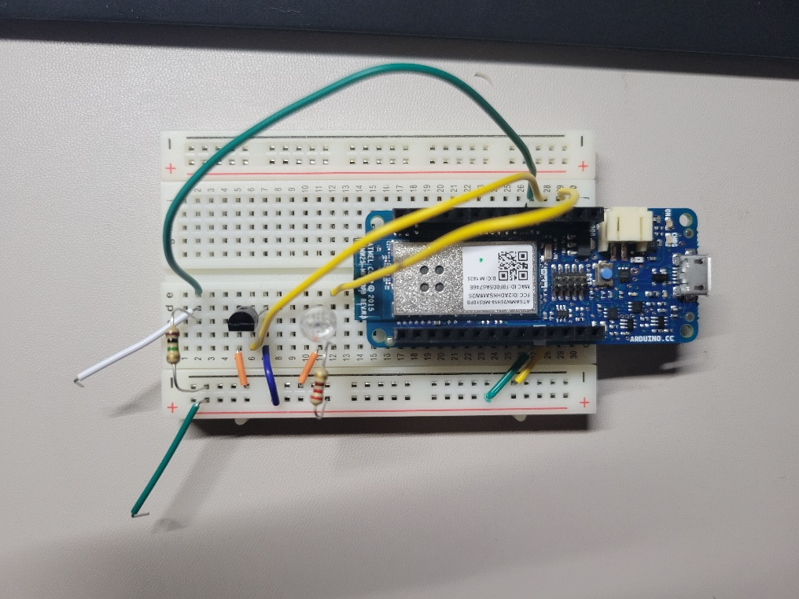

Question 1: Explain in your own words how the DIY moisture sensor works. Specifically address why a 1 MΩ resistor is used in the circuit.

a) The sensor can let the current passes through the soil and measure the resistance of the soil, based on the resistance of the soil, moisture level can be determined since the more water, the more electricity, which means lower resistance.

b) Since we want to calculate the voltage of the soil to determine the moisture level, we need to measure how much voltage drops on soil. So we need to connect the 1M ohms resistor in series.

Question 2: I am trying to grow a pepper plant to spice up my life. Pepper plants thrive at temperatures higher than 55 degrees Fahrenheit. Assume the temperature sensor outputs .5V. Use the code in the sketch to manually convert the reading to (a) Celsius and (b) Fahrenheit. Will my plant die?

a) To Celsius: C = (voltage - 0.5) * 100, we will get 0 Celsius.

b) To Fahrenheit: F = (temperatureC * 9.0 / 5.0) + 32.0, we will get 32 Fahrenheit, which is smaller than 55 degrees Fahrenheit, so your plant will die.