New VSCode Features

# Debugging

VSCode has a debugging feature built in to the text editor itself. To use it, go to “run” at the top of your screen.

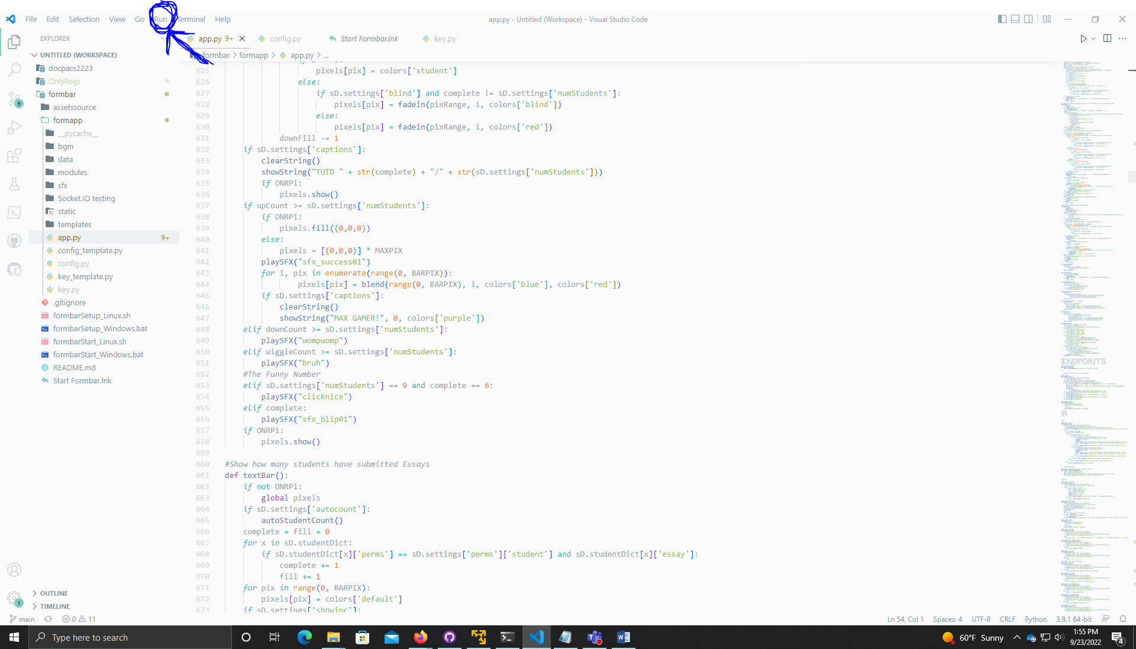

Then select “Start Debugging.” You can also run the code normally by selecting “Run without debugging.”

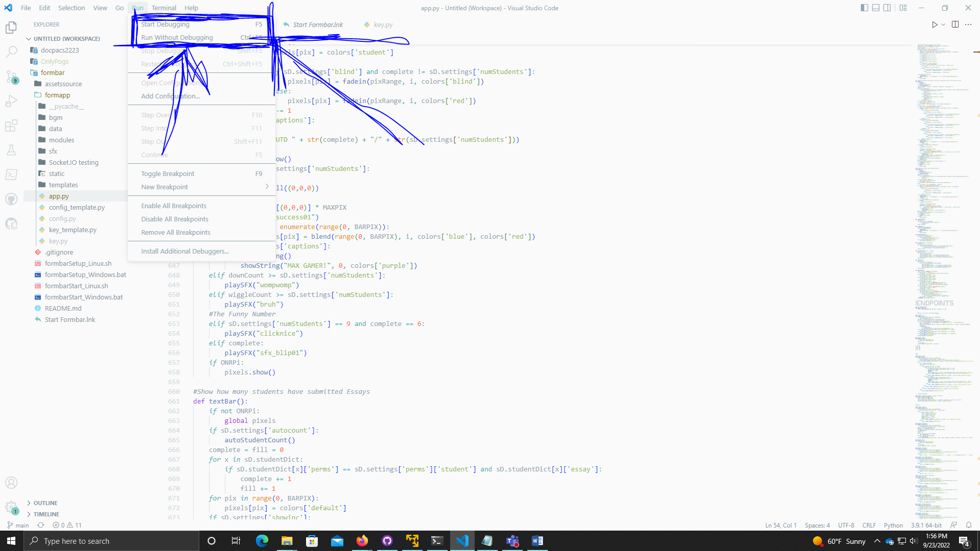

You will then be asked to select a debug configuration. In most cases, the first option is the correct one. The menu will look something like this.

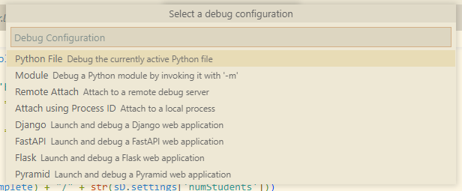

It will automatically run the code with a command line in the bottom of the text editor.

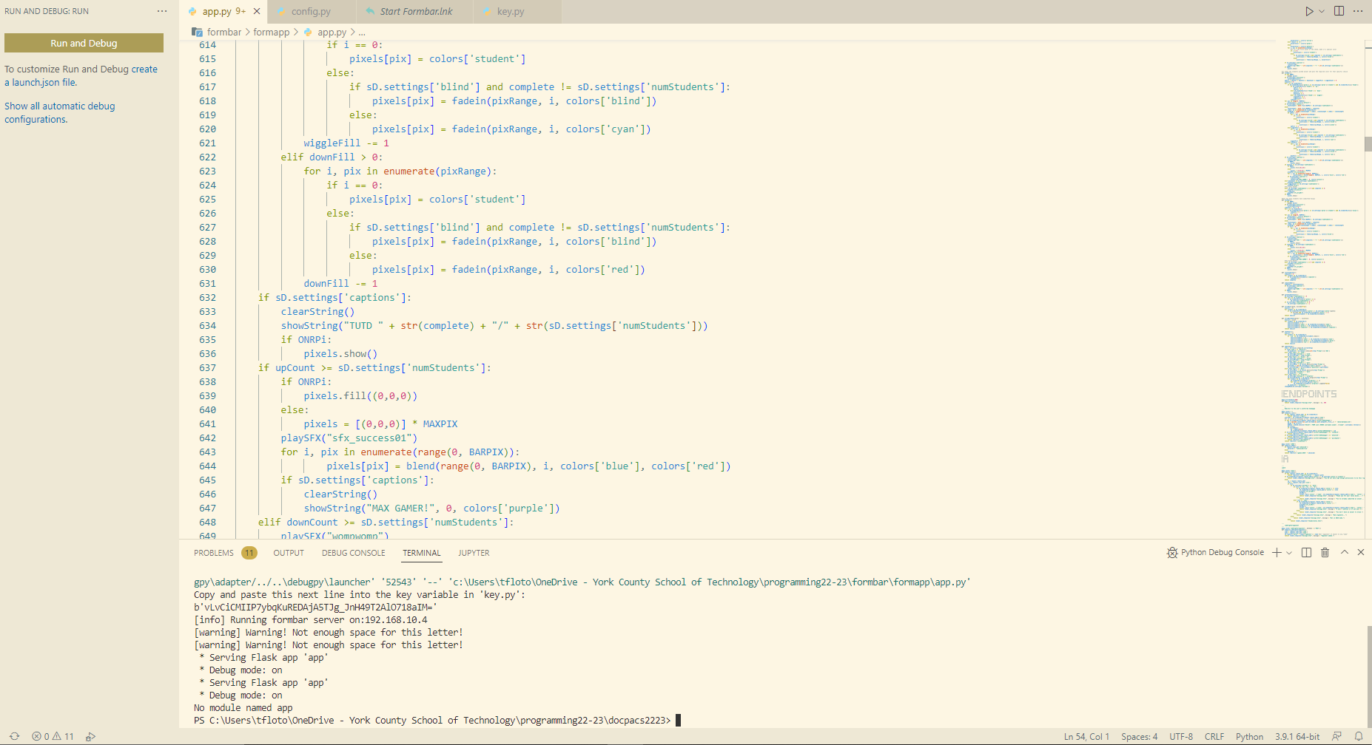

# Workspaces

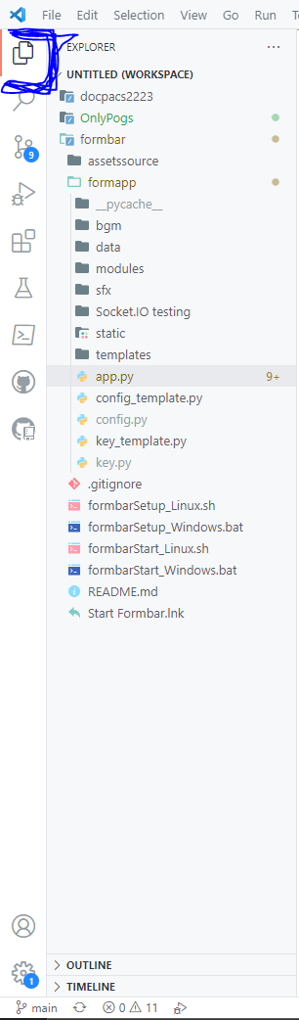From the explorer tab in VSCode on the top left hand of your screen, you can have a workspace of project folders and files. These are unique to VSCode, because your entire explorer can actually be saved as a file and be swapped out for another explorer configuration. To do this, you need to go to file>save workspace as, then save it. You will then save 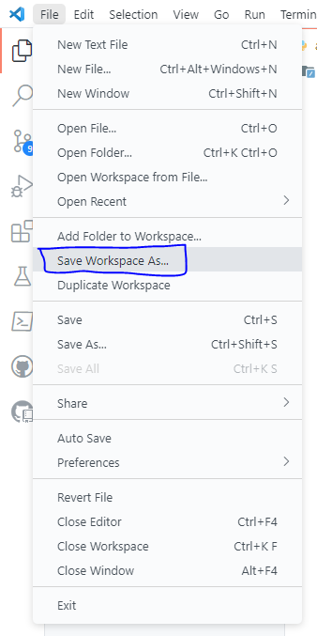the workspace to whichever location you wish. To open another workspace you would select “open workspace from file” and your existing workspace would appear in the explorer.

# Built in Terminal

VSCode has a built in terminal, as mentioned with the first feature, the Debugger. This is a full fledged command line, that you can use for anything you would otherwise do with a command line.

