***Documentation Packet [ 27 17 03 23 ] Mar 17th, 23***

|  |  |
| --- | --- |
| Student Name: |  |
| Goals:  1. Prepare Junior Projects for demonstration 2. Ask questions about projects 3. Prepare for NOCTI Exam | Events:  1. Monday, Junior Presentation 2. Friday, NOCTI Practice Exam |
| Included Documentation  1. Personal Project Progress 2. CIW Completion 3. NOCTI Prep 4. Reflection | Required Documentation:  1. NOCTI Exam 2. CIW Completion 3. Reflection |
| Changes/Notes:  * CIW Completion has been extended for those that didn’t complete it last week. This is not a separate grade. * This DocPac directory in the DocPac Repository includes code examples and documentation from a passing submission for the adult NOCTI for your study. | |

# Personal Project Progress

Maintain a GitHub Repo for a personal project that you or you and several classmates work on. Maintain issues, documentation and Project boards in this repo. Write in the box below what progress was made on this project this week. Prove this work with issue tracking, commits, and PRs. Write your evidence in the box below.

|  |
| --- |
|  |

# CIW Completion

1. Wrap up any loose ends on your CIW Javascript Specialist course.
2. Obtain the “Certificate of Course Completion” with your name and details
3. Save the certificate as “FirstnameLastname.pdf” in the “./CIWCert/” directory of this DocPac folder. If it does not exist, create it.
4. Open a Pull Request to have this file/folder accepted into the DocPac Repository

# Nocti Prep

In order to prepare for the NOCTI, we must practice and test our ability to utilize certain skills from memory. These include:

1. Work with Javascript Objects, basic calculations, arrays, and loops.
2. Create a NodeJS application
3. Use ExpressJS with an HTTP Listen Server
   1. Must be able to handle GET and POST endpoints
   2. Must be able to handle Query Parameters and HTML Form data
4. Create and serve EJS templates
   1. Must be able to send data to the template engine
   2. Must be able to use embedded Javascript in the EJS template to create HTML
5. Create an HTML table using Javascript and populate it with data
   1. This will be done using embedded Javascript in an EJS template
6. Create a cohesive website with a functioning service
7. Create a flowchart or pseudocode list of a program’s functions

Essentially, you will be creating a web page in which users can add order information (customer name, address, items, quantity) to an order, submit that order, add it to a list of orders, and display all of the orders with their information in a table. Below are images that were submitted to the adult NOCTI test. Except for the lack of rounding the pennies, this passed.

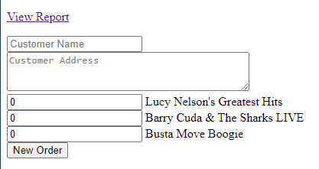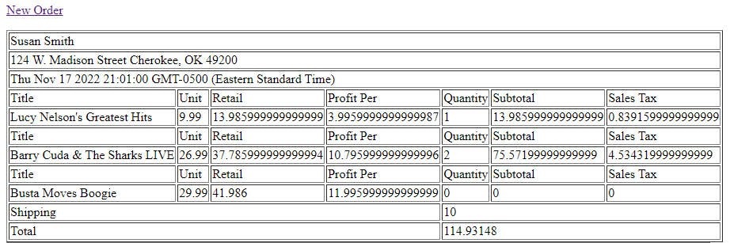

# Reflection

**What is one technique you learned in your coding this week, and what kinds of things can you use it for (the more specifics the better) ?**

|  |
| --- |
|  |
|  |
|  |
|  |
|  |
|  |
|  |
|  |
|  |
|  |
|  |
|  |
|  |
|  |
|  |
|  |
|  |
|  |

**What was a challenge to your time management this week, and what can you do to avoid it in the future (specific plan) ?**

|  |
| --- |
|  |
|  |
|  |
|  |
|  |
|  |
|  |
|  |
|  |
|  |
|  |
|  |
|  |
|  |
|  |
|  |

**What opportunities did you not take advantage of this week, and how would it helped you if you had? *OR* … What opportunity did you take advantage of this week, and what has it changed for you?**

|  |
| --- |
|  |
|  |
|  |
|  |
|  |
|  |
|  |
|  |
|  |
|  |
|  |
|  |
|  |
|  |
|  |
|  |

# A picture containing text, monitor, screen, clipart Description automatically generatedGrading

|  |  |  |
| --- | --- | --- |
| 10 | You went above and beyond expectations. You applied knowledge that was not taught in this class in addition to what was taught. | * All assignments start at 9/10 possible points * 1 point is deducted per infraction   + Lateness   + Mistakes   + Unprofessionalism   + Not following instructions   + Etc. * Outstanding submission increase by 1 point and yield a pog. |
| 9 | You performed as well as can be expected for this class. You show a complete understanding and made no mistakes. You have mastered the subject. |
| 8 | Assignment is complete. You show a good understanding of the subject, but there are mistakes or minor incorrect details. You are ready to move to new subjects. |
| 7 | You show and understanding of the subject, but there are serious errors, or there are pieces you can practically use without understanding them. Remediation needed. |
| 6 | Assignment is incomplete but/or you showed that you understand at least the fundamentals of the subject. Assignment is low effort. Serious need of remediation. |
| 5 | You show minimum effort, assignment is incomplete, or have serious mistakes. You did not demonstrate that you understand the content or purpose of the submission. |
| 0 | The work was not submitted, damaged, seriously incorrect, or unprofessional. The submission is rejected. |

# CIW Completion

# NOCTI Exam

# DocPac / Reflection