NETWORKING
Network: - A network is any collection of independent computers that communicate with one another over a shared network medium. A computer network is a collection of two or more connected computers. If we want to make the network between computers, we need below network requirements.
PC, OS, NIC, IP Address, protocol, cables, connectors and Network devices.
OS (Operating System):- It is an interface between user and computer.
There are types of Operating Systems.
- Client Operating System
- Server Operating System
Server Operating system provides some services to clients like ADS, DNS and DHCP etc.,
Client Operating System doesn’t provide the services, But it access the services from Server OS.
NIC: - NIC Stands for Network Interface Card. Some NIC cards work with wired connections while others are wireless. Most NICs support either wired Ethernet or Wi-Fi wireless standards. Ethernet NICs plug into the system bus of the PC and include jacks for network cables, while Wi-Fi NICs contain built-in transmitters / receivers (transceivers).
It has a MAC (Media Access Control) address. It is a 48 bit address and divided into 12 hexa decimal like 6+6. First 6 is vendor code and second 6 is serial number of NIC. It is unique address.
IP address: - IP stands for Internet Protocol address. It is 32 bit address and it is divided into 4 octets. Each octet is 8 bits designed by IANA (Internet Assigned Numbers Authority).
IPV4 is 32 bit address
IPV6 is 128 bit address.
Now we are using IPV4 only.
- Cables & Connectors
Cables: - Cable is the medium through which information usually moves from one network device to another. There are several types of cable which are commonly used with LANs. In some cases, a network will utilize only one type of cable, other networks will use a variety of cable types. The type of cable chosen for a network is related to the network's topology, protocol, and size. Understanding the characteristics of different types of cable and how they relate to other aspects of a network is necessary for the development of a successful network.
Below are few types of cables.
- UTP Cable
- Coaxial Cable
- OFC Cable
Console cable (or) Roll over cable.
- UTP Cable: - It stands for Unshielded Twisted Pair and again it is divided into two types.
- Straight cabling
- Cross cabling
1. Straight cable:-
Usually use straight cable to connect different type of devices. This type of cable will be used most of the time and can be used to:
1) Connect a computer to a switch/hub's normal port.
2) Connect a computer to a cable/DSL modem's LAN port.
3) Connect a router's WAN port to a cable/DSL modem's LAN port.
4) Connect a router's LAN port to a switch/hub's uplink port. (Normally used for expanding network)
5) Connect two switches/hubs with one of the switch/hub using an uplink port and the other one using normal port.
If you need to check how straight cable looks like, it's easy. Both sides (side A and side B) of cable have wire arrangement with same colour.
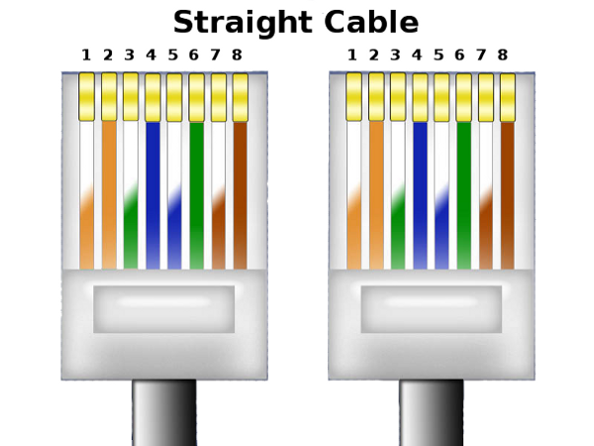
2. Crossover Cable: - Sometimes you will use crossover cable. It’s usually used to connect same type of devices. A crossover cable can be used to:
1) Connect two computers directly.
2) Connect a router's LAN port to a switch/hub's normal port. (Normally used for expanding network)
3) Connect two switches/hubs by using normal port in both switches/hubs.
In you need to check how crossover cable looks like, both side (side A and side B) of cable have wire arrangement with following different colour.
This cable (either straight cable or cross cable) has total 8 wires (or we can say lines), i.e. four twisted pairs (4x2=8) with different colour codes. Right now just forget about colour codes. It doesn’t matter what colour is given to the cable (but there is a standard).
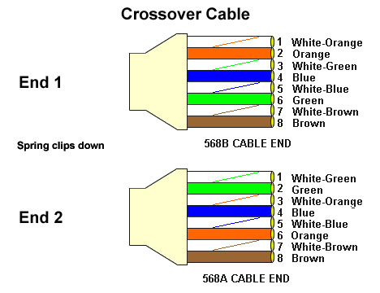
- Coaxial Cable:-
Coaxial cable is a type of cable for high bandwidth data transmission use that typically consists of a single copper wire that is surrounded by a layer of insulation and then by a grounded shield of braided wire or an extruded metal tube.
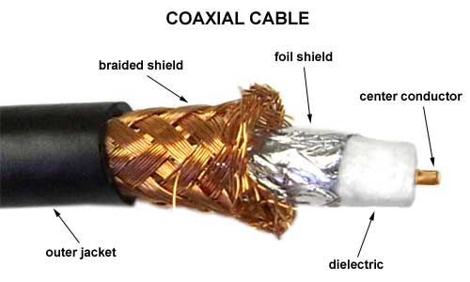
This cable is used to connect their TVs to a cable TV service. However, these cables are also used in networks and what allow a broadband cable Internet connection using a cable modem.

- Fibre Optic Cable: -
A fiber optic cable is a network cable that contains strands of glass fibers inside an insulated casing. These cables are designed for long distance and very high bandwidth (gigabit speed) network communications.
Fiber optic cables carry communication signals using pulses of light. While expensive, these cables are increasingly being used instead of traditional copper cables, because fiber offers more capacity and is less susceptible to electrical interference. So-called Fiber to the Home (FTTH) installations are becoming more common as a way to bring ultra high speed Internet service (100 Mbps and higher) to residences.
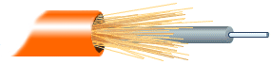

Console cable or Roll over cable:-
Network cable that connects a dumb terminal or computer to a network switch or router console port. Often the rollover cable is flat or yellow to help prevent any confusion between other Cat5 network cables.
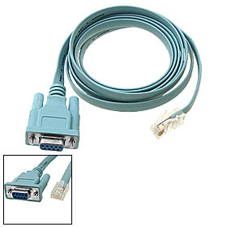

- Connectors
Connectors are below types
RJ45 Connector: - RJ45 is a type of connector commonly used for Ethernet networking. It looks similar to a telephone jack, but is slightly wider. Since Ethernet cables have an RJ45 connector on each end, Ethernet cables are sometimes also called RJ45 cables.
The "RJ" in RJ45 stands for "registered jack," since it is a standardized networking interface. The "45" simply refers to the number of the interface standard. Each RJ45 connector has eight pins, which means an RJ45 cable contains eight separate wires. If you look closely at the end of an Ethernet cable, you can actually see the eight wires, which are each a different color. Four of them are solid colours, while the other four are striped.
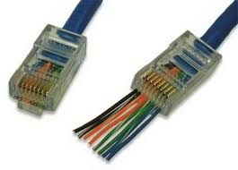
BNC Connector: - Bayonet Neill Concelman connector, a BNC connector is a type of connector used with coaxial Ethernet cable. The connector is bayonet-style, meaning that it is put in then turned and locked in position. This connector is commonly used on a Token Ring network. BNC is also short for Bayonet Nut Connector or British Naval/Navy Connector although more appropriately known as the Bayonet Neill Concelman. The picture is an example of a BNC connector on the end of a coaxial cable.
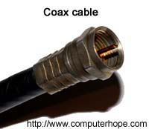
RJ11 Connector: - More commonly known as a phone connector, phone jack or phone line, the RJ-11 is short for Registered Jack-11 and is a four or six wire connection primarily used for telephones and computer modem connectors in the United States. The picture is an example image of what the RJ-11 phone cable and connection looks like.
Although this cable can be used to connect your modem to the Internet it should not be confused with the RJ-45 connector, which is used with your network card.
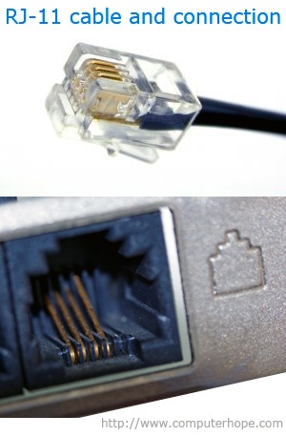
- Network Layers: -
The Open Systems Interconnection (OSI) reference model has been an essential element of computer network design since its ratification in 1984. The OSI is an abstract model of how network protocols and equipment should communicate and work together (interoperate).
The OSI model is a technology standard maintained by the International Standards Organization (ISO).
The OSI Model Stack
The OSI model divides the complex task of computer-to-computer communications, traditionally called internetworking, into a series of stages known as layers. Layers in the OSI model are ordered from lowest level to highest. Together, these layers comprise the OSI stack. The stack contains seven layers in two groups:
Upper layers -
7.Application
6.Presentation
5. Session
Lower layers -
4.Transport
3.Network
2.Datalink
1.Physical

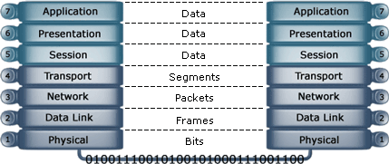

Below is what basically happens when data passes from Host A to Host B:
- The Application, Presentation and Session layer take user input and converts it into data,
- The Transport layer adds a segment header converting the data into segments,
- The Network layer adds a network header and converts the segments into packets / data grams,
- The Data Link layer adds a frame header converting the packets/data grams into frames,
- The MAC sub layer converts the frames into a bit, which the Physical layer can put on the wire.
Application Layer: - The Application layer provides network services directly to the user's application such as a web browser or email client. This layer is said to be "closest to the user". Protocols that operate on this layer include TELNET, HTTP, FTP, TFTP, SMTP, and NTP.
Presentation Layer:- The Presentation layer 'represents' the data in a particular format to the Application layer. It defines encryption, compression, conversion and other coding functions. Examples of specifications defined at this layer are GIF, JPEG, MPEG, MIME, and ASCII.
Session Layer: - The Session layer establishes, maintains, and terminates end-to-end connections (sessions) between two applications on two network nodes. It controls the dialogue between the source and destination node, which node can send when and for how long. It also provides error reporting for the Application, Presentation and Session layer. Examples of protocols/API's that operate on this layer are RPC and NETBIOS.
Transport Layer:- The Transport layer converts the data received from the upper layers into segments and prepares them for transport. The Transport layer is responsible for end-to-end (source-to-destination) delivery of entire messages. It allows data to be transferred reliably and uses sequencing to guarantee that it will be delivered in the same order that it were sent. It also provides services such as error checking and flow control (in software). Examples of protocols that operate on this layer are TCP, UDP,NETBEUI,andSPX.
The above Transport layer protocols are either connectionless or connection-oriented.
Network Layer: - The Network layer converts the segments from the Transport layer into packets (or data grams) and is responsible for path determination, routing, and the delivery of packets across internetworks. The network layer treats these packets independently, without recognizing any relationship between those individual packets. It relies on higher layers for reliable delivery and sequencing.
The Network layer is also responsible for logical addressing (also known as network addressing or Layer 3 addressing) for example IP addressing. Examples of protocols defined at this layer are IP, IPX, ICMP, RIP, OSPF, and BGP. Examples of devices that operate on this layer are layer-3 switches and routers. The latter includes WAPs with built-in routing capabilities (wireless access routers).
Data Link Layer:- The Data Links provides transparent network services to the Network layer so the Network layer can be ignorant about the underlying physical network topology. It is responsible for reassembling bits, taken of the wire by the Physical layer, to frames, and makes sure they are in the correct order and requests retransmission of frames in case an error occurs. It provides error checking by adding a CRC to the frame, and flow control. Examples of devices that operate on this layer are switches, bridges, WAPs, and NICs.
Physical Layer:- This layer communicates directly with the physical media. It is responsible for activating, maintaining and deactivating the physical link. It handles a raw bits stream and places it on the wire to be picked up by the Physical layer at the receiving node. It defines electrical and optical signaling, voltage levels, data transmission rates, as well as mechanical specifications such as cable lengths and connectors, the amount of pins and their functions. Examples of devices that operate on this layer are hubs/concentrators, repeaters, NICs, WAPs, and LAN and WAN interfaces such as RS-232, OC-3, BRI, and antennas.
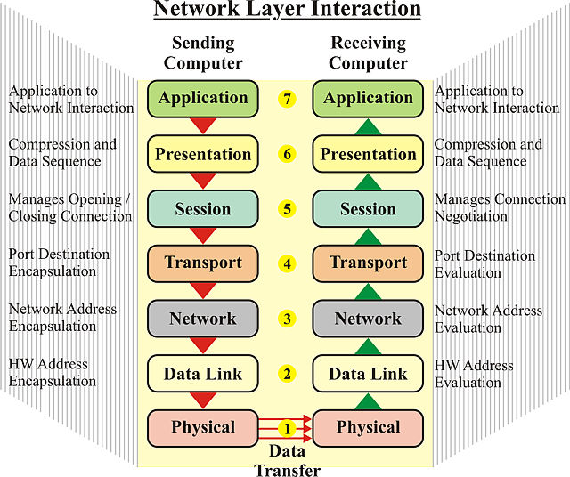
- Protocols: -
Network Protocol is a set of rules that governs the communications between computers on a network. Each protocol has its own method of how data is formatted when sent and what to do with it once received, how that data is compressed or how to check for errors in data.
Protocol Types:
- TCP/IP – Transmission Control Protocol/ Internet Protocol. It is protocol suit
and it is common protocol. OS independent, it has reliable connectivity. It works LAN, WAN, internet and intranet.
TCP/IP protocols:
HTTP – Hyper Text Transfer Protocol
FTP – File Transfer Protocol
SMTP --- Simple Mail Transfer Protocol
IRC --- Internet Relay chat
RPC ---- Remote Procedure call (It is for mail notification)
Telnet --- It is virtual terminal protocol
PPP --- Point to Point Protocol
HDLC --- High Level Data Link Control Protocol
ATM --- Asynchronous Transfer Mode.
- IPX/SPX - Internet Packet Exchange/Serial Packet Exchange. It is OS dependent.
Ex: - Novel Netware OS.
- Apple Talk – It is also OS dependent. Ex:- Macintosh OS.
- NetBEUI – Networking Basic Enhanced user interface. It is always broadcast. It doesn’t have network Layer. It is non-routable. It is OS independent (Advantage.).
Unicast: Unicast is communication between a single sender and a single receiver over a network.
Multicast: Multicast is communication between a single sender and multiple receivers on a network.
Broadcast: Broadcasting is the simultaneous transmission of the same message to multiple recipients. In networking, broadcasting occurs when a transmitted data packet is received by all network devices.
Ports: - A network port is a process-specific or an application-specific software construct serving as a communication endpoint, which is used by the Transport Layer protocols of Internet Protocol suite, such as User Diagram Protocol (UDP) and Transmission Control Protocol (TCP)
A port number is a way to identify a specific process to which an Internet or other network message is to be forwarded when it arrives at a server.
A specific network port is identified by its number commonly referred to as port number, the IP address in which the port is associated with and the type of transport protocol used for the communication.
A port number is a 16-bit unsigned integer that ranges from 0 to 65535.
Any networking process or device uses a specific network port to transmit and receive data. This means that it listens for incoming packets whose destination port matches that port number, and/or transmits outgoing packets whose source port is set to that port number. Processes may use multiple network ports to receive and send data.
There are three different types of port numbers that IANA (The Internet Assigned Numbers Authority) has standards for.
Predefined ports are 1 to 1023
Dynamic ports are 1024 to 8000
Manual ports are greater than (>) 8000.
Every request will move with two port numbers.
Source port is which is always dynamic
Destination port is which is always predefined.
Service  Email  www | Protocol  SMTP  HTTP  FTP  SNMP  DNS | Port number  25  80  20,21  161  53

III. Network Devices
The Network devices are playing an important role in Network Communication, each device has different role.
Network Devices are HUB, Switch, Router and Firewall.
- HUB: -
A hub is a small Network Device. A hub joins multiple computers (or other network devices) together to form a single network segment. On this network segment, all computers can communicate directly with each other. A hub includes a series of ports that each accept a network cable, one port is reserved for "uplink" connections to another hub or similar device.
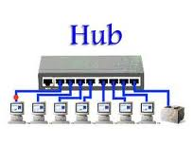
Main Features
1.Operate at Layer 1 devices ( Physical layer ) in the OSI model .
2. Hubs do not read any of the data passing through them and are not aware of their source or destination.
3. Hub simply receives incoming packets, possibly amplifies the electrical signal, and broadcasts these packets out to all devices on the network - including the one that originally sent the packet!
Types of Hub
- Passive hubs
Passive hubs do not amplify the electrical signal of incoming packets before broadcasting them out to the network.
- Active hubs
Active hubs on the other hand, do perform this amplification, as does a different type of dedicated network device called a repeater. Some people use the terms concentrator when referring to a passive hub and multiport repeater when referring to an active hub.
- Intelligent hubs
Intelligent hubs add extra features to an active hub that are of particular importance to businesses. An intelligent hub typically is stackable (built in such a way that multiple units can be placed one on top of the other to conserve space). It also typically includes remote management capabilities via SNMP and virtual LAN (VLAN) support.
Hub Symbol
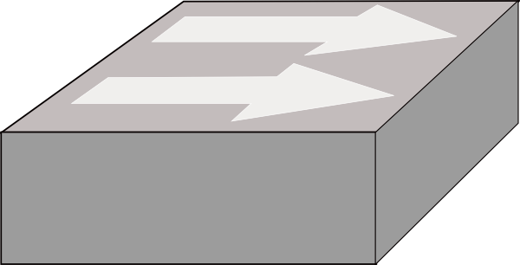
- Switch
A network switch is a small hardware device that joins multiple computers together within one local area network (LAN). Ethernet switch devices were commonly used on home networks before home routers became popular.
- It is an electronic device.
- It is layer2 device (Data Link Layer)
- It doesn’t support broadcast, it supports Unicast only.
- It understands only frames.
Based upon functions switches are two types
- Manageable Switch or Configurable switch: - It is having console port.
- Unmanageable Switch: It doesn’t have console port.
Cisco 1900 Series Switch:
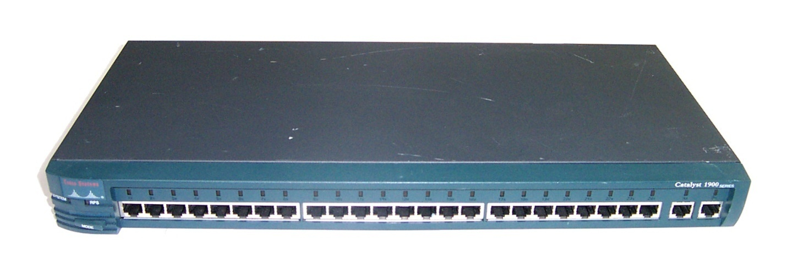
- E1-E24 ports are normal Ethernet ports
- Each port providing 10 mbps speed.
- Each port supporting 132 PCs.
- Fa25, Fa26 are fasted net ports
- Each port providing 100 mbps speed.
- Fasted net ports connect to Second Switch Fasted netports.
Manageble Switch  - It is electronic device  - It is layer2 and layer3 device  - High ports density  - Security can be implemented  - Each port supporting 132 PCs  - There is console port | Unmanageble Switch  - It is also electronic device.  - It is layer 2 device  - Low port density  - There is no security  - Each port supporting only 1 pc  - There is no console port.

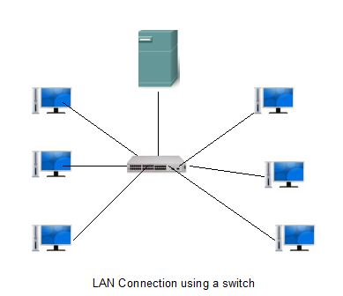

Switch Symbol
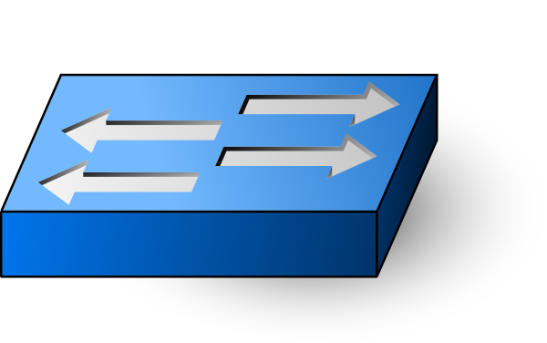
Differences between HUB and Switch
HUB | Switch
It is layer 1 device | It is layer 2 device
Low Bandwidth sharing | High bandwidth sharing
Low port density | High port density
It supports broadcast | It doesn’t support broadcast and it supports uni cast only.
Security can’t be implemented | Security can be implemented
It understands only IP address and bits | It understands only Frames
IOS not existing | IOS is existing
Single collision domain | No. Of collision domain = No. Of ports
No Mac address | Here MAC Address table existing

- Router
Routers are small physical devices that join multiple networks together. Technically, a router is a Layer 3 gateway device, meaning that it connects two or more networks and that the router operates at the network layer of the OSI model.
Router Types: There are mainly 2 types of Routers.
- Modular Router: Interfaces can be change. Ex:- Cisco 1700, 2600, 3000, 4000, 5000, 7000 and 12000 etc.,
- Non-Modular Router: Interfaces are fixed and can’t be changed. Ex:- 700, 800, 1600 and etc.,
- Hybrid Router: Some interfaces manually we can change and some interfaces are fixed. Ex: - 1603.
Based on function, again routers are three types.
- Access Layer Router: It is low cost, low speed, low performance.
Ex:- Cisco 700, 800, 1600, 1700 etc.,
- Distribution Layer: It is medium cost, medium speed, and medium performance.
Ex:- Cisco 2500, 2600, 3000 and 4000 etc.,
- Core Layer Router: It is very expensive, high speed and high performance.
Ex:- Cisco 5000, 7000 and 12000.
Router symbol
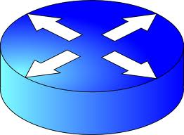

Cisco 2500 Route

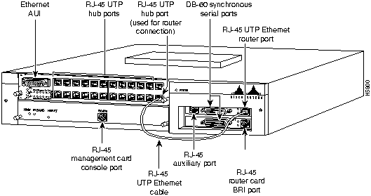
BRI port (BASIC RATE INTERFACE
AUI (ATTACHMENT UNIT INTERNET PORT)

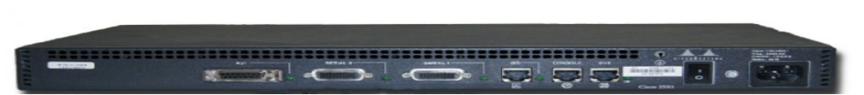
Power button
AUX PORT (AUXILLARY PORT)
Serial 0
Serial 1

Power port
Console port

- Firewall
A firewall is a set of related programs, located at a network gateway server that protects the resources of a private network from users from other networks.
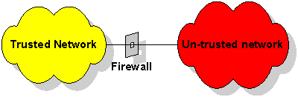
A Firewall disrupts free communication between trusted and un-trusted networks, attempting to manage the information flow and restrict dangerous free access.
There are numerous mechanisms employed to do this, each one being somewhere between completely preventing packets flowing, which would be equivalent to completely disconnected networks, and allowing free exchange of data, which would be equivalent to having no Firewall.
In order to understand how each of these works, it is first necessary to understand the basics of how data moves across the Internet.
Firewall Types:
The two main firewall types are network perimeter firewalls located at the network's perimeter and host-based firewalls located on individual hosts within the network.
- Network Perimeter Firewall:
Network firewalls, located at the boundary between the internal network and external networks such as the Internet, typically provide a variety of services. Such products are either hardware-based, software-based, or a combination of both. Some also provide application proxy services, an example of which is Microsoft® Internet Security and Acceleration (ISA) Server.
Most of these types of network firewall products provide some or all of the following functionality:
- Management and control of network traffic by performing stateful packet inspection, connection monitoring, and application-level filtering.
- Stateful connection analysis by inspecting the state of all communications between hosts and storing connection data in state tables.
- Virtual private network (VPN) gateway functionality by providing IPsec authentication and encryption together with Network Address Translation-Traversal (NAT-T), allowing permitted IPsec traffic to traverse the firewall with public to private IPv4 address translation.
  - Host-based Firewall:
- Network perimeter firewalls cannot provide protection for traffic generated inside a trusted network. For this reason, host-based firewalls running on individual computers are needed. Host-based firewalls, of which Windows Firewall with Advanced Security is an example, protect a host from unauthorized access and attack.
- In addition to blocking unwanted incoming traffic, you can configure Windows Firewall with Advanced Security to block specific types of outgoing traffic as well. Host-based firewalls provide an extra layer of security in a network and function as integral components in a complete defense strategy.
- In Windows Firewall with Advanced Security, firewall filtering and IPsec are integrated. This integration greatly reduces the possibility of conflict between firewall rules and IPSec connection security settings.

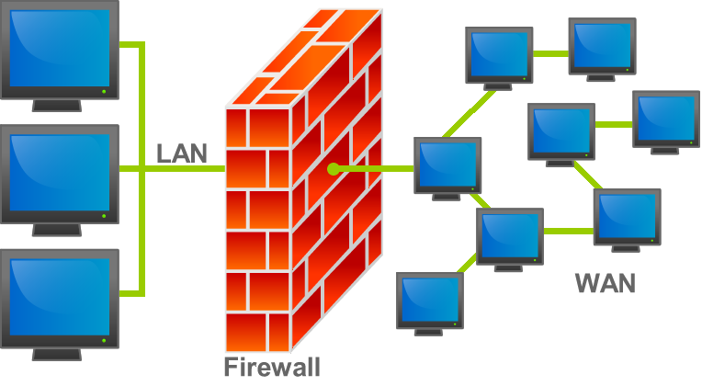
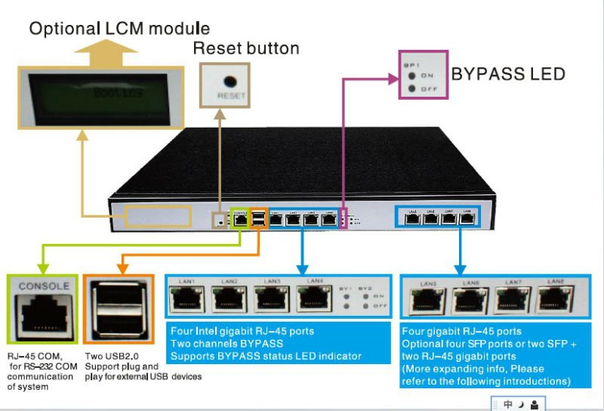
Differences between Router and Switch
 | Router | Switch
Layer | Network Layer (Layer 3 devices) | Data Link Layer. Network switches operate at Layer 2 of the OSI model.
Ports | 2/4/8 | Switch is multi port Bridge. 24/48 ports
Device Type | Networking device | Active Device (With Software) & Networking device
Data Transmission form | Packet | Frame (L2 Switch) Frame & Packet (L3 switch)
Transmission Type | At Initial Level Broadcast then Uni-cast & Multicast | First broadcast; then unicast & multicast as needed.
Function | Directs data in a network. Passes data between home computers, and between computers and the modem. | Allow to connect multiple device and port can be manage, Vlan can create security also can apply
Table |  | A network switch stores MAC addresses in a lookup table.
  Store IP address in Routing table and maintain address at its own.
Transmission Mode | Full duplex
  Full duplex
Used in (LAN, MAN, WAN) | LAN, WAN | LAN
Broadcast Domain | In Router, every port has its own Broadcast domain. | Switch has one broadcast domain [unless VLAN implemented]
Definition | A router is a networking device that connects a local network to other local networks. At the Distribution Layer of the network, routers direct traffic and perform other functions critical to efficient network operation. | A network switch is a computer networking device that is used to connect many devices together on a computer network. A switch is considered more advanced than a hub because a switch will on send msg to device that needs or request it
 | Intelligent Device | Intelligent Device
  Device Category
Bandwidth sharing | Bandwidth sharing is Dynamic (Enables either static or dynamic bandwidth sharing for modular cable interfaces. The default percent-value is 0. The percent-value range is 1-96.) | There no sharing port can be 10, 100, 1000 and 10000 Mbps individual
Speed | 1-10 Mbps(Wireless) 100 Mbps (Wired) | 10/100Mbps, 1Gbps
Routing Decision | Take faster Routing Decision | Take more time for complicated routing Decision
NAT (Network Address Translation) | Can Perform NAT | Switches can Not perform NAT
Faster | In a different network environment (MAN/ WAN) Router is faster than L3 Switch. | In a LAN environment L3 switch is faster than Router (built in switching hardware)
Features | Firewall VPN Dynamic hadling of Bandwidth | Priority rt range On/Off setting of port VLAN Port mirroring
Latest Models | Linksys WRT54GL Juniper MX & EX series Cisco 3900,2900,1900 | Alcatel's OmniSwitch 9000; Cisco Catalyst switch 4500 and 6500(10 Gbps),
Used for | Connecting two or more networks | Connecting two or more nodes in the same network or different network
Address used for data tramsmission | Uses IP address | Uses MAC address

IV Network Setup

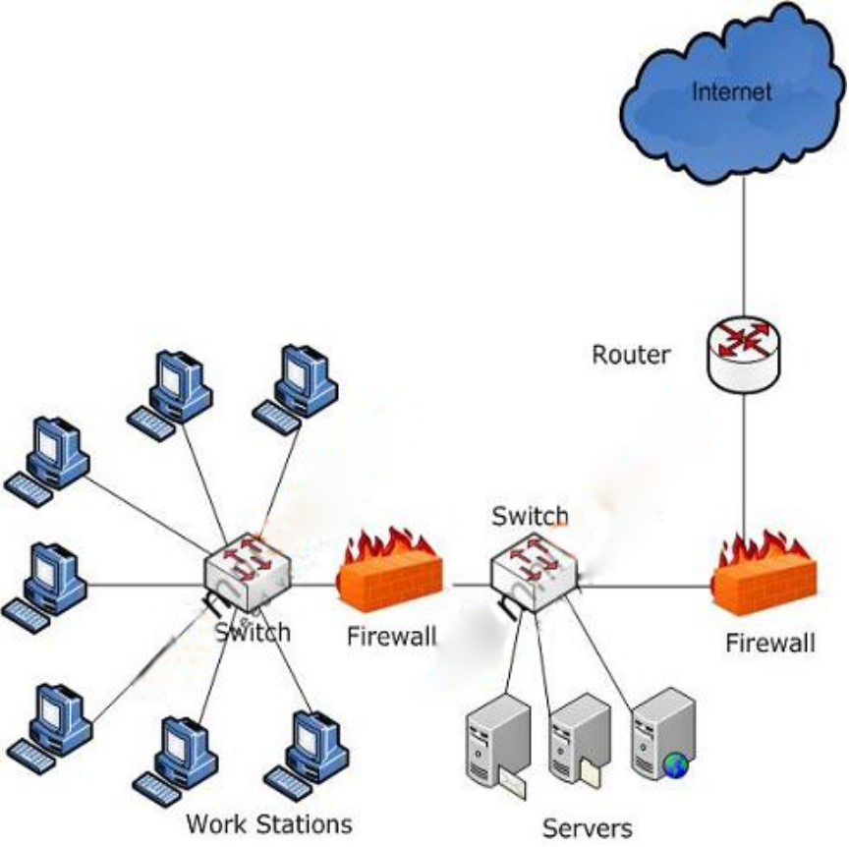

    - What is IP Address
An IP address is an identifier for a computer or device on a TCP/IP network. Networks using the TCP/IP protocol route messages based on the IP address of the destination
To view your IP address you can use the ipconfig (IPCONFIG) command line tool. Ipconfig displays all current TCP/IP network configuration values and refreshes Dynamic Host Configuration Protocol (DHCP) and Domain Name System (DNS) settings.
To launch the command prompt from a Windows-based computer click: Start > All Programs > Accessories > Command Prompt. Type ipconfig and hit enter.
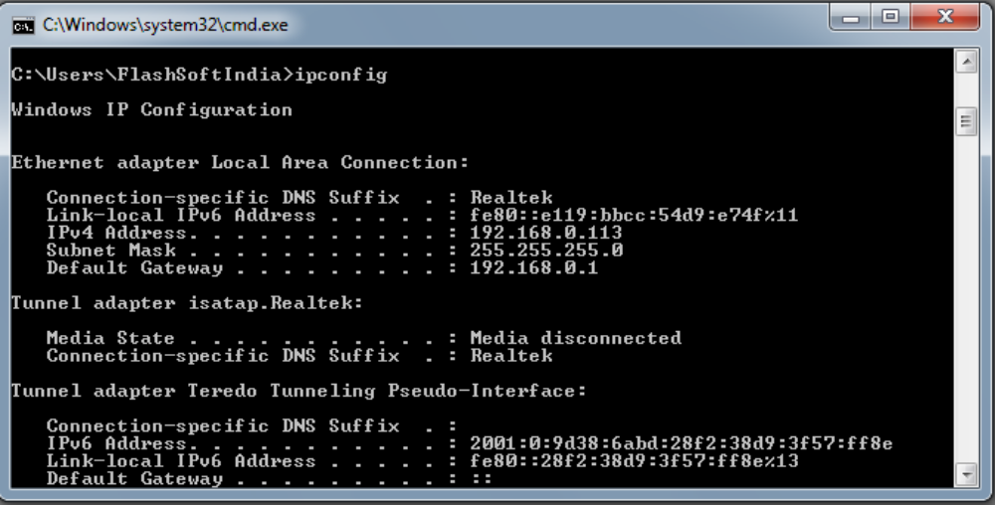
An IP address consists of 32 bits, often shown as 4 octets of numbers from 0-255 represented in decimal form instead of binary form. For example, the IP address: 168.212.226.204 in binary form is 10101000.11010100.11100010.11001100.
But it is easier for us to remember decimals than it is to remember binary numbers, so we use decimals to represent the IP addresses when describing them. However, the binary number is important because that will determine which class of network the IP address belongs to.
The Two Parts of an IP Address
An IP address consists of two parts, one identifying the network and one identifying the node, or host.
The Class of the address determines which part belongs to the network address and which part belongs to the node address. All nodes on a given network share the same network prefix but must have a unique host number.

- Class A Network
In a Class A Network binary address start with 0, therefore the decimal number can be anywhere from 1 to 126. The first 8 bits (the first octet) identify the network and the remaining 24 bits indicate the host within the network. An example of a Class A IP address is 102.168.212.226, where "102" identifies the network and "168.212.226" identifies the host on that network.
- Class B Network
In a Class B Network, binary addresses start with 10, therefore the decimal number can be any where from 128 to 191. The number 127 is reserved for loopback and is used for internal testing on the local machine. The first 16 bits (the first two octets) identify the network and the remaining 16 bits indicate the host within the network. An example of a Class B IP address is 168.212.226.204 where "168.212" identifies the network and "226.204" identifies the host on that network.
- Class C Network
Binary addresses start with 110, therefore the decimal number can be anywhere from 192 to 223. The first 24 bits (the first three octets) identify the network and the remaining 8 bits indicate the host within the network. An example of a Class C IP address is 200.168.212.226 where "200.168.212" identifies the network and "226" identifies the host on that network.
- Class D Network
In a Class D Network, binary addresses start with 1110, therefore the decimal number can be anywhere from 224 to 239. Class D networks are used to support multicasting.
- Class E Network
In a Class E Network, binary addresses start with 1111, therefore the decimal number can be anywhere from 240 to 255. Class E networks are used for experimentation. They have never been documented or utilized in a standard way.
IP address reserved by IANA (Internet Assigned Numbers Authority) for clients called as private ip address.
Private IP address:
10.0.0.0 -10.255.255.255 ---- class A
172.16.0.0 – 172.31.255.255 ---- class B
192.168.0.0 --- 192.168.255.255 ---- class C
Number of HostIDs in one Network ID = 2^{n}-2
n = Number of Bits in Host ID
Class A --- 2²⁴ -2
Class B --- 2¹⁶-2
Class C ---- 2⁸-2 = 254
If all Host ID bits are ‘0’ that is called as Network ID
If all Host ID bits are ‘1’ that is called as Broad cast ID.
Note: Host ID = IP Address of system. No.of Network IDs given free in class A = 1, in class B = 16 and in class c = 256.
To calculate Host ID from a Network ID , find the minimum value, maximum value in the Host ID bits.
Class A:
10.0.0.1
10.0.0.0
10.255.255.255

Class B:
172.16.0.1
172.16.0.0
172.16.255.254

172.31.0.1
172.16.31.0.0
172.31.255.254

Class C:
192.168.0.0
192.168.1.0
192.168.2.1
192.168.2.0
192.168.2.254

Note: Bold letter portion is Network ID portion
Normal letter portion is Host ID portion.
    - Netmask
A netmask is a 32-bit mask used to divide an IP address into subnets and specify the networks available hosts. In a netmask, two bits are always automatically assigned. For example, in 255.255.225.0, "0" is the assigned network address; and in 255.255.255.255, "255" is the assigned broadcast address. The 0 and 255 are always assigned and cannot be used.
Below is an example of a netmask and an example of its binary conversion.
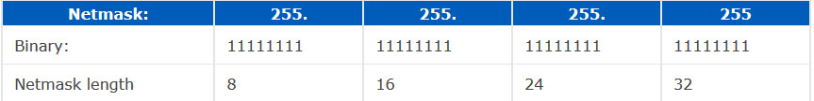
Counting out the bits in the binary conversion allows you to determine the netmask length. In the above example, you have an example of a 32-bit address. However, this address is a broadcast address and does not allow any hosts (computers or other network devices) to be connected to it.
A commonly used netmask is a 24-bit netmask, as seen below.
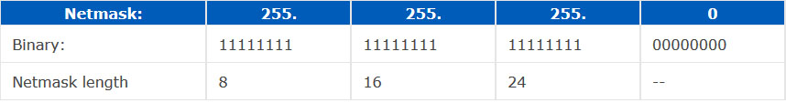
Using a 24-bit netmask, the network would be capable of 2,097,150 networks or 254 different hosts with an IP range of 192.0.1.x - 223.255.254.x. This is commonly plenty of addresses for one network.
A simple formula can be used to determine the capable amount of networks a netmask can support. With the understanding that the netmask length is 24, subtract three from that number, e.g. 24-3 = 21. Once this number is determined, take 2 to the x power - 2 (where x is the number you just determined). Which would be 2^²¹ - 2 = 2,097,150. You are subtracting two from this number because of the broadcast and network addresses that are already being used.
To determine the amount of hosts a netmask is capable of supporting is similar to the above. As you see by the above chart, we have eight zeros. This number is similar to the 21 we determined earlier. Therefore, 2 to the x power - 2. (Where x is the number of zeros in the netmask). This would be 2^⁸ - 2 = 254. Again, two is subtracted from this number to account for the broadcast and network addresses.
Below is a breakdown of each of the commonly used network classes.
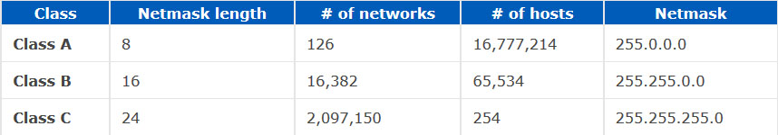

    - SUBNETTING
Subnetting is the strategy used to partition a single physical network into more than one smaller logical sub-networks (subnets). An IP address includes a network segment and a host segment. Subnets are designed by accepting bits from the IP address's host part and using these bits to assign a number of smaller sub-networks inside the original network. Subnetting allows an organization to add sub-networks without the need to acquire a new network number via the Internet service provider (ISP). Subnetting helps to reduce the network traffic and conceals network complexity. Subnetting is essential when a single network number has to be allocated over numerous segments of a local area network (LAN).
Subnets were initially designed for solving the shortage of IP addresses over the Internet.
Dividing the network into a number of subnets provides the following benefits:
- Reduces the network traffic by reducing the volume of broadcasts
- Helps to surpass the constraints in a local area network (LAN), for example, the maximum number of permitted hosts.
- Enables users to access a work network from their homes; there is no need to open the complete network.
How to subnet:- Do you remember that I said “in the subnet mask, bit 1 represents for Network part while bit 0 presents for Host part”? Well, this also means that we can specify how many bits we want to borrow by changing how many bit 0 to bit 1 in the subnet mask.
Let’s come back to our example with the IP 11.0.0.1, we will write all numbers in binary form to reveal what a computer really sees in an IP address.
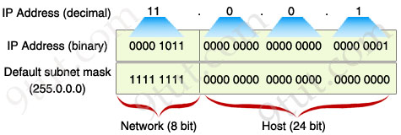
Now you can clearly see that the subnet mask will decide which is the Network part, which is the Host part. By borrowing 8 bits, our subnet mask will be like this:
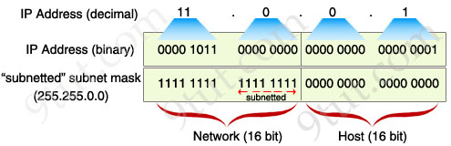
After changing the second octet of the subnet mask from all “0″ to all “1″, the Network part is now extended. Now we can create new networks by changing number in the first or second octet. This greatly increases the number of networks we can create. With this new subnet mask, IP 11.1.0.1 is in different network from IP 11.0.0.1 because “1″ in the second octet now belongs to the Network part.
So, in conclusion we “subnet” by borrowing bit “0″ in the Host portion and converting them to bit “1″. The number of borrowed bits is depended on how many networks we need.
Note: A rule of borrowing bits is we can only borrow bit 0 from the left to the right without skipping any bit 0. For example, you can borrow like this: “1111 1111. 1100 0000.0000 0000.0000 0000″ but not this: “1111 1111. 1010 0000.0000 0000.0000 0000″. In general, just make sure all your bit “1″s are successive on the left and all your bit “0″s are successive on the right.
In the next part we will learn how to calculate the number of sub-networks and hosts-per-subnet.
Exercise 1
Your company has just been assigned the network 4.0.0.0. How many subnets and hosts-per-subnet you can create with a subnet mask of 255.255.255.0?
(Please try to solve by yourself before reading the solution ^^)

Solution
First of all you have to specify which class this network belongs to. According to Table 1, it belongs to class A (simply, class A ranges from 1 to 126) and its default subnet mask is 255.0.0.0. Therefore if we use a subnet mask of 255.255.255.0, it means we borrowed 16 bits (to convert from 0 to 1).
255.0.0.0 = 1111 1111.0000 0000.0000 0000.0000 0000
255.255.255.0 = 1111 1111.1111 1111.1111 1111.0000 0000
Now use our above formulas to find the answers:
The number of newly created subnets = 2¹⁶ = 65536 (with 16 is the borrowed bits)
The number of hosts per subnet = 2⁸ – 2 = 254 (with 8 is the bit “0″s left in the 255.255.255.0 subnet mask)
Exercise 2
Your company has just been assigned the network 130.0.0.0. How many subnets and hosts-per-subnet you can create with a subnet mask of 255.255.128.0?
(Please try to solve by yourself before reading the solution ^^)
Solution
130.0.0.0 belongs to class B with the default subnet mask of 255.255.0.0. But is the subnet mask of 255.255.128.0 strange? Ok, let’s write all subnet masks in binary:
255.255.128.0 = 1111 1111.1111 1111.1000 0000.0000 0000
This is a valid subnet because all bit “1″s and “0″s are successive. Comparing to the default subnet mask, we borrowed only 1 bit:
255.255.0.0 = 1111 1111.1111 1111.0000 0000.0000 0000
Therefore:
The number of newly created subnets = 2¹ = 2 (with 1 is the borrowed bits)
The number of hosts per subnet = 2¹⁵ – 2 = 32766 (with 15 is the bit “0″s left in the 255.255.128.0 subnet mask)
Exercise 3
Your company has just been assigned the network 198.23.16.0/28. How many subnets and hosts-per-subnet you can create with a subnet mask of 255.255.255.252?
(Please try to solve by yourself before reading the solution ^^)
Solution
In this exercise, your company was given a “subnetted” network from the beginning and it is not using the default subnet mask. So we will compare two subnet masks above:
/28 = 1111 1111.1111 1111.1111 1111.1111 0000 (=255.255.255.240)
255.255.255.252 = 1111 1111.1111 1111.1111 1111.1111 1100 (= /30)
In this case we borrowed 2 bits. Therefore:
The number of newly created subnets = 2² = 4 (with 2 is the borrowed bits)
The number of hosts per subnet = 2² – 2 = 2 (with 2 is the bit “0″s left in the 255.255.255.252 subnet mask)
In this exercise I want to go a bit deeper into the subnets created. We learned there are 4 created subnets but what are they? To find out, we should write all things in binary:
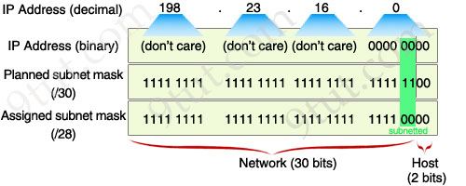
Because two subnet masks (/28 & /30) only affect the 4th octet so we don’t care about the first three octets. In the 4th octet we are allowed to change 2 bits (in the green box) of the IP address to create a new subnet. So there are 4 values we can use: 00, 01, 10 & 11. After changing, we convert them back to decimal numbers. We get 4 subnets:
+ First subnet: 198.23.16.0/30 (the 4th octet is 00000000)
+ Second subnet: 198.23.16.4/30 (the 4th octet is 00000100)
+ Third subnet: 198.23.16.8/30 (the 4th octet is 00001000)
+ Fourth subnet: 198.23.16.12/30 (the 4th octet is 00001100)
So how about hosts per subnet? Please notice that all these 4 subnets are successive. So we can deduce the range of these subnets:
+ First subnet: ranges from 198.23.16.0 to 198.23.16.3
+ Second subnet: ranges from 198.23.16.4 to 198.23.16.7
+ Third subnet: ranges from 198.23.16.8 to 198.23.16.11
+ Fourth subnet: ranges from 198.23.16.12 to 198.23.16.15
Let’s analyze the first subnet which ranges from 198.23.16.0 to 198.23.16.3. Notice that all networks (and subnets) have a network address and a broadcast address. In this case, the network address is 198.23.16.0 and the broadcast address is 198.23.16.3 and they are not assignable or usable for hosts. This is the reason why we have to subtract 2 in the formula “The number of hosts per subnet = 2^{k} – 2″. After eliminating these 2 addresses we have 2 addresses left (which are 198.23.16.1 & 198.23.16.2) as calculated above.
In the next part we will learn how to calculate subnet quickly. This is also a “must” requirement for CCNA so you have to grasp it.
One important thing we should notice is that a valid subnet mask must have all bit “1″s and “0″s successive, in which bit “1″s must be on the left; bit “0″s must be on the right. Therefore we only have 8 situations:
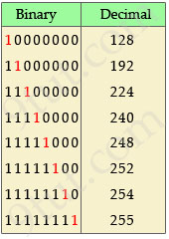
Table 2 – lists all valid subnet masks
This is a very important table to do subnet quickly! Please take some time to learn it by heart. Make sure you remember the right-most bit “1″ position (the least significant bit 1, which are in red in the above table) and their equivalent decimal values.
In most cases, this table is used to quickly convert a number from decimal to binary value without any calculation. For example, you can quickly convert the 4th octet of the subnet mask 255.255.255.248 to 11111000. Or if you are given a subnet of /29 you will know it equals to 255.255.255.248 (by thinking “/24 is the default subnet mask of class C so /29 will have the right-most bit “1″ at 5th position).
Try to practice with these questions:
+ “/28″ in binary form?
+ “255.255.224.0″ in binary form?
+ “255.192.0.0″ in slash notation form?
+ “/26″ in binary form?
+ “255.128.0.0″ in binary form?
+ “248.0.0.0″ in slash notation form?
(Please try to solve by yourself before reading the solution)
Answers:
+/28 -> 1111111.11111111.11111111.1111 0000
+255.255.224.0 -> 11111111.11111111.11100000.0000 0000
+255.192.0.0-> /10
+/26 -> 11111111.11111111.11111111.1100 0000
+255.128.0.0 -> 11111111.10000000.00000000.0000 0000
+ 248.0.0.0 -> /5
How to find out the increment number?
The increment is the heart of subnetting; if you can find out the increment, you can find all the information to solve a subnetting question. So it is usually the first thing you must find out in a subnetting question.
The increment number is the number specifying how “big” your subnets are. Let’s take an example of the increment number! Did you remember the subnets in “Exercise 3″ in the previous part? By changing bits in the Network part, we found out 4 subnets:
+ First subnet: 198.23.16.0/30 (the 4th octet is 00000000)
+ Second subnet: 198.23.16.4/30 (the 4th octet is 00000100)
+ Third subnet: 198.23.16.8/30 (the 4th octet is 00001000)
+ Fourth subnet: 198.23.16.12/30 (the 4th octet is 00001100)
In this case the increment is 4 (in the 4th octet) because the “difference” between two successive subnets is 4 (from 0 -> 4; from 4 -> 8; from 8 -> 12)
There are 2 popular ways to find out the increment number:

1) Use the formula:
Increment = 256 – x
In which “x” is the first octet (counting from the left) which is smaller than 255 in a subnet mask. For example:
+In a subnet mask of 255.224.0.0 -> x = 224
+ In a subnet mask of /29 -> x = 248 (because /29 = 255.255.255.248)
+ In a subnet mask of 1111 1111.1111 1100.0000 0000.0000 0000 -> x = 252
In the case you see a subnet mask of 255.255.255.255 (which is very rare in CCNA), x = 255
Note: Also remember which octet “x” belongs to because we have to plus the increment to that octet.
Now let’s solve Exercise 3 again by using this formula:
Exercise 3 one again (with the formula 256 – x):
Your company has just been assigned the network 198.23.16.0/28. How many subnets and hosts-per-subnet you can create with a subnet mask of 255.255.255.252?
The subnet mask is 255.255.255.252 -> x = 252 (x belongs to 4th octet)
Therefore the Increment = 256 – 252 = 4
The initial network 198.23.16.0/28 is also the first subnet, so:
+ The first subnet: 198.23.16.0/30
+ The second subnet: 198.23.16.4/30 because the increment is 4 so we plus the network address with it to get the next network address (0 + 4 = 4)
+ The third subnet: 198.23.16.8/30 (4 + 4 = 8)
+ The fourth subnet: 198.23.16.12/30 (8 + 4 = 12)
Note: We know there are only 4 subnets because we borrow 2 bits.
2) Learn by heart the decimal value of the rightmost bit “1″ in the subnet mask:
Another way to find the increment value is to write “x” in binary: 11110000. Consider the rightmost bit “1″, the decimal value of this bit is the increment value. In this case it equals to 16.
The table below summarizes the decimal values of bit “1″ depending on its position. To use this method, you should learn by heart this table:
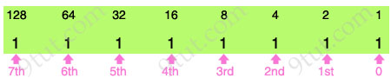
Table 3 – How to find out increment based on the “least-significant” (rightmost) bit 1
Now let’s solve Exercise 3 again by using this method:
Exercise 3 one again (with the “decimal value of the rightmost bit 1″ method):
Your company has just been assigned the network 198.23.16.0/28. How many subnets and hosts-per-subnet you can create with a subnet mask of 255.255.255.252?
First use Table 2 to convert 252 to 1111 1100. The decimal value of the rightmost bit “1″ is 4 (according to Table 3) -> The Increment is 4.
After finding out the increment we can deduce 4 subnets it creates.
The initial network 198.23.16.0/28 is also the first subnet, so:
+ The first subnet: 198.23.16.0/30
+ The second subnet: 198.23.16.4/30 because the increment is 4 so we plus the network address with it to get the next network address (0 + 4 = 4)
+ The third subnet: 198.23.16.8/30 (4 + 4 = 8)
+ The fourth subnet: 198.23.16.12/30 (8 + 4 = 12)
Note: We should only choose one method to use and try to practice, practice & practice more with it. Practice until you can solve any subnetting questions within 20 seconds!
Maybe you will ask why 256 can help you find the increment. In fact, by using the formula Increment = 256 – x you are trying to separate the rightmost bit “1″ from other bits:
256 – x = 255 – x + 1
In which “255 – x” will convert all bit “0″s to bit “1″s and all bit “1″s to “0″s while “+1″ part will make our result have only one bit “1″ left. For example, if x = 240 then:
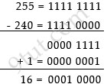
So in fact we can say two above methods are the same!
    - VLSM (Variable Length Subnet Mask)
A Variable Length Subnet Mask (VLSM) is a numerical masking sequence, or IP address subset, based on overall network requirements. A VLSM allows a network administrator to use long masks for networks with few hosts and short masks for networks with multiple hosts. A VLSM is used with a VLSM router and must have routing protocol support.
A VLSM is also known as a classless Internet Protocol (IP) address.
VLSM features include:
- Simple network configuration
- Network IP addressing through empty subnet filling
- Greater efficiency than fixed-length subnet masks (FLSM)
- Streamlined routing, where a router functions only with a VLSM sequence, versus a full IP address
VLSMs are used by a variety of network systems and services, including:
- Intermediate System to Intermediate System Protocol (IS-IS)
- Border Gateway Protocol (BGP)
- Enhanced Interior Gateway Routing Protocol (EIGRP)
- Cisco's Open Shortest Path First (OSPF)
Internet Service Providers may face a situation where they need to allocate IP subnets of different sizes as per the requirement of customer. One customer may ask Class C subnet of 3 IP addresses and another may ask for 10 IPs. For an ISP, it is not feasible to divide the IP addresses into fixed size subnets, rather he may want to subnet the subnets in such a way which results in minimum wastage of IP addresses.
For example, an administrator have 192.168.1.0/24 network. The suffix /24 (pronounced as "slash 24") tells the number of bits used for network address. He is having three different departments with different number of hosts. Sales department has 100 computers, Purchase department has 50 computers, Accounts has 25 computers and Management has 5 computers. In CIDR, the subnets are of fixed size. Using the same methodology the administrator cannot fulfill all the requirements of the network.
The following procedure shows how VLSM can be used in order to allocate department-wise IP addresses as mentioned in the example.
Step - 1
Make a list of Subnets possible.
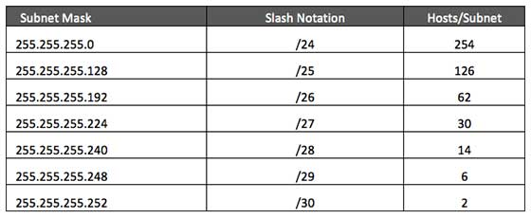
Step - 2
Sort the requirements of IPs in descending order (Highest to Lowest).
- Sales 100
- Purchase 50
- Accounts 25
- Management 5
Step - 3
Allocate the highest range of IPs to the highest requirement, so let's assign 192.168.1.0 /25 (255.255.255.128) to Sales department. This IP subnet with Network number 192.168.1.0 has 126 valid Host IP addresses which satisfy the requirement of Sales Department. The subnet Mask used for this subnet has 10000000 as the last octet.
Step - 4
Allocate the next highest range, so let's assign 192.168.1.128 /26 (255.255.255.192) to Purchase department. This IP subnet with Network number 192.168.1.128 has 62 valid Host IP Addresses which can be easily assigned to all Purchase department's PCs. The subnet mask used has 11000000 in the last octet.
Step - 5
Allocate the next highest range, i.e. Accounts. The requirement of 25 IPs can be fulfilled with 192.168.1.192 /27 (255.255.255.224) IP subnet, which contains 30 valid host IPs. The network number of Accounts department will be 192.168.1.192. The last octet of subnet mask is 11100000.
Step - 6
Allocate next highest range to Management. The Management department contains only 5 computers. The subnet 192.168.1.224 /29 with Mask 255.255.255.248 has exactly 6 valid host IP addresses. So this can be assigned to Management. The last octet of subnet mask will contain 11111000.
By using VLSM, the administrator cans subnet the IP subnet such a way that least number of IP addresses are wasted. Even after assigning IPs to every department, the administrator, in this example, still left with plenty of IP addresses which was not possible if he has used CIDR (Classless Inter-Domain Routing).

Questions on Subnetting:
Q1) Create two subnets from 10.0.0.0?
Q2) Create two subnets from 172.16.0.0?
Q3) Create ten subnets from 10.0.0.0?
Q4) Write down some invalid H.IDs?
Ans : loopback (127.0.0.1)
Network ID
Broadcast ID
Multicast ID
Q5) What is the unicast address from the given below?
  - 224.1.5.2
  - 192.168.24.59/30
  - 255.255.255.255
  - 172.31.128.255/18
Q6) If the IP address is 172.16.45.14, mask is /30 then what is the Network ID?

Q7) Which are the valid addresses for subnet 192.168.15.19/28?
- 192.168.15.17
- 192.168.15.14
- 192.168.15.29
- 192.168.15.61
- 192.168.15.31

Q8) How many bits we can borrow to create a subnet?
Q9) How many subnets and Host IDs can be created from the Class C network if the mask is /30?
Q10) if you create 10 subnets from the Class C with maximum Host IDs, what is the preferable mask?
- /26
- /27
- /28
- /29

