VoxFE-UV 0.41
Technical documentation, voxel-based FEA primer, and practical user tutorial
Document version: 0.41 | Primary environment: Windows application with optional Ubuntu/WSL2 solver | Date: 22 July 2026
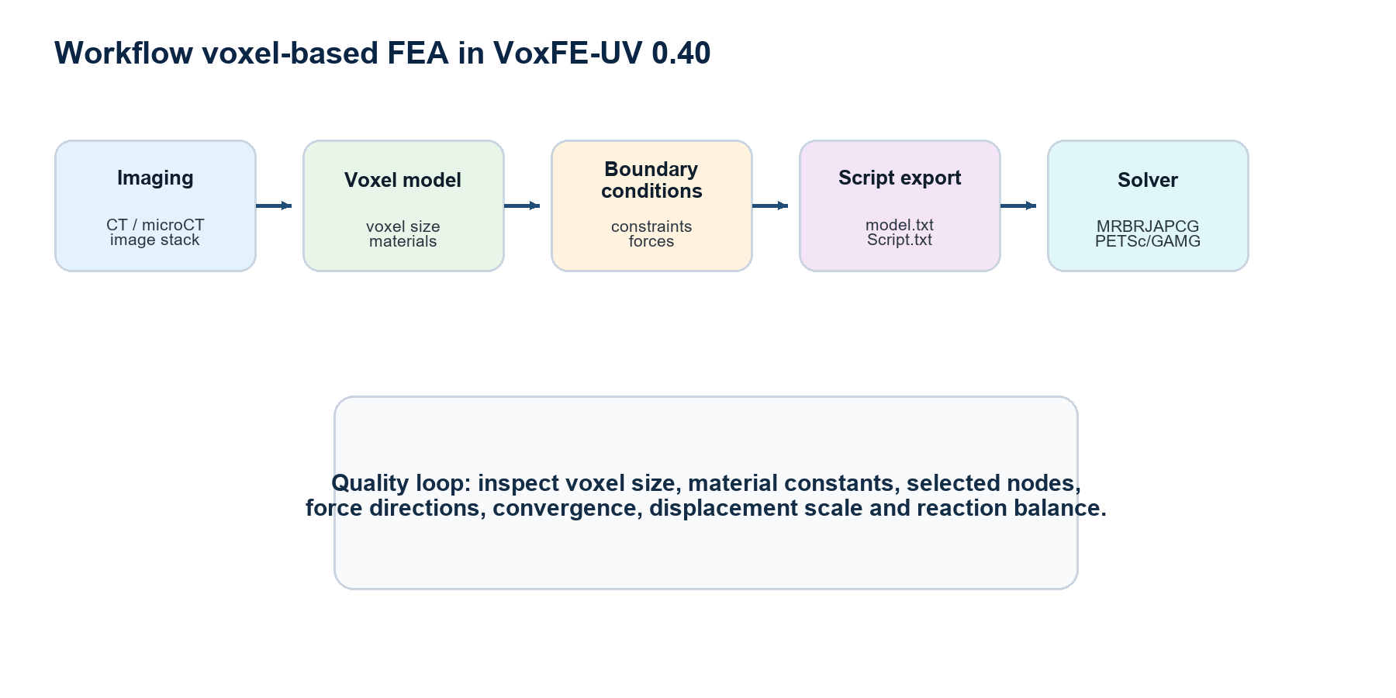
Figure 1. Typical workflow from voxel reconstruction to FEA solution.
Purpose of this guide
This document introduces finite element analysis on voxel-based models and explains how to use VoxFE-UV 0.41 to prepare models, assign materials, define loads and constraints, launch Windows or Ubuntu/WSL2 solvers, and interpret displacement results.

Table of contents
Aggiornare il sommario in Word: tasto destro > Aggiorna campo.

1. Overview
VoxFE-UV 0.41 is designed to turn volumetric image data, segmentations, or voxel models into mechanical finite element analyses. The central idea is direct: each occupied voxel becomes a finite element. This avoids a separate tetrahedral meshing stage and is especially convenient for CT, microCT, serial histology, and biological structures with complex internal geometry.
The 0.41 workflow separates the graphical preparation step from the numerical solution step. The viewer/editor is Windows-oriented. For medium models, the Windows MRBRJAPCG solver is included and validated against the legacy VoxFEA solver when identical materials and boundary conditions are used. For larger models, the recommended route is Ubuntu or WSL2 with PETSc/MPI and the PETSCGAMG solver.
Component | Role | Main outputs
Viewer/editor | Loads geometry, selections, materials, forces, constraints, and results. | project.json, Script.txt, 3D visualization
Exporter | Writes the model and analysis instructions in solver-readable form. | model.txt, Script.txt
Windows solver | Solves with row-by-row sparse matrix assembly. | displacement.txt, force.txt, sed.csv
Ubuntu/WSL2 solver | Solves large models using PETSc/MPI parallel linear algebra. | displacement.txt, residual_history.csv, summary JSON

2. Voxel-based FEA primer

2.1 From image volume to numerical model
In voxel-based FEA, the physical object is represented by a set of occupied voxels. In this guide, the term model volume means the complete physical volume occupied by those voxels. The term element volume means the physical volume of one voxel-element. The term boundary surface means the external or selected internal surface where constraints or loads may be applied.
Each voxel has physical dimensions dx, dy, and dz. These dimensions connect image resolution to the mechanical model. If voxel size is wrong, the solver may still converge, but the result will not describe the intended physical structure.
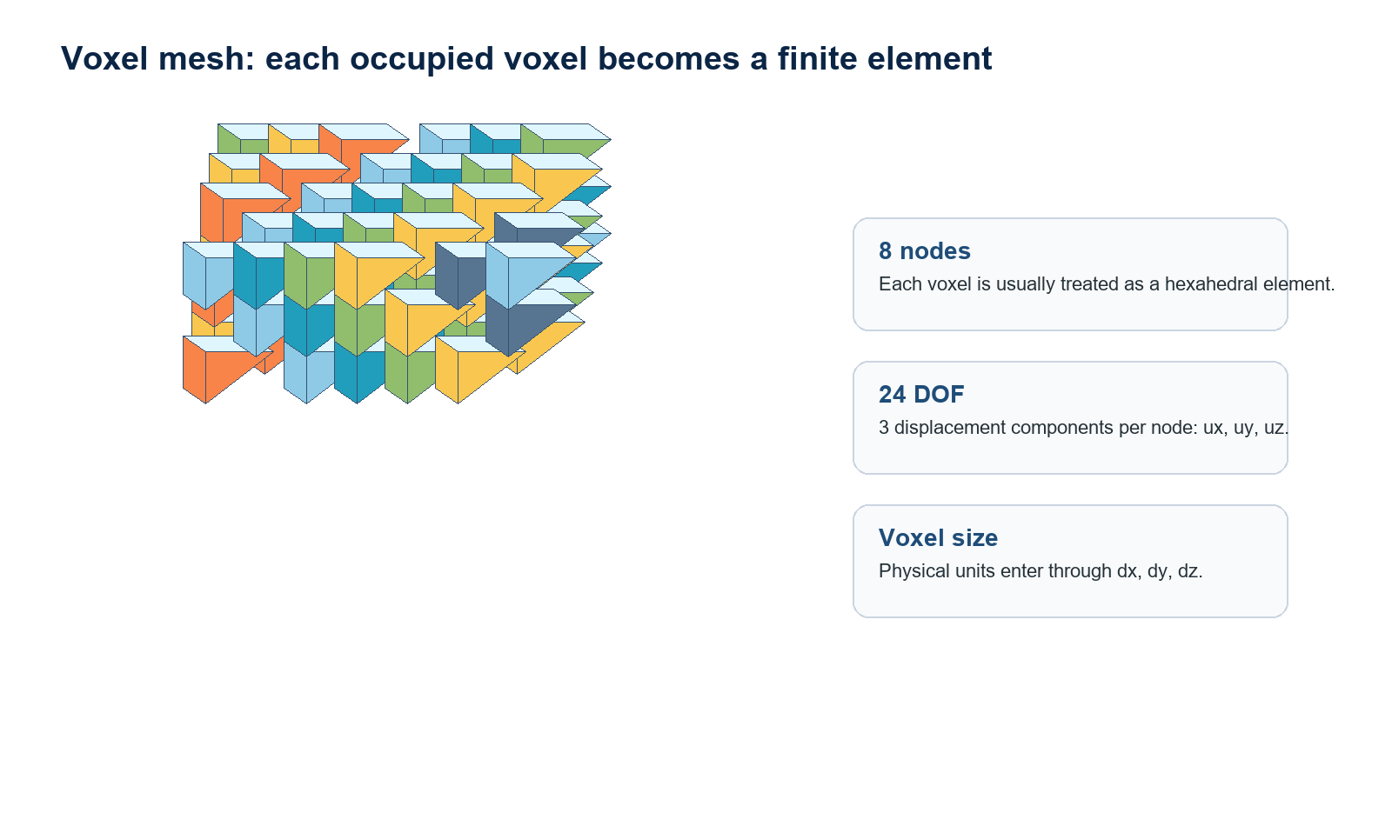
Figure 2. Voxel mesh concept: each occupied cell becomes a hexahedral finite element.
Scale rule
Always verify voxel size before trusting displacement. A wrong length scale changes stiffness, displacement magnitude, and the interpretation of applied forces.

2.2 Displacement and strain
The primary unknown in a linear elastic finite element analysis is the displacement field. For each node, VoxFE solves three components: ux, uy, and uz. The strain tensor is computed from the symmetric part of the displacement gradient.
Nodal displacement
uᵢ = [uₓ, uᵧ, u_z]ᵀ
Each node has three displacement components.

Displacement magnitude
|u| = √(uₓ² + uᵧ² + u_z²)
This scalar value is commonly displayed as total displacement.

Small strain tensor
ε = 1/2 · (∇u + ∇uᵀ)
Strain is derived from spatial changes in displacement.

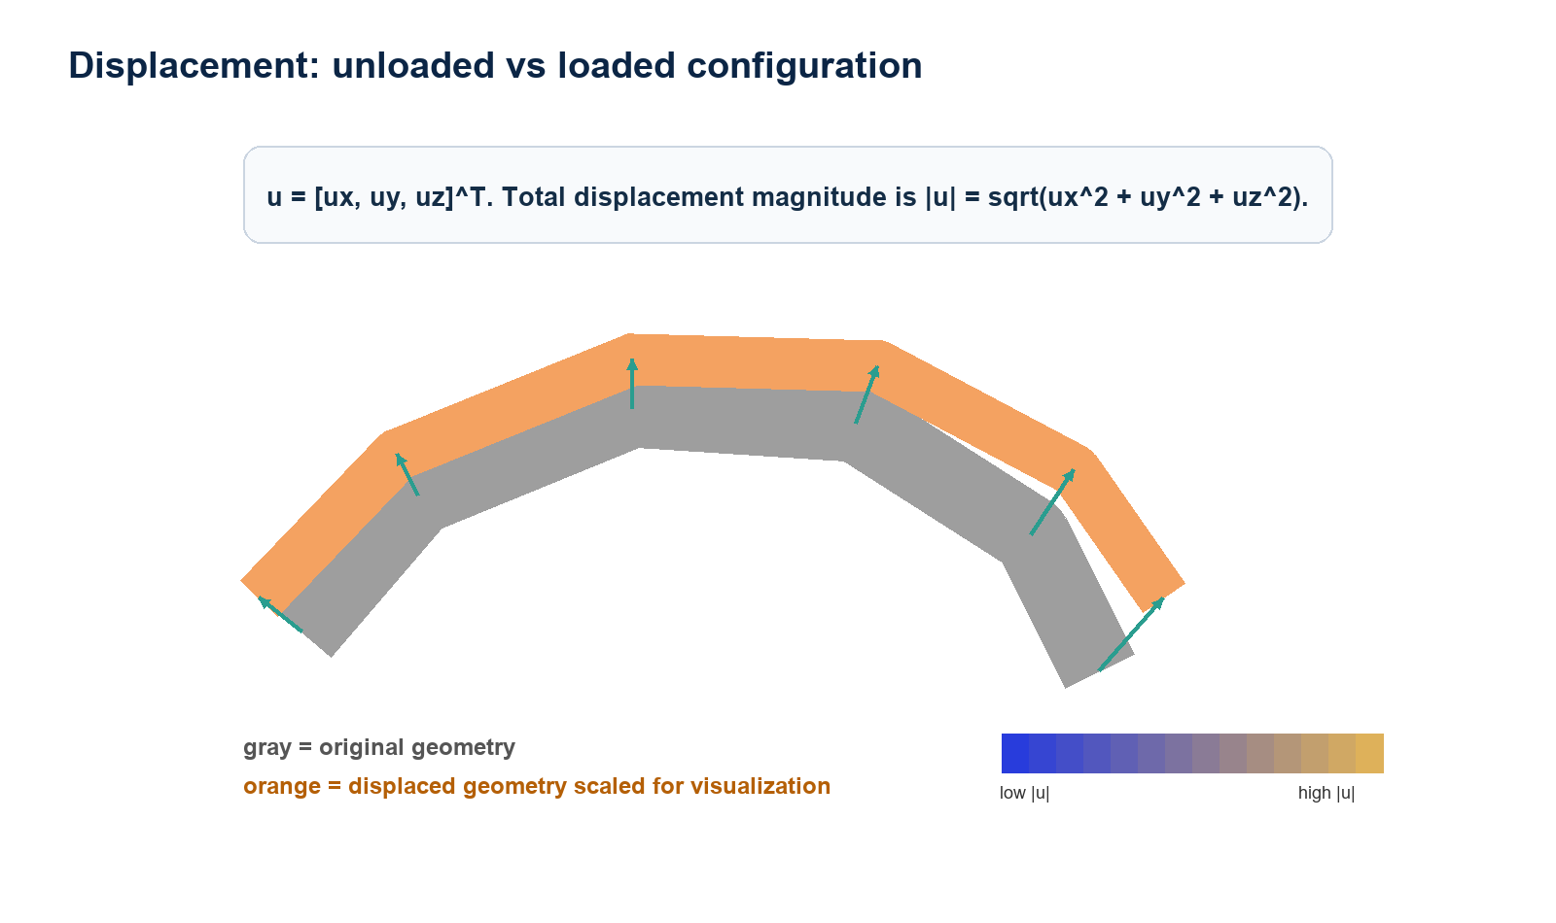
Figure 3. Displacement: the deformed shape is often visually amplified for inspection.

2.3 Stress, Young's modulus, and Poisson's ratio
For isotropic linear elasticity, stress is related to strain by Hooke's law. The two material constants used most often are Young's modulus E and Poisson's ratio nu. In biological models, using an incorrect E value can change displacement by orders of magnitude.
Isotropic Hooke law
σ = C : ε
The material matrix C converts strain into stress.

Lame parameters
μ = E / [2(1+ν)] λ = Eν / [(1+ν)(1−2ν)]
These are alternative elastic constants derived from Young's modulus and Poisson's ratio.

Elastic energy
U = 1/2 · uᵀKu = 1/2 · ∫model volume εᵀCε dV
This is the stored strain energy in the model.

Von Mises stress
σᵥₘ = √{1/2[(σₓₓ−σᵧᵧ)² + (σᵧᵧ−σzz)² + (σzz−σₓₓ)² + 6(σₓᵧ²+σᵧz²+σₓz²)]}

2.4 Weak form and global stiffness matrix
FEA turns the continuous equilibrium equation into a discrete linear system. For a voxel hexahedral element, the element stiffness matrix depends on the strain-displacement matrix B, the material matrix C, and the physical element volume.
Strong equilibrium
div(σ) + b = 0 inside the model volume
Internal stress divergence balances body forces.

Weak form
∫model volume ε(v)ᵀ C ε(u) dV = external virtual work
The weak form is the starting point for finite element discretization.

Element stiffness
Kₑ = ∫element volume Bᵀ C B dV
For voxel elements, the integral is evaluated over one voxel-element.

Global system
K u = f
Solve for displacement u given stiffness K and applied load vector f.

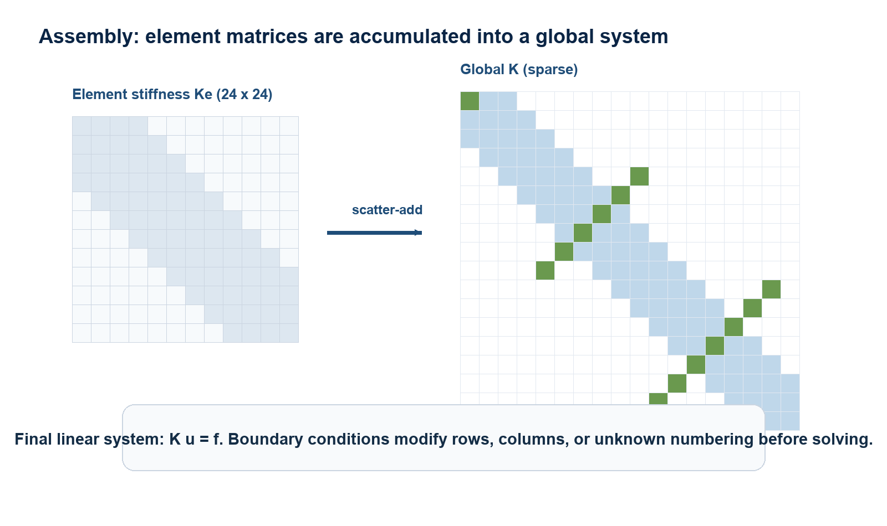
Figure 4. Assembly: element contributions are accumulated into a global sparse matrix.

2.5 Boundary conditions and stability
A linear elastic model without enough constraints can move as a rigid body. Constraints remove or prescribe degrees of freedom; loads fill the right-hand-side vector f. The boundary condition set must be mechanically plausible: too many constraints artificially stiffen the model, while too few constraints make the system singular or poorly conditioned.
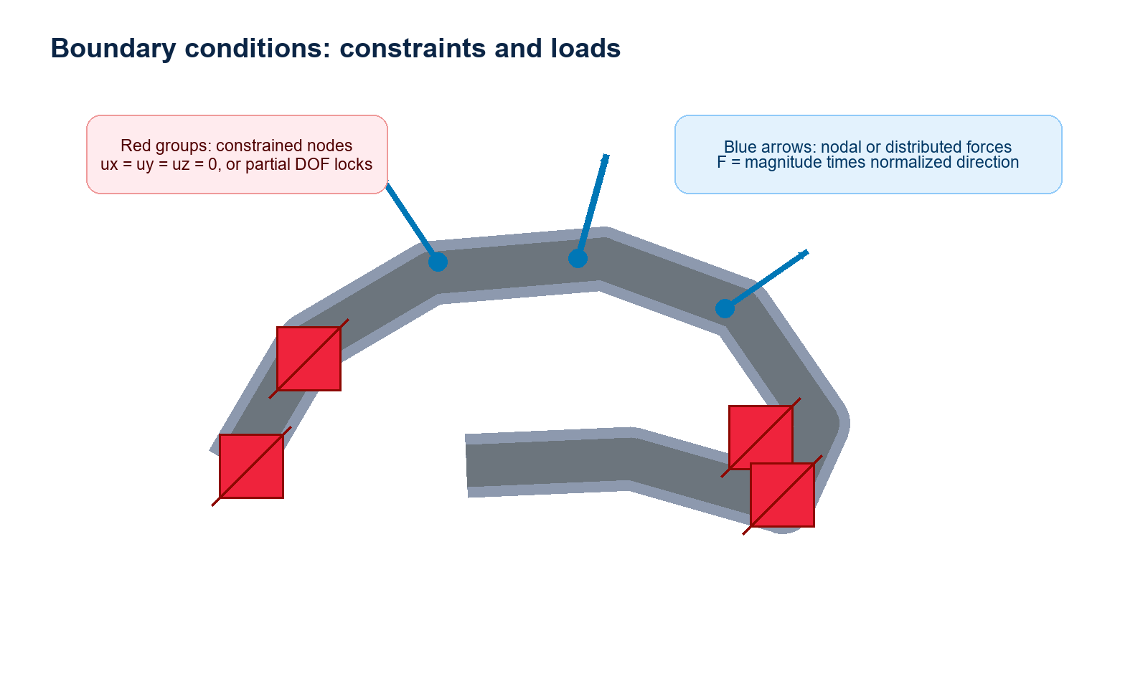
Figure 5. Schematic example of constrained nodes and distributed forces.
Entity | Meaning | Common mistake
Constraint | Prescribes ux, uy, uz, or selected displacement components. | Constraining an unrealistically large surface.
Force | Applies nodal or distributed loads with a physical magnitude. | Confusing visual arrow length with force magnitude.
Voxel size | Converts voxel indices into physical length. | Leaving 1 1 1 when the model uses metres or millimetres.
Material ID | Connects voxels to E, nu, and a material label. | Assuming a label such as METAL implies physical stiffness.

3. Data, units, and file formats

3.1 model.txt
The model.txt file stores voxel geometry. Legacy files typically contain material ID and integer x, y, z voxel coordinates. Voxel size may be absent in old files; in that case VoxFE-UV uses a fallback value or reads scale information from the project/script.
Field | Meaning | Recommended check
Material ID | Integer material identifier. | Every ID must have E and nu.
x, y, z | Voxel grid coordinates. | Check bounds and dimensions.
Voxel count | Number of occupied voxels. | Compare with expected model size.
Bounds | Minimum and maximum voxel indices. | Useful for grid size and origin checks.

3.2 Script.txt
The script defines solver settings, materials, voxel size, selections, constraints, and forces. VoxFE-UV 0.41 preserves legacy YOUNG_MODULUS and POISSON_RATIO entries during import, but exports explicit MATERIAL lines with neutral material names.
Material script line
MATERIAL 2 MATERIAL_2 500000000 0.300000011921 PASSIVE
Material ID 2, neutral label, E = 500,000,000 Pa, ν ≈ 0.30.

Voxel size script line
VOXEL_SIZE 0.000436 0.000436 0.000436 1
Voxel dimensions are written in physical units.

Material names in 0.41
Version 0.41 uses neutral names such as MATERIAL_1 and MATERIAL_2. Legacy labels like BONE and METAL are accepted for compatibility, but the actual stiffness is defined by the material ID and its Young's modulus.

3.3 Unit consistency
Quantity | Recommended SI unit | Note
Length | m | Voxel size in metres is consistent with Pa and N.
Force | N | The exported magnitude is physical; arrow thickness is visual.
Young's modulus | Pa | 1 GPa = 1e9 Pa.
Stress | Pa | Computed from C:epsilon.
Displacement | m | Convert to mm or micrometres only for reporting.

4. Solver strategy
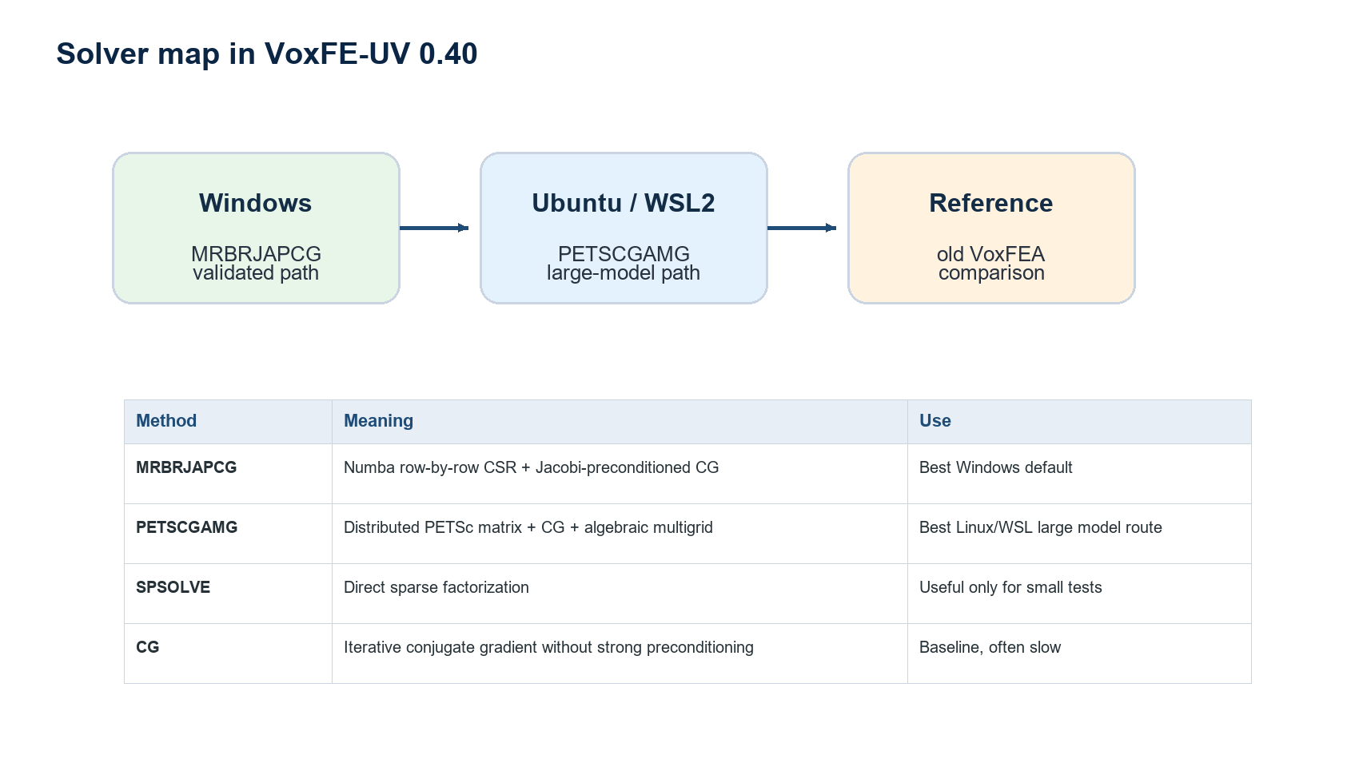
Figure 6. Solver map and recommended use in VoxFE-UV 0.41.
All solvers try to find the displacement vector u that satisfies the same mechanical equilibrium equation, K u = f. They differ in how they build or apply K, how they reduce the residual, how much memory they need, and how quickly they reach an acceptable solution. The most important practical distinction is between direct sparse factorization, classical iterative CG, row-by-row voxel-specialized CG, and PETSc/MPI multigrid-preconditioned CG.
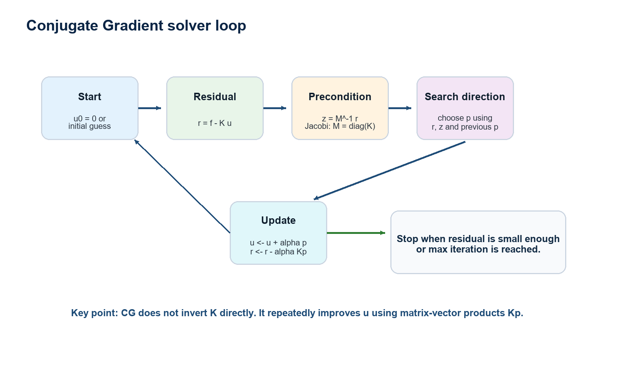
Figure 7. Generic conjugate-gradient loop used by several iterative solver variants.
Conjugate Gradient does not compute K inverse. Instead, it repeatedly evaluates matrix-vector products and updates the current displacement estimate. The preconditioner M is a cheaper approximation that makes the system easier for CG. A Jacobi preconditioner uses only the diagonal of K, while GAMG builds a multilevel algebraic approximation.

4.1 MRBRJAPCG on Windows
MRBRJAPCG is the recommended native Windows solver in the clean 0.41 release. MRBR means Modified Row-By-Row sparse matrix assembly, inspired by the legacy VoxFEA approach. JAPCG means Jacobi-preconditioned conjugate gradient with a convergence metric compatible with the old solver.
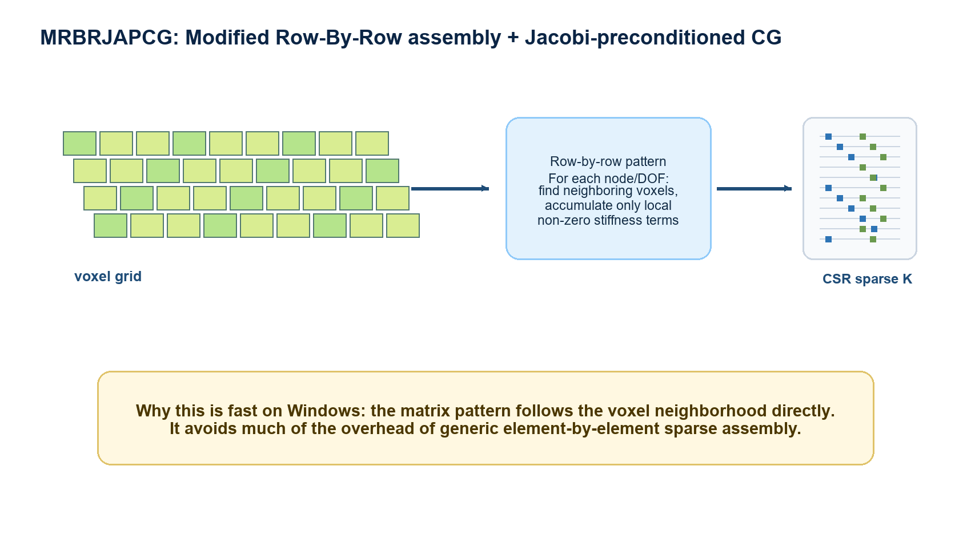
Figure 8. MRBRJAPCG builds the sparse matrix using the voxel neighborhood pattern directly.
The row-by-row idea is important for voxel models because the connectivity pattern is highly regular. A node is influenced only by nearby voxel elements, so each global row has a limited neighborhood of non-zero coefficients. MRBRJAPCG exploits this locality: it preallocates and fills the sparse matrix in a structure closer to the original VoxFEA implementation rather than using a generic element-COO path.
- Strength: validated against the old VoxFEA result on the Macaque test case when material constants match.
- Limitation: very large models can become memory-limited on Windows.
- Recommended use: small-to-medium models, validation, and comparison runs.

4.2 PETSCGAMG on Ubuntu/WSL2
PETSCGAMG uses PETSc/MPI and an algebraic multigrid preconditioner. It is the preferred strategy for large models, particularly on Linux machines with enough RAM. Runtime can be dominated by preconditioner setup, not only by the visible CG iterations.
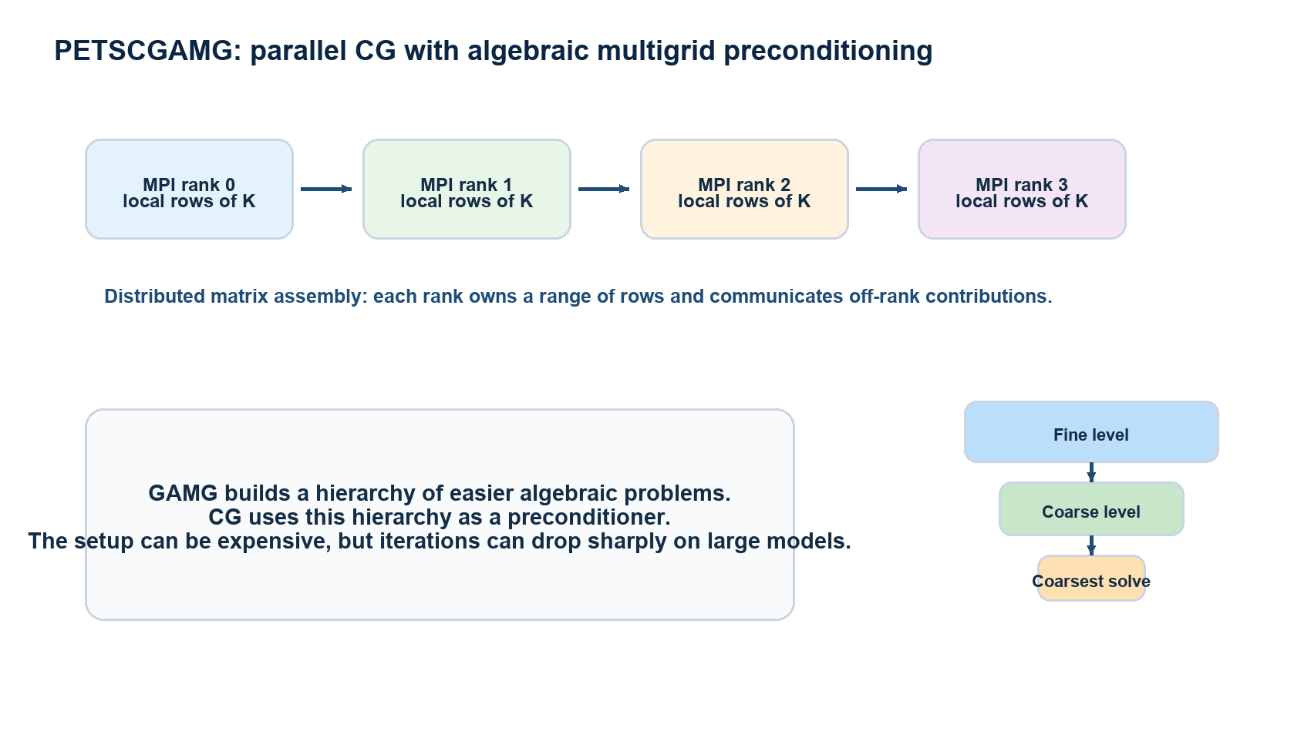
Figure 9. PETSCGAMG distributes matrix rows across MPI ranks and uses a multigrid hierarchy as preconditioner.
PETSc distributes the global sparse matrix across MPI ranks. Each rank owns a subset of rows and communicates when a matrix-vector product requires values from neighbouring ranks. GAMG then builds coarser algebraic representations of the problem. During each CG iteration, this hierarchy helps remove error components that Jacobi alone would reduce slowly.
- Strength: better scaling route for large voxel models.
- Limitation: GAMG setup can require substantial memory.
- Recommended use: full-resolution models and high-RAM Linux/WSL2 systems.
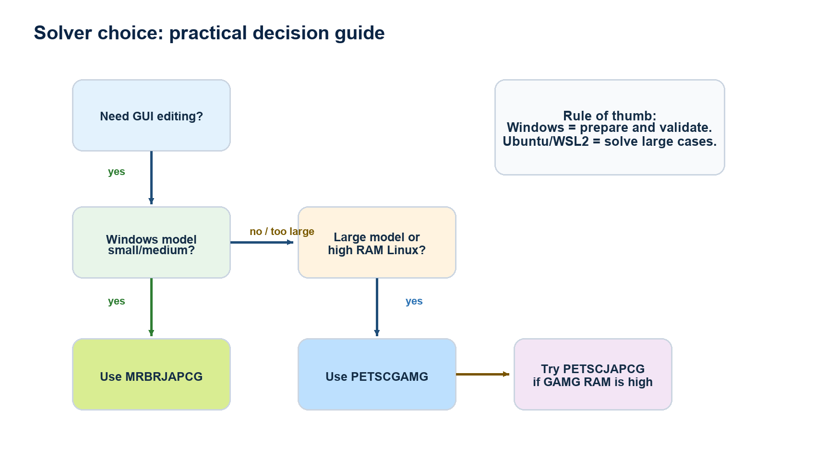
Figure 10. Practical solver decision guide for the 0.41 release.
Method | What it does | When to use it
MRBRJAPCG | Row-by-row CSR assembly + Jacobi-preconditioned CG. | Default Windows 0.41 solver.
PETSCGAMG | PETSc/MPI CG + algebraic multigrid preconditioning. | Default Ubuntu/WSL2 solver for large models.
PETSCJAPCG | PETSc CG with simpler preconditioning. | Comparison if GAMG uses too much RAM.
CG | Basic conjugate gradient. | Benchmark only, often slow.
SPSOLVE | Direct sparse factorization. | Small tests only; not recommended for full models.

4.3 Convergence and residuals
An iterative solver produces both a displacement field and a residual history. The residual measures how well the current solution satisfies K u = f. A residual curve that does not decrease, oscillates strongly, or stops only because the maximum iteration count was reached should be treated with caution.
Residual
rₖ = f − K uₖ
The residual measures the remaining force imbalance.

Relative residual
relresₖ = ‖rₖ‖ / ‖r₀‖
This normalizes the residual by the initial residual.

Typical stopping criterion
converged if ‖rₖ‖ ≤ tolerance · ‖r₀‖

Important
Numerical convergence does not guarantee physical correctness. A model with wrong material constants, wrong voxel size, or wrong force scaling can converge to the wrong physical answer.

4.4 How to read solver timing
Solver time is usually split into phases. Parsing and renumbering identify active nodes and degrees of freedom. Assembly builds or prepares the stiffness operator. Preconditioner setup builds Jacobi, GAMG, or another acceleration structure. Iteration time is the repeated process of reducing the residual. Export time writes displacement, force, energy, and coordinate files.
Timing field | Meaning | Interpretation
assembly_time_seconds | Time spent building the stiffness matrix/operator. | High values suggest matrix construction or I/O is the bottleneck.
solve_time_seconds | Time spent in the numerical linear solve. | High values suggest slow convergence or weak preconditioning.
summary_total_time_seconds | Total time measured by the solver internals. | Useful for comparing algorithms under the same setup.
wall_time_seconds | External elapsed time measured by the launcher. | Includes Python startup, script preparation, export, and logging.

Practical reading
If assembly is fast but solve time is high, improve preconditioning or boundary conditions. If setup/assembly is slow, improve matrix construction, file location, or use the voxel-specialized MRBR path. If GAMG setup uses too much memory, reduce MPI ranks or try a simpler PETSc preconditioner.

5. Windows tutorial: using VoxFE-UV 0.41

5.1 Launching the application
- Open the 01_Windows_VoxFE_UV_0_40 folder.
- Double-click LAUNCH_VoxFE_UV_0_40_WINDOWS.bat.
- If the app does not start, run INSTALL_OR_UPDATE_DEPENDENCIES.bat and try again.
- Use Open or Import project to load an existing model.

5.2 Importing a model and script
- Load model.txt or an existing VoxFE-UV project.
- Import Script.txt to recover materials, voxel size, forces, and constraints.
- Open Properties and check voxel size, bounds, voxel count, and material IDs.
- In Materials/Solver, verify that every material has the correct E and nu.

5.3 Defining materials
The safest convention is to treat materials as numerical IDs with neutral labels. For example, MATERIAL_2 can be renamed cortical bone or trabecular bone for readability, but the solver uses the ID and numerical E, nu values.
Step | Action | Check
1 | Open Materials/Solver. | Verify the list of material IDs.
2 | Select a material. | Check Young's modulus in Pa.
3 | Set Poisson's ratio. | Use a value appropriate for the specimen/material.
4 | Export the script. | Reopen the script if you need to inspect MATERIAL lines.

5.4 Defining constraints and forces
- Use the selection tools to create node or voxel groups.
- Save a group as a constraint if it represents prescribed displacement.
- Save a group as a force if it represents an applied load.
- Verify magnitude, normalized direction, and visual arrow thickness.
- Use distinct colours for different groups and check the active selection before export.

5.5 Solving on Windows
- Export the project/script from the GUI.
- For the included validation case, run RUN_MACAQUE_OLD_WINDOWS_MRBRJAPCG_0_40.bat.
- For a custom model, copy the BAT and modify CASE_DIR, or place the script in the model folder.
- During the run, inspect residual_history.csv and the solver log.
- After solving, import displacement.txt into the GUI and inspect displacement magnitude and deformed shape.

6. Ubuntu/WSL2 tutorial: PETSc/MPI solver

6.1 Installing WSL2 and Ubuntu
- From Windows, open PowerShell or Command Prompt as administrator if WSL is not installed.
- Run: wsl --install -d Ubuntu.
- If Ubuntu already exists, check it with: wsl -l -v.
- Open Ubuntu from the Start menu or run: wsl -d Ubuntu.

6.2 Installing Miniforge and PETSc
Download Miniforge
wget -O Miniforge3.sh https://github.com/conda-forge/miniforge/releases/latest/download/Miniforge3-Linux-x86_64.sh

Install
bash Miniforge3.sh

Enable conda
source ~/miniforge3/etc/profile.d/conda.sh

Create environment
conda create -n voxfe-petsc-mpi -c conda-forge python=3.11 numpy scipy mpi4py petsc petsc4py openmpi -y

Activate environment
conda activate voxfe-petsc-mpi

6.3 Copying the solver folder into Ubuntu
For better performance, copy the solver folder into the Ubuntu home directory. Avoid solving large models directly from /mnt/c when possible, because Windows-to-WSL file I/O can be slower.
Example copy command
cp -r "/mnt/c/path/to/VoxFE_0.41/02_Ubuntu_WSL_PETSc_MPI_0_40" ~/VoxFE_0.41

6.4 Running a model
Macaque validation model
cd ~/VoxFE_0.41 && MPI_PROCS=4 METHOD=PETSCGAMG bash ./solve_macaque_old_petsc_mpi_0_40.sh

Macaque 2.5M model
cd ~/VoxFE_0.41 && MPI_PROCS=4 METHOD=PETSCGAMG bash ./solve_macaque_2_5m_petsc_mpi_0_40.sh

Variable | Example | Meaning
MPI_PROCS | 4 | Number of MPI processes. Start with 4 on a 32 GB RAM machine.
METHOD | PETSCGAMG | Solver method. PETSCGAMG is the recommended Ubuntu default.
TOLERANCE | 1e-06 | Numerical convergence tolerance.
MAX_ITER | 60000 | Maximum iteration count.

7. Understanding output files
File | Content | Use
displacement.txt | Nodal displacements ux, uy, uz. | Import into the GUI and compute |u|.
force.txt | Forces actually exported/solved. | Check magnitudes and directions.
sed.csv | Strain energy density or related energy values. | Identify high-energy regions.
residual_history.csv | Residual values by iteration. | Check convergence.
voxfe_solver_summary.json | Run metadata, timing, DOF, convergence status. | Reporting and debugging.
voxel_coordinates_loaded.tsv | Coordinates after applying displacement. | Geometry export for comparisons.
voxel_coordinates_unloaded.tsv | Original coordinates. | Baseline geometry.

7.1 Worked example: a tiny voxel beam
A very small beam is useful for learning file structure without the cognitive load of a large anatomical model. The example below represents a cantilever-like voxel beam: one end is fixed and a downward force is applied at the opposite end.
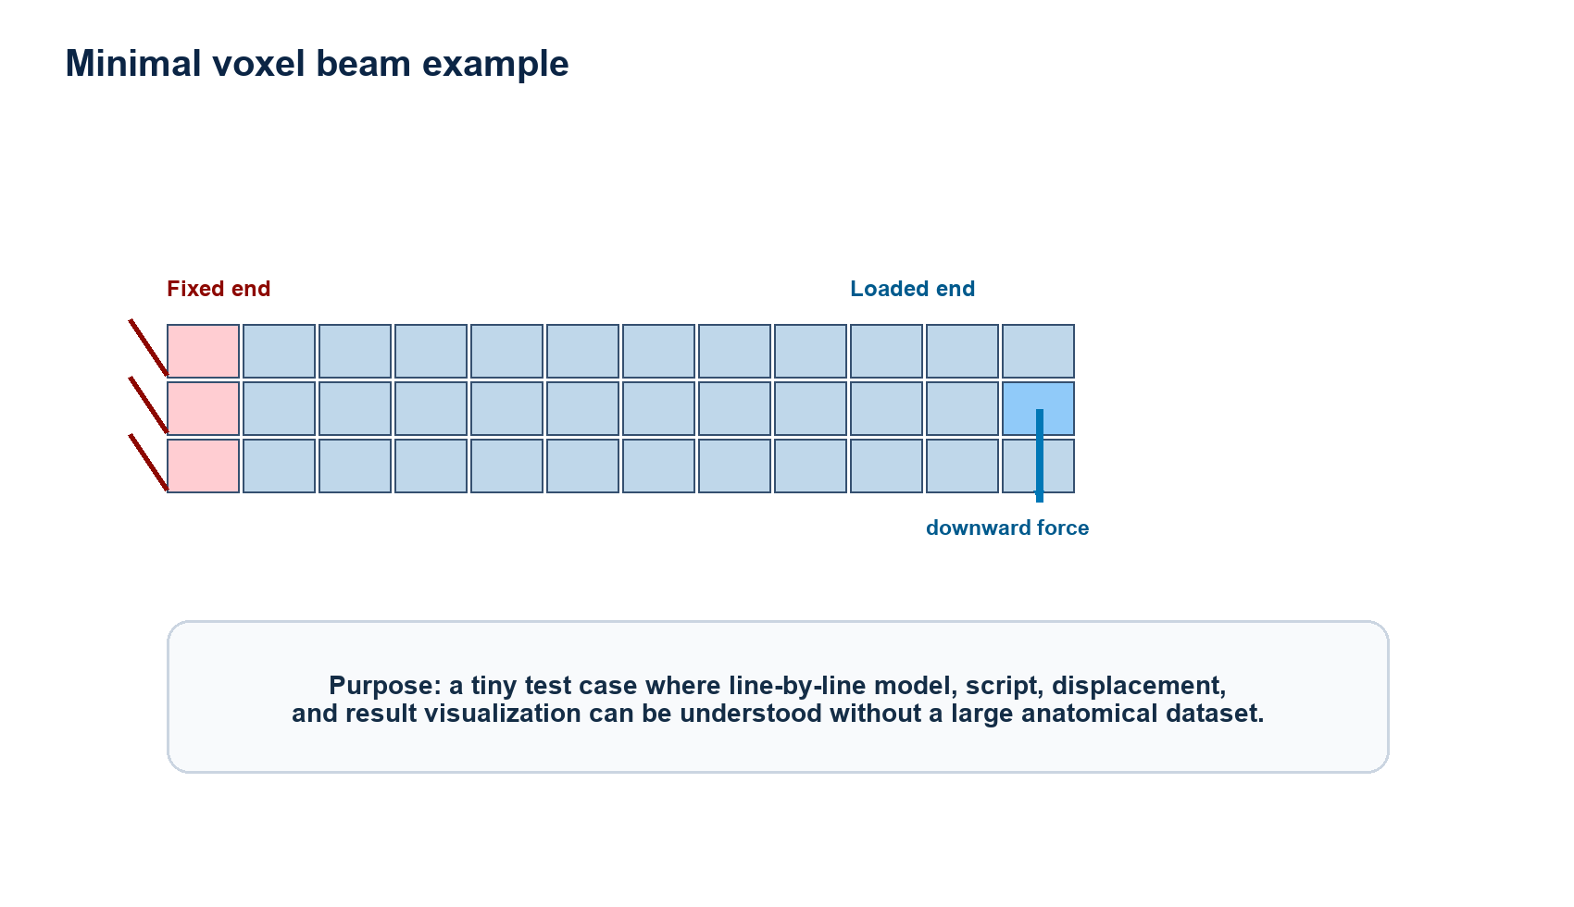
Figure 11. Minimal beam example used to explain model, script, displacement, and visualization outputs.
Example model.txt
# material_id x y z
1 0 0 0
1 1 0 0
1 2 0 0
1 3 0 0
1 4 0 0
1 5 0 0

Line or field | Meaning
# material_id x y z | Comment documenting the column order.
1 | Material ID. Here all voxels use MATERIAL_1.
x y z | Integer voxel coordinates in the model grid.
0..5 | A six-voxel beam along the x direction.

Example Script.txt
MATERIAL 1 MATERIAL_1 17000000000 0.30 PASSIVE
VOXEL_SIZE 0.001 0.001 0.001 1
ALGORITHM_FEA MRBRJAPCG
MAX_ITER 10000
TOLERANCE 1e-06
CONSTRAINT_GROUP fixed_left
SELECT_NODE_3D 0 0 0 0 0 0
END_GROUP
FORCE_GROUP loaded_right
SELECT_NODE_3D 5 0 0 0 -1 0
FORCE_VECTOR 0 -1 0 10
END_GROUP

Script line | Meaning
MATERIAL | Defines material ID, label, Young's modulus E, Poisson's ratio nu, and status.
VOXEL_SIZE | Defines physical voxel dimensions. Here each voxel is 1 mm.
ALGORITHM_FEA | Requests a solver method. Launchers can override this line.
MAX_ITER / TOLERANCE | Controls iterative solver stopping conditions.
CONSTRAINT_GROUP | Starts a named group of constrained nodes.
SELECT_NODE_3D in constraint | Selects node/voxel coordinates to lock or constrain.
FORCE_GROUP | Starts a named load group.
FORCE_VECTOR | Defines direction and physical magnitude of the applied force.

Example displacement.txt
# node_id x y z ux uy uz |u|
0 0 0 0 0.000000e+00 0.000000e+00 0.000000e+00 0.000000e+00
1 1 0 0 2.100000e-08 -1.200000e-07 0.000000e+00 1.218236e-07
2 2 0 0 6.900000e-08 -4.400000e-07 0.000000e+00 4.453089e-07
5 5 0 0 2.600000e-07 -1.800000e-06 0.000000e+00 1.818681e-06

Column | Meaning | How to read it
node_id | Solver node identifier. | Useful for comparing solver outputs.
x y z | Original grid coordinate. | Connects displacement back to model geometry.
ux uy uz | Displacement components. | Signed values in physical units.
|u| | Total displacement magnitude. | Scalar used for colour maps.

7.2 Graphical visualization of solver outputs
VoxFE-UV visualizes solver outputs as layers on the original or displaced model. The most important distinction is between raw vector quantities, such as displacement components, and derived scalar quantities, such as total displacement, strain energy density, or Von Mises stress.
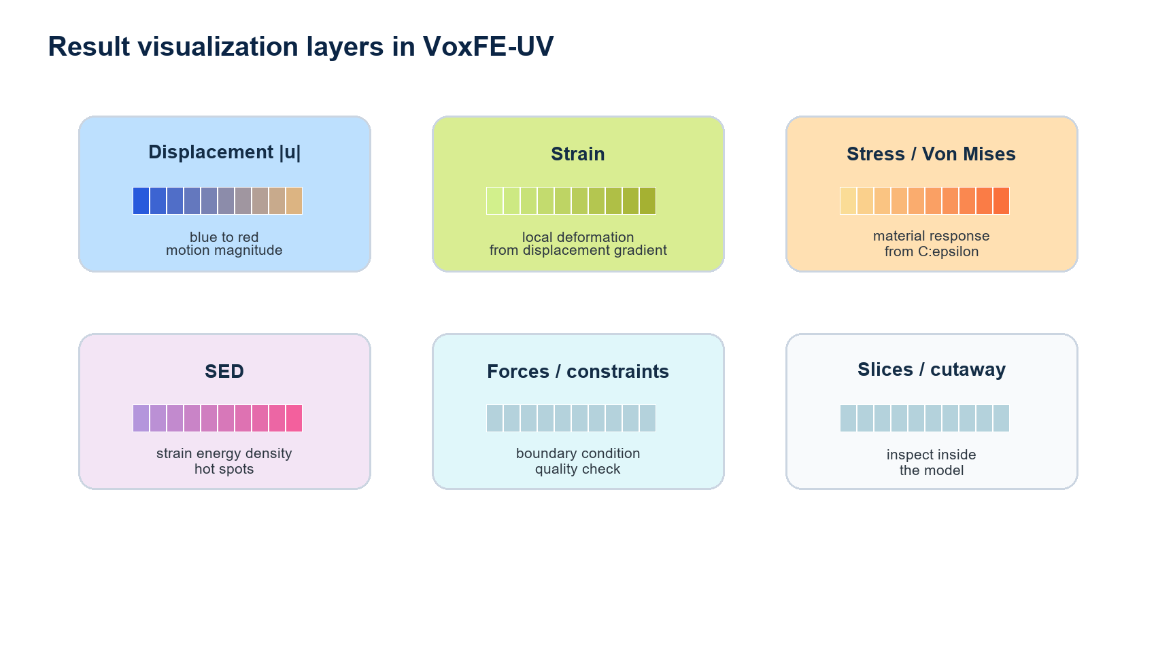
Figure 12. Main visualization layers available or expected in the VoxFE-UV result workflow.
Visualization | Data source | What it shows | Typical check
Total displacement |u| | displacement.txt | Magnitude of nodal displacement. | Loaded side moves more than constrained side.
Displacement components | displacement.txt | ux, uy, uz separately. | Movement direction matches applied load.
Loaded/unloaded geometry | coordinate export | Original versus displaced coordinates. | Deformed shape is plausible after scale factor.
Strain | computed from displacement gradient | Local deformation. | High values near bending or load transfer regions.
Stress / Von Mises | material law plus strain | Equivalent stress measure. | Peaks near constraints and load application should be interpreted carefully.
SED | sed.csv | Strain energy density. | Useful for identifying mechanically active regions.
Forces and constraints | Script.txt / force.txt | Boundary condition overlays. | Confirm selected groups, directions, and magnitudes.
Slices / cutaway | viewer state | Interior values. | Check whether hot spots are surface-only or internal.

Interpreting colour maps
Colour maps are not proof of correctness. Always check the numerical scale, units, material constants, constraints, force magnitudes, convergence, and whether the displayed geometry is visually amplified.

7.3 Bone remodelling: SED-driven Z -> T example
Bone remodelling is a model-update loop rather than a single static solve. A mechanical analysis is run, a local stimulus is computed, and the voxel model is updated according to rules for resorption and formation. In this guide, T means an existing tissue/remodelled material voxel, while Z means an empty or background candidate site. The transition T -> Z represents removal/resorption; the transition Z -> T represents formation/addition.
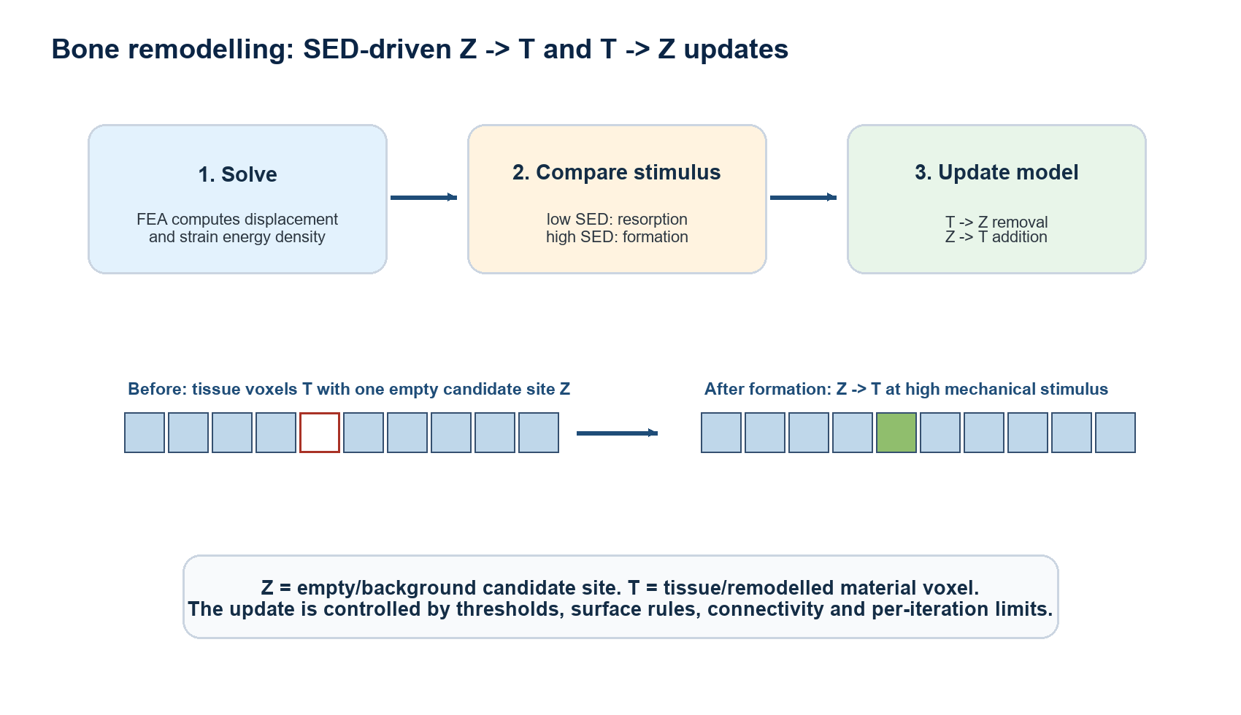
Figure 13. SED-driven remodelling loop with Z -> T formation and T -> Z resorption.
Mechanical stimulus
S = SED = 1/2 · εᵀσ
The current implementation uses strain energy density as the local mechanical signal.

Resorption rule
if S < lower threshold: T -> Z
Low mechanical stimulus can remove remodelled tissue voxels.

Formation rule
if S > upper threshold: Z -> T
High mechanical stimulus can add tissue voxels near the current surface, subject to limits.

Example remodelling script block
COMPUTE_SED
MODEL_ITERATIONS 10
REMODEL_LOWER_THRESHOLD 2.0e-04
REMODEL_UPPER_THRESHOLD 8.0e-04
REMODEL_SURFACE_ONLY 1
REMODEL_CONNECTIVITY 26
REMODEL_FORMATION_LAYER 1
REMODEL_KEEP_LARGEST_COMPONENT 1
REMODEL_PROTECT_SELECTED_NODES 1
REMODEL_MAX_REMOVALS 500
REMODEL_MAX_ADDITIONS 250
REMODEL_HISTORY_OUTPUT_DIR history_models
PRINT_SED sed.csv

Parameter | Meaning | Practical effect
COMPUTE_SED | Requests strain energy density output. | Required if remodelling is driven by SED.
MODEL_ITERATIONS | Number of solve-update cycles. | More iterations allow progressive shape/material change.
REMODEL_LOWER_THRESHOLD | SED value below which tissue may be removed. | Controls T -> Z resorption.
REMODEL_UPPER_THRESHOLD | SED value above which tissue may be formed. | Controls Z -> T formation.
REMODEL_SURFACE_ONLY | Restricts changes to surface voxels/candidates. | Prevents unrealistic internal holes or growth.
REMODEL_CONNECTIVITY | Neighbourhood used for surface/candidate checks. | 26 is permissive in 3D; 6 is stricter face connectivity.
REMODEL_FORMATION_LAYER | How many candidate layers outside the surface can be considered. | Higher values allow thicker growth per iteration.
REMODEL_KEEP_LARGEST_COMPONENT | Keeps the model connected after removals. | Avoids fragmenting the structure.
REMODEL_PROTECT_SELECTED_NODES | Protects selected load/constraint nodes. | Prevents boundary conditions from disappearing.
REMODEL_MAX_REMOVALS | Maximum removals per iteration. | Limits how aggressive resorption can be.
REMODEL_MAX_ADDITIONS | Maximum additions per iteration. | Limits how aggressive formation can be.
REMODEL_HISTORY_OUTPUT_DIR | Folder for intermediate models. | Allows animation and audit of each remodelling step.
PRINT_SED | Writes the SED file. | Useful for debugging and visualization.

Choosing thresholds
If thresholds are left unspecified in the GUI workflow, percentile-based defaults can be used internally. For reproducible scientific runs, write explicit lower and upper thresholds in the script and report them with the model.

Transition | Input state | Condition | Output state
T -> Z | Existing remodelled tissue voxel | SED below lower threshold and removal does not violate protection/connectivity rules. | Voxel is removed or converted to background.
Z -> T | Empty candidate site near the model surface | Neighbouring tissue has high SED and addition limit is not exceeded. | New tissue voxel is added with the remodelled material ID.
No change | Tissue or candidate site | Stimulus remains inside the lazy zone or limits are reached. | Voxel state is preserved.

7.4 Plausible displacement
A plausible displacement field must be consistent with loads, constraints, scale, and material stiffness. There is no universal correct value. A small stiff model under modest load may move very little; a softer material may produce much larger displacement.
- Constrained nodes should have zero or prescribed displacement in the locked components.
- Loaded regions should move in the expected direction.
- If material or voxel size changes, compare displacement ratios, not only colours.
- The visually scaled deformed shape is an inspection aid, not the absolute displacement value.

8. Validation and troubleshooting
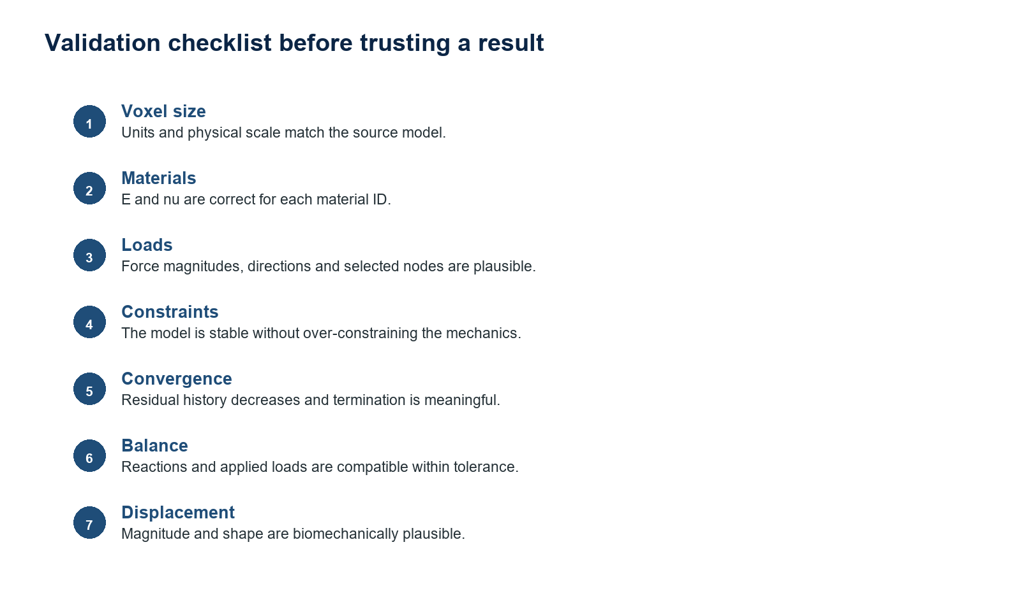
Figure 7. Validation checklist before accepting a result.

8.1 Common problems
Symptom | Possible cause | Action
All-zero displacement | No applied loads, excessive constraints, export/import issue, or false convergence. | Check force.txt, selected nodes, and summary JSON.
Very large displacement | Material too soft, wrong voxel size, or force magnitude too high. | Check E in Pa, voxel size, and Newton units.
Slow assembly | Large sparse matrix or file I/O through /mnt/c. | Use MRBR on Windows or copy the case into Ubuntu home.
GAMG uses too much RAM | Multigrid preconditioner setup is memory-heavy. | Reduce MPI_PROCS or try a simpler method.
Residual does not decrease | Poor conditioning, insufficient constraints, or extreme material contrast. | Check rigid body modes and boundary conditions.

8.2 Comparing with legacy VoxFEA
A meaningful comparison with legacy VoxFEA requires the same model, voxel size, materials, loads, and constraints. During VoxFE-UV 0.41 development, a key issue was ambiguous legacy material handling: a label such as METAL must not automatically imply metallic stiffness if the material actually represents biological tissue.
- Compare displacement.txt node by node.
- Compute relative L2 error between old and new displacement vectors.
- Compare directions and magnitudes, not only the rendered colour map.
- If cases are identical, the mean displacement magnitude ratio should be close to 1.

9. Appendix A: essential formulas
Strain-displacement
ε = B uₑ

Element stress
σ = C B uₑ

Element stiffness
Kₑ = ∫element volume Bᵀ C B dV

Assembly
K = Σₑ Aₑᵀ Kₑ Aₑ

Global equilibrium
K u = f

Strain energy density
SED = 1/2 · εᵀσ

Residual
r = f − K u

Euclidean norm
‖r‖₂ = √(Σᵢ rᵢ²)

10. Appendix B: operational checklist
Check | Question | OK
Voxel size | Is the physical scale correct and documented? | [ ]
Materials | Does every material ID have correct E and nu? | [ ]
Forces | Are magnitudes in Newtons and directions correct? | [ ]
Constraints | Is the model stable without being over-constrained? | [ ]
Solver | Is the method appropriate for problem size? | [ ]
Convergence | Does the residual decrease meaningfully? | [ ]
Output | Are displacement and reactions physically plausible? | [ ]
Archive | Are script, model, summary, and log stored together? | [ ]

11. Appendix C: reporting conventions
- Always report VoxFE-UV version, solver, backend, maximum iterations, and tolerance.
- Report voxel size, voxel count, number of elements, and number of DOF.
- Report materials by numerical ID with E, nu, and descriptive biological label.
- Specify total force magnitude and how it is distributed over nodes.
- Show unloaded geometry, scaled loaded geometry, and a |u| colour map.
- Attach residual_history.csv or at least final residual and iteration count.
Figure note
The figures included in this document are technical placeholders generated for documentation. They can be replaced later with real VoxFE-UV screenshots, anatomical model views, or validation plots.

Version 0.41 Update: Solver Validation Log
VoxFE-UV 0.41 adds a structured validation report to every solver run. The normal console log is still produced, and the solver also writes voxfe_run_validation_log.json inside the model folder. This file is intended to make numerical checks repeatable instead of relying only on a visual inspection of the displacement map.
- Force/reaction equilibrium: The log stores total applied force, total reaction, force plus reaction, and a relative balance value. For a balanced static solution, total_applied_force + total_reaction should be close to zero.
- Displacement statistics: The log stores minimum, maximum, mean, median, standard deviation, percentiles, component-wise min/mean/max and the node with maximum displacement magnitude.
- Spatial distribution: The log stores model bounds and voxel size, making it easier to identify unit or scale mistakes.
- Disconnected islands: The log reports connected components using 6-neighbour face connectivity, including how many voxels are outside the largest connected component.
- Materials and units: The log lists material IDs, names, voxel counts, Young modulus, Poisson ratio and a reminder that voxel size, force and stiffness must use a consistent unit system.
- Old-vs-new comparison: If VOXFE_REFERENCE_DISPLACEMENT points to a previous displacement.txt file, the log reports mean, maximum and RMS vector differences between old and new results.

Convergence Interpretation in 0.41
The historical VoxFE/JAPCG convergence value SigmaNew is preserved for compatibility, but it should not be interpreted as the true relative residual. SigmaNew is a Jacobi-preconditioned scalar criterion. It can start near 1e-6 when the system is strongly scaled or when the force vector is small. Therefore, a low SigmaNew at iteration 0 is not by itself proof that the displacement field is mechanically reliable.
The historical threshold is:
SigmaEnd = number_of_equations * tolerance^2
- Check residual_norm_relative when available.
- Check force/reaction balance.
- Check displacement statistics and spatial distribution.
- Compare against a known reference displacement when available.
- Use MIN_ITER when you want to force a minimum number of iterations before accepting convergence.

MIN_ITER and Saving Non-Production Outputs
Important: the BAT regenerates Script_autorun...txt from Script.txt, so the cleanest way is either edit the original Script.txt, or set MIN_ITER before launching the BAT.
In Script.txt:
MIN_ITER 1580
In Windows Command Prompt before launching a BAT:
set MIN_ITER=3000
By default, SKIP_NONCONVERGED_OUTPUTS=0. This means displacement and reaction files are saved even when the stricter production_valid flag is false. Set SKIP_NONCONVERGED_OUTPUTS=1 only when you want to avoid writing huge output files for failed or exploratory runs.

Reference Displacement Comparison
To compare a new run with a previous solver result, set VOXFE_REFERENCE_DISPLACEMENT before launch:
set VOXFE_REFERENCE_DISPLACEMENT=C:\path\to\old\displacement.txt
export VOXFE_REFERENCE_DISPLACEMENT=/path/to/old/displacement.txt

