Project:- [www.amazon.com/](http://www.amazon.com/)

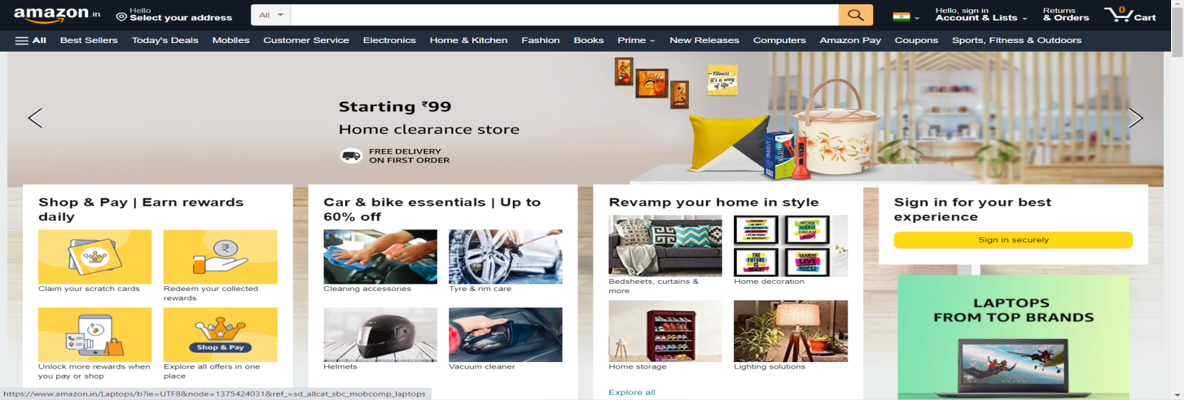

* About
* Amazon.com is an ecommerce platform.
* It sells many products baby products, [consumer electronics](https://en.wikipedia.org/wiki/Consumer_electronics), [beauty products](https://en.wikipedia.org/wiki/Cosmetics), gourmet food, groceries, health and personal care products
* Structure

1. Home Page
   * + - Navigation Bar
       - Search bar
       - Login/Signup button
       - Search by category
       - Carousel
       - Add to cart
2. Listing Page
   * + - Filters

Cost filter

Ratings filter

etc,

1. Details Page

Details related to the object/items which the customer opt to buy

e.g Price, No.of copies, Total Amount,etc

1. Order Placement Page

In this page you will see the final order details like total no. of items in the order and total amount payable with address confirmation.

1. Technology used
   * + - React
       - HTML
       - CSS
       - Bootstrap
       - JavaScript

