1. What is the difference between a database and a table?

2. What is entity integrity and referential integrity?

3. Why are entity integrity and referential integrity important in a database?

4. A database user manual notes that, “The file contains two hundred records, each one of which contains nine fields.” Use appropriate relational database terminology to “translate” the statement.

5. Identify and describe the components of the table shown belowin Figure Q3.11, using correct terminology. You should label: Entities, tuples, attributes, primary keys. Also, attempt to label the probable foreign key.

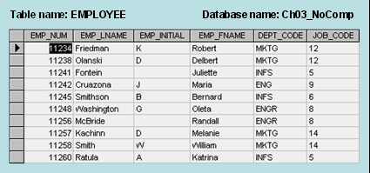

6. Describe (in your own words) the five integrity constraints specified in the Relational Model Version 2.

7. List the Primary and Foreign key attribute(s) for each table in the following database:

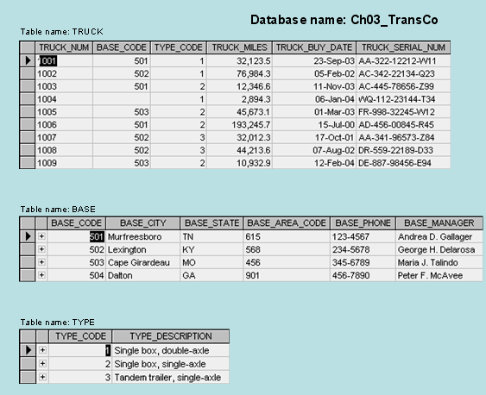

8. Which attributes in the database above enforce Entity integrity?

9. Which attributes in the database above enforce Referential integrity?

10. Using the below table, describe what the database would output using the following command:

SELECT *only* DEPARTMENT MKTG

Answer:

11. Using the same data, what would the database output using the following command?

**SELECT** EMP_NUM, EMP_LNAME, EMP_FNAME, JOB_CODE

**WHERE** JOB_CODE = 12

12. Using the two sets of data below, describe the output of using the UNION command in a table:

|  |  |  |  |
| --- | --- | --- | --- |
| **Emp_num** | **Emp_Initial** | **Emp_Name** | **Job_Code** |
| 101 | Z | Ali | 501 |
| 102 | A | Al Shiri | 508 |
| 103 | B | Hussain | 601 |
| 104 | M | Mohammed | 610 |
| 105 | S | Radhi | 615 |

|  |  |  |  |
| --- | --- | --- | --- |
| **Emp_num** | **Emp_Initial** | **Emp_Name** | **Job_Code** |
| 106 | S | Murad | 508 |
| 107 | A | Abdulla | 610 |
| 108 | B | Hesham | 501 |