1. What is the difference between a database and a table?

A table, a logical structure that represents an entity set, is only one of the components of a database. The database is a structure that houses one or more tables and metadata. The metadata are data about data. Metadata include the data (attribute) characteristics and the relationships between the entity sets.

2. What is entity integrity and referential integrity?

Entity integrity describes a condition in which all tuples within a table are uniquely identified by their primary key. The unique value requirement prohibits a null primary key value because nulls are not unique. Referential integrity describes a condition in which a foreign key value has a match in the corresponding table or in which the foreign key value is null. The null foreign key value makes it possible not to have a corresponding value, but the matching requirement on values that are not null makes it impossible to have an invalid value.

3. Why are entity integrity and referential integrity important in a database?

Entity integrity and referential integrity are important because they are the basis for expressing and implementing relationships in the entity relationship model. Entity integrity ensures that each row is uniquely identified by the primary key. Therefore, entity integrity means that a proper search for an existing tuple (row) will always be successful. Also, the failure to find a match on a row search will always mean that the row for which the search is conducted does not exist in that table. Referential integrity means that, if the foreign key contains a value, that value refers to an existing valid tuple (row) in another relation. Therefore, referential integrity ensures that it will be impossible to assign a non-existing foreign key value to a table.

4. A database user manual notes that, “The file contains two hundred records, each one of which contains nine fields.” Use appropriate relational database terminology to “translate” the statement.

Using the proper relational terminology, the statement may be translated to "the table-- contains two hundred rows -- or, if you like, two hundred tuples. Each of these rows contains nine attributes or nine columns."

5. Identify and describe the components of the table shown below in Figure Q3.11, using correct terminology. You should label: Entities, tuples, attributes, primary keys. Also, attempt to label the probable foreign key.

PK

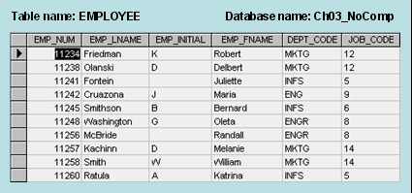

Lets look at some definitions:

Entity: A matrix of rows (Tuples) and columns (Attributes)  
relation or Entity.

Tuples: Refers to a row in a table. A row in a table that contains data about a specific item in a database table.

Attribute: Refers to a column in a table. An attribute is a piece of data to be stored about each entity instance and is a descriptive property or characteristic of the entity  
column of a table

Primary key: A Primary key (PK) is the attribute that is selected to be used to uniquely identify each entity instance  
must be unique  
must be consistent  
must not be null (Entity Integrity)  
must not change over time  
auto-generate if possible.

Foreign key: An attribute in one table whose value contains the PK of another table is called a Foreign key (FK).

6. Describe (in your own words) the five integrity constraints specified in the Relational Model Version 2.

Integrity constraints are of five types:

(1) D-type or domain integrity

(2) C-type or column integrity

(3) E-type or entity integrity

(4) R-type or referential integrity

(5) U-type or user-defined integrity

7. List the Primary and Foreign key attribute(s) for each table in the following database:

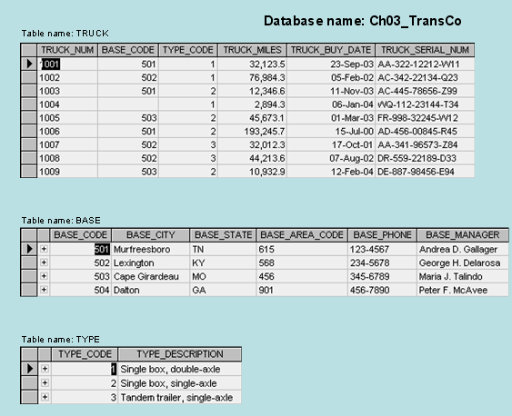

TRUCK:

PK: TRUCK_NUM

FK: BASE_CODE, TYPE_CODE

BASE:

PK: BASE_CODE

TYPE:

PK: TYPE_CODE

8. Which attributes in the database above enforce Entity integrity?

TRUCK_NUM

BASE_CODE

TYPE_CODE

In their own tables.

9. Which attributes in the database above enforce Referential integrity?

FK: BASE_CODE, TYPE_CODE in the TRUCK table.

10. Using the below table, describe what the database would output using the following command:

SELECT *only* DEPARTMENT MKTG

Answer:

Every row that has DEPT_CODE = ‘MKTG’ .

11. Using the same data, what would the database output using the following command?

**SELECT** EMP_NUM, EMP_LNAME, EMP_FNAME, JOB_CODE

**WHERE** JOB_CODE = 12

The first 2 rows as they both have job_code equal to 12.

12. Using the two sets of data below, describe the output of using the UNION command in a table:

It would display all of the rows from both tables.

|  |  |  |  |
| --- | --- | --- | --- |
| **Emp_num** | **Emp_Initial** | **Emp_Name** | **Job_Code** |
| 101 | Z | Ali | 501 |
| 102 | A | Al Shiri | 508 |
| 103 | B | Hussain | 601 |
| 104 | M | Mohammed | 610 |
| 105 | S | Radhi | 615 |

|  |  |  |  |
| --- | --- | --- | --- |
| **Emp_num** | **Emp_Initial** | **Emp_Name** | **Job_Code** |
| 106 | S | Murad | 508 |
| 107 | A | Abdulla | 610 |
| 108 | B | Hesham | 501 |