Quiz 2

Total Marks 100

# **Time**: **4 hours** Section I – MCQs

Encircle the correct answer out of the given options. Cutting or overwriting will result in no marks. [Mark: 10]

1. Javascript is an _______ language?

1. Object Oriented
2. Object Based
3. Procedural
4. None of the above

2. Which of the following keywords is used to define a variable in Javascript?

a) var

1. let
2. Both A and B
3. None of the above

3. How the objects are passed in JavaScript?

1. By value
2. By reference
3. Both by value and reference
4. None of the above

4. Which of the following methods is used to access HTML elements using Javascript? a) getElementById()

1. getElementsByClass()
2. Both A and B
3. None of the above

5. How can a datatype be declared to be a constant type?

1. const
2. var
3. let
4. constant

6. What will be the output of the following code snippet?

a) al

var

a

=

"Scaler"

;

var

result

=

a

.

substring

(

2

,

4

)

;

document

.

write

(

result

)

;

1. ale
2. cal
3. caler

7. What will be the output of the following code snippet?

a) 20

var

x

=

12

;

var

y

=

8

;

var

res

=

eval

(

"x+y"

)

;

document

.

write

(

res

)

;

1. x+y
2. 128
3. None of the above

8. AJAX is about updating ______, without reloading the full-page.

1. parts of a web page
2. parts of a database records
3. parts of a HTML tags dynamically
4. parts of a CSS classes dynamically

9. In Github After you add a file, it becomes

1. Modified
2. Staged
3. Untracked
4. Commited

e)

10. What command lets you create a connection between a local and remote repository? a) Git remote add origin

1. Git remote add new
2. Git remote new origin
3. Git remote origin

# Section – II

1. Write a JavaScript program that convert Age into days. You can give hard code value of the number. [Marks: 15]

CODE:

function calculateage(dob) {

var diff = Date.now() - dob.getTime();

var age = new Date(diff);

return Math.abs(age.getUTCFullYear() - 1970);

}

console.log(calculateage(new Date(1982, 11, 4)));

console.log(calculateage(new Date(1962, 1, 1)));

1. Write a java script function program check whether a string is palindrome or not. [Marks: 15]

CODE:

function Palindrome(string) {

const len = string.length;

for (let i = 0; i < len / 2; i++) {

if (string[i] !== string[len - 1 - i]) {

return 'It is not a palindrome';

} }

return 'It is a palindrome';

}

const string = prompt('Enter a string: ');

const value = Palindrome(string);

console.log(value);

1. Write a JavaScript function to format a number up to specified decimal places [Marks: 15]

function decimals(x, y) {

if ((typeof x !== 'number') || (typeof y !== 'number'))

return false;

n = parseFloat(x) || 0;

return n.toFixed(y);

}

console.log(decimals(2.100212, 2));

console.log(decimals(2.100212, 3));

console.log(decimals(2100, 2));

# Section – III

1. Differentiate arrow functions and regular functions. [Marks:5]

ANSWER:

Arrow functions and regular functions are both ways of writing functions in JavaScript, but they differ in syntax and behavior.

Regular functions are the traditional way of writing a function in JavaScript, and are written with the keyword `function` followed by the function name and parentheses. The function body is enclosed in curly braces and the return statement is used to return a value.

JavaScript

function add(a, b) {

return a + b;

}

Arrow functions are a more modern way of writing functions, and are written with an arrow between the parameters and the body. Unlike regular functions, arrow functions do not require the `function` keyword and do not have their own `this` context. They also use implicit returns, meaning the return statement can be omitted if the function body is a single expression.

JavaScript

const add = (a, b) => a + b;

1. Write a program that takes a number of greater than 5 digits from input field and shows sum of all odd numbers. For example, if the input is 196783, the sum would

be 1 + 9 + 7 + 3 = 20. [Marks: 5]

CODE:

function sumofoddnumbers(input) {

let result = 0;

for (let i = 0; i < input.length; i++) {

let number = parseInt(input.charAt(i));

if (number % 2 !== 0) {

result += number;

}

}

return result;

}

let input = prompt("Enter digits more than five : ");

console.log("sum of odd numbers is : " + sumofoddnumbers(input));

1. Given an integer N, the task is to find the sum of interior angles of an N-sided

polygon. [Marks: 5]

CODE:

function sumofpolygonangles(x){

return (x-2)*180;

}

let x = prompt("Please enter the sides of a polygon : ");

console.log("sum of polygon angles = " +sumofpolygonangles(x));

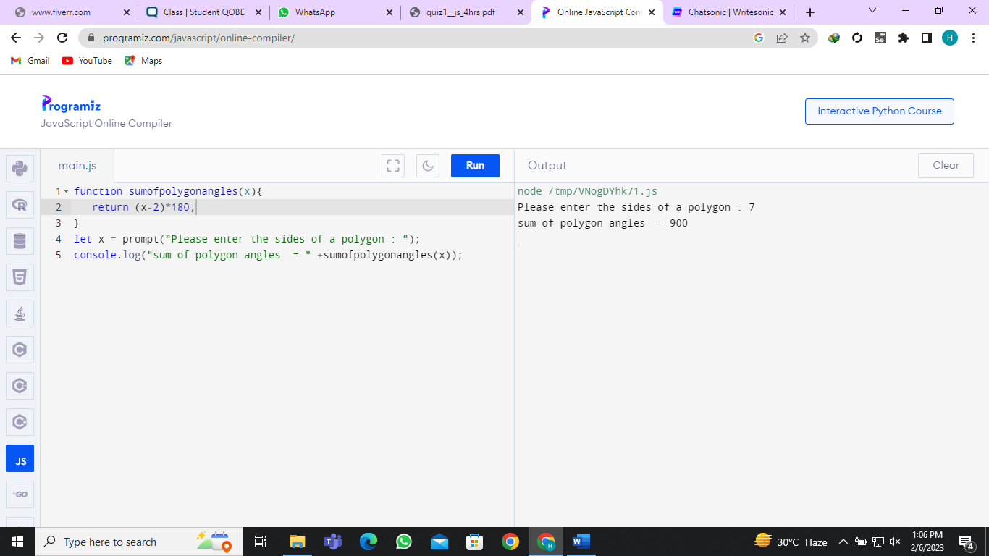

1. Create a age calculator that takes date of birth of user and shows age in years,

months and days. [Marks: 5]

CODE:

function calculateAge(dateOfBirth){

let today = new Date();

let birthDate = new Date(dateOfBirth);

let age = today.getFullYear() - birthDate.getFullYear();

let month = today.getMonth() - birthDate.getMonth();

let day = today.getDate() - birthDate.getDate();

if (month < 0 || (month === 0 && day < 0)) {

age = age - 1;

month = 12 + month;

}

if (day < 0) {

day = 30 + day;

}

console.log("Age: " + age + " Years, " + month + " Months, " + day + " Days");

}

calculateAge("October 15, 1990");

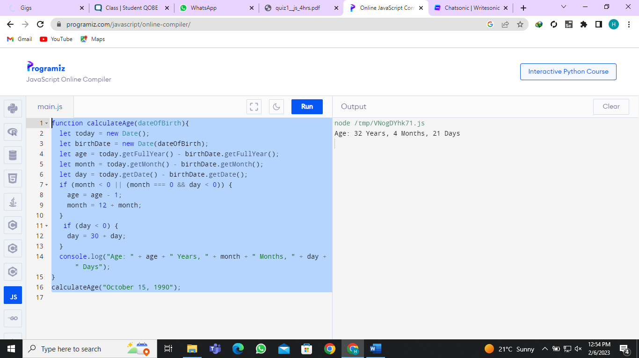

# Section – IV

1. In this question you must multiply two matrices A and B and store the answer in matrix C. For multiplying matrices, you must take care of the matrix multiplication rule i.e the column number of matrix A should be equal to matrix B.

Step 1: Get matrix size from the user for both matrices and compare them. If it

don’t follow the matrix multiplication rule, ask user again for the correct values.

Step 2: Store values in list for each matrix by prompting user to enter the values.

Step 3: Calculate the product of matrix A and matrix B.

Step 4: Display the out in proper format. [Marks: 25]

CODE:

function multiplyMatrices(x, y) {

let rowsOne = x.length;

let colsOne = x[0].length;

let rowsTwo = y.length;

let colsTwo = y[0].length;

if (colsOne !== rowsTwo) {

console.log("Error: matrices multiplication Method is Wrong");

return;

}

let z = [];

for (let i = 0; i < rowsOne; i++) {

z[i] = [];

for (let j = 0; j < colsTwo; j++) {

z[i][j] = 0;

for (let k = 0; k < colsOne; k++) {

z[i][j] += x[i][k] * y[k][j];

}

}

}

return z;

}

let x = [[7, 5, 10], [6, 4, 2]];

let y = [[5, 8], [8, 3], [-3, -8]];

let z = multiplyMatrices(x, y);

console.log("Matrix X: " + JSON.stringify(x));

console.log("Matrix Y: " + JSON.stringify(y));

console.log("Matrix Z: " + JSON.stringify(z));

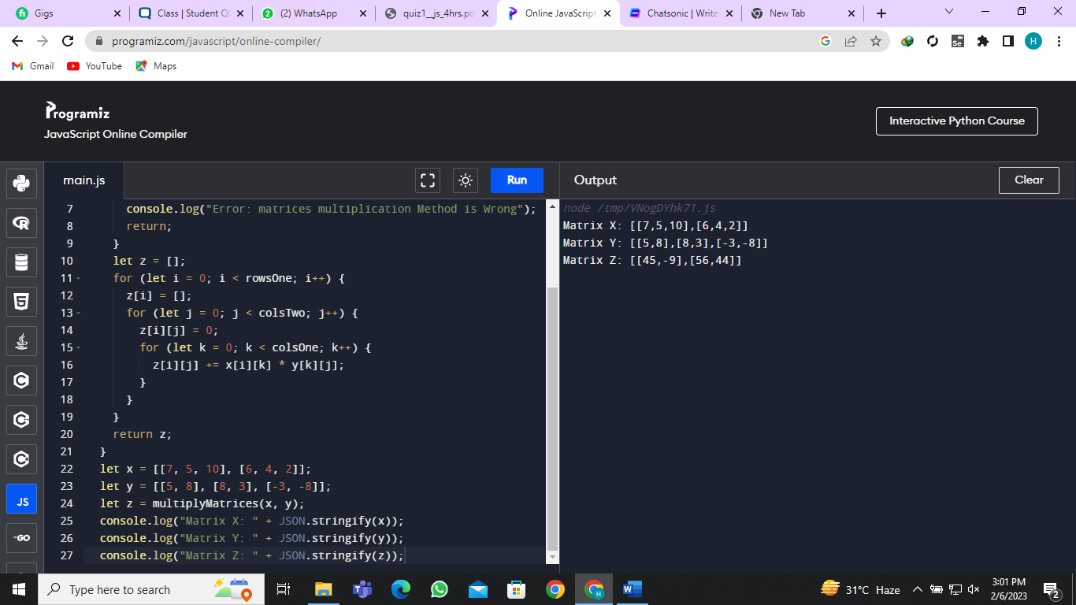

4