Air Quality Monitoring System Using Zone-Based Sensing via Internet of Things

Lyle Vince A. Dela Cuesta, Kristjan Renascence V. Mariano, Vonn Christian Q. Mesina, Dennis A. Martillano

1 Malayan Colleges Laguna, Cabuyao City Laguna 4025, Philippines

Email: lylevincedelacuesta@gmail.com; renascence22@live.com; vonnmesina@gmail.com, damartillano@mcl.edu.ph

***Abstract*** – Air pollution has become a great problem all around the globe, and it still causing problems today. In the Philippines, the DENR or the Department of Environment and National Resources implemented the Republic Act No. 8749 or the Philippine Clean Air Act of 1999, wherein it outlines government’s measures to reduce air pollution and incorporate environmental protection into its development plans. However, they have only few ways of actually implementing the law. For instance, in Carmona, Cavite, wherein cleanliness is always observed, they still have limited means to conduct an air quality monitoring that could determine if the standards in the National Ambient Air Quality Guidelines are met even though they are always awarded for their environmental activities. This study designed and created a system that could monitor the air quality of the two zones of Carmona that is in compliance with the guidelines set by the DENR, namely AQMS Carmona. AQMS Carmona is a cost-effective and portable air quality monitoring system, which is equipped with three (3) sensors, and each of it is responsible for monitoring a specific pollutant (Carbon Monoxide, Nitrogen Dioxide, and Sulfur Dioxide). This study demonstrated that AQMS Carmona is reliable based on tests conducted namely: self-calibration, third-party calibration, and actual data collection and testing, which showed the readings of the sensory devices have low percent error, and are in-line with the values indicated in the National Ambient Air Quality Guideline Values (NAAQGV) of the Philippine Clean Air Act. Results also show that the citizens of Carmona became more aware of the quality of air they’re breathing.

***Index Terms*** – Internet of Things, Air Quality Monitoring, Air Quality, Air Pollution, Sensors, Microcontrollers, Arduino

##### Introduction

Philippines is one of the countries that follows the trend of industrialization to pursue a better economy. As time passes by, more factories and establishments are being built to accommodate services and employment. The Philippines is also famous for its local transportation, which majority of the Filipinos use to be able to go to work, school or reach a particular destination. However, being exposed to open air is not as safe as before. According to health experts, the quality of air in the Philippines is becoming worse, and citizens who use public transportations are highly vulnerable to the harmful effects of air pollution. (Health & Environmental Effects of Air Pollution, n.d.).

To balance the environmental impact of the developments in the country, laws were created to guide and protect the welfare of the people. A law has been enacted in the Philippines entitled as the “The Philippine Clean Air Act” or also known as “RA 8749 or the CAA”. This act aims to provide a sustainable environment in the Philippines through prevention and control of air pollution by setting standards, guidelines and regulations for government, people, and industries to follow. It recognizes the responsibility of the local government to deal with environmental problems and recognizes the right of the citizens to breathe clean air, participate in the formulation, planning and implementation of the law. (DENR, 2014).

One of the municipalities that share the common goal of “commitment for economic growth without compromising ecological preservation and protection” is the Municipality of Carmona, resulting to the awards it has achieved over the years. The focus of the municipality is on their climate change adaptation program, which aims to reduce the greenhouse effect produced by human activities in Carmona. Their supervising environmental management specialist stated that the major source of air pollution in Carmona is from mobile sources. Because of this, they have determined SLEX – Carmona Entrance/Exit and Bancal Junction/intersection as the two most pollutant-prone areas affected by mobile sources in Carmona. Currently, the only way to determine the occurrence of air pollution in these areas is through reports given to the municipality. Once they receive a report, the municipality will immediately inspect the area and investigate where the pollution comes from, and then from there decide what actions to take. Yet usually, upon arriving at the reported area, the trace of pollution has already been diminished, gone, or was already replaced by other air pollutants. The municipality would like to focus and monitor criteria pollutants that contribute to the greenhouse effect and are from the major source of air pollution in Carmona namely: Carbon Monoxide (CO), Nitrogen Dioxide (NO2), and Sulfur Dioxide (SO2). The ability to measure air pollution in real-time will enable the municipality of Carmona to improve its implementation of Clean Air Act in its vicinity.

The objective of the study was to develop an IOT based air quality monitoring system placed in the two key areas of Carmona that can help in determining whether the standards provided in the National Ambient Air Quality Guideline are met by collecting actual concentration of air pollution data. Another objective was to develop a web application (with a mobile friendly feature) for the municipality and citizens. It will collect and display the data, generate raw data reports, and provide indications when certain amount of levels of air pollution has been reached which will help in the improvement of the implementation of standards and policies provided in the Clean Air Act, and compliance with the provisions set in the Municipal Environment Code. The last objective was to provide an IoT device that will enable real-time collection of the air pollution concentration data in distant zones and retrieval whenever it is needed to help the experts in their investigation. By implementing this project, the study will benefit the Municipal Environment and National Resources Office (MENRO) Carmona, its officers; Residents of Carmona, DENR; and future researchers. First, the study will provide Municipal Environment and National Resources Office (MENRO) Carmona a way to validate air pollution occurrences that will help in the implementation of the policies to fight air pollution. Next, its officers will be given a more convenient way of monitoring air pollution in key areas through a website that can collect and display air pollution data; alert the municipality office when an area’s AQI category level change (through beeping sounds and flashing bulb lights); and generate raw data reports based on selected start/end date which include elements, concentration values and date/time occurrences in each/specific areas. Next, the residents will be provided a way to be more aware of the quality of air they are breathing. Also, the DENR can use this study and apply it to other municipalities or areas that are in need of an air quality monitoring system that could also improve the Integrated Air Quality Framework of the Philippines. Lastly, the researchers will be able to access the air pollution data that will help other studies as well.

##### METHODOLOGY

The methodology that was used in the study is a modified prototyping for the development of projects which is under Internet of Things. This prototyping is based on Nurun process (Bliss, 2014) that provides a way to use microcontrollers like Arduino in fusing with IOT. Fig. 1 shows the 3-way methodology that was used in the study.



Fig 1. Nurun-Based Modified Prototyping for IoT

Research. In this stage, the stakeholders were identified. These stakeholders are the guiding environmental experts, officers of MENRO that contributed in giving information about what elements and areas the system should monitor, and the citizen of the target municipality. The background of the target municipality and its current state with respect to air quality monitoring was studied, and the technologies they are currently using to comply with the Clean Air Act Law were identified. Furthermore, the information gathered was sufficient to help identify the gaps, opportunities, and problems which leads to identification of the main objective.

Model. The conceptualization and creation of prototypes of the system were done in this stage. This includes identification of the sensors needed for the elements, that were identified in the initial phase, namely: MQ-135 for Nitrogen Dioxide 36 (NO2), MQ-2 for Sulphur Dioxide (SO2), and MQ-7 for Carbon Monoxide (CO). The components needed to create the sensory device were also identified, such as the Arduino Mega, WEMOS D1, and exhaust fan, and the specific pins that were used in order for the sensors to properly work. For example, the gas sensor MQ-7 was pinned on a breadboard that is connected to A0 pin, MQ-2 to A1 pin, and MQ-135 to A2 pin. In addition, the WEMOS D1, which was used to connect to the internet, has RX and TX pins that was placed on TX and RX pins of the Arduino respectively. Afterwards, computations through linear regression, self-calibration and third party-calibration of the sensory device were performed to ensure that the data output readings are correctly tested and validated. Valid data sheets of the sensors in calibrating the sensory device were used. These steps were repeated until the sensory device had no further problems, that lead to the last stage of the prototyping. (See Appendix X for the System Architecture Diagram)

Realize. During this stage, the final design of the prototype was created and the results of the calibration were compared to the results of the third-party. After the calibration, the system was presented and User Acceptance Testing was conducted with the MENRO officials and citizens to evaluate the system’s usability, aesthetics, and usefulness on February 17, 2017. Afterwards, the data collected on the key areas were validated by the chief of MENRO office whether the standards provided in the National Ambient Air Quality Guidelines were met. Lastly, the devices were tested at the key areas of Carmona, Bancal Interjunction, and Carmona SLEX Entrance/Exit, on February 18 to 23, 2017.

##### RESULTS AND DISCUSSION

The results of the study can be viewed based on the conceptualized diagram, test performed, evaluation and air quality information as seen in the web application and the mobile friendly feature. The following tests were conducted: (1) self-calibration, (2) third-party calibration, (3) actual data collection and testing, and (4) User acceptance test (UAT). For self-calibration, each sensor, MQ-7, MQ-2, and MQ-135 was exposed to different substances that contains Carbon Monoxide, Nitrogen Dioxide, Sulfur Dioxide, and clean air. These substances that contains the said pollutants are: Butane, alcohol, and combustion of gasoline. For third party calibration, the readings of the hand-held device of the air pollution expert from Pigmentex Inc. were compared against the readings of the sensory device. For actual data collection and testing, the sensory device was tested on the two key areas in Carmona: SLEX Entrance/Exit, and Bancal inter-junction. The test at Bancal Inter-junction was conducted on February 18 to 20 and the test of the sensory device at SLEX Entrance/Exit was conducted on February 21 to 23. For the user acceptance test, aesthetics, usefulness, and usability were tested with 30 respondents which comprise of 26 citizens of Carmona, and the 4 MENRO officials.

As shown in Figure 2, there are 2 axes on the graph and these are Rs/Ro ratio and ppm. The Rs/Ro ratio is the ratio of sensor resistance at various concentration gases and the sensor resistance at 1000 ppm of H2 in clean air. The graph shows that if the parts per million (ppm) reaches 200, the Rs/Ro ration value should be at 1.75. In order to test the reliability of the data sheet, the gas sensor was exposed to a substance until the readings met the specified Rs/Ro ratio value on the graph. Afterwards, the ppm was computed and compared with the expected value based on the graph, which is 200.See Appendix T and U for MQ135 and MQ-7 Gas Sensor Data sheet.

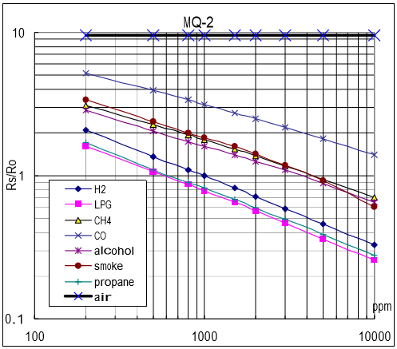

Figure 2. MQ-2 (Nitrogen Dioxide or LPG) Gas Sensor Data Sheet

Mathematically, a specific ppm can be pointed out by identifying the Rs/Ro ratio, given on the graph. In order to get the Rs/Ro ratio, the Rs and Ro values were identified. Ro can be identified in the graph as air, while Rs is identified by calculating the resistance of the gas sensor to a specific gas. After determining both values, the ratio can be solved by dividing the Rs to Ro.

In order to create a self-calibrating algorithm, the slope was computed as the graph in the data sheet shows linear exponentiation of values. To create the said algorithm, the 3 values needed, which is the logarithmic value of initial ppm and initial Rs/Ro, and the slope were identified. There are four values needed to solve the slope of a linear graph: Initial ppm, initial Rs/Ro ratio, final ppm and final Rs/Ro ratio. For the pollutant nitrogen dioxide, these 4 values are: (2.301029996, 0.243038049,4, -0.782516056) respectively. Using the formula (y2 - y1) / (x2 - x1), the slope was determined, which is -0.60363284965919. After solving for the slope, the next step was to compute for the ppm based on the Rs/Ro ratio. To compute for the ppm, the formula provided by Sandbox Electronics was utilized, which is: pow (10, (((log(rs_ro_ratio)-value 2)/value 3) + value 1)). The result from this formula is the theoretical value that was used in computing the percent error. In order to reduce the percent error, the values assigned to a curve should be adjusted manually until a minimal percent error is solved. The results of the theoretical values and expected values were compared, and was nearly identical to each other. Additionally, unstable electric current may affect the readings of the sensors, resulting to some escalating percent errors.

Therefore, an algorithm that could calibrate the sensory device programmatically was created, which was based on the values computed using slope as shown in Figure 3.

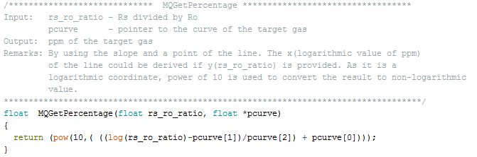

Figure 3. Algorithm Used to Convert Rs/Ro ratio to ppm

Using the results collected in the self-calibration, the percent error was computed and checked, whether the results were accepted or rejected. Percent error is defined as the margin of error and difference of the expected reading and the actual reading of the sensory device. The sensor collects data for every 5 minutes, and afterwards, the average of the data collected was computed. The averaging varies from each pollutant. For instance, the average values collected for Carbon Monoxide was computed every 8 hours, the average values collected for Sulphur Dioxide was computed every 24 hours, and the average values for Nitrogen Dioxide was computed every hour. A third-party calibration was also conducted with the help of an air pollution expert from Pigmentex Inc. located in Carmona. In addition to the third-party calibration, the sensory device has been preheated for over 48 hours as indicated in the data sheet provided by the manufacturers. All of this was done in the presence of an expert, responsible in identifying correct readings in a manufacturing company base also on the national standard on gas emission.

After the third-party calibration, the sensory device was deployed on the two key areas in Carmona. The sensory device was placed 1 to 2 meters above the ground level and was left for 3 hours to collect air concentration data which was sent to the cloud server in order for the users to view and evaluate the system. Figure 4 shows the block diagram setup of the system.

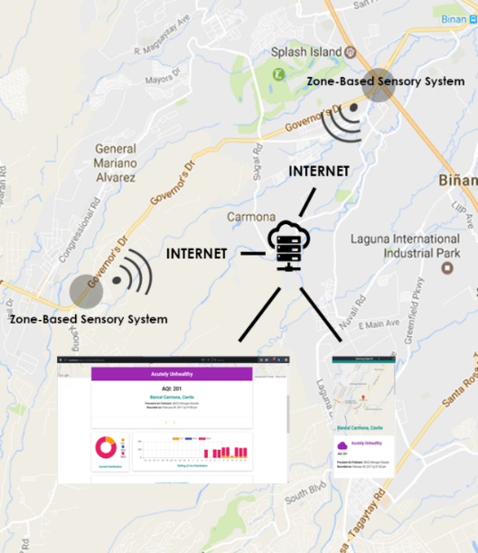

Figure 4. Block diagram of the System Setup

Illustrated in figure 5 is the deployment of the sensory device from each area (Bancal Junction and SLEX Carmona). In order to collect air concentration data and send it to the cloud server, each device was connected to the internet with the use of a Wi-Fi module (Wemos D1 R2 mini) installed in it. The data collected were used to calculate the AQI of the area, and was displayed on the web application. The results can be viewed by the experts, MENRO officers, citizens of Carmona, and researchers through the web application. Alternatively, they can access the website on their smartphone.

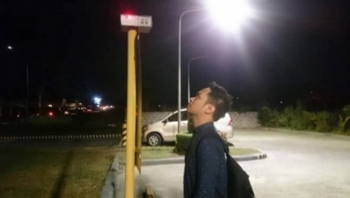

(A)

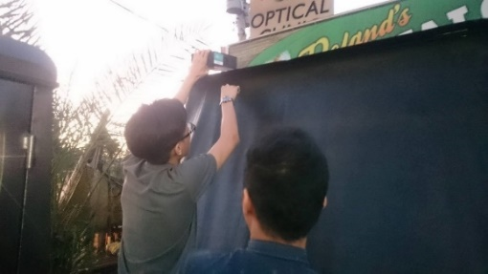

(B)

Figure 5. Actual Deployment of the Sensory Device in Bancal (A) and SLEX (B)Carmona Vicinities

Figure 6 shows the prototype device that was used for testing and calibration.

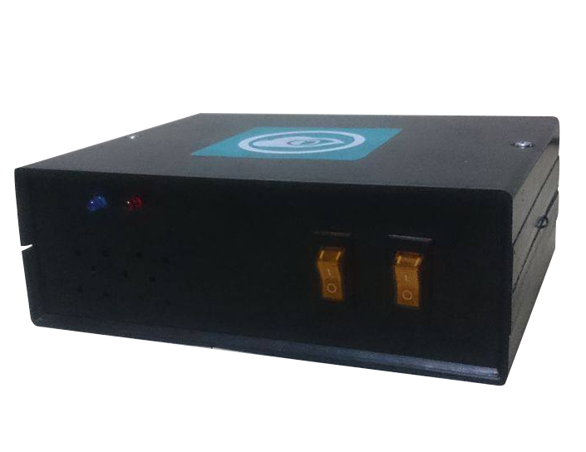

(A)

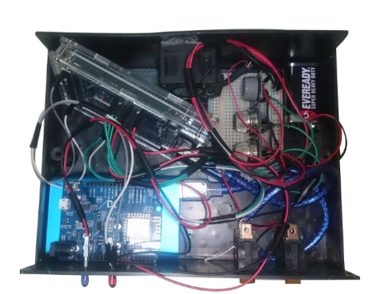

(B)

Figure 6. AQMS Carmona Prototype, (A) casing-enclosed, (B) inside-components.

Figure 7 shows the website application, the following information are displayed based on the selected area: (1) the prevalent pollutant of the current hour, (2) its AQI equivalent, and (3) the cautionary statement that is based from the air quality indicies. Furthermore, citizens could also view the website using their smartphones. In addition to this, generation of reports is also possible. The page shows a list of the actual readings, area on where it occured, and when it occured based on the user’s selection of date, area, and pollutant. Also, the website contains a feed for MENRO officers to monitor the sensors’ readings in real-time. (See Appendix J for the screenshots of the website from a smartphone).

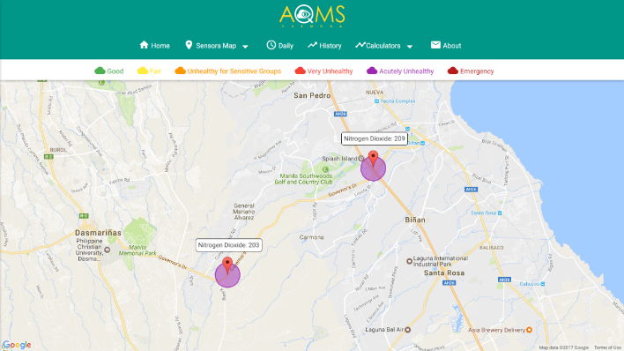

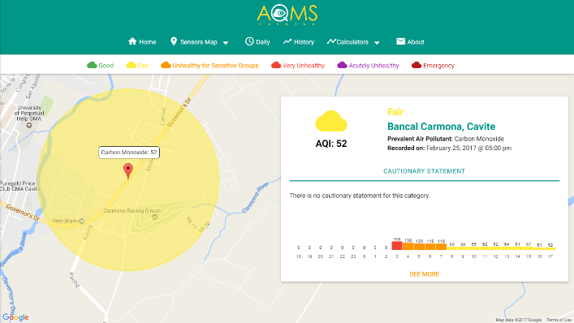

Figure 7. The Air Quality Monitoring System Website

Table 1 shows the values of expected and computed ppm and the actual reading of sensors when exposed to gas, which was computed using the slope formula. According to the data collected, the readings of each sensors has a minimal percent error, and therefore, it is acceptable.

TABLE 1: SELF-CALIBRATION RESULTS OF THE SENSORS USED BY COMPARING THE COMPUTED PPM BASED FROM THE DATA SHEET OF THE SENSORS.

|  |  |  |  |
| --- | --- | --- | --- |
| Element | Expected and Computed PPM | Actual Reading (in ppm) | Percent Error |
| NO2 | 200 | 198.65 | 0.675 |
| SO2 | 10 | 9.892 | 1.08 |
| CO | 200 | 199.23 | 0.385 |

Table 2 to 4 shows the values of the readings from the third party’s hand-held device and from the sensory device. Each test has a 60-minute difference from each other. According to the data collected, the readings from the hand-held device and sensory device are nearly identical, resulting to an acceptable percent error.

TABLE 2. COMPARISON OF SENSORY READINGS AGAINST THIRD PARTY RESULTS (FIRST TEST)

|  |  |  |  |  |
| --- | --- | --- | --- | --- |
| Element | Actual Reading from Hand held (in ppm) (60 min average) | Actual Reading from Sensory Device (in ppm)  (60 min average) | Percent Error | Remarks |
| NO2 | 0.05 | 0.0497 | 0.6 | ACCEPTABLE |
| SO2 | 0.052 | 0.05192 | 0.153 | ACCEPTABLE |
| CO | 3.6 | 3.582 | 0.5 | ACCEPTABLE |

TABLE 3. COMPARISON OF SENSORY READINGS AGAINST THIRD PARTY RESULTS (SECOND TEST)

|  |  |  |  |  |
| --- | --- | --- | --- | --- |
| Element | Actual Reading from Hand held (in ppm) (60 min average) | Actual Reading from Sensory Device (in ppm)  (60 min average) | Percent Error | Remarks |
| NO2 | 0.04 | 0.0393 | 1.75 | ACCEPTABLE |
| SO2 | 0.046 | 0.0457 | 0.652 | ACCEPTABLE |
| CO | 3.8 | 3.582 | 0.5 | ACCEPTABLE |

TABLE 4. COMPARISON OF SENSORY READINGS AGAINST THIRD PARTY RESULTS (THIRD TEST)

|  |  |  |  |  |
| --- | --- | --- | --- | --- |
| Element | Actual Reading from Hand held (in ppm) (60 min average) | Actual Reading from Sensory Device (in ppm)  (60 min average) | Percent Error | Remarks |
| NO2 | 0.04 | 0.041 | 2.5 | ACCEPTABLE |
| SO2 | 0.048 | 0.047 | 2.08 | ACCEPTABLE |
| CO | 3.7 | 3.76 | 1.62 | ACCEPTABLE |

A reliability testing was conducted by obtaining 3 hours worth of data for 3 days in each key area in Carmona. The trials results were then computed for its average eper day and an air pollution expert counter-checked the data to determine if it is aligned with the national ambient air quality guidelines.

The expert counter checked the computed average readings of air concentration data of SLEX and based on the national ambient air quality guidelines, CO having concentration values or 3.9 ppm, 3.8 ppm, and 3.4 ppm for groups 1, 2 and 3 respectively indicate that it is lower than the limit stated for CO – 8hr, therefore the expert gave a passing remark for the CO readings. The expert then checked the readings for NO2, having 0.035 ppm, 0.029 ppm, and 0.012 ppm for groups 1, 2, and 3 respectively indicate that it is lower than the limit stated for NO2, therefore the expert also gave a passing remark for the NO2 readings. The expert then checked the readings for SO2, having 0.05 ppm, 0.05 ppm, and 0.05 ppm for groups 1, 2, and 3 respectively indicate that it is lower than the limited stated for SO2, therefore the expert also gave a passing remark for the NO2 readings. Having a passing mark for all CO, SO2, and NO2 readings for SLEX area indicates that the device senses acceptable and reliable values as shown in table 9. (See Appendix R for the Averaged Concentration Data in SLEX approved by the Municipality)

TABLE 5. AVERAGED CONCENTRATION DATA OF POLLUTANTS IN SLEX

|  |  |  |  |  |  |
| --- | --- | --- | --- | --- | --- |
| Pollutants | Group 1 (ppm) | Group 2 (ppm) | Group 3 (ppm) | Accceptable Ambient Value (ppm) | Remarks |
| CO | 3.9 | 3.8 | 3.4 | 9 | PASSED |
| SO2 | 0.05 | 0.05 | 0.05 | 0.07 | PASSED |
| NO2 | 0.035 | 0.029 | 0.012 | 0.08 | PASSED |

The expert counter checked the averaged readings of air concentration data of Bancal and based from the national ambient air quality guidelines, CO having concentration values of 4.3 ppm, 4.2 ppm, and 4.2 ppm for groups 1, 2 and 3 respectively indicate that it is lower than the limit stated for CO – 8hr, therefore the expert gave a passing remark for the CO readings. The expert then checked the readings for NO2, having 0.029 ppm, 0.029 ppm, and 0.025 ppm for groups 1, 2, and 3 respectively indicate that it is lower than the limit stated for NO2, therefore the expert also gave a passing remark for the NO2 readings. The expert then checked the readings for SO2, having 0.02 ppm, 0.03 ppm, and 0.04 ppm for groups 1, 2, and 3 respectively indicate that it is lower than the limited stated for SO2, therefore the expert also gave a passing remark for the NO2 readings. Having a passing mark for all CO, SO2, and NO2 readings for the BANCAL area indicates that the device senses acceptable and reliable values as shown in table 10. (See Appendix S for the Averaged Concentration Data in Bancal approved by the Municipality)

TABLE 6. AVERAGED CONCENTRATION DATA OF POLLUTANTS IN BANCAL

|  |  |  |  |  |  |
| --- | --- | --- | --- | --- | --- |
| Pollutants | Group 1 (ppm) | Group 2 (ppm) | Group 3 (ppm) | Accceptable Ambient Value (ppm) | Evaluation |
| CO | 4.3 | 4.2 | 4.2 | 9 | PASSED |
| SO2 | 0.02 | 0.03 | 0.04 | 0.07 | PASSED |
| NO2 | 0.029 | 0.029 | 0.025 | 0.08 | PASSED |

Table 7 shows that there is a higher concentration of Carbon Monoxide at the Bancal Area, while there are higher concentrations of Sulfur Dioxide, and Nitrogen Dioxide present at the SLEX Area.

TABLE 7. COMPARISION OF THE AVERAGED GROUPS OF THE TWO AREAS

|  |  |  |
| --- | --- | --- |
| Pollutants | SLEX Area Group Average | Bancal Area Group Average |
| CO | 3.7 | 4.2 |
| SO2 | 0.05 | 0.03 |
| NO2 | 0.025 | 0.027 |

Web Application Evaluation Results

The user acceptance testing was conducted with 30 people in Carmona, comprising of 26 citizens and 4 MENRO officers which evaluated aesthetics and usability of the website. The average of the results were then computed to determine the final rating of each group. The criterion can be viewed in table 12.

TABLE 8. LIKERT SCALE INTERPRETATION

|  |  |
| --- | --- |
| Criteria | Interpretation |
| 4 | Strongly Agree |
| 3 | Agree |
| 2 | Disagree |
| 1 | Strongly Disagree |

Table 12

Likert Scale Interpretation

Criteria Interpretation

4 Strongly Agree

3 Agree

2 Disagree

1 Strongly Disagree

Figure 10shows the results of visual aesthetics survey. The web application met the citizen’s expectation in terms of design and gave an average rating of 3.6. The system received a remark of “Agree” on the aethetics survey.

Figure 10. Citizen Aesthetics Survey Results

Figure 11 shows the results of visual aesthetics survey. The web application met the respondents expectation in terms of design and gave an average rating of 3.375. The system receiveda remark of “Agree” on the aethetics survey.

Figure 11. MENRO Aesthetics Survey Results

Figure 12 shows the results of usability survey. The result showed that the web application was easy to learn and understandable at first use. The respondents also agreed that navigating through the web application was easy. The citizens of Carmona gave an average rating of 3.45 on the web-application’s usability. The system received a remark of “Agree” on the usability survey.

Figure 12. Citizen Usability Survey Results

Figure 13 shows the results of usability survey. The result showedthat the web application was easy to learn and understandable at first use. The MENRO officers also agreed that navigating through the web application was easy. The respondents gave an average rating of 3.58 on the web-application’s usability. The system received a remark of “Agree” on the usability survey.

Figure 13. MENRO Usability Survey Results

Figure 14 shows the results from the Usefulness Survey. The result showed that the web application allows the users to calculate the AQI and concentration values of air pollutants.It also provided cautionary statement, air quality data, and air quality safety level for the two key areas. The respondents gave an average rating of 3.79 on the web-application’s usefulness. The system received a remark of “Agree” on the usefulness survey.

Figure 14. Citizen Usefulness Survery Results

Figure 15shows that the MENRO officers agreed that the website provides air quality safety level; provides a cautionary statement that allows them and the citizens to be more aware of the quality of air they’re breathing; provides air quality data that can be used as a reference for study and research purposes; and provides the capability to calculate either the AQI equivalent or concentration value of an air pollutant. The MENRO officers also agreed that the system was able to produce reliable information of air quality data that meets the national ambient air quality guidelines, help in compliance with the Philippine clean air act, and help in the improvement of the implementation of standards and policies against air pollution. Lastly, the MENRO officers agreed that the website was capable of monitoring the air quality of two key areas in real time, provides a way for the municipality to be alert as good or dangerous level of air pollution occurs in an hourly basis, and displays correct information regarding air quality indices, and cautionary statements based on the Philippine clean air act law. MENRO gave an average rating of 3.325 on the usefulness of the web application. The system received a remark of “Agree” on the usefulness survey.

Figure 15. MENRO Usefulness Survey Results

Summary of Comments of the Respondents

The respondents agreed that the design of the web applicationwas user friendly or easy to navigate as they were able to understand it when they used it the first time. The MENRO officers also agreed that the output readings collected and displayed on the websitewere accurate and reliable due to the calibration done beforehand. Lastly, they also agreed that the system was able to provide air quality data that couldhelp the Municipality in complying with the Municipal code and Clean Air Act and increase the awareness of the citizens. However, the MENRO officers have concerns regarding the casing of the sensory device and its ability to widthstand weather percusions.

Compatibility

The web application was hosted online for 24 hours. The web application used a PHP 5.6 framework. The website supports the latest version of the most popular default web browsers as shown in Table 13.

Table 13

Compatible Browsers on Desktop Browsers

Desktop Browsers Chrome Firefox Safari Edge Opera

Mac ✓Supported ✓ Supported ✓ Supported N/A ✓ Supported

Windows ✓ Supported ✓ Supported ✕ Not Supported ✓ Supported ✓ Supported

The website performed well in a 1366x768 and 1920x1080 resolution desktop LCD, while in mobile, it performed well in 360x480 (tested on Samsung S5) up to 414x736 (tested on iPhone 6 Plus) as shown on table 14.

Table 14

Compatible Browsers on Mobile Devices

Mobile Devices Chrome Firefox Safari

Android ✓ Supported ✓ Supported N/A

iOS ✓ Supported ✓ Supported ✓ Supported