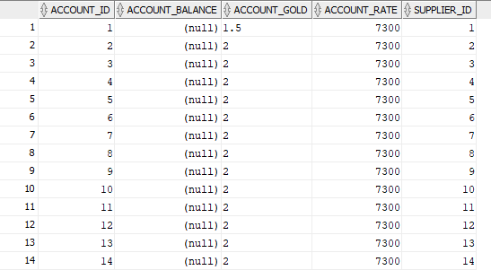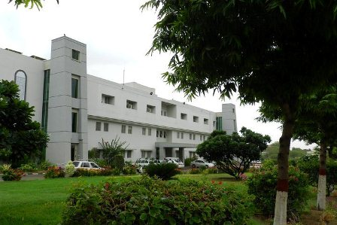g

**DATABASE MANAGEMENT SYSTEMS**

**CT-257**

AL-MUSTAFA JEWELLERY DATABASE

NED UNIVERSITY OF ENGINEERING AND TECHNOLOGY

**PROJECT MEMBERS**

**CT-17047 - SHAHEER GHANI IMAM**

**CT-17055 - SHAHEER AKRAM**

**CT-17064 - ABDUL QADIR SHEIKH**

**SUBMITTED TO:**

**MR. UMER FAROOQ**

**DATED:**

**24/06/2018**

**INTRODUCTION TO COMPANY**

Al-Mustafa Jewelry Store has a wide range of jewelry collection which either they order from their suppliers. The shop mostly sells only 22 karat gold and do not buys or sell less than 22 karat gold. It’s main purpose is to provide with authentic and good quality product with great customer services to its customer. The shop was formed in 2001 and since then it has been providing high quality jewelry its customer and its vision is to grow even more.

The success of this shop is defined by how great they have been providing customer services. The shop does not have a wide area so there are limited number of employees in the shop which are mostly person from their own family and two external employees.

The shop maintains all its sale records and supplier’s data in a register and has a file based approach in their billing system. According to the owner of the company it is easy to maintain all of its purchasing and selling but it becomes tedious when they have to search a record because there is a pile of register to be searched so it consumes a lot of time for them when they have to go through a stack of records to find a particular one

**PROBLEM OF THE COMPANY**

The problem of the shop is that they have to maintain all their sales record and customer purchases in a register which can be difficult when they have to search for a particular sales or purchase record or sometimes the register gets lost so they have no other resources to search or check their sales which it difficult for them to analyze their sales history or evaluate their product purchases. Furthermore, every use of different register for different records makes it data isolation for the owner and can also be inconsistent

**AIMS AND OBJECTIVES**

The idea for this project occurred when one of our project talked about Al-Mustafa shop that he knew the owner and the owner once asked that being a computer science student if he knew how to automate their data entry system. We then had a conversation with the shop owner and took relevant information for how we will form this database system. The aims and objectives for this system will be:

1. **MASS STORAGE**

The database for the shop can store a lot of data in it. It can store thousands of records in it from customer data to the products they own and the orders they receive. In addition they can store the information of all their suppliers and the employee that work in their shop

1. **REMOVES DUPLICITY**

Keeping thousands of data will sure at some point will produce data duplicity so this database will guarantee that there will be no data duplicity among all records. While storing new records the database will insure that it was inserted before

1. **MULTIPLE USER ACCESS**

No one handles the whole database alone. There are lots of users who are able to access database. So this situation may happen that two or more users are accessing database. They can change whatever they want, at that time DBMS makes it sure that they can work concurrently.

1. **DATA PROTECTION**

Information such as product details, employee’s details and sale purchase details should always be kept secured. Also, all the shop need their data secured from unauthorized use. DBMS gives a master level security to their data. No one can alter or modify the information without the privilege of using that data.

1. **DATA BACKUP AND RECOVERY**

Sometimes database failure occurs so there is no option like one can say that all the data has been lost. There should be a backup of database so that on database failure it can be recovered. DBMS has the ability to backup and recover all the data in database.

**MISSION OBJECTIVES**

1. The database will serve as a more organized means of keeping track of the Al Mustafa Jewelers collection.

2. The database will also be a means of keeping statistics of how often the various items been purchased and sold.

3. Should it prove successful; this database will provide a template for future inventory projects that could have their own databases.

5. Again, if it proves to be successful, the database of the store will allow to complete its phasing out of the old card catalog system.

6. The database could play a part in developing an organized way of tracking individual stock item without the burden of checking it manually.

7. If the owner wishes whether he has a specific stock, our database will be able to guide him while negotiating with customers.

**FACT FINDING**

**INTERVIEW WITH THE OWNER**

**Q1. How many different types of worker you have?**

Ans: We have a total of 2 admin and 3 cashier

**Q2. How many workers do you have?**

Ans: We have total workers

**Q3. How many customers have purchased from your shop?**

Ans: Around 350 customers

**Q4. How many different products you have based on its karat?**

Ans: Around 25 products

**Q5. How many products you have without the basis of karat?**

Ans: 8 products

**Q6. How many suppliers do you have contract with?**

Ans: 9 suppliers

**Q7. How many orders you have got customer up till now?**

Ans: Around 80 orders

**Q8. How many products you possess are worth more than 100,000 Rs?**

Ans: More than 15 products

**Q9. How many orders do you have pending at this moment?**

Ans: Around 6 products

**Q10. How many of your suppliers have name starting A?**

Ans: One(1)

**Q11. What are the names of your cashier?**

Ans: Ashar, Rehan, Sheraz

**Q12. Which product do you have the maximum in your shop?**

Ans: Rings

**Q13. Which is the expensive product that you have in your shop?**

Ans: Necklace (165,000 Rs)

**Q14. Which is the cheapest product that you have in your shop?**

Ans: Tiara (55,000 Rs)

**Q15. Do you have any balances from your suppliers?**

Ans: Yes from 3 suppliers

**Q16. Which is the highest quantity of product you have ever got?**

Ans: Rings which was 15 different products

**Q17. Do you have any product that weighs more than 20 grams?**

Ans: Yes, our all necklace weighs more than 20 grams

**Q18. Which is the cheapest order you have got from your customer?**

Ans: It was around 40,000 back in 2010

**Q19. What is the average weight of your ring in your shop?**

Ans: Around 6 grams

**Q20. What is your highest sale date?**

Ans: It was 6/6/2018 the day I remember

**Q21. What is your lowest sale date?**

Ans: 24/3/2018 three months ago

**Q22. How many accounts have a null balance?**

Ans: 5 accounts have a null balance currently

**Q23. How many cashiers do you have in your shop?**

Ans: 3 cashiers

**Q24. What is the average product rate?**

Ans: 135,00 Rs for necklace, 76,000 Rs for ring and 94,000 for bangles

***QUESTIONNAIRE:***

1.What is the name of your company?

|  |
| --- |
|  |

2. What kind of project do you want? Database Website

3. Describe your project

|  |
| --- |
|  |

4. Do you want any specific functionality in the project? Yes No

If yes please specify

|  |
| --- |
|  |

5. In how much time you want this project to be done?

1 month 2 months 3 months 4 months

Others: ____________________

6. Do you want your to be delivered?

Completely Time to time with prototypes

7. What are your expectations?

|  |
| --- |
|  |

8. What is your budget for the project?

Below Rs 5,000/- Below Rs 10,000/- Below Rs 15,000/-

9. What would you view as a success?

|  |
| --- |
|  |

10. Do you need to be able to audit record changes?

Yes No

11. Do you need a separate data warehouse for reporting?

Yes No

12. Do you need to migrate data from the old system?

Yes No

13. Will different groups of users need different accesses?

Yes No

14. How large to you expect the data to get?

Low Moderate High Very High

15. Do you want weekly, monthly reports of the sales and purchase?

Yes No

16. Do you want to setup an OLAP system after you get enough data?

Yes No

17. How flexible do you want the system to be?

|  |
| --- |
|  |

**SCENARIO OF PROJECT**

A shop with so much information requires a database management system to manipulate data, control the transaction or orders and sales and keep track of customer and supplier records. It requires receipts and reports to be generated for the owner for the monthly evaluation of sales records and the product that the suppliers supplied.

The shop comprises of cashiers who manages the cash input and gold information who must at the end of month or at a certain time period generate the report. The records of the employee and their respective information such as salaries and negotiation with the supplier must be maintained correspondingly

Also, the shop keeps track the account of their suppliers to check either they have a credit or debit balance which must be maintained accordingly after each product is supplied and to generate invoice whenever a transaction occurs between the shop and the supplier

**ENTITY RELATION DIAGRAM**

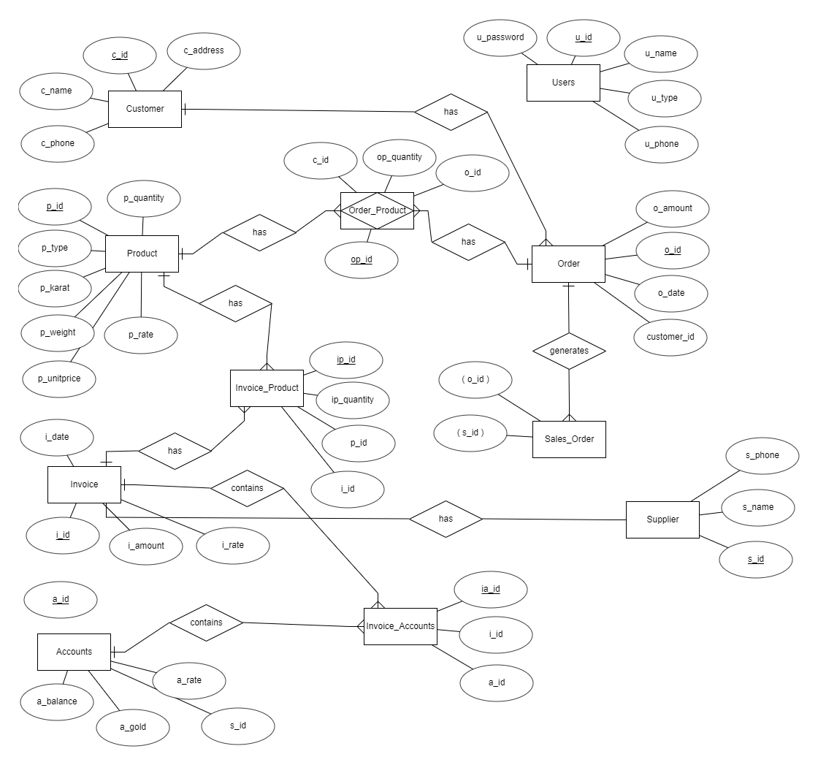

**PHYSICAL SCHEMA**

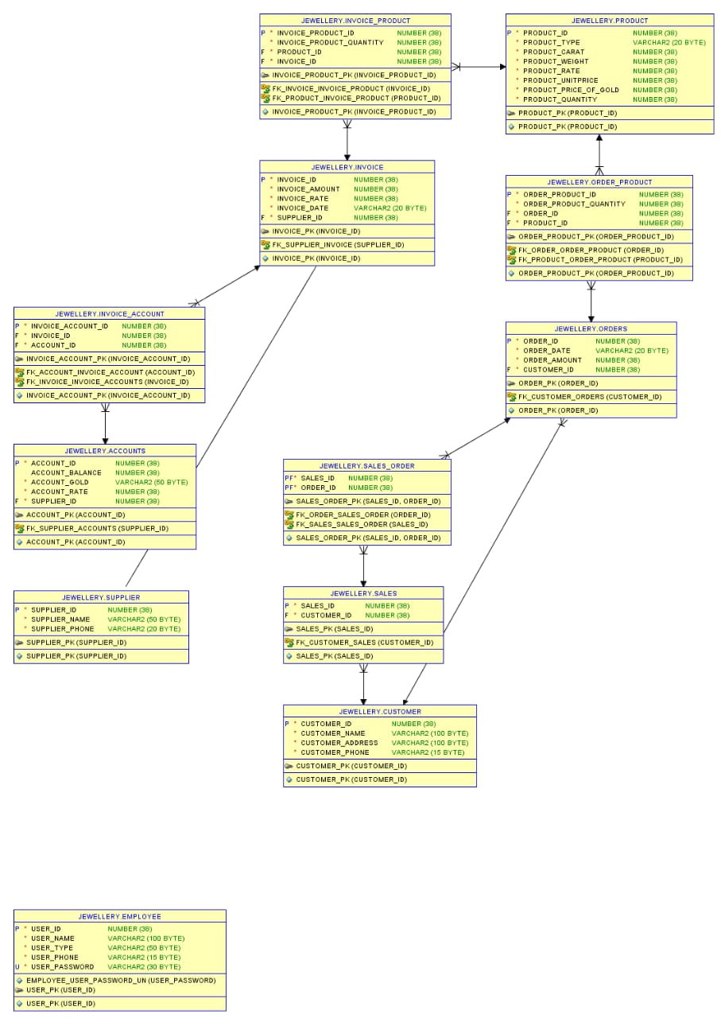

**TABLES DESCRIPTION**

Customer

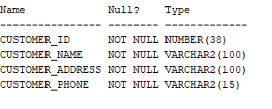

Account

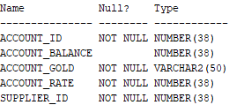

User

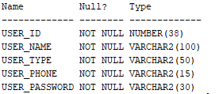

Invoice

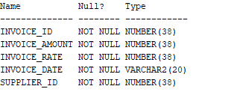

Order_product

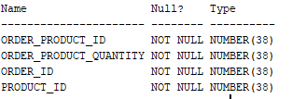

Order

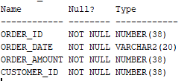

Supplier

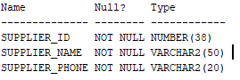

Sales_order

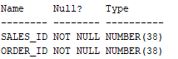

Sales

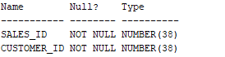

Product

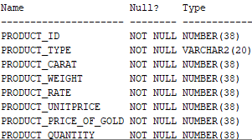

Invoice account

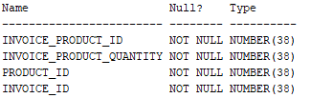

Invoice product

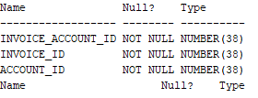

**NORMALIZATION**

**TABLE 1**

This is a sample on how the shop enters its data in their register and how have to manually check everything. To apply normalization, we have to pass to multiple steps to convert the table into **1NF** first normal form each row should contain atomic value and must have unique value

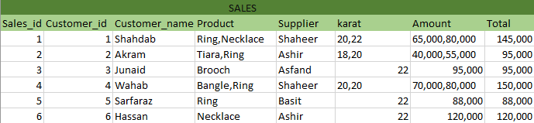

After first normal form the table will look like this:

**FIRST NORMAL FORM:**

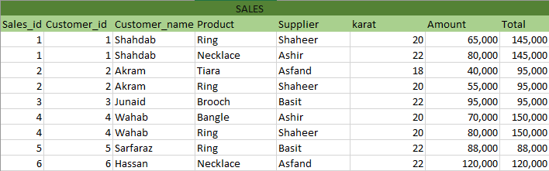

**SECOND NORMAL FORM:**

In order for the table to be in second normal form it has to follow two condtions

* The table must be in 1 NF
* It must have a single column primary key

We have eliminated all rows which resulted in data redundancy and selected table’s distinctive primary key such as sales_id and customer_id and made the table second normalized form

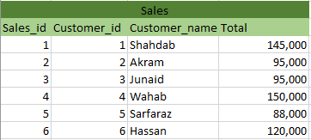

We can also make a table for just the sales table by omitting the customer_id and select only the sales id column so that each sales can be retrived easily by its primary key without any use of second primary key

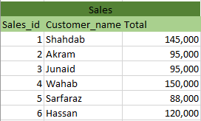

Thus, **Insert, Update and Delete anomalies are eliminated from table 1.** Each entry uniquely depends on primary key. Data can be modified without changing unnecessary information

**TABLE 2**

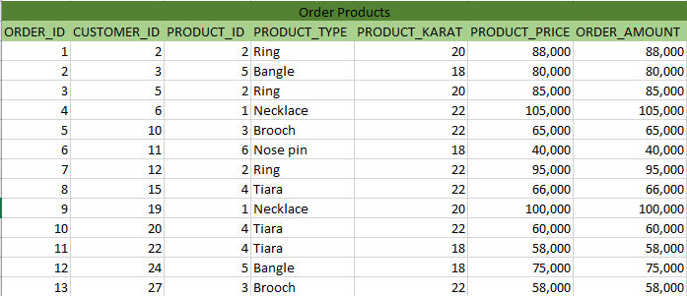

Another table that is used in the shop is the order that customer gives for the product they want to be manufactured which is stored by order id and customer as primary keys and product type and amount is entered for each corresponding customer

* Single each row contains an atomic value so the table is already in **1NF** form
* To eliminate the insert, update and anomalies and for all the columns to depend on the table’s distinctive primary key, we will split for **2NF** form

**TABLE 1**

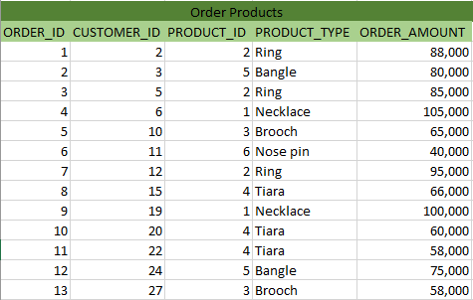

**TABLE 2**

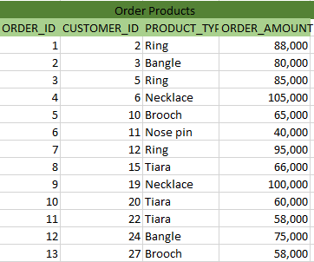

To remove **transitive property,** we can reduce the table to **third normal form.**

**TABLE 1**

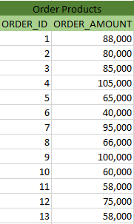

**TABLE 2**

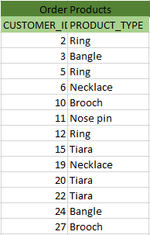

**TABLES AND DATA**

**CUSTOMERS**

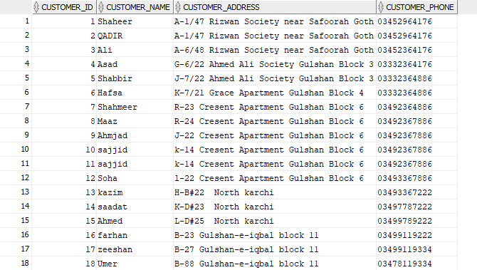

**USERS**

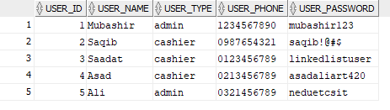

**PRODUCTS**

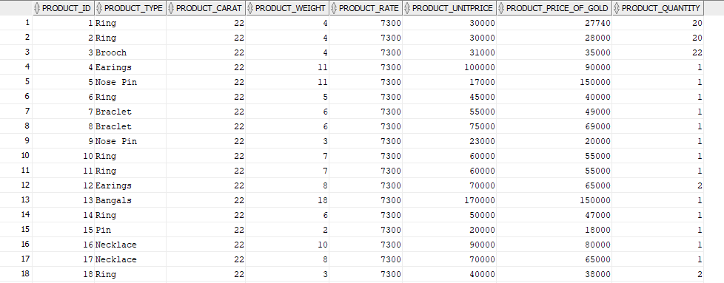

**ORDER**

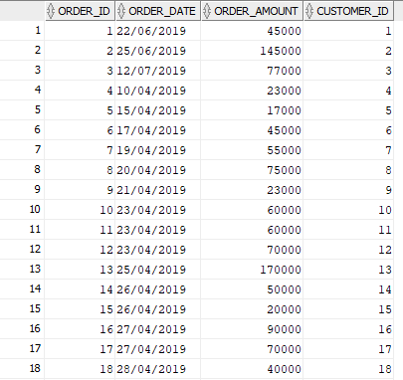

**SUPPLIER**

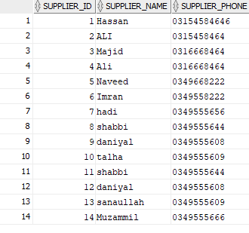

**SALES**

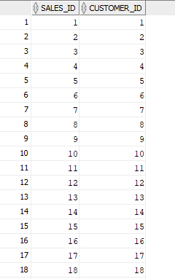

**INVOICE**

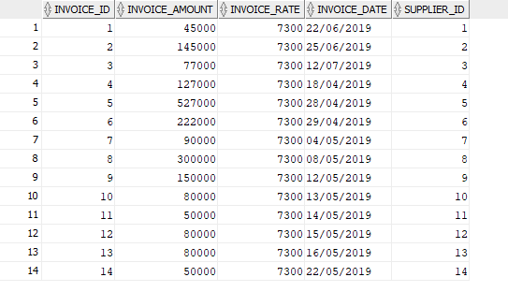

**INVOICE PRODUCT**

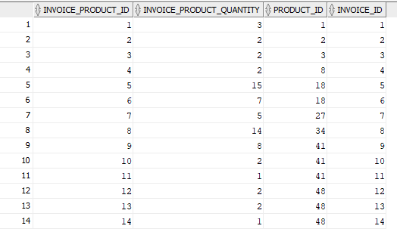

**INVOICE ACCOUNT**

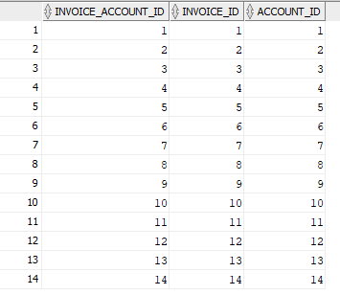

**ORDER PRODUCT**

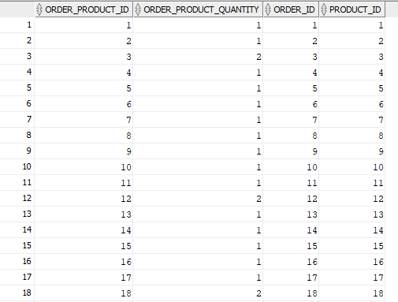

**ACCOUNTS**



**FACT FINDING QUERIES**

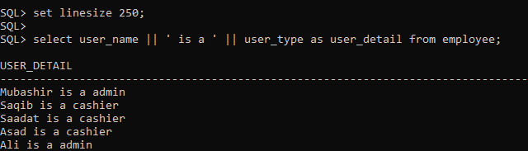

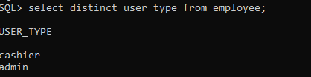

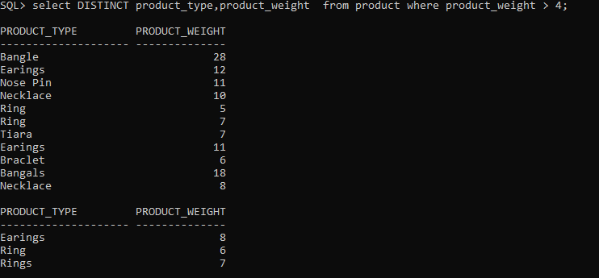

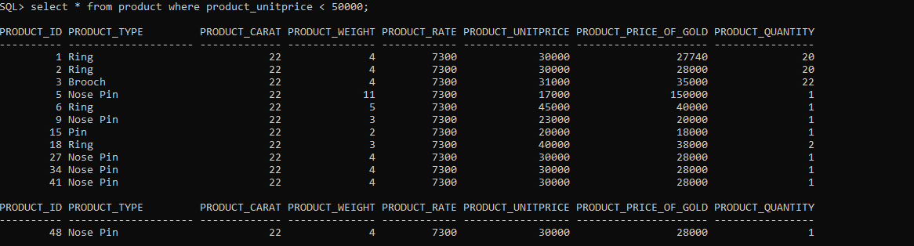

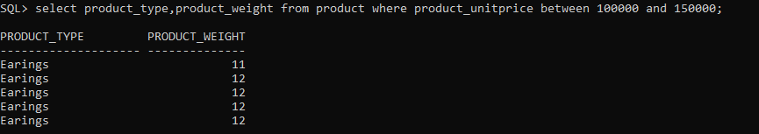

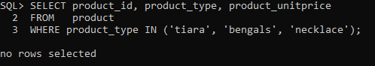

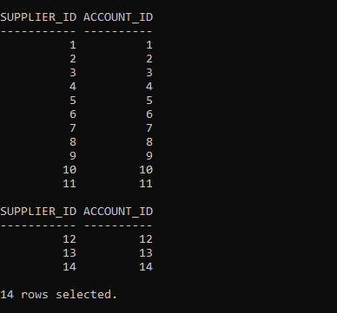

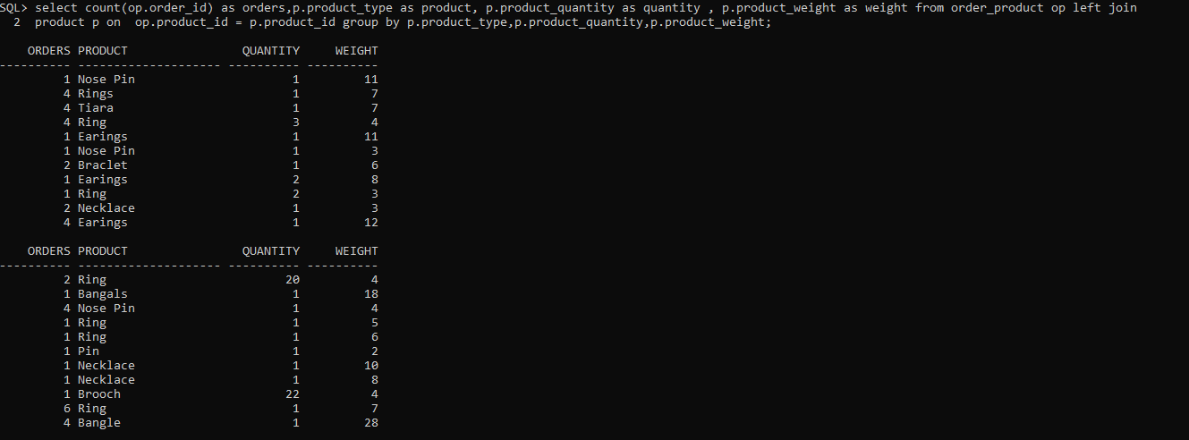

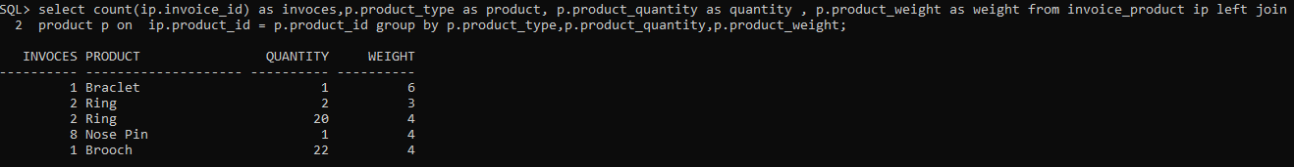

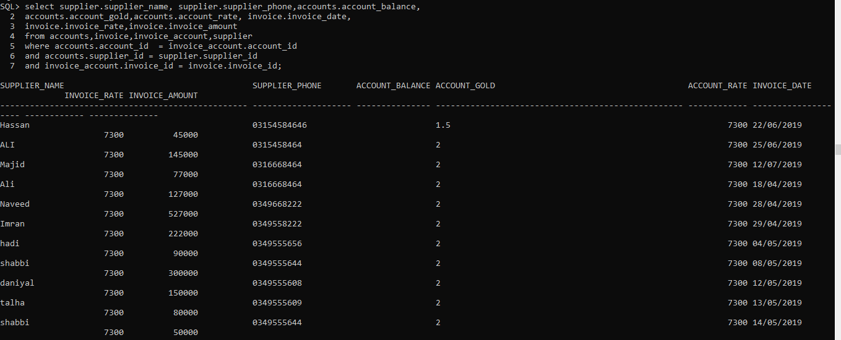

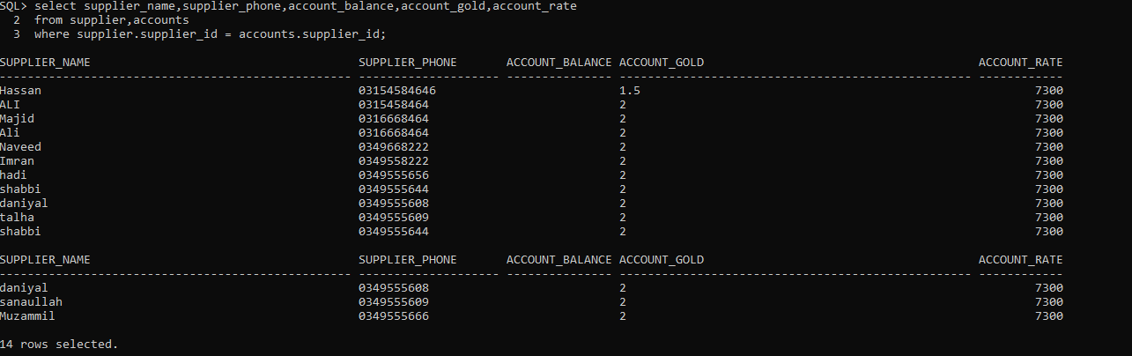

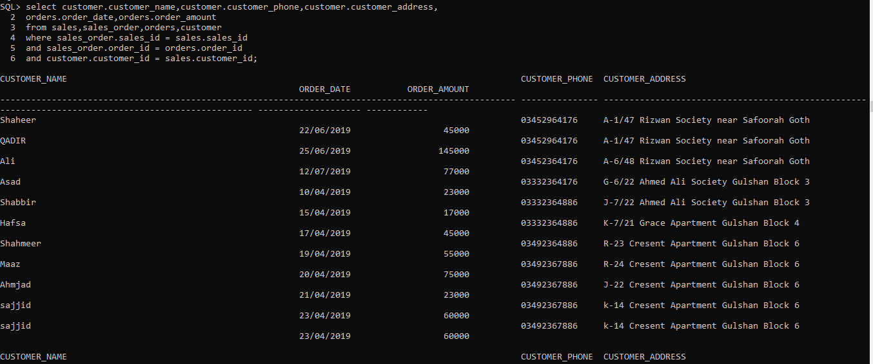

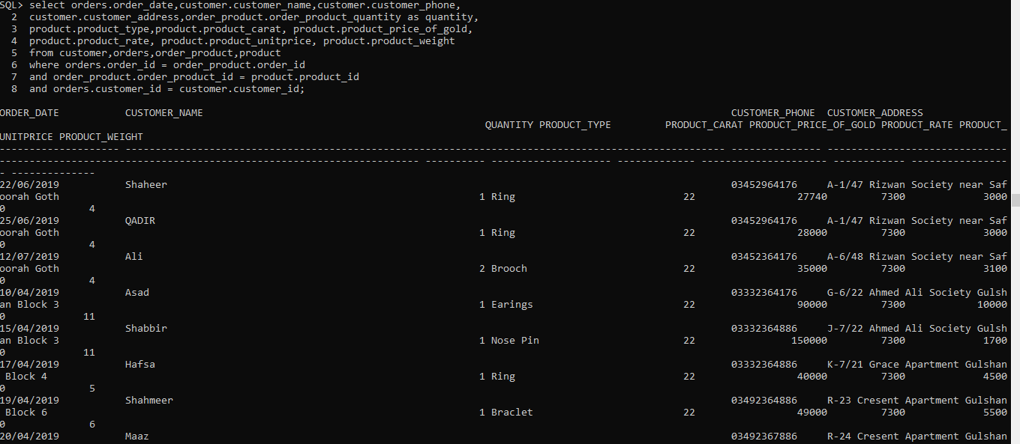

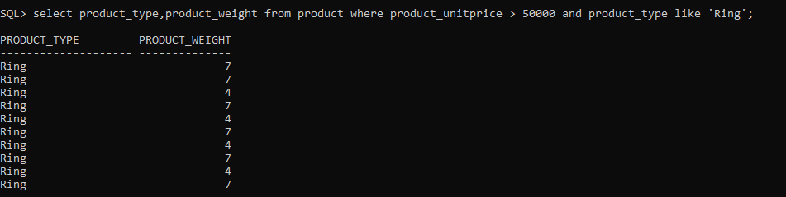

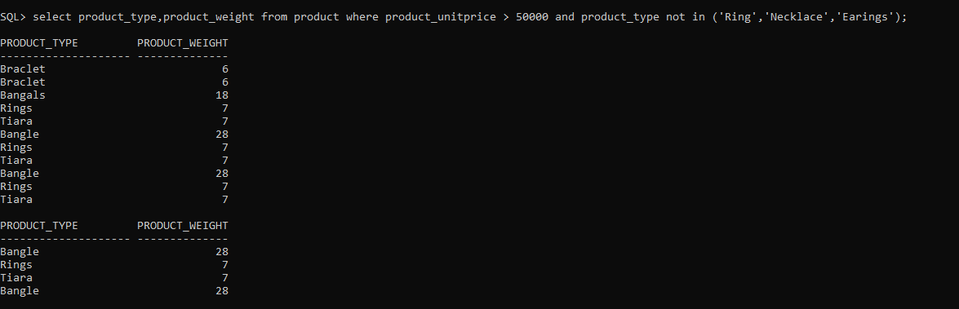

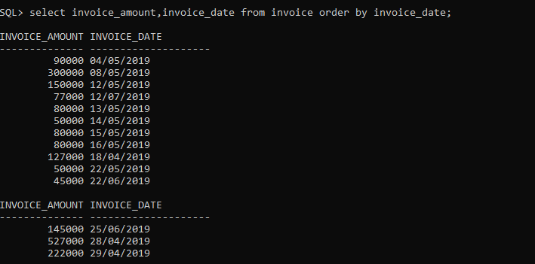

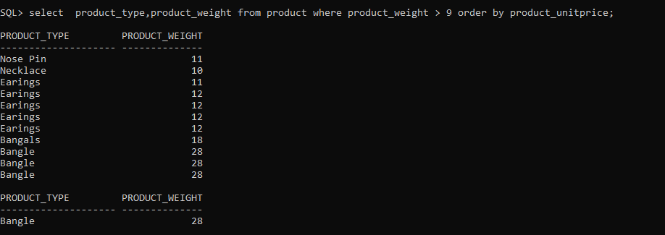

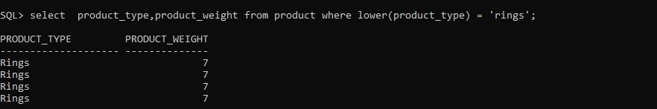

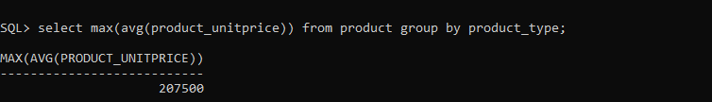

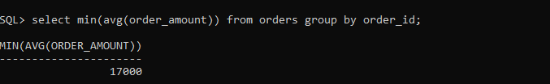

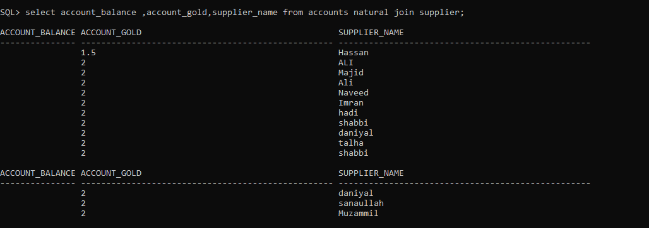

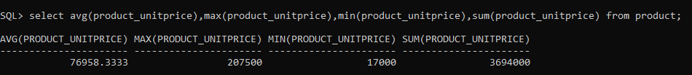

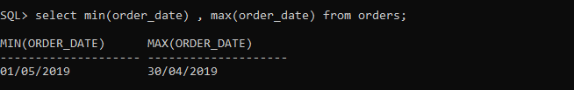

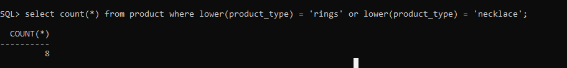

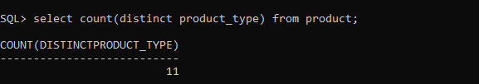

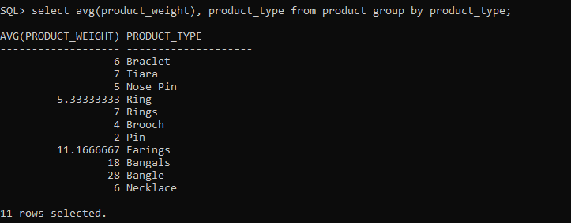

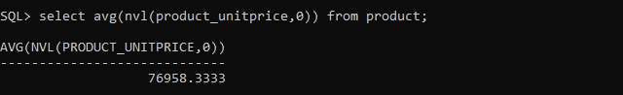

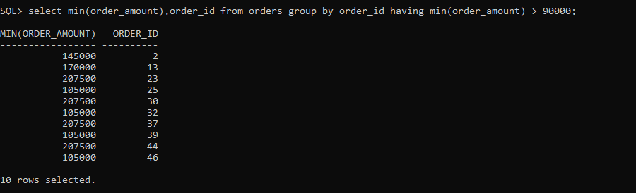

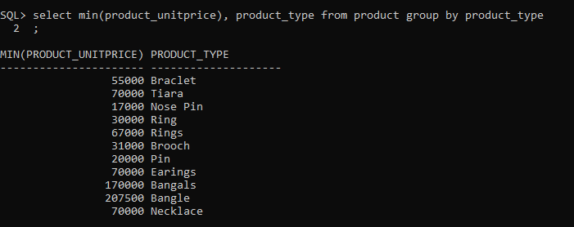

**FUTURE WORK**

Through this database we can make this system to make decisions for the owner on the basis of past product sells and give a good visualization of transaction to the admin so that he could analyze his shop performance. This type of database can be beneficial for shop on small basis to large organization and can remove all the paperwork on all scales and can automate for everyone so that they dont need to follow the old file based approach and this system will help this shop to maintain all their records and can generate reports in the future which will help in decision making