Fireball Meatball Adventure Racer

Spring 2021 | Tim Handley

DESIGN FUNDAMENTALS

Player Motivation/Experience:

What motivations are you targeting? Novelty, challenge, harmony, etc.? What do you want your player’s experience to be?

Two players have to play as a couple who have known each other for many years, and they will encounter many trivia in life while living in this room. They need to solve these problems to keep each other happy, so the player needs to observe the movement of a lot of objects in the room to solve some problems to keep their partner happy.

Game Structure:

Outline the player format, challenges faced by the player, procedures, rules, boundaries, and resolution.

The player is in a closed room, complete the mission, break the time, etc.

Narrative:

What is the setting or premise for your game? If there are characters, who are they? If there are stories, what are they? What role does your player have in this narrative?

Players take on the roles of a couple who have known each other for years and are troubled by chores. In the game, players need to help them work together to solve problems in their lives, avoid quarrelling, and achieve a successful outcome.

Core Mechanic:

What is the core thing that the player is doing? The core gameplay loop?

Solve random problems in the room within the limits of the red line, complete each other's to-do list within the time limit, and make it through a difficult day.

Other mechanics:

What else is the player doing, as side/supporting activities?

no

GAME SYSTEMS OVERVIEW

Players:

Attribute：

Two players, a boy and a girl, have their own tasks

Completing the same thing can have completely different results.

Both players will have the same rage and rage values will vary as events unfold.

behavior:

The two characters can move around freely and interacting with objects around them will trigger some changes in the objects

furniture：

Attribute：

There are a variety of furniture items that can be used in different ways, some of which are cyclical, some of which require the player to trigger, and all of which make the player angry or defuse, severely affecting their rage level.

behavior：

The cat will periodically call the player to pet the cat to calm him down, and if the cat keeps barking, rage will increase. The kettle will boil. If the player does not turn off the kettle, the boiling water will also increase the player's rage. Other items that the player can use will have different effects.

dialogue box

attribute：

Show dialogue

Behavior:

After the player interacts with the item, some ideas will be displayed in the dialog box, and the player can take the initiative to obtain some conversations.

Systems 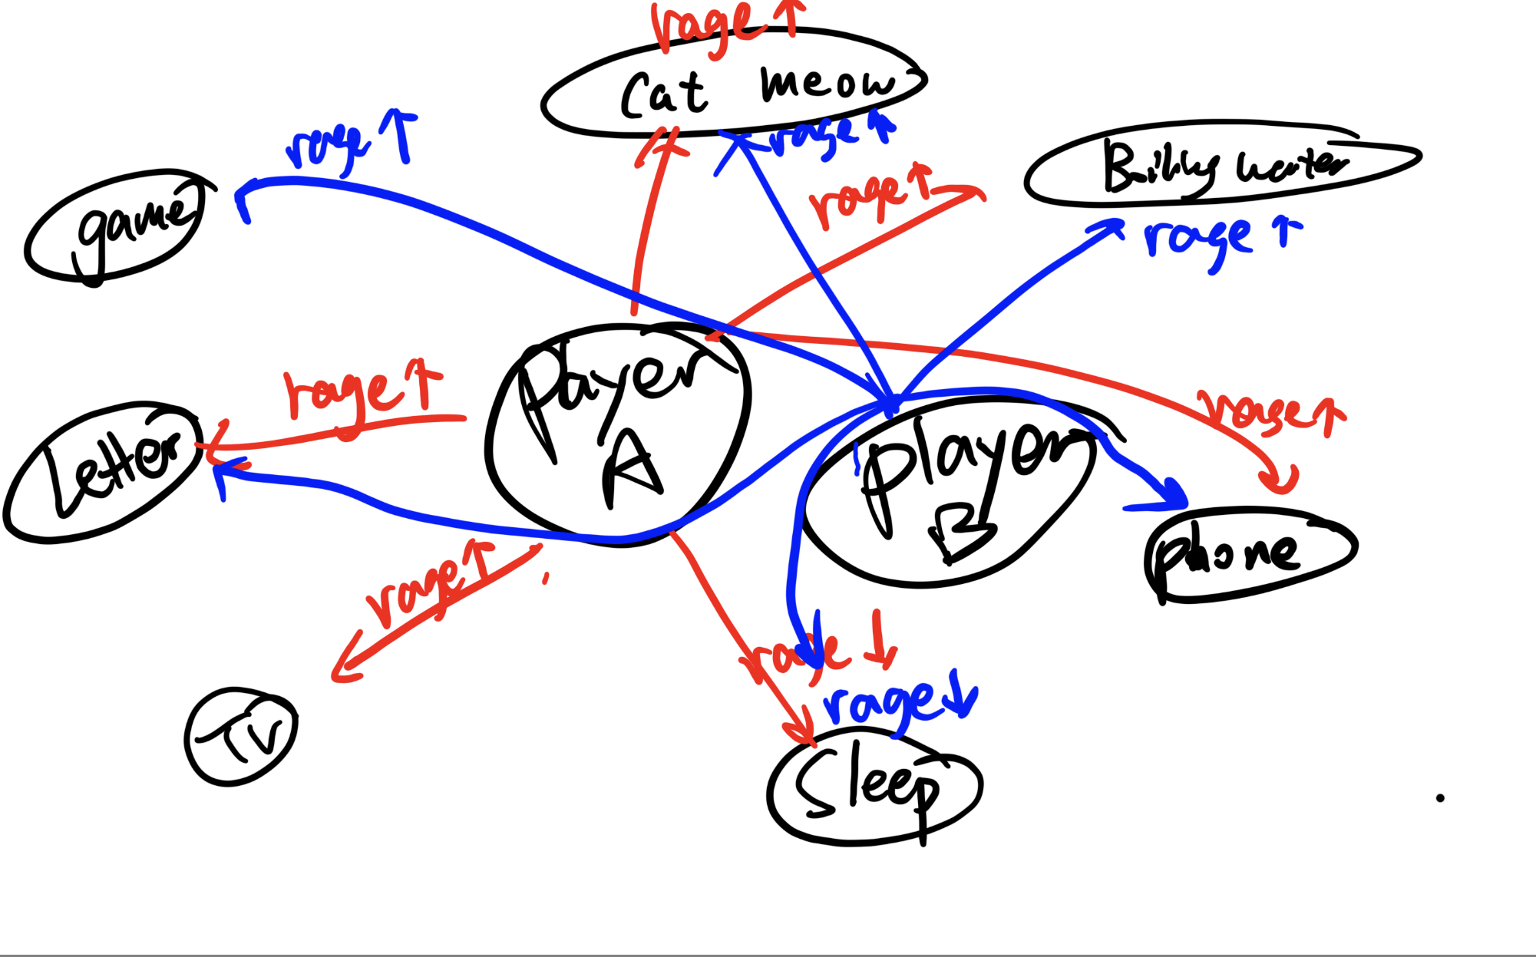Diagram

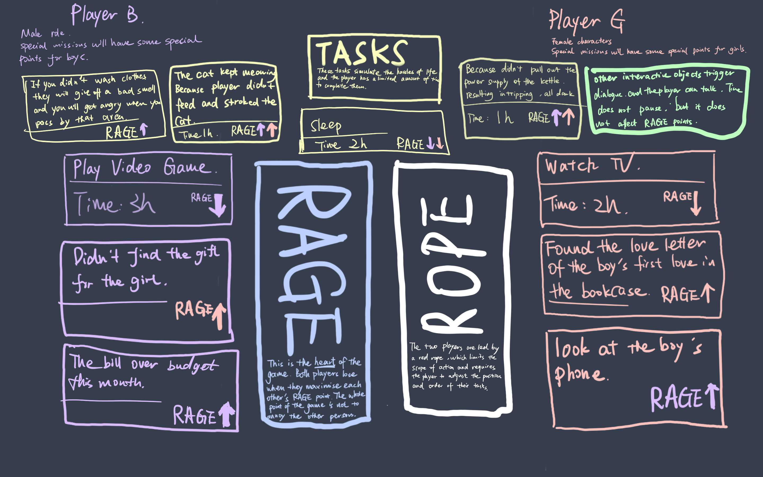

ADDRESSING PROJECT REQUIREMENTS

Physics:

How are you using the Unity physics system? How does your game use physics Components? How does your game use the physics API? Write a few sentences to explain.

Character movement uses physical systems. Rigidbody and scripts are bound to the player to control movement.The player has to do multiple collision detection to interact with the surrounding environment

Animators and Animations:

How are you using the animation system? Describe 2-3 interesting things you do with Animator Controllers and Animations.

Player movement. The characters walk, and raise their hands.

Object will play animation if player touch them

C#, Algorithms, & Complexity:

Does your code tackle and solve challenging problems? Does your code effectively connect and use a wide range of components and concepts? Is it well-organized and easily readable? Write a few sentences to explain.

Yes

Player need to control movement and interect with the object around them. Dialogues and ui are also obtain in the task. Most challenging part might be the rope and timing of different tasks,