Project Title: Microcontroller-Based Smart Dustbin with Automatic Lid Control and Fill-Level Monitoring for Hygienic and Sustainable Waste Management
Survey:
This survey aims to collect feedback on the usefulness and social impact of a microcontroller-based Smart Dustbin. The proposed system uses sensors to automatically open and close the lid, monitor the fill level of the dustbin, and provide visual and audible alerts when the bin becomes full. The survey will help evaluate public opinions about hygiene, convenience, waste overflow, cleanliness, and the usefulness of smart waste-management features. The collected responses will be used to understand the need for the proposed system and its possible benefits in universities, hospitals, offices, homes, and public places.
Survey Link:

Aims and Objective of the Project:
- Design and implement a microcontroller-based Smart Dustbin to improve hygiene and waste management through automated operation.
- Utilize ultrasonic sensors to detect the presence of users and measure the fill level of the dustbin in real time.
- Integrate a servo motor to automatically open and close the dustbin lid, reducing physical contact and improving hygiene.
- Incorporate an I2C LCD display to show the current waste level and provide real-time information about the dustbin's status.
- Implement LED indicators and a buzzer to provide visual and audible alerts when the dustbin reaches different fill levels or becomes full.
- Develop a control mechanism to prevent waste overflow by detecting when the dustbin reaches its maximum capacity and providing appropriate warnings.
- Simulate and implement the complete system using a microcontroller, sensors, and actuators to verify its functionality.
- Analyze the performance of the system by evaluating sensor accuracy, lid response time, fill-level detection, and alert functionality.
Literature Review:
Smart waste management has become increasingly important due to the growing amount of waste generated in residential and public areas. Traditional dustbins require physical contact and regular manual inspection, which can lead to unhygienic conditions and waste overflow. To address these problems, researchers have developed smart dustbin systems using microcontrollers, ultrasonic sensors, servo motors, and Internet of Things (IoT) technologies.
Jaware et al. (2026) [1] developed an Arduino-based smart dustbin using an HC-SR04 ultrasonic sensor and an SG90 servo motor. The system automatically opens the lid when an object is detected nearby and closes it after a short period, providing a simple and hygienic waste disposal solution.
Agalyaa et al. (2025) [2] proposed a smart bin using an ESP32 microcontroller and ultrasonic sensors for real-time waste-level monitoring. The system sends alerts when the dustbin reaches 90% capacity and prevents additional waste disposal when completely full. It also uses Wi-Fi and GPS to support waste monitoring and collection.
Pamudji et al. (2025) [3] developed an IoT-based smart bin using a Wemos microcontroller, infrared sensors, and ultrasonic sensors. The system automatically opens and closes the lid, measures waste volume, and displays the collected information through a web-based dashboard for real-time monitoring.
Shaharil and Ahmad Po'ad (2024) [4] designed an Arduino-based smart dustbin using ultrasonic, infrared, load-cell, and MQ-2 sensors. Their system automatically controls the lid, monitors waste levels, measures waste weight, and detects harmful gases. It also uses the Blynk application to provide real-time notifications.
Salodkar et al. (2024) [5] proposed an IoT-based smart dustbin using Arduino, NodeMCU, ultrasonic sensors, soil-moisture sensors, and servo motors. The system separates wet and dry waste, monitors the dustbin's fill level, and sends notifications through the Blynk application when the bin becomes full.
Enache et al. (2024) [6] developed an intelligent waste-level detection system using an ESP32-CAM module. The system captures images of the waste inside the bin and processes them to estimate its fill level. It also uses solar energy and a battery to support continuous monitoring.
Arthur et al. (2024) [7] reviewed different smart dustbin systems that use IoT, sensors, microcontrollers, and deep learning techniques. Their study highlighted how automated waste monitoring can help reduce overflowing bins, unnecessary manual inspection, and waste collection costs.
Ahmed et al. (2023) [8] developed an IoT-based intelligent waste management system for smart cities. Their system uses data from smart waste bins to improve energy consumption, handle missing sensor information, and optimize waste collection routes.
These studies demonstrate the importance of microcontrollers, ultrasonic sensors, servo motors, and automated monitoring in improving waste management. Based on these existing works, the proposed project aims to develop a low-cost microcontroller-based Smart Dustbin with automatic lid control, real-time fill-level monitoring, an LCD display, LED indicators, and a buzzer alert system. The proposed system will focus on improving hygiene, preventing waste overflow, and promoting sustainable waste management.
Possible Outcomes of the Project:
- Expected Results of the Proposed System
- The project is expected to provide an automated waste disposal system that reduces physical contact with dustbins and promotes better hygiene.
- The system will use ultrasonic sensors to detect users and monitor waste levels in real time, helping prevent waste overflow.
- An automatic lid mechanism will improve convenience by opening and closing the dustbin without requiring physical contact.
- An LCD display, LED indicators, and buzzer alerts will provide real-time information about the dustbin's status and notify users or cleaning staff when it becomes full.
- The system is expected to reduce unnecessary manual inspection of dustbins and improve the efficiency of waste collection.
- The project will encourage responsible waste disposal habits and promote cleaner and healthier surroundings in homes, universities, hospitals, and public places.
- Future Improvements
- Integrate IoT technology to enable remote monitoring of waste levels through a mobile application or web dashboard.
- Implement automatic waste segregation to separate recyclable, non-recyclable, wet, and dry waste using additional sensors.
- Incorporate solar power to reduce electricity consumption and improve energy efficiency.
- Introduce cloud-based data storage to record waste levels and support waste collection planning.
- Develop a notification system to alert cleaning staff remotely when dustbins reach their maximum capacity.
Experimental Circuit Diagram:
Project Timeline (Gantt Chart):
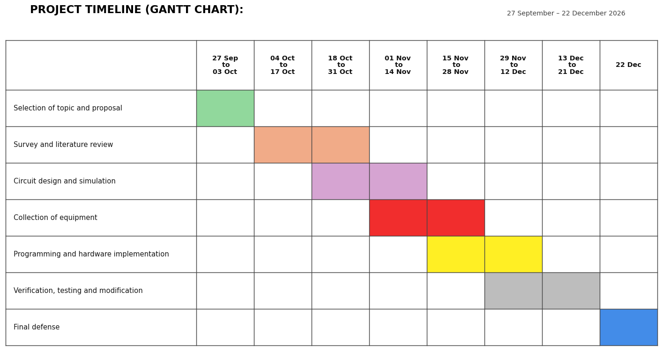
References:
[1] A. Jaware, R. Pande, D. Gawai, S. Veerbhadra, and P. Wakchaure, “Smart Dustbin: An Automated Waste Management Solution Using Arduino and Ultrasonic Sensing,” VT International Press Journal of Multidisciplinary Research and Review, vol. 1, no. 2, pp. 18–23, 2026, doi: 10.66648/VTIPJMRR.vol.01.issue.02.06.
[2] T. Agalyaa, S. Madhushri, S. Divya Sri, R. Dharani, and M. Saratha, “Smart Bin with Level Sensing and Real Time Automation,” in Proc. 6th International Conference on Electronics and Sustainable Communication Systems (ICESC), 2025, pp. 266–273, doi: 10.1109/ICESC65114.2025.11212260.
[3] A. K. Pamudji, T. B. Chandrawati, and S. I. S. Dewi, “IoT-Based Smart Bin Waste Management System with Real-Time Capacity Monitoring,” SISFORMA, vol. 12, no. 1, pp. 90–96, 2025, doi: 10.24167/sisforma.v12i1.13753.
[4] M. H. F. Shaharil and F. Ahmad Po'ad, “Arduino-Based Smart Dustbin with Ultrasonic Sensor for Efficient Waste Management,” Evolution in Electrical and Electronic Engineering, vol. 5, no. 2, pp. 92–97, 2024, doi: 10.30880/eeee.2024.05.02.011.
[5] Y. R. Salodkar, D. Gaur, P. Choudhari, and M. Kolhekar, “IoT-Based Smart Dustbin for Waste Level Monitoring and Segregation,” in Proc. 2024 IEEE Pune Section International Conference (PuneCon), 2024, doi: 10.1109/PuneCon63413.2024.10895446.
[6] B.-A. Enache, C.-K. Banica, and A. G. Bogdan, “Intelligent Trash Level Detection for Sustainable Urban Waste Management,” The Scientific Bulletin of Electrical Engineering Faculty, vol. 24, no. 1, pp. 56–59, 2024, doi: 10.2478/sbeef-2024-0010.
[7] M. P. Arthur, S. Shoba, and A. Pandey, “A Survey of Smart Dustbin Systems Using the IoT and Deep Learning,” Artificial Intelligence Review, vol. 57, Art. no. 56, 2024, doi: 10.1007/s10462-023-10646-6.
[8] M. M. Ahmed, E. Hassanien, and A. E. Hassanien, “IoT-Based Intelligent Waste Management System,” Neural Computing and Applications, vol. 35, pp. 23551–23579, 2023, doi: 10.1007/s00521-023-08970-7.

