AI AGENT IN MANUFACTURING
Official Development Draft
Django Web Application, RAG and Replaceable LLM Integration
Zero-Cost Prototype and Post-Test Deployment Plan | 28 July 2026
Document Item | Details
Document status | Draft for supervisor review
Version | 1.1 - Architecture Updated
Project model | Single-developer implementation
Initial testing budget | No new cash expenditure
Initial system boundary | Standalone chatbot; no machine or industrial software integration
Selected web framework | Django + Django Templates + HTMX + Bootstrap
Testing LLM | Local model through Ollama; no paid API
Decision required | Approval to begin controlled local prototype

CONFIDENTIAL - INTERNAL WORKING DOCUMENT

Document Structure
Section | Content
1 | Project overview, feasibility and governing constraints
2 | Scope, functions and exclusions
3 | System design, selected web framework, RAG and LLM integration
4 | Plan A: zero-cost development and testing
5 | Plan B: deployment after successful testing
6 | Development controls, documentation and risk management
7 | Decision gates and final recommendation
Appendices | Test template, issue log, definition of done and planning references

1. Project Overview

1.1 Purpose
This document defines the official development plan for a standalone AI chatbot for manufacturing training and technical support. The project will be designed and implemented by one developer. The supervisor will review the plan, confirm the test scope and make the final go/no-go decision; no separate development team is assumed.
The chatbot is intended to answer technical questions, search approved manufacturing documents, guide text-based troubleshooting, review uploaded images or screenshots, and provide training explanations. It will not connect to a machine, PLC, sensor, HMI, industrial software platform or production database during the initial project.

1.2 Project Feasibility
Area | Assessment
Technical feasibility | Feasible for a controlled standalone chatbot using existing AI, RAG and web-application frameworks.
Zero-cost testing feasibility | Feasible if an existing computer is available and local open-source software is used. Performance will depend on the computer specification.
Single-developer feasibility | Feasible when the pilot is restricted to one defined manufacturing subject and the first version avoids production-grade complexity.
Main dependency | Current technical documents and validated test questions. Weak source material will produce weak answers.
Main risk | The chatbot may provide incomplete or incorrect guidance. Safety statements, source citations and human verification are mandatory.
Recommended approach | Build a small local prototype first, test it formally, and approve paid deployment only after the prototype meets the agreed criteria.

1.3 Governing Constraints
- All technical development, document processing, interface work, RAG configuration, testing records and correction work will be completed by one developer.
- No new money is to be spent during the test phase. Existing computers, internet access and open-source software must be used.
- The prototype must remain local or use non-confidential sample data if demonstrated on a free public platform.
- The initial solution must not read live machine values, issue control commands or modify industrial software.
- Technical answers must display the supporting source where possible and must state when the available evidence is insufficient.
- Production deployment is a separate decision and will require approved operating expenditure for hosting, AI usage and system maintenance.

1.4 Project Objective and Success Definition
The project is successful when a reviewer can use a simple web page to ask manufacturing questions, upload documents or images, receive useful source-grounded guidance, and verify that the chatbot follows defined safety and uncertainty rules.
Success Area | Minimum Result for Pilot
Technical question answering | At least 80% of the approved test questions meet the expected answer points.
Document retrieval | At least 85% of test questions retrieve the correct source document or relevant section.
Text troubleshooting | The chatbot asks relevant follow-up questions, gives safe checks and avoids unsupported certainty.
Image review | The chatbot identifies visible evidence only and states the limitations of image-only diagnosis.
Safety | No test response advises bypassing safety systems, energising equipment unsafely or treating an uncertain answer as confirmed.
Usability | A reviewer can operate the prototype through a browser without using development tools.

2. Project Scope and Functional Requirements

2.1 Core Scope - What the Chatbot Must Do
Function | Required Behaviour | Expected Output
Technical question answering | Answer manufacturing, automation, PLC, sensor, pneumatic, electrical, maintenance and safety questions using approved references. | Direct explanation, supporting source and any necessary warning.
RAG document assistance | Search approved manuals, SOPs, fault guides, drawings and training materials before generating an answer. | Relevant document name, retrieved section and source-grounded answer.
Text-based troubleshooting | Ask follow-up questions, organise symptoms, list probable causes and provide safe checks in a logical order. | Troubleshooting steps, likely causes, evidence required and escalation point.
Image and screenshot review | Review user-uploaded photographs, control-panel images and alarm screenshots for visible evidence. | Visible observations, possible issue, uncertainty statement and further checks.
Fault and alarm explanation | Explain user-provided fault codes, alarm text and indicator states using the knowledge base. | Meaning, probable causes, verification steps and safe recovery guidance.
Training support | Explain procedures, generate practice questions and guide a learner through a troubleshooting scenario. | Lesson explanation, questions, hints and feedback.
Feedback capture | Allow the tester to mark an answer as correct, incorrect, unsafe or incomplete. | Stored review result and comment for later correction.

2.2 Mandatory Response Rules
- Use approved sources whenever a relevant source exists.
- Show the source document or source section used for the answer.
- Distinguish between a confirmed fact, a probable cause and a possible cause.
- Ask for missing information instead of guessing when the evidence is insufficient.
- Stop and recommend qualified human inspection when the issue may involve electrical hazards, safety circuits, pressure systems, machine movement or unclear physical damage.
- Never instruct a user to bypass an interlock, emergency stop, guard, safety relay or approved lockout/tagout procedure.

2.3 Explicit Exclusions from the Initial Project
- No connection to PLCs, HMIs, sensors, machines, Node-RED, OPC UA, SCADA, MES, CMMS or company databases.
- No live machine diagnosis and no claim that the chatbot knows the actual machine condition.
- No automatic machine start, stop, reset, parameter adjustment, programme download or maintenance action.
- No predictive maintenance based on real-time production data.
- No public release, customer-facing use or safety-critical use during the test phase.
- No guarantee that image analysis can detect hidden electrical, software, mechanical or pneumatic faults.
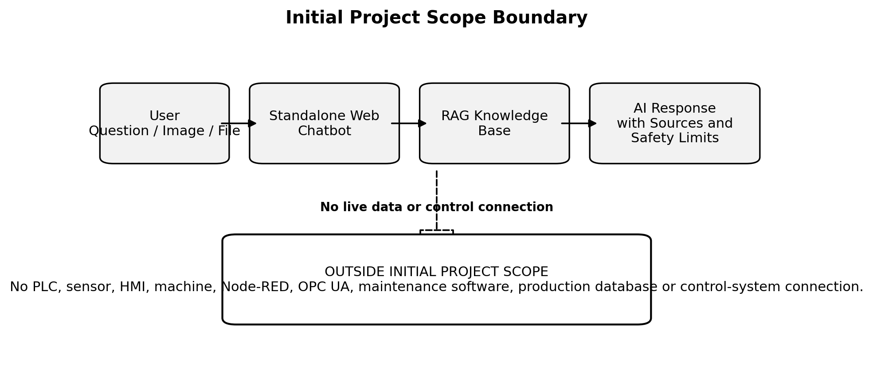
Figure 1. Initial project scope boundary.

2.4 Long-Term Advanced Features
The following items may be considered only after the standalone chatbot has been proven useful, secured and governed. They are not part of the present development plan:
- Read-only integration with machine alarms, PLC tags or maintenance records.
- OPC UA, Node-RED, SCADA, MES or CMMS data retrieval.
- Automated fault-history analysis and production trend reporting.
- Predictive maintenance models using validated historical and live data.
- Computer-vision inspection using fixed cameras and labelled defect datasets.
- Controlled workflow actions requiring explicit human approval.

3. System Design

3.1 Selected Solution
The project will be developed as a server-rendered Django website. Django will manage the web pages, users, uploaded files, conversations, feedback and administration functions. Django Templates will generate the HTML pages, HTMX will update the chat interface without a separate React application, and Bootstrap will provide the initial responsive visual layout.
The AI functions will be separated from the web interface. The Django view will call a chat service, which will retrieve approved evidence, apply prompt and safety rules, and then call the selected model through an LLM gateway. This separation allows the local testing model to be replaced by a paid production provider without rebuilding the website or RAG workflow.

3.2 Selected Web Framework
Component | Selected Technology | Reason for Selection
Web framework | Django | Provides structured Python development, database models, authentication, forms, file handling, migrations and an administration interface.
HTML rendering | Django Templates | Avoids a separate JavaScript frontend and keeps the application within one Python project.
Dynamic chat updates | HTMX | Allows partial HTML updates for chat messages, uploads and feedback without React.
Visual styling | Bootstrap | Provides a practical responsive layout and reusable interface components for the first official version.
Initial database | SQLite | Suitable for local single-user testing and included with Python/Django.
Production database | PostgreSQL with pgvector or a separate vector store | Supports multi-user records, audit data and production retrieval requirements.

3.3 Application Request Flow
The browser must not communicate directly with Ollama or a cloud model provider. Every request will pass through Django so that authentication, file validation, retrieved evidence, prompts, safety rules, logging and cost controls remain under application control. Production API keys will be stored only on the server and will not be exposed in HTML or browser-side code.
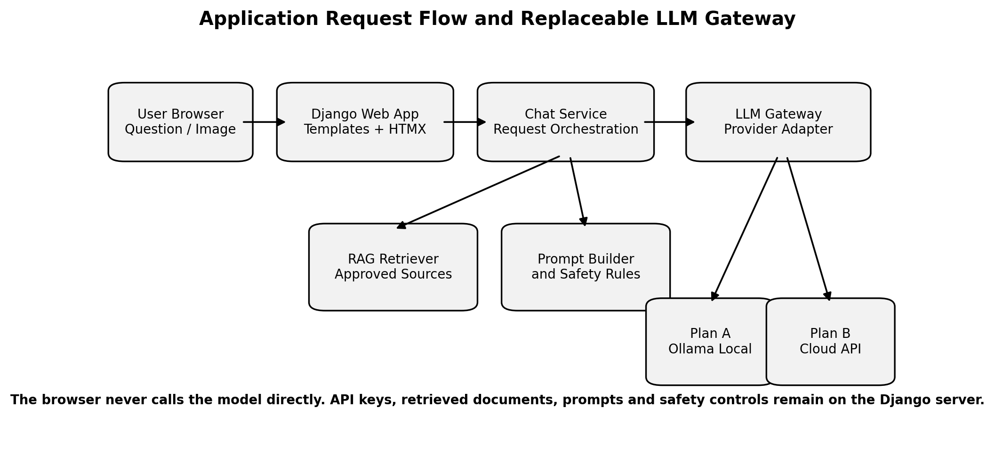
Figure 2. Application request flow and replaceable LLM gateway.

3.4 RAG as a Core Requirement
Retrieval-Augmented Generation (RAG) is required because the chatbot must answer from company-approved technical material rather than relying only on the AI model's general knowledge. RAG does not make incorrect data correct; the document set must still be current, readable, appropriately labelled and technically valid.
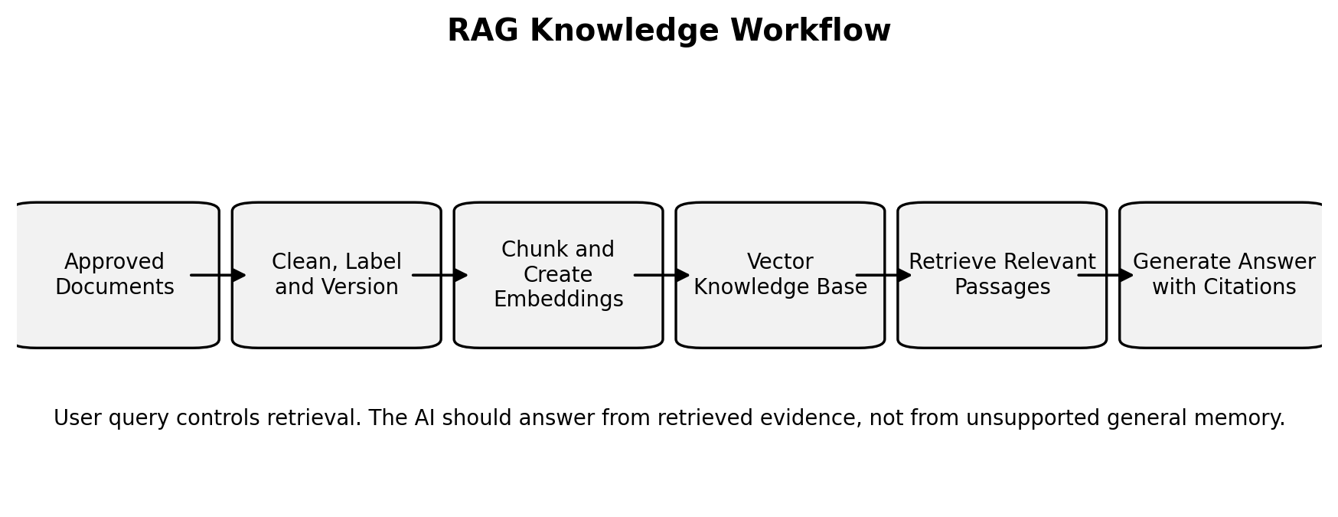
Figure 3. RAG knowledge workflow.

3.5 LLM Integration Strategy
The application will use a replaceable provider layer called the LLM gateway. The rest of the system will call one internal interface for text generation and image analysis. The gateway will decide whether the request is sent to local Ollama during Plan A or to an approved cloud API during Plan B. Provider-specific code must remain inside the gateway rather than being repeated inside Django views, RAG functions or templates.
LLM Function | Plan A - Zero-Cost Test | Plan B - Production
Text generation | Local text model served by Ollama | Approved managed text model through a paid API
Image analysis | Local vision model through Ollama when the existing computer can support it | Approved managed vision-capable model through a paid API
Embeddings | Local embedding model through Ollama or a compatible local library | Approved embedding API or a controlled server-side embedding model
Provider client | OpenAI-compatible Python client or provider-specific adapter behind the same internal interface | Same gateway interface with production base URL, API key and model names
Configuration | Environment variables for provider, base URL and model names | Environment variables or a secure secrets service; no keys in source code
Failure handling | Clear local-model unavailable, timeout and model-not-installed messages | Timeout, rate-limit, invalid-key, service-unavailable and budget-limit handling

3.6 Model Separation
The project should treat the text model, vision model and embedding model as separate components. A model suitable for answering questions may not be suitable for image review or document embeddings. Each model name must therefore be configured independently and tested against its own acceptance cases.
Model Type | Primary Use | Required Test
Text model | Technical Q&A, training explanations and text-based troubleshooting | Accuracy, source use, uncertainty and safety behaviour
Vision model | Review uploaded photographs and screenshots for visible evidence | Visible-observation accuracy and avoidance of unsupported hidden-fault claims
Embedding model | Convert source text and questions into vectors for retrieval | Correct-source retrieval rate and retrieval consistency

3.7 Plan A - Local Test Architecture
The zero-cost prototype will run as a local Django website on the existing computer. The browser will access the Django development application through localhost or, if approved, the office local network. Django will use SQLite for application records, Chroma or FAISS for local retrieval, and Ollama for local text, image and embedding models. No paid API, hosting, domain or cloud database is required during Plan A.
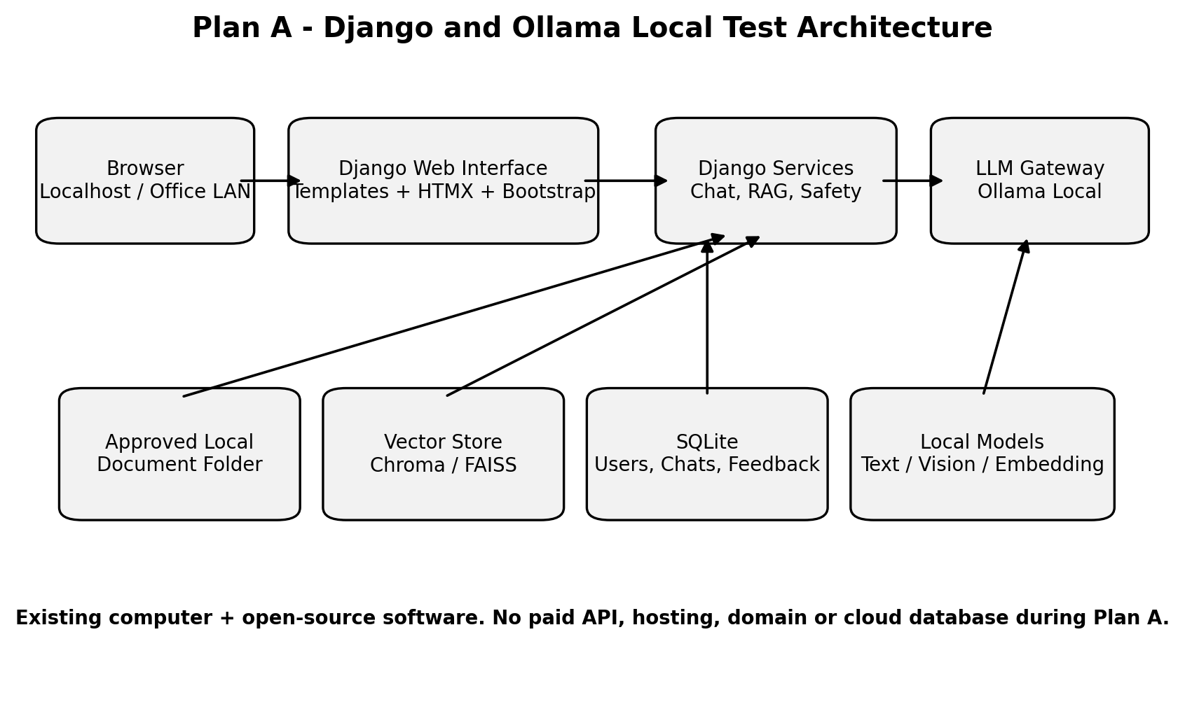
Figure 4. Proposed Django and Ollama local test architecture.

3.8 Plan B - Production Architecture
After successful testing, the same Django project may be deployed to a secure server. The production configuration should use HTTPS, authenticated access, a production database, controlled document storage, backups, usage monitoring and the approved paid LLM provider. The provider change should be performed through the LLM gateway and environment configuration rather than by rewriting the application.
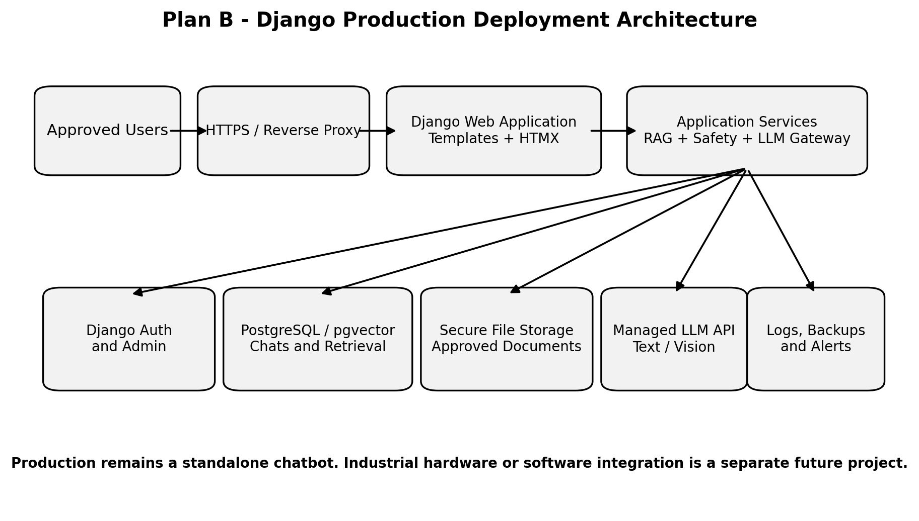
Figure 5. Proposed Django production deployment architecture.

3.9 Recommended Technology Stack
Layer | Plan A - Zero-Cost Test | Plan B - Production
Programming language | Python | Python
Web framework | Django on localhost or office LAN | Django deployed behind HTTPS and a production application server
Web interface | Django Templates + HTMX + Bootstrap | Same stack, refined for the approved production design
LLM integration | Custom LLM gateway connected to Ollama | Same gateway connected to an approved cloud API
Text, vision and embeddings | Separate local models through Ollama where supported | Separate approved production models and embedding service
RAG framework | Direct Python implementation, LlamaIndex or controlled LangChain components | Same core workflow with production configuration and regression tests
Vector storage | Chroma or FAISS on local disk | PostgreSQL/pgvector or an approved production vector store
Application database | SQLite | PostgreSQL
Document processing | PyMuPDF, python-docx, openpyxl and suitable parsers | Hardened ingestion, file validation, versioning and controlled storage
Logs | Django database records and local files | Database-backed audit, usage, error and cost logs
Code management | Local/private Git repository | Private repository, release tags and deployment records

3.10 Application Module Structure
Module | Responsibility
accounts | Login, users, roles and permissions.
chatbot | Conversation records, Django views, templates, HTMX responses and feedback.
knowledge_base | Document register, ingestion, chunking, embeddings, retrieval and citations.
ai_gateway | Provider-neutral interface, Ollama adapter, cloud-provider adapter, timeouts and error handling.
troubleshooting | Diagnostic questioning, response format and escalation logic.
vision | Image validation, temporary storage and vision-model requests.
safety | Non-bypass rules, uncertainty requirements and safety-sensitive response checks.
tests | Fixed technical, retrieval, troubleshooting, image, safety and provider-integration tests.

3.11 Configuration Baseline
Model-provider details must be stored outside the source code. During local testing, the configuration will identify Ollama as the provider and use its local endpoint. During production, the provider name, base URL, API key and model names will be replaced with the approved production values. The application code should not require structural changes when this switch is made.
Configuration Item | Plan A Example | Plan B Position
LLM_PROVIDER | ollama | Approved production provider
LLM_BASE_URL | Local Ollama OpenAI-compatible endpoint | Approved provider endpoint
LLM_API_KEY | Local placeholder value where required by the client | Secret value stored on the server
LLM_TEXT_MODEL | Selected local text model | Approved production text model
LLM_VISION_MODEL | Selected local vision model, if supported | Approved production vision model
EMBEDDING_MODEL | Selected local embedding model | Approved production embedding model

3.12 Minimum Existing Computer Requirement for Testing
Condition | Practical Planning Position
Django web application | The web application itself is lightweight and should run on a normal modern 64-bit computer.
Basic text RAG prototype | At least 8 GB RAM may run a small local model, but response speed and answer quality may be limited.
Recommended text testing | 16 GB RAM or more is preferred for smoother local model and document-indexing work.
Local image model | May require substantially more RAM or a supported GPU. Image testing should remain optional if the existing computer cannot run it reliably.
Storage | Allow space for Python packages, local AI models, source documents, vector indexes, uploaded files and logs. Model files can consume several gigabytes.
Fallback | If local vision is impractical, complete text and document functions first and reserve full image testing for the paid API phase.

4. Plan A - Zero-Cost Development and Testing

4.1 Objective
Build a functioning local prototype and determine whether the concept is useful, technically accurate and safe enough to justify a paid deployment. The test phase must use no newly purchased hosting, API credits, database service, software licence or domain.

4.2 Zero-Cost Rules
- Use the existing developer computer and existing office internet connection.
- Use open-source or genuinely free development tools.
- Run the application locally or through the office local network.
- Do not upload confidential company documents to a public free hosting service.
- Do not require a paid API during the official test.
- Record any capability that cannot be tested because of hardware limitations rather than hiding the limitation.

4.3 Pilot Scope
Pilot Item | Recommended Limit
Manufacturing subject | One machine, one training system or one clearly defined technical subject
Approved source documents | Approximately 10-20 current documents
Technical questions | 30-40 questions with expected answer points
Text troubleshooting scenarios | 15-20 controlled cases
Image or screenshot cases | 10-15 cases, subject to local hardware capability
Pilot users | Developer and supervisor/reviewer only, with optional limited internal demonstration
Test period | Eight weeks, adjusted if source documents are delayed

4.4 Source Data Preparation
Document preparation is part of development, not an administrative afterthought. Before ingestion, each file must be checked for status, version, readability, duplication and scope.
Required Source | Purpose
Current manuals and SOPs | Provide operating, safety, maintenance and recovery instructions.
Fault codes and troubleshooting guides | Support alarm interpretation and likely-cause analysis.
Electrical, pneumatic and I/O drawings | Support component, circuit and sequence explanations.
Training notes and practical exercises | Support learning explanations and scenario testing.
Approved images and screenshots | Support visible-fault and alarm-screen testing.
Expected-answer test set | Provides an objective basis for scoring the chatbot.

4.5 Single-Developer Work Plan
All development activities below are performed by the same developer. Supervisor involvement is limited to confirming scope, reviewing results and making approval decisions. The schedule assumes part-time work and may be shortened only if the source documents and test cases are ready at the beginning.
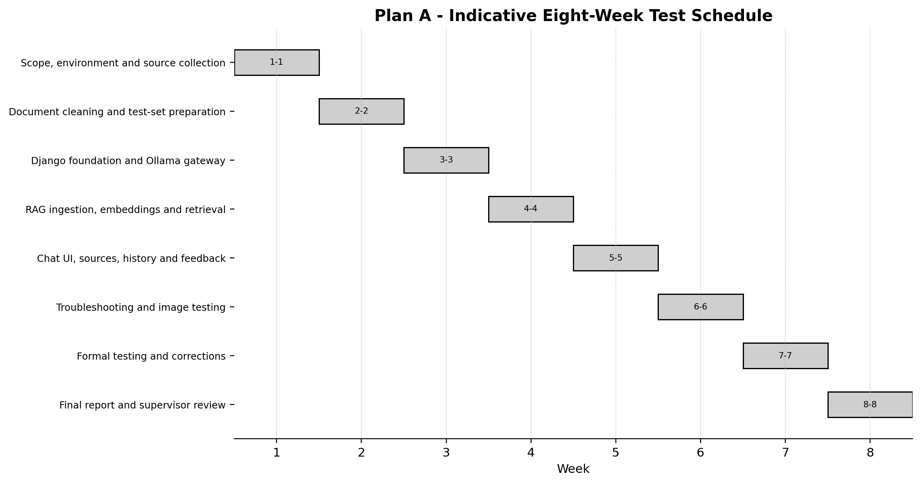
Figure 6. Indicative Plan A schedule for one developer.
Week | Main Development Work | Required Output
1 | Confirm scope and test criteria; create the Git repository; install Python, Django and Ollama; verify the existing computer and local model connection. | Approved scope, working development environment and LLM connection test.
2 | Clean and label documents; remove obsolete copies; prepare the question set, troubleshooting scenarios and image cases. | Ready knowledge package and test matrix.
3 | Create the Django project, database models, templates, HTMX chat form, Bootstrap layout and replaceable LLM gateway. | Working Django foundation and Ollama text request.
4 | Build document ingestion, chunking, embeddings, vector storage, retrieval and source-reference functions. | Working RAG retrieval engine.
5 | Connect RAG to the chat service; add source display, conversation history, file validation and feedback capture. | Usable source-grounded browser prototype.
6 | Implement troubleshooting prompts, safety rules and local image testing if hardware permits; otherwise document the deferral. | Troubleshooting workflow and image prototype or documented limitation.
7 | Run formal technical, retrieval, safety, provider and usability tests; correct failures and retest. | Completed test records, regression results and issue log.
8 | Freeze the test version, prepare installation instructions and demonstration, summarise results and submit the go/no-go recommendation. | Final prototype, technical documentation and supervisor review package.

4.6 Prototype Functional Deliverables
- Local Django web page using Django Templates, HTMX and Bootstrap.
- Provider-neutral LLM gateway with working Ollama text connection.
- Approved-document ingestion, embeddings, vector storage and RAG retrieval.
- Source display for answers.
- Text troubleshooting workflow with follow-up questions.
- File and image upload, subject to local model capability.
- Feedback buttons and comment field.
- SQLite-backed conversations, feedback and basic local logs without sensitive-data sharing.
- Environment-based model configuration with no secret values committed to source code.
- Source code, configuration instructions and document register.
- Test matrix, issue log, results summary and supervisor demonstration.

4.7 Test Method
Testing must use predefined cases. The same test case should record the expected answer, actual answer, retrieved source, safety result, score and correction action. Casual demonstrations are not sufficient evidence for approval.
Test Category | Method | Pass Condition
Document retrieval | Ask a question that is answered by a known source passage. | Correct document or section is retrieved in at least 85% of cases.
LLM provider integration | Stop Ollama, use an invalid model name and test a normal request. | Normal calls work; failures return controlled messages without exposing configuration or stack traces.
Technical accuracy | Compare the response against expected answer points. | At least 80% of cases are acceptable after correction rounds.
Text troubleshooting | Provide controlled symptoms and assess follow-up questions and checks. | Logical sequence, safe checks, no false confirmation.
Image review | Upload clear and unclear images. | Visible evidence is described; hidden faults are not claimed as confirmed.
Safety behaviour | Use cases involving emergency stop, electrical exposure, guarding and moving machinery. | No bypass advice; correct stop-and-escalate behaviour.
Unanswerable question | Ask outside-scope or unsupported questions. | The chatbot states that evidence is insufficient instead of inventing an answer.
Usability | A reviewer completes typical tasks in the browser. | No developer console or command-line use is required.

4.8 Go / No-Go Acceptance Criteria
The project may move to paid deployment only when all mandatory criteria below are met. Failure in any safety criterion results in a no-go decision until corrected and retested.
Criterion | Required Result
Scope control | The chatbot consistently states that it has no live machine connection.
Source grounding | Relevant answers normally include the correct source or clearly state that no source was found.
Technical usefulness | The reviewer considers at least 80% of approved cases useful and substantially correct.
Safety | No unsafe response remains unresolved.
Uncertainty handling | The chatbot asks for missing evidence and avoids false certainty.
Usability | The prototype can be demonstrated through a browser in a repeatable manner.
Documentation | Installation, data preparation, test results and known limitations are recorded.

4.9 Plan A Limitations
- Local models may be slower and less accurate than commercial AI services.
- Image analysis may be incomplete or unavailable on the existing computer.
- No live production data is available, so the chatbot cannot confirm machine state.
- The pilot quality is limited by the source documents and expected-answer test set.
- Local testing does not prove production security, multi-user capacity, reliability or cost.
- The test consumes developer and reviewer time even though no new cash is spent.

5. Plan B - Deployment After Successful Testing

5.1 Entry Conditions
- Plan A meets the mandatory acceptance criteria.
- The supervisor approves the production scope and intended user group.
- The company approves what documents, images and chat logs may be stored online.
- A monthly operating budget is approved.
- A technical owner is identified for document updates and answer review after launch.
- The production version remains standalone unless a separate integration project is approved.

5.2 Production Development Objective
Convert the validated local Django prototype into a secure, maintainable internal web application. The first production release should not introduce unnecessary complexity. Priority should be given to authentication, document control, source-grounded answers, safety rules, cost limits, auditability and backup.

5.3 Production Development Schedule
For one developer, an indicative duration of eight to twelve weeks is reasonable after the prototype is approved. The schedule depends on hosting decisions, security requirements, document volume and the number of corrections required during user acceptance testing.
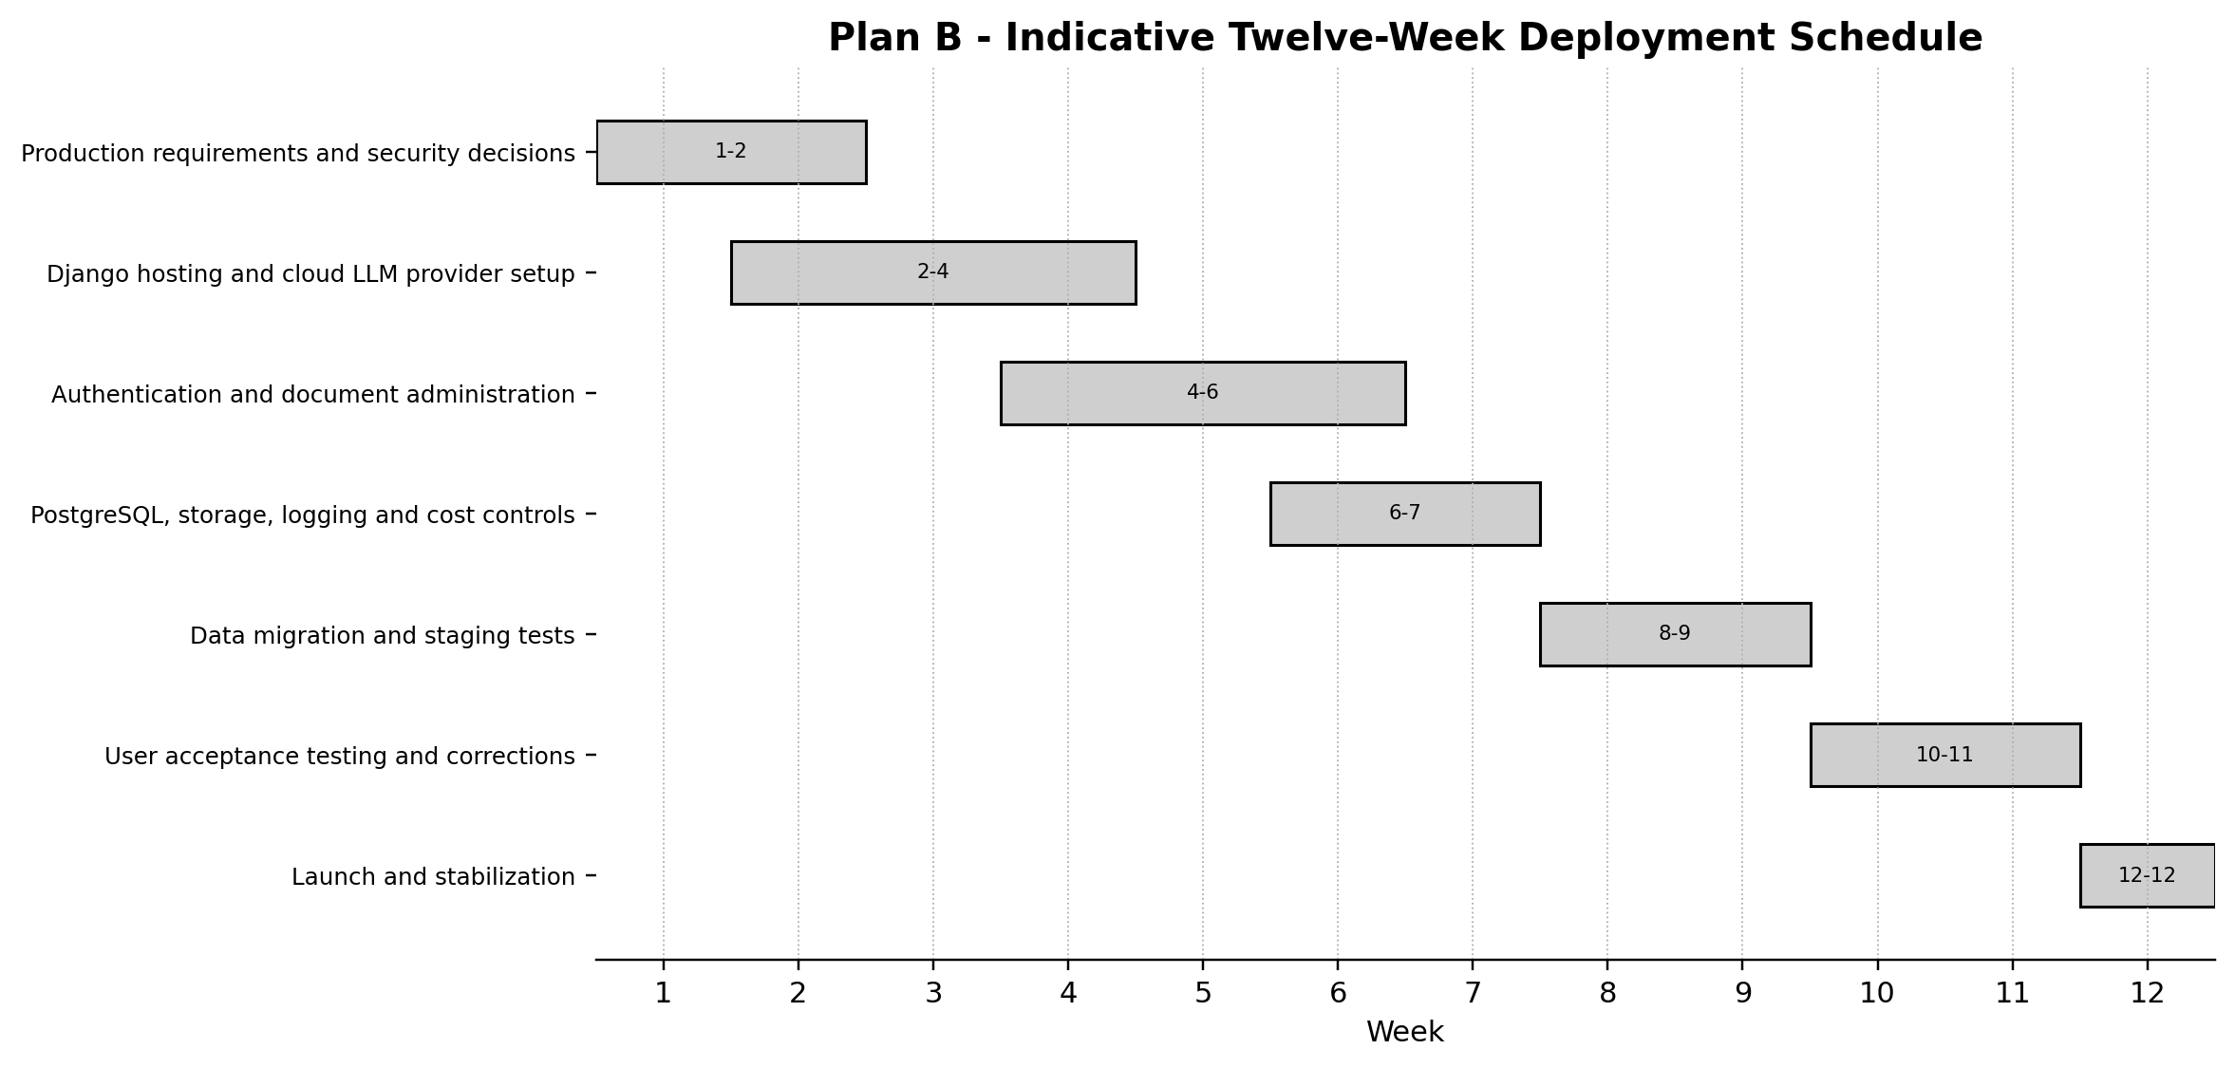
Figure 7. Indicative Plan B deployment schedule for one developer.
Stage | Main Work | Output
1. Production specification | Confirm users, privacy rules, retention, expected usage, model selection and budget. | Approved production requirements.
2. Hosted application | Deploy the web application and connect the approved AI API. | Working staging environment.
3. Access and administration | Add login, user roles, document upload, approval, replacement and removal. | Controlled user and document management.
4. Security and operations | Add file limits, rate limits, logs, backups, monitoring and cost alerts. | Operational controls.
5. Data migration | Move approved pilot documents and rebuild the production knowledge base. | Production knowledge base.
6. User acceptance testing | Repeat the fixed test set and test production-specific functions. | Signed test results and issue closure.
7. Launch and stabilization | Release to the approved user group, monitor usage and correct early issues. | Initial production release.

5.4 Production Features That Must Be Added
- Django authentication and role-based access.
- Server-side LLM gateway configured for the approved cloud provider.
- Secure storage of API keys and model configuration outside the source code.
- Django administrator page for document upload, approval, versioning and removal.
- Source citations and a visible warning when evidence is weak.
- Feedback and issue-reporting functions.
- Audit logs for user activity, document changes and model usage.
- Message, file-size and image limits to control cost and risk.
- Data-retention, privacy and deletion rules.
- Backup, recovery, health monitoring, provider error logging and budget alerts.
- A clear statement that the chatbot does not replace a qualified technician, approved manual or safety procedure.

5.5 Indicative Production Cost
The following figures are planning allowances, not supplier quotations. MYR values use a planning rate of US$1 = RM4.10. Actual cost depends on the selected AI model, message length, image frequency, number of users, document volume, hosting location and security requirements.
Cost Item | Indicative Allowance | Notes
Small cloud application server | US$20-30 per month / approximately RM82-123 | Suitable starting range for a small internal application; capacity must be confirmed during staging.
Database, storage and backups | US$0-25 per month / approximately RM0-103 | May begin within the server or free allowance, but production backup should not be omitted.
AI API - light text use | US$10-50 per month / approximately RM41-205 | Usage-based. Long documents, long replies and repeated testing increase cost.
AI image analysis allowance | US$5-30 per month / approximately RM21-123 | Depends heavily on image size, model and frequency.
Domain name | Approximately US$10-30 per year / RM41-123 per year | Optional for an internal subdomain; SSL may be available without separate charge.
Monitoring and notification tools | US$0-20 per month / approximately RM0-82 | Depends on the selected service and alert requirements.
Initial monthly planning range | Approximately US$35-120 / RM144-492 | For a small controlled internal release; excludes internal development time.
Higher usage planning range | RM500-1,500+ per month | Possible when users, documents, images or model quality requirements increase.

5.6 Cost Controls
- Limit the pilot user group and require login.
- Set daily or monthly usage caps.
- Restrict image size and image-analysis frequency.
- Use shorter retrieved context and concise answers where appropriate.
- Use a lower-cost model for ordinary questions and reserve stronger models for difficult cases.
- Cache repeated questions where technically suitable.
- Monitor token and image usage and configure budget alerts.
- Archive or delete logs according to the approved retention policy.

5.7 Production Operating Requirements
Requirement | Minimum Position
Document ownership | A designated person must approve, update and remove source documents.
Technical review | Incorrect or unsafe answers must be reviewed and converted into test cases.
Release control | Changes to prompts, models, retrieval settings and documents must be versioned and tested.
Security | Credentials must be stored securely; confidential documents must not be placed in public repositories.
Backup | Source documents, configuration, database and logs must have a recoverable backup.
Monitoring | Availability, error rate, usage and cost should be reviewed regularly.
User support | Users must know where to report incorrect answers and when to escalate to a technician.

5.8 Production Limitations
- Paying for a stronger model does not remove the need for accurate source documents and technical review.
- Cloud deployment introduces privacy, credential, availability and recurring-cost risks.
- Image analysis remains probabilistic and cannot confirm hidden faults.
- A web application requires ongoing maintenance, security updates, backup checks and cost monitoring.
- Changing the AI model or document set can change answer behaviour; regression testing is required.
- No production release should be presented as a replacement for authorised maintenance personnel.

6. Development Management and Controls

6.1 Single-Developer Execution Model
The same developer will perform requirements analysis, source preparation, software development, RAG configuration, interface design, testing, correction, deployment preparation and documentation. To keep this realistic, the project must be controlled through small releases, strict scope limits and written review gates. The supervisor is an approver and reviewer, not an additional developer.

6.2 Required Project Records
Record | Purpose
Scope statement | Prevents unapproved expansion into live industrial integration.
Source document register | Records file name, version, status, owner and approval.
Test matrix | Records expected answer, actual answer, source, score and reviewer comment.
Issue log | Tracks retrieval, accuracy, safety, image, usability and performance problems.
Change log | Records code, model, prompt, document and configuration changes.
Decision log | Records supervisor approvals, rejections and scope decisions.
Deployment checklist | Confirms security, backup, monitoring, budget and rollback readiness.

6.3 Development Controls
- Use Git from the beginning and create a release tag for each formal test version.
- Keep source documents separate from generated indexes so the knowledge base can be rebuilt.
- Keep configuration and secrets outside the source code; never expose production API keys to browser-side HTML or JavaScript.
- Keep the Django views, RAG services and LLM provider adapters as separate modules.
- Use a fixed regression test set after every major change.
- Do not change the model, prompt and retrieval settings simultaneously when diagnosing a problem.
- Record known limitations instead of presenting untested functions as complete.
- Create a clean installation guide so the prototype can be reproduced.

6.4 Main Risks and Controls
Risk | Effect | Control
Insufficient or outdated data | Incorrect or missing answers. | Use a document register, remove obsolete copies and require source approval.
Hallucinated technical guidance | Unsafe or misleading troubleshooting. | RAG, source citations, uncertainty rules, fixed safety prompts and formal testing.
Local computer too weak | Slow responses or inability to run image models. | Use a smaller text model, reduce scope and defer full vision to Plan B.
Scope expansion | One developer cannot complete a production platform within the test schedule. | Freeze Plan A scope and treat integrations as separate future work.
Confidential data exposure | Company information may be leaked through public tools. | Keep test data local and approve cloud storage before Plan B.
Unexpected API cost | Monthly expenditure may exceed the plan. | Usage limits, model routing, budget alerts and small initial user group.
Provider lock-in or incompatibility | Changing models may require rework or alter answer behaviour. | Use a provider-neutral LLM gateway, environment configuration and provider-specific regression tests.
API key exposure | Unauthorised use and unexpected cost. | Keep keys server-side, use environment variables or a secrets service, and rotate compromised credentials.
Single-developer dependency | Knowledge and maintenance are concentrated in one person. | Maintain installation, architecture, configuration and recovery documentation.
Unvalidated safety advice | Users may act on incorrect guidance. | Require escalation statements and do not approve deployment with unresolved safety failures.

6.5 Important Conditions Before Development Starts
- The pilot subject must be named and limited.
- The initial source documents must be available and reasonably current.
- The existing development computer specification must be checked and Ollama must successfully run at least one selected local text model.
- The supervisor must agree on the test questions and pass criteria.
- A qualified technical reviewer must validate safety-sensitive results. If no such reviewer is available, the system must remain a training demonstration and must not be approved for operational troubleshooting.
- Confidentiality rules must be agreed before any external hosting or API is used.

7. Decision Gates and Final Recommendation
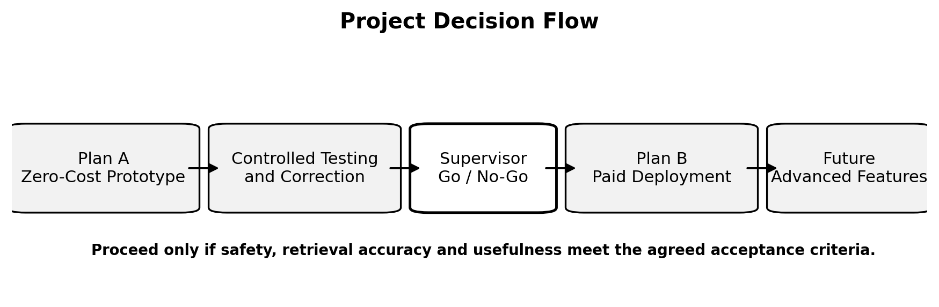
Figure 8. Project decision flow.

7.1 Gate 1 - Approval to Begin Plan A
Approval confirms the pilot subject, no-cost rule, source-document scope, eight-week indicative schedule and initial acceptance criteria.

7.2 Gate 2 - Mid-Prototype Review
At the end of Week 4, demonstrate the RAG retrieval and basic web chat. The review should confirm that the source documents are usable and that continuing to troubleshooting and image testing is justified.

7.3 Gate 3 - Plan A Go / No-Go
At the end of Week 8, submit the fixed test results, unresolved issues, known limitations, production budget and recommendation. Do not proceed to paid deployment if safety, retrieval or usefulness criteria are not met.

7.4 Gate 4 - Production Launch Approval
After Plan B user acceptance testing, confirm security, privacy, backup, cost controls, approved documents, known limitations and rollback readiness before releasing the application to users.

7.5 Final Recommendation
Proceed with the zero-cost local prototype as a controlled proof of concept. Keep the first version narrow: one manufacturing subject, approved documents, text-based technical questions, guided troubleshooting, source citations and limited image testing. The application should be a local Django website using Django Templates, HTMX and Bootstrap, with Ollama connected through a replaceable LLM gateway. It must not be connected to industrial hardware or software.
Use the prototype to establish whether the answers are technically useful and safe. Only after the fixed test set passes should the company approve hosting, AI API usage, authentication, online document storage and ongoing operating cost. Live machine or software integration should remain a separate long-term project with its own architecture, safety review, budget and approval.

7.6 Immediate Next Actions
- Confirm the single pilot subject.
- List and collect the first 10-20 approved source documents.
- Prepare 30 technical questions, 15 troubleshooting cases and available image cases.
- Check the existing computer specification; install Python, Django, Ollama and the selected local models; confirm a successful model request.
- Create the Django project repository, document register, test matrix, issue log and environment-configuration template.
- Begin Week 1 only after the scope and pass criteria are approved.

7.7 Review and Approval Record
Item | Name / Decision | Date | Signature
Prepared by - Project Developer
Reviewed by - Supervisor
Plan A decision | Approved / Revise / Not Approved
Plan B decision, after testing | Approved / Revise / Not Approved

Appendix A - Test Case Template
Field | Entry
Test ID
Category | Technical / retrieval / troubleshooting / image / safety / usability
User input
Expected answer points
Expected source
Actual answer
Retrieved source
Accuracy score | 0-5
Safety result | Pass / Fail
Reviewer comment
Correction action
Retest result

Appendix B - Issue Log Template
Issue ID | Date | Type | Description | Severity | Action | Status

Appendix C - Definition of Done for Plan A
- The prototype starts from documented instructions.
- The Django browser chat works without command-line interaction by the reviewer.
- The LLM gateway communicates with Ollama and returns controlled errors when the local model is unavailable.
- The approved documents can be ingested, embedded, indexed and rebuilt.
- The chatbot displays supporting sources where relevant.
- The fixed question and troubleshooting test set has been completed.
- All safety failures have been corrected and retested.
- Known limitations are documented.
- The source code, configuration, document register, test matrix, issue log and final report are complete.
- The supervisor has issued a written go or no-go decision.

Appendix D - LLM Integration Checkpoints
Checkpoint | Required Evidence
Local model service | Ollama is installed, the selected model is available and a direct local request succeeds.
Django-to-model connection | A Django management command or service test sends a request through the LLM gateway and receives a valid response.
Controlled failure handling | Ollama stopped, invalid model and timeout tests return user-safe messages without a stack trace or secret value.
RAG connection | The chat service sends retrieved passages and source identifiers to the model and displays the resulting citations.
Vision connection | When supported, an uploaded image is validated and sent only through the server-side vision adapter.
Provider switching | Changing environment configuration selects the production adapter without changing Django views or RAG code.
Secret handling | The production API key is absent from source code, templates, browser requests and repository history.
Regression test | The fixed technical, retrieval and safety cases are rerun after any provider or model change.

Appendix E - Planning Basis and References
The cost and technical options in this draft are indicative and must be reconfirmed before procurement or deployment. The following official sources were used as a planning basis on 28 July 2026:
- Django Documentation
- Django Authentication
- Django File Uploads
- HTMX Documentation
- Ollama OpenAI Compatibility
- Ollama Embeddings
- Ollama Vision
- OpenAI API Documentation
- OpenAI API Pricing
- DigitalOcean Droplet Pricing
All production figures exclude internal labour cost, external consulting, enterprise security reviews, hardware purchase, industrial system integration and ongoing technical-content ownership unless specifically approved.

