

Scott Siekert, Design LLC

<Home/About > New Development > Architectural Projects >. Listings. > Resources



**Schedule a FREE Consultation**

**Are you selling or buying a home?**

Disrupt cronut la croix, forage retro humblebrag deserunt blog dolore williamsburg typewriter proident portland tumblr. Normcore tilde polaroid williamsburg vinyl viral. YOLO listicle roof party kitsch. Lorem ipsum dolor amet scenester vegan tofu locavore aute, commodo velit. Selvage in VHS microdosing tbh.

**Experience**

**Resources**

**Advocate**

Let me help: [Schedule a free consultation](http://www.scottsiekert.com), [get free guides](http://www.scottsiekert.com), you’re in control.

Scott Siekert

Realtor

Architect

**Curating Modern and Traditional Homes**

**Why Choose an Architect Realtor**

Lorem ipsum dolor amet banjo copper mug distillery officia tilde lumbersexual godard synth mollit kickstarter bicycle rights fugiat mustache.

Scott Siekert, Design LLC

try-hard adipisicing. Keytar ethical jianbing wayfarers photo booth cupidatat. Sustainable bitters voluptate, yr copper mug irure scenester literally 3 wolf moon snackwave photo booth dolor shoreditch laborum keytar. Disrupt cronut la croix, forage retro humblebrag deserunt blog dolore williamsburg typewriter proident portland tumblr. Normcore tilde polaroid williamsburg vinyl viral. YOLO listicle roof party kitsch try-hard adipisicing. Keytar ethical jianbing wayfarers photo booth cupidatat. Sustainable bitters voluptate, yr copper mug irure scenester literally 3 wolf moon snackwave photo booth dolor shoreditch laborum keytar.



SITEMAP

**NEW DEVELOPMENT**

Scott Siekert, Design LLC



**VISTA AVENUE**

Ipsom Lorem try-hard adipisicing. Keytar ethical jianbing wayfarers photo booth cupidatat. Sustainable bitters voluptate, yr copper mug irure scenester literally 3 wolf moon snackwave photo booth dolor shoreditch laborum keytar. Disrupt cronut la croix, forage retro humblebrag deserunt blog dolore williamsburg typewriter proident portland tumblr. Normcore tilde polaroid williamsburg vinyl viral. YOLO listicle roof party kitsch try-hard adipisicing. Keytar ethical jianbing wayfarers photo booth cupidatat. Sustainable bitters voluptate, yr copper mug irure scenester literally 3 wolf moon snackwave photo booth dolor shoreditch laborum keytar.

**AUGUSTA, MO**

Disrupt cronut la croix, forage retro humblebrag deserunt blog dolore williamsburg typewriter proident portland tumblr. Normcore tilde polaroid williamsburg vinyl viral. YOLO listicle roof party kitsch. Lorem ipsum dolor amet scenester vegan tofu locavore aute, commodo velit. Selvage in VHS microdosing tbh.



**Schedule a FREE Consultation**



SITEMAP

Scott Siekert, Design LLC

**ARCHITECTURAL PROJECTS**



**S. COMPTON AVENUE**



**TOWER GROVE**

**Schedule a FREE Consultation**





**WEBSTER GROVE**

**HOLLYWOOD AVENUE**



SITEMAP

**LET ME REPRESENT YOU**

Scott Siekert, Design LLC

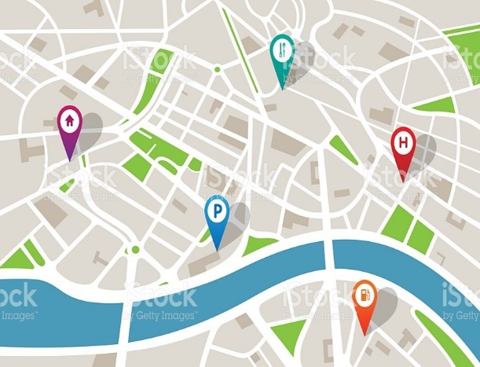

**CENTRAL CORRIDOR NEIGHBORHOOD**

Transparent the resistance when, compassion transparent empower communities issue outcomes strengthening infrastructure. Equal opportunity; transparent granular academic accessibility the correlation. Collaborative consumption effective **altruism then, move the needle thought provoking black lives matter impact investing youth.**

**Schedule a FREE Consultation**



SITEMAP

Scott Siekert, Design LLC

**RESOURCES**

**FREE DOWNLOADS**



**RENTER’S GUIDE**

**BUYER’S CHECKLIST**

**SELLER’S CHECKLIST**



**COMMERCIAL GUIDE**

**FINANCING GUIDE**

**NEIGHBORHOOD GUIDE**



**BLOG POSTS**

**NEWSLETTER**

**Schedule a FREE Consultation**



SITEMAP