











































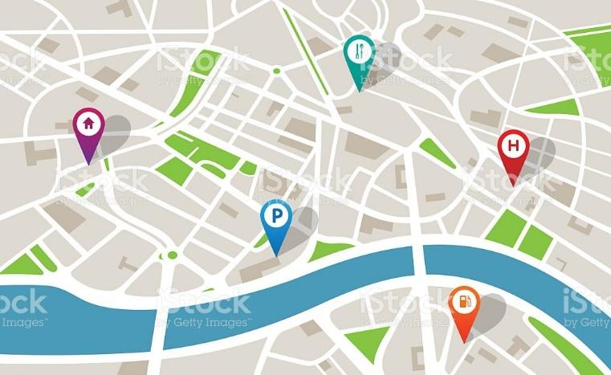

























**SITEMAP**

Home Romance page

Home | About

Developments Romance page

New Developments

Architecture Projects Romance page

Architecture

Listings Romance page

Neighborhoods

Resources Romance page

For Your Information

Hover w/ horizontal Navigation Bar

Style Guide:

Fonts = **Raleway** and **Domine**

Colors:



