**Name :** Anisur Rahman Shahin

**ID :** 2018200000018

**Project name :** Potato Price Prediction using Artificial Neural Network where you can predict price by unit.

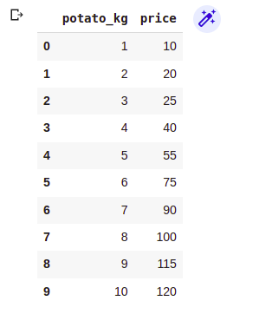

In this project, I have defined an ANN model to predict the protao price by unit. To do that I used a couple of libraries and modules. Like Tensorflow, Keras, Numpy, Pandas,Sklearn and Matplotlib.

**Tensorflow :** Tensorflow is a free and opensource software library for machine learning and Atrificial Inteliengece by Goggle. It is one of the most popular framework for deep learning.

**Keras :** Keras is not a proper framework. It is just a wrapper arround Tensorflow and CNTK.

**Numpy :** NumPy is a library for the Python programming language, adding support for large, multi-dimensional arrays and matrices, along with a large collection of high-level mathematical functions to operate on these arrays.

**Pandas** : Pandas is a software library written for the Python programming language for data manipulation and analysis.

**Matplotlib** : Matplotlib is a plotting library for the Python programming language and its numerical mathematics extension NumPy. It provides an object-oriented API for embedding plots into applications using general-purpose GUI toolkits like Tkinter, wxPython, Qt, or GTK.

**ANN** : Artificial neural networks, usually simply called neural networks or, more simply yet, neural nets, are computing systems inspired by the biological neural networks that constitute animal brains

**Work Procedure :** Now I am going to discuss about, how to make a ANN model. Well, first I import all required libraries and modules likeTensorflow, Keras, Numpy, Pandas,Sklearn and Matplotlib.

import tensorflow as tf

from tensorflow import keras

import pandas as pd

import numpy as np

import matplotlib.pyplot as plt

Well, after then I load the data using pandas. I’ve uploaded my dataset in the google drive. To do that first you have to mount your data from the google drive.

df = pd.read_csv("/content/drive/MyDrive/data/PotatoPrice.csv")

This is a tiny dataset where two columns and ten rows.

After then the visulize the data I use matplotlib library like below.

plt.xlabel("Potato in KG")

plt.ylabel("Price")

plt.scatter(df.potato_kg,df.price)

plt.show()

It shows me a graph.

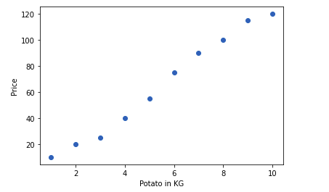

In this graph, the X axis is Kg in product and Y axis is price of the product.

Now I split data according to feature and target like below where feature level should be in the 2D array.

X = df[['potato_kg']]

Y = df['price']

Now I split the dataset for the training and testing. To do that, I imported the sklearn library’s train_test_split Method.

from sklearn.model_selection import train_test_split

X_train,X_test,Y_train,Y_test = train_test_split(X,Y,test_size=0.3)

Print X_train

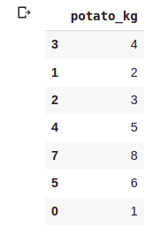

In this method, I passed 3 perimeters they are X,Y and test size.

Now define an ANN model using tensorflow and keras like below.

model = tf.keras.Sequential([

tf.keras.layers.Dense(1,input_shape=[1],activation='linear')

])

Now compile the Model, that means how model will learn.

model.compile(optimizer='sgd',

loss='mean_squared_error',

metrics=['accuracy'])

Here I passed 3 three perimeters they are optimizer that means how to update bias and weight values. Second perimeter is the loss that means how to calculate the error and last perimeter is for the accuracy.

Right Now we have to train our model using data. To do that you have to call fit method and pass data like below.

model.fit(X_train,Y_train,epochs=500)

Here first perimeter is the feature level, second perimeter is the output level and last perimeter is the iteration number that how many times it can calculate the value.

Well, it time to predict our data using predict method like below.

model.predict(X_test)

Now I evaluate the model’s loss and accuracy using evaluate function.

test_loss,test_acc = model.evaluate(X_test,Y_test,verbose=2)

Finally, I peridect model using custom value like below.

#Predict The Output Manually

model.predict([[100]])

Output is : 1200.569