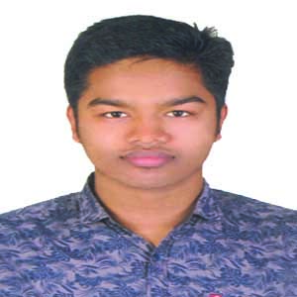***AsikurRahmanSumon***

**Contact Information**

***RESUME***

***RESUME***

Moktinagar, Chattagong Road,

Siddirganj, Narayanganj.

Email ID: sumonct3489@gmail.com

Mobile**:+8801685152632**

**Career Objective**

To work in a dynamic, intensive environment, where the creativity and interest can be found to develop the skills as well as the career with a strong emphasis on sustained growth and development.

**Academic Details**

* **Bachelor of Science(B.S.C Honor’s)**
* Institute Name **: University of Asia Pacific.**
* Subject **:** Computer Science and Engineering.
* Passing Year **:** Running
* **Higher Secondary School Certificate (H.S.C)**
* Institute Name **: Dhaka City College.**
* Board **:**Dhaka
* Group **:** Science
* Passing Year **:** 2018
* GPA **:**4.92 (out of 5.00)
* **Secondary School Certificate (S.S.C)**
* School Name **:**Kanchpur Omar Ali High School.
* Board **:**Dhaka
* Group **:**Science
* Passing Year **:** 2016
* GPA **:**5.00 (Out of 5.0)

**Computer Literacy**

* Package Program **:**Microsoft Office:Ms-Word, Ms-Excel, Ms-PowerPoint.
* Graphics Program **:** Illustrator 10, Adobe Photoshop7.0
* Others **:** E-mail and Internet Browsing.

**SKILLS:**

* Good organization and interpersonal communication skills.
* Ability to work in a team environment.
* Self- Confident and being positive.
* Quick learner and have a zeal for learning new things.
* Hard working, sincerer and eager to learn.
* Ability to take responsibility.

**Language Proficiency**

* Bengali **:** Mother tongue.
* English **:**Excellent reading, writing and speaking and listening ability.

**Personal Details**

* Father’s Name **:** Azgar Ali
* Mother’s Name **:** Shahida Khatun
* Date of Birth **:** 7th January 2001
* Gender **:** Male
* Marital Status **:** Single
* Religion **:** Islam
* Blood Group **:** O (+Ve)
* Nationality **:** Bangladeshi
* Current Location **:** Dhaka

Permanent Address

Vill : Durgapur.

Post : Lokkhonpur.

Thana : Sharsha.

Dist. : Jessore.

I undersigned, hereby declare that I will be responsible for any wrong information providedhere.

Signature

…...…………………….

***(AsikurRahmanSumon)***

Date**:**