Day 26 Intermediate Lists and the Nato Alphabet

<https://www.udemy.com/course/100-days-of-code/learn/lecture/20761314#questions>

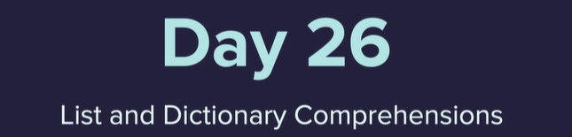

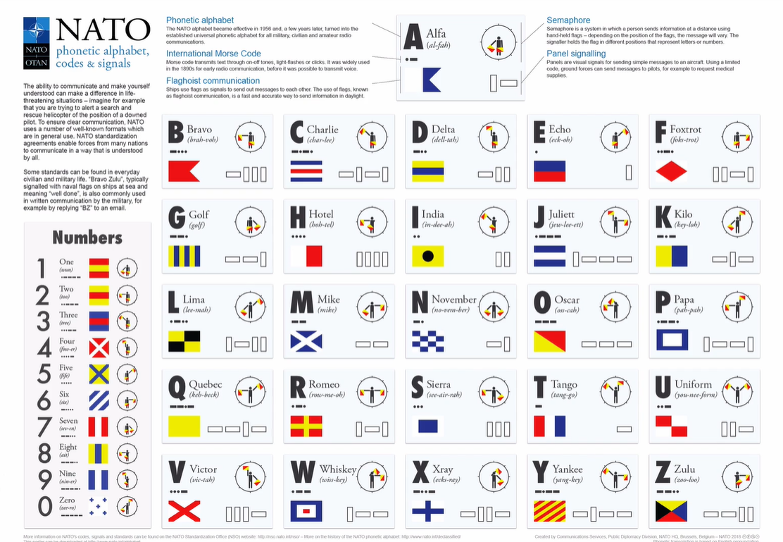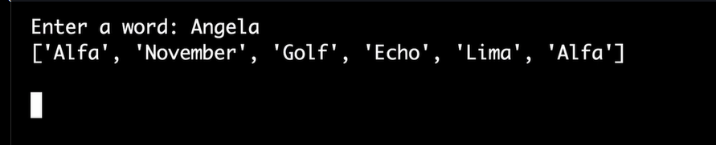

List Comprehension -A new list from a previous list

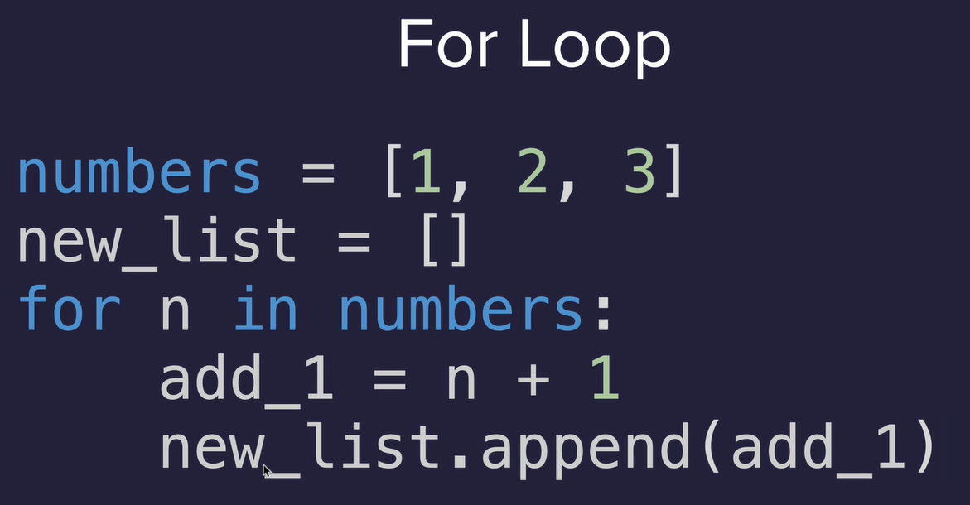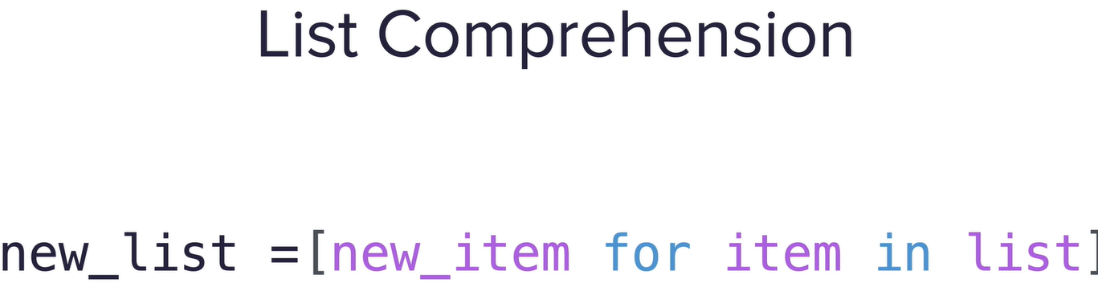

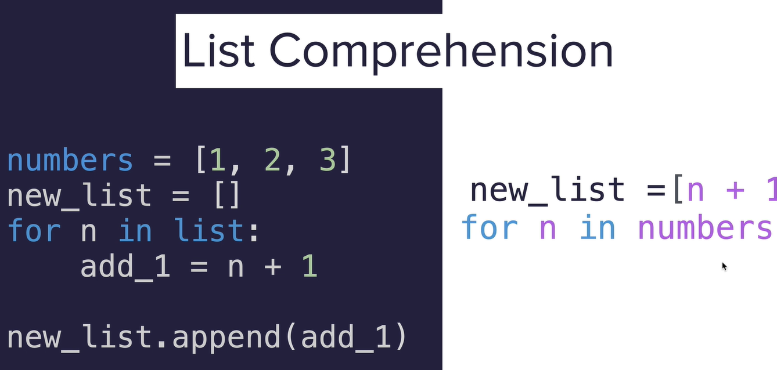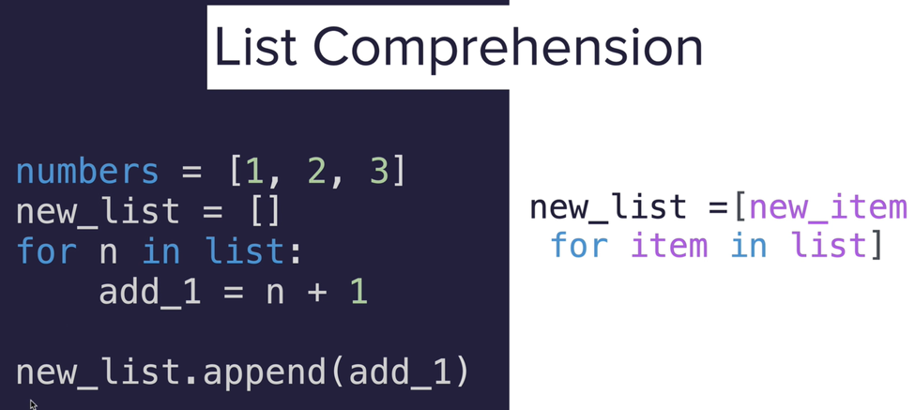

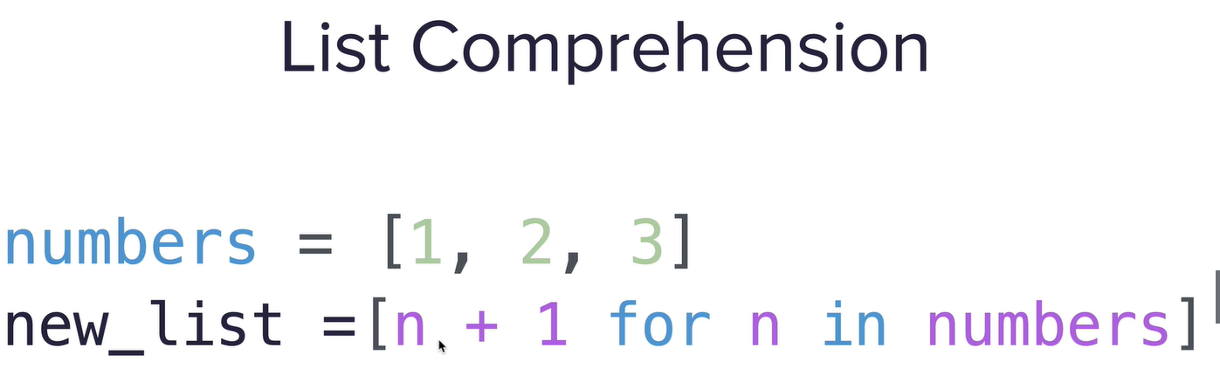

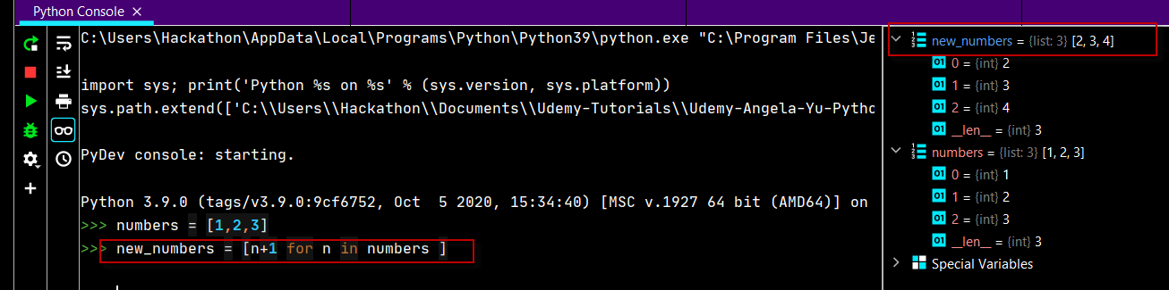

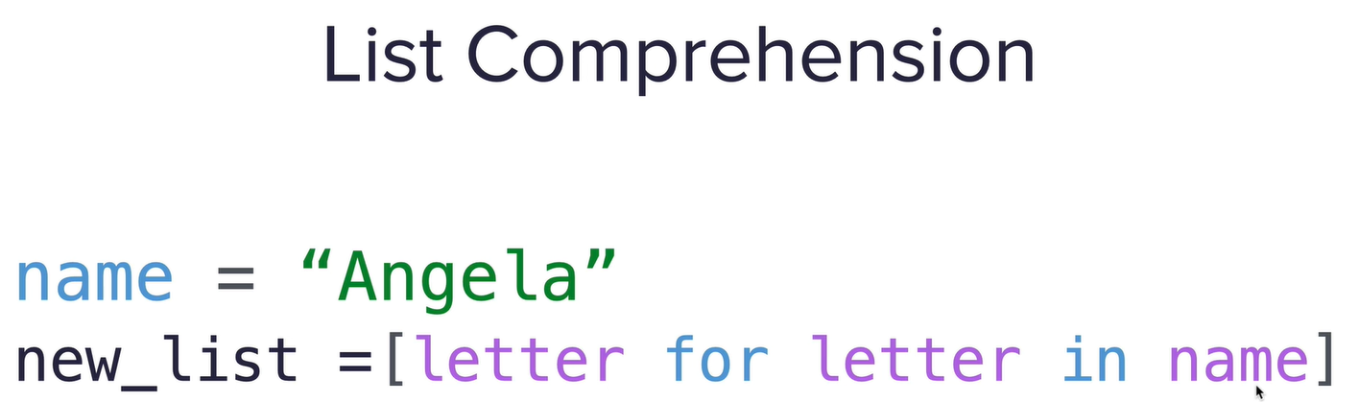

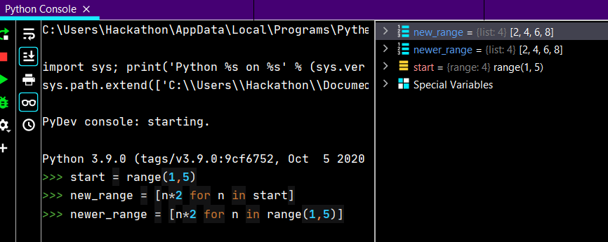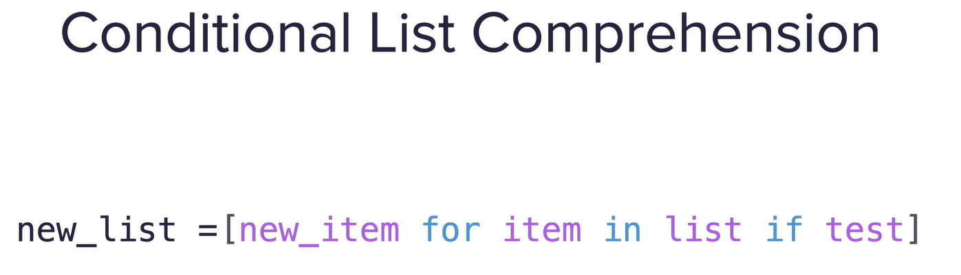

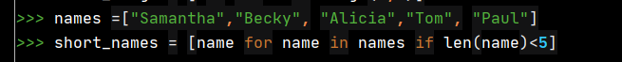

Only even numbers

numbers = [**1, 1, 2, 3, 5, 8, 13, 21, 34, 55**]  
# 🚨 Do Not Change the code above  
  
#Write your 1 line code 👇 below:  
  
result =[n for n in numbers if n%**2**==**0**]  
  
#Write your code 👆 above:  
  
print(result)

Combine the common numbers between 2 files

file1 = open("file1.txt"**,**"r").read().splitlines()  
file2 = open("file2.txt"**,** "r").read().splitlines()  
combined = [int(item) for item in file1 if item in file2]  
print(combined)

Another way

with open("file1.txt")as file1:

    file1_data = file1.readlines()

with open("file2.txt")as file2:

    file2_data = file2.readlines()

print(file1_data)

print(file2_data)

result =[ int(item) for item in file1_data if item in file2_data ]

print(result)

Dictionary Comprehensions

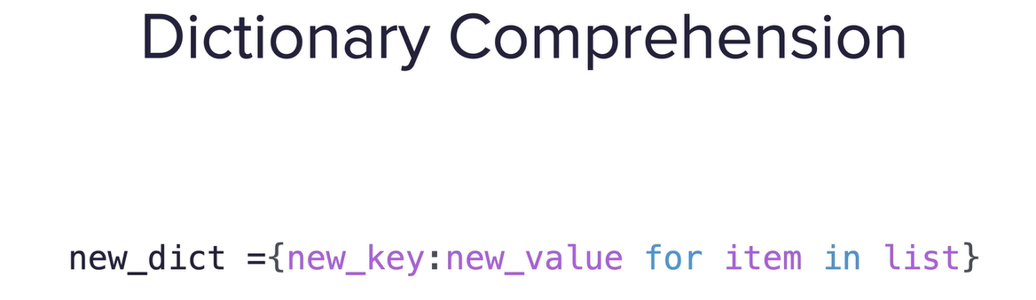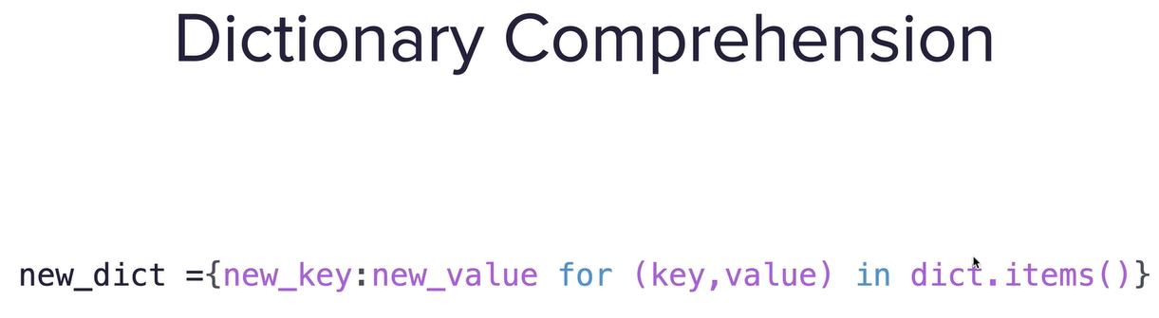

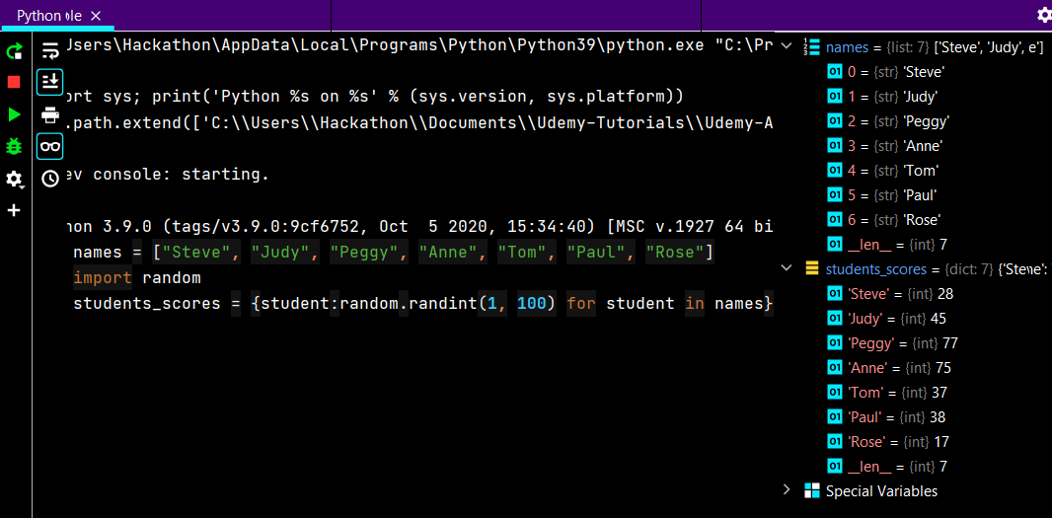

Python split method

<https://www.w3schools.com/python/ref_string_split.asp>

Nato Alpahabet

#TODO 1. Create a dictionary in this format:

# {"A": "Alfa", "B": "Bravo"}

# Keyword Method with iterrows()

# {new_key:new_value for (index, row) in df.iterrows()}

import pandas

data = pandas.read_csv("nato_phonetic_alphabet.csv")

nato_dic = {row.letter: row.code for (index, row) in data.iterrows()}

print(nato_dic)

#TODO 2. Create a list of the phonetic code words from a word that the user inputs.

word = input("Enter a word: ").upper()

output_list = [nato_dic[letter] for letter in word]

print(output_list)