Day 27 Create a GUI Program Tkinter

https://www.udemy.com/course/100-days-of-code/learn/lecture/20781124#overview

What is being made – a converter program mile to kg

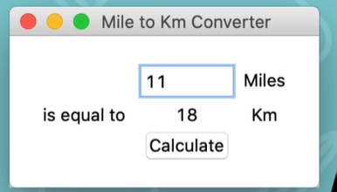

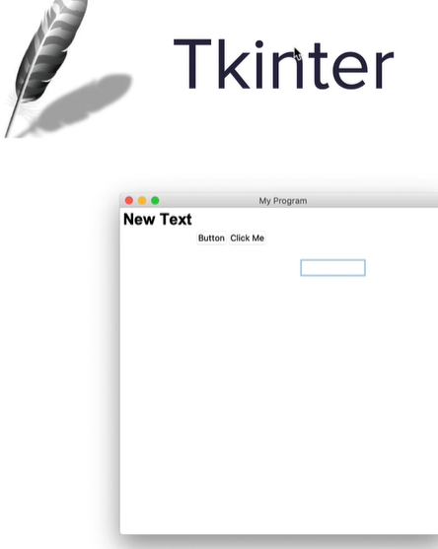

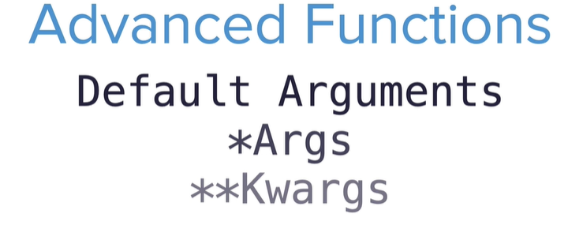

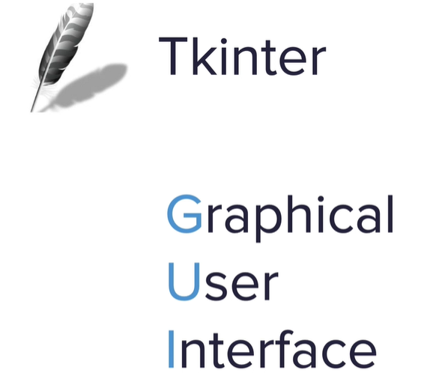

TK docs

<http://tcl.tk/man/tcl8.6/TkCmd/pack.htm>

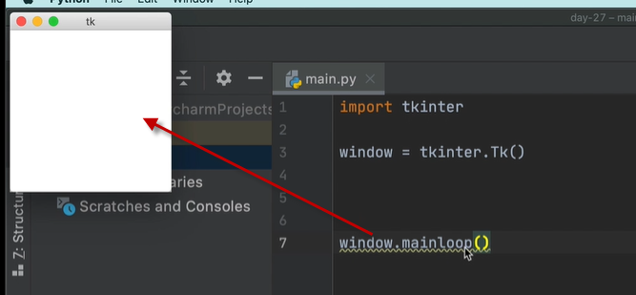

The Packer

<https://docs.python.org/3/library/tkinter.html#the-packer>

import tkinter  
#create window  
window = tkinter.Tk()  
#title bar  
window.title("My first GUI Python program ")  
#size  
window.minsize(width=**500,**height=**300**)  
  
#label  
#text and tupel font  
my_label = tkinter.Label(text="I am a label"**,** font=("Arial"**,24,**"bold"))  
#.pack() puts on screen and centers it  
# my_label.pack()  
#can change where it is moved too  
my_label.pack(side="bottom")  
  
  
# Keep window open always at the bottom  
window.mainloop()

pack() function

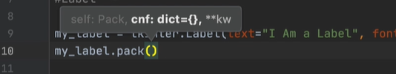

**kw – python arguments

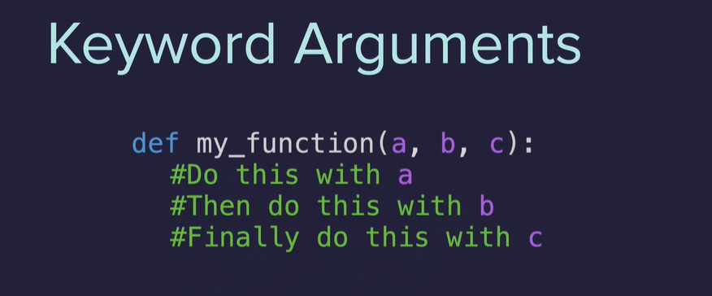

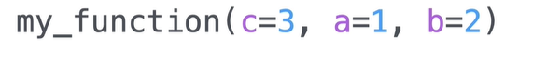

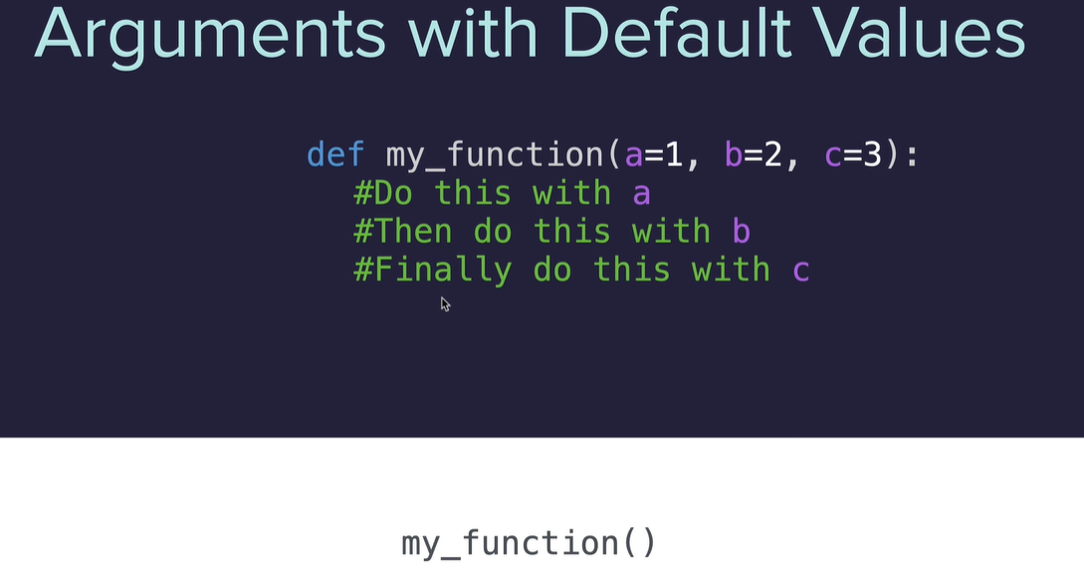

Turtle comes with …..

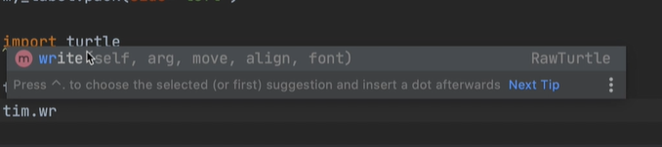

Some default, some are required

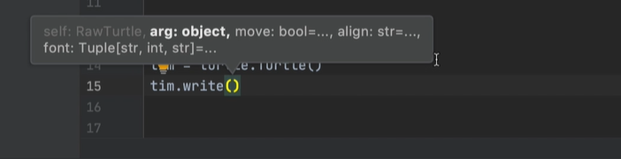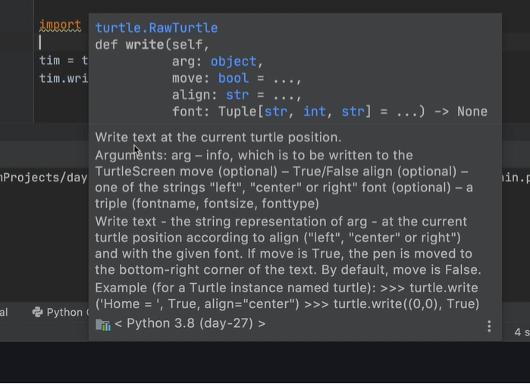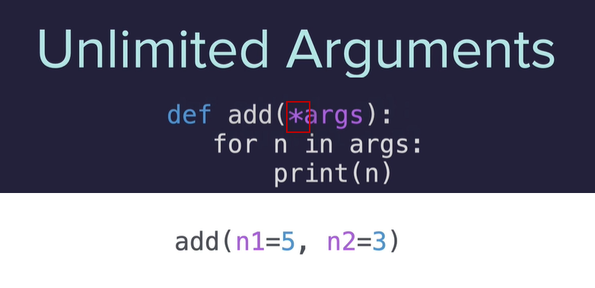

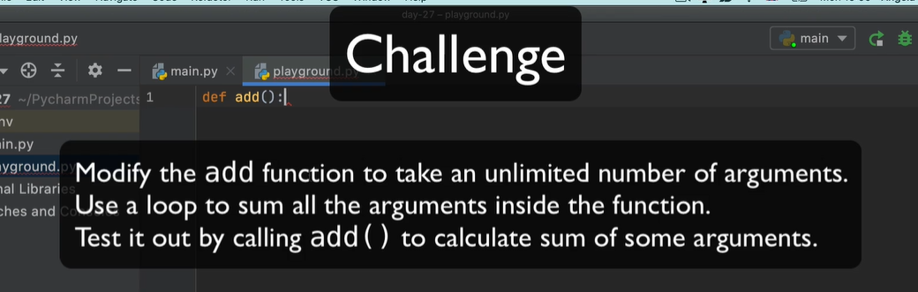

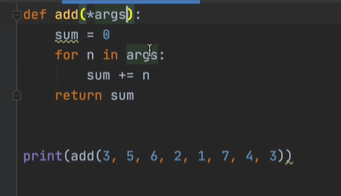

Can also access the index of the tupple

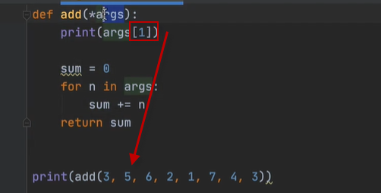



Index at 1 is 5



**kwargs are a dictionary

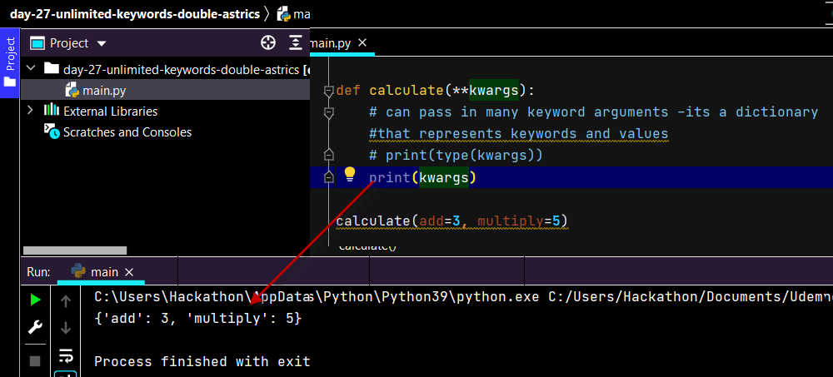

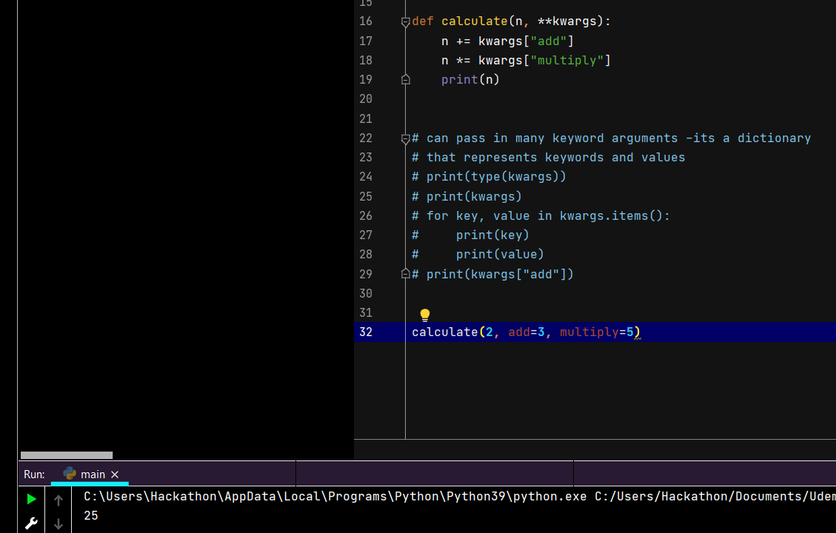

The stuff in the tkinter library is a bunch of **kwargs

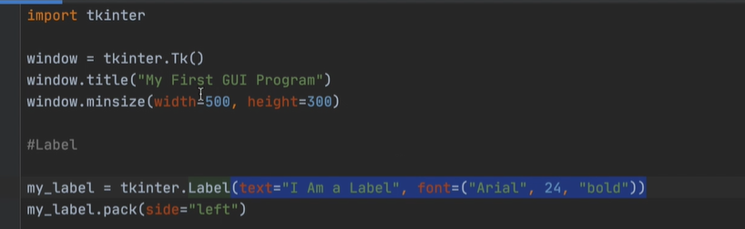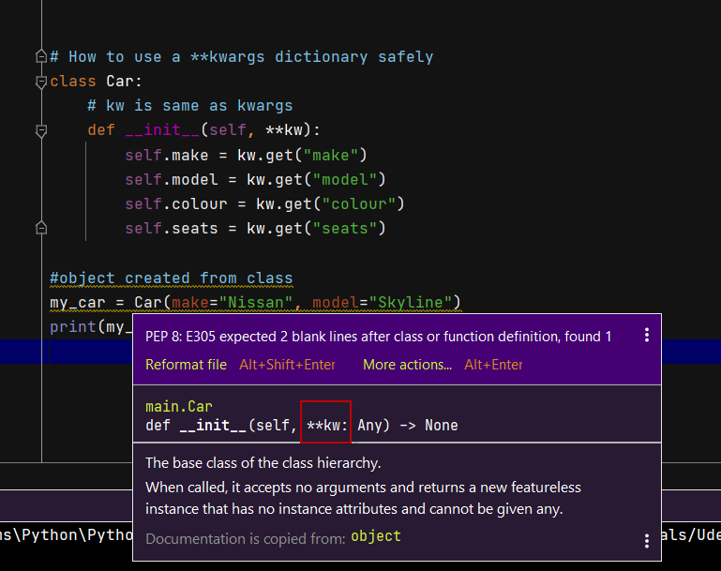

tkinter docs

<http://tcl.tk/man/tcl8.6/TkCmd/entry.htm>

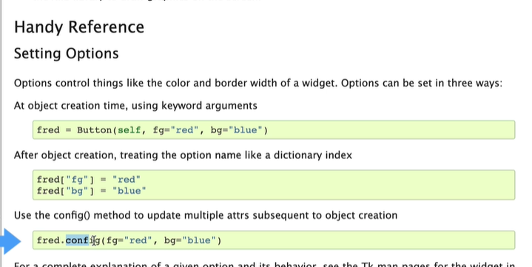

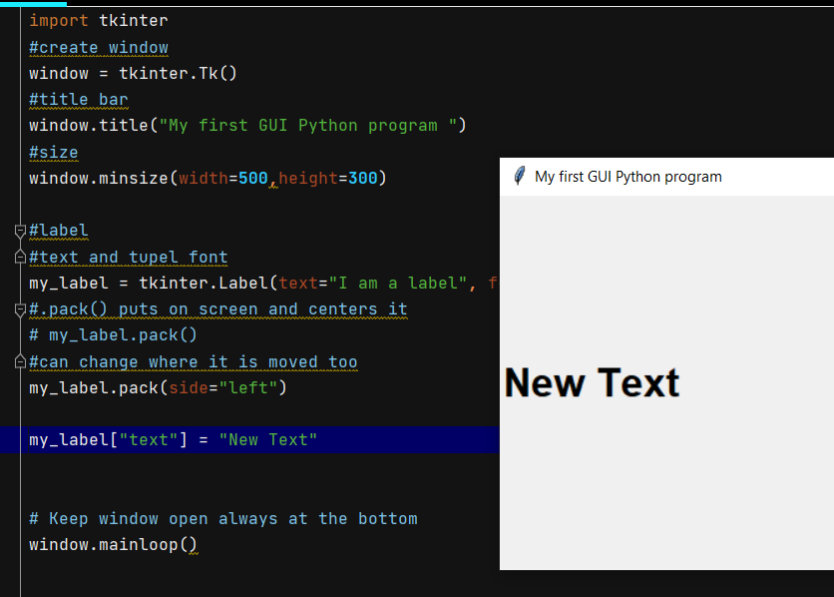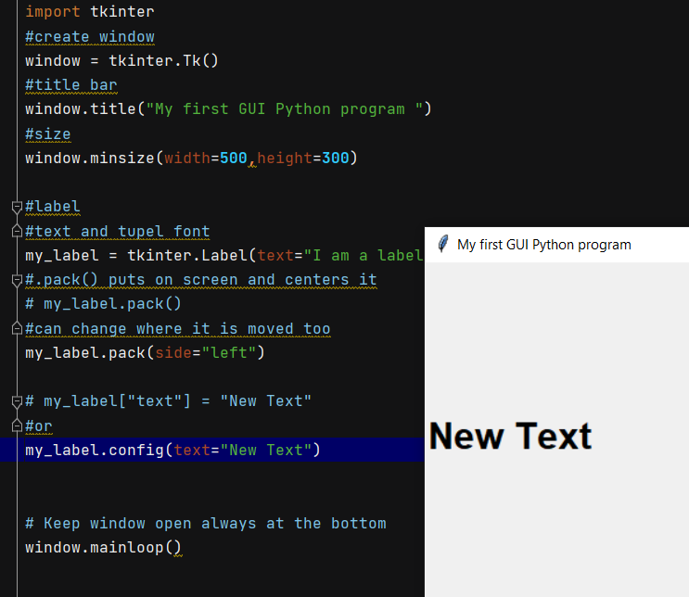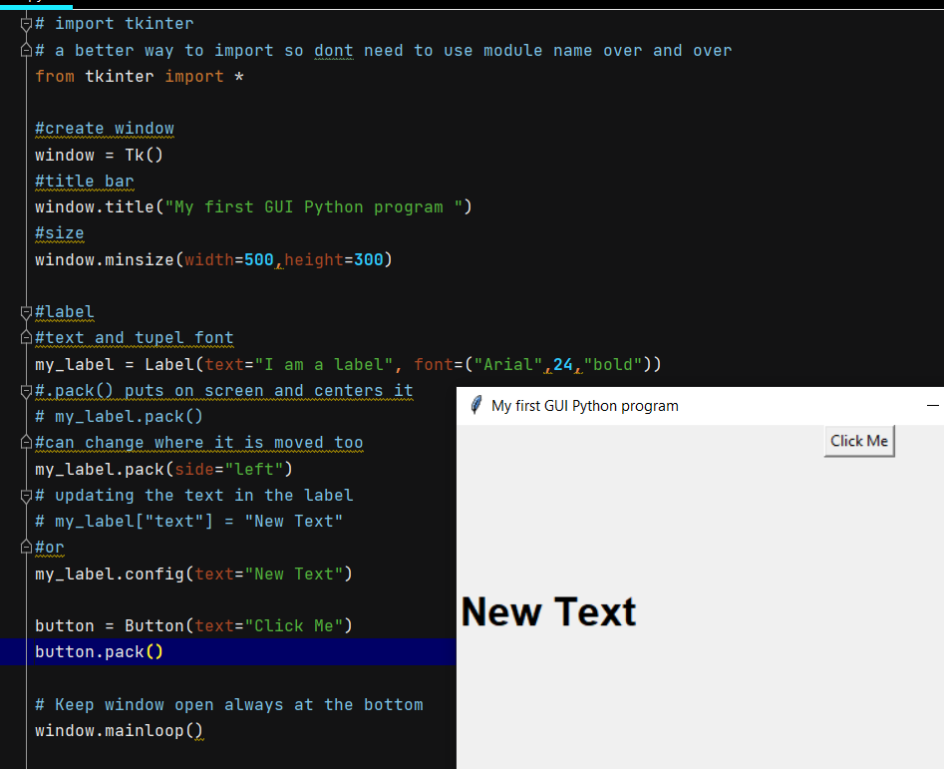

More widgets 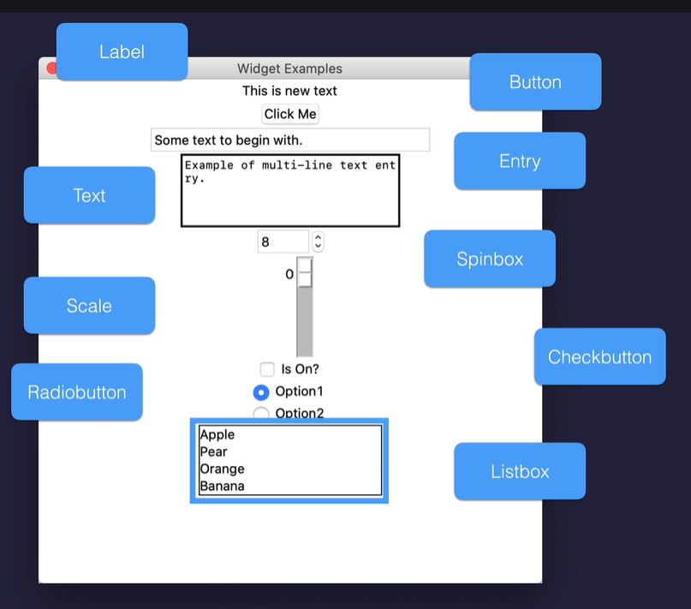

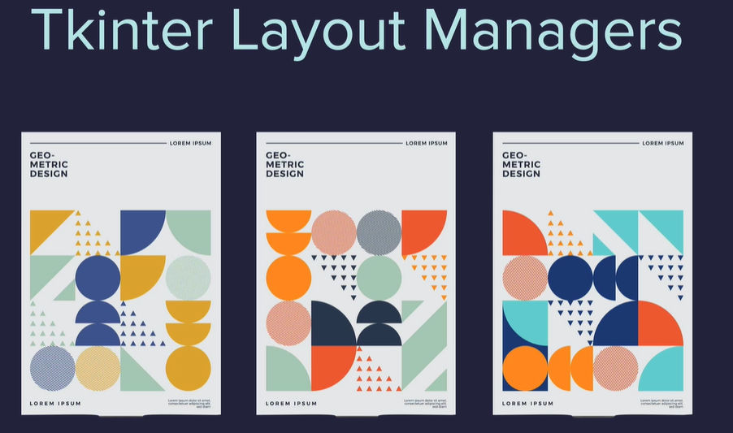

<https://www.udemy.com/course/100-days-of-code/learn/lecture/20781174#questions>