PROJECT PLAN
Identity and Access Management (IAM) System Deployment for Cybersecurity Enhancement
Corella Health Group (case organisation), regional New South Wales
Version 1.0 · 25 October 2026
Team member | Project role | Plan sections owned
Toufiq Ahmed Joy | Project Manager (team lead) | 1, 3, 4, 5, 6, 8
Kritika Bhattarai | Resource and Communications Manager | 7, 9, 12, 14
Fardin Rahman Tanvir | Quality Assurance Lead | 2, 13, References
Ahmed Mahir Daiyan | Change and Configuration Manager | 10, 11, Appendices
Project repository: https://github.com/AR13X3/iam-deployment-project-plan
Project sponsor: Catherine Doyle, Chief Operating Officer, Corella Health Group
Document control
Document | IAM System Deployment — Project Plan
Version | 1.0 (baseline for sponsor approval at Gate 1)
Date | 25 October 2026
Prepared by | Toufiq Ahmed Joy, Kritika Bhattarai, Fardin Rahman Tanvir, Ahmed Mahir Daiyan
Approval | Catherine Doyle, Chief Operating Officer (project sponsor)
Source files | GitHub repository https://github.com/AR13X3/iam-deployment-project-plan; schedule, WBS, risk register and templates are kept there under version control (Section 11).
Case note | Corella Health Group, its people and its audit figures are a hypothetical case organisation used for this plan. All other facts are cited.

1. Introduction 3
2. Background research 3
2.1 Why identity, and why now 3
2.2 How strong MFA needs to be 3
2.3 Usability and the access model in clinical settings 3
2.4 Project-management practice 4
3. Project overview and objectives 4
4. Project charter and scope statement 4
4.1 Charter summary 4
4.2 Scope 5
4.3 Stakeholders 5
4.4 Project team 6
4.5 Milestones and gates 6
5. Work breakdown structure 6
6. Project schedule (Gantt chart) 9
7. Resource allocation and responsibility matrix 12
8. Risk management plan 13
9. Issue management strategy 16
10. Change request and change management process 16
11. Configuration management (GitHub) 18
12. Communication management plan 21
13. Quality management approach 22
14. Conclusion 23
References 23
Appendix A. Jira project evidence 25
Appendix B. GitHub history 27
Appendix C. Working calendar 27

1. Introduction
Section owner: Toufiq Ahmed Joy
Corella Health Group (CHG) is a not-for-profit healthcare provider in regional New South Wales. It has 1,180 staff and about 320 contractors and visiting clinicians across 9 sites. They use 42 applications, including an electronic medical record (EMR) and a patient administration system (PAS).
Problem statement. CHG cannot reliably control who has access to what: every application keeps its own accounts, managed by hand. A 2026 audit found 186 active accounts of people who had left, 38 administrator accounts where about 12 are needed, a 6.5-day wait for new-starter access, and multi-factor authentication (MFA) used by only 31% of staff. A phished password later caused a notifiable data breach. Credentials were stolen in a quarter of healthcare breaches worldwide [1], and Australian health providers made the most breach notifications of any sector in 2025 [2].
The project. CHG will deploy a central identity and access management (IAM) system: single sign-on (SSO), phishing-resistant MFA for every user, access driven by the HR system, role-based access, quarterly access reviews and privileged access management. It runs from 2 November 2026 to 28 July 2027 within a budget ceiling of AUD 1,250,000. Sections 2–14 follow the contents list.

2. Background research
Section owner: Fardin Rahman Tanvir

2.1 Why identity, and why now
Worldwide, exploited software flaws (31%) now outrank stolen credentials (13%) as the first step in a breach, but credential abuse is still 25% in Asia-Pacific and credentials were taken in 25% of healthcare breaches [1]. In Australia, phishing, stolen credentials and brute force caused 151 of 247 cyber incidents in July–December 2024, with health the worst-hit sector [3]. For this plan: identity is a major exposure but not the only one, so patching stays with CHG's Essential Eight program and risk R09 covers attacks during the transition.

2.2 How strong MFA needs to be
All sources agree any MFA beats none: in Microsoft's data it cut account takeover by 99.22% [4], though that figure is vendor data and not peer-reviewed. Government sources set a higher bar: CISA calls SMS codes a last resort [5], NIST restricts SMS [6], and the Essential Eight requires phishing-resistant MFA at Maturity Level Two [7]. With 14.2% of nearly three million test phishing emails clicked at US health institutions [8], codes can be stolen. For this plan: phishing-resistant MFA for all users (passkeys, or security keys at shared workstations), SMS only by approved exception, administrators and HR first.

2.3 Usability and the access model in clinical settings
Controls that slow clinicians lead to workarounds: in compulsory two-factor rollouts more than one attempt in twenty failed, worse with many separate log-ins [9]. Health-record studies favour attribute-based rules but find gaps in MFA, emergency access and audit trails [10]. NIST also bases access on identity plus attributes and advises migrating one process at a time, report-only first [11]. No source requires quarterly reviews; the Essential Eight asks for yearly checks of administrator access [7]. For this plan: SSO, tap-and-go keys on ward computers, roles from HR job codes with site and shift rules, monitored break-glass accounts, report-only testing, rollout in waves, and quarterly reviews chosen for the risk.

2.4 Project-management practice
The PMBOK Guide (8th edition) expects each project to tailor its methods [12], and ISO 21502 fits any delivery approach [13]; neither picks one. ISO 31000 gives a general risk process [14], but risk management adds value only if people see and use it [15]. For this plan: a hybrid approach, with gates, baselines and a change control board for contract and compliance work, iterative SSO waves and a pilot, and clinical and IT staff in risk reviews, every risk with an owner and trigger.

3. Project overview and objectives
Section owner: Toufiq Ahmed Joy
The project replaces account management application by application with one identity platform fed by the HR system. When People and Culture records a hire, move or exit, the platform creates, changes or removes access in connected applications using role-based rules. Staff sign in once with phishing-resistant MFA; administrators use separate privileged accounts; managers re-certify their staff's access every quarter. The business case is to close the audit findings, lower the likelihood and cost of another breach, end the wait for new-starter access, cut password-reset calls and reach Essential Eight Maturity Level Two for MFA and restricting administrative privileges [7], which the board has set as its target for 30 June 2027. Table 1 lists the measurable objectives.
Table 1. SMART objectives
ID | Objective | Measure and target | Date
O1 | Phishing-resistant MFA for every identity | 100% of 1,500 in-scope identities enrolled and enforced (passkeys or FIDO2 keys); SMS used only by approved exception | 16 Jun 2027
O2 | Single sign-on | 12 priority applications sign in through the IAM platform | 16 Jun 2027
O3 | Fast, reliable leavers | Access to all in-scope applications removed within 4 hours of the HR termination record, in a monthly sample of 30 leavers | From 16 Jun 2027; first check 14 Jul 2027
O4 | Day-one access | At least 95% of new starters have role-based access before their first shift (currently a 6.5-day wait) | Measured over the 3 months to 30 Sep 2027
O5 | Account clean-up | All 186 orphaned accounts disabled; administrator accounts cut from 38 to 12 or fewer | 28 Jul 2027
O6 | Access reviews | First quarterly review covers 100% of entitlements in the 12 applications, with every revocation actioned | 14 Jul 2027
O7 | On time and on budget | Project closed within the AUD 1,250,000 budget ceiling | 28 Jul 2027

4. Project charter and scope statement
Section owner: Toufiq Ahmed Joy

4.1 Charter summary
Table 2. Project charter
Project title | Identity and Access Management (IAM) System Deployment for Cybersecurity Enhancement
Organisation | Corella Health Group (CHG), regional New South Wales
Project sponsor | Catherine Doyle, Chief Operating Officer
Project manager | Toufiq Ahmed Joy
Purpose | Give every staff member and contractor the right access at the right time, protected by phishing-resistant MFA, and remove access promptly when it is no longer needed.
Start and finish | 2 Nov 2026 to 28 Jul 2027 (182 working days)
Budget | Ceiling AUD 1,250,000: cost baseline AUD 1,199,030 (including AUD 159,000 contingency reserve) plus AUD 50,970 management reserve held by the sponsor. Excludes GST.
Authority | The project manager may commit funds within approved work packages and approve changes within the limits in Section 10.

4.2 Scope
Table 3 shows what is in and out of scope. Anything not listed as in scope is out unless the change control board adds it (Section 10). Table 4 lists the deliverables, assumptions, constraints and acceptance criteria.
Table 3. In-scope and out-of-scope items
In scope | Out of scope
- 1,500 workforce identities: 1,180 staff and 320 contractors, agency staff and visiting medical officers  - 12 applications: Microsoft 365, intranet, VPN, rostering, EMR, PAS, HR system (HRIS), payroll, finance, pathology results portal, imaging viewer, incident management  - MFA for all users; privileged access management for 40 privileged accounts  - Joiner-mover-leaver automation from the HRIS; role catalogue of about 25 business roles  - Quarterly access reviews; training at all 9 sites | - Patient and consumer identities (patient portal)  - The other 30 lower-risk applications (phase 2 backlog)  - Medical devices and building access cards  - Replacing the HRIS, EMR or any other application  - Endpoint management, patching and email security (Essential Eight program)  - Identities for partner organisations other than contractors
Table 4. Deliverables, assumptions, constraints and acceptance criteria
Deliverables | Configured IAM platform; HR-driven joiner-mover-leaver workflows; SSO for 12 applications; phishing-resistant MFA for all users; role catalogue; privileged access management; access review campaigns; trained staff and support materials; runbooks and handover; the project documents in this plan
Assumptions | The HRIS is the authoritative record of staff and contractors; CHG's Microsoft 365 tenant can be federated with the IAM platform; application vendors support integration under standard support; clinical testers are available with funded backfill; the implementation partner is engaged at M3
Constraints | Budget ceiling AUD 1,250,000; go-live before 30 June 2027; no clinical system cut-overs in business hours; identity data stored in Australia; change freeze during the Christmas shutdown (24 December to 1 January)
Acceptance criteria | Objectives O1–O6 met and evidenced; no open severity 1–2 defects at Gate 3; all high or critical penetration-test findings fixed; runbooks accepted by the IT Operations Manager; closure report signed by the sponsor

4.3 Stakeholders
Table 5. Stakeholder register (summary)
Stakeholder | Interest | Influence | Needs from the project
Project sponsor: Catherine Doyle, Chief Operating Officer | Close audit findings; meet the board's Essential Eight target | High | Early escalation; status against baseline
Executive leadership team and Board Audit and Risk Committee | Cyber risk, compliance, budget | High | Evidence of risk reduction; budget kept
Head of Information Technology | Owns the platform after handover | High | Supportable design; runbooks; trained staff
IT operations and service desk | Run sign-in and provisioning day to day | Medium | Knowledge articles; rollout dates; staffing at go-live
Clinical staff and the Director of Nursing | Fast, reliable access at the bedside | High | Tap-and-go sign-in; no disruption to care; training on shift
Administrative and corporate staff | Simpler sign-in | Medium | One sign-in; clear instructions
Contractors, agency staff and visiting medical officers | Access ready on first shift | Low | Simple enrolment and access requests
People and Culture (HR) | HRIS becomes the trigger for access | High | Data rules and process changes agreed
Privacy Officer and compliance | Privacy and health-record obligations | Medium | Privacy impact assessment; Australian data residency; audit evidence
IAM platform vendor and implementation partner | Deliver the contract on time | Medium | Clear requirements; quick decisions; system access
Application owners (EMR, PAS, payroll, finance and others) | Integration without breaking their systems | Medium | Test windows; cut-over and rollback plans

4.4 Project team
Table 6. Project team roles and responsibilities
Name | Project role | Responsibilities
Toufiq Ahmed Joy | Project Manager (team lead) | Leads planning and delivery; owns the charter, scope, WBS, schedule and risk register; reports to the sponsor; presents change requests to the CCB
Kritika Bhattarai | Resource and Communications Manager | Resource plan and RACI matrix; issue log; stakeholder communication, training and the clinical champions network
Fardin Rahman Tanvir | Quality Assurance Lead | Requirements traceability; test strategy, system and user acceptance testing; quality metrics and audits; research and references
Ahmed Mahir Daiyan | Change and Configuration Manager | Change control (CCB secretary); GitHub configuration management; pilot and rollout coordination; handover to operations
Other project roles (IAM Architect, implementation partner, HR systems analyst, Privacy Officer and service desk) are allocated in Section 7.

4.5 Milestones and gates
Table 7. Milestones (dates match the Gantt chart in Section 6)
ID | Milestone | Date | Exit criteria (approved by sponsor)
M1 | Charter approved | 6 Nov 2026 | Charter signed
M2 | Plan baselined (Gate 1) | 24 Nov 2026 | Plan, schedule and cost baselines approved
M3 | Platform contract signed | 23 Dec 2026 | Contract signed after privacy impact assessment
M4 | Design approved (Gate 2) | 15 Jan 2027 | Design, role model and privacy impact assessment approved
M5 | Go-live readiness (Gate 3) | 29 Apr 2027 | Testing passed; no open severity 1–2 defects; high or critical penetration-test findings fixed
M6 | Go-live complete | 16 Jun 2027 | All 9 sites live; MFA enforced for all users
M7 | Project closed | 28 Jul 2027 | Handover accepted; closure report signed

5. Work breakdown structure
Section owner: Toufiq Ahmed Joy
Figure 1 shows the WBS. It has seven level-2 elements covering the whole life cycle, from planning to closure, with project management as its own branch.
- 29 work packages. Each produces one deliverable, has one owner and appears on the Gantt chart under the same code.
- Size. Each work package takes 4–20 working days, so progress can be reported weekly.
- Exception. Package 1.1.4 covers ongoing monitoring and control from Gate 1 to the end of hypercare.
- Milestones. M1–M7 are approval points with zero duration, not work packages.
A text version is in wbs/wbs.csv.
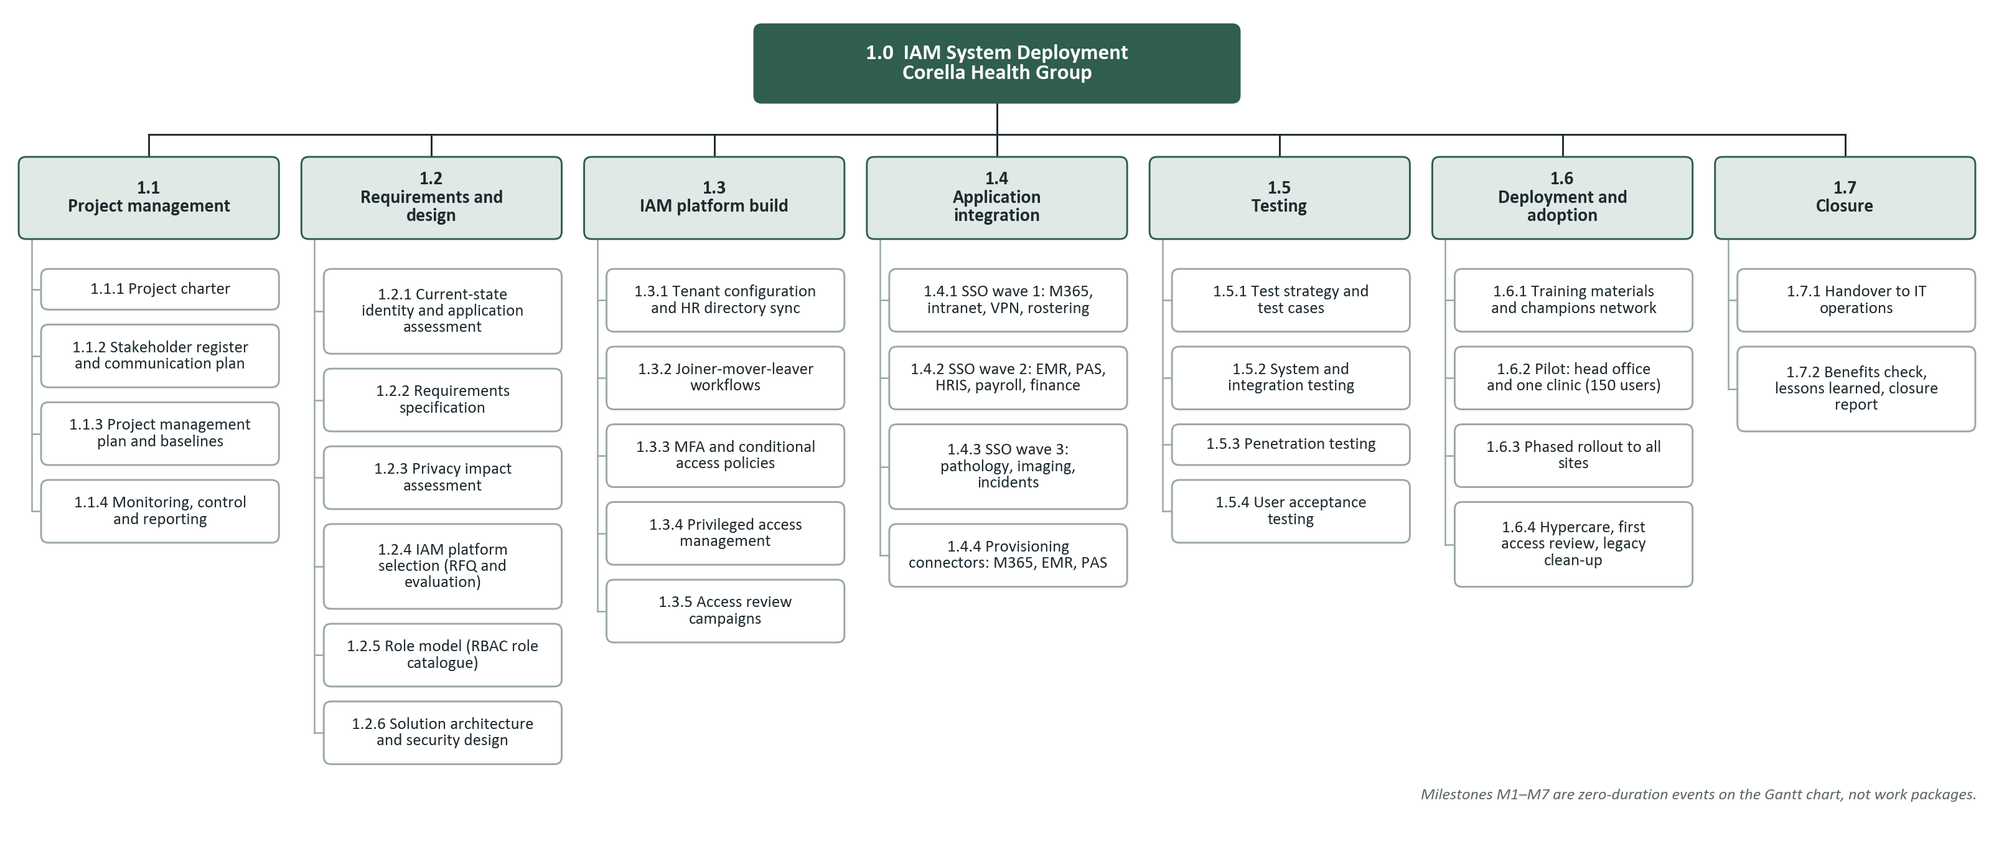
Figure 1. Work breakdown structure: 7 level-2 elements and 29 work packages

6. Project schedule (Gantt chart)
Section owner: Toufiq Ahmed Joy
The schedule was built from the WBS. It uses a five-day working week that leaves out NSW public holidays and CHG's Christmas shutdown (Appendix C), and durations are in working days.
Figure 2 is the Gantt chart. It shows every work package, every dependency link and the seven milestones, with the critical path in red.
The project starts on 2 November 2026, goes live on 16 June 2027 and closes on 28 July 2027. Go-live is before the board's 30 June target, and the close date matches the charter.
Critical path. The 182-day critical path runs through requirements, platform selection, design, MFA policies, the three SSO waves, system and user acceptance testing, pilot, rollout, hypercare and closure; platform selection and SSO wave 2 (EMR and PAS) are watched most closely. Table 8 explains the key dependencies. Test preparation (43 days) and training materials (37 days) have the most float; penetration testing has only 2, so it is managed as near-critical.
Table 8. Key dependencies and why they exist
Link | Type | Reason
1.2.4 evaluation and 1.2.3 privacy impact assessment → M3 contract | Finish-to-start | Data residency is settled before the contract is signed
1.3.3 MFA policies → 1.4.1 SSO wave 1 → waves 2 and 3 | Finish-to-start | No application moves to SSO without MFA in place
1.4.3, 1.4.4, 1.3.4, 1.3.5, 1.5.1 → 1.5.2 system testing | Finish-to-start | Testing starts only when every build and integration package is done
1.3.2 joiner-mover-leaver → 1.4.4 provisioning connectors | Start-to-start + 5 days | Connectors reuse the attribute mappings defined in the first week of 1.3.2
1.6.2 pilot → 1.6.3 rollout | Finish-to-start + 3 days | Leaves time for the go/no-go review after the pilot
Table 9, after the chart, lists each task's dates, predecessors, float and resources.
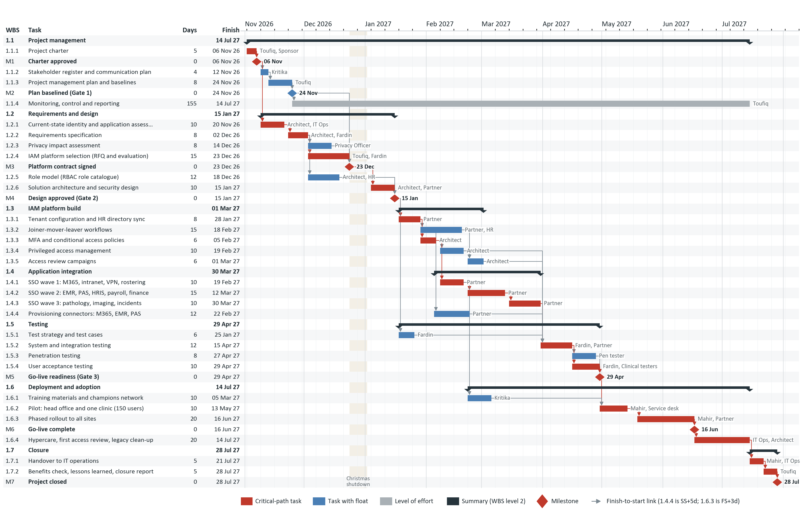
Figure 2. Gantt chart, 2 Nov 2026 to 28 Jul 2027, with dependency links, milestones and the critical path (red). Source: schedule/IAM_Schedule.gan
Table 9. Schedule task list (WBS order). Float 0 = critical path
WBS | Task | Days | Start | Finish | Predecessors | Float | Resources
1.1 | Project management |  | 2 Nov 2026 | 14 Jul 2027
1.1.1 | Project charter | 5 | 2 Nov 2026 | 6 Nov 2026 | - | 0 | Toufiq, Sponsor
M1 | Charter approved | 0 | 6 Nov 2026 | 6 Nov 2026 | 1.1.1 | 0 | Sponsor
1.1.2 | Stakeholder register and communication plan | 4 | 9 Nov 2026 | 12 Nov 2026 | M1 | 10 | Kritika
1.1.3 | Project management plan and baselines | 8 | 13 Nov 2026 | 24 Nov 2026 | 1.1.2 | 10 | Toufiq
M2 | Plan baselined (Gate 1) | 0 | 24 Nov 2026 | 24 Nov 2026 | 1.1.3 | 10 | Sponsor
1.1.4 | Monitoring, control and reporting (level of effort) | 155 | 25 Nov 2026 | 14 Jul 2027 | M2 | – | Toufiq
1.2 | Requirements and design |  | 9 Nov 2026 | 15 Jan 2027
1.2.1 | Current-state identity and application assessment | 10 | 9 Nov 2026 | 20 Nov 2026 | M1 | 0 | Architect, IT Ops
1.2.2 | Requirements specification | 8 | 23 Nov 2026 | 2 Dec 2026 | 1.2.1 | 0 | Architect, Fardin
1.2.3 | Privacy impact assessment | 8 | 3 Dec 2026 | 14 Dec 2026 | 1.2.2 | 7 | Privacy Officer
1.2.4 | IAM platform selection (RFQ and evaluation) | 15 | 3 Dec 2026 | 23 Dec 2026 | 1.2.2 | 0 | Toufiq, Fardin
M3 | Platform contract signed | 0 | 23 Dec 2026 | 23 Dec 2026 | 1.2.4, 1.2.3, M2 | 0 | Sponsor
1.2.5 | Role model (RBAC role catalogue) | 12 | 3 Dec 2026 | 18 Dec 2026 | 1.2.2 | 13 | Architect, HR
1.2.6 | Solution architecture and security design | 10 | 4 Jan 2027 | 15 Jan 2027 | M3 | 0 | Architect, Partner
M4 | Design approved (Gate 2) | 0 | 15 Jan 2027 | 15 Jan 2027 | 1.2.6, 1.2.5 | 0 | Sponsor
1.3 | IAM platform build |  | 18 Jan 2027 | 1 Mar 2027
1.3.1 | Tenant configuration and HR directory sync | 8 | 18 Jan 2027 | 28 Jan 2027 | M4 | 0 | Partner
1.3.2 | Joiner-mover-leaver workflows | 15 | 29 Jan 2027 | 18 Feb 2027 | 1.3.1 | 20 | Partner, HR
1.3.3 | MFA and conditional access policies | 6 | 29 Jan 2027 | 5 Feb 2027 | 1.3.1 | 0 | Architect
1.3.4 | Privileged access management | 10 | 8 Feb 2027 | 19 Feb 2027 | 1.3.3 | 19 | Architect
1.3.5 | Access review campaigns | 6 | 22 Feb 2027 | 1 Mar 2027 | 1.3.2, 1.3.4 | 19 | Architect
1.4 | Application integration |  | 5 Feb 2027 | 30 Mar 2027
1.4.1 | SSO wave 1: M365, intranet, VPN, rostering | 10 | 8 Feb 2027 | 19 Feb 2027 | 1.3.3 | 0 | Partner
1.4.2 | SSO wave 2: EMR, PAS, HRIS, payroll, finance | 15 | 22 Feb 2027 | 12 Mar 2027 | 1.4.1 | 0 | Partner
1.4.3 | SSO wave 3: pathology, imaging, incidents | 10 | 15 Mar 2027 | 30 Mar 2027 | 1.4.2 | 0 | Partner
1.4.4 | Provisioning connectors: M365, EMR, PAS | 12 | 5 Feb 2027 | 22 Feb 2027 | 1.3.2 SS+5d | 24 | Partner
1.5 | Testing |  | 18 Jan 2027 | 29 Apr 2027
1.5.1 | Test strategy and test cases | 6 | 18 Jan 2027 | 25 Jan 2027 | M4 | 43 | Fardin
1.5.2 | System and integration testing | 12 | 31 Mar 2027 | 15 Apr 2027 | 1.4.3, 1.4.4, 1.3.4, 1.3.5, 1.5.1 | 0 | Fardin, Partner
1.5.3 | Penetration testing | 8 | 16 Apr 2027 | 27 Apr 2027 | 1.5.2 | 2 | Pen tester
1.5.4 | User acceptance testing | 10 | 16 Apr 2027 | 29 Apr 2027 | 1.5.2 | 0 | Fardin, Clinical testers
M5 | Go-live readiness (Gate 3) | 0 | 29 Apr 2027 | 29 Apr 2027 | 1.5.3, 1.5.4 | 0 | Sponsor
1.6 | Deployment and adoption |  | 22 Feb 2027 | 14 Jul 2027
1.6.1 | Training materials and champions network | 10 | 22 Feb 2027 | 5 Mar 2027 | 1.4.1 | 37 | Kritika
1.6.2 | Pilot: head office and one clinic (150 users) | 10 | 30 Apr 2027 | 13 May 2027 | M5, 1.6.1 | 0 | Mahir, Service desk
1.6.3 | Phased rollout to all sites | 20 | 19 May 2027 | 16 Jun 2027 | 1.6.2 FS+3d | 0 | Mahir, Partner
M6 | Go-live complete | 0 | 16 Jun 2027 | 16 Jun 2027 | 1.6.3 | 0 | Sponsor
1.6.4 | Hypercare, first access review, legacy clean-up | 20 | 17 Jun 2027 | 14 Jul 2027 | M6 | 0 | IT Ops, Architect
1.7 | Closure |  | 15 Jul 2027 | 28 Jul 2027
1.7.1 | Handover to IT operations | 5 | 15 Jul 2027 | 21 Jul 2027 | 1.6.4 | 0 | Mahir, IT Ops
1.7.2 | Benefits check, lessons learned, closure report | 5 | 22 Jul 2027 | 28 Jul 2027 | 1.7.1 | 0 | Toufiq
M7 | Project closed | 0 | 28 Jul 2027 | 28 Jul 2027 | 1.7.2 | 0 | Sponsor

7. Resource allocation and responsibility matrix
Section owner: Kritika Bhattarai
Table 10 assigns responsibility for each major deliverable using RACI: Responsible (does the work), Accountable (approves it; exactly one per row), Consulted and Informed. Assignments were levelled so that no named person and no IAM Architect is booked on two work packages at once (apart from the level-of-effort package 1.1.4). This is why privileged access management (1.3.4) and access review campaigns (1.3.5) follow the MFA policies (1.3.3) instead of running alongside them.
Table 10. RACI matrix
Deliverable (WBS) | Sponsor | PM (Toufiq) | Res. & Comms (Kritika) | QA Lead (Fardin) | Change & Config (Mahir) | IAM Architect | Partner | HR | IT Ops
Project charter and management plan (1.1.1, 1.1.3) | A | R | C | C | C | C |  | I | I
Stakeholder register and communication plan (1.1.2) | I | A | R | I | I | I | I | C | C
Current-state assessment (1.2.1) | I | A |  | C | C | R |  | C | R
Requirements and privacy impact assessment (1.2.2–1.2.3) | I | A | C | R |  | R |  | C | C
Platform selection and contract (1.2.4, M3) | A | R | I | R | I | C |  |  | C
Role model (1.2.5) | I | A |  | C | I | R | C | R | I
Solution architecture and security design (1.2.6) | I | A | I | C | C | R | C | I | C
Platform build: JML, MFA, PAM, access reviews (1.3) |  | I | I | C | I | A | R | C | C
SSO and provisioning integration (1.4) |  | I | I | C | I | A | R |  | C
Testing: system, penetration, user acceptance (1.5) | I | I | C | A | I | C | R |  | C
Training and adoption (1.6.1) | I | I | A | C | R | C | C | C | R
Pilot, rollout and hypercare (1.6.2–1.6.4) | I | A | C | C | R | C | R | I | R
Risk register and issue log | I | A | R | C | C | C | I | I | I
Change control and configuration management | C | A | I | C | R | C | C |  | I
Quality assurance reviews and audits | I | A | I | R | C | C | C |  | I
Handover and closure report (1.7) | A | R | C | C | R | C | I | I | C
Table 11 estimates labour and other costs. Rates are fully loaded, assume a 38-hour week and exclude GST. The contingency reserve equals the total expected monetary value of the risks in Section 8.
Table 11. Resource and cost estimate (AUD)
Resource or item | Person or source | Allocation | Hours | Rate/h | Cost
Project Manager | Toufiq Ahmed Joy | 100% × 39 wks | 1,482 | 115 | 170,430
Resource and Communications Manager | Kritika Bhattarai | 50% × 39 wks | 741 | 90 | 66,690
Quality Assurance Lead | Fardin Rahman Tanvir | 50% × 39 wks | 741 | 90 | 66,690
Change and Configuration Manager | Ahmed Mahir Daiyan | 50% × 39 wks | 741 | 90 | 66,690
IAM Architect (contract) | To be engaged | 80% × 35 wks | 1,064 | 150 | 159,600
HR systems analyst | People and Culture | 20% × 20 wks | 152 | 75 | 11,400
Service desk and IT operations | IT Operations | 50% × 16 wks | 304 | 70 | 21,280
Implementation partner (fixed-price SOW) |  |  |  |  | 185,000
IAM platform subscription, year 1 (1,500 identities) |  |  |  |  | 162,000
FIDO2 security keys for shared workstations and admins (650) |  |  |  |  | 55,250
Independent penetration test |  |  |  |  | 28,000
UAT backfill shifts for clinical testers |  |  |  |  | 32,000
Training delivery and materials |  |  |  |  | 15,000
Work package estimate |  |  |  |  | 1,040,030
Contingency reserve (risk EMV, Section 8) |  |  |  |  | 159,000
Cost baseline |  |  |  |  | 1,199,030
Management reserve (sponsor) |  |  |  |  | 50,970
Budget ceiling |  |  |  |  | 1,250,000

8. Risk management plan
Section owner: Toufiq Ahmed Joy
The process follows ISO 31000 [14] and the PMBOK Guide's risk domain [12]:
- Identify risks at kickoff, from the current-state assessment and the research in Section 2, and again at each gate.
- Analyse each risk first by score, using the 5 × 5 scales in Table 12, then in dollars as expected monetary value (EMV = probability × cost impact).
- Plan responses: avoid, mitigate, transfer or accept. Every risk has a mitigation (done beforehand) and a contingency (done if it happens).
- Monitor triggers through each risk's owner. The register is reviewed weekly with clinical and IT staff present [15], top risks go to the sponsor monthly, and the register is version-controlled in risk/risk_register.csv.
Table 12. Probability and impact scales
Score | Probability | Impact (the highest of cost, schedule or clinical effect)
1 | Rare (< 10%) | Negligible: < AUD 5,000; < 2 days; no clinical effect
2 | Unlikely (10–29%) | Minor: AUD 5,000 to < 20,000; 2–5 days; workaround available
3 | Possible (30–49%) | Moderate: AUD 20,000 to < 50,000; 1–2 weeks; disruption at one site
4 | Likely (50–69%) | Major: AUD 50,000 to < 100,000; 2–4 weeks; clinical access disrupted at several sites
5 | Almost certain (≥ 70%) | Severe: ≥ AUD 100,000; > 4 weeks or a milestone missed; patient-safety effect
Score = probability × impact: 1–4 Low, 5–9 Medium, 10–16 High, 20–25 Extreme.
Table 13. Probability × impact matrix showing where each risk sits
Probability ↓ / Impact → | 1 Negligible | 2 Minor | 3 Moderate | 4 Major | 5 Severe
5 Almost certain
4 Likely |  |  | R03 | R02
3 Possible |  | R06 | R05, R07, R10 | R01, R09
2 Unlikely |  |  | R12 | R04, R11 | R08
1 Rare
Quantitative analysis. Table 14 gives the EMV of the 5 High risks. The EMVs of all 12 risks add up to AUD 158,400, which is rounded up to a contingency reserve of AUD 159,000. The project manager can release contingency only for a risk that has occurred, and records each release in the change log.
Table 14. Expected monetary value of High risks (AUD)
ID | Risk | Probability | Cost impact | EMV
R01 | EMR or PAS cannot support modern SSO (SAML/OIDC), needing a custom connector | 40% | 60,000 | 24,000
R02 | Inaccurate HR data (job codes, managers, end dates) grants wrong access or removes access in error | 50% | 40,000 | 20,000
R03 | Clinicians resist MFA at shared ward workstations and adopt workarounds | 60% | 30,000 | 18,000
R09 | Credential phishing attack succeeds during the transition while old and new sign-ins coexist | 30% | 60,000 | 18,000
R08 | Misconfigured conditional access policy locks users or administrators out | 20% | 80,000 | 16,000
 | All 12 risks (contingency basis) |  |  | 158,400
The full register is shown in Table 15 on the next page.
Table 15. Risk register (all risks open at baseline; P = probability score, I = impact score, EMV in AUD)
ID | Risk | Category | P | I | Score | EMV | Owner | Response | Mitigation (before) | Contingency (if it happens) | Trigger
R01 | EMR or PAS cannot support modern SSO (SAML/OIDC), needing a custom connector | Technical | 3 | 4 | 12 High | 24,000 | IAM Architect | Mitigate | Confirm protocol support for every in-scope app during the current-state assessment (1.2.1); make vendor-confirmed connectors a mandatory RFQ criterion | Front the app with an application proxy or password-vaulting SSO and move it to wave 3 | App vendor cannot confirm SAML/OIDC support by Gate 2
R02 | Inaccurate HR data (job codes, managers, end dates) grants wrong access or removes access in error | Data / privacy | 4 | 4 | 16 High | 20,000 | Kritika (with HR) | Mitigate | HR data cleansing before 1.3.2; run leaver automation in report-only mode for two weeks with daily reconciliation | Switch affected changes to a manual approval queue; restore wrongly removed clinical access through the break-glass process within 15 minutes | Reconciliation mismatch above 2% of records
R03 | Clinicians resist MFA at shared ward workstations and adopt workarounds | People | 4 | 3 | 12 High | 18,000 | Kritika | Mitigate | Tap-and-go FIDO2 security keys for shared workstations; clinical champions at every site; nurses in UAT | Extend that site's rollout by one week with floor-walkers and extra keys | Site MFA enrolment below 80% two weeks after rollout
R04 | Implementation partner loses or reassigns a key integration engineer | Vendor | 2 | 4 | 8 Medium | 12,500 | Toufiq | Transfer | Named-resource clause with 10-day replacement and service credits; configuration documented in GitHub | Call on the standing-offer second partner; resequence SSO waves to protect the critical path | Key engineer absent for more than 5 working days
R05 | Platform procurement and contract negotiation run late, delaying design | Schedule | 3 | 3 | 9 Medium | 10,000 | Toufiq | Mitigate | Issue the RFQ in week 3 with a pre-approved contract template; legal engaged from kickoff | Start role model and test strategy early and use the vendor's trial tenant for design | Contract not signed by the M3 date
R06 | Licence prices rise (USD-priced quote or exchange rate) before contract signature | Budget | 3 | 2 | 6 Medium | 5,400 | Toufiq | Mitigate | Require AUD-denominated pricing held for 90 days in the RFQ | Draw on contingency; license lower-risk contractor identities on a cheaper tier | Final quote exceeds the baseline licence line by more than 5%
R07 | Clinical staff unavailable for UAT because of roster pressure | Organisational | 3 | 3 | 9 Medium | 8,000 | Fardin | Mitigate | Book testers six weeks ahead with funded backfill shifts; agree dates with the Director of Nursing | Add evening UAT sessions and test critical clinical scenarios first; if UAT still slips, shorten the pilot from 10 to 7 days with sponsor approval | Fewer than 70% of booked testers attend in UAT week 1
R08 | Misconfigured conditional access policy locks users or administrators out | Technical | 2 | 5 | 10 High | 16,000 | IAM Architect | Mitigate | Two monitored break-glass accounts excluded from policies; policies run in report-only mode first; every policy change peer-reviewed through change control | Invoke the rollback runbook and break-glass access; communicate through the service desk | More than 20 lockouts in one hour
R09 | Credential phishing attack succeeds during the transition while old and new sign-ins coexist | External | 3 | 4 | 12 High | 18,000 | IAM Architect | Mitigate | MFA for remote access and admin accounts in wave 1; sign-in risk alerts monitored daily | Run the cyber incident response plan; assess for a notifiable data breach to the OAIC | Risky sign-in alert or user report of a suspicious prompt
R10 | Departments push extra applications into phase 1 (scope creep) | Organisational | 3 | 3 | 9 Medium | 13,500 | Mahir | Avoid | Signed scope statement with a named out-of-scope list; all requests through the change control board | CCB defers new apps to the phase 2 backlog; contingency used only with sponsor approval | More than two change requests for new apps in a month
R11 | Identity or audit data stored offshore conflicts with privacy obligations | Data / privacy | 2 | 4 | 8 Medium | 10,000 | Fardin (with Privacy Officer) | Avoid | Australian data residency as a mandatory RFQ criterion; privacy impact assessment (1.2.3) before contract | Select the vendor's Australian region or the runner-up vendor | PIA identifies offshore storage of personal information
R12 | Project manager or a workstream lead unavailable for an extended period | People | 2 | 3 | 6 Medium | 3,000 | Toufiq | Accept | Named deputy for each role; decisions and plans kept in GitHub and Jira | Deputy steps in; re-baseline the schedule through change control if needed | Absence longer than 10 working days

9. Issue management strategy
Section owner: Kritika Bhattarai
A risk might happen; an issue has happened and needs action now. When a risk occurs, its owner starts the contingency and logs an issue. Table 16 sets out how issues are handled. The log is reviewed weekly, P1 issues are reviewed daily until closed, and open issues go in the monthly sponsor report.
Table 16. Issue handling steps
Step | What happens | Who
1. Log | Record the issue within one working day as a Jira card of type Issue; the issue log (templates/issue_log.csv) mirrors it | Anyone
2. Prioritise | Set priority P1–P4 using Table 17 | Workstream lead
3. Assign | Name a single owner and a target date | Workstream lead
4. Escalate | If not resolved within the response time, escalate as in the priority table. An issue that needs more time, money or scope becomes a change request (Section 10) | Owner
5. Close | Record the action taken and close. If the issue revealed a new risk, add it to the register | Owner; project manager closes
Table 17. Issue priorities, response times and escalation
Priority | Definition | Owner assigned | Escalate if unresolved
P1 Critical | Stops clinical work, go-live or a gate, or is a security incident | Within 2 hours | Project manager immediately; sponsor within 24 hours
P2 High | Threatens a critical-path task or milestone date | Within 1 working day | Project manager after 2 days; sponsor or CCB after 5 days
P3 Medium | Affects a task that still has float | Within 3 working days | Workstream lead, then project manager after 10 days
P4 Low | Minor; no schedule effect | Next weekly meeting | Project manager at the weekly review
Table 18. Issue log (I-001 and I-002 are examples of how to fill it in; I-003 is a real issue from preparing this plan)
ID | Raised | Description | By | Priority | Owner | Action | Status | Closed
I-001 | 12 Jan 2027 | HR export has no end dates for 41 contractor records, so leaver rules cannot run for them | IAM Architect | P2 | Kritika (with HR) | HR backfills end dates; contractor coordinator confirms them | Closed | 20 Jan 2027
I-002 | 2 Mar 2027 | Pathology portal vendor's test environment is unavailable for wave 3 | Partner | P3 | Mahir | Vendor escalation; test against staging copy if not fixed in 5 days | Open
I-003 | 25 Oct 2026 | Plan pull requests #1–#4 were merged into main without the required review (#4 by admin bypass), and #4 placed files in the repository root instead of plan/sections/ | Toufiq | P2 | Toufiq | Retrospective review comments on #1–#3; Fardin re-submits #4's files to plan/sections/ through a reviewed pull request; no more admin bypass | Open

10. Change request and change management process
Section owner: Ahmed Mahir Daiyan
Change control protects the scope, schedule and cost baselines approved at Gate 1. Figure 3 shows the process.
- Raise: anyone can submit a change request (CR) on the form in Table 19.
- Log: within one working day the Change and Configuration Manager logs it as CR-###.
- Assess: within five days the project manager, IAM Architect and QA Lead assess its impact on scope, time, cost, quality and risk.
- Decide: the board in Table 20 decides, within the approval limits in the figure.
- Implement: approved changes are made on a GitHub branch (cr-###), merged after the QA Lead reviews them, and saved as a new tagged baseline.
- Close: every decision is recorded in the change log (Table 21).
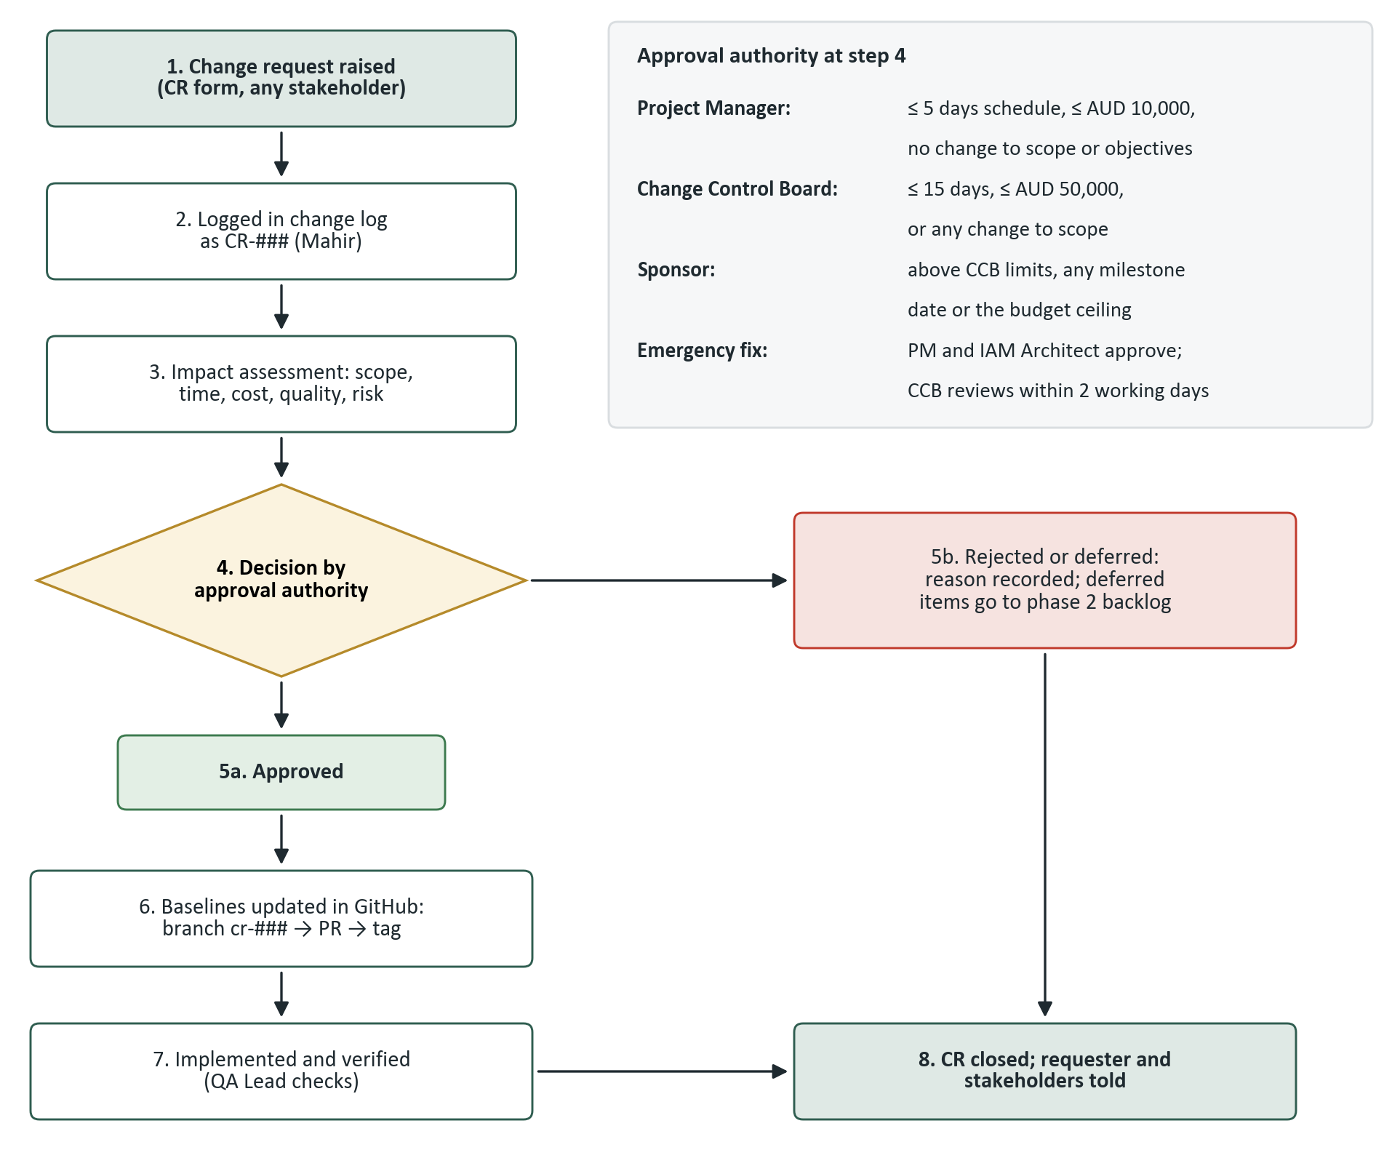
Figure 3. Change control process and approval authority
Table 19. Change request form template
CR ID and date raised | CR-### (assigned by Change and Configuration Manager); dd/mm/yyyy
Requested by | Name, role, department
Description of change
Reason and benefit
WBS elements affected | e.g. 1.4.3, M5
Impact: scope | Deliverables added, removed or changed
Impact: schedule | Working days; milestones moved; effect on critical path
Impact: cost | AUD; funding source (contingency, management reserve, new funds)
Impact: quality and risk | Effect on acceptance criteria; new or changed risks (IDs)
Urgency | Normal / urgent / emergency
Recommendation | Project manager's recommendation and options considered
Decision | Approved / rejected / deferred, with reason; approver name and date
Implementation | Owner; GitHub branch and baseline tag; Jira card
Table 20. Change control board (meets fortnightly, or within two working days for an urgent CR)
CCB role | Member | Part in decisions
Chair | Catherine Doyle, Chief Operating Officer (sponsor) | Final approval; casting vote
Members | Project manager (presents CRs); IAM Architect; IT Operations Manager; QA Lead; Director of Nursing's delegate (clinical impact) | Vote
Secretary | Change and Configuration Manager (Mahir) | Keeps the change log; no vote
Table 21. Change log (the two rows are examples of how to fill it in)
ID | Date | Change | Impact | Decision | Approver | Baseline | Status
CR-001 | 18 Feb 2027 | Add the dental practice system to phase 1 SSO | +8 days on wave 3; +AUD 22,000 | Deferred to phase 2 | CCB | – | Closed
CR-002 | 1 Mar 2027 | Extra night-shift training sessions at the day hospital | 0 days (1.6.1 has float); +AUD 3,500 from contingency | Approved | Project manager | baseline-1.1 | Closed

11. Configuration management (GitHub)
Section owner: Ahmed Mahir Daiyan
Every project artefact that defines a baseline is a configuration item and is kept under version control in one GitHub repository:
https://github.com/AR13X3/iam-deployment-project-plan
Table 22. Repository structure
Folder or file | Contents | Owner
README.md | Purpose, folder guide, branch and commit rules, how to raise a CR | Mahir
plan/ | Plan drafts and released versions (.docx) | Toufiq
schedule/ | GanttProject source (IAM_Schedule.gan), schedule.csv, Gantt image | Toufiq
wbs/ | WBS outline (wbs.csv) and diagram | Toufiq
risk/ | Risk register (risk_register.csv) | Toufiq
change-management/ | Change log, CR form and process flowchart | Mahir
templates/ | Issue log, status report and CR templates | Kritika
config/ (from build) | Exported IAM platform configuration (access policies, role definitions, provisioning mappings) as JSON | IAM Architect
Table 23. Version-control rules
Practice | Rule
Branches | main is protected. Each owner works on a branch for their area (charter, schedule, risk, change-management, quality, communication) and merges through a pull request approved by another member. Approved change requests use cr-### branches
Commits | One commit per meaningful change, with an imperative message naming the area, e.g. risk: add EMV for high risks or schedule: add SS+5d link for 1.4.4
Versions | Drafts are tagged v0.x; the released plan is GitHub Release v1.0; later approved baselines are tagged baseline-1.x
Readable history | Risk register, schedule, WBS and logs are kept as CSV alongside the .docx so changes show line by line
Status accounting and audit | At each gate the QA Lead checks that the tagged baseline matches the approved documents and the change log
During the build, platform configuration (MFA and conditional access policies, role definitions, provisioning mappings) is exported to config/, so every production change can be traced to an approved CR. Figure 4, Figure 5 and Figure 6 show the repository.
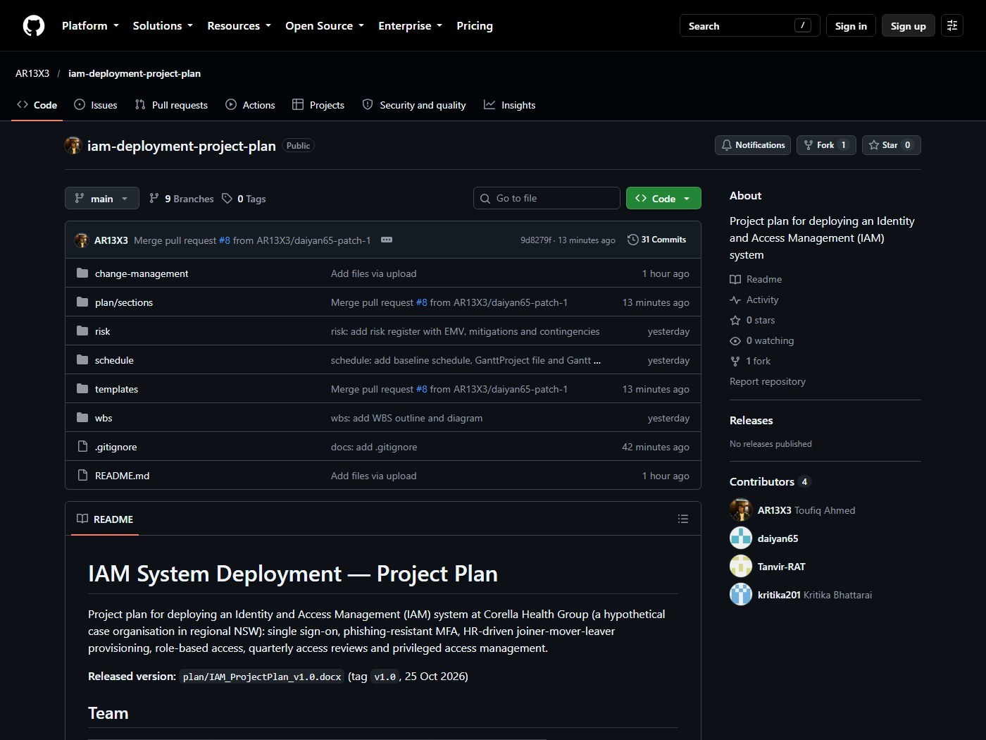
Figure 4. Repository README
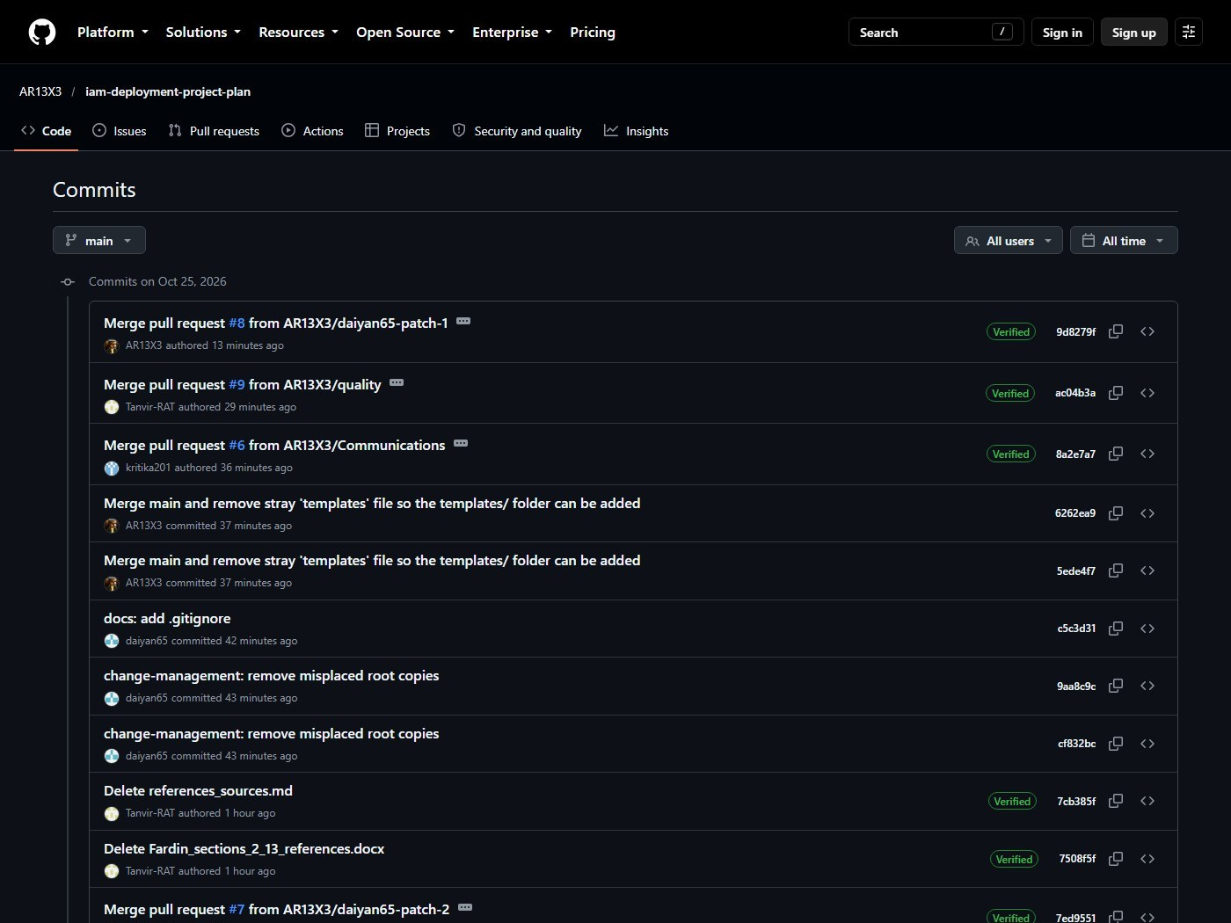
Figure 5. Commit history
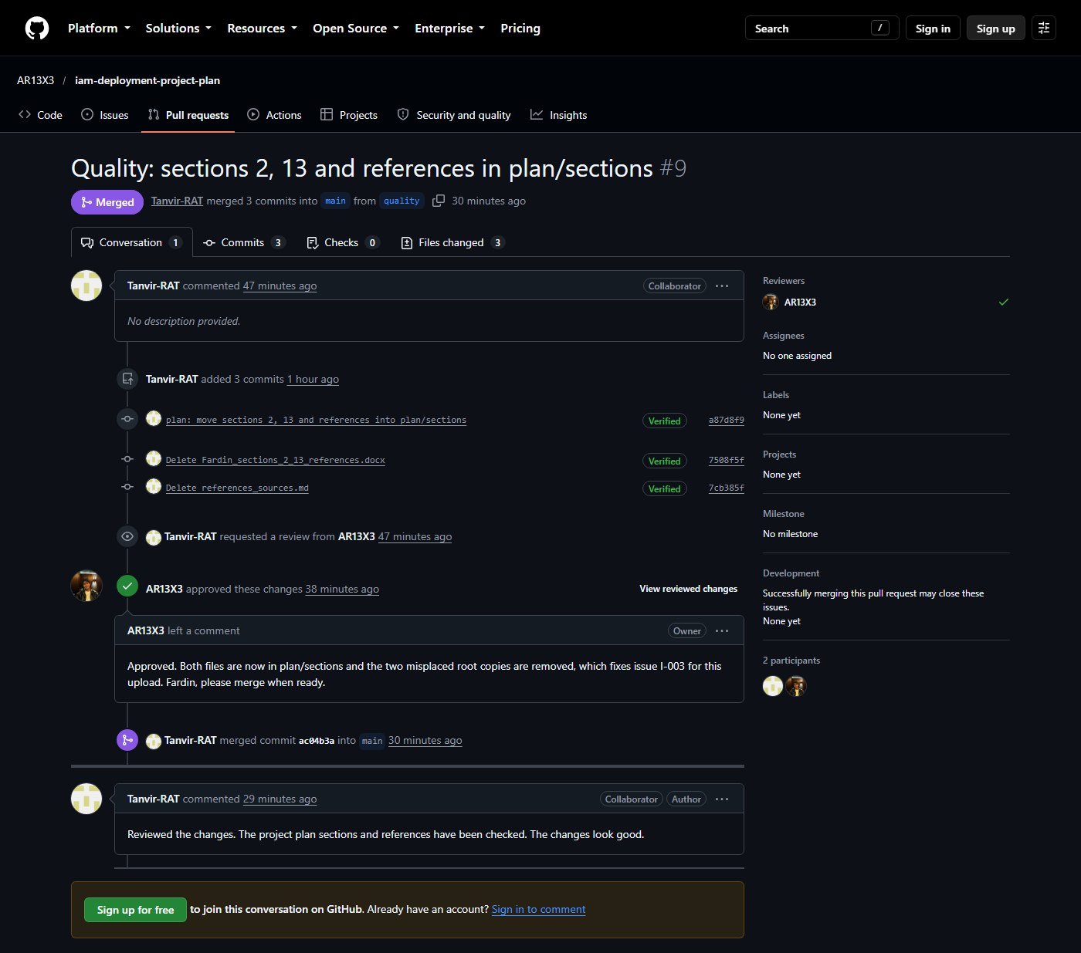
Figure 6. Merged pull request with review

12. Communication management plan
Section owner: Kritika Bhattarai
Table 24 lists every stakeholder from the charter, plus the project team and the CCB. For each it shows what they need to know, how and how often they hear it, and who sends it. The tools are:
- Microsoft Teams for meetings: a 15-minute stand-up three times a week and a weekly status meeting;
- Jira for tracking tasks;
- GitHub for documents and baselines;
- email and the intranet for reaching staff.
Problems are escalated as set out in Section 9.
Table 24. Communication plan
Stakeholder | Information needed | Method | Frequency | Owner
Project sponsor | Status against baseline; top risks and issues; decisions needed | One-page status report and 30-minute meeting | Fortnightly; at each gate | Toufiq
Executive leadership team and Board Audit and Risk Committee | Progress to the Essential Eight target; budget; key risks | Written briefing | Monthly (ELT); quarterly (committee) | Toufiq
Head of Information Technology | Design decisions; handover readiness | Steering meeting; design reviews | Fortnightly | Toufiq
IT operations and service desk | Build progress; runbooks; rollout dates; known issues | Teams channel; weekly operations sync; knowledge articles | Weekly; daily during rollout | Mahir
Clinical staff and the Director of Nursing | What changes, when; how to enrol; where to get help | Champions at site huddles; intranet news; quick-reference cards | Monthly; weekly from 4 weeks before their site goes live | Kritika
Administrative and corporate staff | What changes, when; how to enrol | Email; intranet; short videos | Monthly; weekly before rollout | Kritika
Contractors, agency staff and visiting medical officers | Enrolment steps; how to request access | Email through agency coordinators; onboarding pack | At onboarding and before rollout | Kritika
People and Culture (HR) | Data quality issues; changed joiner-mover-leaver process | Working session | Weekly during design and build; then fortnightly | Kritika
Privacy Officer and compliance | Privacy impact assessment; data residency; audit evidence | Meeting and assessment report | During 1.2.3 and at each gate | Fardin
IAM platform vendor and implementation partner | Tasks, defects, change requests | Jira board; weekly delivery meeting | Weekly | Toufiq
Application owners | Integration dates; test windows; cut-over and rollback plans | Email and integration meeting | 2 weeks before and during their wave | Mahir
Project team | Tasks, blockers, decisions | Jira; Teams stand-up; GitHub pull requests | Stand-up 3 times a week; weekly status meeting | Toufiq
Change control board | CRs with impact assessments | CR pack and meeting | Fortnightly, or within 2 days if urgent | Mahir

13. Quality management approach
Section owner: Fardin Rahman Tanvir
Standards. Project quality management follows the principles of ISO 9001:2026 [16]. The IAM system is designed to support CHG's information security management system under ISO/IEC 27001:2022 [17], in particular its controls for access control, identity management, authentication information, access rights, privileged access and secure authentication. Authentication follows NIST SP 800-63B-4 [6], and the target is Essential Eight Maturity Level Two [7].
Table 25 separates quality assurance (is the process right?) from quality control (is the product right?). Table 26 sets measurable targets.
Table 25. Quality assurance and quality control activities
Quality assurance (process) | Quality control (product)
- Every deliverable is peer-reviewed through a GitHub pull request before merging  - Gate reviews at M2, M4 and M5 check entry and exit criteria  - The QA Lead audits the risk register and change log at the midpoint of the build  - The partner's configuration is reviewed against the approved design before testing | - System test cases are traced to every requirement  - UAT uses real clinical scenarios  - Independent penetration test, retested after fixes  - Reconciliation reports confirm MFA enrolment and joiner-mover-leaver results  - Acceptance criteria (Section 4) checked before sign-off
Table 26. Quality metrics
Metric | Target | Method | When | Owner
Requirements covered by test cases | 100% | Traceability matrix | Before system testing | Fardin
System and UAT test cases passed | ≥ 95%; no open severity 1–2 defects | Test log | Gate 3 | Fardin
Penetration-test findings | No open high or critical findings | Test report and retest | Before M5 | IAM Architect
SSO sign-in success rate | ≥ 99.5% | Platform sign-in logs | Daily in rollout; then weekly | IT Ops
Phishing-resistant MFA enrolment | 100% of in-scope identities | Enrolment report | Weekly in rollout | Mahir
Leaver access removal | ≤ 4 hours | Monthly sample of 30 HR terminations against application logs | Monthly from go-live | Fardin
New starters with access on day one | ≥ 95% | Joiner report and onboarding survey | Monthly | Kritika
Orphaned accounts in in-scope apps | 0 | Account reconciliation | End of hypercare; then quarterly | IAM Architect
Privileged accounts | ≤ 12, all with FIDO2 keys | PAM report | Go-live; then quarterly | IAM Architect
Deliverables peer-reviewed before merge | 100% | GitHub pull request history | Each gate | Mahir
Password-reset tickets | 50% fewer than Q1 2027 | Service desk reports | 3 months after go-live | IT Ops
Staff satisfaction with sign-in | ≥ 4 out of 5 | Pulse survey | 4 weeks after each site goes live | Kritika

14. Conclusion
Section owner: Kritika Bhattarai
This plan turns CHG's audit findings into a funded, scheduled project. Research shows only phishing-resistant MFA meets the Essential Eight benchmark (Section 2). Seven measurable objectives (Section 3) and a charter with 12 in-scope applications and a AUD 1,250,000 ceiling (Section 4) set the boundaries. 29 work packages and seven milestones (Section 5) run 182 working days to 28 Jul 2027, with go-live on 16 Jun 2027 (Section 6).
Each deliverable has one accountable owner within a AUD 1,199,030 cost baseline (Section 7). 12 risks, 5 High, each have a mitigation, contingency and trigger, and their EMV funds the AUD 159,000 contingency (Section 8). Issues follow four priority levels (Section 9); changes pass approval limits and a change control board (Section 10) into tagged GitHub baselines (Section 11). All 13 stakeholder groups are reached on a fixed schedule (Section 12), and 12 quality measures each have a target and owner (Section 13). The next step is the sponsor's approval of the charter (M1).

References
Section owner: Fardin Rahman Tanvir
[1] Verizon Business, “2026 Data Breach Investigations Report: Executive summary,” Verizon, Rep. OGES2110526, May 2026. Accessed: Oct. 24, 2026. [Online]. Available: https://www.verizon.com/business/resources/executivebriefs/2026-dbir-executive-summary.pdf
[2] Office of the Australian Information Commissioner, “Data breach notifications increase to all-time high in 2025, new NDB stats show,” Media release, Jul. 6, 2026. Accessed: Oct. 24, 2026. [Online]. Available: https://www.oaic.gov.au/news/media-centre/data-breach-notifications-increase-to-all-time-high-in-2025,-new-ndb-stats-show
[3] Office of the Australian Information Commissioner, “Notifiable Data Breaches Report: July to December 2024,” May 13, 2025. Accessed: Oct. 24, 2026. [Online]. Available: https://www.oaic.gov.au/privacy/notifiable-data-breaches/notifiable-data-breaches-publications/notifiable-data-breaches-report-july-to-december-2024
[4] L. A. Meyer, S. Romero, G. Bertoli, T. Burt, A. Weinert, and J. Lavista Ferres, “How effective is multifactor authentication at deterring cyberattacks?,” arXiv:2305.00945, May 2023, doi: 10.48550/arXiv.2305.00945.
[5] Cybersecurity and Infrastructure Security Agency, “Implementing phishing-resistant MFA,” Fact sheet, Oct. 2022. Accessed: Oct. 24, 2026. [Online]. Available: https://www.cisa.gov/sites/default/files/publications/fact-sheet-implementing-phishing-resistant-mfa-508c.pdf
[6] D. Temoshok et al., “Digital identity guidelines: Authentication and authenticator management,” National Institute of Standards and Technology, Gaithersburg, MD, USA, NIST SP 800-63B-4, Jul. 2025, doi: 10.6028/NIST.SP.800-63b-4.
[7] Australian Signals Directorate, “Essential Eight maturity model,” Australian Cyber Security Centre, Nov. 27, 2023. Accessed: Oct. 24, 2026. [Online]. Available: https://www.cyber.gov.au/publication/essential-eight-maturity-model
[8] W. J. Gordon et al., “Assessment of employee susceptibility to phishing attacks at US health care institutions,” JAMA Netw. Open, vol. 2, no. 3, Mar. 2019, Art. no. e190393, doi: 10.1001/jamanetworkopen.2019.0393.
[9] J. Reynolds et al., “Empirical measurement of systemic 2FA usability,” in Proc. 29th USENIX Secur. Symp., Aug. 2020, pp. 127–143.
[10] U. N. Cobrado, S. Sharief, N. G. Regahal, E. Zepka, M. Mamauag, and L. C. Velasco, “Access control solutions in electronic health record systems: A systematic review,” Inform. Med. Unlocked, vol. 49, 2024, Art. no. 101552, doi: 10.1016/j.imu.2024.101552.
[11] S. Rose, O. Borchert, S. Mitchell, and S. Connelly, “Zero trust architecture,” National Institute of Standards and Technology, Gaithersburg, MD, USA, NIST SP 800-207, Aug. 2020, doi: 10.6028/NIST.SP.800-207.
[12] Project Management Institute, A Guide to the Project Management Body of Knowledge (PMBOK Guide), 8th ed. Newtown Square, PA, USA: PMI, 2025.
[13] Project, Programme and Portfolio Management — Guidance on Project Management, ISO 21502:2020, International Organization for Standardization, Geneva, Switzerland, Dec. 2020.
[14] Risk Management — Guidelines, ISO 31000:2018, International Organization for Standardization, Geneva, Switzerland, Feb. 2018.
[15] P. Willumsen, J. Oehmen, V. Stingl, and J. Geraldi, “Value creation through project risk management,” Int. J. Proj. Manag., vol. 37, no. 5, pp. 731–749, Jul. 2019, doi: 10.1016/j.ijproman.2019.01.007.
[16] Quality Management Systems — Requirements, ISO 9001:2026, International Organization for Standardization, Geneva, Switzerland, Sep. 2026.
[17] Information Security, Cybersecurity and Privacy Protection — Information Security Management Systems — Requirements, ISO/IEC 27001:2022, International Organization for Standardization, Geneva, Switzerland, Oct. 2022.

Appendix A. Jira project evidence
Section owner: Ahmed Mahir Daiyan
The Jira Scrum project holds one epic for the plan and one card per section, each assigned to its owner with a due date. The screenshots below show the board during the sprint, the backlog, a card's comments and history, and the timeline.
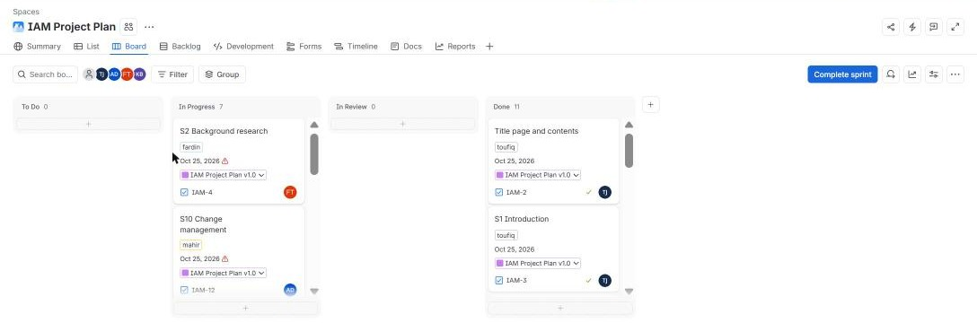
Figure 7. Jira board during the sprint
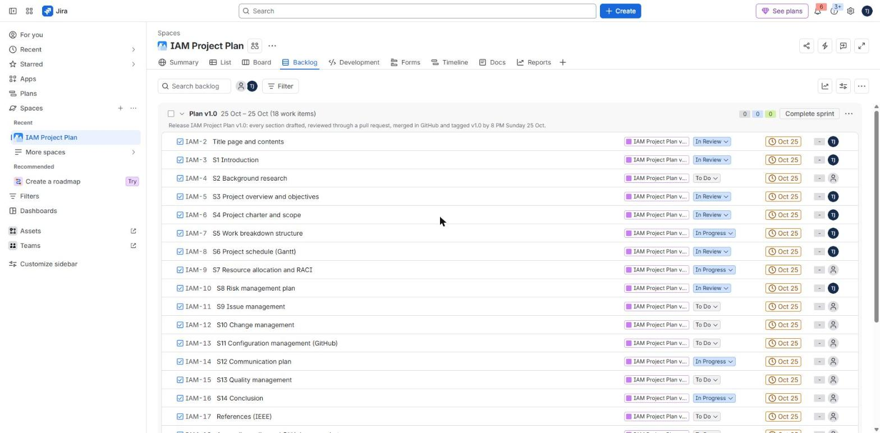
Figure 8. Jira backlog
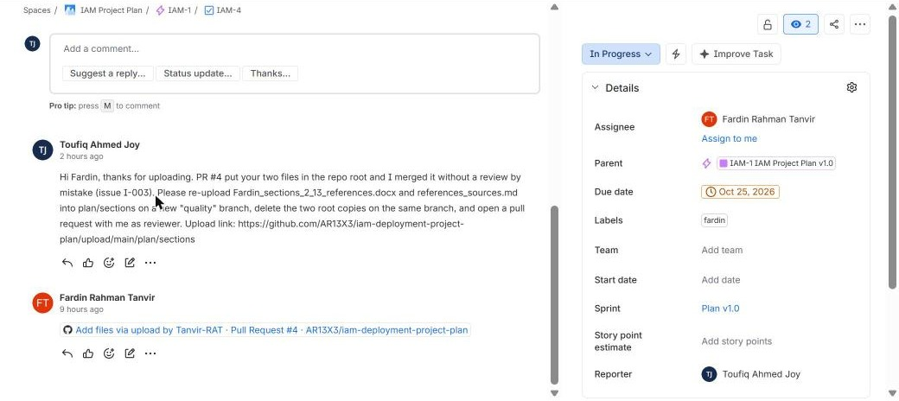
Figure 9. Card comments and history
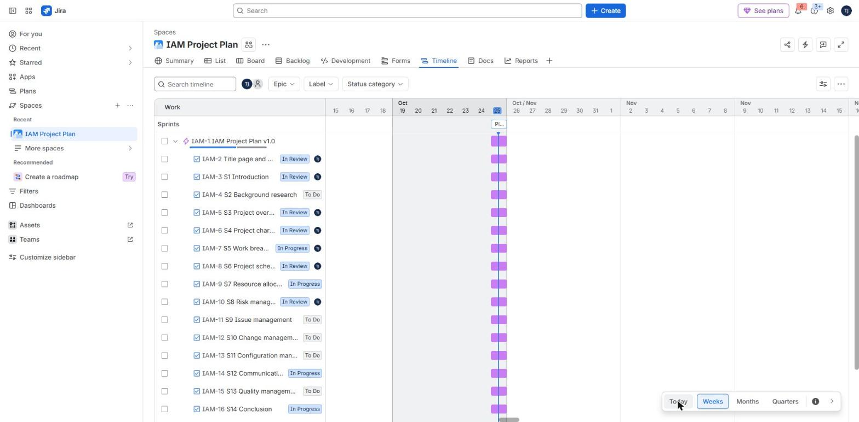
Figure 10. Jira timeline

Appendix B. GitHub history
Section owner: Ahmed Mahir Daiyan
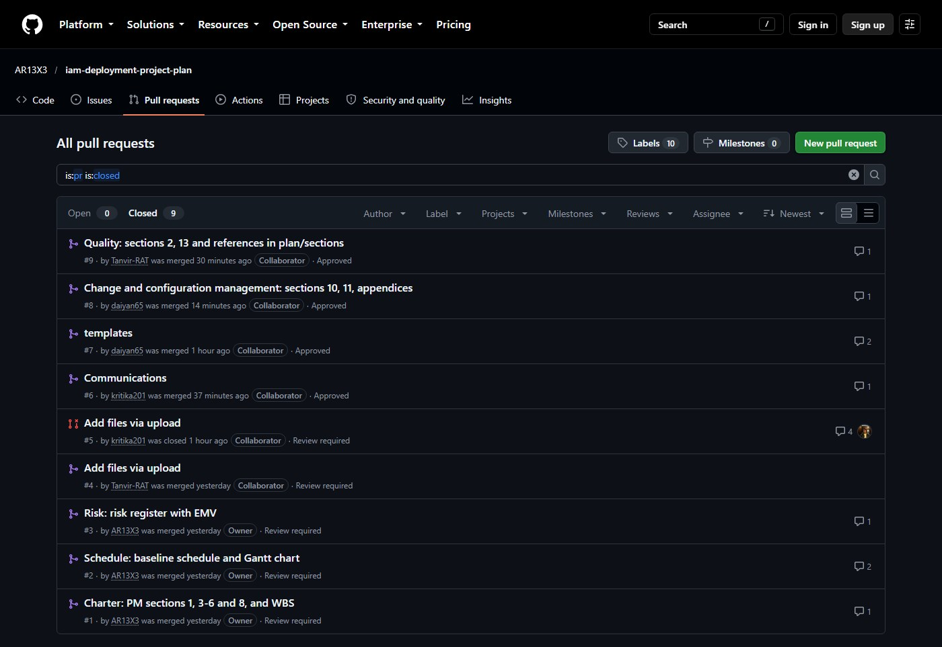
Figure 11. Merged pull requests

Appendix C. Working calendar
Section owner: Ahmed Mahir Daiyan
The schedule uses a Monday-to-Friday calendar with these non-working days. All other weekdays are working days.
Table 27. Non-working weekdays in the schedule
Date | Reason
24 Dec 2026 | Christmas shutdown
25 Dec 2026 | Christmas Day
28 Dec 2026 | Boxing Day (additional day)
29 Dec 2026 | Christmas shutdown
30 Dec 2026 | Christmas shutdown
31 Dec 2026 | Christmas shutdown
1 Jan 2027 | New Year's Day
26 Jan 2027 | Australia Day
26 Mar 2027 | Good Friday
29 Mar 2027 | Easter Monday
14 Jun 2027 | King's Birthday

