IAM SYSTEM DEPLOYMENT — PROJECT PLAN v1.0
Sections 10 and 11, and Appendices A–C
Ahmed Mahir Daiyan · Change and Configuration Manager
Your sections only, taken from the full plan (plan/IAM_ProjectPlan_v1.0.docx). Table, figure and reference numbers match the full plan, so some numbers are skipped. If you change anything here, send the change to Toufiq so it goes into the full plan before release.

10. Change request and change management process
Section owner: Ahmed Mahir Daiyan
Change control protects the scope, schedule and cost baselines approved at Gate 1. Figure 3 shows the process.
- Raise: anyone can submit a change request (CR) on the form in Table 19.
- Log: within one working day the Change and Configuration Manager logs it as CR-###.
- Assess: within five days the project manager, IAM Architect and QA Lead assess its impact on scope, time, cost, quality and risk.
- Decide: the board in Table 20 decides, within the approval limits in the figure.
- Implement: approved changes are made on a GitHub branch (cr-###), merged after the QA Lead reviews them, and saved as a new tagged baseline.
- Close: every decision is recorded in the change log (Table 21).
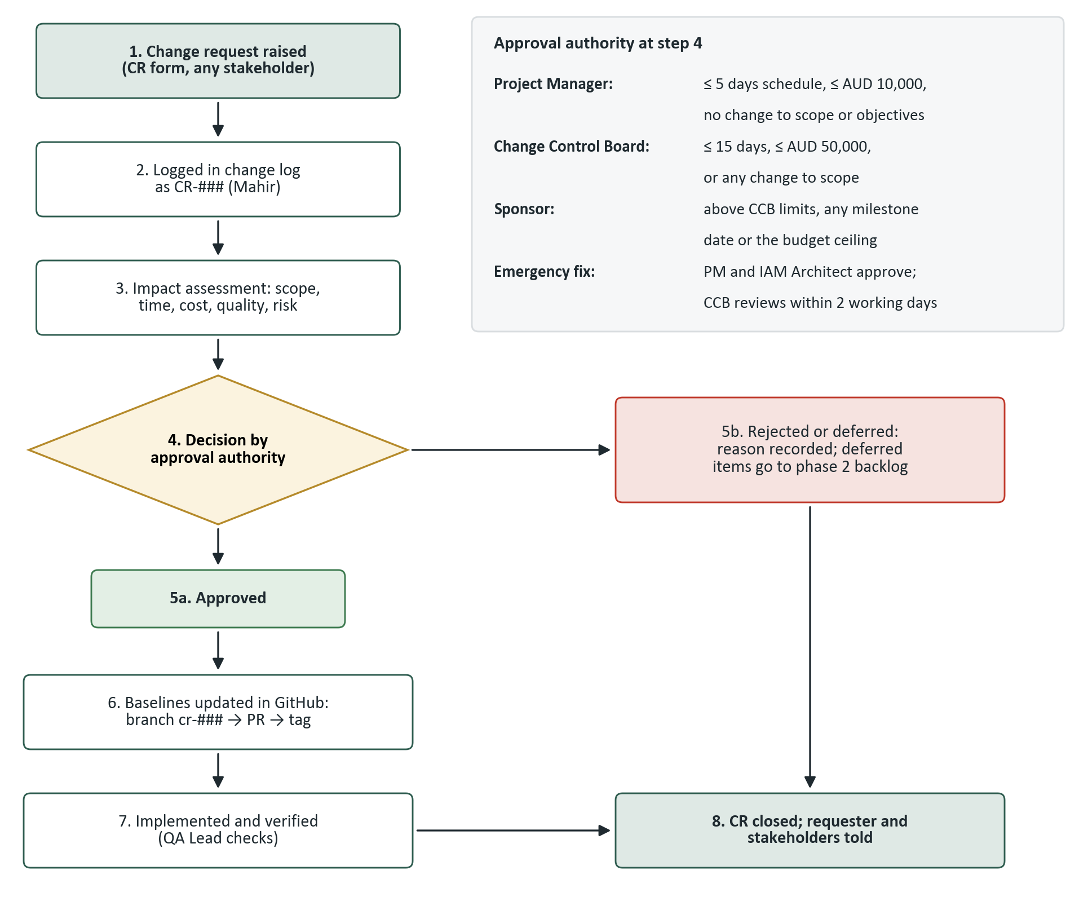
Figure 3. Change control process and approval authority
Table 19. Change request form template
CR ID and date raised | CR-### (assigned by Change and Configuration Manager); dd/mm/yyyy
Requested by | Name, role, department
Description of change
Reason and benefit
WBS elements affected | e.g. 1.4.3, M5
Impact: scope | Deliverables added, removed or changed
Impact: schedule | Working days; milestones moved; effect on critical path
Impact: cost | AUD; funding source (contingency, management reserve, new funds)
Impact: quality and risk | Effect on acceptance criteria; new or changed risks (IDs)
Urgency | Normal / urgent / emergency
Recommendation | Project manager's recommendation and options considered
Decision | Approved / rejected / deferred, with reason; approver name and date
Implementation | Owner; GitHub branch and baseline tag; Jira card
Table 20. Change control board (meets fortnightly, or within two working days for an urgent CR)
CCB role | Member | Part in decisions
Chair | Catherine Doyle, Chief Operating Officer (sponsor) | Final approval; casting vote
Members | Project manager (presents CRs); IAM Architect; IT Operations Manager; QA Lead; Director of Nursing's delegate (clinical impact) | Vote
Secretary | Change and Configuration Manager (Mahir) | Keeps the change log; no vote
Table 21. Change log (the two rows are examples of how to fill it in)
ID | Date | Change | Impact | Decision | Approver | Baseline | Status
CR-001 | 18 Feb 2027 | Add the dental practice system to phase 1 SSO | +8 days on wave 3; +AUD 22,000 | Deferred to phase 2 | CCB | – | Closed
CR-002 | 1 Mar 2027 | Extra night-shift training sessions at the day hospital | 0 days (1.6.1 has float); +AUD 3,500 from contingency | Approved | Project manager | baseline-1.1 | Closed

11. Configuration management (GitHub)
Section owner: Ahmed Mahir Daiyan
Every project artefact that defines a baseline is a configuration item and is kept under version control in one GitHub repository:
https://github.com/AR13X3/iam-deployment-project-plan
Table 22. Repository structure
Folder or file | Contents | Owner
README.md | Purpose, folder guide, branch and commit rules, how to raise a CR | Mahir
plan/ | Plan drafts and released versions (.docx) | Toufiq
schedule/ | GanttProject source (IAM_Schedule.gan), schedule.csv, Gantt image | Toufiq
wbs/ | WBS outline (wbs.csv) and diagram | Toufiq
risk/ | Risk register (risk_register.csv) | Toufiq
change-management/ | Change log, CR form and process flowchart | Mahir
templates/ | Issue log, status report and CR templates | Kritika
config/ (from build) | Exported IAM platform configuration (access policies, role definitions, provisioning mappings) as JSON | IAM Architect
Table 23. Version-control rules
Practice | Rule
Branches | main is protected. Each owner works on a branch for their area (charter, schedule, risk, change-management, quality, communication) and merges through a pull request approved by another member. Approved change requests use cr-### branches
Commits | One commit per meaningful change, with an imperative message naming the area, e.g. risk: add EMV for high risks or schedule: add SS+5d link for 1.4.4
Versions | Drafts are tagged v0.x; the released plan is GitHub Release v1.0; later approved baselines are tagged baseline-1.x
Readable history | Risk register, schedule, WBS and logs are kept as CSV alongside the .docx so changes show line by line
Status accounting and audit | At each gate the QA Lead checks that the tagged baseline matches the approved documents and the change log
During the build, platform configuration (MFA and conditional access policies, role definitions, provisioning mappings) is exported to config/, so every production change can be traced to an approved CR. Figure 4, Figure 5 and Figure 6 show the repository.
INSERT SCREENSHOT README of the repository (github.com/AR13X3/iam-deployment-project-plan)
Figure 4. Repository README
INSERT SCREENSHOT Commit history showing commits from all four members on at least three different days (Insights → Contributors also works)
Figure 5. Commit history
INSERT SCREENSHOT A merged pull request with another member's approval
Figure 6. Merged pull request with review

Appendix A. Jira project evidence
Section owner: Ahmed Mahir Daiyan
The Jira Scrum project holds one epic for the plan and one card per section, each assigned to its owner with a due date. The screenshots below show the board during the sprint, the backlog, a card's comments and history, and the timeline.
INSERT SCREENSHOT Jira board mid-sprint, with cards for all four members in To Do, In Progress and Done
Figure 7. Jira board during the sprint
INSERT SCREENSHOT Jira backlog with the plan epic and one issue per section
Figure 8. Jira backlog
INSERT SCREENSHOT One Jira card showing comments from another member and its history
Figure 9. Card comments and history
INSERT SCREENSHOT Jira timeline view
Figure 10. Jira timeline

Appendix B. GitHub history
Section owner: Ahmed Mahir Daiyan
INSERT SCREENSHOT Insights → Contributors graph, and the list of merged pull requests (Pull requests → Closed)
Figure 11. Contributors and merged pull requests

Appendix C. Working calendar
Section owner: Ahmed Mahir Daiyan
The schedule uses a Monday-to-Friday calendar with these non-working days. All other weekdays are working days.
Table 27. Non-working weekdays in the schedule
Date | Reason
24 Dec 2026 | Christmas shutdown
25 Dec 2026 | Christmas Day
28 Dec 2026 | Boxing Day (additional day)
29 Dec 2026 | Christmas shutdown
30 Dec 2026 | Christmas shutdown
31 Dec 2026 | Christmas shutdown
1 Jan 2027 | New Year's Day
26 Jan 2027 | Australia Day
26 Mar 2027 | Good Friday
29 Mar 2027 | Easter Monday
14 Jun 2027 | King's Birthday

