IAM SYSTEM DEPLOYMENT — PROJECT PLAN v1.0
Sections 1, 3, 4, 5, 6 and 8
Toufiq Ahmed Joy · Project Manager (team lead)
Your sections only, taken from the full plan (plan/IAM_ProjectPlan_v1.0.docx). Table, figure and reference numbers match the full plan, so some numbers are skipped. If you change anything here, send the change to Toufiq so it goes into the full plan before release.

1. Introduction
Section owner: Toufiq Ahmed Joy
Corella Health Group (CHG) is a not-for-profit healthcare provider in regional New South Wales. It has 1,180 staff and about 320 contractors and visiting clinicians across 9 sites. They use 42 applications, including an electronic medical record (EMR) and a patient administration system (PAS).
Problem statement. CHG cannot reliably control who has access to what. Every application keeps its own accounts, which are added and removed by hand. A 2026 internal audit found:
- 186 active accounts belonging to people who had left;
- 38 administrator accounts where about 12 are needed;
- a 6.5-day wait for a new starter's access;
- multi-factor authentication (MFA) used by only 31% of staff.
In 2026 a phished password exposed a manager's mailbox, and CHG had to report a notifiable data breach. Health is a target: credentials were stolen in a quarter of healthcare breaches worldwide [1], and Australian health providers made more breach notifications in 2025 than any other sector [2].
The project. CHG will deploy a central identity and access management (IAM) system with these parts:
- single sign-on (SSO);
- phishing-resistant MFA for every user;
- access granted and removed automatically from the HR system;
- role-based access;
- quarterly access reviews;
- privileged access management.
The project runs from 2 November 2026 to 28 July 2027, with a budget ceiling of AUD 1,250,000. Sections 2–14 follow the order in the contents list.

3. Project overview and objectives
Section owner: Toufiq Ahmed Joy
The project replaces account management application by application with one identity platform fed by the HR system. When People and Culture records a hire, move or exit, the platform creates, changes or removes access in connected applications using role-based rules. Staff sign in once with phishing-resistant MFA; administrators use separate privileged accounts; managers re-certify their staff's access every quarter. The business case is to close the audit findings, lower the likelihood and cost of another breach, end the wait for new-starter access, cut password-reset calls and reach Essential Eight Maturity Level Two for MFA and restricting administrative privileges [7], which the board has set as its target for 30 June 2027. Table 1 lists the measurable objectives.
Table 1. SMART objectives
ID | Objective | Measure and target | Date
O1 | Phishing-resistant MFA for every identity | 100% of 1,500 in-scope identities enrolled and enforced (passkeys or FIDO2 keys); SMS used only by approved exception | 16 Jun 2027
O2 | Single sign-on | 12 priority applications sign in through the IAM platform | 16 Jun 2027
O3 | Fast, reliable leavers | Access to all in-scope applications removed within 4 hours of the HR termination record, in a monthly sample of 30 leavers | From 16 Jun 2027; first check 14 Jul 2027
O4 | Day-one access | At least 95% of new starters have role-based access before their first shift (currently a 6.5-day wait) | Measured over the 3 months to 30 Sep 2027
O5 | Account clean-up | All 186 orphaned accounts disabled; administrator accounts cut from 38 to 12 or fewer | 28 Jul 2027
O6 | Access reviews | First quarterly review covers 100% of entitlements in the 12 applications, with every revocation actioned | 14 Jul 2027
O7 | On time and on budget | Project closed within the AUD 1,250,000 budget ceiling | 28 Jul 2027

4. Project charter and scope statement
Section owner: Toufiq Ahmed Joy

4.1 Charter summary
Table 2. Project charter
Project title | Identity and Access Management (IAM) System Deployment for Cybersecurity Enhancement
Organisation | Corella Health Group (CHG), regional New South Wales
Project sponsor | Catherine Doyle, Chief Operating Officer
Project manager | Toufiq Ahmed Joy
Purpose | Give every staff member and contractor the right access at the right time, protected by phishing-resistant MFA, and remove access promptly when it is no longer needed.
Start and finish | 2 Nov 2026 to 28 Jul 2027 (182 working days)
Budget | Ceiling AUD 1,250,000: cost baseline AUD 1,199,030 (including AUD 159,000 contingency reserve) plus AUD 50,970 management reserve held by the sponsor. Excludes GST.
Authority | The project manager may commit funds within approved work packages and approve changes within the limits in Section 10.

4.2 Scope
Table 3 shows what is in and out of scope. Anything not listed as in scope is out unless the change control board adds it (Section 10). Table 4 lists the deliverables, assumptions, constraints and acceptance criteria.
Table 3. In-scope and out-of-scope items
In scope | Out of scope
- 1,500 workforce identities: 1,180 staff and 320 contractors, agency staff and visiting medical officers  - 12 applications: Microsoft 365, intranet, VPN, rostering, EMR, PAS, HR system (HRIS), payroll, finance, pathology results portal, imaging viewer, incident management  - MFA for all users; privileged access management for 40 privileged accounts  - Joiner-mover-leaver automation from the HRIS; role catalogue of about 25 business roles  - Quarterly access reviews; training at all 9 sites | - Patient and consumer identities (patient portal)  - The other 30 lower-risk applications (phase 2 backlog)  - Medical devices and building access cards  - Replacing the HRIS, EMR or any other application  - Endpoint management, patching and email security (Essential Eight program)  - Identities for partner organisations other than contractors
Table 4. Deliverables, assumptions, constraints and acceptance criteria
Deliverables | Configured IAM platform; HR-driven joiner-mover-leaver workflows; SSO for 12 applications; phishing-resistant MFA for all users; role catalogue; privileged access management; access review campaigns; trained staff and support materials; runbooks and handover; the project documents in this plan
Assumptions | The HRIS is the authoritative record of staff and contractors; CHG's Microsoft 365 tenant can be federated with the IAM platform; application vendors support integration under standard support; clinical testers are available with funded backfill; the implementation partner is engaged at M3
Constraints | Budget ceiling AUD 1,250,000; go-live before 30 June 2027; no clinical system cut-overs in business hours; identity data stored in Australia; change freeze during the Christmas shutdown (24 December to 1 January)
Acceptance criteria | Objectives O1–O6 met and evidenced; no open severity 1–2 defects at Gate 3; all high or critical penetration-test findings fixed; runbooks accepted by the IT Operations Manager; closure report signed by the sponsor

4.3 Stakeholders
Table 5. Stakeholder register (summary)
Stakeholder | Interest | Influence | Needs from the project
Project sponsor: Catherine Doyle, Chief Operating Officer | Close audit findings; meet the board's Essential Eight target | High | Early escalation; status against baseline
Executive leadership team and Board Audit and Risk Committee | Cyber risk, compliance, budget | High | Evidence of risk reduction; budget kept
Head of Information Technology | Owns the platform after handover | High | Supportable design; runbooks; trained staff
IT operations and service desk | Run sign-in and provisioning day to day | Medium | Knowledge articles; rollout dates; staffing at go-live
Clinical staff and the Director of Nursing | Fast, reliable access at the bedside | High | Tap-and-go sign-in; no disruption to care; training on shift
Administrative and corporate staff | Simpler sign-in | Medium | One sign-in; clear instructions
Contractors, agency staff and visiting medical officers | Access ready on first shift | Low | Simple enrolment and access requests
People and Culture (HR) | HRIS becomes the trigger for access | High | Data rules and process changes agreed
Privacy Officer and compliance | Privacy and health-record obligations | Medium | Privacy impact assessment; Australian data residency; audit evidence
IAM platform vendor and implementation partner | Deliver the contract on time | Medium | Clear requirements; quick decisions; system access
Application owners (EMR, PAS, payroll, finance and others) | Integration without breaking their systems | Medium | Test windows; cut-over and rollback plans

4.4 Project team
Table 6. Project team roles and responsibilities
Name | Project role | Responsibilities
Toufiq Ahmed Joy | Project Manager (team lead) | Leads planning and delivery; owns the charter, scope, WBS, schedule and risk register; reports to the sponsor; presents change requests to the CCB
Kritika Bhattarai | Resource and Communications Manager | Resource plan and RACI matrix; issue log; stakeholder communication, training and the clinical champions network
Fardin Rahman Tanvir | Quality Assurance Lead | Requirements traceability; test strategy, system and user acceptance testing; quality metrics and audits; research and references
Ahmed Mahir Daiyan | Change and Configuration Manager | Change control (CCB secretary); GitHub configuration management; pilot and rollout coordination; handover to operations
Other project roles (IAM Architect, implementation partner, HR systems analyst, Privacy Officer and service desk) are allocated in Section 7.

4.5 Milestones and gates
Table 7. Milestones (dates match the Gantt chart in Section 6)
ID | Milestone | Date | Exit criteria (approved by sponsor)
M1 | Charter approved | 6 Nov 2026 | Charter signed
M2 | Plan baselined (Gate 1) | 24 Nov 2026 | Plan, schedule and cost baselines approved
M3 | Platform contract signed | 23 Dec 2026 | Contract signed after privacy impact assessment
M4 | Design approved (Gate 2) | 15 Jan 2027 | Design, role model and privacy impact assessment approved
M5 | Go-live readiness (Gate 3) | 29 Apr 2027 | Testing passed; no open severity 1–2 defects; high or critical penetration-test findings fixed
M6 | Go-live complete | 16 Jun 2027 | All 9 sites live; MFA enforced for all users
M7 | Project closed | 28 Jul 2027 | Handover accepted; closure report signed

5. Work breakdown structure
Section owner: Toufiq Ahmed Joy
Figure 1 shows the WBS. It has seven level-2 elements covering the whole life cycle, from planning to closure, with project management as its own branch.
- 29 work packages. Each produces one deliverable, has one owner and appears on the Gantt chart under the same code.
- Size. Each work package takes 4–20 working days, so progress can be reported weekly.
- Exception. Package 1.1.4 covers ongoing monitoring and control from Gate 1 to the end of hypercare.
- Milestones. M1–M7 are approval points with zero duration, not work packages.
A text version is in wbs/wbs.csv.
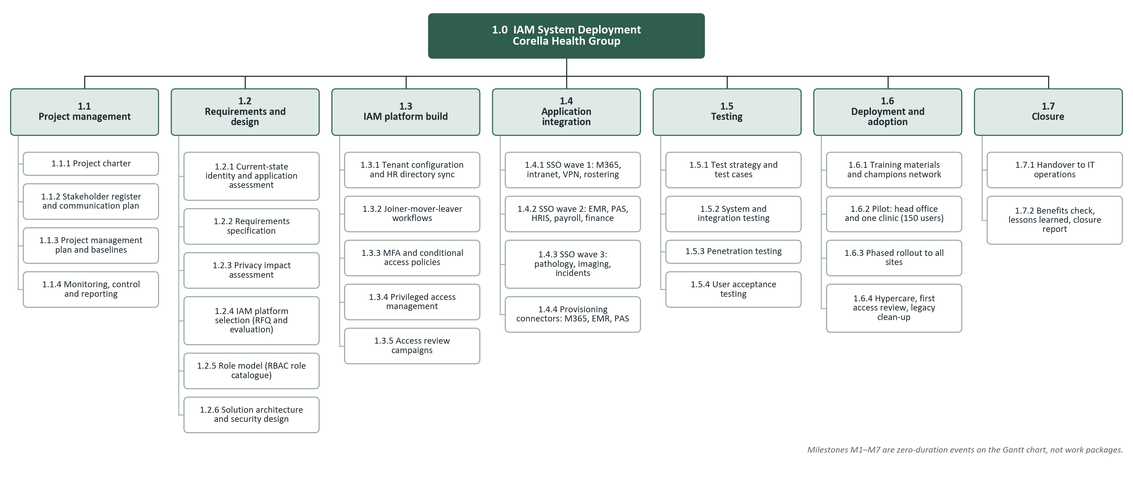
Figure 1. Work breakdown structure: 7 level-2 elements and 29 work packages

6. Project schedule (Gantt chart)
Section owner: Toufiq Ahmed Joy
The schedule was built from the WBS. It uses a five-day working week that leaves out NSW public holidays and CHG's Christmas shutdown (Appendix C), and durations are in working days.
Figure 2 is the Gantt chart. It shows every work package, every dependency link and the seven milestones, with the critical path in red.
The project starts on 2 November 2026, goes live on 16 June 2027 and closes on 28 July 2027. Go-live is before the board's 30 June target, and the close date matches the charter.
Critical path. The critical path is 182 working days long and runs through the following tasks:
- requirements and platform selection;
- solution design;
- MFA policies;
- the three SSO waves;
- system testing and user acceptance testing (UAT);
- the pilot, rollout, hypercare and closure.
A delay to any of these delays the whole project. The two longest critical tasks are watched most closely: platform selection and SSO wave 2, which covers the EMR and PAS. Table 8 explains the key dependencies. Test preparation (1.5.1, 43 days) and training materials (1.6.1, 37 days) have the most float, so their staff can help critical tasks. Penetration testing has only 2 days of float, so it is managed as near-critical.
Table 8. Key dependencies and why they exist
Link | Type | Reason
1.2.4 evaluation and 1.2.3 privacy impact assessment → M3 contract | Finish-to-start | Data residency is settled before the contract is signed
1.3.3 MFA policies → 1.4.1 SSO wave 1 → waves 2 and 3 | Finish-to-start | No application moves to SSO without MFA in place
1.4.3, 1.4.4, 1.3.4, 1.3.5, 1.5.1 → 1.5.2 system testing | Finish-to-start | Testing starts only when every build and integration package is done
1.3.2 joiner-mover-leaver → 1.4.4 provisioning connectors | Start-to-start + 5 days | Connectors reuse the attribute mappings defined in the first week of 1.3.2
1.6.2 pilot → 1.6.3 rollout | Finish-to-start + 3 days | Leaves time for the go/no-go review after the pilot
Table 9, after the chart, lists each task's dates, predecessors, float and resources.
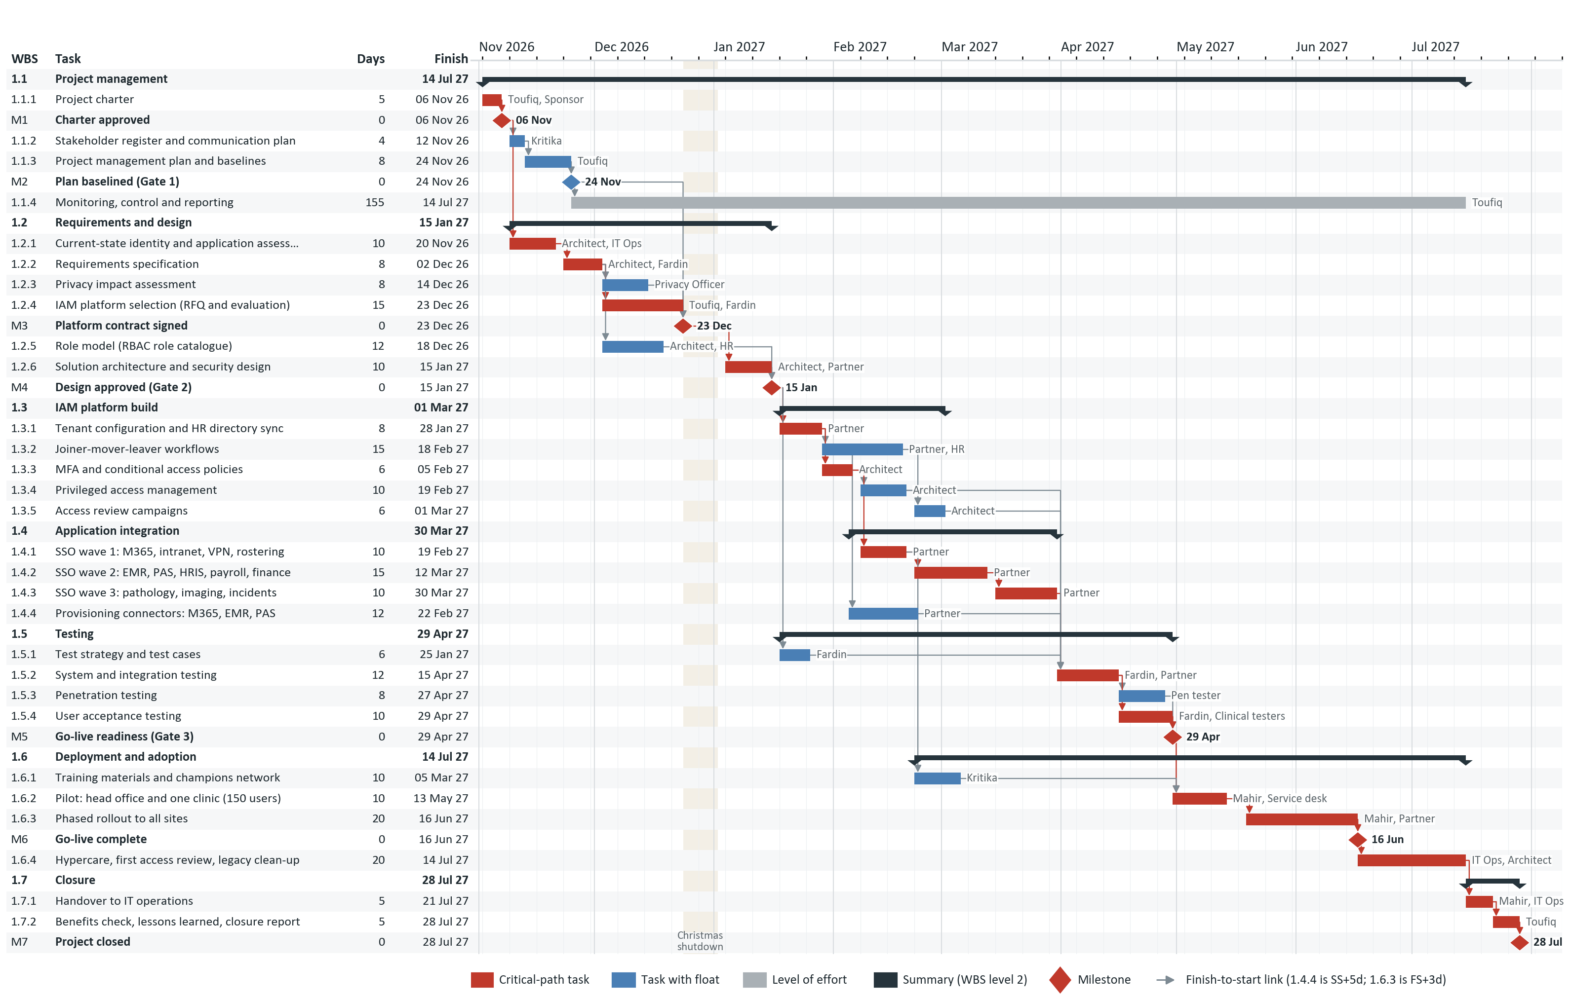
Figure 2. Gantt chart, 2 Nov 2026 to 28 Jul 2027, with dependency links, milestones and the critical path (red). Source: schedule/IAM_Schedule.gan
Table 9. Schedule task list (WBS order). Float 0 = critical path
WBS | Task | Days | Start | Finish | Predecessors | Float | Resources
1.1 | Project management |  | 2 Nov 2026 | 14 Jul 2027
1.1.1 | Project charter | 5 | 2 Nov 2026 | 6 Nov 2026 | - | 0 | Toufiq, Sponsor
M1 | Charter approved | 0 | 6 Nov 2026 | 6 Nov 2026 | 1.1.1 | 0 | Sponsor
1.1.2 | Stakeholder register and communication plan | 4 | 9 Nov 2026 | 12 Nov 2026 | M1 | 10 | Kritika
1.1.3 | Project management plan and baselines | 8 | 13 Nov 2026 | 24 Nov 2026 | 1.1.2 | 10 | Toufiq
M2 | Plan baselined (Gate 1) | 0 | 24 Nov 2026 | 24 Nov 2026 | 1.1.3 | 10 | Sponsor
1.1.4 | Monitoring, control and reporting (level of effort) | 155 | 25 Nov 2026 | 14 Jul 2027 | M2 | – | Toufiq
1.2 | Requirements and design |  | 9 Nov 2026 | 15 Jan 2027
1.2.1 | Current-state identity and application assessment | 10 | 9 Nov 2026 | 20 Nov 2026 | M1 | 0 | Architect, IT Ops
1.2.2 | Requirements specification | 8 | 23 Nov 2026 | 2 Dec 2026 | 1.2.1 | 0 | Architect, Fardin
1.2.3 | Privacy impact assessment | 8 | 3 Dec 2026 | 14 Dec 2026 | 1.2.2 | 7 | Privacy Officer
1.2.4 | IAM platform selection (RFQ and evaluation) | 15 | 3 Dec 2026 | 23 Dec 2026 | 1.2.2 | 0 | Toufiq, Fardin
M3 | Platform contract signed | 0 | 23 Dec 2026 | 23 Dec 2026 | 1.2.4, 1.2.3, M2 | 0 | Sponsor
1.2.5 | Role model (RBAC role catalogue) | 12 | 3 Dec 2026 | 18 Dec 2026 | 1.2.2 | 13 | Architect, HR
1.2.6 | Solution architecture and security design | 10 | 4 Jan 2027 | 15 Jan 2027 | M3 | 0 | Architect, Partner
M4 | Design approved (Gate 2) | 0 | 15 Jan 2027 | 15 Jan 2027 | 1.2.6, 1.2.5 | 0 | Sponsor
1.3 | IAM platform build |  | 18 Jan 2027 | 1 Mar 2027
1.3.1 | Tenant configuration and HR directory sync | 8 | 18 Jan 2027 | 28 Jan 2027 | M4 | 0 | Partner
1.3.2 | Joiner-mover-leaver workflows | 15 | 29 Jan 2027 | 18 Feb 2027 | 1.3.1 | 20 | Partner, HR
1.3.3 | MFA and conditional access policies | 6 | 29 Jan 2027 | 5 Feb 2027 | 1.3.1 | 0 | Architect
1.3.4 | Privileged access management | 10 | 8 Feb 2027 | 19 Feb 2027 | 1.3.3 | 19 | Architect
1.3.5 | Access review campaigns | 6 | 22 Feb 2027 | 1 Mar 2027 | 1.3.2, 1.3.4 | 19 | Architect
1.4 | Application integration |  | 5 Feb 2027 | 30 Mar 2027
1.4.1 | SSO wave 1: M365, intranet, VPN, rostering | 10 | 8 Feb 2027 | 19 Feb 2027 | 1.3.3 | 0 | Partner
1.4.2 | SSO wave 2: EMR, PAS, HRIS, payroll, finance | 15 | 22 Feb 2027 | 12 Mar 2027 | 1.4.1 | 0 | Partner
1.4.3 | SSO wave 3: pathology, imaging, incidents | 10 | 15 Mar 2027 | 30 Mar 2027 | 1.4.2 | 0 | Partner
1.4.4 | Provisioning connectors: M365, EMR, PAS | 12 | 5 Feb 2027 | 22 Feb 2027 | 1.3.2 SS+5d | 24 | Partner
1.5 | Testing |  | 18 Jan 2027 | 29 Apr 2027
1.5.1 | Test strategy and test cases | 6 | 18 Jan 2027 | 25 Jan 2027 | M4 | 43 | Fardin
1.5.2 | System and integration testing | 12 | 31 Mar 2027 | 15 Apr 2027 | 1.4.3, 1.4.4, 1.3.4, 1.3.5, 1.5.1 | 0 | Fardin, Partner
1.5.3 | Penetration testing | 8 | 16 Apr 2027 | 27 Apr 2027 | 1.5.2 | 2 | Pen tester
1.5.4 | User acceptance testing | 10 | 16 Apr 2027 | 29 Apr 2027 | 1.5.2 | 0 | Fardin, Clinical testers
M5 | Go-live readiness (Gate 3) | 0 | 29 Apr 2027 | 29 Apr 2027 | 1.5.3, 1.5.4 | 0 | Sponsor
1.6 | Deployment and adoption |  | 22 Feb 2027 | 14 Jul 2027
1.6.1 | Training materials and champions network | 10 | 22 Feb 2027 | 5 Mar 2027 | 1.4.1 | 37 | Kritika
1.6.2 | Pilot: head office and one clinic (150 users) | 10 | 30 Apr 2027 | 13 May 2027 | M5, 1.6.1 | 0 | Mahir, Service desk
1.6.3 | Phased rollout to all sites | 20 | 19 May 2027 | 16 Jun 2027 | 1.6.2 FS+3d | 0 | Mahir, Partner
M6 | Go-live complete | 0 | 16 Jun 2027 | 16 Jun 2027 | 1.6.3 | 0 | Sponsor
1.6.4 | Hypercare, first access review, legacy clean-up | 20 | 17 Jun 2027 | 14 Jul 2027 | M6 | 0 | IT Ops, Architect
1.7 | Closure |  | 15 Jul 2027 | 28 Jul 2027
1.7.1 | Handover to IT operations | 5 | 15 Jul 2027 | 21 Jul 2027 | 1.6.4 | 0 | Mahir, IT Ops
1.7.2 | Benefits check, lessons learned, closure report | 5 | 22 Jul 2027 | 28 Jul 2027 | 1.7.1 | 0 | Toufiq
M7 | Project closed | 0 | 28 Jul 2027 | 28 Jul 2027 | 1.7.2 | 0 | Sponsor

8. Risk management plan
Section owner: Toufiq Ahmed Joy
The process follows ISO 31000 [14] and the PMBOK Guide's risk domain [12]:
- Identify risks at kickoff, from the current-state assessment and the research in Section 2, and again at each gate.
- Analyse each risk first by score, using the 5 × 5 scales in Table 12, then in dollars as expected monetary value (EMV = probability × cost impact).
- Plan responses: avoid, mitigate, transfer or accept. Every risk has a mitigation (done beforehand) and a contingency (done if it happens).
- Monitor triggers through each risk's owner. The register is reviewed weekly with clinical and IT staff present [15], top risks go to the sponsor monthly, and the register is version-controlled in risk/risk_register.csv.
Table 12. Probability and impact scales
Score | Probability | Impact (the highest of cost, schedule or clinical effect)
1 | Rare (< 10%) | Negligible: < AUD 5,000; < 2 days; no clinical effect
2 | Unlikely (10–29%) | Minor: AUD 5,000 to < 20,000; 2–5 days; workaround available
3 | Possible (30–49%) | Moderate: AUD 20,000 to < 50,000; 1–2 weeks; disruption at one site
4 | Likely (50–69%) | Major: AUD 50,000 to < 100,000; 2–4 weeks; clinical access disrupted at several sites
5 | Almost certain (≥ 70%) | Severe: ≥ AUD 100,000; > 4 weeks or a milestone missed; patient-safety effect
Score = probability × impact: 1–4 Low, 5–9 Medium, 10–16 High, 20–25 Extreme.
Table 13. Probability × impact matrix showing where each risk sits
Probability ↓ / Impact → | 1 Negligible | 2 Minor | 3 Moderate | 4 Major | 5 Severe
5 Almost certain
4 Likely |  |  | R03 | R02
3 Possible |  | R06 | R05, R07, R10 | R01, R09
2 Unlikely |  |  | R12 | R04, R11 | R08
1 Rare
Quantitative analysis. Table 14 gives the EMV of the 5 High risks. The EMVs of all 12 risks add up to AUD 158,400, which is rounded up to a contingency reserve of AUD 159,000. The project manager can release contingency only for a risk that has occurred, and records each release in the change log.
Table 14. Expected monetary value of High risks (AUD)
ID | Risk | Probability | Cost impact | EMV
R01 | EMR or PAS cannot support modern SSO (SAML/OIDC), needing a custom connector | 40% | 60,000 | 24,000
R02 | Inaccurate HR data (job codes, managers, end dates) grants wrong access or removes access in error | 50% | 40,000 | 20,000
R03 | Clinicians resist MFA at shared ward workstations and adopt workarounds | 60% | 30,000 | 18,000
R09 | Credential phishing attack succeeds during the transition while old and new sign-ins coexist | 30% | 60,000 | 18,000
R08 | Misconfigured conditional access policy locks users or administrators out | 20% | 80,000 | 16,000
 | All 12 risks (contingency basis) |  |  | 158,400
The full register is shown in Table 15 on the next page.
Table 15. Risk register (all risks open at baseline; P = probability score, I = impact score, EMV in AUD)
ID | Risk | Category | P | I | Score | EMV | Owner | Response | Mitigation (before) | Contingency (if it happens) | Trigger
R01 | EMR or PAS cannot support modern SSO (SAML/OIDC), needing a custom connector | Technical | 3 | 4 | 12 High | 24,000 | IAM Architect | Mitigate | Confirm protocol support for every in-scope app during the current-state assessment (1.2.1); make vendor-confirmed connectors a mandatory RFQ criterion | Front the app with an application proxy or password-vaulting SSO and move it to wave 3 | App vendor cannot confirm SAML/OIDC support by Gate 2
R02 | Inaccurate HR data (job codes, managers, end dates) grants wrong access or removes access in error | Data / privacy | 4 | 4 | 16 High | 20,000 | Kritika (with HR) | Mitigate | HR data cleansing before 1.3.2; run leaver automation in report-only mode for two weeks with daily reconciliation | Switch affected changes to a manual approval queue; restore wrongly removed clinical access through the break-glass process within 15 minutes | Reconciliation mismatch above 2% of records
R03 | Clinicians resist MFA at shared ward workstations and adopt workarounds | People | 4 | 3 | 12 High | 18,000 | Kritika | Mitigate | Tap-and-go FIDO2 security keys for shared workstations; clinical champions at every site; nurses in UAT | Extend that site's rollout by one week with floor-walkers and extra keys | Site MFA enrolment below 80% two weeks after rollout
R04 | Implementation partner loses or reassigns a key integration engineer | Vendor | 2 | 4 | 8 Medium | 12,500 | Toufiq | Transfer | Named-resource clause with 10-day replacement and service credits; configuration documented in GitHub | Call on the standing-offer second partner; resequence SSO waves to protect the critical path | Key engineer absent for more than 5 working days
R05 | Platform procurement and contract negotiation run late, delaying design | Schedule | 3 | 3 | 9 Medium | 10,000 | Toufiq | Mitigate | Issue the RFQ in week 3 with a pre-approved contract template; legal engaged from kickoff | Start role model and test strategy early and use the vendor's trial tenant for design | Contract not signed by the M3 date
R06 | Licence prices rise (USD-priced quote or exchange rate) before contract signature | Budget | 3 | 2 | 6 Medium | 5,400 | Toufiq | Mitigate | Require AUD-denominated pricing held for 90 days in the RFQ | Draw on contingency; license lower-risk contractor identities on a cheaper tier | Final quote exceeds the baseline licence line by more than 5%
R07 | Clinical staff unavailable for UAT because of roster pressure | Organisational | 3 | 3 | 9 Medium | 8,000 | Fardin | Mitigate | Book testers six weeks ahead with funded backfill shifts; agree dates with the Director of Nursing | Add evening UAT sessions and test critical clinical scenarios first; if UAT still slips, shorten the pilot from 10 to 7 days with sponsor approval | Fewer than 70% of booked testers attend in UAT week 1
R08 | Misconfigured conditional access policy locks users or administrators out | Technical | 2 | 5 | 10 High | 16,000 | IAM Architect | Mitigate | Two monitored break-glass accounts excluded from policies; policies run in report-only mode first; every policy change peer-reviewed through change control | Invoke the rollback runbook and break-glass access; communicate through the service desk | More than 20 lockouts in one hour
R09 | Credential phishing attack succeeds during the transition while old and new sign-ins coexist | External | 3 | 4 | 12 High | 18,000 | IAM Architect | Mitigate | MFA for remote access and admin accounts in wave 1; sign-in risk alerts monitored daily | Run the cyber incident response plan; assess for a notifiable data breach to the OAIC | Risky sign-in alert or user report of a suspicious prompt
R10 | Departments push extra applications into phase 1 (scope creep) | Organisational | 3 | 3 | 9 Medium | 13,500 | Mahir | Avoid | Signed scope statement with a named out-of-scope list; all requests through the change control board | CCB defers new apps to the phase 2 backlog; contingency used only with sponsor approval | More than two change requests for new apps in a month
R11 | Identity or audit data stored offshore conflicts with privacy obligations | Data / privacy | 2 | 4 | 8 Medium | 10,000 | Fardin (with Privacy Officer) | Avoid | Australian data residency as a mandatory RFQ criterion; privacy impact assessment (1.2.3) before contract | Select the vendor's Australian region or the runner-up vendor | PIA identifies offshore storage of personal information
R12 | Project manager or a workstream lead unavailable for an extended period | People | 2 | 3 | 6 Medium | 3,000 | Toufiq | Accept | Named deputy for each role; decisions and plans kept in GitHub and Jira | Deputy steps in; re-baseline the schedule through change control if needed | Absence longer than 10 working days

References cited in these sections
Numbers match the full reference list in the plan (Fardin's section).
[1] Verizon Business, “2026 Data Breach Investigations Report: Executive summary,” Verizon, Rep. OGES2110526, May 2026. Accessed: Oct. 24, 2026. [Online]. Available: https://www.verizon.com/business/resources/executivebriefs/2026-dbir-executive-summary.pdf
[2] Office of the Australian Information Commissioner, “Data breach notifications increase to all-time high in 2025, new NDB stats show,” Media release, Jul. 6, 2026. Accessed: Oct. 24, 2026. [Online]. Available: https://www.oaic.gov.au/news/media-centre/data-breach-notifications-increase-to-all-time-high-in-2025,-new-ndb-stats-show
[7] Australian Signals Directorate, “Essential Eight maturity model,” Australian Cyber Security Centre, Nov. 27, 2023. Accessed: Oct. 24, 2026. [Online]. Available: https://www.cyber.gov.au/publication/essential-eight-maturity-model
[12] Project Management Institute, A Guide to the Project Management Body of Knowledge (PMBOK Guide), 8th ed. Newtown Square, PA, USA: PMI, 2025.
[14] Risk Management — Guidelines, ISO 31000:2018, International Organization for Standardization, Geneva, Switzerland, Feb. 2018.
[15] P. Willumsen, J. Oehmen, V. Stingl, and J. Geraldi, “Value creation through project risk management,” Int. J. Proj. Manag., vol. 37, no. 5, pp. 731–749, Jul. 2019, doi: 10.1016/j.ijproman.2019.01.007.

