**Complex Engineering Problem**

**Course:** Electromagnetics and its Applications

**Semester:** Fifth (Fall 2024)

**Instructor:** Dr. Adeem Aslam

**Submitted by:** Syed Abdul Rehman (2022-EE-11)

**Abstract:** In this report, a Radome design is proposed for Automotive RADAR applications, working in the 76-81 GHz frequency range. Factors such as temperature variations, mechanical durability and electromagnetic properties of the material are considered. MATLAB simulations for wave propagation and code have also been included. Also, the system will be integrated into the Car. The design will ensure cost-effectiveness, ease of fabrication and compatibility with automotive safety standards.  
  
**Theoretical Background:**  The problem at hand is effectively a wave incidence problem at a dielectric slab, separating the environment from the radome. Consider the general expression for the Electric field: (1)

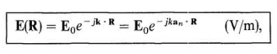

Where **a**n represents the unit vector in the direction of the propagating wave. **R** represents the vector signifying a point on the Surface where the phase is constant. Generally, we can think of the above equation as an optimization problem in **R,** where **R** may be now considered as a vector on the surface of Radome. This optimization problem is obviously complicated, so we will make some simplifying assumptions about the direction of field’s propagation. We will consider the Antenna’s Radiation in the Far-Field, where the field is almost propagating radially outward, so we can make a confident approximation by letting **a**n = r**a**r. In this way, the incident field at the radome becomes: (2)

k here represents the wavenumber, generally written as (for lossy media): (3)



Where: (4)



Our assumption about the Far-Field enables us to construct a simplistic geometry of the radome, namely spherical, due to the radial propagation of wave. This will be justified in later calculations of Reflection and Transmission coefficients.

**Wave Incidence at a Dielectric Slab:**

Assume incidence at a spherical slab by a wave:

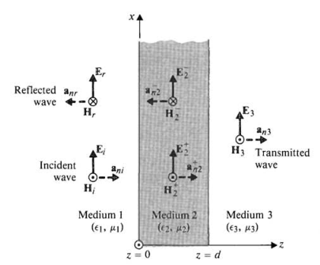

The fields are:

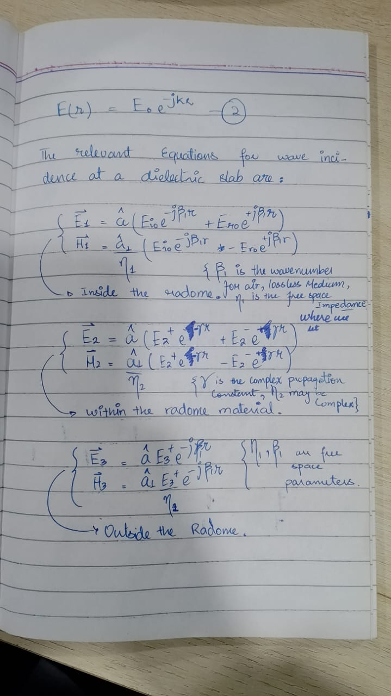

From which the transmission and reflection coefficients are to be obtained, along with the optimal parameters for thickness and radius of the radome. Following is the complete derivation of the EM fields and the Transmission and reflection coefficients:

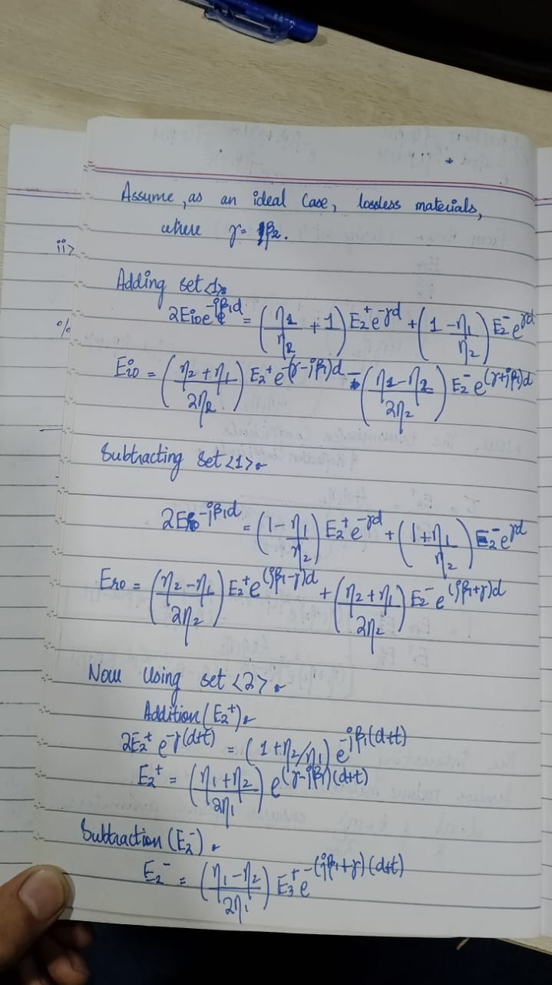



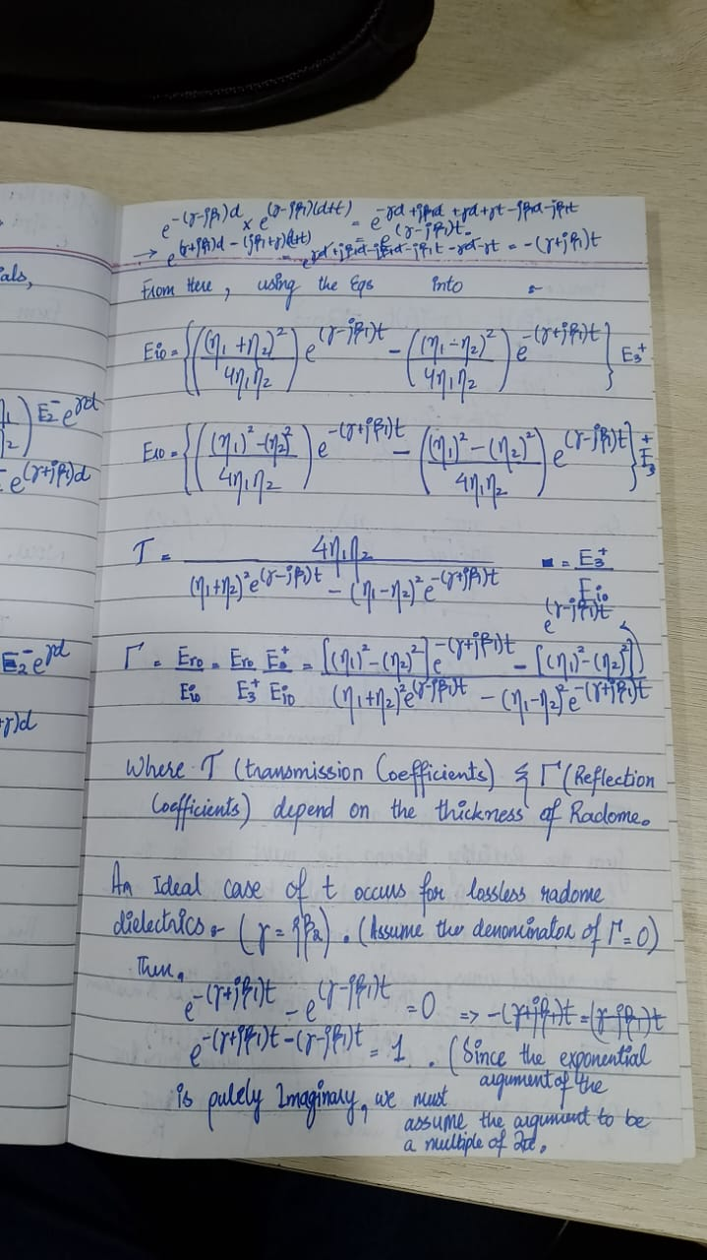

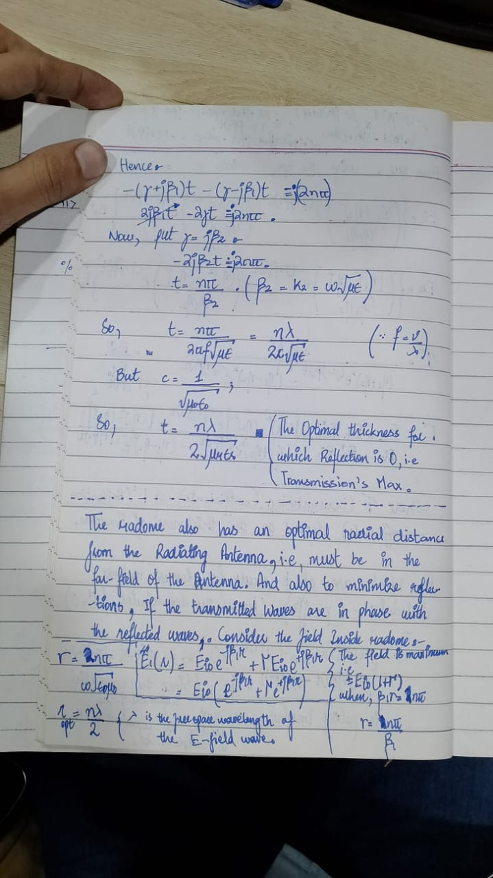

The derived results will be used extensively for analysis and design of the radome. The Electromagnetic Fields will be found by the Equations described above.

**Choice of Material:**

Polytetraflouroethylene (PTFE) was chosen as the radome material, as it has one of the best dielectric constants (2), is non-magnetic, has an extremely low loss tangent (0.004), and a good refractive index of about 1.44 (Better than most considerable materials). Also, Teflon is extremely durable to UV, chemical degradation (Chemically Inert), and invariant to temperature variation in its characteristics. Some tradeoffs were made, such as mechanical strength (not extremely tough, high stress conditions may not make it suitable), fabrication of the material is sometimes tricky. However, for automotive applications, the choice of material complies with the set automotive standards of safety and industry capabilites of manufacturing.

**Dimensions of the Radome:**

From our mathematical analysis and aur assumption about radial propagation, the optimal geometry will be of a sphere, as our analysis shows (We want as much plane incidence as possible). Since we have assumed EM fields in the Far-Field of the antenna (Propagating radially outward with non-uniform amplitude), we must account for the radius. The region where R >> c/2πf is the far zone. Since f = 78.5GHz (mean of the range), R >> 0.6082 mm. This is easily achievable for our application by choosing n such that R = nc/2f and the above condition is satisfied. Furthermore, the thickness must also be determined. The minimum (by using the derived condition) is 1.3511 mm. We will choose R = 4.01cm, and t = 2.03cm. These dimensions are not outrageous, and can be easily accomodated into the car’s structure (naturally, in the bumpers).

**Characteristics:**

The MATLAB code for the analysis of the Radome’s electromagnetic characteristics is given below:

clc; clear; close all;

% Constants

f = linspace(76e9, 81e9, 3000); % Frequency range

c = 3e8; % Speed of light

lambda = c ./ f; % Wavelength

freeSph = (2 * pi * f) / c; % Free space Phase Factor

epsilon_r = 2; % Relative permittivity of radome

tan_delta = 4e-4; % Loss tangent for radome material

eta_rad = (1 + 1i * (tan_delta / 2)) * 120 * pi / sqrt(epsilon_r); % Wave impedance

% Attenuation and phase factor

attenuation = (pi .* tan_delta ./ c) * sqrt(epsilon_r) .* f;

phasefactor = (2 .* pi ./ c) .* (1 + (tan_delta^2) / 8) * sqrt(epsilon_r) .* f;

wavenumber = (attenuation + 1i*phasefactor);

% Radome dimensions

d = 21 *(mean(lambda) / 2); % Radome Radius

thickness = 15 * (mean(lambda) / (2 * sqrt(epsilon_r))); % Thickness

reg_width = 15e-2; % Region Width

% Reflection and Transmission Coefficients

e1 = exp((wavenumber - 1i*freeSph)*thickness);

e2 = exp(-(wavenumber + 1i*freeSph)*thickness);

sum = (120 * pi + eta_rad)^2;

prod = 4 * 120 * pi * eta_rad;

diff = (120 * pi - eta_rad)^2;

Reflection = ((120*pi)^2 - (eta_rad)^2)*(e2 - e1) ./ ((sum)*e1 - diff*e2);

Transmission = prod ./ ((sum .* e1) - (diff .* e2));

% Plot both Reflection and Transmission

figure;

hold on;

plot(f / 1e9, abs(Reflection), 'r', 'LineWidth', 1.5, 'DisplayName', 'Reflection $\Gamma^2$');

plot(f / 1e9, abs(Transmission), 'b', 'LineWidth', 1.5, 'DisplayName', 'Transmission $\tau^2$');

plot(f / 1e9, (1 - exp(-attenuation * thickness)), 'k', 'LineWidth', 1.5, 'DisplayName', 'Attenuation $e^{-\alpha d}$');

legend('Interpreter', 'latex');

hold off;

% Add title, labels, legend, and grid

title('Reflection, Transmission & Attenuation Coefficients');

xlabel('Frequency (GHz)');

grid on;

legend('show');

% Region

r = linspace(0, reg_width, 3000);

E_fields = zeros(length(f), length(r)); % Electric fields

H_fields = zeros(length(f), length(r)); % Magnetic fields

for idx_f = 1:length(f)

k = wavenumber(idx_f); % Wavenumber for the current frequency

E0 = 5; % Incident electric field amplitude (V/m)

for idx_r = 1:length(r)

if r(idx_r) < d

% Region before the radome

E_fields(idx_f, idx_r) = E0 * (exp(-1i .* freeSph(idx_f) .* r(idx_r)) + Reflection(idx_f) .* exp(1i .* freeSph(idx_f) .* r(idx_r)));

H_fields(idx_f, idx_r) = (E0 / 120 * pi) * (exp(-1i .* freeSph(idx_f) .* r(idx_r)) - Reflection(idx_f) .* exp(1i .* freeSph(idx_f) .* r(idx_r)));

elseif r(idx_r) <= d + thickness

% Region inside the radome

E2f = Transmission(idx_f) * E0 * (sqrt(sum) / 240*pi) * exp((k - j*(freeSph(idx_f)))*(d+thickness));

E2b = Transmission(idx_f) * E0 * (sqrt(diff) / 240*pi) * exp(-(k + j*(freeSph(idx_f)))*(d+thickness));

E_fields(idx_f, idx_r) = E2f*exp(-k*r(idx_r)) + E2b*exp(k*r(idx_r));

H_fields(idx_f, idx_r) = (E2f*exp(-k*r(idx_r)) - E2b*exp(-k*r(idx_r)))/eta_rad;

else

% Region after the radome

E_fields(idx_f, idx_r) = E0 * Transmission(idx_f) * exp(-1i * freeSph(idx_f) * r(idx_r));

H_fields(idx_f, idx_r) = (E0 / 120 * pi) * Transmission(idx_f) * exp(-1i * freeSph(idx_f) * r(idx_r));

end

end

End

% 3D Plot for Electric Field (|E|)

[R, F] = meshgrid(r * 1e2, f * 1e-9);

figure;

surf(R, F, abs(E_fields) , 'EdgeColor', 'none');

title('Electric Field Intensity (|E|) Across the Radome');

xlabel('Radius (cm)');

ylabel('Frequency (GHz)');

zlabel('|E| (V/m)');

colorbar;

grid on;

view(3);

% 3D Plot for Magnetic Field (|H|)

figure;

surf(R, F, abs(H_fields), 'EdgeColor', 'none');

title('Magnetic Field Intensity (|H|) Across the Radome');

xlabel('Radius (cm)');

ylabel('Frequency (GHz)');

zlabel('|H| (A/m)');

colorbar;

grid on;

view(3);

The Plots for the Electromagnetic characteristics are:

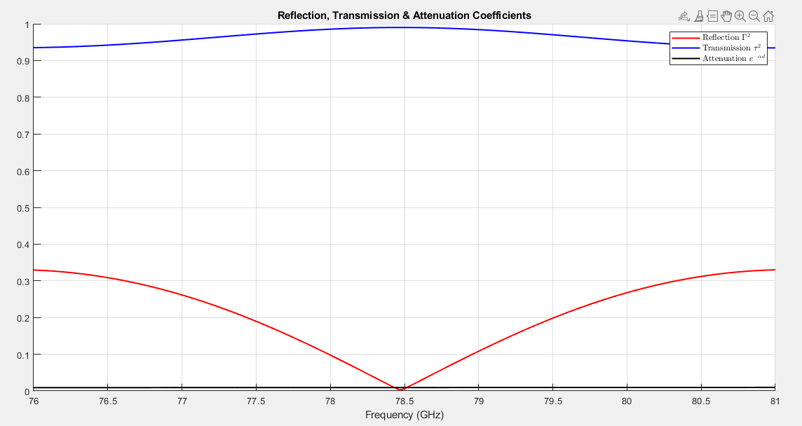

It is visibly clear that Teflon provides excellent Electromagnetic characteristics for the desired thickness of 2.03cm. The periodic behavior of Gamma and Tau comes from their expressions, as the (almost) zeros of the equations occur at integer multiples of λ/(2sqrt(ϵr)). The attenuation factor is also less than 0.01, which is excellent for many Radome applications.

Also, for an incident field in the x-direction for all frequencies, the magnetic and electric field intensities are as follows:

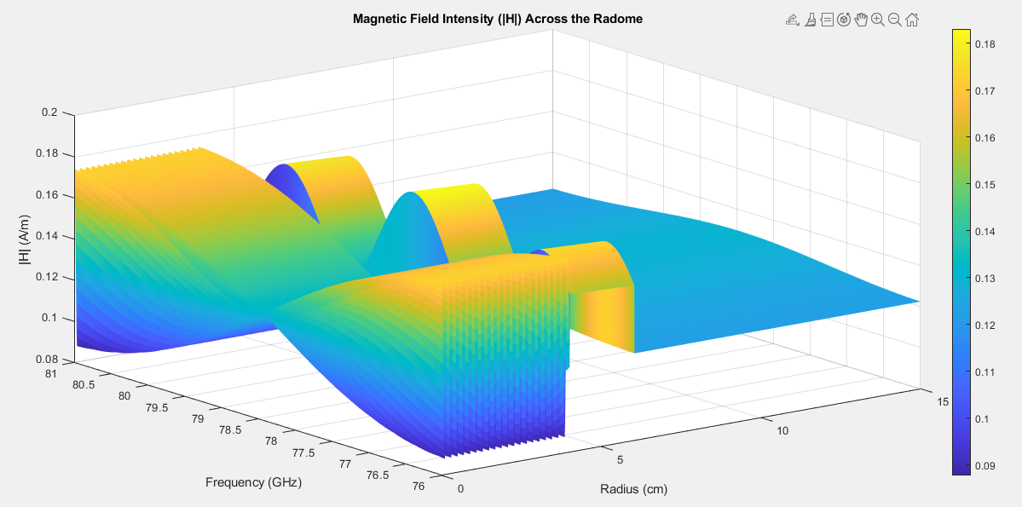

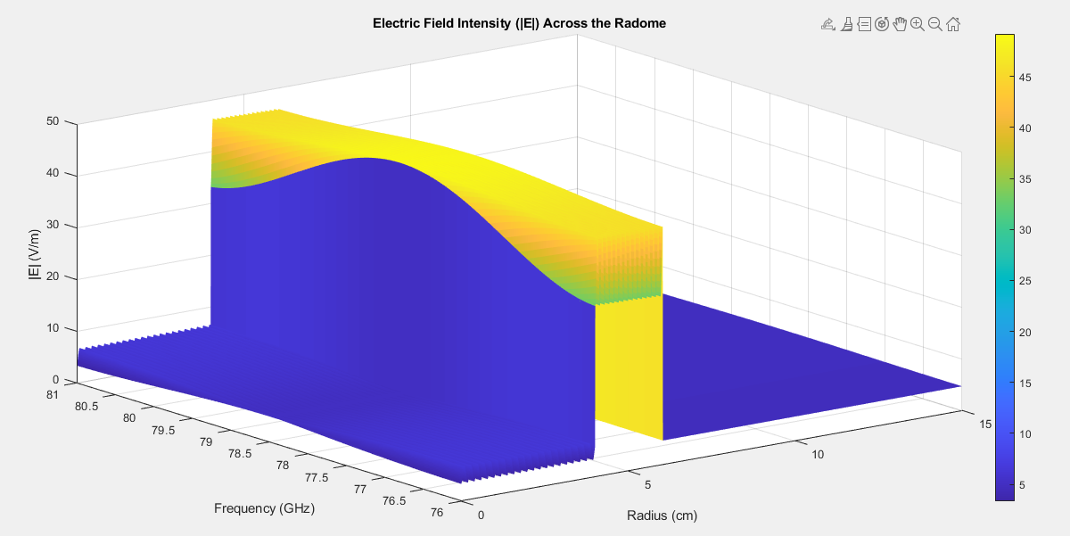

The jump is expected in this case, as the characteristic impedance inside a dielectric with relative permittivity > 1 is less than the free space permitivitty, hence the EM fields are scaled by the factor. As we shall see with the analysis of the radiation pattern of the antenna, we have achieved good transmission characteristics with our radome design.

**Radiation Pattern Analysis:**

The MATLAB code for the analysis is given below:

clc; clear; close all;

% Constants

f = 76.5e9; % Frequency

c = 3e8; % Speed of light

lambda = c ./ f; % Wavelength

freeSph = (2 * pi) / lambda; % Free space Phase Factor

epsilon_r = 2; % Relative permittivity of radome

tan_delta = 4e-4; % Loss tangent for radome material

eta_rad = (1 + 1i * (tan_delta / 2)) * 120 * pi / sqrt(epsilon_r); % Wave impedance

% Attenuation and phase factor

attenuation = (pi .* tan_delta ./ c) * sqrt(epsilon_r) .* f;

phasefactor = (2 .* pi ./ c) .* (1 + (tan_delta^2) / 8) * sqrt(epsilon_r) .* f;

wavenumber = (attenuation + 1i*phasefactor);

% Radome dimensions

thickness = 15 * (mean(lambda) / (2 * sqrt(epsilon_r))); % Thickness

% Reflection and Transmission Coefficients

e1 = exp((wavenumber - 1i*freeSph)*thickness);

e2 = exp(-(wavenumber + 1i*freeSph)*thickness);

sum = (120 * pi + eta_rad)^2;

prod = 4 * 120 * pi * eta_rad;

diff = (120 * pi - eta_rad)^2;

Reflection = ((120*pi)^2 - (eta_rad)^2)*(e2 - e1) ./ ((sum)*e1 - diff*e2);

Transmission = prod ./ ((sum .* e1) - (diff .* e2));

% Geometry of Radome

d = 21 * (lambda / 2); % Radome radius (R >> λ/2π & R = nλ/2)

r = linspace(0, 50e-2, 500); % Radial distances (m), 0.6mm step

theta = linspace(-pi / 2, pi / 2, 500); % Elevation angles (rad)

phi = linspace(0, 2 * pi, 500); % Azimuth angles (rad)

[Theta, Phi] = meshgrid(theta, phi);

% Patch Antenna Field

eps_s = 2.2;

W = (0.5 * lambda) / sqrt(eps_s);

L = W;

wx = (L .* sin(Theta) .* cos(Phi)) / lambda;

wy = (W .* sin(Theta) .* sin(Phi)) / lambda;

f = abs(cos(pi * wx) .* sinc(pi * wy)); % Patch antenna

E0 = 5 * ((cos(Theta) .* sin(Phi)).^2 + cos(Phi).^2) .* f; % Incident E-field (V/m)

% Initialize field arrays

[R, Theta, Phi] = meshgrid(r, theta, phi);

E_fields = zeros(size(R)); % Electric fields

H_fields = zeros(size(R)); % Magnetic fields

% Compute fields for all regions

for idx_r = 1:length(r)

if r(idx_r) < d

% Region before the radome

E_fields(idx_r, :, :) = E0 .* (exp(-1i .* freeSph .* r(idx_r)) + Reflection .* exp(1i .* freeSph .* r(idx_r)));

H_fields(idx_r, :, :) = (E0 ./ 120 * pi) .* (exp(-1i .* freeSph .* r(idx_r)) - Reflection .* exp(1i .* freeSph .* r(idx_r)));

elseif r(idx_r) <= d + thickness

% Region inside the radome

E2f = Transmission * E0 * (sqrt(sum) / 240*pi) * exp((wavenumber - j*(freeSph))*(d+thickness));

E2b = Transmission * E0 * (sqrt(diff) / 240*pi) * exp(-(wavenumber + j*(freeSph))*(d+thickness));

E_fields(idx_r, :, :) = E2f*exp(-wavenumber*r(idx_r)) + E2b*exp(wavenumber*r(idx_r));

H_fields(idx_r, :, :) = (E2f*exp(-wavenumber*r(idx_r)) - E2b*exp(-wavenumber*r(idx_r)))/eta_rad;

else

% Region after the radome

E_fields(idx_r, :, :) = E0 .* Transmission .* exp(-1i * freeSph .* r(idx_r));

H_fields(idx_r, :, :) = (E0 ./ 120 * pi) .* Transmission .* exp(-1i * freeSph .* r(idx_r));

end

End

% Extract fields for a fixed radius

fixed_r_idx = round(length(r));

Er = squeeze(E_fields(fixed_r_idx, :, :)); % Electric field for fixed radius

Hr = squeeze(H_fields(fixed_r_idx, :, :)); % Magnetic field for fixed radius

% Radiation Patterns

figure;

subplot(1, 1, 1);

polarplot(theta, abs(E0(round(end/2), :)), 'b', 'LineWidth', 1.5);

hold on;

polarplot(theta, abs(Er(round(end/2), :)), 'r--', 'LineWidth', 1.5);

title('Radiation Pattern Comparison');

legend('Without Radome', 'With Radome');

grid on;

% 3D Radiation Pattern for Fixed r

figure;

subplot(1, 2, 1);

surf(theta * 180 / pi, phi * 180 / pi, abs(Er), 'EdgeColor', 'none');

title('Electric Field Intensity (|E|) for Fixed Radius');

xlabel('\theta (deg)');

ylabel('\phi (deg)');

zlabel('|E| (V/m)');

colorbar;

view(3);

subplot(1, 2, 2);

surf(theta * 180 / pi, phi * 180 / pi, abs(Hr), 'EdgeColor', 'none');

title('Magnetic Field Intensity (|H|) for Fixed Radius');

xlabel('\theta (deg)');

ylabel('\phi (deg)');

zlabel('|H| (A/m)');

colorbar;

view(3);

The Radiation Pattern outside the Radome is:

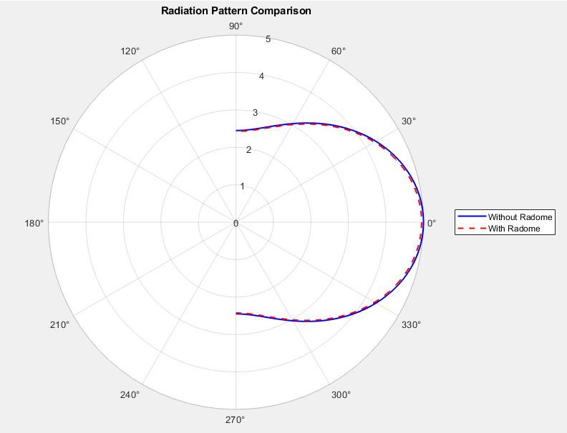

Here, we can see that the Electric field distribution outside the Radome is minimally attenuated, further solidifying our radome design.

The EM field intensities w.r.t theta and phi are given (outside Radome):

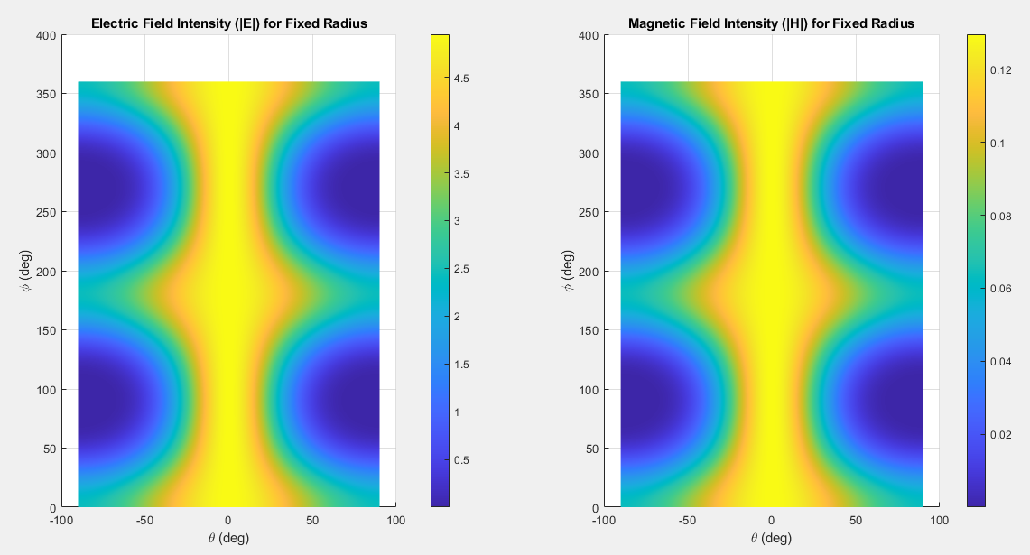

With our reasonable assumptions about the geometry, we have achieved optimal transmission characteristics for an Antenna. The pattern is mostly unchanged and only slightly attenuated.

**Integration of the system:**

From our calculations, the Radome will have a thickness of 2.03cm for max signal transfer. Also, the Radome’s radius must be greater than the far-field distance of the antenna and a multiple of λ/2, which for our case, turns out to be about 4.01cm. These parameters are not outrageous, and would require small space in the car for integration. The normal, and natural choice for our application would be in the bumpers of the car. Below is one possible implementation:

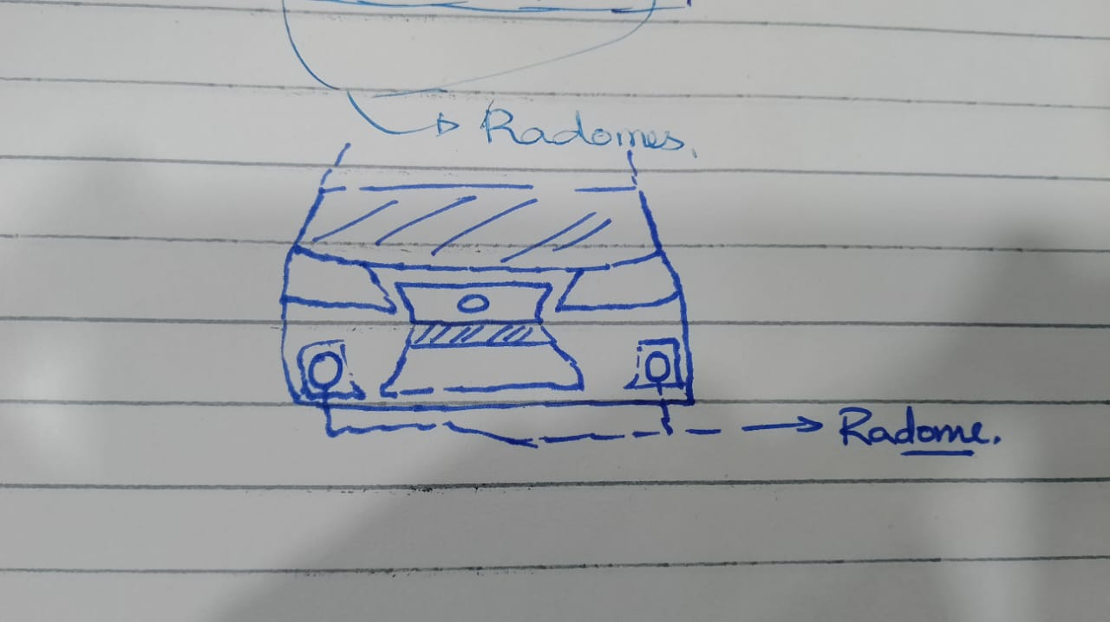

As the RADAR system is directly responsible for object detection, there must be no unnecessary obstructions in the path of the Radiation.

**Challenges:** Major challenges were in figuring out the way to simplify the design problem (i.e the other approach taken was to design a custom geometry, which would be a function of the direction of wave propagation, and **a**n**.R** would be maximized by averaging the direction of wave propagation over some reasonable patch, etc). However, for our application, we were at liberty to make some very reasonable assumptions about the Directivity. A more precise analysis would involve the use of snell’s law to model oblique incidences, mathematical models for multiple layers of radome material (for optimiztion of the refractive index for instance). Major improvement in our design may be made by use of tools like HFSS for much complicated analyses.