**PADP LAB OUTPUS**

**PROGRAM 2 ( Matrix Multiplication)**

|  |  |  |  |  |
| --- | --- | --- | --- | --- |
| Input size | Execution Time-Number of threads | | | |
|  | 1 | 2 | 4 | 8 |
| 500 | 1.247000 | 0.531000 | 0.336000 | 0.296000 |
| 1000 | 9.539000 | 5.952000 | 3.864000 | 2.876000 |
| 1500 | 31.832000 | 15.949000 | 9.494000 | 6.872000 |
| 2000 | 90.786000 | 50.553000 | 31.000000 | 22.856000 |

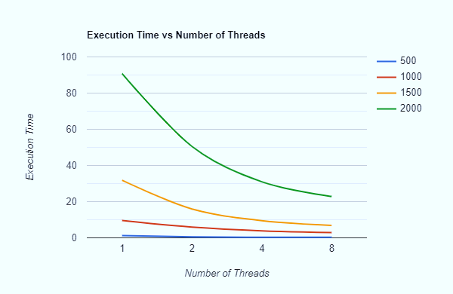

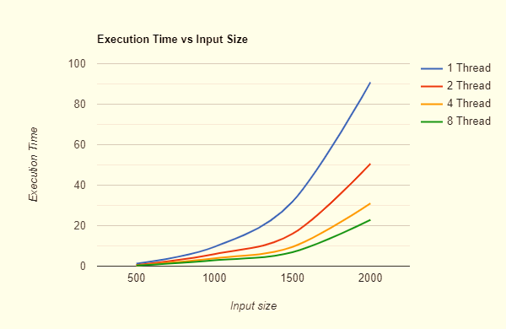

**PROGRAM 1 ( Pi Calculation )**

|  |  |  |  |  |  |  |  |  |
| --- | --- | --- | --- | --- | --- | --- | --- | --- |
| Input size | Execution Time vs Number of threads | | | | | | | |
| **1** | | **2** | | **4** | | **8** | |
| Value | Time | Value | Time | Value | Time | Value | Time |
| 100000 | 3.14076 | 0.008000 | 3.13668 | 0.005000 | 3.12744 | 0.004000 | 3.1164 | 0.004000 |
| 1000000 | 3.14234 | 0.036000 | 3.14166 | 0.024000 | 3.14078 | 0.014000 | 3.13622 | 0.014000 |
| 10000000 | 3.1417 | 0.334000 | 3.14145 | 0.168000 | 3.14068 | 0.109000 | 3.14036 | 0.069000 |
| 100000000 | 3.14158 | 3.385000 | 3.1414 | 1.724000 | 3.14121 | 1.023000 | 3.14108 | 0.653000 |
| 1000000000 | 3.14154 | 32.923000 | 3.14148 | 17.479000 | 3.14146 | 9.933000 | 3.14137 | 6.409000 |

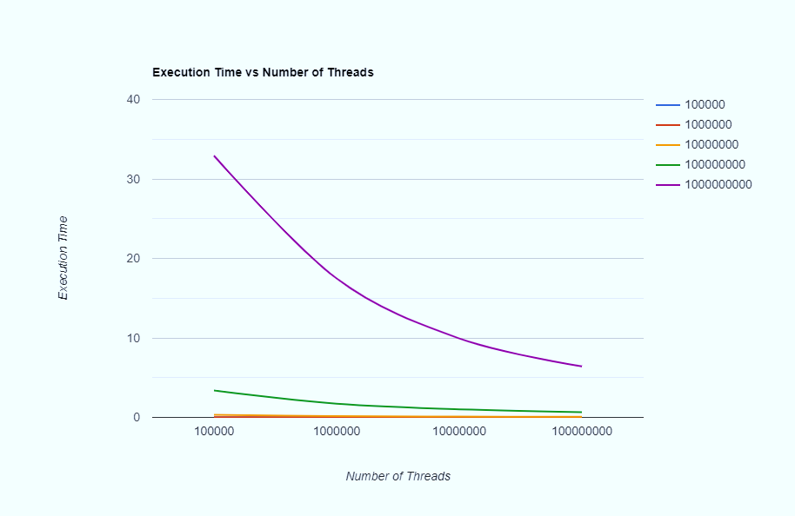

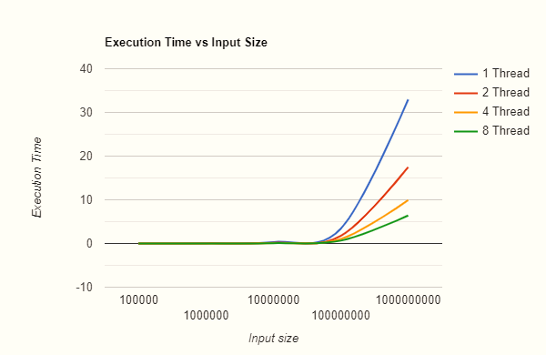

1b

|  |  |  |  |
| --- | --- | --- | --- |
| Iterations | Execution Time | | |
| 3 | 5 | 9 |
| 10000 | 1.48E-03 | 8.57E-04 | 1.36E-02 |
| 100000 | 9.86E-03 | 7.58E-03 | 1.71E-02 |
| 1000000 | 0.105168 | 0.074548 | 0.065742 |
| 10000000 | 0.949605 | 0.67502 | 0.567609 |

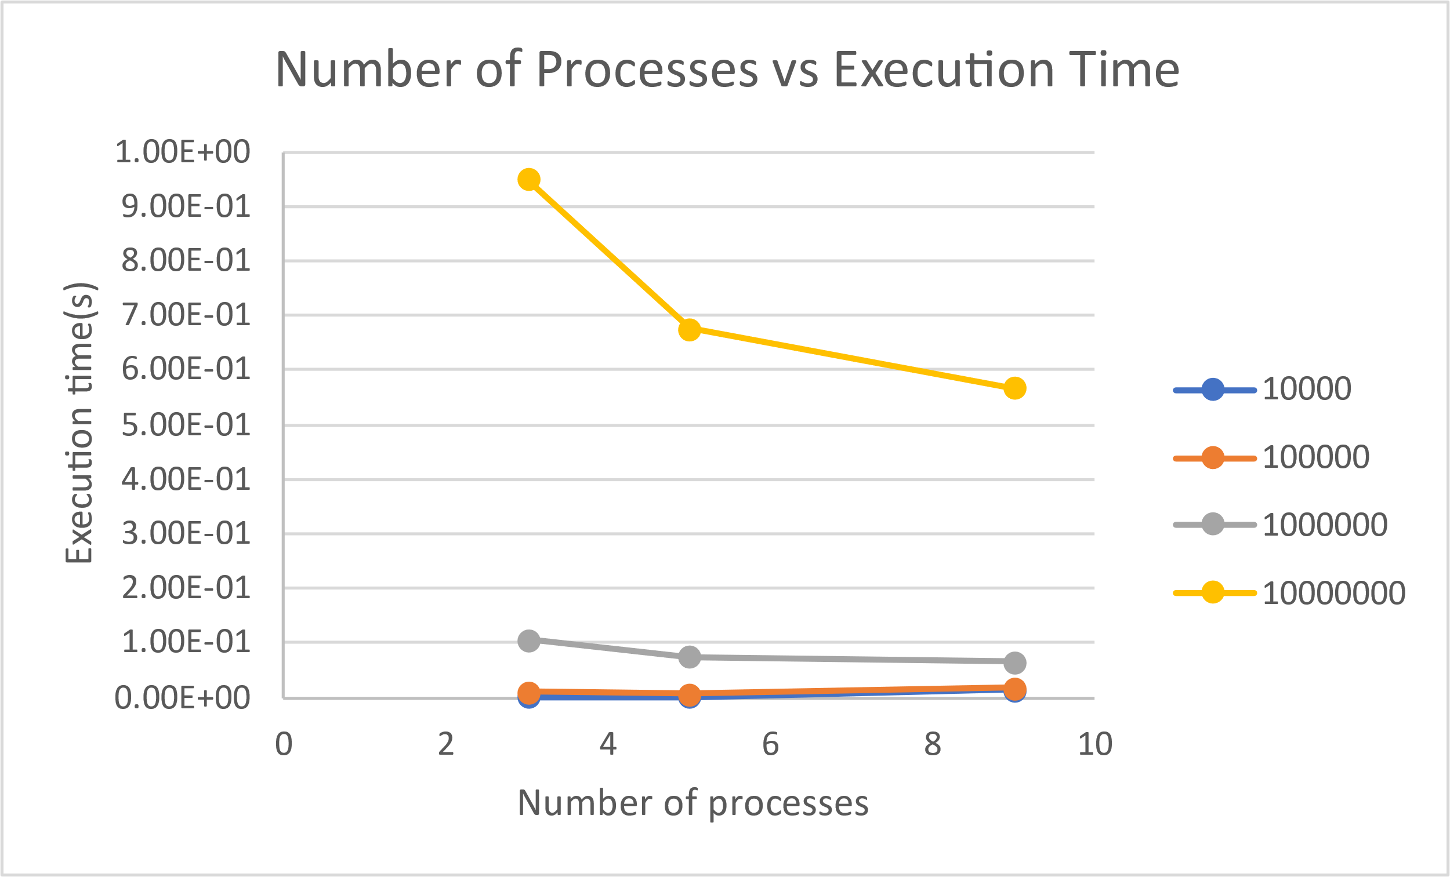

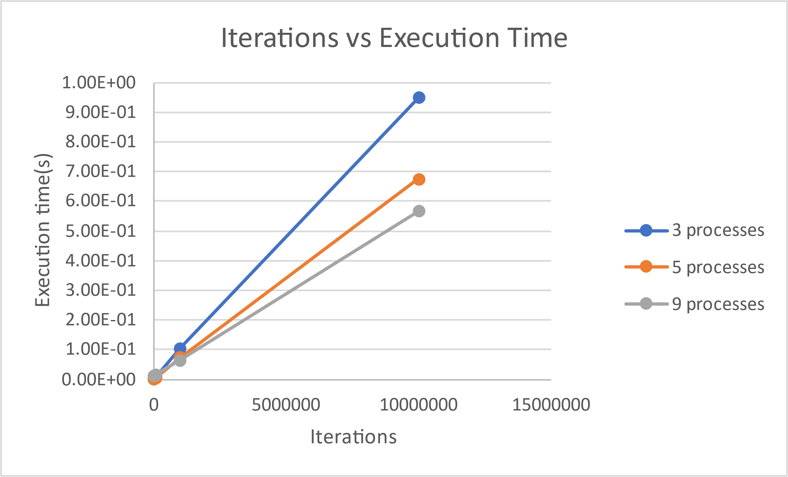

**PROGRAM 3 : Sieve of Eratosthenes**

|  |  |  |  |  |  |
| --- | --- | --- | --- | --- | --- |
|  | Execution | Time | | | |
| Cache Unfriendly Sieve | Cache Friendly Sieve | Cache Parallel Sieve |  |  |  |
| 1 | 2 | 4 | 8 |
| 0.000818 | 0.000913 | 0.00103 | 0.001074 | 0.000896 | 0.001647 |
| 0.008269 | 0.009027 | 0.008996 | 0.005949 | 0.003532 | 0.004876 |
| 0.122772 | 0.079445 | 0.082135 | 0.052763 | 0.025498 | 0.019586 |
| 1.79078 | 0.805944 | 0.797903 | 0.422097 | 0.245255 | 0.245255 |

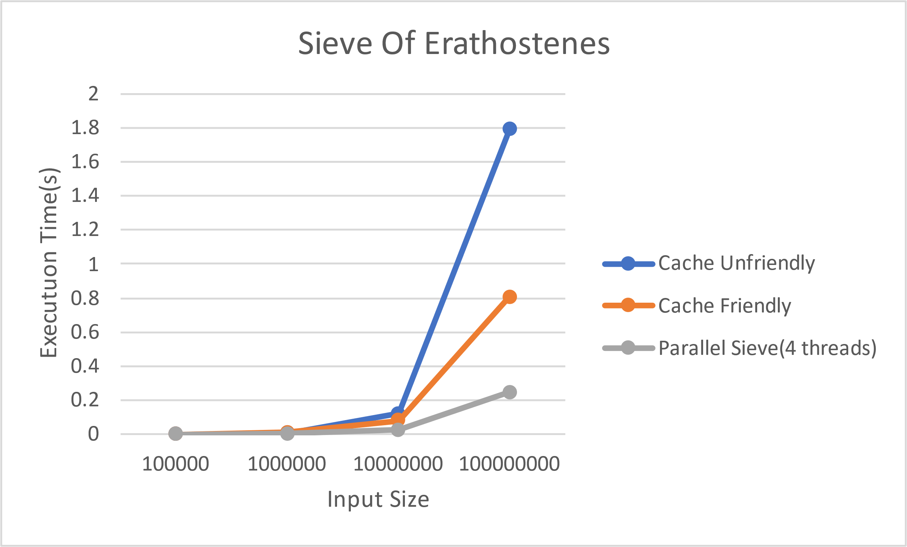

**PROGRAM 4 : Negative of an Image**

|  |  |  |  |  |
| --- | --- | --- | --- | --- |
| **Image Size** | **Scheduling Type** | | | |
| **Default** | **Static** | **Dynamic** | **Guided** |
| 640 x 369 | 0.002399 | 0.002054 | 0.002046 | 0.002064 |
| 1280 x 890 | 0.012213 | 0.011349 | 0.01147 | 0.011197 |
| 1920 x 658 | 0.011911 | 0.016365 | 0.022557 | 0.013992 |
| 1800 x 1350 | 0.030596 | 0.028528 | 0.027761 | 0.027577 |

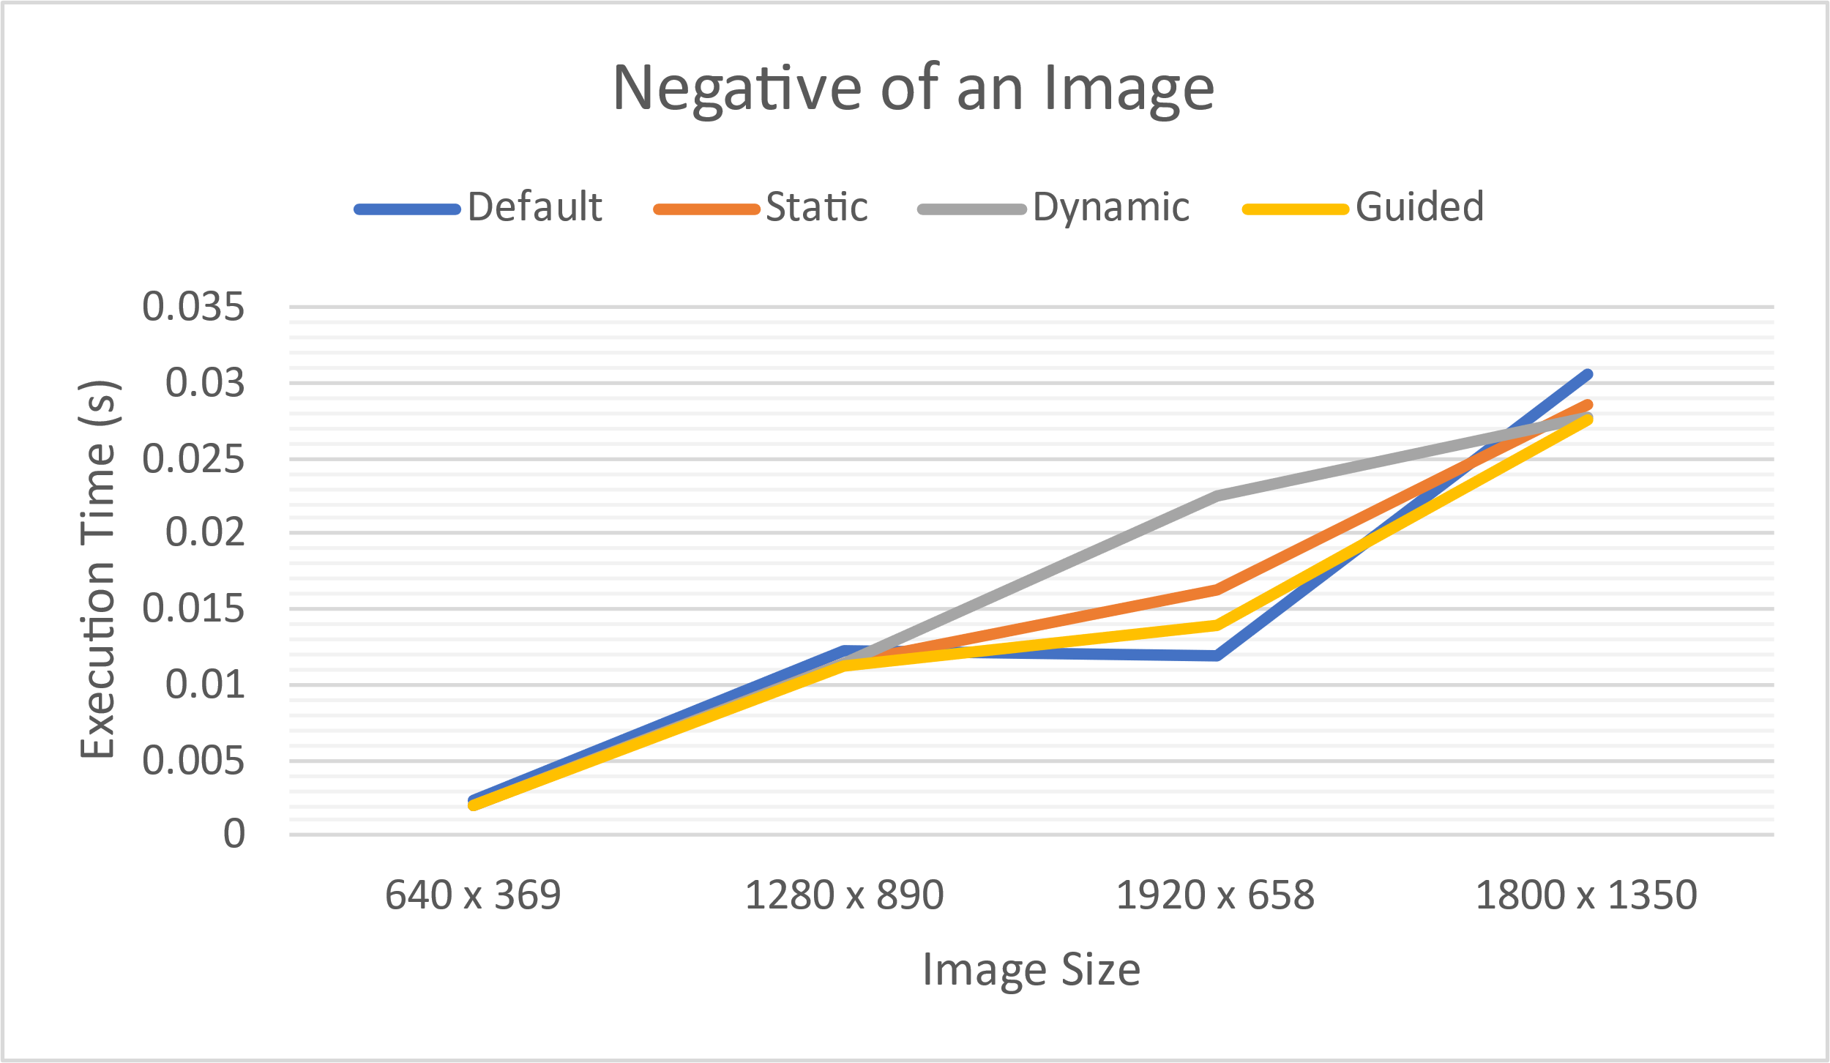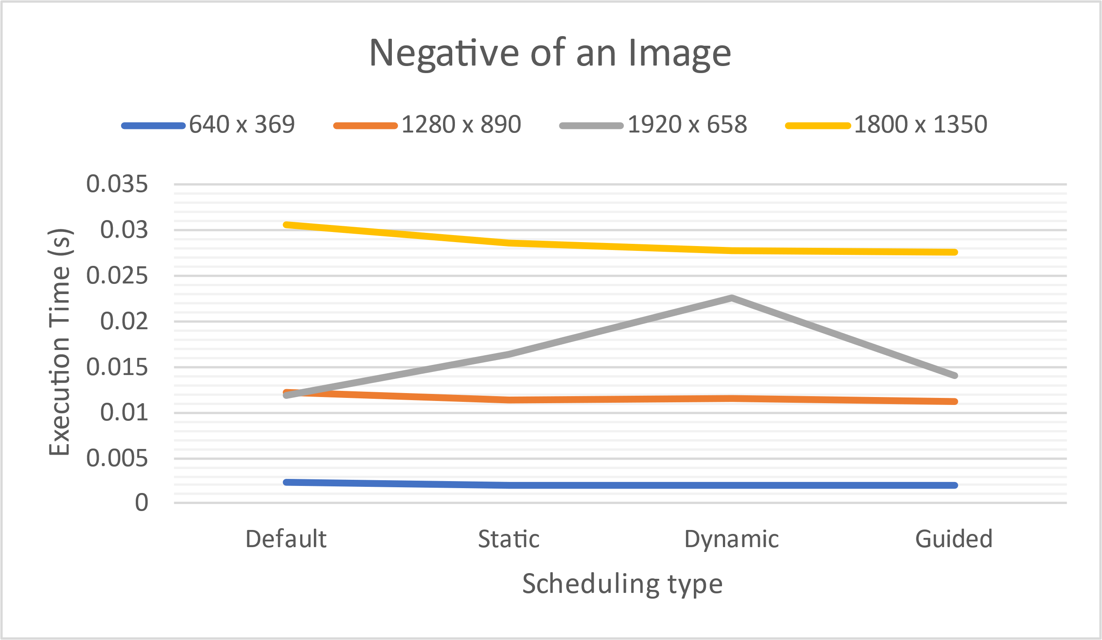

**PROGRAM 5**

|  |  |  |  |  |
| --- | --- | --- | --- | --- |
| **Input size** | **No. of threads** | | | |
| **1** | **2** | **4** | **8** |
| 100000 | 0.00712 | 0.003562 | 0.002419 | 0.00258 |
| 500000 | 0.039103 | 0.023072 | 0.011795 | 0.011747 |
| 1000000 | 0.063634 | 0.037818 | 0.022952 | 0.023618 |
| 5000000 | 0.332384 | 0.183873 | 0.131114 | 0.11797 |

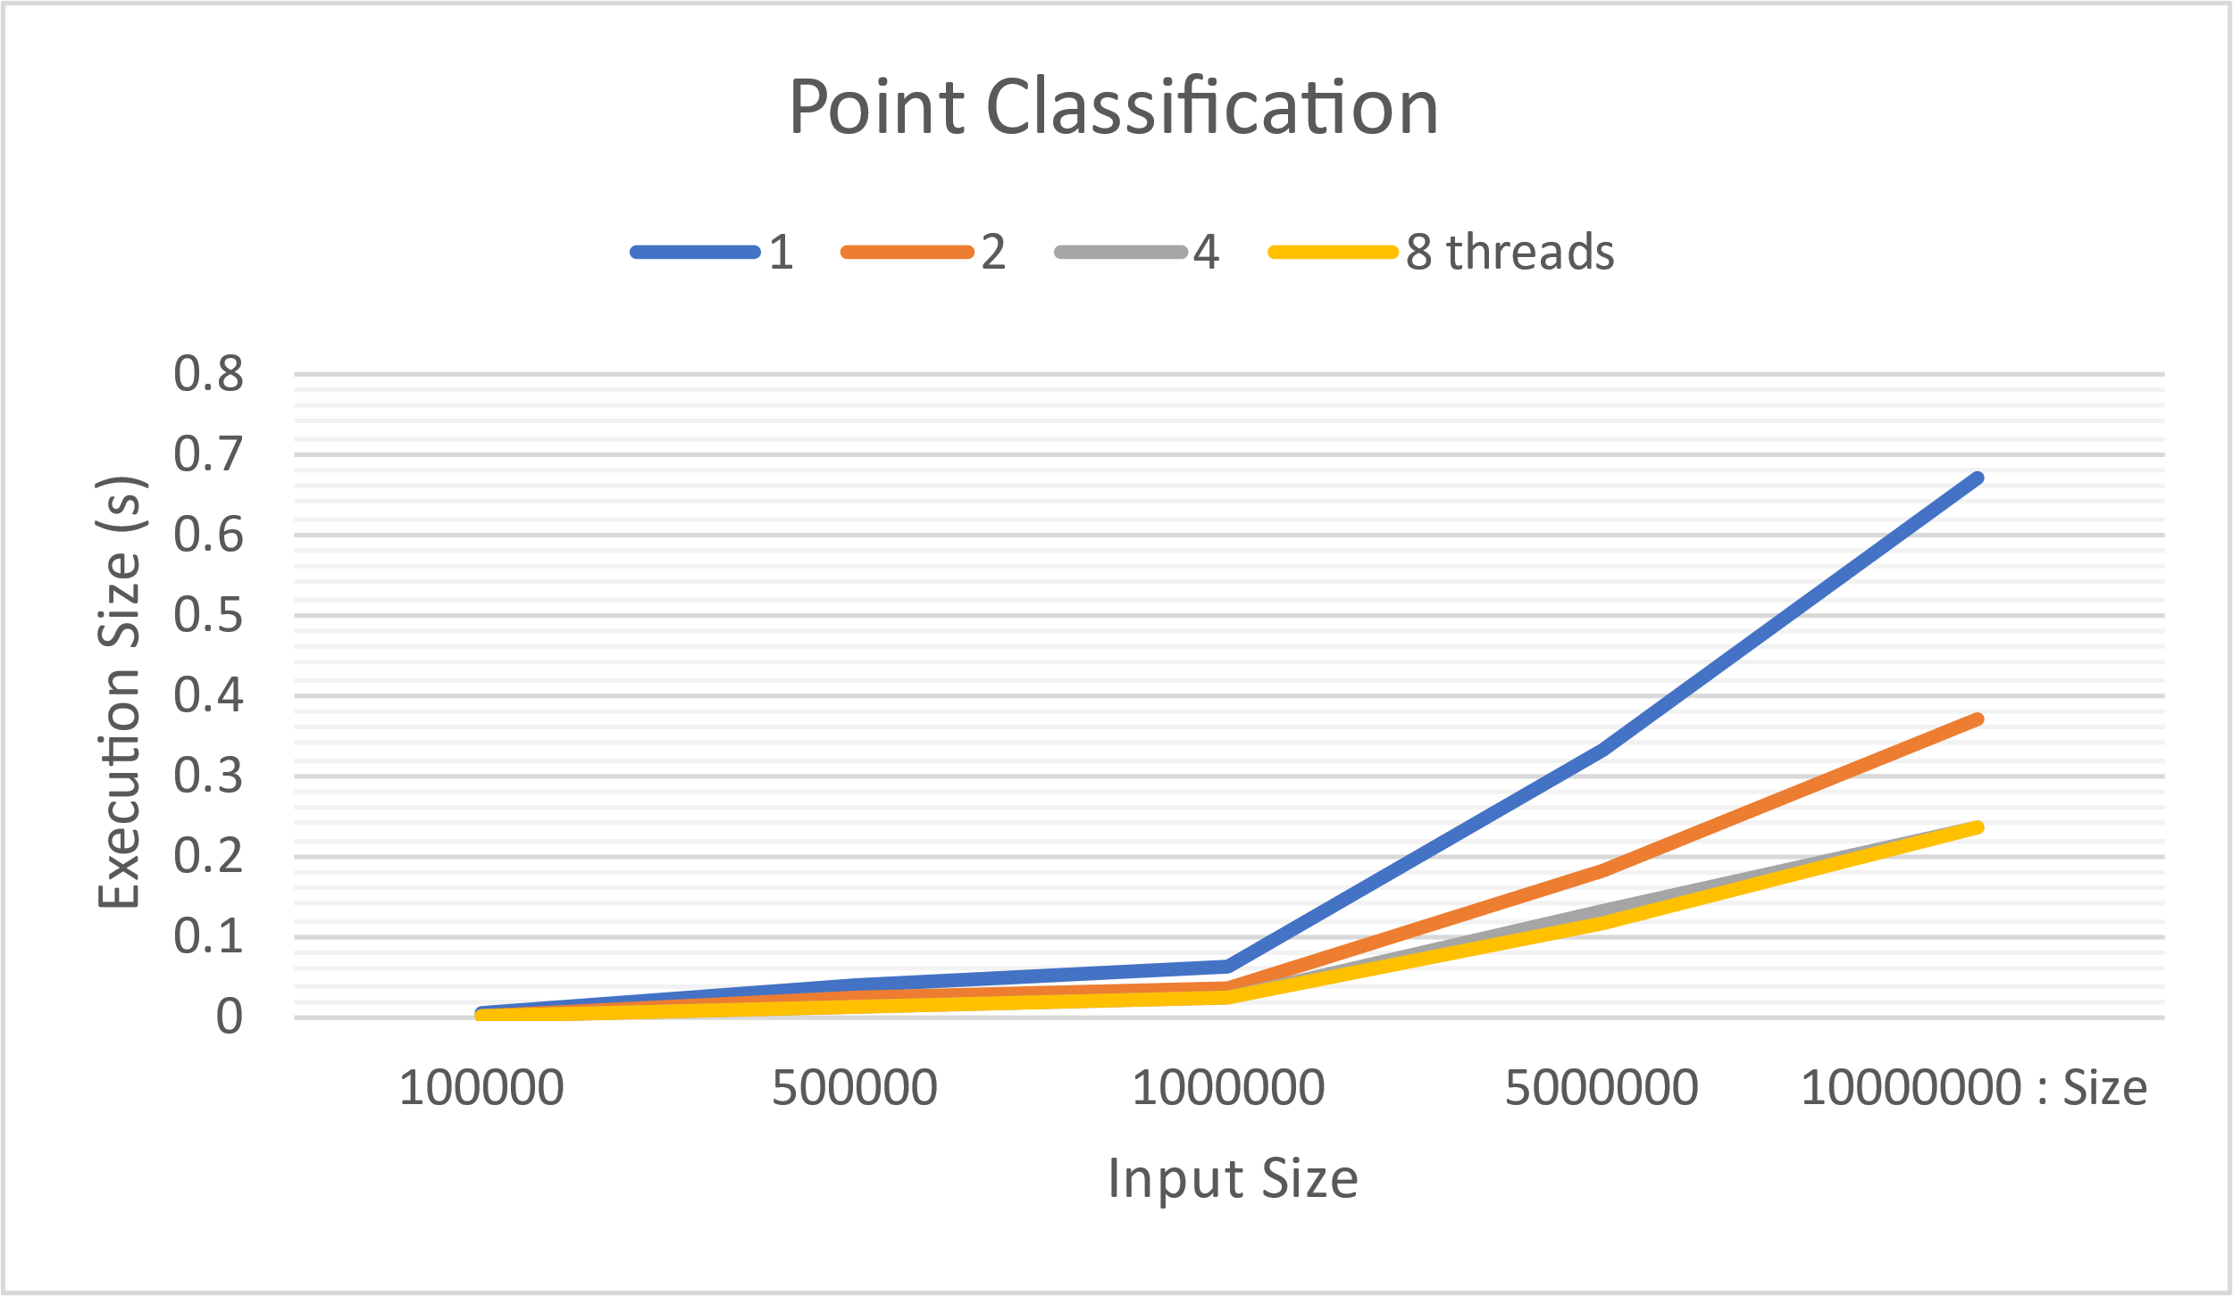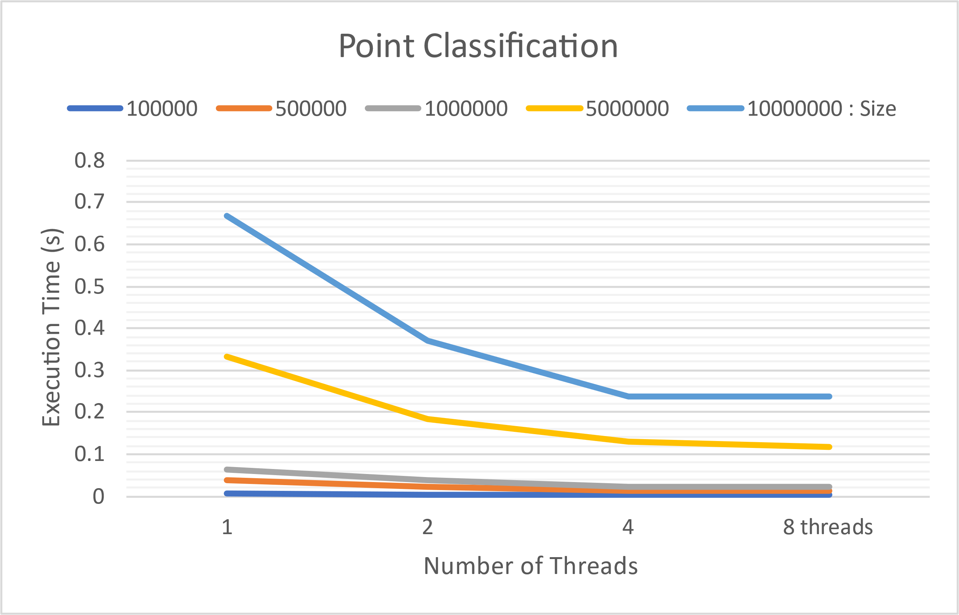

**PROGRAM 6**

|  |  |  |  |  |
| --- | --- | --- | --- | --- |
| File Size(KB) | Execution Time | | | |
| 1 | 2 | 4 | 8 |
| 1 | 0.006009 | 0.054372 | 0.010441 | 0.014479 |
| 2 | 0.013115 | 0.013621 | 0.014502 | 0.015667 |
| 3 | 0.019483 | 0.015392 | 0.014927 | 0.016296 |
| 4 | 0.01105 | 0.0115 | 0.016502 | 0.009686 |

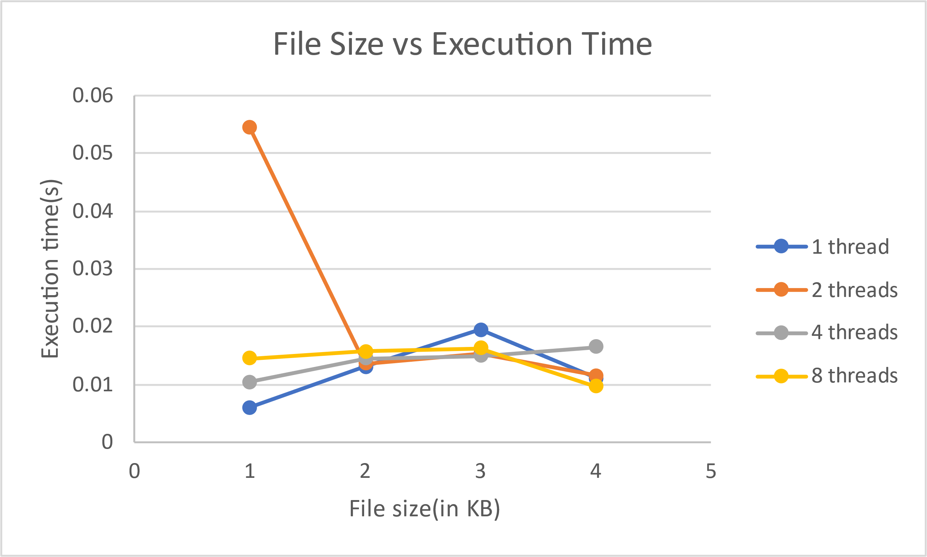

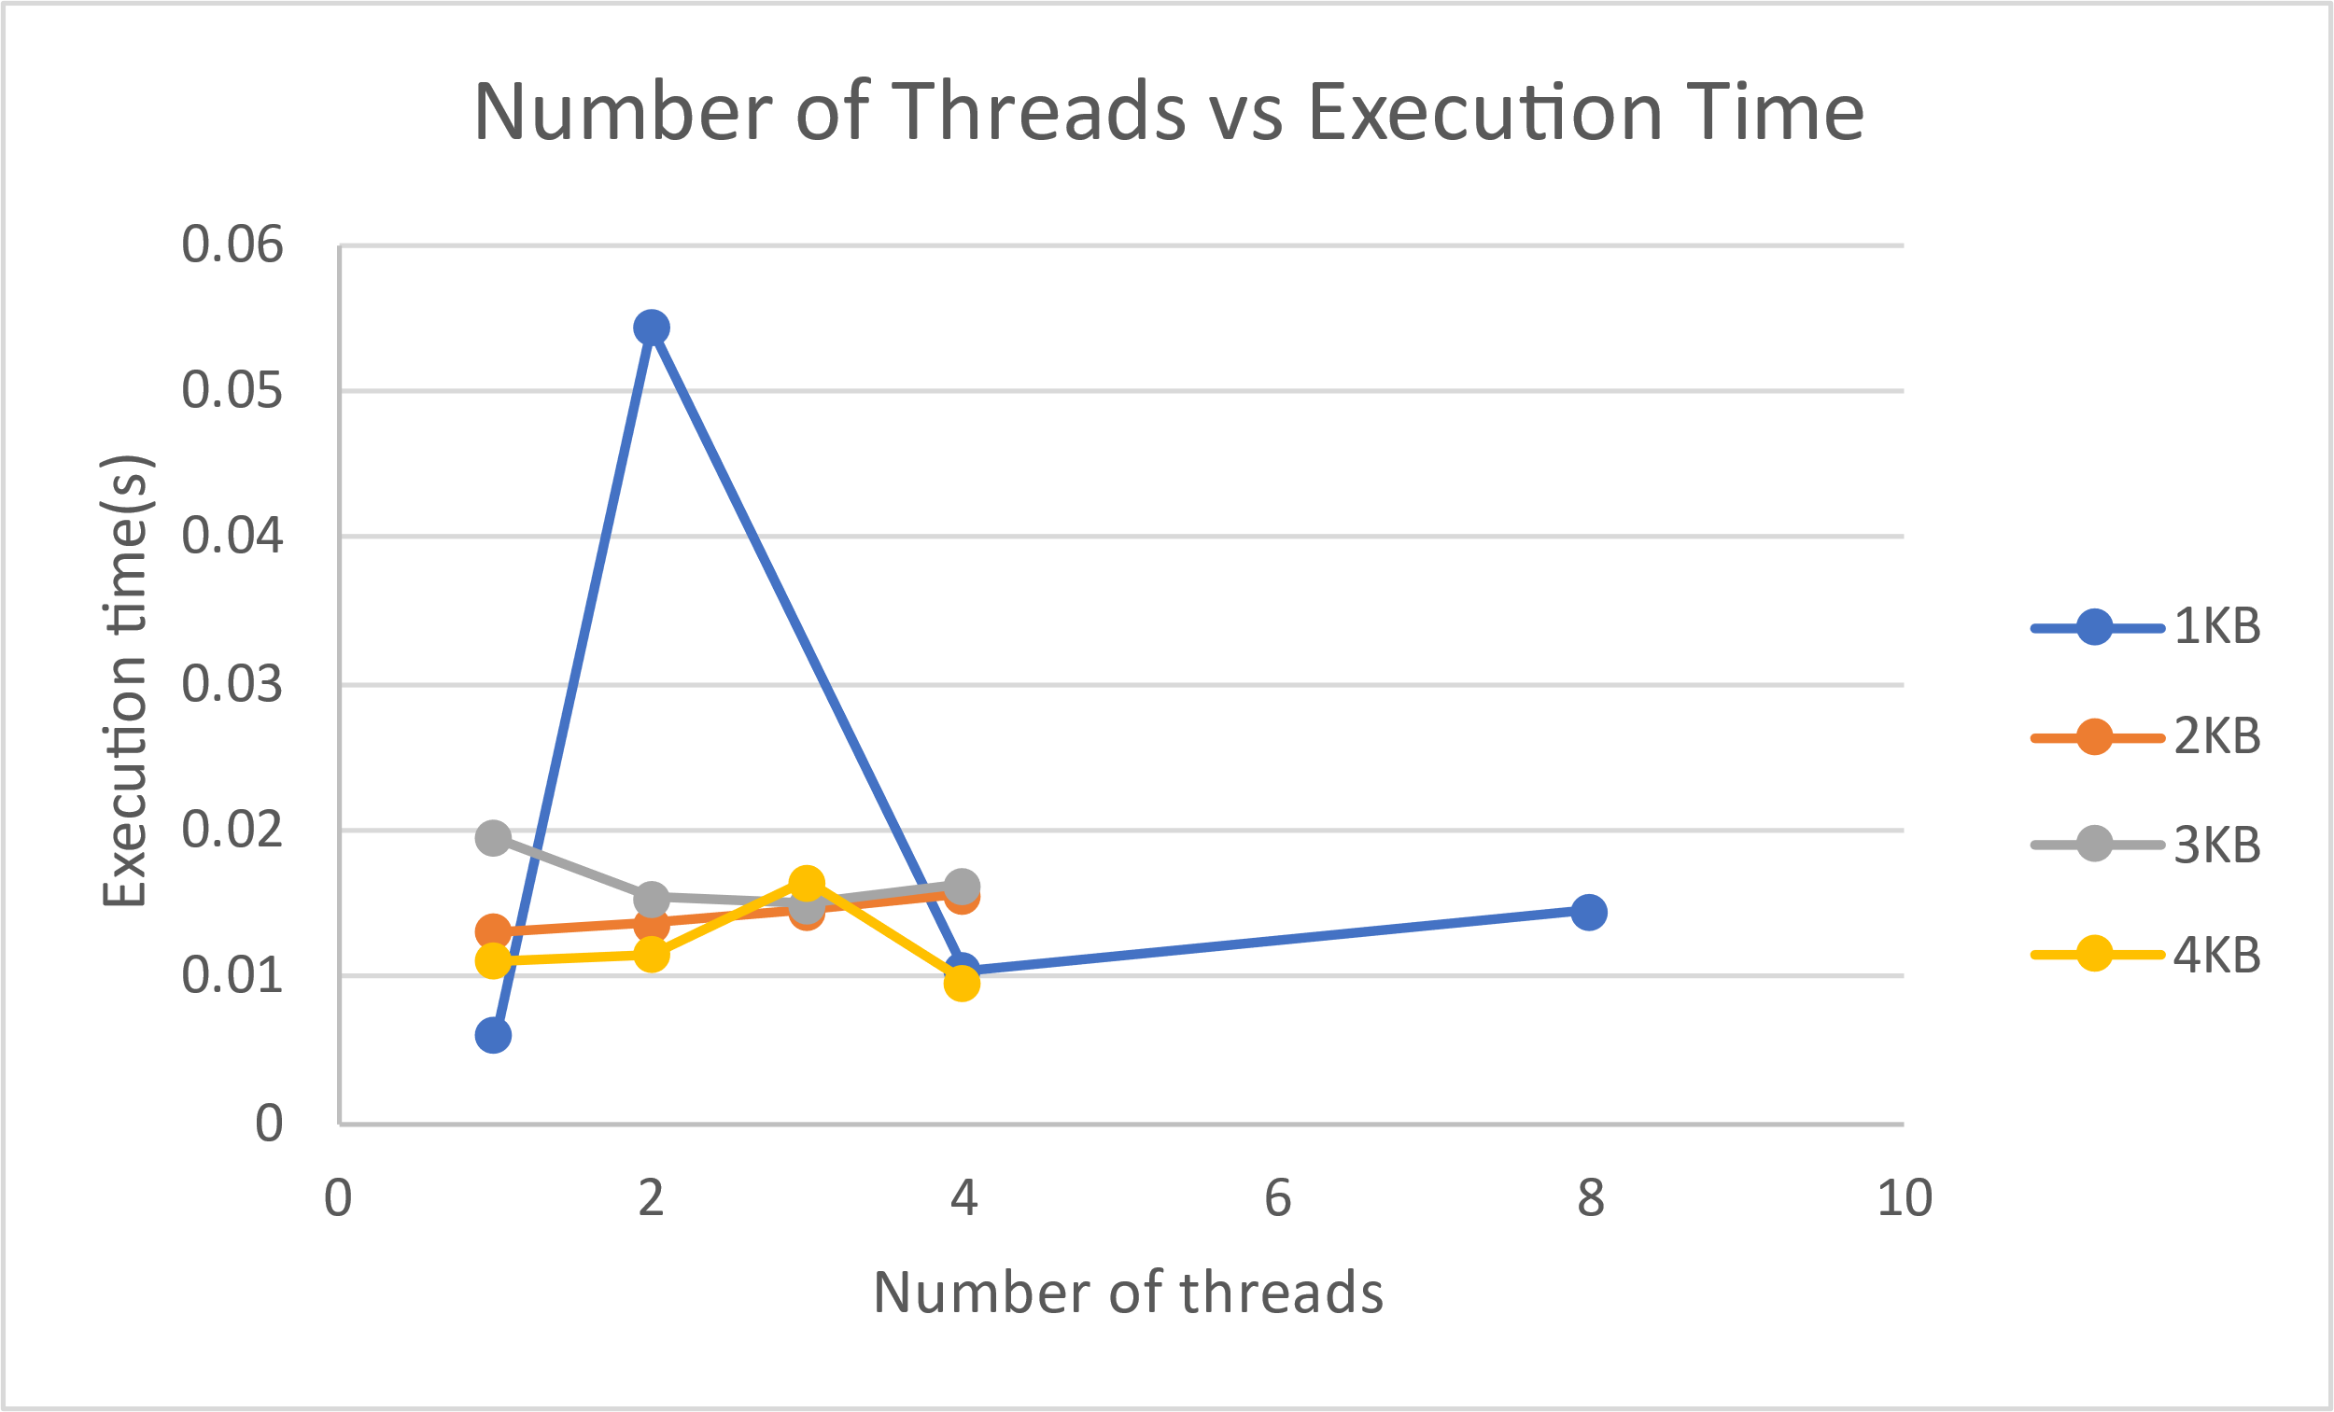

**PROGRAM 8**

|  |  |  |  |
| --- | --- | --- | --- |
| Evaluations | Execution Time | | |
| 2 | 4 | 8 |
| 1000 | 5.50E-04 | 6.68E-04 | 1.96E-03 |
| 10000 | 8.08E-04 | 7.56E-04 | 9.43E-04 |
| 100000 | 0.003111 | 0.001608 | 0.001559 |
| 1000000 | 0.0255 | 0.009783 | 0.004566 |

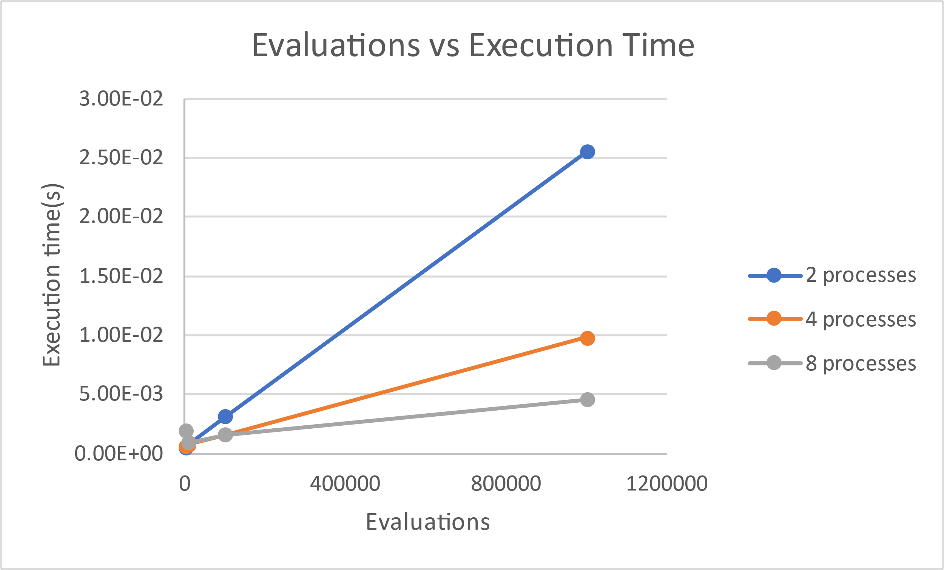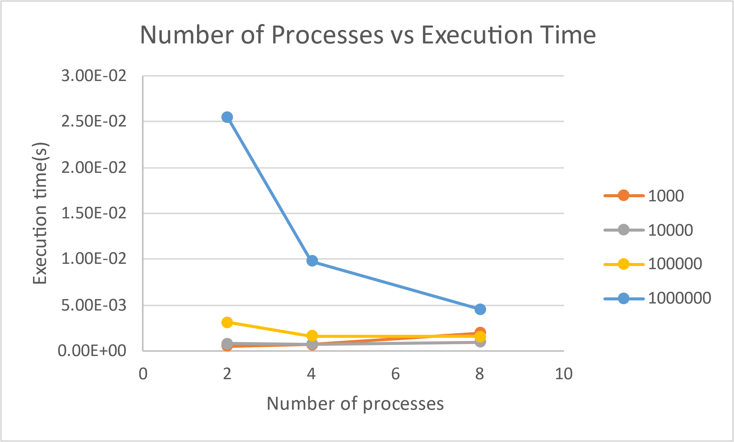

**PROGRAM 9**

|  |  |  |  |
| --- | --- | --- | --- |
| Input Size | Execution Time | | |
| 2 | 4 | 8 |
| 100 | 5.27E-05 | 1.67E-05 | 6.29E-05 |
| 1000 | 1.07E-05 | 1.48E-05 | 6.76E-05 |
| 10000 | 0.001448 | 0.006482 | 0.019143 |
| 100000 | 0.000243 | 0.000422 | 0.001558 |
| 1000000 | 0.002617 | 0.006074 | 0.013918 |

