**DASH BOARD :**

Link for the dashboard

[**http://gbrsipdbdp01.corp.internal/dashboard/**](http://gbrsipdbdp01.corp.internal/dashboard/)

EPOS AppsMgmt is defined as Retail in dashboard. Please click on it

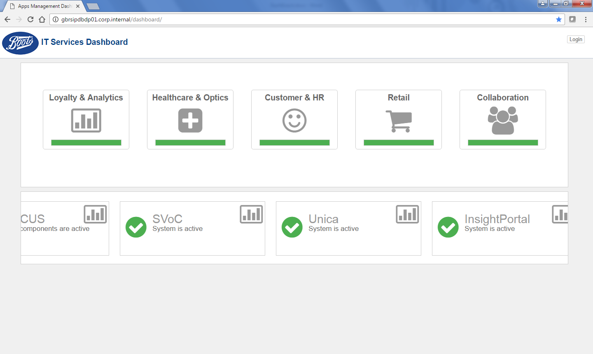

You will get a screen like below

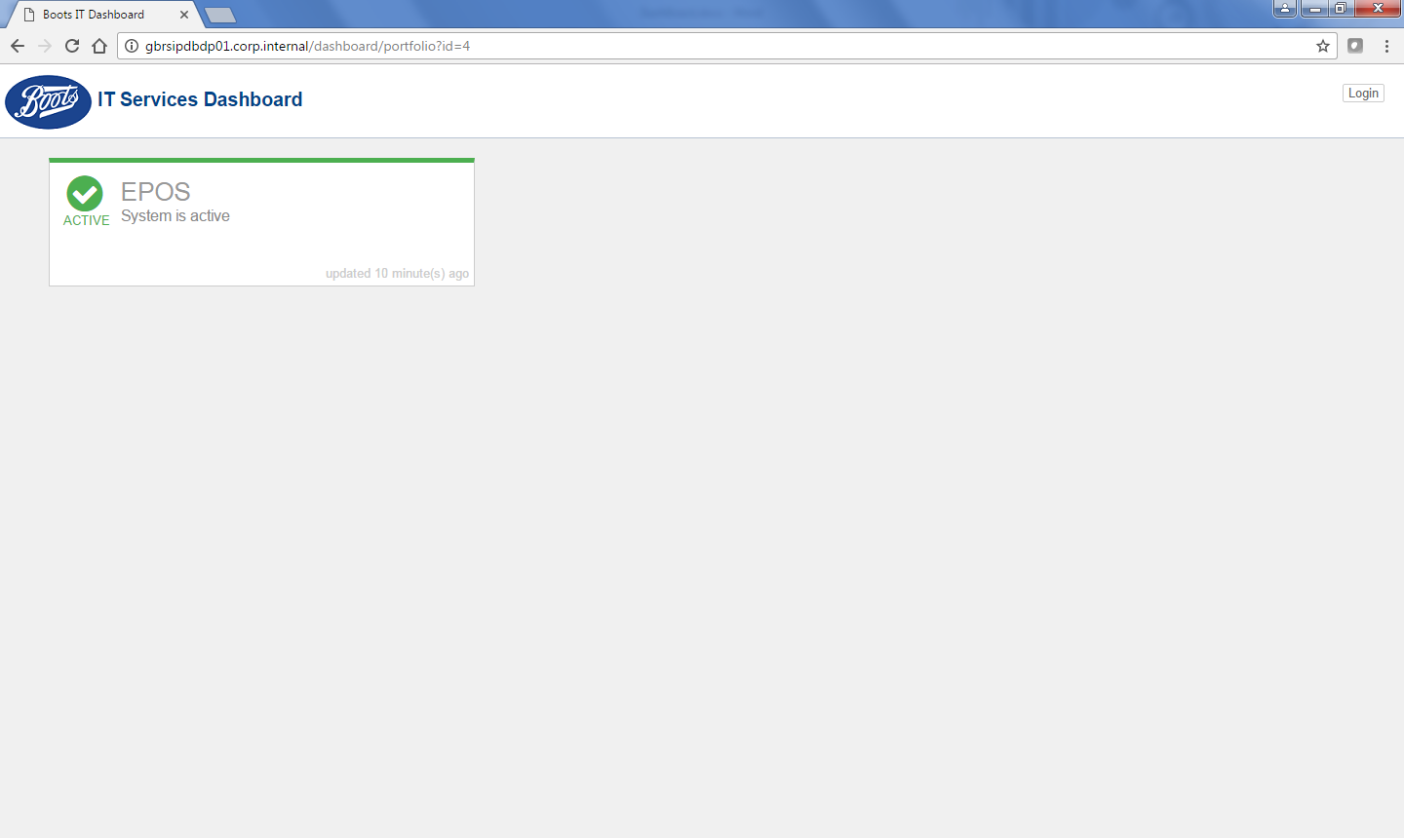

Click on EPOS ( in the word itself rather than on the green tick mark to see the component level details)

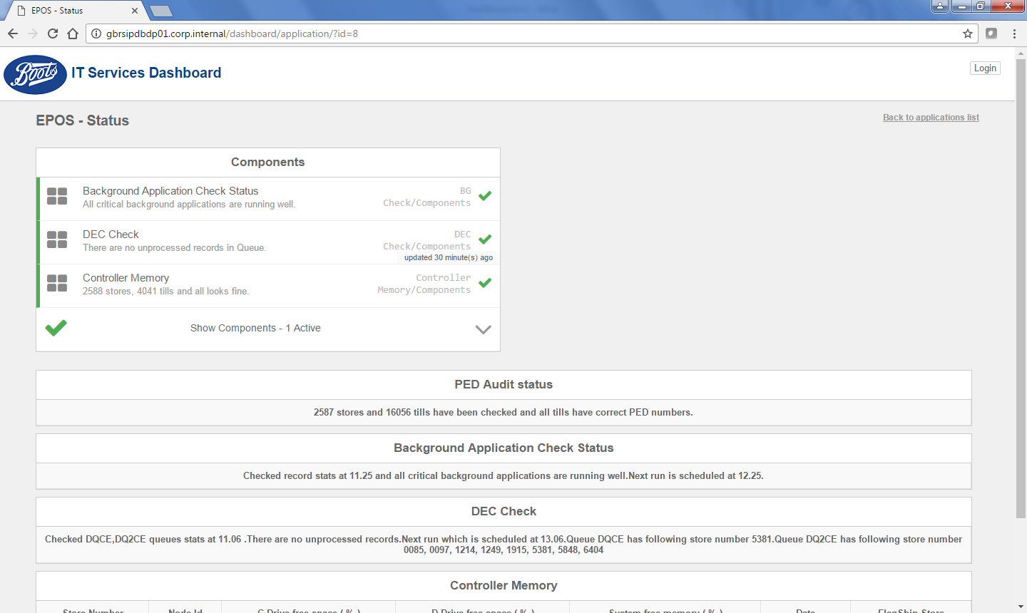

There are total 5 components as below

1. PEDCHECK – Once a day
2. BACKGROUND Application Check – every hour between 9am to 6pm(9 runs)
3. DEC check – 6 times a day ( 3 times for flagship stores and 3 times for all stores)
4. Controller Memory – once a day
5. Critical file status - Once a month ( deactivated currently due to not up to date with status)

What each report does.

**PEDCHECK :**

Report the PEDNUMBER and type of the device from all the tills in all stores, and if there is any corruption with those it gets reported. Below are the thresholds

1. More than 98% tills in our estate has right PED numbers – Green
2. Between 95% to 98% has right PED numbers - Amber
3. Less than 95% of the tills have PED Numbers – Red

**Background Application check:**

Background application check monitors all 10 Critical applications running in the background and reports it once an hour. The checked applications are below

* EALCS00L.286 - Sales support/Checkout support
* PSS35.286 - Stock support
* Transact - HHT client/server module
* NFMC - NFM client module
* BGMON – Background application monitor program
* QHANDLER – DEC outbound module to WMB
* QSERVER - DEC inbound module from WMB
* QPROCESS – Controller logic engine for updating HUMSS UOD data.
* QMON - Queue Depth Monitors
* PSB90 - ENDOK cut off program

so if any store has program ended the report will indicate that

**Threshold**

Less than 25 stores have issues with one or multiple programs – Green

25 to 50 stores have issues with background application - Amber

More than 50 stores have failed background applications – Red

**Dec check :**

Dec check monitors the status of trickle feed and Adcard data status in stores 6 times a day. When a store has issue with one of its queue then the store number gets reported in the dashboard

**Threshold**

Less than 25 stores have issues with one or multiple programs – Green

25 to 50 stores have issues with background application - Amber

More than 50 stores have failed background applications – Red

**Controller Memory status**

Controller memory reports the status of the controller whose RAM memory goes below 50% of the available space. The reason for that is , since PCI we have noticed controller with less memory has card payment and settlement issues. This will give an indication on stores who are not in very healthy status.

**Threshold**

Less than 25 stores have issues with one or multiple programs – Green

25 to 50 stores have issues with background application - Amber

More than 50 stores have failed background applications – Red

**Fixing issues with Dashboard :**

After taking appropriate actions on the issues reported technically status of the report needs to be changed manually in the dashboard. As some of the reports doesn’t get reported until next day, the status will stay as amber/red until new run.

Click on the retail tab

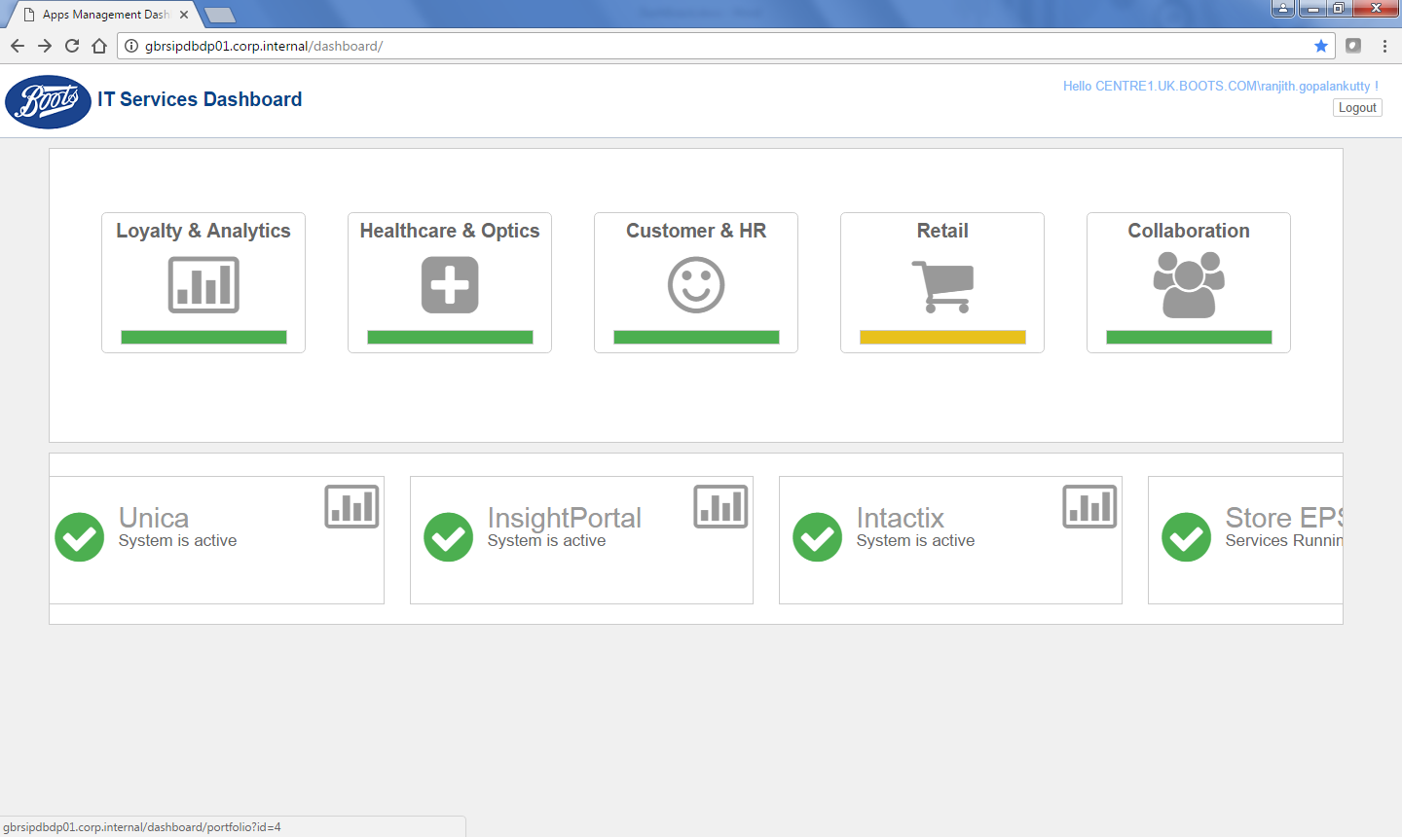

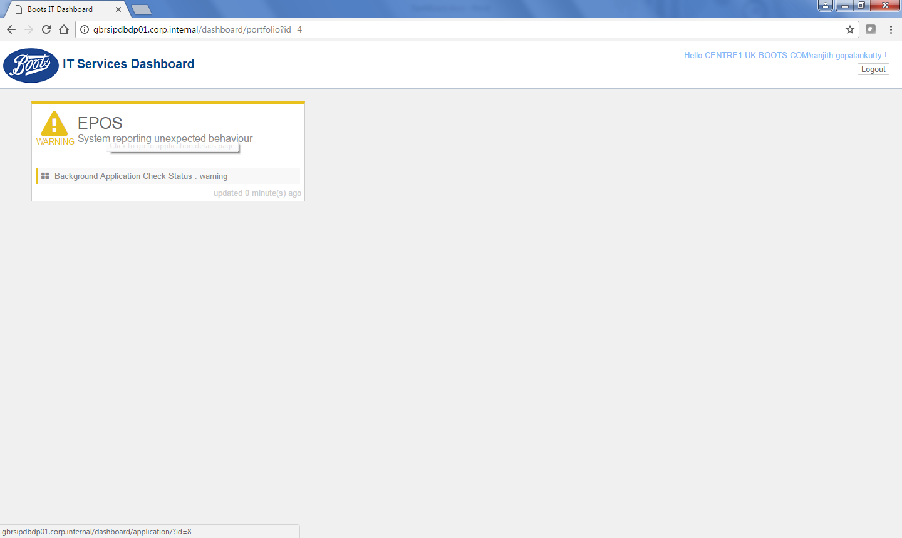

Identify the report which is in error

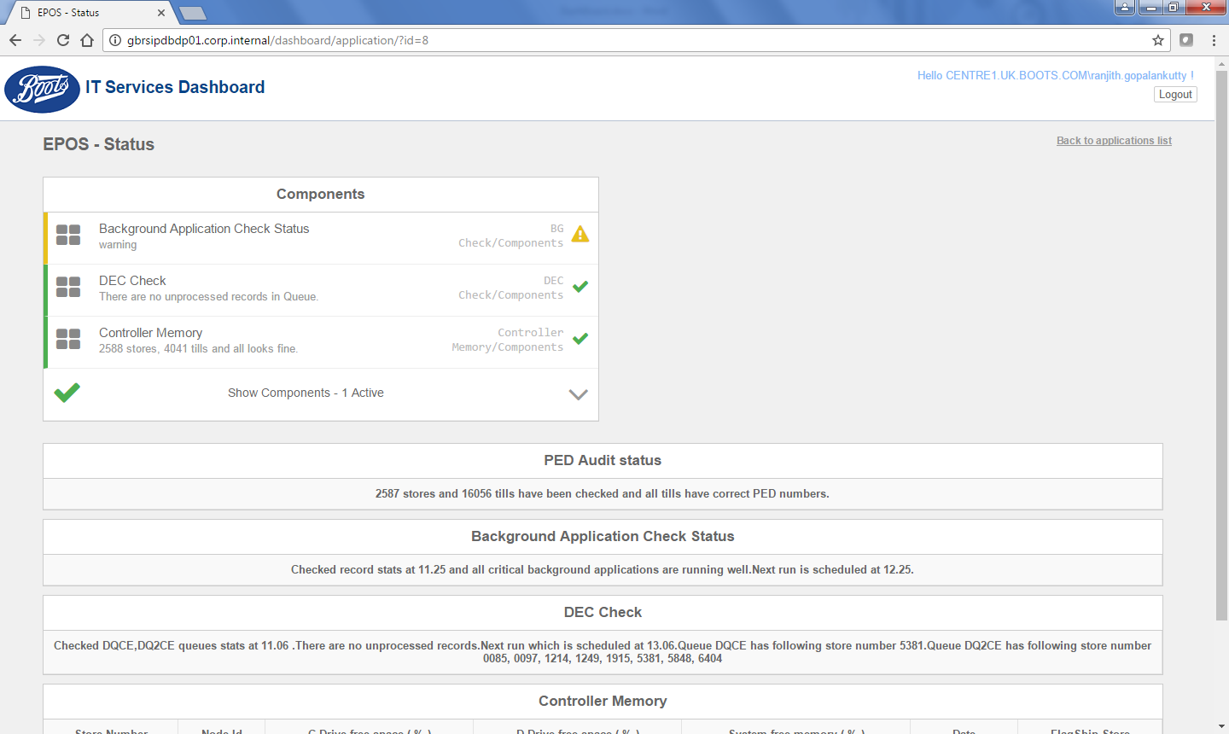

Click on the amber/red symbol

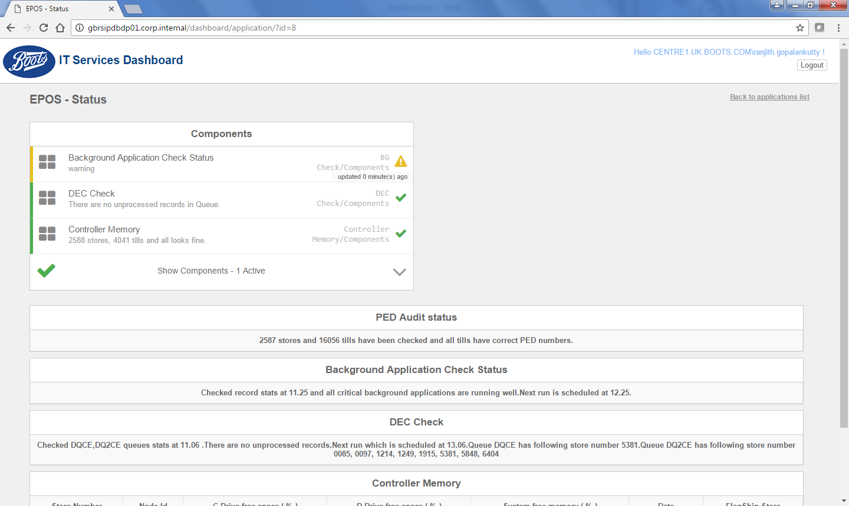

You will get a screen like below

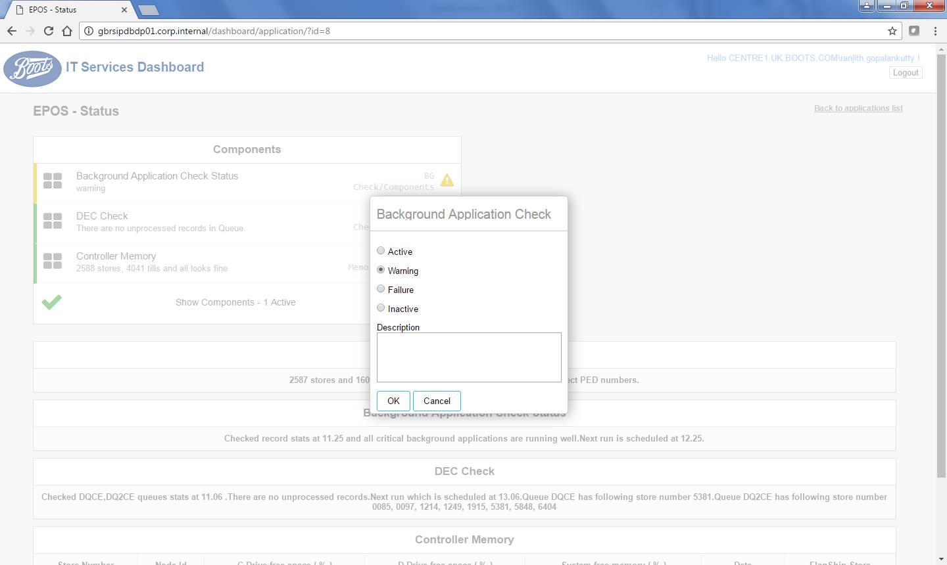

Change the status from warning/Red to Green by giving right comments on what was the error and what you fixed and click OK.

Now come back to the main screen and refresh the page. Status should be green now.

