Assignment for Module 10
The assignment for Module 10 involves problems for schema conversion. Problems 1 to 4 involve the ERD in Figure 1.
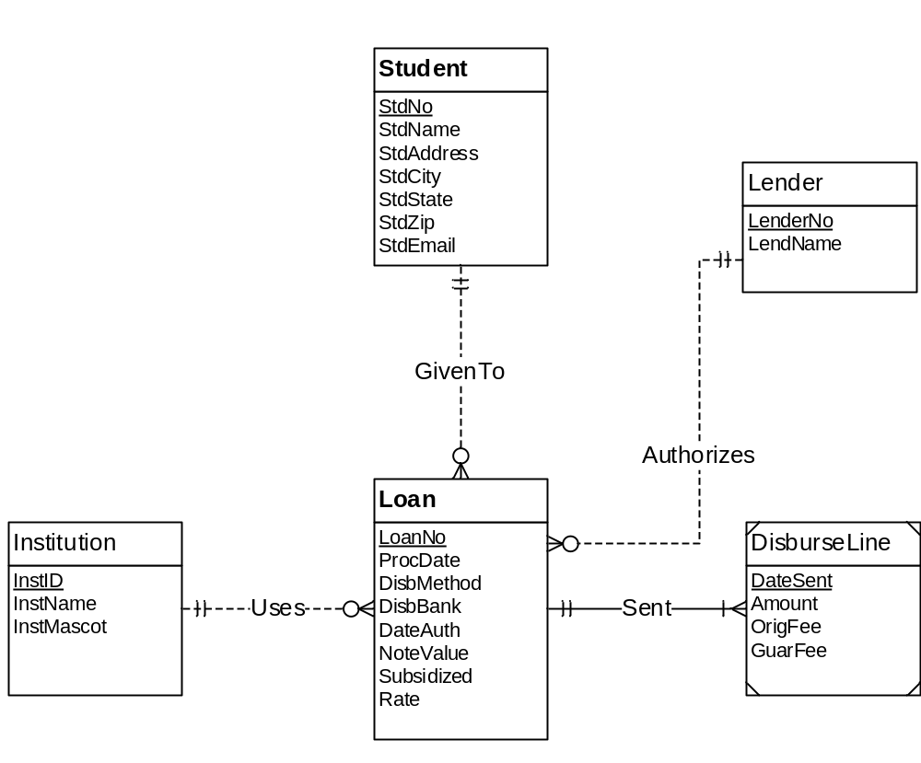
Figure 1: ERD for Problems 1 to 4
1. Requirements for Data Modeling Problems
- For the ERD in Figure 1, you should indicate the applications of the entity type rule. For each entity type rule application, you should identify the table name, primary key, and other columns. You do not need to write CREATE TABLE statements.
Ans). Entity type rule for converting each entity
Student(StdNo primaryKey ,StdName,StdAddress,StdCity,StdStteate,StdEmail)
Loan(LoanNo primaryKey ,ProcDate,DisbMethod,DisbBank,DateAuth,Notevaalue,Subsidized,Rate)
Institution(InstID primaryKey,instName,instMascot)
DisburseLine(DateSent primaryKey,Amount,OrigFee,GuarFee)
Lender(LenderNo primaryKey,LendName);

- For the ERD in Figure 1, you should indicate applications of the 1-M relationship rule. For each 1-M relationship rule application, you should indicate the changes to the tables you listed in problem 1 including foreign key columns and NOT NULL constraints for foreign keys if necessary.A
Ans ) 1-M Relationship Rule
Loan(
LoanNo primaryKey ,StdNo,InstID,LenderNo,ProcDate,DisbMethod,DisbBank,
DateAuth,Notevaalue,Subsidized,Rate
FOREIGN KEY(stdNo) REFRENCES Student(stdNo),
FOREIGN KEY(InstID) REFRENCES Institution(InstID),
FOREIGN KEY(LenderNo) REFRENCES Lender(LenderNo)
)
DisburseLine(
DateSent primaryKey,Amount,OrigFee,GuarFee,LoanNo
FOREIGN KEY (LoanNo) REFERENCES Loan(LoanNo)
)

- For the ERD in Figure 1, you should indicate applications of the M-N relationship rule. For each M-N relationship rule application, you should list the table name, primary key, and other columns.
Ans) Many to Many RelationshipRule
In the figure 1 there is no many to many dependency involved

- For the ERD in Figure 1, you should indicate applications of the identifying relationship rule. For each identifying relationship rule application, you should indicate the changes to the tables you listed in problem 2.
Ans)Identifying relationship rule
This rule makes primary key of parent table acts as primary key for child table also
since DistributeLine is a weak entity so its a good practise to apply this rule
DisburseLine(
DateSent primaryKey,LoanNo primaryKey,Amount,OrigFee,GuarFee,LoanNo
)
- Convert the ERD shown in Figure 2 into tables. List the conversion rules used and table design. For each table, you should list the primary key, foreign keys, other columns, and NOT NULL constraints for foreign keys if necessary. You do not need to write CREATE TABLE statements.
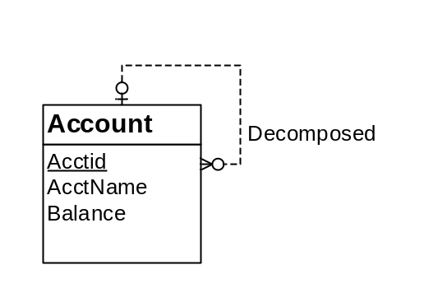
Figure 2: ERD for Conversion Problem 5

Ans): Entity type rule
Account(AcctId primaryKey, AcctName, Balance)
- Convert the ERD shown in Figure 3 into tables. List the conversion rules used and table design. For each table, you should list the primary key, foreign keys, other columns, and NOT NULL constraints for foreign keys if necessary. You do not need to write CREATE TABLE statements.
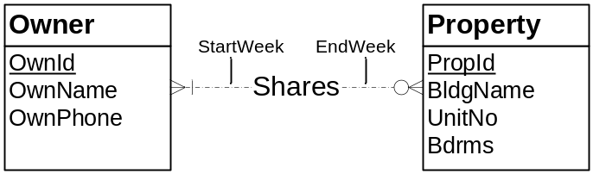
Figure 3: ERD for Conversion Problem 6
Ans ) Entity type rule
Owner(OwndId primaryKey,OwnName,OwnPhone)
Property(PropId primaryKey,BldgName,UnitNo,Bdrms)
Many to Many Rule
Shares(OwnId,PropId
FOREIGN KEY(OwnId) REFERENCES Owner(OwnID),
FOREIGN KEY(PropId) REFERENCES Property(PropId)
);

