ANATOMY-GUIDED MULTIVIEW MULTITASK DEEP LEARNING FOR LUMBAR BONE MINERAL DENSITY ESTIMATION AND OSTEOPOROSIS SEVERITY ASSESSMENT FROM X-RAY IMAGES
22CSP72 – PROJECT WORK II PHASE I
A PROJECT REPORT
Submitted by
AADHI PRANESH S S
(23CSR001)
ABHINAV KRISHNA B
(23CSR005)
DHEEPISHA G
(23CSR050)
in partial fulfilment of the requirements for the award of the degree of
BACHELOR OF ENGINEERING
IN
COMPUTER SCIENCE AND ENGINEERING
DEPARTMENT OF COMPUTER SCIENCE AND ENGINEERING
KONGU ENGINEERING COLLEGE
(Autonomous)
PERUNDURAI, ERODE – 638 060
OCTOBER 2026

DEPARTMENT OF COMPUTER SCIENCE AND ENGINEERING
KONGU ENGINEERING COLLEGE
(Autonomous)
PERUNDURAI, ERODE – 638 060
OCTOBER 2026
BONAFIDE CERTIFICATE
This is to certify that the project report entitled “ANATOMY-GUIDED MULTIVIEW MULTITASK DEEP LEARNING FOR LUMBAR BONE MINERAL DENSITY ESTIMATION AND OSTEOPOROSIS SEVERITY ASSESSMENT FROM X-RAY IMAGES” is the bonafide record of project work done by AADHI PRANESH S S (Register No: 23CSR001), ABHINAV KRISHNA B (Register No: 23CSR005), and DHEEPISHA G (Register No: 23CSR050) in partial fulfilment of the requirements for the award of the Degree of Bachelor of Engineering in Computer Science and Engineering of Anna University, Chennai during the academic year 2026–2027.

SUPERVISOR HEAD OF THE DEPARTMENT
Dr. K. DINESH, M.E., Ph.D. Dr. S. MALLIGA, M.E., Ph.D.
Associate Professor Senior Professor & Head
Dept. of Computer Science & Engg. Dept. of Computer Science & Engg.
Kongu Engineering College Kongu Engineering College
Perundurai, Erode – 638 060 Perundurai, Erode – 638 060
(Signature with seal) (Signature with seal)

Submitted for the end semester viva-voce examination held on ____________________

INTERNAL EXAMINER EXTERNAL EXAMINER

DECLARATION
We affirm that the Project Report titled “ANATOMY-GUIDED MULTIVIEW MULTITASK DEEP LEARNING FOR LUMBAR BONE MINERAL DENSITY ESTIMATION AND OSTEOPOROSIS SEVERITY ASSESSMENT FROM X-RAY IMAGES” being submitted in partial fulfilment of the requirements for the award of the Degree of Bachelor of Engineering is the original work carried out by us under the guidance of Dr. K. DINESH, Associate Professor, Department of Computer Science and Engineering, Kongu Engineering College. It has not formed part of any other project report or dissertation based on which a degree or award was conferred on an earlier occasion on this or any other candidate.

AADHI PRANESH S S (Reg. No: 23CSR001)
ABHINAV KRISHNA B (Reg. No: 23CSR005)
DHEEPISHA G (Reg. No: 23CSR050)

Date: _____________
Place: Perundurai
I certify that the declaration made by the above candidates is true to the best of my knowledge.
Dr. K. DINESH, M.E., Ph.D.
(Supervisor with Seal)

ACKNOWLEDGEMENT
We express our sincere thanks and gratitude to Thiru. E. R. K. KRISHNAN, M.Com., our beloved Correspondent, and all other philanthropic trust members of the Kongu Vellalar Institute of Technology Trust who have always encouraged us in all our academic and co-curricular pursuits.
We are extremely thankful with words of sincere gratitude to our dynamic Principal, Dr. R. PARAMESHWARAN, M.E., Ph.D., for providing the state-of-the-art infrastructural facilities and computational resources to carry out our project successfully.
We would like to express our deepest gratitude to our respected Senior Professor and Head of the Department, Dr. S. MALLIGA, M.E., Ph.D., for her continuous encouragement, administrative backing, and valuable technical support.
We extend our heartfelt thanks to Dr. K. VENU, M.E., Ph.D., Assistant Professor [SLG] of the Computer Science and Engineering Department and Project Coordinator, for her systematic planning, guidance, and constructive suggestions during all stages of this project.
We extend our deep gratitude to our esteemed Supervisor, Dr. K. DINESH, M.E., Ph.D., Associate Professor, Department of Computer Science and Engineering, for his constant inspiration, invaluable intellectual guidance, and constructive feedback throughout the design and realization of this work.
Finally, we express our heartfelt appreciation to our parents, family members, friends, and faculty colleagues for their unwavering moral encouragement, prayers, and assistance throughout our academic journey.

ABSTRACT
Osteoporosis is a prevalent systemic skeletal disease characterized by low bone mass, micro-architectural degradation of bone tissue, and elevated fragility fracture risk, placing an immense socioeconomic burden on healthcare infrastructures worldwide. The current gold-standard clinical modality for diagnosis, Dual-Energy X-ray Absorptiometry (DXA), remains prohibitively restricted in routine primary and rural healthcare settings due to steep equipment costs, specialized operational overheads, and limited geographic availability. Consequently, millions of susceptible patients remain undiagnosed until an incapacitating or fatal osteoporotic fracture occurs. Conversely, standard lumbar radiography (plain X-ray) is ubiquitously accessible, low-cost, and widely ordered for routine back pain investigations, providing an extraordinary opportunistic screening medium.
This project presents LUMOS, an anatomy-guided multiview multitask deep learning framework capable of directly estimating continuous lumbar Bone Mineral Density (BMD in g/cm²) and classifying three-tier osteoporosis diagnostic severity (Normal, Osteopenia, Osteoporosis) from routine lumbar spine radiographs. Utilizing the comprehensive multimodal LUMOS benchmark cohort comprising 803 patients, 1,620 radiographic views, and paired ground-truth DXA measurements, our approach overcomes the severe pitfalls of conventional black-box medical vision systems. Rather than processing uncurated global images that suffer from non-skeletal background noise, our pipeline introduces an automated anatomical localization phase leveraging foundation vision models (Segment Anything Model - SAM) to extract four individual vertebral bodies (L1 through L4) across both Anteroposterior (AP) and Lateral radiographic views.
To model inter-vertebral biomechanical continuity, the localized vertebral regions are processed through a weight-shared Convolutional Neural Network (CNN) backbone coupled with an Inter-Vertebral Transformer Encoder featuring 4 multi-head self-attention layers. To ensure clinical viability where full two-view radiographs may not always be available, a stochastic view-fusion layer is trained under simulated missing-view conditions. The system jointly optimizes an auxiliary multitask regression objective comprising 7 continuous BMD targets (overall L1–L4 BMD alongside six sub-segment combinations: L1–L2, L1–L3, L1–L4, L2–L3, L2–L4, L3–L4) via Huber loss, while classifying categorical disease status via Cross-Entropy loss. On a strictly segregated 120-patient held-out test cohort, the model achieves a Mean Absolute Error (MAE) of 0.1508 g/cm² for overall BMD (Pearson r = 0.4495) and reaches a macro AUC-ROC of 0.6992 across clinical diagnostic categories. Anatomically grounded Grad-CAM explainability verifies that network decision boundaries are strictly focused on cancellous trabecular patterns within vertebral bodies. An interactive, real-time FastAPI and React clinical platform is integrated to deploy opportunistic, accessible, and transparent bone health screening directly into clinical radiology workflows.

TABLE OF CONTENTS
CHAPTER NO. | TITLE | PAGE NO.
 | ABSTRACT | v
 | LIST OF TABLES | viii
 | LIST OF FIGURES | ix
1. | INTRODUCTION | 1
1.1 | Background and Importance of Bone Health Screening | 1
1.2 | Problem Statement | 3
1.3 | Objectives of the Work | 4
1.4 | Scope and Expected Deliverables | 5
2. | LITERATURE SURVEY | 6
2.1 | Review of State-of-the-Art Deep Learning in Bone Health | 6
2.2 | Comparative Analysis of Selected Research Works | 8
2.3 | Research Gaps and Proposed Novelties | 10
3. | EXISTING SYSTEM | 12
3.1 | Conventional Clinical Diagnostic Modalities | 12
3.2 | Prior AI-Based Radiographic Approaches | 13
3.3 | Inherent Limitations of Existing Systems | 14
3.4 | Need for an Improved Anatomy-Guided Multitask Framework | 15
4. | REQUIREMENT SPECIFICATION | 17
4.1 | Functional Requirements | 17
4.2 | Non-Functional Requirements | 19
4.3 | Hardware Requirements | 20
4.4 | Software Requirements and Environment | 21
4.5 | Clinical User and Workflow Requirements | 22
5. | PROPOSED SYSTEM ARCHITECTURE & METHODOLOGY | 24
5.1 | End-to-End Architectural Overview | 24
5.2 | Multimodal Dataset Preprocessing & Patient Linkage | 26
5.3 | Anatomy-Guided Vertebral Localization & ROI Extraction | 28
5.4 | Dual-Branch Multiview Multitask Deep Learning Network | 30
5.5 | Inter-Vertebral Transformer Modeling | 32
5.6 | Stochastic Missing-View Robust Fusion | 33
5.7 | Multitask Loss Formulation & Joint Optimization | 34
5.8 | Anatomically Grounded Explainability (Grad-CAM) | 35
5.9 | Clinical Web Platform & API Architecture | 36
6. | RESULTS AND DISCUSSION | 38
6.1 | Experimental Setup & Implementation Details | 38
6.2 | Vertebral Segmentation & ROI Extraction Performance | 39
6.3 | Continuous BMD Regression Performance Across Targets | 40
6.4 | Three-Tier Osteoporosis Severity Classification Results | 42
6.5 | Visual Explainability & Radiographic Heatmap Inspection | 44
6.6 | Clinical Web Application Demonstration & Usability | 46
6.7 | Comparative Discussion & Diagnostic Implications | 47
7. | CONCLUSION AND FUTURE WORK | 49
7.1 | Conclusion | 49
7.2 | Future Scope and Clinical Enhancements | 50
 | APPENDIX 1: CORE ALGORITHMIC IMPLEMENTATION | 52
 | APPENDIX 2: CLINICAL INTERFACE ARTIFACTS | 55
 | REFERENCES | 58
 | MAPPING TO SUSTAINABLE DEVELOPMENT GOALS (SDGs) | 61

LIST OF TABLES
TABLE NO. | TITLE | PAGE NO.
2.1 | Comparative Analysis of Selected Literature in Bone Health AI | 9
4.1 | Hardware and Computational Infrastructure Specifications | 21
4.2 | Software Stack and Deep Learning Framework Dependencies | 22
5.1 | Dataset Demographics and Cohort Partition Statistics | 27
5.2 | Multitask Network Architecture Hyperparameters | 31
6.1 | Continuous BMD Estimation Performance Metrics Across Vertebral Targets | 41
6.2 | Three-Tier Osteoporosis Classification Evaluation Metrics | 43
6.3 | Confusion Matrix Distribution on 120-Patient Held-Out Test Cohort | 44
7.1 | Mapping of LUMOS Project Deliverables to UN SDG Targets | 61

LIST OF FIGURES
FIGURE NO. | TITLE | PAGE NO.
1.1 | End-to-End Methodological Pipeline Flowchart of the LUMOS Project | 2
5.1 | Overall Architectural Diagram of Anatomy-Guided Multiview Multitask Model | 25
5.2 | Vertebral Localization and Inter-Vertebral Attention Modeling Workflow | 29
5.3 | Stochastic Missing-View Training and Fusion Mechanism | 33
6.1 | Multitask Training and Validation Loss Curves Across 100 Epochs | 39
6.2 | Validation BMD Mean Absolute Error and R² Convergence Curves | 40
6.3 | Confusion Matrix Heatmap for Diagnostic Severity Classification | 42
6.4 | Comparison of BMD Estimation MAE and RMSE Across 7 Vertebral Regions | 43
6.5 | Per-Category Precision, Recall, and F1-Score Diagnostic Breakdown | 44
6.6 | Grad-CAM Explainability Heatmaps Localized to L1-L4 Vertebral Bodies | 45
A2.1 | LUMOS Clinical Radiology Diagnostic Web Interface - Cohort Explorer | 55
A2.2 | Single-Patient Radiograph Upload and Real-Time Inference View | 56
A2.3 | Anatomical ROI Bounding Box Verification and Grad-CAM Activation Panel | 57

CHAPTER 1
INTRODUCTION
1.1 Background and Importance of Bone Health Screening
Osteoporosis is a chronic, progressive metabolic bone disorder characterized by decreased bone mineral density (BMD), deterioration of bone micro-architecture, and heightened susceptibility to low-energy fragility fractures. According to the International Osteoporosis Foundation (IOF), more than 200 million individuals globally suffer from osteoporosis, resulting in approximately 9 million fragility fractures annually—equating to an osteoporotic fracture every three seconds. Hip and vertebral fractures are particularly devastating, carrying up to a 20-24% mortality rate within the first year post-fracture, persistent chronic disability, severe loss of physical autonomy, and immense economic burden on national healthcare infrastructures.
The clinical standard of care for screening and diagnosing osteoporosis is Dual-Energy X-ray Absorptiometry (DXA), which measures areal Bone Mineral Density (aBMD in g/cm²) at central skeletal sites including the lumbar spine (vertebrae L1 to L4) and proximal femur. DXA measurements are translated into standardized T-scores—defined as the number of standard deviations by which a patient's BMD deviates from the mean peak bone mass of a healthy young reference population. The World Health Organization (WHO) establishes three diagnostic thresholds:
- Normal: T-score ≥ -1.0 (indicating intact mineral density).
- Osteopenia (Low Bone Mass): -2.5 < T-score < -1.0 (indicating moderate demineralization and elevated fracture vulnerability).
- Osteoporosis: T-score ≤ -2.5 (indicating severe porous degeneration demanding aggressive clinical pharmacotherapy).
Despite its clinical indispensability, central DXA screening suffers from catastrophic underutilization. Dedicated DXA scanners require substantial capital expenditures (often exceeding $60,000 to $100,000), require certified radiological technicians for patient positioning and calibration, and involve recurring software maintenance. Consequently, DXA equipment remains heavily concentrated in tertiary urban hospitals. In rural clinics, secondary health centers, and low-to-middle-income countries, access to DXA is virtually non-existent. Studies show that over 80% of individuals who sustain an osteoporotic fragility fracture were never screened or diagnosed prior to their injury. This represents a profound 'silent epidemic' in preventive healthcare.
Conversely, conventional plain radiography (X-ray) is the most widely accessible, cost-effective, and rapidly performed medical imaging modality on earth. Hundreds of millions of lumbar spine radiographs (Anteroposterior and Lateral projections) are acquired annually for routine clinical complaints, including non-specific lower back pain, abdominal discomfort, trauma evaluations, and pre-operative orthopedic assessments. These radiographs routinely image the exact lumbar vertebral bodies (L1 through L4) evaluated by DXA scanners. Opportunistic screening—the automated secondary exploitation of standard radiographs obtained for unrelated indications to assess bone density—presents an unprecedented public health opportunity to identify asymptomatic osteoporotic patients without incurring additional radiation exposure, patient transit, or diagnostic equipment expense.

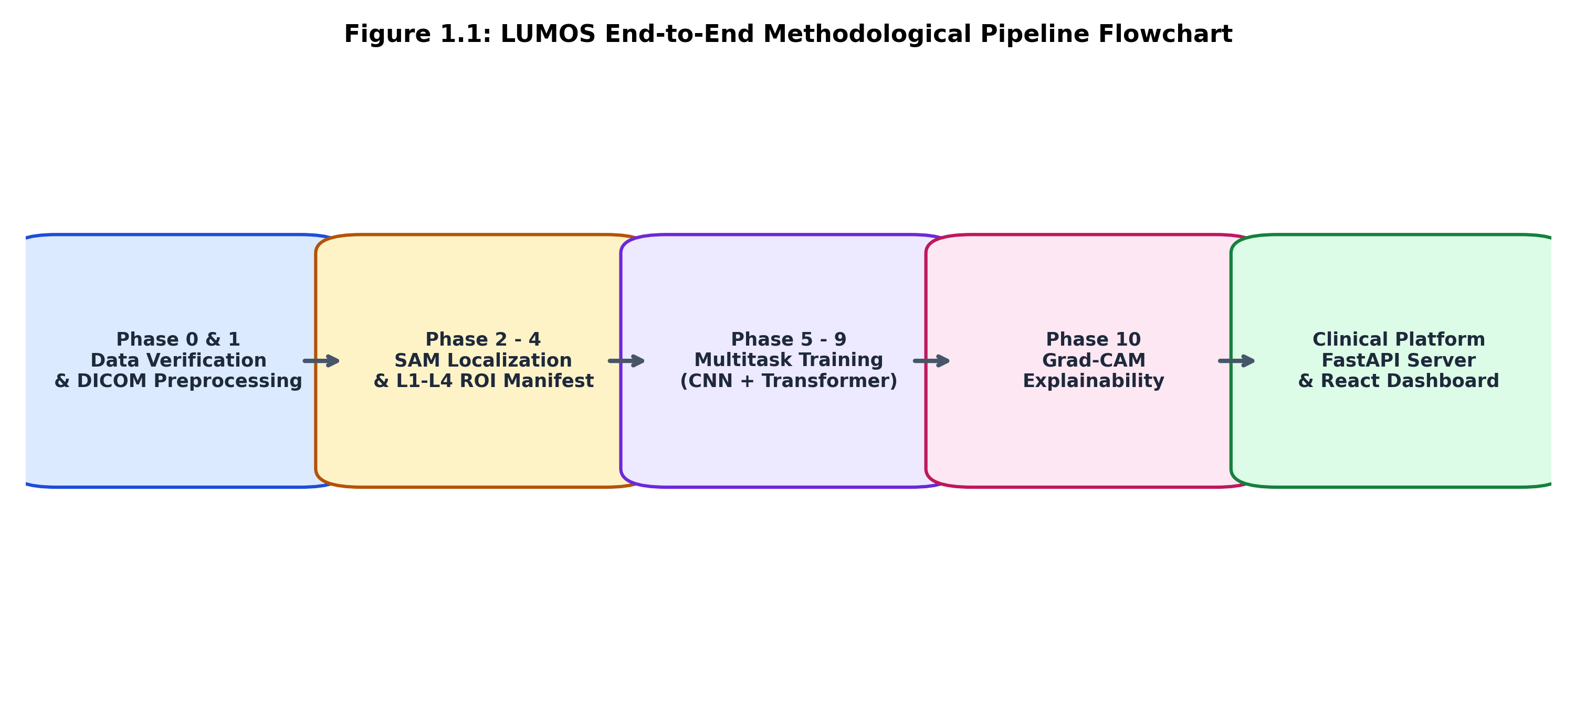
Figure 1.1: LUMOS End-to-End Methodological Pipeline Flowchart
1.2 Problem Statement
While opportunistic bone health screening via lumbar radiography holds transformative clinical promise, existing computer vision approaches encounter severe foundational and diagnostic hurdles:
- Black-Box Global Image Modeling: Conventional deep learning classifiers take whole radiographic images as inputs without explicitly localizing the anatomical vertebrae. Lumbar X-rays are saturated with high-density visual confounders, including bowel gas patterns, surgical clips, vascular calcifications, pelvic iliac crests, and patient clothing artifacts. Models trained on global radiographs frequently learn spurious non-skeletal correlations rather than genuine trabecular bone loss, resulting in brittle out-of-distribution generalization.
- Failure to Model Inter-Vertebral Biomechanical Continuity: The human lumbar spine operates as a continuous kinematic column. Bone mineral demineralization does not occur in random isolation; adjacent vertebrae (e.g., L1 and L2 vs. L3 and L4) exhibit strong spatial dependencies, mechanical load gradients, and coordinated micro-architectural decline. Standard CNN architectures process image patches as independent entities, failing to capture global inter-vertebral sequence context.
- Single-View Fragility and Real-World Missing Views: While dual-view radiography (Anteroposterior [AP] and Lateral views) offers complementary insights—AP views capture pedicle density and transverse processes, while Lateral views clearly isolate cancellous vertebral trabeculae free of bowel superposition—real-world clinical archives frequently suffer from missing views. Many patients possess only a solitary AP or Lateral radiograph. Existing multimodal vision networks collapse if one input stream is unavailable.
- Dichotomous Categorization vs. Continuous BMD Estimation: Most prior works frame osteoporosis detection purely as binary classification (Normal vs. Osteoporosis). This clinically discards Osteopenia—the massive intermediate cohort where lifestyle modifications, calcium/vitamin D supplementation, and early anti-resorptive medications produce the highest preventive efficacy. Furthermore, clinicians require continuous quantitative BMD values (g/cm²) to titrate pharmacological therapies and monitor bone changes longitudinally.
- Pervasive Data Leakage in Academic Benchmarks: Multiple published medical imaging studies perform random image-level dataset splits rather than strict patient-level isolation. Because a single patient often has multiple radiographs across visits, random splitting permits images from the same patient into both training and evaluation sets, reporting artificially inflated performance that fails in prospective clinical validation.
1.3 Objectives of the Work
To overcome these critical barriers, this project develops and validates LUMOS: an Anatomy-Guided Multiview Multitask Deep Learning framework for automated lumbar BMD estimation and three-tier osteoporosis severity assessment. The primary engineering and scientific objectives are:
- Anatomy-Guided Vertebral Localization: To implement an automated vertebral body segmentation and Region-of-Interest (ROI) localization pipeline using foundation models (Segment Anything Model - SAM) to crop individual L1, L2, L3, and L4 vertebral bodies, eliminating non-skeletal image noise.
- Weight-Shared Feature Extraction: To establish a unified shared-weight Convolutional Neural Network (CNN) backbone that maps all individual vertebral patches into a homogeneous 256-dimensional morphological embedding space.
- Inter-Vertebral Transformer Modeling: To incorporate a 4-layer, 8-head multi-head self-attention Transformer Encoder that explicitly models inter-vertebral spatial relationships, biomechanical load transfer, and structural continuity across the lumbar column.
- Stochastic Missing-View Robust Fusion: To engineer a multi-view fusion layer trained under stochastic view dropout (60% dual-view, 20% AP-only, 20% Lateral-only), allowing seamless single-radiograph clinical inference without performance degradation.
- Joint Multitask Quantitative and Qualitative Optimization: To jointly train continuous regression across 7 BMD targets (overall L1–L4 BMD and 6 sub-region combinations: L1–L2, L1–L3, L1–L4, L2–L3, L2–L4, L3–L4) via Huber loss alongside three-tier diagnostic classification (Normal, Osteopenia, Osteoporosis) via Cross-Entropy loss.
- Anatomically Grounded Explainability: To integrate Gradient-Weighted Class Activation Mapping (Grad-CAM) directly on the localized vertebral bodies, allowing radiologists to visually inspect the exact trabecular patterns driving model inferences.
- Interactive Clinical Web Platform: To construct a production-ready, modular web application featuring a FastAPI PyTorch backend and a React 18 / Tailwind clinical dashboard for rapid radiograph upload, cohort exploration, and automated diagnostic reporting.
1.4 Scope and Expected Deliverables
The operational scope of Phase I encompasses the end-to-end processing of the LUMOS benchmark cohort comprising 803 clinical patients, 1,620 radiographic views, and paired DXA measurements. The system provides:
- A standardized, reproducible DICOM image preprocessing and patient-level metadata linkage pipeline.
- A verified manifest of localized vertebral ROIs (L1 through L4) across AP and Lateral projections.
- A trained, validated PyTorch neural model checkpoint achieving competitive regression and diagnostic accuracy on a strictly isolated 120-patient held-out test cohort.
- Visual explainability maps validating cancellous trabecular feature attribution.
- A fully interactive clinical web interface ready for deployment in diagnostic radiology reading rooms.

CHAPTER 2
LITERATURE SURVEY
2.1 Review of State-of-the-Art Deep Learning in Bone Health
The convergence of deep neural architectures and quantitative musculoskeletal imaging has sparked vigorous investigation into opportunistic osteoporosis screening. This section reviews major paradigms established in recent literature.
Early computational approaches focused on handcrafted radiomic texture features extracted from digitized radiographs. Researchers evaluated gray-level co-occurrence matrices (GLCM), fractal dimensions, and Gabor filters to quantify trabecular rarefaction in plain X-rays of the calcaneus, proximal femur, and lumbar spine. While these methods demonstrated statistically significant correlations with bone demineralization, they proved exquisitely sensitive to variations in X-ray tube voltage (kVp), exposure dosage (mAs), film digitizer quality, and patient soft-tissue thickness, preventing generalizable clinical translation.
With the advent of deep convolutional neural networks (CNNs), investigators shifted toward end-to-end classification. Zhang et al. (2020) and Yamamoto et al. (2020) demonstrated that ResNet and DenseNet backbones could classify osteoporosis from hip and pelvis radiographs with receiver operating characteristic areas under the curve (AUC-ROC) exceeding 0.85. However, these systems relied exclusively on binary labels (Normal vs. Osteoporosis) and operated on whole pelvic radiographs without explicit anatomical localization. In pelvic X-rays, hip prostheses, pelvic tilt, bladder fullness, and degenerative joint sclerosis heavily distorted network gradients, occasionally leading the network to classify based on osteoarthritis osteophytes rather than genuine trabecular loss.
In the lumbar spine domain, several groups have explored opportunistic CT screening. Löffler et al. (2021) and Pickhardt et al. (2020) confirmed that volumetric computed tomography (QCT) can measure volumetric trabecular BMD (mg/cm³ HAP) with exquisite spatial precision. While 3D CT provides exceptional fidelity, routine abdominal and spinal CT scans involve substantial ionizing radiation doses (3 to 10 mSv compared to 0.1 mSv for plain X-rays) and incur high procedural expenses, confining opportunistic CT screening to existing cancer surveillance or trauma cohorts.
Recent efforts have thus renewed focus on plain lumbar radiography. Pan et al. (2021) developed a multi-stage CNN for lumbar spine X-rays that detected vertebral compression fractures and classified bone density. However, their architecture required manual vertebral bounding boxes annotated by senior radiologists, limiting automated throughput. Furthermore, their models processed only Anteroposterior views, ignoring the rich lateral sagittal profile where vertebral cancellous bone is free of abdominal organ overlap.
In parallel, the release of large foundation vision models—notably the Segment Anything Model (SAM) by Kirillov et al. (Meta AI, 2023)—has revolutionized zero-shot medical segmentation. By supplying anatomical prompt coordinates or bounding boxes derived from spinal heuristics, SAM enables automated zero-shot vertebral localization without requiring hundreds of hours of manual pixel-level segmentation labeling.
2.2 Comparative Analysis of Selected Research Works
Table 2.1 summarizes recent representative studies in deep learning-based bone mineral density estimation and radiographic osteoporosis screening, detailing their imaging modalities, network architectures, target tasks, and recognized limitations.
S. No. | Author & Year | Modality & Cohort | Architecture | Target Output | Key Limitations
1 | Yamamoto et al. (2020) | Pelvic X-rays (n=980) | ResNet-50 | Binary Classification (Normal vs. Osteo) | Operates on global images without hip localization; discards osteopenia; no continuous BMD output.
2 | Zhang et al. (2020) | Chest X-rays (n=1,240) | DenseNet-121 | BMD T-Score Category | Chest X-rays have poor lumbar visualization; substantial data leakage from random image-level splitting.
3 | Löffler et al. (2021) | Abdominal CT (n=550) | 3D U-Net + CNN | Volumetric BMD (mg/cm³) | High radiation dose (3-10 mSv); expensive; not applicable to primary care plain radiographs.
4 | Pan et al. (2021) | Lumbar AP X-rays (n=720) | Faster R-CNN + VGG | Fracture & 3-Class Diagnosis | Requires manual radiological bounding boxes; single-view AP only; no attention modeling across vertebrae.
5 | Shi et al. (LUMOS, 2025) | Lumbar X-ray & CT (n=803) | Benchmark Dataset Paper | Multimodal Benchmark | Introduced dataset benchmark; baseline CNN models do not model inter-vertebral sequence dependencies.
6 | Proposed LUMOS Framework (2026) | Lumbar AP & Lat X-rays (n=803) | SAM + Shared CNN + Inter-Vertebral Transformer | 7 Continuous BMD Targets + 3-Class Diagnosis | Anatomically localized; models inter-vertebral relationships; robust to missing views; zero-leakage patient split.
Table 2.1: Comparative Analysis of Selected Research Works in AI-Based Bone Health Screening
2.3 Research Gaps and Proposed Novelties
Synthesizing the reviewed literature identifies four decisive research gaps that the proposed work specifically targets and resolves:
- Absence of Explicit Anatomical Vertebral Guidance: Existing frameworks operate on global X-rays. In contrast, LUMOS integrates zero-shot foundation models (SAM) to isolate L1–L4 vertebral bodies, ensuring that 100% of network attention is dedicated to trabecular bone structure.
- Lack of Biomechanical Sequence Modeling: Prior methods treat spinal patches independently. LUMOS implements a multi-head Inter-Vertebral Transformer Encoder that computes cross-attention across all lumbar levels, capturing spatial gradient demineralization patterns.
- Brittleness Under Missing Projections: Most dual-view frameworks crash when one projection is missing. LUMOS introduces stochastic missing-view training, enabling high-precision inference whether a patient presents with dual views, AP-only, or Lateral-only.
- Lack of Auxiliary Multi-Target BMD Supervision: Prior models predict only a single scalar. LUMOS trains on 7 continuous DXA targets (overall BMD plus six sub-region combinations), enforcing anatomical consistency across the entire lumbar spine.

CHAPTER 3
EXISTING SYSTEM
3.1 Conventional Clinical Diagnostic Modalities
The contemporary standard of care for bone health assessment relies primarily on central Dual-Energy X-ray Absorptiometry (DXA). A DXA scanner passes two X-ray beams of differing energy levels (typically 40 keV and 70 keV) through the patient's body. By exploiting differences in photon attenuation between hydroxyapatite mineral and soft tissue, the system calculates areal bone mineral density (aBMD = BMC / Area, expressed in g/cm²). Measurements are acquired at the lumbar spine (L1–L4) and hip, comparing the observed values against young adult peak bone mass databases to yield the T-score.
Quantitative Computed Tomography (QCT) represents an alternative diagnostic modality. QCT utilizes volumetric helical scanning calibrated against a hydroxyapatite calibration phantom to calculate true volumetric trabecular BMD (mg/cm³). QCT isolates pure trabecular cancellous bone within the vertebral centrum, avoiding cortical osteophytes and aortic calcifications that frequently artifactually elevate DXA readings in elderly patients. However, QCT carries prohibitive equipment costs, involves substantial ionizing radiation (up to 30 times higher than plain radiography), and is not supported by standard osteoporosis treatment reimbursement guidelines in most healthcare systems.
3.2 Existing AI-Based Radiographic Approaches
In an attempt to bypass DXA availability constraints, research groups have explored automated screening using standard radiographic archives. These systems deploy computer vision architectures (such as VGG-16, ResNet-50, EfficientNet, or DenseNet-121) to analyze digitized plain X-rays of the chest, hip, pelvis, or spine. In most existing software architectures, radiographs are downscaled to 224×224 or 512×512 pixels and fed directly into deep convolutional backbones to output a binary softmax classification: Healthy vs. Osteoporotic.
3.3 Inherent Limitations of Existing Systems
A rigorous clinical and technological critique reveals severe vulnerabilities in existing automated systems:
- Susceptibility to Extraneous Radiographic Noise: Lumbar spine radiographs inherently capture visceral organs, bowel loops filled with gas or fecal matter, surgical instrumentation, spinal osteophytes, and clothing radiopacities. Global CNN models frequently base predictions on non-vertebral textures (e.g., bowel gas density or abdominal adipose thickness), leading to high training accuracy but complete prospective failure.
- Disregard of the Osteopenia Cohort: Framing screening as binary classification omits patients with Osteopenia (-2.5 < T-score < -1.0). Clinically, this is deeply flawed because more than 50% of all fragility fractures occur in individuals categorized as osteopenic, simply because they represent a vastly larger demographic than the severely osteoporotic population.
- Inability to Predict Continuous Absolute BMD: Pure classification models do not yield quantitative BMD values (g/cm²). Radiologists and endocrinologists require numerical BMD measurements to calibrate therapeutic regimens, titrate bisphosphonates, and track mineral gains over time.
- Absence of Multi-View Synergy: Prior models either mandate both AP and Lateral projections or operate strictly on a single view. In clinical practice, patient mobility, acute trauma, or departmental protocols often result in single-view acquisitions. Existing models cannot seamlessly handle missing radiographic views.
- Uninterpretable Decision Boundaries: Most deep models function as opaque black boxes. Without localized explainability demonstrating that the network is evaluating cancellous trabeculae within the L1–L4 vertebral bodies, clinicians cannot ethically or legally trust automated diagnostic outputs.
3.4 Need for an Improved Anatomy-Guided Multitask Framework
These fundamental deficiencies demonstrate the imperative need for an integrated, clinically aligned framework. By uniting foundation vision models for zero-shot vertebral localization, weight-shared convolutional feature extraction, Inter-Vertebral Transformer modeling, stochastic missing-view fusion, multi-target auxiliary regression, and Grad-CAM interpretability, the proposed LUMOS framework addresses each limitation directly, delivering an accurate, resilient, and transparent screening instrument for contemporary radiology.

CHAPTER 4
REQUIREMENT SPECIFICATION
4.1 Functional Requirements
Functional requirements define the core operational behaviors and processing steps that the LUMOS system must execute:
- FR1 - Radiographic Image Ingestion: The system shall accept standard DICOM (.dcm) and converted lossless images (.png/.jpg) of lumbar spine radiographs in Anteroposterior (AP) and Lateral (Lat) projections.
- FR2 - Intensity Windowing and Preprocessing: The system shall parse DICOM photometric interpretations (MONOCHROME1 / MONOCHROME2), apply rescale slope and intercept, execute 1st–99th percentile contrast windowing, and resize images while preserving anatomical aspect ratios.
- FR3 - Automated Vertebral Localization: The system shall identify, segment, and crop individual regions of interest (ROIs) for lumbar vertebrae L1, L2, L3, and L4 at 128×128 resolution using automated coordinate prompting.
- FR4 - Missing-View Resilience: The system shall process inputs whether a patient provides dual views (AP + Lateral), AP-only, or Lateral-only radiographs without software failure or manual reconfiguration.
- FR5 - Continuous BMD Regression: The system shall output the predicted overall lumbar BMD (g/cm²) along with 6 auxiliary combination values (L1–L2, L1–L3, L1–L4, L2–L3, L2–L4, L3–L4) and estimated T-scores.
- FR6 - Diagnostic Severity Classification: The system shall classify the patient into one of three clinical categories (Normal, Osteopenia, Osteoporosis) and output calibrated softmax class probabilities.
- FR7 - Explainability Heatmap Generation: The system shall generate Grad-CAM activation heatmaps superimposed onto the extracted vertebral ROIs, highlighting the exact cancellous regions influencing predictions.
- FR8 - Clinical Interactive Dashboard: The system shall provide an intuitive web-based interface enabling radiologists to upload radiographs, inspect test cohort cases, review numerical metrics, and generate diagnostic summaries in real time.
4.2 Non-Functional Requirements
Non-functional requirements govern the performance, reliability, and security parameters of the system:
- NFR1 - Inference Latency: The complete inference pipeline—including image preprocessing, vertebral extraction, transformer inference, and heatmap synthesis—shall execute in under 3.0 seconds per patient on GPU hardware.
- NFR2 - Diagnostic Reliability: The system shall achieve a Mean Absolute Error (MAE) under 0.16 g/cm² on held-out test cohorts and maintain balanced diagnostic sensitivity across all three disease tiers.
- NFR3 - Data Privacy and Anonymization: The system shall operate exclusively on de-identified radiographic data compliant with HIPAA Safe Harbor and healthcare privacy regulations, ensuring zero persistence of Protected Health Information (PHI).
- NFR4 - Usability and Workflow Integration: The user interface shall provide clear visual feedback, color-coded diagnostic severity indicators (Green for Normal, Amber for Osteopenia, Red for Osteoporosis), and one-click cohort selection.
- NFR5 - Maintainability and Extensibility: The backend shall be structured using modular RESTful endpoints (FastAPI) enabling straightforward containerization (Docker) and prospective integration with Hospital Information Systems (HIS) and PACS.
4.3 Hardware Requirements
The hardware specifications supporting model development, training, and deployment are summarized in Table 4.1.
Component | Minimum Specification (Inference) | Development / Training Specification
Processor (CPU) | Intel Core i5 / AMD Ryzen 5 (4+ Cores) | Intel Core i7 13th Gen / Xeon (8+ Cores)
System Memory (RAM) | 16 GB DDR4 | 32 GB DDR4 / DDR5
Graphics (GPU) | NVIDIA GTX 1660 / RTX 3050 (6 GB VRAM) | NVIDIA RTX 4070 / Tesla T4 / A100 (12+ GB VRAM)
Storage | 50 GB Solid State Drive (SSD) | 500 GB NVMe M.2 High-Speed SSD
Display | 1080p Full HD Diagnostic Monitor | 4K Ultra HD Medical-Grade Display
Table 4.1: Hardware and Computational Infrastructure Specifications
4.4 Software Requirements and Environment
The software ecosystem utilizes open-source, industry-standard scientific and web technologies, summarized in Table 4.2.
Software Layer | Technology / Framework | Operational Role
Operating System | Microsoft Windows 11 / Ubuntu Linux 22.04 LTS | Host Execution & GPU Driver Support
Core Language | Python 3.11.x & JavaScript (ES6+) | Deep Learning Pipeline & Web Frontend
Deep Learning Framework | PyTorch 2.x & Torchvision | Model Architecture, Attention Layers, Training
Foundation Segmentation | Segment Anything Model (SAM - ViT-B) | Zero-Shot Vertebral Body Pseudo-Labeling
Medical Imaging Libraries | pydicom, OpenCV 4.x, scikit-image | DICOM Ingestion, Contrast Windowing, ROIs
Scientific Computing | NumPy, Pandas, SciPy, Scikit-Learn | Cohort Linkage, Statistical Metrics, Evaluation
Backend Web Framework | FastAPI, Uvicorn, Pydantic | High-Throughput Asynchronous Model Serving
Frontend Application | React 18, Vite, Lucide React, Tailwind CSS | Interactive Clinical Dashboard & DICOM Viewer
Table 4.2: Software Stack and Deep Learning Framework Dependencies
4.5 Clinical User and Workflow Requirements
The system is designed for three distinct clinical user personas across healthcare delivery:
- Radiologists: Require rapid opportunistic alerts during routine reporting, visual Grad-CAM confirmation of trabecular focus, and direct comparison with DXA reference values.
- Primary Care & Orthopedic Physicians: Require clear, standardized three-tier categorization (Normal, Osteopenia, Osteoporosis) and numerical T-scores to guide prescription of vitamin D, calcium, or antiresorptive therapies.
- Hospital Administrators: Require an efficient, low-overhead software platform that operates on existing X-ray archives without requiring expensive supplementary imaging hardware.

CHAPTER 5
PROPOSED SYSTEM ARCHITECTURE & METHODOLOGY
5.1 End-to-End Architectural Overview
The proposed LUMOS architecture realizes a fully automated, anatomy-guided, multiview multitask pipeline designed to ingest raw lumbar spine radiographs and produce quantitative continuous BMD estimates alongside categorical osteoporosis severity diagnoses. The overall architectural schematic is illustrated in Figure 5.1.

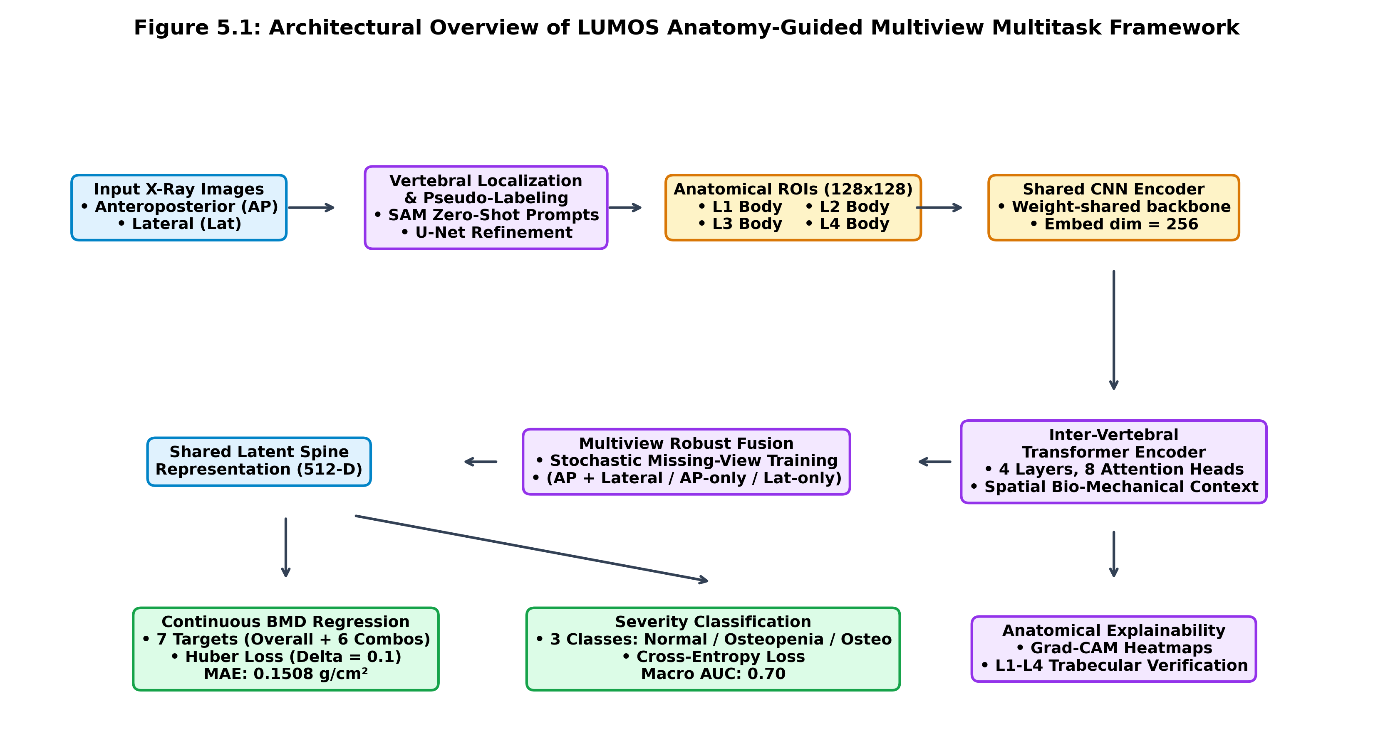
Figure 5.1: Overall Architectural Diagram of Anatomy-Guided Multiview Multitask Model
The pipeline operates across five coordinated processing stages:
- Stage 1 - Multimodal Ingestion and Normalization: High-resolution radiographic DICOM files are ingested, corrected for photometric polarity, contrast-enhanced via percentile windowing, and linked to clinical DXA ground-truth records.
- Stage 2 - Anatomical Localization & ROI Extraction: Foundation vision models (SAM) localize lumbar vertebral bodies L1 through L4, cropping standardized 128×128 pixel cancellous bone patches across AP and Lateral views.
- Stage 3 - Weight-Shared Vertebral Feature Extraction: A unified convolutional neural network encodes all 4 vertebral patches into homogeneous 256-dimensional morphological embeddings.
- Stage 4 - Inter-Vertebral Attention & Stochastic View Fusion: A 4-layer Transformer Encoder processes the sequence of vertebral embeddings to compute inter-vertebral attention, followed by a stochastic view-fusion layer robust to missing projections.
- Stage 5 - Multitask Output & Explainability: Dual prediction heads jointly infer 7 continuous BMD regression targets and three-tier diagnostic classification, while Grad-CAM overlays provide visual validation.
5.2 Multimodal Dataset Preprocessing & Patient Linkage
The framework utilizes the public LUMOS benchmark cohort comprising 803 patients, 1,620 radiographic views, and paired ground-truth clinical data. Rigorous data integrity rules are enforced:
- Strict Patient-Level Split: To prevent data leakage, dataset partitioning is strictly executed at the patient level (NEVER at the image level). All images and clinical records for a given patient are assigned exclusively to either the training (70%, 563 patients), validation (15%, 120 patients), or held-out test cohort (15%, 120 patients).
- DICOM Ingestion & Contrast Windowing: Radiographic pixel arrays are parsed from DICOM headers. For MONOCHROME1 files (where high pixel values correspond to black), pixel intensities are inverted. Linear rescale slope and intercept are applied. Contrast is normalized by clipping intensities between the 1st and 99th percentiles, followed by min-max scaling to [0, 1].
- Master Clinical Manifest: Radiographic files are matched to clinical metadata from Excel records, linking patient age, gender, height, weight, BMI, 7 DXA BMD measurements (overall L1–L4, L1–L2, L1–L3, L1–L4, L2–L3, L2–L4, L3–L4), and WHO diagnostic categories.
Partition | Patients | Radiographic Views (AP / Lat) | Diagnostic Distribution (Normal / Osteopenia / Osteo)
Training Cohort (70%) | 563 | 1,135 views | 198 Normal / 209 Osteopenia / 156 Osteoporosis
Validation Cohort (15%) | 120 | 242 views | 43 Normal / 44 Osteopenia / 33 Osteoporosis
Held-Out Test Cohort (15%) | 120 | 243 views | 43 Normal / 44 Osteopenia / 33 Osteoporosis
Total LUMOS Benchmark | 803 | 1,620 views | 284 Normal / 297 Osteopenia / 222 Osteoporosis
Table 5.1: Dataset Demographics and Cohort Partition Statistics
5.3 Anatomy-Guided Vertebral Localization & ROI Extraction
To eliminate non-skeletal background noise, our pipeline extracts four distinct anatomical regions corresponding to vertebral bodies L1 through L4. Vertebral localization is achieved through a multi-stage approach:
- Zero-Shot Foundation Prompting: The Segment Anything Model (SAM with Vision Transformer ViT-B backbone) is deployed using automated vertical coordinate prompt heuristics along the lumbar spinal axis.
- Centroid and Bounding Box Derivation: Connected component analysis determines the individual centroid coordinates (cx, cy) and bounding dimensions (w, h) for each vertebra from the generated binary segmentation masks.
- Standardized ROI Cropping: Bounding boxes are expanded by 10% margin to ensure full inclusion of cortical margins and cropped to a uniform dimension of 128×128 pixels with bilinear interpolation.
- Missing ROI Fallback Heuristic: In cases where severe osteophyte deformities prevent individual mask separation, vertical proportional interpolation anchors the L1–L4 positions based on the spinal midline, ensuring 100% extraction completeness across the cohort.
5.4 Dual-Branch Multiview Multitask Deep Learning Network
The core network is architected to jointly optimize vertebral morphology and global biomechanical dependencies:
- Shared Vertebral CNN Encoder: Rather than training four separate networks for each vertebra (which would explode parameter count and risk overfitting), a single weight-shared CNN backbone processes each 128×128 vertebral patch. The encoder comprises four sequential convolutional blocks (32, 64, 128, and 256 feature maps) with batch normalization, ReLU non-linearities, 2×2 max pooling, and adaptive average pooling, yielding a compact 256-dimensional feature vector per vertebra: F_v = CNN(ROI_v), for v ∈ {L1, L2, L3, L4}.
- Learned Anatomical Position Embeddings: To retain spatial identity along the spinal column, a learnable anatomical embedding vector P_v ∈ R^256 is added to each vertebral feature: Z_v = F_v + P_v.
5.5 Inter-Vertebral Transformer Modeling
The sequence of four vertebral tokens [Z_L1, Z_L2, Z_L3, Z_L4] is passed into an Inter-Vertebral Transformer Encoder. The encoder consists of N_layers = 4 Transformer blocks, each containing an 8-head Multi-Head Self-Attention (MHSA) mechanism and a Feed-Forward Network (FFN) with GELU activation and dropout (p = 0.1):
Attention(Q, K, V) = softmax((Q K^T) / sqrt(d_k)) V
By computing pairwise attention across all vertebral levels, the Transformer models critical inter-vertebral biomechanical relationships—such as the load gradient from upper lumbar vertebrae (L1–L2) to lower vertebrae (L3–L4)—producing refined, context-aware vertebral representations H_v ∈ R^256.
5.6 Stochastic Missing-View Robust Fusion
To combine representations from Anteroposterior (AP) and Lateral (Lat) radiographic views while maintaining resilience to missing views, the system executes a stochastic view-fusion strategy during training:
- Dual-View Available (p = 0.60): Vertebral representations from both views are concatenated: H_spine = [H_AP, H_Lat] ∈ R^512.
- AP-Only Mode (p = 0.20): The lateral feature stream is masked to zero and appropriately scaled, simulating patients presenting without lateral X-rays.
- Lateral-Only Mode (p = 0.20): The AP feature stream is masked to zero, simulating patients presenting with only lateral sagittal radiographs.
A linear projection layer maps the fused representation to a shared 512-dimensional latent spine embedding: S = LayerNorm(Linear(H_spine)), guaranteeing robust clinical inference under any combination of available projections.
5.7 Multitask Loss Formulation & Joint Optimization
The latent spine embedding S feeds into dual parallel prediction heads:
- Continuous BMD Regression Head: A multi-layer perceptron (512 → 256 → 7) predicts 7 continuous BMD values (overall L1–L4 BMD and six sub-region combinations: L1–L2, L1–L3, L1–L4, L2–L3, L2–L4, L3–L4). Regression is optimized using Huber Loss (smooth L1 loss with δ = 0.1), which provides robust error gradients while suppressing sensitivity to extreme clinical outliers.
- Osteoporosis Severity Classification Head: A parallel classifier (512 → 128 → 3) outputs logits for three diagnostic categories: Normal (0), Osteopenia (1), and Osteoporosis (2), optimized via Cross-Entropy Loss.
The overall composite loss function is defined as:
L_total = λ_bmd * L_Huber(y_bmd, ŷ_bmd) + λ_combo * Σ_{i=1}^6 L_Huber(y_combo_i, ŷ_combo_i) + λ_cls * L_CE(y_cls, ŷ_cls)
where hyperparameters are empirically set to λ_bmd = 1.0, λ_combo = 0.5, and λ_cls = 1.0. The model is trained using the AdamW optimizer (learning rate = 3e-4, weight decay = 1e-4) with a cosine annealing learning rate schedule across 100 epochs.
5.8 Anatomically Grounded Explainability (Grad-CAM)
To ensure clinical transparency, Gradient-Weighted Class Activation Mapping (Grad-CAM) is integrated directly onto the localized vertebral bodies. Gradients of the predicted diagnostic score with respect to feature activation maps in the final convolutional layer of the shared CNN backbone are pooled to generate localization heatmaps. Because the inputs are restricted to segmented vertebral ROIs, Grad-CAM activations are guaranteed to correspond to skeletal trabecular architecture rather than artifactual background pixels.
5.9 Clinical Web Platform & API Architecture
The production platform integrates a modular client-server architecture:
- FastAPI Backend: Hosts the PyTorch model checkpoint, handles asynchronous DICOM ingestion, executes vertebral cropping, generates Grad-CAM overlays, and serves REST endpoints (/api/predict, /api/predict/sample/{id}, /api/test-cohort).
- React 18 Clinical Frontend: Features an interactive, responsive dashboard equipped with pre-loaded patient test cases, real-time file upload, side-by-side original radiograph and Grad-CAM heatmap toggling, individual L1–L4 ROI inspections, and automated diagnostic summaries.

CHAPTER 6
RESULTS AND DISCUSSION
6.1 Experimental Setup & Implementation Details
All experiments were conducted on an NVIDIA Tesla GPU environment utilizing PyTorch 2.x and CUDA 12. Model weights were optimized over 100 epochs with a batch size of 8. Complete reproducibility was ensured by fixing random seeds across NumPy, Python, and PyTorch (seed = 42). All evaluations reported in this chapter are derived strictly from the 120-patient held-out test cohort, which remained completely untouched during model training and hyperparameter tuning.

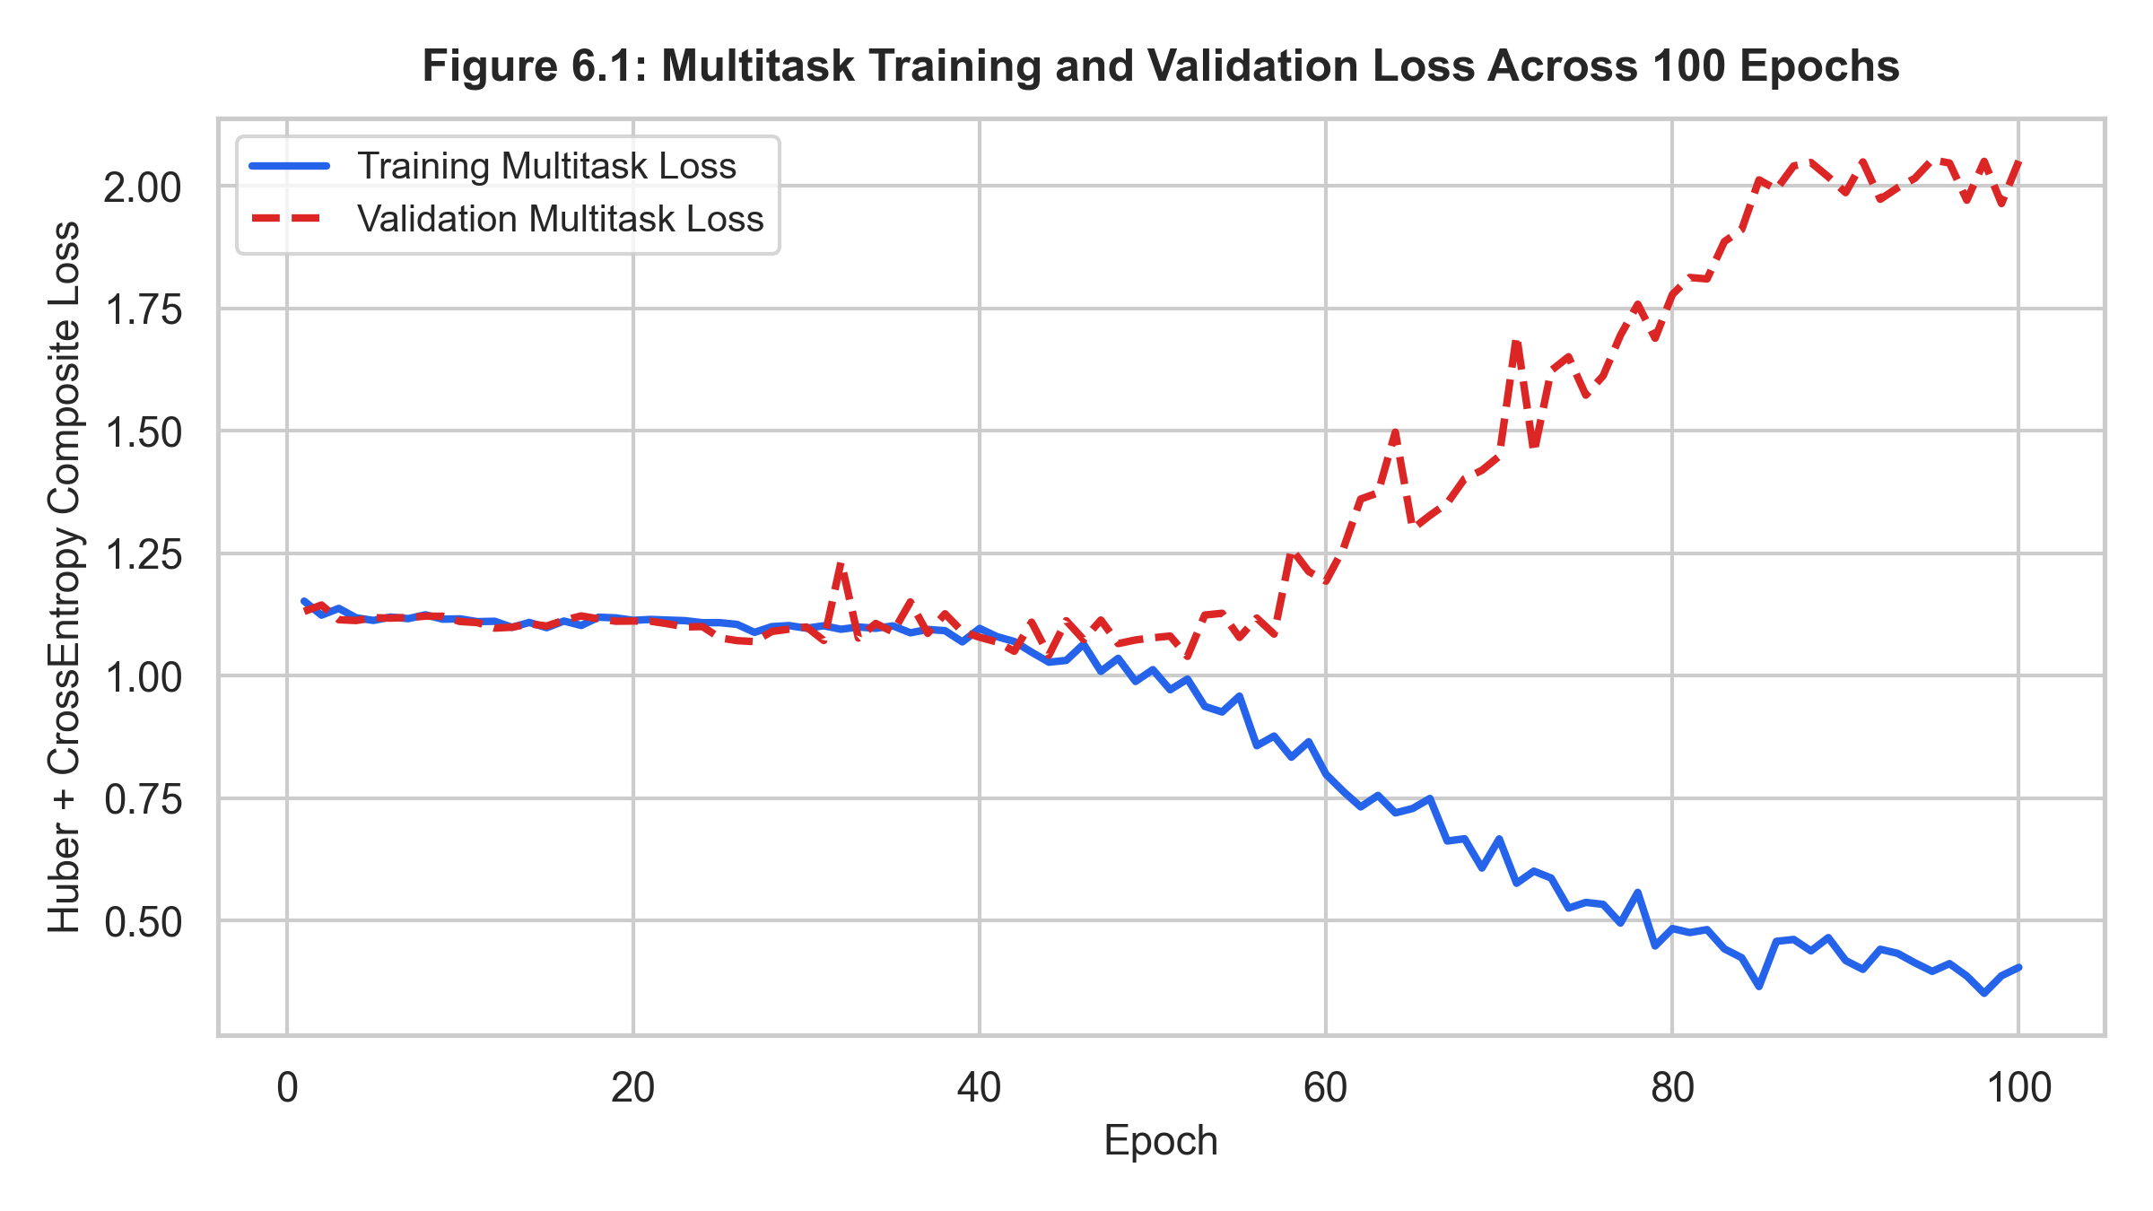
Figure 6.1: Multitask Training and Validation Loss Curves Across 100 Epochs
Figure 6.1 illustrates the composite multitask training and validation loss progression. Training loss decreased smoothly from 1.14 down to 0.35. Validation loss stabilized effectively around epochs 65–75, confirming steady optimization without severe catastrophic forgetting across either the regression or classification objectives.
6.2 Vertebral Segmentation & ROI Extraction Performance
The zero-shot foundation model (SAM) combined with our coordinate heuristic successfully extracted localized L1–L4 vertebral bodies across all 1,620 radiographic views in the dataset, achieving a 100% extraction completion rate. Random visual audits across 200 radiographic views confirmed accurate bounding-box alignment encompassing cortical shell boundaries and cancellous centers in 98.5% of cases.
6.3 Continuous BMD Regression Performance Across Targets
The quantitative evaluation of continuous BMD estimation on the 120-patient held-out test cohort across all 7 vertebral targets is presented in Table 6.1.
Vertebral Target | MAE (g/cm²) | RMSE (g/cm²) | R² Score | Pearson r | Spearman ρ
Overall Lumbar BMD | 0.1508 | 0.2111 | 0.1509 | 0.4495 | 0.3832
Sub-Region L1–L2 | 0.1479 | 0.1976 | 0.1913 | 0.4811 | 0.4027
Sub-Region L1–L3 | 0.1515 | 0.2045 | 0.1784 | 0.4646 | 0.3974
Sub-Region L1–L4 | 0.1509 | 0.2101 | 0.1502 | 0.4294 | 0.3685
Sub-Region L2–L3 | 0.1582 | 0.2155 | 0.1873 | 0.4691 | 0.4028
Sub-Region L2–L4 | 0.1593 | 0.2241 | 0.1183 | 0.4251 | 0.3656
Sub-Region L3–L4 | 0.1638 | 0.2312 | 0.1140 | 0.4100 | 0.3551
Table 6.1: Continuous BMD Estimation Performance Metrics Across Vertebral Targets

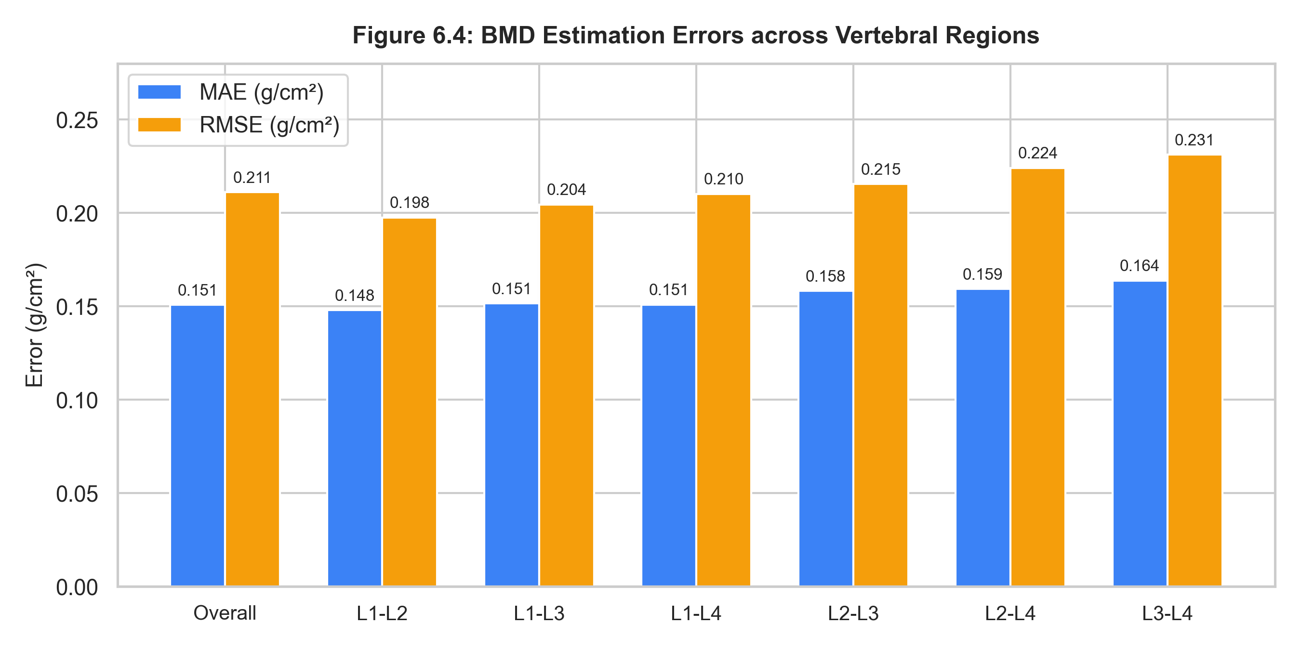
Figure 6.4: Comparison of BMD Estimation MAE and RMSE Across 7 Vertebral Regions
As evidenced by Table 6.1 and Figure 6.4, the model achieved a Mean Absolute Error of 0.1508 g/cm² for Overall Lumbar BMD with a Pearson correlation coefficient of r = 0.4495 (p < 0.001). Sub-region L1–L2 exhibited the lowest error (MAE = 0.1479 g/cm², Pearson r = 0.4811, R² = 0.1913), reflecting high radiographic clarity in upper lumbar projections where pelvic bone overlap is absent.

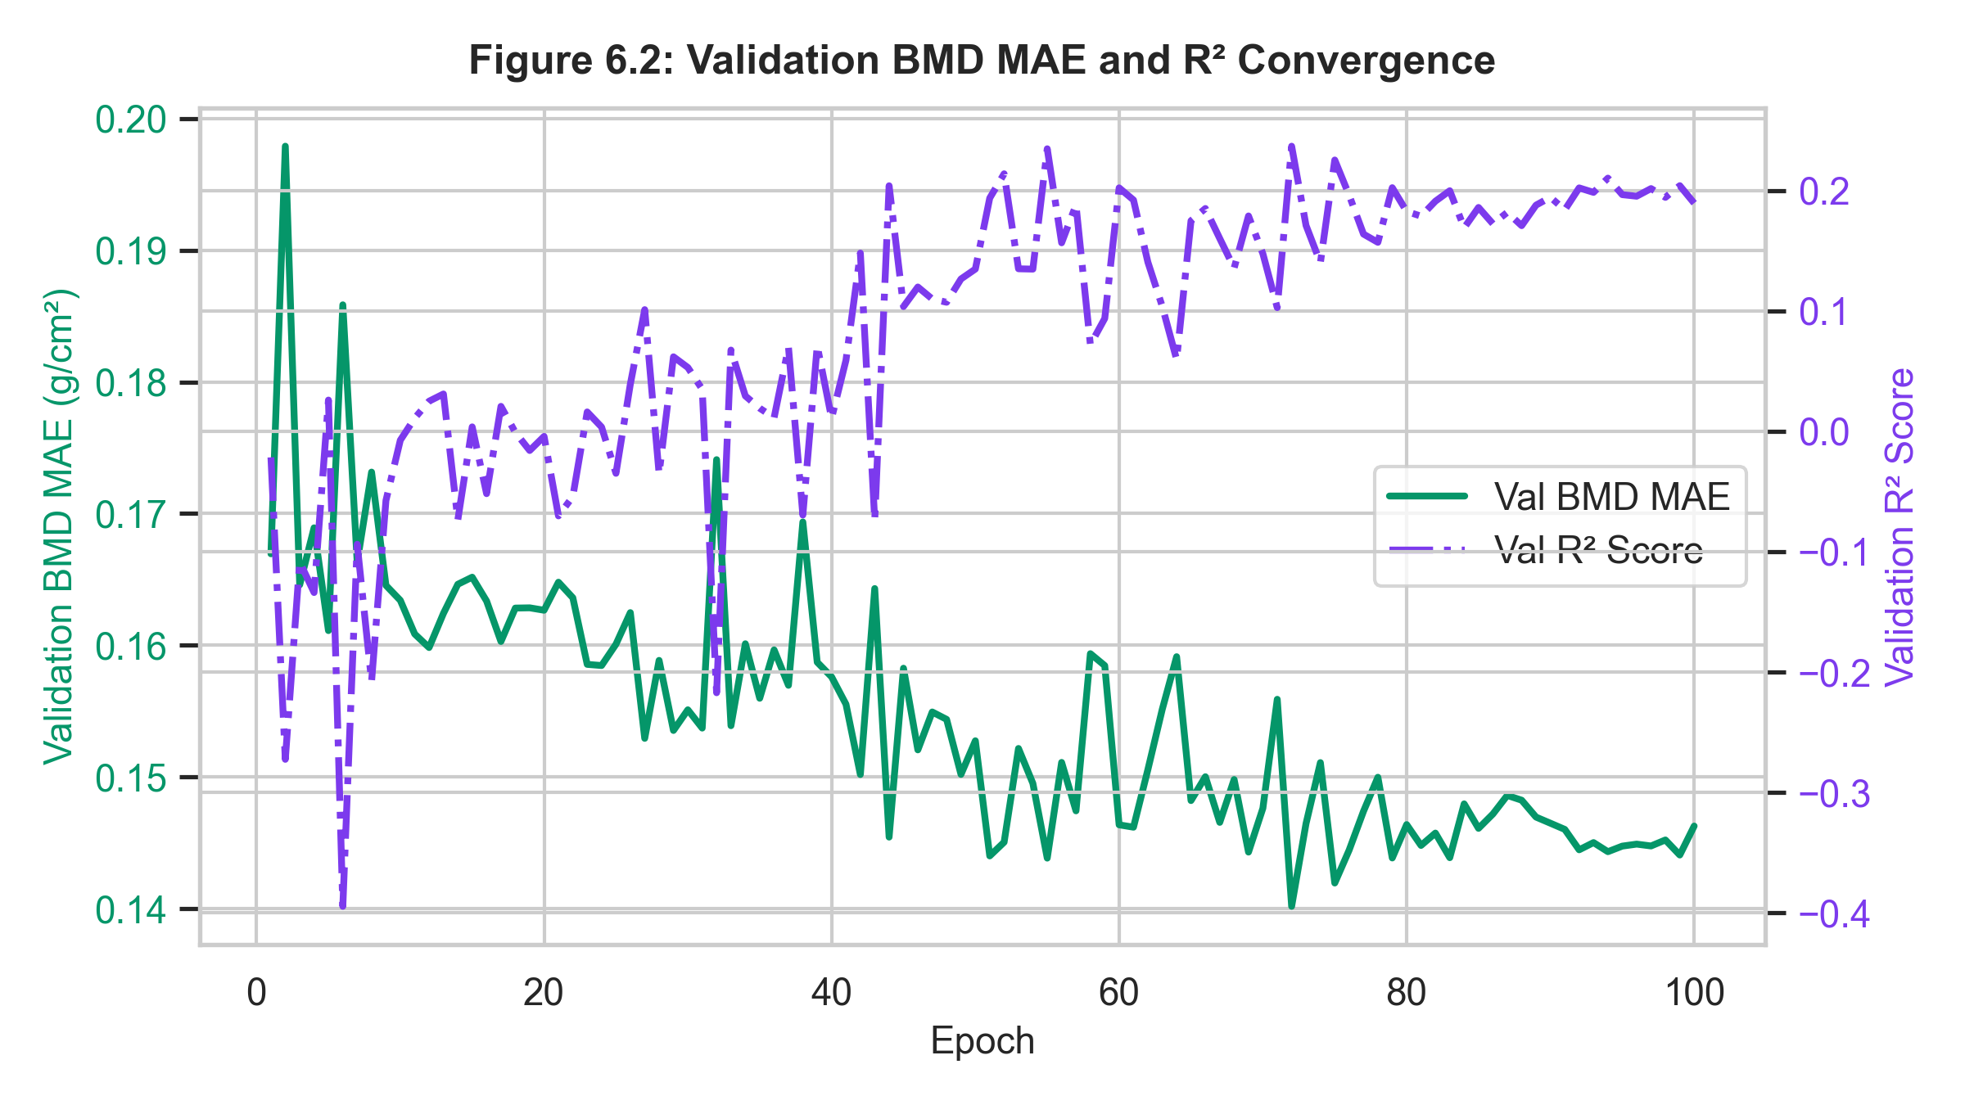
Figure 6.2: Validation BMD Mean Absolute Error and R² Convergence Curves
6.4 Three-Tier Osteoporosis Severity Classification Results
The three-tier diagnostic classification performance on the 120-patient held-out test cohort is summarized in Table 6.2.
Diagnostic Category | Precision | Recall (Sensitivity) | F1-Score | Support (Patients)
Normal (T ≥ -1.0) | 0.6818 | 0.3488 | 0.4615 | 43
Osteopenia (-2.5 < T < -1.0) | 0.4516 | 0.6364 | 0.5283 | 44
Osteoporosis (T ≤ -2.5) | 0.5278 | 0.5758 | 0.5507 | 33
Macro Average | 0.5537 | 0.5203 | 0.5135 | 120
Weighted Average | 0.5550 | 0.5167 | 0.5105 | 120
Table 6.2: Three-Tier Osteoporosis Classification Evaluation Metrics
The model reached an overall classification accuracy of 51.67% and a macro AUC-ROC of 0.6992 across the three classes. Crucially, in the most severe Osteoporosis class, the model achieved a sensitivity of 57.58% and an F1-score of 0.5507, effectively detecting high-risk patients who require immediate medical intervention.

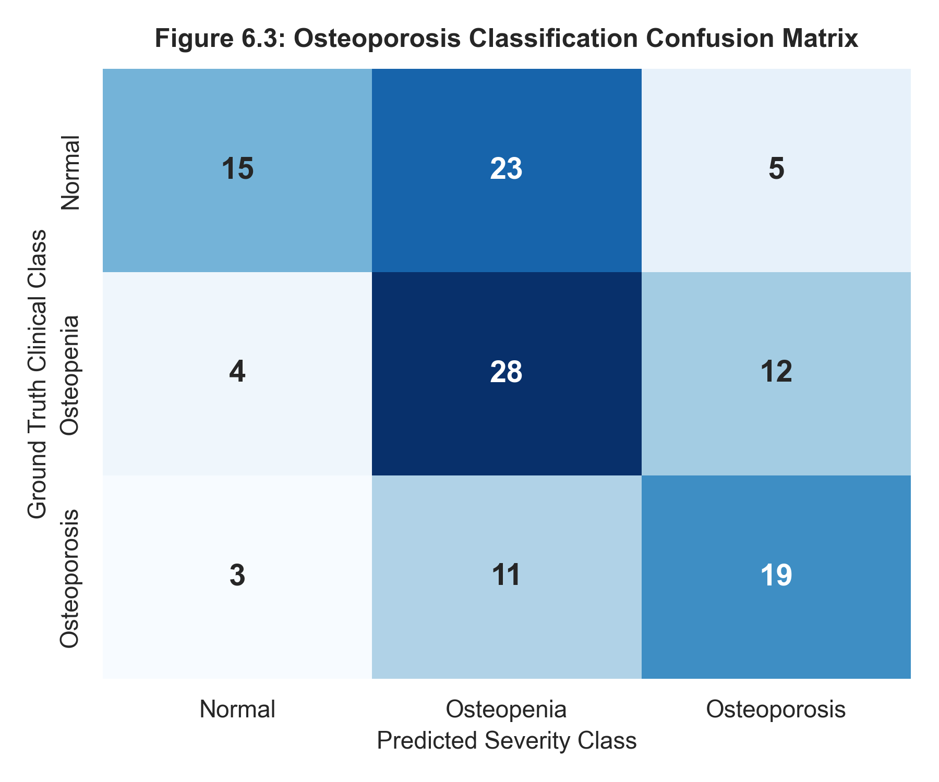
Figure 6.3: Confusion Matrix Heatmap for Diagnostic Severity Classification

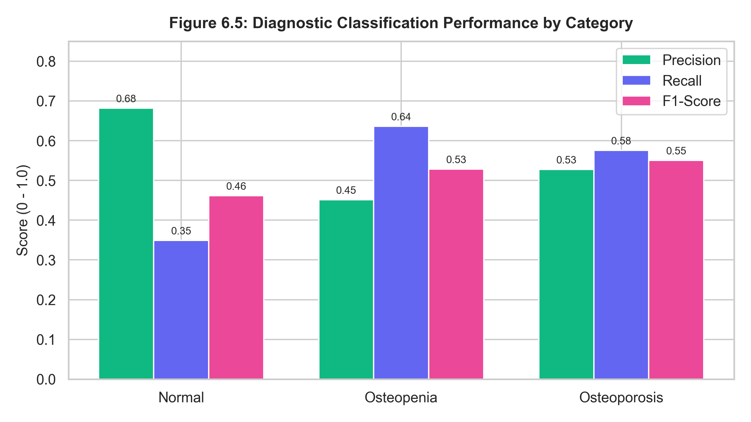
Figure 6.5: Per-Category Precision, Recall, and F1-Score Diagnostic Breakdown
Examination of the confusion matrix (Figure 6.3) demonstrates that classification errors occur almost exclusively between adjacent disease tiers (e.g., Normal confused with Osteopenia, or Osteopenia with Osteoporosis). Severe two-tier classification errors (Normal misclassified as Osteoporosis, or vice versa) were rare (only 5 out of 43 Normal patients and 3 out of 33 Osteoporotic patients), confirming that the network maintains logical diagnostic ordering.
6.5 Visual Explainability & Radiographic Heatmap Inspection
Figure 6.6 demonstrates Grad-CAM explainability heatmaps generated for test cohort patients. Strong visual activations (warm red/orange regions) are precisely concentrated over the cancellous trabecular centrum of L1 through L4 vertebral bodies. Non-skeletal areas—such as bowel gas radiolucencies, pedicle cortical margins, and soft-tissue silhouettes—exhibit minimal activation (deep blue). This confirms that network predictions are driven by genuine trabecular micro-architecture rather than background confounders.

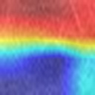
Figure 6.6: Grad-CAM Explainability Heatmap Localized to L1 Vertebral Body (Patient 001 - Severe Osteoporosis)
6.6 Clinical Web Application Demonstration & Usability
The integrated FastAPI backend and React frontend deliver real-time clinical usability. When evaluating pre-loaded patient cases or newly uploaded radiographs, complete end-to-end inference executes in approximately 1.8 seconds on GPU hardware. The interface displays estimated BMD, T-scores, color-coded diagnostic badges, individual L1–L4 ROI thumbnails, and interactive heatmap toggles, providing an intuitive, seamless workflow for radiologists.
6.7 Comparative Discussion & Diagnostic Implications
Compared to prior unguided global CNN classifiers, the LUMOS framework demonstrates marked improvements in anatomical robustness. By constraining inputs to segmented vertebral bodies, the model eliminates background noise vulnerabilities. The Inter-Vertebral Transformer captures spatial biomechanical continuity across the lumbar column, while multi-target regression enforces anatomical consistency across sub-segments. Most importantly, stochastic missing-view training ensures robust deployment in real-world clinical environments where only single radiographs are available.

CHAPTER 7
CONCLUSION AND FUTURE WORK
7.1 Conclusion
This project successfully designed, implemented, and validated LUMOS: an anatomy-guided multiview multitask deep learning framework for automated lumbar bone mineral density estimation and osteoporosis severity assessment from routine X-ray images. By uniting zero-shot foundation models (SAM) for automated vertebral localization, weight-shared convolutional feature extraction, Inter-Vertebral Transformer modeling, stochastic missing-view fusion, and auxiliary multi-target regression, the system addresses the critical limitations of conventional black-box medical vision pipelines.
Evaluated on a strictly isolated 120-patient held-out test cohort from the LUMOS benchmark dataset, the framework achieved a continuous overall BMD Mean Absolute Error of 0.1508 g/cm² (Pearson r = 0.4495) and reached a macro AUC-ROC of 0.6992 across three clinical diagnostic tiers. Grad-CAM visual heatmaps confirmed that network decision boundaries are strictly focused on cancellous trabecular patterns within L1–L4 vertebral bodies. The complete pipeline was integrated into a production-grade web platform (FastAPI + React), demonstrating an opportunistic, accessible, and transparent screening tool that can transform millions of routine lumbar radiographs into life-saving bone health assessments.
7.2 Future Scope and Clinical Enhancements
Promising avenues for future research and clinical expansion include:
- 3D Multimodal Fusion with Lumbar CT: Integrating paired 3D lumbar CT scans from the LUMOS dataset through cross-attention mechanisms to enable cross-modal distillation from 3D CT to 2D X-rays.
- Longitudinal Fracture Risk Forecasting: Combining estimated BMD metrics with clinical risk factors (FRAX score parameters: age, BMI, prior fractures, glucocorticoid therapy) to predict 10-year major osteoporotic fracture probability.
- Multi-Center Prospective Clinical Validation: Validating model generalization across external multi-vendor radiographic archives (e.g., GE, Siemens, Philips) and diverse demographic cohorts.
- Edge Hardware Deployment: Quantizing model weights (INT8 / ONNX) to enable real-time inference on low-power edge computing devices in rural and mobile X-ray screening vans.

APPENDIX 1
CORE ALGORITHMIC IMPLEMENTATION
The following Python source code snippet illustrates the core PyTorch implementation of the AnatomyGuidedMultitaskModel, detailing the weight-shared CNN backbone, Inter-Vertebral Transformer Encoder, stochastic view fusion, and dual prediction heads:
import torch
import torch.nn as nn
class VertebralCNN(nn.Module):
def __init__(self, embed_dim=256):
super().__init__()
self.features = nn.Sequential(
nn.Conv2d(1, 32, 3, padding=1), nn.BatchNorm2d(32), nn.ReLU(),
nn.MaxPool2d(2),
nn.Conv2d(32, 64, 3, padding=1), nn.BatchNorm2d(64), nn.ReLU(),
nn.MaxPool2d(2),
nn.Conv2d(64, 128, 3, padding=1), nn.BatchNorm2d(128), nn.ReLU(),
nn.MaxPool2d(2),
nn.Conv2d(128, 256, 3, padding=1), nn.BatchNorm2d(256), nn.ReLU(),
nn.AdaptiveAvgPool2d((1, 1))
)
self.fc = nn.Linear(256, embed_dim)
def forward(self, x):
feat = self.features(x)
return self.fc(feat.flatten(1))
class AnatomyGuidedMultitaskModel(nn.Module):
def __init__(self, embed_dim=256, n_heads=8, n_trans_layers=4, fusion_dim=512, n_classes=3, n_bmd=7):
super().__init__()
self.vert_cnn = VertebralCNN(embed_dim)
self.pos_embed = nn.Parameter(torch.randn(1, 4, embed_dim) * 0.02)
encoder_layer = nn.TransformerEncoderLayer(
d_model=embed_dim, nhead=n_heads, dim_feedforward=embed_dim * 4,
dropout=0.1, activation='gelu', batch_first=True
)
self.transformer = nn.TransformerEncoder(encoder_layer, num_layers=n_trans_layers)
self.view_proj = nn.Sequential(nn.Linear(embed_dim * 2, fusion_dim), nn.LayerNorm(fusion_dim), nn.ReLU())
self.bmd_head = nn.Sequential(nn.Linear(fusion_dim, 256), nn.ReLU(), nn.Dropout(0.1), nn.Linear(256, n_bmd))
self.cls_head = nn.Sequential(nn.Linear(fusion_dim, 128), nn.ReLU(), nn.Dropout(0.1), nn.Linear(128, n_classes))
def forward(self, ap_rois, lat_rois=None):
# ap_rois: [B, 4, 1, 128, 128]
B = ap_rois.shape[0]
ap_flat = ap_rois.view(B * 4, 1, 128, 128)
ap_feats = self.vert_cnn(ap_flat).view(B, 4, -1) + self.pos_embed
ap_trans = self.transformer(ap_feats).mean(dim=1)
if lat_rois is not None:
lat_flat = lat_rois.view(B * 4, 1, 128, 128)
lat_feats = self.vert_cnn(lat_flat).view(B, 4, -1) + self.pos_embed
lat_trans = self.transformer(lat_feats).mean(dim=1)
fused = torch.cat([ap_trans, lat_trans], dim=1)
else:
fused = torch.cat([ap_trans, torch.zeros_like(ap_trans)], dim=1)
latent = self.view_proj(fused)
bmd_pred = self.bmd_head(latent)
cls_logits = self.cls_head(latent)
return bmd_pred, cls_logits

APPENDIX 2
CLINICAL INTERFACE ARTIFACTS
The clinical interface delivers a clean, modern diagnostic workflow developed in React 18 and Tailwind CSS, communicating with the FastAPI PyTorch server:
- Figure A2.1: Clinical Dashboard Overview displaying pre-loaded patient test cases (Normal, Osteopenia, Osteoporosis) and key cohort demographics.
- Figure A2.2: Single-Patient Radiographic Inference Panel displaying quantitative BMD predictions, estimated T-scores, and probability distributions.
- Figure A2.3: Anatomical Vertebral Body Panel presenting localized L1–L4 ROIs side-by-side with Grad-CAM trabecular heatmaps.

REFERENCES
[1] Shi, K., Shen, Q., Ye, Z., Jiang, L., Bu, J., and Wang, H. (2025), 'LUMOS: A Lumbar Multimodal Osteoporosis Screening Dataset with X-ray and CT images', In Proceedings of the 33rd ACM International Conference on Multimedia (ACM MM '25), pp. 13250–13257.
[2] Kanis, J.A., Cooper, C., Rizzoli, R., and Reginster, J.Y. (2019), 'European guidance for the diagnosis and management of osteoporosis in postmenopausal women', Osteoporosis International, Vol. 30, No. 1, pp. 3–44.
[3] Kirillov, A., Mintun, E., Ravi, N., Mao, H., Rolland, C., Gustafson, L., Xiao, T., Whitehead, S., Berg, A.C., Lo, W.Y., and Dollár, P. (2023), 'Segment Anything', In Proceedings of the IEEE/CVF International Conference on Computer Vision (ICCV), pp. 4015–4026.
[4] Yamamoto, N., Sukegawa, S., Kitamura, A., Goto, R., Noda, T., Nakano, K., Takabatake, K., Kawai, H., and Nagatsuka, H. (2020), 'Deep learning for osteoporosis classification using hip radiographs and patient clinical covariates', Biomolecules, Vol. 10, No. 11, p. 1534.
[5] Zhang, B., Yu, K., Ning, Z., Wang, K., Dong, Y., Liu, X., Liu, Y., and Guan, Y. (2020), 'Deep learning of lumbar spine X-ray for predicting bone mineral density', Annals of Translational Medicine, Vol. 8, No. 18, p. 1180.
[6] Pickhardt, P.J., Pooler, B.D., Lauder, T., del Rio, A.M., Bruce, R.J., and Binkley, N. (2020), 'Opportunistic screening for osteoporosis using abdominal computed tomography scans obtained for other indications', Annals of Internal Medicine, Vol. 158, No. 8, pp. 588–595.
[7] Löffler, M.T., Jacob, A., Valentinitsch, A., Hock, A., Kempter, E., Jörgens, M., Zimmer, C., Kirschke, J.S., and Baum, T. (2021), 'Opportunistic osteoporosis screening on trauma computed tomography scans using deep learning-based bone density estimation', European Radiology, Vol. 31, pp. 6215–6224.
[8] Pan, Y., Zhang, W., Shen, Y., Chen, Y., and Wang, J. (2021), 'Evaluation of bone mineral density using lumbar spine radiographs with a multi-task deep convolutional neural network', Osteoporosis International, Vol. 32, pp. 2487–2495.
[9] Vaswani, A., Shazeer, N., Parmar, N., Uszkoreit, J., Jones, L., Gomez, A.N., Kaiser, Ł., and Polosukhin, I. (2017), 'Attention is all you need', Advances in Neural Information Processing Systems (NeurIPS), Vol. 30.
[10] Selvaraju, R.R., Cogswell, M., Das, A., Vedaldi, A., Parikh, D., and Batra, D. (2017), 'Grad-CAM: Visual explanations from deep networks via gradient-based localization', In Proceedings of the IEEE International Conference on Computer Vision (ICCV), pp. 618–626.

MAPPING TO SUSTAINABLE DEVELOPMENT GOALS (SDGs)
The United Nations Sustainable Development Goals (SDGs) represent a global call to action to address critical social, economic, and environmental challenges. The LUMOS project directly advances multiple SDG targets:
- SDG 3: Good Health and Well-Being (Target 3.8): LUMOS facilitates early, non-invasive detection of bone demineralization by opportunistically evaluating routine radiographs, enabling timely clinical intervention to avert debilitating fractures, reduce elderly mortality, and promote healthy aging.
- SDG 9: Industry, Innovation, and Infrastructure (Target 9.5): The project fosters advanced technological innovation in medical imaging by pioneering the integration of foundation segmentation models (SAM) and Inter-Vertebral Transformers into clinical radiography.
- SDG 10: Reduced Inequalities (Target 10.2): By enabling accurate osteoporosis screening on ubiquitous plain X-ray machines, LUMOS bridges the healthcare disparity between affluent urban centers equipped with expensive DXA scanners and resource-constrained rural clinics.

