MOBILE APPLICATION FOR DHARANI JEWELLERY
PROJECT REPORT
Submitted by
AGALYA S
23CSR013
DHARANEESH S S
23CSR044
DHINAGAR B
23CSR051
in partial fulfilment of the requirements for
the award of the degree of
BACHELOR OF ENGINEERING
IN
COMPUTER SCIENCE AND ENGINEERING

DEPARTMENT OF COMPUTER SCIENCE AND ENGINEERING

KONGU ENGINEERING COLLEGE
(Autonomous)
PERUNDURAI, ERODE – 638 060
MARCH 2026

DEPARTMENT OF COMPUTER SCIENCE AND ENGINEERING
KONGU ENGINEERING COLLEGE
(Autonomous)
PERUNDURAI, ERODE – 638 060
MARCH 2026

BONAFIDE CERTIFICATE

This is to certify that the Project report entitled MOBILE APPLICATION FOR DHARANI JEWELLERY is the Bonafide record of the project work done by AGALYA S (Register No:23CSR013), DHARANEESH S S (Register No:23CSR044), DHINAGAR B (Register No:23CSR051) in the partial fulfillment of the requirements for the award of the Degree of Bachelor of Engineering in Computer Science and Engineering of Anna University Chennai during the year 2025 – 2026.

SUPERVISOR HEAD OF THE DEPARTMENT
Date: (Signature with seal)

Submitted for the end semester viva voce examination held on ___________

INTERNAL EXAMINER EXTERNAL EXAMINER

DEPARTMENT OF COMPUTER SCIENCE AND ENGINERRING
KONGU ENGINEERING COLLEGE
(Autonomous)
PERUNDURAI, ERODE - 638 060
MARCH 2026
DECLARATION

We affirm that the Project Report title MOBILE APPLICATION FOR DHARANI JEWELLERY being submitted in partial fulfilment of the requirements for the award of Bachelor of Engineering is the original work carried out by us. It has not formed the part of any other project report or dissertation on the basis of which a degree or award was conferred on an earlier occasion this or any other candidate.
Date:
AGALYA S
(23CSR013)

DHARANEESH S S
(23CSR044)

DHINAGAR B
(23CSR051)
I certify that the declaration made by the above candidate is true to the best of my knowledge.

Date: Name and Signature of the Supervisor

ABSTRACT
The rapid growth of digital technology has transformed traditional business operations into smart and efficient systems. Small-scale jewellery businesses often rely on manual processes for managing inventory, sales, and employee activities, which can lead to inefficiencies, data errors, and lack of proper tracking. To overcome these challenges, this project presents the development of a Mobile Application for Dharani Jewellery Management System, designed specifically for shop owners and workers.

Initially, the system was developed as a web-based application using modern web technologies such as ReactJS, Node.js, and MongoDB. The web application was later converted into a mobile application to improve accessibility, usability, and real-time management.
Unlike customer-based e-commerce applications, this system is designed exclusively for internal use by the jewellery shop staff. It provides a secure login system where only authorized users (owner and workers) can access the platform. The application includes essential features such as product management, stock tracking, sales recording, and employee operations, ensuring efficient day-to-day business management.
The mobile application enables the shop owner to monitor inventory, update product details, and track sales performance in real time. Workers can easily access product information, update stock status, and assist in managing daily operations. This reduces manual workload and increases operational efficiency.
Overall, the system improves business productivity, ensures accurate record management, and supports digital transformation in small jewellery businesses by providing a simple, secure, and efficient mobile-based solution.

ACKNOWLEDGEMENT
We express our sincere thanks and gratitude to Thiru. E. R. K. KRISHNAN, M.Com., our beloved Correspondent, and all other philanthropic trust members of Kongu Vellalar Institute of Technology Trust who have always encouraged us in academic and co-curricular activities.
We are extremely thankful with no words of a formal nature to the dynamic Principal Dr. R. PARAMESHWARAN, M.E., Ph.D., for providing the necessary facilities to complete our work.
We would like to express our sincere gratitude to our respected Head of the Department Dr. S. MALLIGA, M.E., Ph.D., for providing the necessary facilities.
We extend our thanks to Mr. V. MANIMARAN, M.E., Ph.D., Assistant Professor of Computer Science and Engineering, Project Coordinator for his encouragement and valuable advice that made us carry out the project work successfully.
We extend our gratitude to our Supervisor Dr. K. VENU, M.E., Ph.D., Assistant Professor of Computer Science and Engineering, for her valuable ideas and suggestions, which have been very helpful in the project. We are grateful to all the faculty members of the Computer Science and Engineering Department, for their support.

TABLE OF CONTENTS

Chapter No. |  |  | TITLE | PAGE NO.
1.  2.  3.  4.  5.  6. |  | ABSTRACT  LIST OF FIGURES  INTRODUCTION  - EXISTING SYSTEM  - SYSTEM STUDY  - OBJECTIVE  - SCOPE  GENERAL DESCRIPTION  2.1 PROJECT PERSPECTIVE  2.2 USER CHARACTERISTICS  2.3 DESIGN AND IMPLEMENTATION CONSTRAINTS  REQUIREMENTS  3.1 FUNCTIONAL REQUIREMENTS  3.2 NON – FUNCTIONAL REQUIREMENTS  3.3 USER INTERFACES  DETAILED DESIGN  4.1 ARCHITECTURAL DESIGN  4.1.1 USER MODULE CHARACTERISTICS  4.1.2 USE CASE DIAGRAM  4.1.3 SEQUENCE DIAGRAM  TESTING  5.1 UNIT TESTING  5.2 REGRESSION TESTING  5.3 VALIDATION TESTING  5.4 VERIFICATION TESTING  5.5 INTEGRATION TESTING  CONCLUSION AND FUTURE SCOPE  APPENDIX 1  APPENDIX 2  REFERENCES |  | IV  VIII  1  1  2  3  4  6  6  7  8  10  10  12  14  19  19  20  21  22  24  24  24  25  25  26  27  28  34  37
MAPPING TO SDG GOALS 38

LIST OF FIGURES

FIGURE NO. | TITLE | PAGE NO.
4.1 | FLOW DIAGRAM FOR USER FLOW | 21
4.2 | USE CASE DIAGRAM FOR THE FUNCTIONALITIES OF USER | 22
4.3 | SEQUENCE DIAGRAM FOR HOW THE USER ENGAGE | 23

CHAPTER 1
INTRODUCTION

The Dharani Jewellery App is a smart business management solution developed to simplify and enhance the daily operations of a jewellery shop. In traditional jewellery businesses, managing product inventory, tracking stock levels, and maintaining sales records are often handled manually or with basic digital tools, which can lead to inefficiencies and data inconsistencies. This application addresses these challenges by providing a centralized and user-friendly platform designed specifically for the shop owner and workers to manage their tasks efficiently. The system was initially developed as a web-based application and later transformed into a mobile application to improve accessibility and real-time usage within the shop environment. Enabling easy access and seamless updates, while ensuring that only authorized users such as the owner and staff can securely access the system.
Built using modern technologies such as React for the frontend, Node.js for backend processing, and MongoDB for database management, the application ensures a responsive, scalable, and efficient system. It provides key functionalities including product management, inventory tracking, and sales recording, helping users maintain accurate data and streamline business processes. Overall, the Dharani Jewellery Mobile Application supports digital transformation in small-scale jewellery businesses by reducing manual workload, improving operational efficiency, and enabling better decision-making through organized data management. Its simple interface and mobile accessibility make it a practical and effective tool for everyday business activities.
  - EXISTING SYSTEM
Many small-scale jewellery businesses like Dharani Jewellery, daily operations are primarily managed using manual methods or basic digital tools. These traditional approaches focus on recording product details, stock levels, and sales transactions in notebooks or simple spreadsheets, which often leads to inefficiencies and lack of proper data management. The absence of a centralized digital system makes it difficult to track real-time updates and maintain accurate records. Here are some key limitations:
- Manual Record Maintenance: Most jewellery shops rely on handwritten records or basic spreadsheets to manage inventory and sales, which increases the chances of human error and data loss.
- Lack of Real-Time Updates: Existing systems do not provide real-time synchronization of stock and sales data, making it difficult for workers and the owner to access updated information instantly.
- Inefficient Inventory Management: Tracking stock levels manually can lead to overstocking or stock shortages, as there is no automated system to monitor inventory effectively.
- Limited Accessibility: Traditional systems are not mobile-friendly and cannot be accessed easily from different devices, restricting flexibility in managing shop operations.
- Poor Data Organization: Without a structured system, retrieving past records or analyzing business performance becomes time-consuming and unreliable.
- Absence of Secure Access Control: Existing methods do not provide proper authentication, allowing data to be accessed or modified without security restrictions.
By addressing these limitations, the Dharani Jewellery Mobile Application introduces a centralized and secure digital platform that improves inventory management, ensures accurate data handling, and enables real-time access to business operations for the shop owner and workers.
  - SYSTEM STUDY
The Dharani Jewellery App is designed to overcome the limitations of traditional jewellery shop management by providing a centralized, efficient, and user-friendly digital system. The application focuses on improving internal operations by enabling real-time access to inventory, sales data, and product management features. It is specifically developed for the shop owner and workers, ensuring secure and streamlined business processes. Key components of the system include:
- User Interface: The application is developed using React to provide a responsive and intuitive interface that is easy to use for both the owner and workers. The design is kept simple and clean, allowing users to quickly navigate through features such as product management, stock updates, and sales records. The mobile-friendly interface ensures accessibility and smooth performance across devices, making it convenient for daily shop operations.
- Backend and Data Management: The backend is built using Node.js, which handles application logic and processes user requests efficiently. MongoDB is used as the database to store product details, stock information, and sales records in a structured and secure manner. This setup ensures that all data is centrally stored and can be accessed or updated in real time, reducing inconsistencies and improving accuracy.
- Authentication and Security: The system includes a secure login mechanism that restricts access to authorized users only. Both the shop owner and workers must log in using valid credentials to access the application. This ensures that sensitive business data is protected and prevents unauthorized modifications.
- Product and Inventory Management: The application allows users to add, update, and delete jewellery products easily. It also provides real-time tracking of stock levels, helping users monitor inventory and avoid issues such as stock shortages or overstocking. This feature improves efficiency and ensures better control over shop resources.
- Sales Management: The system enables users to record daily sales transactions and maintain accurate sales data. This helps in tracking business performance and maintaining proper financial records. The centralized system makes it easy to retrieve past sales information whenever required.
This system aims to provide a reliable and efficient mobile-based solution for managing jewellery shop operations. By integrating modern technologies with a user-friendly design, the application ensures smooth workflow, improved data management, and enhanced productivity for the business.
  - OBJECTIVE
The main objectives of the Dharani Jewellery App include:
- Provide Efficient Jewellery Shop: The application aims to simplify daily shop operations by offering a centralized system to manage product details, inventory, and sales records, reducing dependency on manual processes.
- Enable Real-Time Inventory Tracking: The system allows users to monitor stock levels in real time, helping to avoid issues such as stock shortages or overstocking and ensuring better inventory control.
- Ensure Secure Access and Data Protection: The application includes a secure authentication system that restricts access to authorized users such as the shop owner and workers, protecting sensitive business data from unauthorized access.
- Improve Sales Management: The system enables users to record and track daily sales transactions efficiently, helping maintain accurate financial records and analyze business performance over time.
- Enhance Usability with a Mobile-Friendly Interface: The application is designed with a simple and intuitive user interface, ensuring ease of use for users with different levels of technical knowledge and allowing smooth operation on mobile devices.
- Reduce Manual Work and Errors: By digitizing business operations, the application minimizes human errors associated with manual record-keeping and improves overall efficiency and accuracy.
- Support Scalability and Future Enhancements: The system is designed using modern technologies that allow future expansion, such as adding customer modules, online ordering, and advanced analytics features.
  - SCOPE
The scope of the Dharani Jewellery App focuses on providing a complete digital solution for managing the internal operations of a jewellery shop. The application is designed specifically for the shop owner and workers, enabling efficient handling of inventory, product details, and sales data through a centralized mobile platform. It aims to replace traditional manual methods with a faster, more reliable, and user-friendly system. Some key aspects of the project’s scope include:
- User Authentication and Role-Based Access: The system provides secure login functionality, ensuring that only authorized users such as the shop owner and workers can access the application. This protects sensitive business data and maintains operational security.
- Product and Inventory Management: Users can add, update, and delete jewellery products while maintaining accurate stock levels. The system helps in real-time inventory tracking, reducing errors and improving stock management efficiency.
- Sales Recording and Monitoring: The app allows users to record daily sales transactions and maintain organized records. This helps in tracking business performance and simplifies
- Mobile Accessibility and Real-Time Usage: Since the application is converted from a web platform to a mobile-friendly system, users can access it easily within the shop environment, ensuring quick updates and real-time data handling.
- WhatsApp Communication for Customer Engagement: The system includes WhatsApp integration to communicate with regular or preferred customers. This feature allows the shop owner to send messages about offers, discounts, or product updates directly, helping to maintain strong customer relationships and improve sales opportunities.
- Centralized Data Management: All product, inventory, and sales data are stored in a structured database, allowing easy retrieval and reducing the risk of data loss or duplication.
- Performance and Scalability: The system is designed to handle increasing data and user activity efficiently. It can be expanded in the future to include additional features without major redesign.
- Future Enhancement Potential: The application can be further extended to include customer modules, online ordering systems, advanced analytics, and automated notification features for better business growth.

CHAPTER 2
GENERAL DESCRIPTION

The Dharani Jewellery App is a business management system developed to streamline and automate the internal operations of a jewellery shop. It provides a centralized platform for the shop owner and workers to efficiently manage product inventory, track stock levels, and record daily sales. The system ensures secure access through authentication, allowing only authorized users to operate the application. By focusing on simplicity, usability, and real-time data handling, the application reduces manual effort and improves accuracy in managing business activities within a mobile environment.
The app is built using modern technologies such as React for the frontend, Node.js for backend processing, and MongoDB for flexible data storage, ensuring a responsive and scalable system. It supports real-time updates and easy accessibility for daily operations in the shop. In addition, the system includes WhatsApp integration to communicate with regular customers by sending notifications about offers and discounts, helping improve customer engagement and support business growth.

2.1 PROJECT PERSPRECTIVE
The Dharani Jewellery App is positioned as an internal business management system within the domain of small-scale retail operations. Unlike customer-oriented e-commerce platforms, this application focuses on improving the efficiency of internal shop activities such as inventory management, product tracking, and sales recording. It is specifically designed for use by the shop owner and workers, ensuring a controlled and secure environment for managing business data. By transforming traditional manual processes into a digital system, the application enhances accuracy, reduces workload, and supports real-time decision-making in day-to-day operations.
From a technical perspective, the application is developed by converting an existing web-based system into a mobile-friendly platform to improve accessibility and usability within the shop environment. The system integrates modern technologies and services to ensure smooth functionality and scalability:
- Frontend Development (React): The user interface is built using React, providing a responsive and interactive experience. The design ensures easy navigation for both the shop owner and workers, making it simple to manage products, inventory, and sales operations efficiently.
- Backend Processing (Node.js): Node.js is used to handle server-side logic, manage user requests, and ensure smooth communication between the frontend and the database. It plays a key role in processing data related to products, inventory updates, and sales transactions.
- Database Management (MongoDB): MongoDB is used as the primary database to store product details, stock information, and sales records. Its flexible and scalable structure allows efficient data handling and supports future expansion of the system.
- WhatsApp Integration: The system includes integration with WhatsApp to enhance customer engagement. This feature allows the shop owner to send promotional messages, discounts, and product updates directly to regular customers, improving communication and supporting business growth.
- Sales and Analytics Module: The app provides insights into business performance through weekly sales charts and location-based sales reports. These analytics help the owner understand trends and improve decision-making.
- Loan Management Module: The system supports tracking of customer loans,repayments,and pending balances. This feature is essential for jewellery shops that offer installment or credit-based purchases.

2.2 USER CHARACTERISTICS
The Dharani Jewellery App is designed for a specific group of users involved in the internal operations of the jewellery shop. Unlike public-facing applications, this system is restricted to authorized personnel such as the shop owner and workers. The design focuses on simplicity, efficiency, and ease of use, considering that users may have varying levels of technical knowledge. Below are the primary user groups and their key characteristics:
- Shop Owner: The shop owner is the primary user of the application and has full control over all system functionalities. The owner is responsible for managing product details, monitoring inventory levels, and tracking daily sales performance. This user typically has moderate technical knowledge and expects accurate, real-time data to support decision-making. The system is designed to provide clear insights and easy access to business information, enabling efficient management of shop operations.
- Shop Workers: Shop workers use the application for handling day-to-day activities such as checking product availability, updating stock levels, and recording sales transactions. They usually have basic technical knowledge, so the application is designed with a simple and user-friendly interface. The system minimizes complexity and ensures that tasks can be performed quickly and efficiently without requiring advanced technical skills.
- Sales Assistants in Customer Interaction: These users interact directly with customers in the shop and rely on the application to provide accurate product information and stock availability. They require quick access to data to assist customers effectively. The system supports them by offering real-time updates and an easy navigation structure, helping improve customer service and reduce delays.
- Owner for Customer Engagement (WhatsApp Communication): The shop owner also acts as a communicator for maintaining relationships with regular customers. Using the WhatsApp integration feature, the owner can send updates about offers, discounts, and new arrivals. This user requires a simple mechanism to select customers and send messages efficiently, helping to improve customer retention and business growth.
2.3 DESIGN AND IMPLEMENTATION CONSTRAINTS
Several constraints are considered in the design and implementation of the Dharani Jewellery Mobile Application, particularly in areas such as technology usage, performance, security, and scalability. These constraints influence how the system is developed and deployed to ensure reliable and efficient operation within the shop environment:
- Technology and Resource Constraints: The application is developed using open-source technologies such as React, Node.js, MongoDB. Since the project is built within an academic environment, there are limitations in terms of advanced infrastructure and paid services. This requires careful selection of tools and efficient use of available resources to ensure smooth system performance.
- Data Privacy and Security: The system handles sensitive business data, including product details, stock information, and sales records. Therefore, implementing secure authentication and access control is essential. Only authorized users (owner and workers) are allowed to access the system, and proper validation mechanisms are required to prevent unauthorized data access or modifications.
- Scalability and Performance: The application must be capable of handling increasing data as the business grows. As more products and sales records are added, the database should maintain performance without delays. Efficient database design and optimized backend processing are necessary to ensure quick data retrieval and smooth operation.
- Frontend Responsiveness and Usability: Since the application is used on mobile devices within a shop environment, the user interface must be responsive and easy to navigate. Users with basic technical knowledge should be able to operate the system without difficulty. Proper testing across different screen sizes and devices is required to maintain a consistent user experience.
- Internet Dependency: The system relies on internet connectivity for accessing the database and updating data in real time. Any network issues or slow connectivity may affect system performance. Therefore, the application must include proper error handling and fallback mechanisms to manage such situations.
- Whatsapp Integration Constraints: The application includes WhatsApp communication for sending offers and updates to customers. This feature depends on external services or APIs, which may have limitations such as message restrictions or connectivity issues. Proper integration and handling are required to ensure reliable communication.

CHAPTER 3
REQUIREMENTS

The Dharani Jewellery App is designed with a set of functional and non-functional requirements to ensure an efficient, secure, and user-friendly business management system. The functional requirements focus on key operations such as product management, inventory tracking, sales recording, and WhatsApp communication for customer engagement, enabling the shop owner and workers to manage daily activities effectively. The non-functional requirements emphasize system performance, security, usability, and scalability, ensuring smooth operation within the shop environment. The application is built with a simple and responsive interface, allowing users with different levels of technical knowledge to use it بسهولة and efficiently, ultimately supporting better organization, accuracy, and productivity in jewellery shop management.

3.1 FUNCTIONAL REQUIREMENTS
The functional requirements of the Dharani Jewellery App describe the key operations and features available to users. These requirements focus on simplifying jewellery shop management by enabling efficient handling of products, inventory, sales, and customer communication. Each feature is designed to support the daily activities of the shop owner and workers in an organized and user-friendly manner.
- User Authentication and Access Control:
  - Users (owner and workers) can log in using valid credentials.
  - The system restricts access to authorized users only.
  - Secure login ensures protection of business data.
- Product Management:
  - Users can add new jewellery products with details such as name, type, price, and description.
  - Existing product details can be updated whenever required.
  - Products can be deleted if they are no longer available.
- Inventory Management:
  - The system allows tracking of stock levels for each product.
  - Users can update stock availability in real time.
  - The application helps prevent stock shortages or overstocking.
- Sales Management:
  - Users can record daily sales transactions easily.
  - Sales data is stored and can be viewed for future reference.
  - The system helps in monitoring overall business performance.
- Product Viewing and Search:
  - Users can view the list of available jewellery items.
  - Basic search functionality allows quick access to specific products.
  - Product details are displayed clearly for easy understanding.
- WhatsApp Communication Feature:
  - The system allows the shop owner to send messages to regular customers.
  - Notifications about offers, discounts, and new arrivals can be shared.
  - Helps in maintaining customer relationships and improving sales.
- Data Management and Storage:
  - All product, inventory, and sales data are stored in a centralized database.
  - Data can be accessed and updated in real time.
  - Ensures accuracy and reduces duplication or data loss.

3.2 NON – FUNCTIONAL REQUIREMENTS
The non-functional requirements ensure that the Dharani Jewellery Mobile Application is efficient, reliable, secure, and easy to use within the shop environment. These requirements focus on performance, usability, scalability, and security to provide a smooth and consistent experience for the shop owner and workers.
- Performance:
  - The application should load product details, inventory data, and sales records quickly, with minimal delay.
  - Data retrieval and updates should be processed efficiently to support real-time operations.
  - Optimized backend processing reduces response time during peak usage within the shop.
- Usability:
  - The application interface is designed to be simple and user-friendly for users with basic technical knowledge.
  - Clear layout, readable fonts, and intuitive navigation help users perform tasks easily.
  - The system is optimized for mobile devices, ensuring smooth interaction within the shop environment.
- Reliability:
  - The system should provide consistent performance with minimal downtime during working hours.
  - Proper error-handling mechanisms should notify users in case of system or network issues.
  - Data operations such as product updates and sales recording should be accurate and dependable.

- Scalability:
  - The application should handle increasing product data, inventory records, and sales transactions as the business grows.
  - MongoDB supports flexible data storage, allowing easy expansion of data without affecting performance.
  - The system architecture allows integration of additional features in the future.
- Security:
  - Secure login authentication ensures that only authorized users can access the system.
  - Sensitive business data such as product details and sales records are protected from unauthorized access.
  - Proper session management prevents misuse when users log out or leave the application inactive.
- Data Privacy:
  - Business data is securely stored and accessed only by authorized users within the shop.
  - The system prevents unauthorized modification or deletion of important records.
  - Data handling follows basic security practices to maintain confidentiality and integrity.
- Adaptability:
  - The application is designed to support future enhancements such as customer modules and online ordering.
  - The modular structure allows new features to be added without major changes to the existing system.
  - Integration with additional services can be implemented as business needs grow.
3.3 USER INTERFACES
The Dharani Jewellery App user interfaces are designed to be simple, intuitive, and responsive across devices. The interface structure focuses on clarity and ease of use, enabling shop owners and workers to manage daily operations efficiently without complexity.
- Dashboard Page:
  - The dashboard provides a complete overview of the jewellery shop’s performance as shown in Figure 3.3.1.
  - It displays key details such as total jewellery items, total inventory value, items sold, total sales amount, active loans, and total loan amount.
  - Users can analyze business performance using weekly and yearly graphs.
  - A bar chart represents customer locations, helping identify areas with higher sales as shown in Figure 3.3.2.
  - All information is presented in a card-based layout for quick and easy access.

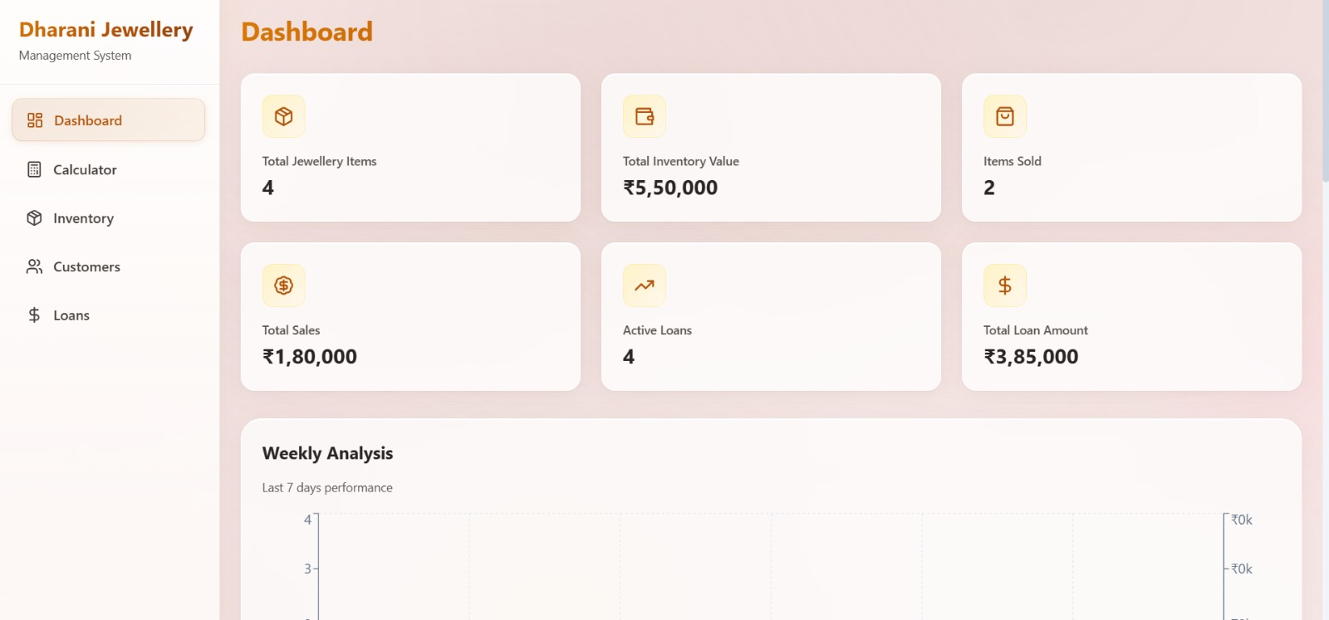

Figure 3.3.1: Dashboard Page for Interaction

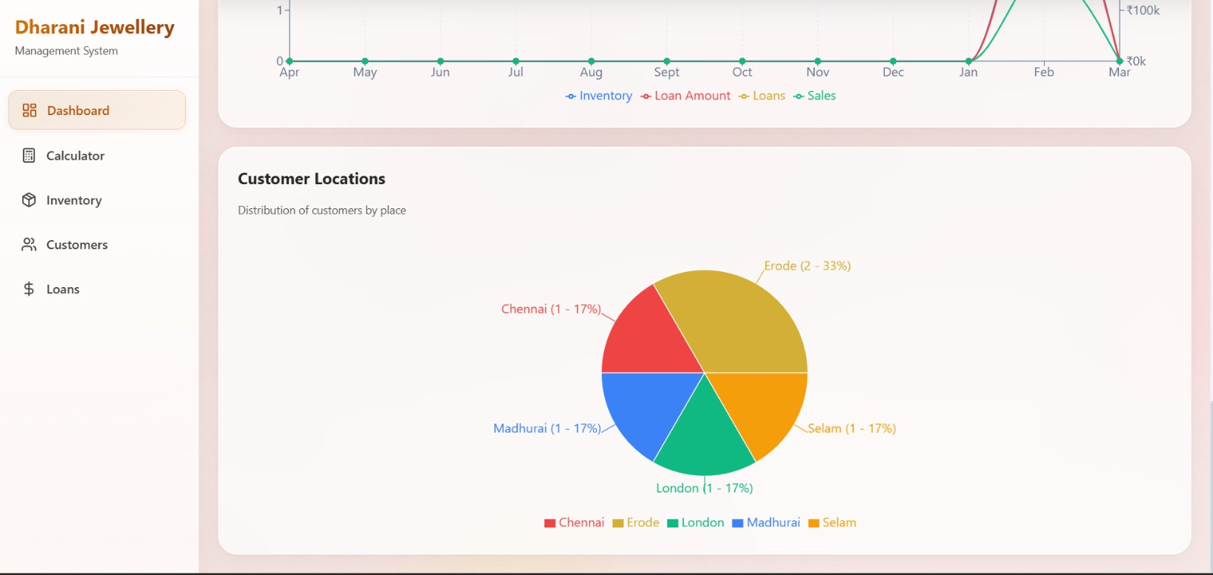
Figure 3.3.2: Bar Chart for Customer Loaction
- Calculator Page:
  - The calculator page is designed to perform jewellery price calculations efficiently as shown in Figure 3.3.3.
  - Users can enter details such as gold weight (grams), gold rate (per gram), stone price, making charges, wastage, and GST.
  - Upon clicking the calculate button, the system generates the total price along with a detailed receipt.
  - The generated receipt can be downloaded or printed, making it useful for billing purposes.
  - This feature reduces manual calculation errors and ensures accurate pricing.
  - The system automatically calculates the final amount based on the given inputs, ensuring quick and accurate results.
  - Users can reuse the calculator for multiple transactions, making it convenient for continuous billing operations.

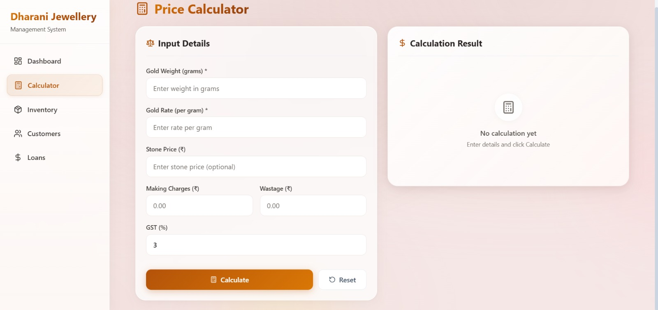
Figure 3.3.3: Price Calculator Interface for Jewellery Billing
- Inventory Page:
  - The inventory page allows users to manage all types of jewellery items as shown in Figure 3.3.4.
  - It displays a list of available jewellery products along with their details such as name, type, and stock quantity.
  - Users can add new jewellery items, including products with different names that are not already existing in the system.
  - Existing items can be updated or removed based on availability.
  - This feature helps maintain accurate stock records and ensures efficient inventory management.
  - Users can easily search and filter jewellery items, making it quicker to locate specific products.
  - The system provides real-time updates of stock levels, helping users avoid stock shortages or overstocking.

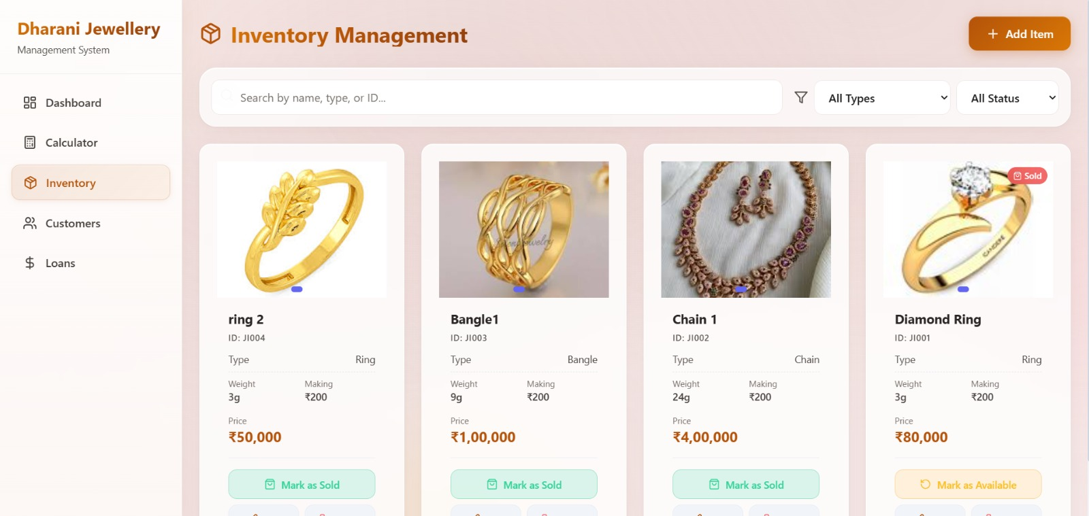
Figure 3.3.4: Inventory Management Interface for Jewellery Items
- Customer Page:
  - The customers page allows users to manage and store all customer details as shown in Figure 3.3.5.
  - Users can add new customers and maintain important information for future reference.
  - The system includes a favorites feature, where frequently purchasing customers can be marked for easy access.
  - Through WhatsApp integration, messages such as offers and discounts can be sent to all favorite customers at once.
  - This feature helps improve customer engagement and maintain strong relationships with regular buyers.
  - Users can quickly search and view customer details, making it easier to access information during shop operations.
  - The system helps maintain organized customer records, reducing manual effort and improving data accuracy.
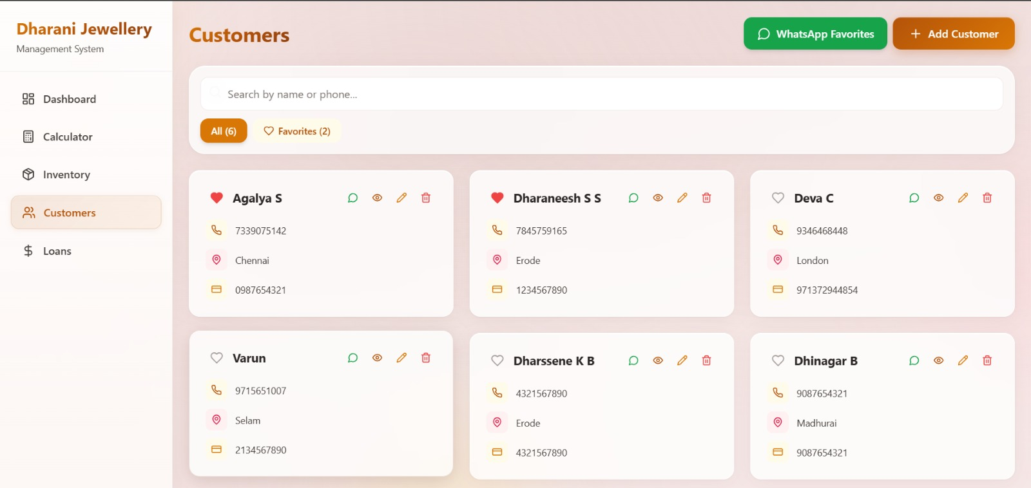
Figure 3.3.5: Customer Management Interface
- Loan Page:
  - Users can add new loan records by selecting the customer and the jewellery item along with loan details such as amount and due date.
  - The system displays all loan transactions with relevant information including customer name, jewellery details, and repayment status.
  - Loans are categorized as active or overdue to help users easily monitor pending payments and track repayment progress.
  - Users can update loan status and manage repayments efficiently, ensuring accurate loan tracking and better financial management.
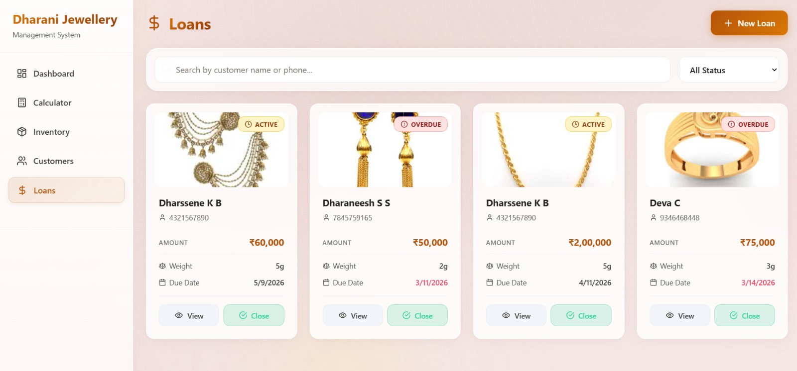
Figure 3.3.6: Loan Management Interface for Tracking Customer Loans
CHAPTER 4
DETAILED DESIGN

4.1 ARCHITECTURAL DESIGN
The architectural design includes various diagrams such as use case diagram, sequence diagram and activity diagram for the user module.

4.1.1 MODULE CHARACTERISTICS
The Dharani Jewellery App is built using a modular architecture, where each module is designed to handle specific functionalities of the system. This approach improves maintainability, scalability, and ease of development. The main modules of the system are as follows:
- Dashboard Module: This module provides an overview of the jewellery shop’s performance. It displays key metrics such as total jewellery items, total inventory value, items sold, total sales amount, active loans, and total loan amount. It also includes graphical representations such as weekly and yearly analysis charts and a bar chart for customer location-based sales. This module helps the owner monitor business performance at a glance.
- Calculator Module: This module is used for calculating jewellery prices based on inputs such as gold weight, gold rate per gram, stone price, making charges, wastage, and GST. It processes the inputs and generates a detailed total price along with a receipt. The module also allows users to print or download the receipt, making it useful for billing purposes.
- Inventory Module: This module manages all jewellery items available in the shop. It allows users to add new items, update existing product details, and remove items when necessary. It maintains accurate stock records and ensures that inventory data is always up to date. This module also supports adding new jewellery items with unique names that are not already present in the system.
- Customer Module: This module handles customer-related information such as customer details and purchase history. It allows users to add and manage customer records efficiently. The module also includes a favorites feature, where frequently purchasing customers can be marked. These favorite customers can be targeted for promotional messages such as offers and discounts via WhatsApp integration.
- Loan Module: This module manages customer loans associated with jewellery purchases. It allows users to add loan details including customer name, jewellery item, loan amount, and due date. Loans are categorized as active or overdue based on their repayment status. The module helps track pending payments and maintain proper loan records, ensuring efficient financial management of credit-based transactions.
4.1.1.1 USER MODULE CHARACTERISTICS
The User Module serves as the central component responsible for managing access control within the Dharani Jewellery App. It ensures that only authorized users such as the shop owner and workers can access the system. This module handles secure authentication using valid credentials like username and password, thereby protecting sensitive business information from unauthorized access.
The module performs validation of user inputs during the login process and verifies the credentials against stored data. It includes proper error handling mechanisms to notify users in case of incorrect login attempts. In addition, session management is supported, allowing users to remain logged in during active usage without the need to repeatedly enter credentials, thereby improving usability and convenience. .
Furthermore, the User Module can support basic user role management to distinguish between different types of users such as administrators and workers. This ensures controlled access to various functionalities within the application. Overall, the module plays a crucial role in maintaining system security, integrity, and smooth user interaction, forming the foundation for the entire application.
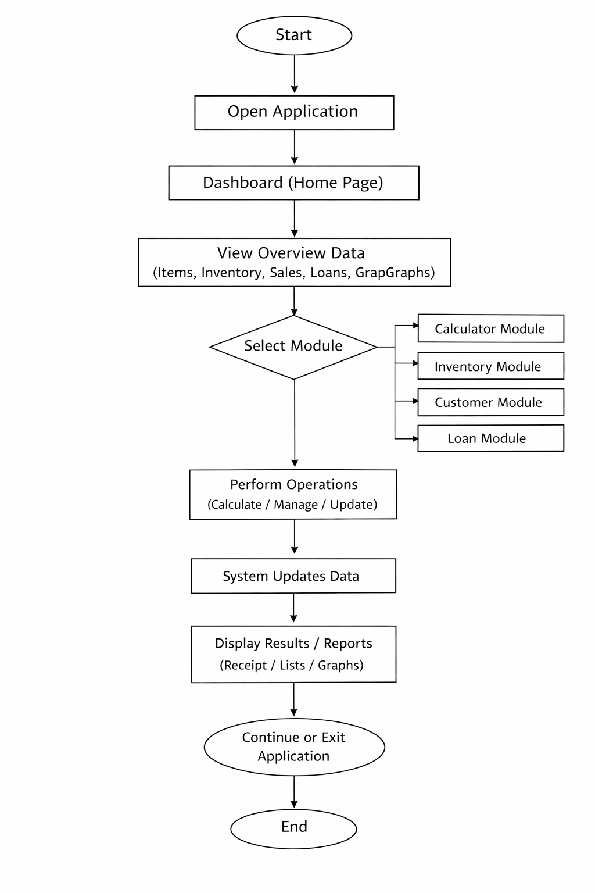
Figure 4.1: Flow Diagram

4.1.2 USE CASE DIAGRAM
The Use Case Diagram for the Dharani Jewellery App illustrates the interactions between the users and the system, where the main actors are the shop owner and workers. The primary use cases include accessing the dashboard to view overall business insights such as total jewellery items, inventory value, total sales, and loan details. Users can perform operations like managing inventory by adding, updating, and deleting jewellery items, using the calculator module to compute jewellery prices, managing customer details including adding customers and marking frequent customers as favorites, and handling loan records by adding new loans, tracking active and overdue loans, and updating repayment status. Figure 4.2 represents how these users interact with the system and how each module is accessed through the application to perform different business operations efficiently.
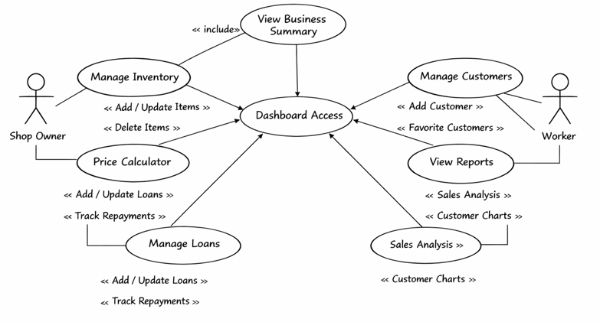
Figure 4.2: Use Case Diagram

4.1.3 SEQUENCE DIAGRAM
Figure 4.3 illustrates the interaction flow of the Dharani Jewellery Mobile Application, showing the sequence of messages exchanged between the user interface, system modules, and data storage during various operations. When the application is opened, the user accesses the dashboard, which retrieves and displays overall business information such as total jewellery items, inventory value, sales, and loan details. In the calculator module, user inputs such as gold weight, gold rate, stone price, making charges, wastage, and GST are processed by the system to generate the total amount and receipt, which is then displayed with options to print or download. In the inventory module, operations like adding or updating jewellery items are sent to the system and stored, with updated data reflected on the interface. Similarly, customer details and favorites are managed in the customer module, and loan details are processed in the loan module, where statuses such as active and overdue are maintained. This sequence ensures proper communication between components and maintains accurate and real-time data across the application.

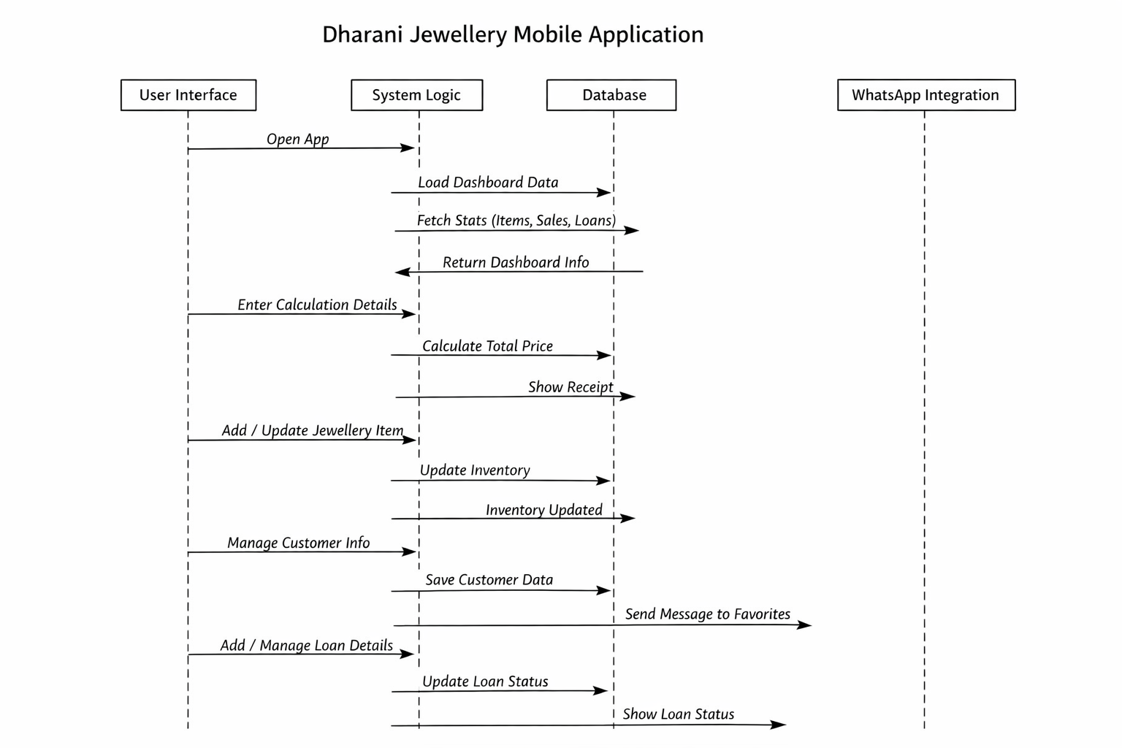
Figure 4.3: Sequence Diagram

CHAPTER 5
TESTING

5.1 UNIT TESTING
Unit testing in the Dharani Jewellery App focuses on validating individual modules such as inventory, customer, loan, and billing systems to ensure each works correctly in isolation. The inventory module is tested for adding, updating, deleting, and retrieving jewellery items with proper handling of valid and invalid inputs, while maintaining accurate data like name, weight, purity, price, and stock.
Similarly, the customer and loan modules are tested to ensure correct addition and management of customer details, favorites, and loan records, including status updates like active and overdue with proper tracking of repayments. The billing/calculation module is also tested to verify accurate price computation based on gold rate, weight, making charges, and GST, along with proper error handling for missing or incorrect inputs to ensure system reliability.
5.2 REGRESSION TESTING
Regression testing in the Dharani Jewellery App ensures that any updates, such as adding new features or fixing bugs, do not affect the existing functionality of the system. After changes are made, core modules like inventory management, customer management, loan management, and billing/calculation are retested to confirm that previously working features continue to function correctly without errors.
This testing verifies that operations such as adding or updating jewellery items, managing customer details and favorites, processing loans with accurate status updates (active or overdue), and calculating jewellery prices remain stable after modifications. Regression testing helps maintain system reliability by ensuring that integrations like database updates and any UI changes do not introduce unexpected issues, thereby preserving the overall performance and consistency of the application.

5.3 VALIDATION TESTING
Validation testing in the Dharani Jewellery App ensures that the system meets both functional and non-functional requirements as specified for the project. It verifies that all modules, including inventory management, customer management, loan management, and the calculator module, function correctly and produce accurate results according to user expectations.
This testing also checks whether the application provides a smooth and user-friendly interface, where users can easily navigate between the dashboard and different modules such as inventory, customers, and loans. Functional validation includes confirming operations like adding and updating jewellery items, managing customer records and favorites, processing loans with correct status updates (active or overdue), and generating accurate billing calculations with GST and other charges. Additionally, User Acceptance Testing (UAT) can be performed with sample users to ensure the system is practical, efficient, and satisfies real-world requirements of jewellery shop operations.

5.4 VERIFICATION TESTING
Verification testing in the Dharani Jewellery App ensures that the developed system conforms to the specified requirements and follows proper design and coding standards. This process includes reviewing the code to check adherence to coding conventions, logical correctness, and efficient implementation of modules such as inventory management, customer management, loan handling, and the calculator module.
Code reviews and manual inspections are performed to identify any errors, inconsistencies, or inefficiencies in the application. Static analysis practices may also be used to ensure code quality, readability, and maintainability. Verification testing confirms that all implemented features align with the functional specifications of the system, ensuring that operations like adding jewellery items, updating customer details, processing loans, and calculating prices are implemented correctly and function as intended.

5.5 INTEGRATION TESTING
Integration testing in the Dharani Jewellery App focuses on verifying the interaction between different modules such as the dashboard, inventory, customer management, loan management, and calculator modules, along with the underlying database. This testing ensures that data flows correctly between the frontend and backend, and that updates made in one module are accurately reflected across the system.
For example, when a user adds or updates jewellery items in the inventory module, the changes are properly stored in the database and immediately reflected in the dashboard and inventory views. Similarly, when customer details are added or loan records are created or updated, the information is consistently stored and retrieved across modules. The calculator module is also tested to ensure that calculated billing data is correctly processed and, if required, stored or displayed. Integration testing confirms that all modules work together seamlessly, ensuring reliable communication, data consistency, and proper system functionality across the entire application.

CHAPTER 6
CONCLUSION AND FUTURE WORK
The Dharani Jewellery App is a system designed to manage jewellery shop operations efficiently. It includes features such as dashboard analytics, inventory management, customer management, loan tracking, and a price calculator, helping users handle daily business tasks in an organized manner. The application provides real-time insights into key metrics like total items, inventory value, sales, and loan details, supporting better decision-making and improving overall efficiency.
The system follows a modular architecture where each module works independently while maintaining proper integration with other components. Functions such as inventory updates, customer management, loan tracking with active and overdue status, and price calculation improve accuracy and reduce manual errors. Analytical graphs like weekly and yearly sales, along with customer location-based data, provide useful business insights. Overall, the system delivers a simple and effective solution for managing jewellery shop operations.
Future improvements for the system include adding advanced analytics for sales prediction and inventory demand, along with a customer-facing application for browsing products. Additional features such as barcode/QR code scanning, low-stock alerts, and WhatsApp or SMS notifications can enhance functionality. Cloud deployment with better scalability and security can also be implemented to support multiple branches and a larger user base.

APPENDIX 1
CODING:
Loan.js:
import mongoose from 'mongoose';
const paymentSchema = new mongoose.Schema({
date: {
type: Date,
required: true,
},
amount: {
type: Number,
required: true,
},
note: {
type: String,
},
});
const loanSchema = new mongoose.Schema({
customer: {
type: mongoose.Schema.Types.ObjectId,
ref: 'Customer',
required: true,
},
jewellery_description: {
type: String,
required: [true, 'Jewellery description is required'],
},
jewellery_weight: {
type: Number,
required: [true, 'Jewellery weight is required'],
},
jewellery_image_url: {
type: String,
},
cloudinary_public_id: {
type: String,
},
loan_amount: {
type: Number,
required: [true, 'Loan amount is required'],
},
interest_rate: {
type: Number,
required: [true, 'Interest rate is required'],
},
loan_start_date: {
type: Date,
required: [true, 'Loan start date is required'],
},
due_date: {
type: Date,
required: [true, 'Due date is required'],
},
monthly_interest: {
type: Number,
required: true,
},
total_payable: {
type: Number,
required: true,
},
loan_status: {
type: String,
enum: ['Active', 'Closed', 'Overdue'],
default: 'Active',
},
payments: [paymentSchema],
}, {
timestamps: true,
});
const Loan = mongoose.model('Loan', loanSchema);
export default Loan;
Inventory.js:
import express from 'express';
import JewelleryItem from '../models/JewelleryItem.js';
import Loan from '../models/Loan.js';
import Customer from '../models/Customer.js';
const router = express.Router();
const getDateRanges = () => {
const now = new Date();
const weeklyStart = new Date(now);
weeklyStart.setDate(now.getDate() - 6);
weeklyStart.setHours(0, 0, 0, 0);
const monthlyStart = new Date(now);
monthlyStart.setDate(now.getDate() - 29);
monthlyStart.setHours(0, 0, 0, 0);
const yearlyStart = new Date(now);
yearlyStart.setMonth(now.getMonth() - 11);
yearlyStart.setDate(1);
yearlyStart.setHours(0, 0, 0, 0);
return { weeklyStart, monthlyStart, yearlyStart, now };
};
router.get('/analytics', async (req, res) => {
try {
const { weeklyStart, monthlyStart, yearlyStart, now } = getDateRanges();
const loans = await Loan.find();
const jewelleryItems = await JewelleryItem.find();
const weeklyData = [];
for (let i = 6; i >= 0; i--) {
const date = new Date(now);
date.setDate(now.getDate() - i);
date.setHours(0, 0, 0, 0);
const nextDate = new Date(date);
nextDate.setDate(date.getDate() + 1);
const dayLoans = loans.filter(loan => {
const loanDate = new Date(loan.createdAt);
return loanDate >= date && loanDate < nextDate;
});
const dayItems = jewelleryItems.filter(item => {
const itemDate = new Date(item.createdAt);
return itemDate >= date && itemDate < nextDate;
});
const soldItems = jewelleryItems.filter(item => {
const soldDate = item.sold_at ? new Date(item.sold_at) : new Date(item.updatedAt);
return (item.status === 'sold' || item.sold_at) && !item.sale_removed && soldDate >= date && soldDate < nextDate;
});
weeklyData.push({
name: date.toLocaleDateString('en-IN', { weekday: 'short' }),
loans: dayLoans.length,
loanAmount: dayLoans.reduce((sum, loan) => sum + loan.loan_amount, 0),
inventory: dayItems.length,
sales: soldItems.reduce((sum, item) => sum + item.price, 0),
});
}
const monthlyData = [];
for (let i = 4; i >= 0; i--) {
const weekEnd = new Date(now);
weekEnd.setDate(now.getDate() - (i * 7));
const weekStart = new Date(weekEnd);
weekStart.setDate(weekEnd.getDate() - 6);
weekStart.setHours(0, 0, 0, 0);
const loanDate = new Date(loan.createdAt);
return loanDate >= monthStart && loanDate <= monthEnd;
});
router.get('/stats', async (req, res) => {
try {
const jewelleryItems = await JewelleryItem.find();
const totalJewellery = jewelleryItems.length;
const availableItems = jewelleryItems.filter(item => (item.status || 'available') === 'available');
const soldItems = jewelleryItems.filter(item => (item.status === 'sold' || item.sold_at) && !item.sale_removed);
const totalInventoryValue = availableItems.reduce((sum, item) => sum + item.price, 0);
const totalSoldItems = soldItems.length;
const totalSalesValue = soldItems.reduce((sum, item) => sum + item.price, 0);
const loans = await Loan.find();
const activeLoans = loans.filter(loan => loan.loan_status === 'Active');
const totalActiveLoans = activeLoans.length;
const totalLoanAmount = activeLoans.reduce((sum, loan) => sum + loan.loan_amount, 0);
res.json({
totalJewellery,
totalActiveLoans,
totalLoanAmount,
totalInventoryValue,
totalSoldItems,
totalSalesValue,
});
} catch (error) {
console.error(error);
res.status(500).json({ message: error.message });
}
});
router.get('/customer-locations', async (req, res) => {
try {
const customers = await Customer.find({}, 'address');
const locationMap = {};
customers.forEach(customer => {
const address = (customer.address || '').trim();
const parts = address.split(',').map(p => p.trim()).filter(Boolean);
const place = parts.length > 0 ? parts[parts.length - 1] : 'Unknown';
if (locationMap[place]) {
locationMap[place]++;
} else {
locationMap[place] = 1;
}
});
const locations = Object.entries(locationMap)
.map(([name, value]) => ({ name, value }))
.sort((a, b) => b.value - a.value);
res.json(locations);
} catch (error) {
console.error(error);
res.status(500).json({ message: error.message });
}
});
export default router;

APPENDIX 2
SNAPSHOTS

FIGURE A2.1 Dashboard Page for User Interface



FIGURE A2.2 Calculator Page


FIGURE A2.3 Inventory Management Page


FIGURE A2.4 Customer page


FIGURE A2.5 Loan Page



FIGURE A2.6 Bar Chart for Customer Loaction

REFERENCES
- Kumar and S. Reddy, "Design and Development of Jewellery Management System," International Journal of Computer Applications, vol. 182, no. 25, pp. 15–22, 2021.
- P. Sharma and R. Gupta, "Inventory Management Techniques for Retail Jewellery Businesses," Journal of Retail Technology, vol. 8, no. 2, pp. 45–60, 2022.
- M. Singh and K. Verma, "A Study on Billing and Accounting Systems in Jewellery Shops," International Journal of Business and Management Technology, vol. 9, no. 3, pp. 101–110, 2023.
- S. Rao and D. Iyer, "Web-Based Application Development Using React and Node.js," Journal of Software Engineering Trends, vol. 11, no. 2, pp. 88–97, 2023.
- H. Thomas and J. Brown, "Database Management for Inventory Systems Using MongoDB," International Journal of Data Engineering, vol. 6, no. 3, pp. 55–63, 2021.
- R. Wilson, "Dashboard Analytics for Business Decision Making," Journal of Information Systems, vol. 10, no. 1, pp. 12–20, 2022.
- L. Nair and S. Menon, "Customer Relationship Management in Jewellery Retail Industry," Journal of Business Systems, vol. 7, no. 1, pp. 25–34, 2020.

MAPPING TO SDG GOALS
The project “Dharani Jewellery Mobile Application” supports the United Nations Sustainable Development Goals (SDGs), particularly SDG 9 – Industry, Innovation and Infrastructure. The system provides a digital platform that helps jewellery businesses manage inventory, customers, billing, and loan details more efficiently. By digitizing traditional business operations, the application improves productivity, reduces manual effort, and enhances overall business management.
The project promotes technological innovation by implementing a modern mobie-based system using technologies such as React, Firebase, and MongoDB, along with integration of analytics and customer management features. Additionally, the system supports better data organization and decision-making by maintaining accurate records of sales, customer interactions, and inventory levels. Overall,the application demonstrates how digital solutions can modernize traditional businesses and contribute to sustainable industrial innovation and infrastructure development.

