{%logo}EuroLanka Travel

143/16, Bandaranayaka Place,

Samagi Mawatha,

Galle,

Sri Lanka.

Phone (Sri Lanka): +94 755 8383 00

Email: yusuf@eurolanka.de

Web: www.eurolanka.de / www.eurolanka.net

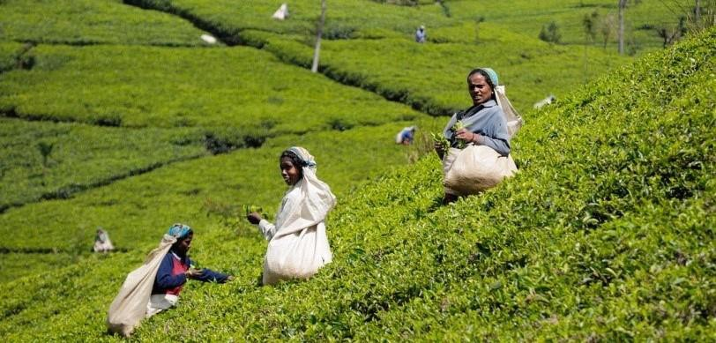

1 Days - Sri Lanka

1 Days/ 0 Nights



**Route**: BIA - BIA

**Name: hnakkk**

**Travellers:** 2

**Travel Date:** Start - 22/06/2024, End - 22/06/2024

**Itinerary Brief**

|  |  |
| --- | --- |
| **Day 1** | Dambulla, Sigiriya |
|  | Departure |

**Itinerary Detail**

B: Breakfast L: Lunch D:Dinner

**Day1 – Dambulla, Sigiriya – (22/06/2024)**

Arrival or pick up from hotel in Colombo. Heading to Sigiriya via Dambulla. Enroute visit Dambulla cave temple. The Rangiri Dambulla Cave Temple is a sacred pilgrimage site for 22 centuries, this cave monastery, with its five sanctuaries, is the largest, best-preserved cave-temple complex in Sri Lanka. The Buddhist mural paintings (covering an area of 2,100 m2 ) are of particular importance, as are the 157 statues. take the authentic village tour of the Kashyapa. In the late afternoon, we take a tour of Sigiriya village before climbing Lion Rock for a stunning sunset view.

**Overnight stay:** None of the above hotel

(B /L /D)

**Accomodations**

|  |  |
| --- | --- |
| **City** | **Accommodation** |
| Sigiriya | None of the above hotel |
| Departure |  |

accommodations on this tour are in, primarily, locally owned home stays, farm stays, Eco friendly, child friendly small hotels. The food in the accommodation is primarily sourced locally or organically grown in the own garden and the large number of dishes on the menus are home made. We encourage and educate local guides in the villages and hire them in places where their expertise and local knowledge will enhance your experience and understanding of historical context and on the environmental impact of your visit.

We work together with a variety of local accommodations. Their room availability will be checked at your booking. If one accommodation is already fully booked, you will stay in a similar accommodation of the same category.

* Each hotel has been personally requested to create the best child-friendly atmosphere.

**Information**

**Included**

* 1 Days/ 0 Nights’ accommodation according tour plan. If one accommodation is already full, you will stay in a similar accommodation of the same category.
* Meals according tour plan (1 x Break fasts, 1 x Lunch, 1 x Dinner)
* Transportation from arrival to departure (air-conditioned vehicle, public transportation such as bus or train, 4x4 Safari Jeep, bicycle, tuk-tuk, Boat)
* all taxes
* Fees / Charges for Sigiriya.
* English speaking guide.

**Not Included**

* + Flight tickets
  + Other entrance fees
  + camera permissions
  + other meals and drinks
  + tips
  + travel insurance
  + Visa (approx. $222