{%logo}undefined

Phone (Sri Lanka): undefined

Email: undefined

Web: undefined

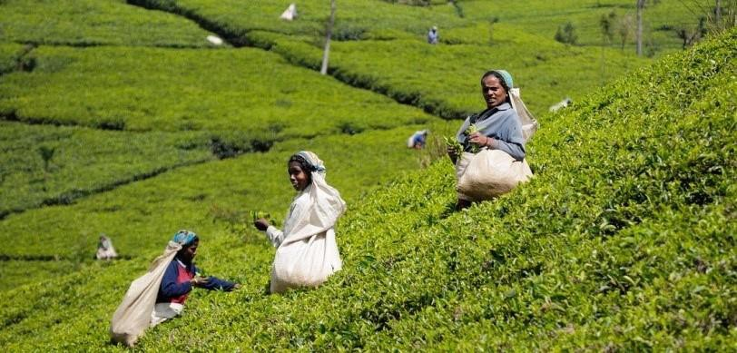

5 Days - Sri Lanka

5 Days/ 4 Nights



**Route**: BIA - Seegiriya - Nuwara Eliya - Alla - Galle - BIA

**Name: Tailor**

**Travellers:** 1

**Travel Date:** 2024-06-21

**Itinerary Brief**

|  |  |
| --- | --- |
| **Day 1** | Dambulla, Sigiriya |
| **Day 2** | Minneriya, Kandy |
| **Day 3** | Nuwara Eliya, Ella |
| **Day 4** | Ella, Galle |
| **Day 5** | Galle,Colombo, Departure |
|  | Departure |

**Itinerary Detail**

B: Breakfast L: Lunch D:Dinner

**Day1 – undefined – (21/06/2024)**

Arrival or pick up from hotel in Colombo. Heading to Sigiriya via Dambulla. Enroute visit Dambulla cave temple. The Rangiri Dambulla Cave Temple is a sacred pilgrimage site for 22 centuries, this cave monastery, with its five sanctuaries, is the largest, best-preserved cave-temple complex in Sri Lanka. The Buddhist mural paintings (covering an area of 2,100 m2 ) are of particular importance, as are the 157 statues. take the authentic village tour of the Kashyapa. In the late afternoon, we take a tour of Sigiriya village before climbing Lion Rock for a stunning sunset view.\

**Overnight stay:** Nethmi Home

(B /L /D)

**Day2 – undefined – (22/06/2024)**

After early breakfast, our driver will be waiting to take you for Minneriya Safari. Among the 24 species of mammal’s resident in the park are Elephants, Leopards, Sloth Bear, Spotted Deer, Sambar Deer, Wild Buffalo, Wild Pig, Grey Langers, Purple-faced Leaf Monkey, three species of Mongoose, Porcupine and Indian Pangolin. Minneriya National Park has recorded over 170 species of birds. From Migrating waders like Woodsand Piper, Common Sandpiper & Kentish Plovers to forest birds like Malabar-pied Hornbills, Rufus Woodpecker the globally endangered Lesser Adjutant and the endemics Sri Lanka Grey Horn-bill, Sri Lanka Green Pigeon, Brown-capped Babbler and Sri Lanka Jungle Fowl are some of the highlights. After lunch transfer to Kandy. The second largest city in Sri Lanka and a UNESCO world heritage site, due its rich, vibrant culture and history. This historic city was the Royal Capital during the 16th century and maintains its sanctified glory predominantly due to the sacred temples. In the evening do a city tour including evening visit to Temple of Tooth Relic, cultural show and then set you free in Kandy town to explore it on your own. Dinner at Balaji Dosai.\

**Overnight stay:** Hanthana Jungle View

(B /L /-)

**Day3 – undefined – (23/06/2024)**

After early breakfast we drive to Nuwara Eliya, travel through the winding green hills to the salubrious, misty hills of Nuwara Eliya - a prominent tourist and local holiday destination, assuring you tranquillity and relaxation amidst the exhilarating vista of tea plantations, waterfalls, and lakes. Enroute, visit Damro tea factory to witness the tea industry of the island, as Sri- Lanka is one of the largest producers and exporters of tea in the world. In Nuwara Eliya, a city tour of the Hill Club, Main City, Post Office, Victoria Park, Holy Trinity Church, Gayathri Kovil, Lake Gregory and Race Course is possible until we catch the train to Ella. Get on board the scenic train to Ella (4,5 hours). You will be received by our driver in Ella train station on arrival. A small, yet astonishingly beautiful town Ella, located close to Nuwara Eliya. Explore the beautiful nature of Ella and the surrounding by hiking, cycling or car. Your guide will assist you with things to do in and around\

**Overnight stay:** River Splendour Home

(B /- /-)

**Day4 – undefined – (24/06/2024)**

After breakfast we have time to continue enjoying and exploring the nature of Ella until your transfer to In the afternoon, we are heading to Galle. Dinner with my family in Galle\

**Overnight stay:** Amaranthe Beach Cabana

(B /- /-)

**Day5 – undefined – (25/06/2024)**

Breakfast in Galle–Explore Dutch heritage in Galle by tuk-tuk and you will explore historical importance of Galle Fort. The ramparts, colonial buildings, clock tower, light house, museum & old church, mosque & Buddhist temple are covered in this guided tour. After lunch we are heading to colombo for site seeing the Red Mosque and other attractions in Colombo. After a mouthwatering Banana Leaf dinner, driver will drop you at the airport for departure flight\

**Overnight stay:** None of the above

(B /- /-)

**Accomodations**

|  |  |
| --- | --- |
| **City** | **Accommodation** |
| Departure |  |

accommodations on this tour are in, primarily, locally owned home stays, farm stays, Eco friendly, child friendly small hotels. The food in the accommodation is primarily sourced locally or organically grown in the own garden and the large number of dishes on the menus are home made. We encourage and educate local guides in the villages and hire them in places where their expertise and local knowledge will enhance your experience and understanding of historical context and on the environmental impact of your visit.

We work together with a variety of local accommodations. Their room availability will be checked at your booking. If one accommodation is already fully booked, you will stay in a similar accommodation of the same category.

* Each hotel has been personally requested to create the best child-friendly atmosphere.

**Information**

**Included**

* 5 Days/ 4 Nights’ accommodation according tour plan. If one accommodation is already full, you will stay in a similar accommodation of the same category.
* Meals according tour plan (5 x Break fasts, 2 x Lunch, 1 x Dinner)
* Transportation from arrival to departure (air-conditioned vehicle, public transportation such as bus or train, 4x4 Safari Jeep, bicycle, tuk-tuk, Boat)
* all taxes
* Fees for .
* English speaking guide

**Not Included**

* + Flight tickets
  + Other entrance fees
  + camera permissions
  + other meals and drinks
  + tips
  + travel insurance
  + Visa (approx. $undefined US$