{%logo}EuroLanka Travel

143/16, Bandaranayaka Place,

Samagi Mawatha,

Galle,

Sri Lanka.

Phone (Sri Lanka): +94 755 8383 00

Email: yusuf@eurolanka.de

Web: www.eurolanka.de / www.eurolanka.com

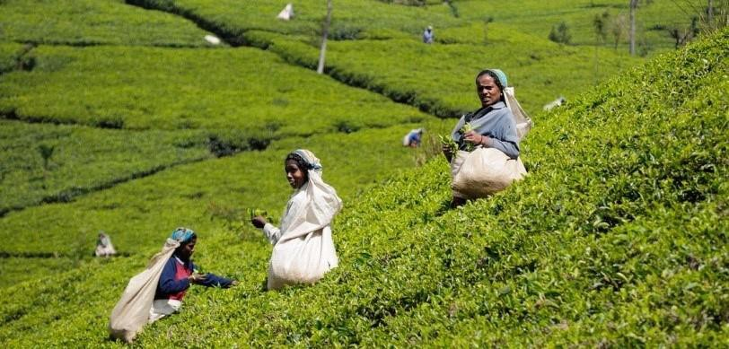

1 Days - Sri Lanka

1 Days/ 0 Nights



**Route**: BIA - BIA

**Name: Jhon Smith**

**Travellers:** 1

**Travel Date:** 2024-06-22

**Itinerary Brief**

|  |  |
| --- | --- |
| **Day 1** | Galle,Colombo, Departure |
|  | Departure |

**Itinerary Detail**

B: Breakfast L: Lunch D:Dinner

**Day1 – Galle,Colombo, Departure – (22/06/2024)**

Breakfast in Galle–Explore Dutch heritage in Galle by tuk-tuk and you will explore historical importance of Galle Fort. The ramparts, colonial buildings, clock tower, light house, museum & old church, mosque & Buddhist temple are covered in this guided tour. After lunch we are heading to colombo for site seeing the Red Mosque and other attractions in Colombo. After a mouthwatering Banana Leaf dinner, driver will drop you at the airport for departure flight

**Overnight stay:** Chaayaa Inn

(- /- /-)

**Accomodations**

|  |  |
| --- | --- |
| **City** | **Accommodation** |
| Departure |  |

accommodations on this tour are in, primarily, locally owned home stays, farm stays, Eco friendly, child friendly small hotels. The food in the accommodation is primarily sourced locally or organically grown in the own garden and the large number of dishes on the menus are home made. We encourage and educate local guides in the villages and hire them in places where their expertise and local knowledge will enhance your experience and understanding of historical context and on the environmental impact of your visit.

We work together with a variety of local accommodations. Their room availability will be checked at your booking. If one accommodation is already fully booked, you will stay in a similar accommodation of the same category.

* Each hotel has been personally requested to create the best child-friendly atmosphere.

**Information**

**Included**

* 1 Days/ 0 Nights’ accommodation according tour plan. If one accommodation is already full, you will stay in a similar accommodation of the same category.
* Meals according tour plan (0 x Break fasts, 0 x Lunch, 0 x Dinner)
* Transportation from arrival to departure (air-conditioned vehicle, public transportation such as bus or train, 4x4 Safari Jeep, bicycle, tuk-tuk, Boat)
* all taxes
* Fees for Galle.
* English speaking guide

**Not Included**

* + Flight tickets
  + Other entrance fees
  + camera permissions
  + other meals and drinks
  + tips
  + travel insurance
  + Visa (approx. $36 US$