EuroLanka Travel

143/16, Bandaranayake Place Samagi Mawatha

Galle

Sri Lanka

Phone (Sri Lanka): +94 755 8383 00 Email: [yusuf@eurolanka.de](mailto:yusuf@eurolanka.de)

Web: [www.eurolanka.de](http://www.eurolanka.de/)

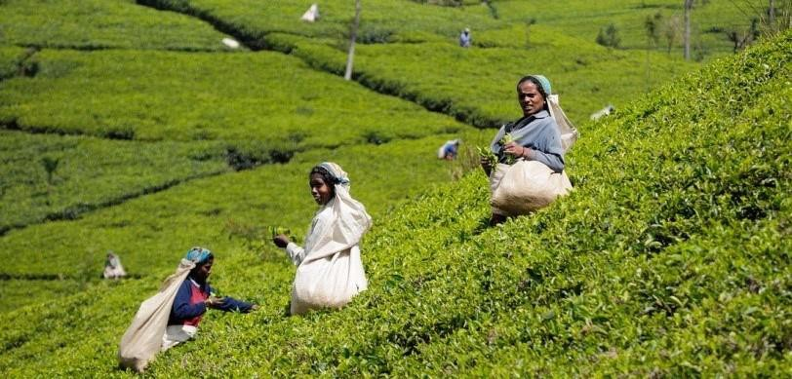

{tourDur}

{noOfNights}



**Route:** {route}

### Name: {name} Travellers: {travellers}

**Travel Date:** {travelDate}

**Itinerary Brief**

|  |  |
| --- | --- |
| {#travelTbEntries} **{day}** | {activity} {/travelTbEntries} |
|  | Departure |

**Itinerary Detail**

B: Breakfast L: Lunch D: Dinner

{#travelDays}

{description}

**{day} – {activity} - {date}**

**Overnight stay:** {hotel}  
{meals}  
  
{/travelDays}

**Accommodations**

|  |  |
| --- | --- |
| **City** | **Accommodation** |
| {#accommodationsEntries}{city} | {hotel}{/accommodationsEntries} |
| Departure |  |

accommodations on this tour are in, primarily, locally owned home stays, farm stays, Eco friendly, child friendly small hotels. The food in the accommodation is primarily sourced locally or organically grown in the own garden and the large number of dishes on the menus are home made. We encourage and educate local guides in the villages and hire them in places where their expertise and local knowledge will enhance your experience and understanding of historical context and on the environmental impact of your visit.

We work together with a variety of local accommodations. Their room availability will be checked at your booking. If one accommodation is already fully booked, you will stay in a similar accommodation of the same category.

* Each hotel has been personally requested to create the best child-friendly atmosphere.

**Information**

**Included**

* 19 nights’ accommodation according tour plan. If one accommodation is already full, you will stay in a similar accommodation of the same category.
* Meals according tour plan (19 x Break fasts, 1 x Lunch, 1 x Dinner)
* Transportation from arrival to departure (air-conditioned vehicle, public transportation such as bus or train, 4x4 Safari Jeep, bicycle, tuk-tuk, Boat)
* all taxes
* Fees for Galle Tour, Udawalawe Safari entrance ticket, jeep and guide/ Ella Train tickets/ Kandy Temple entrance, cultural show/ Village Safari.
* English speaking guide

**Not Included**

* Flight tickets
* Other entrance fees
* camera permissions
* other meals and drinks
* tips
* travel insurance
* Visa (approx. 35 US$