ONLINE

image

Phone (Sri Lanka): 0704281955

Email: arabdullahdev@gmail.com

Web: https://arabdullah.top

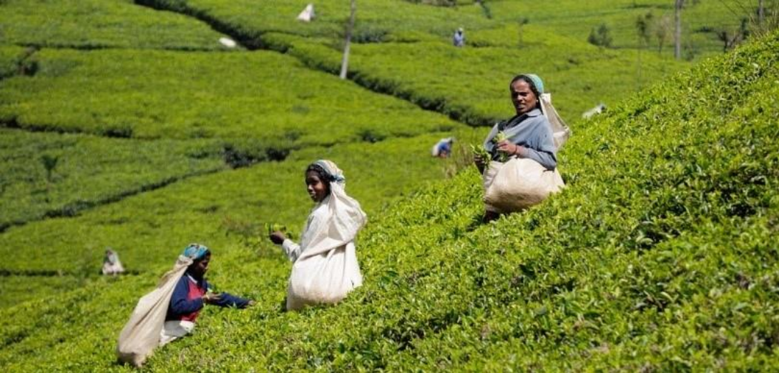

3 Days – Sri Lanka

3 Days / 2 Nights

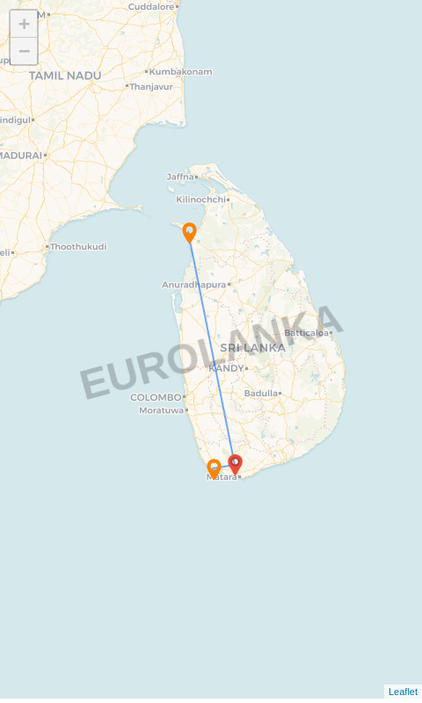

**Route:** Galle - Akuressa - Mannar

# Name: Jhon Doe

**Travellers:** 5 (Adults)

**Travel Date:** 21 Jun 2025 – 23 Jun 2025

**Itinerary Brief**

|  |  |
| --- | --- |
| **Day 1** | Galle – Galle,Colombo, Departure |
| **Day 2** | Akuressa – Running in Akuressa :D |
| **Day 3** | Mannar – Mannar- Jaffna |

**Itinerary Detail**

B: Breakfast L: Lunch D: Dinner

**Day 1 – Galle (21 Jun 2025)**

Breakfast in Galle–Explore Dutch heritage in Galle by tuk-tuk and you will explore historical importance of Galle Fort. The ramparts, colonial buildings, clock tower, light house, museum & old church, mosque & Buddhist temple are covered in this guided tour. After lunch we are heading to colombo for site seeing the Red Mosque and other attractions in Colombo. After a mouthwatering Banana Leaf dinner, driver will drop you at the airport for departure flight

# Overnight Stay: Jetwing Lighthouse:

## (B/L/D)

**Day 2 – Akuressa (22 Jun 2025)**

Running in Akuressa :D...............

# Overnight Stay: hotel custom test:

## (B/-/-)

**Day 3 – Mannar (23 Jun 2025)**

After breakfast in Mannar, we are heading to Jaffna; Jaffna or Yalpanam is the capital city of the Northern Province of Sri Lanka. Most of the residents of Jaffna are Sri Lankan Tamils with a presence of Sri Lankan Moors and Portuguese Burghers .Yarlpanam is believed to have got its name from Yarl and Panam meaning the land of the Yarl or Veenai, a musical instrument; derived from the myth that this land was received by a Yarl player as a Royal grant in appreciation of his musical performance. In the evening, we do a city tour of Jaffna covering culture, religions and enjoy some food while mingling with locals

# No overnight stay:

## (B/L/-)

**Accommodations**

|  |  |
| --- | --- |
| **City** | **Accommodation** |
| Galle | Jetwing Lighthouse |
| Akuressa | hotel custom test |
| Departure | 23 Jun 2025 |