ONLINE

image

Phone (Sri Lanka): 0704281955

Email: arabdullahdev@gmail.com

Web: https://arabdullah.top

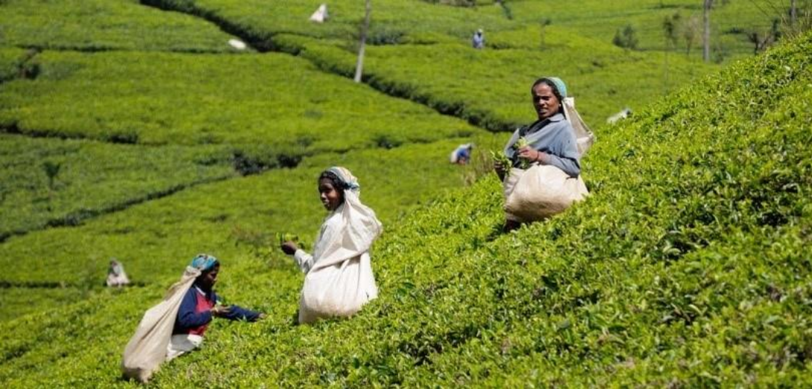

3 Days – Sri Lanka

3 Days / 2 Nights

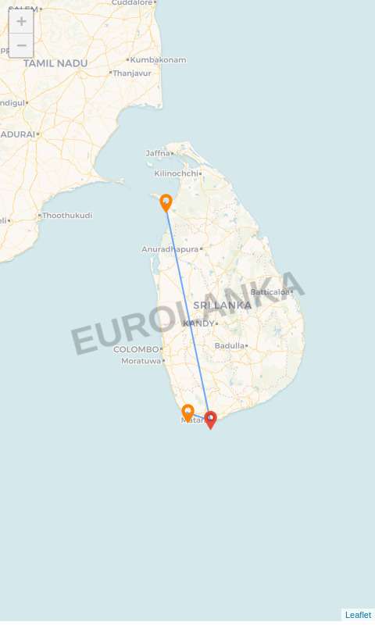

**Route:** Galle - Matara - Mannar

# Name: Jhon Doe

**Travellers:** 4

**Travel Date:** 21 Jun 2025 – 23 Jun 2025

**Itinerary Brief**

|  |  |
| --- | --- |
| **Day 1** | Galle – Galle,Colombo, Departure |
| **Day 2** | Matara – Walking on Matara Beach.... |
| **Day 3** | Mannar – Anawilundawa - Mannar |

**Itinerary Detail**

B: Breakfast L: Lunch D: Dinner

**Day 1 – Galle (21 Jun 2025)**

Breakfast in Galle–Explore Dutch heritage in Galle by tuk-tuk and you will explore historical importance of Galle Fort. The ramparts, colonial buildings, clock tower, light house, museum & old church, mosque & Buddhist temple are covered in this guided tour. After lunch we are heading to colombo for site seeing the Red Mosque and other attractions in Colombo. After a mouthwatering Banana Leaf dinner, driver will drop you at the airport for departure flight

# Overnight Stay: Jetwing Lighthouse:

## (B/L/D)

**Day 2 – Matara (22 Jun 2025)**

Walking on Matara Beach....

# No overnight stay:

## (B/-/D)

**Day 3 – Mannar (23 Jun 2025)**

After breakfast, we are heading to the city Sun-blasted Mannar Island is a dry near-peninsula with lots of white sand and palm trees, gulls and terns, wild donkeys and fishing boats. Culturally, it's an intriguing place: dotted with ancient baobab trees (native to Africa and said to have been planted by Arab merchants many centuries ago) and crumbling colonial edifices built by the Portuguese, Dutch and Brits. Off the Coast you can see small islands named as first and second islands.Some travelers record their experience of walking across several small islets in the second island is buzzing with activity of fish, crabs and seagulls.And some other traveler identifies the island to be the playground for rare birds.You can also have a look at a popular tourist attraction near Adam’s Bridge called Dancing Islands. The chain of sprinkled islands here has sand dunes in which the sand keeps ‘shifting’ from one location to another. This creates the beautiful illusion of the sands constantly moving and dancing

# Overnight Stay: El Shaddai:

## (B/L/D)

**Accommodations**

|  |  |
| --- | --- |
| **City** | **Accommodation** |
| Galle | Jetwing Lighthouse |
| Mannar | El Shaddai |
| Departure | 23 Jun 2025 |