ONLINE

image

Phone (Sri Lanka): 0704281955

Email: arabdullahdev@gmail.com

Web: https://arabdullah.top

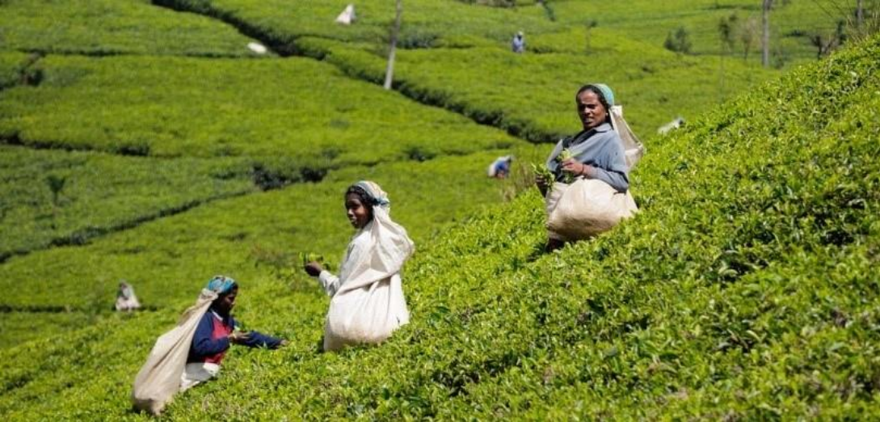

3 Days – Sri Lanka

3 Days / 2 Nights

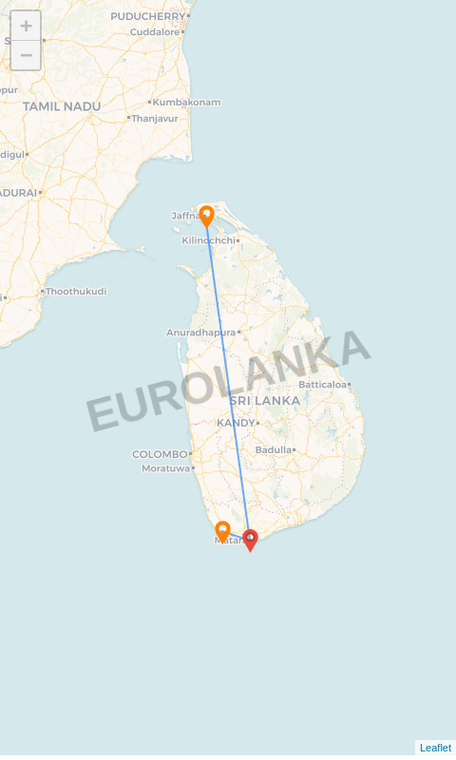

**Route:** Jaffna - Matara - Galle

# Name: jhon doe

**Travellers:** 4

**Travel Date:** 28 Jun 2025 – 30 Jun 2025

**Itinerary Brief**

|  |  |
| --- | --- |
| **Day 1** | Jaffna – Mannar- Jaffna |
| **Day 2** | Matara – running............ |
| **Day 3** | Galle – Ella, Galle |

**Itinerary Detail**

B: Breakfast L: Lunch D: Dinner

**Day 1 – Jaffna (28 Jun 2025)**

After breakfast in Mannar, we are heading to Jaffna; Jaffna or Yalpanam is the capital city of the Northern Province of Sri Lanka. Most of the residents of Jaffna are Sri Lankan Tamils with a presence of Sri Lankan Moors and Portuguese Burghers .Yarlpanam is believed to have got its name from Yarl and Panam meaning the land of the Yarl or Veenai, a musical instrument; derived from the myth that this land was received by a Yarl player as a Royal grant in appreciation of his musical performance. In the evening, we do a city tour of Jaffna covering culture, religions and enjoy some food while mingling with locals

# Overnight Stay: Malabar Home Stay:

## (-/L/-)

**Day 2 – Matara (29 Jun 2025)**

running............

# No overnight stay:

## (-/-/-)

**Day 3 – Galle (30 Jun 2025)**

After breakfast we have time to continue enjoying and exploring the nature of Ella until your transfer to In the afternoon, we are heading to Galle. Dinner with my family in Galle

# Overnight Stay: Jetwing Kurulubedda:

## (B/-/-)

**Accommodations**

|  |  |
| --- | --- |
| **City** | **Accommodation** |
| Jaffna | Malabar Home Stay |
| Galle | Jetwing Kurulubedda |
| Departure | 30 Jun 2025 |