ONLINE

image

Phone (Sri Lanka): 0704281955

Email: arabdullahdev@gmail.com

Web: https://arabdullah.top

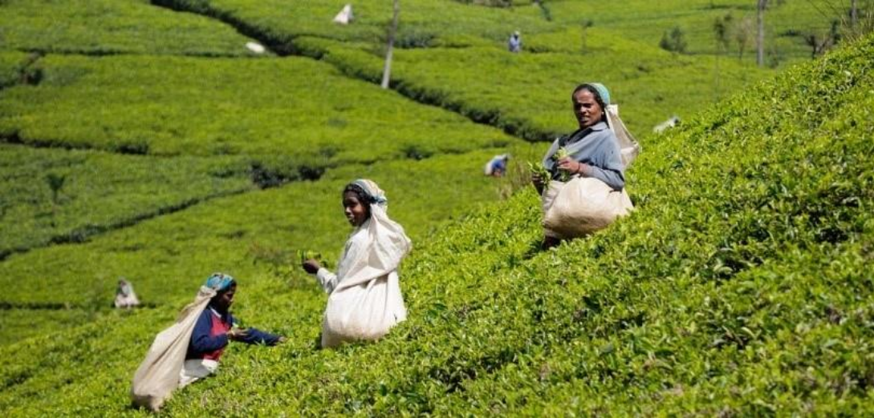

3 Days – Sri Lanka

3 Days / 2 Nights

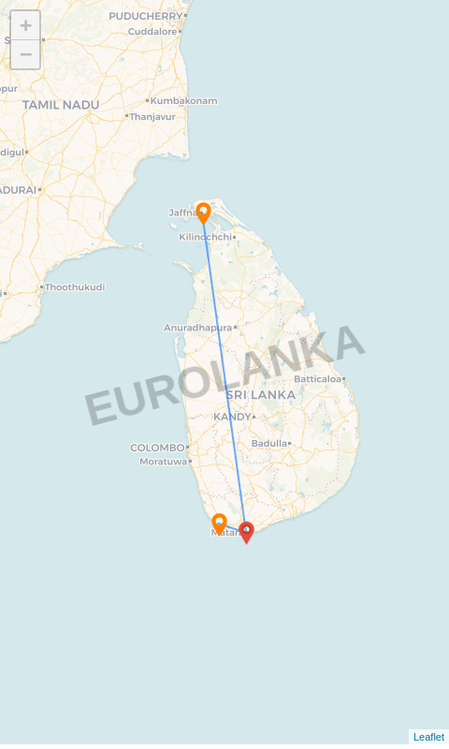

**Route:** Jaffna - Matara - Galle

# Name: mr. jhon

**Travellers:** 1

**Travel Date:** 28 Jun 2025 – 30 Jun 2025

**Itinerary Brief**

|  |  |
| --- | --- |
| **Day 1** | Jaffna – Jaffna City Tour |
| **Day 2** | Matara – running..... |
| **Day 3** | Galle – Galle-Whales watching and Cookery class |

**Itinerary Detail**

B: Breakfast L: Lunch D: Dinner

**Day 1 – Jaffna (28 Jun 2025)**

After breakfast we proceed to the tour of Jaffna city. You will see the train station that was completely destroyed being rebuilt. Even the new tracks are being layed, and some important land marks of the town which show significant progress in the city after the war. This specially designed tour will also cover Jaffna Fort, Alfred Duraiaappah Stadium, Jaffna clock tower, Jaﬁna library, High Court, Ariyakulam Buddhist Temple — Nallur Temple, Jamunari Bottomless well, Manthirimanai (King Sangilians Palace) with so many other spectacular and historical places.

# Overnight Stay: Malabar Home Stay:

## (-/L/-)

**Day 2 – Matara (29 Jun 2025)**

runningg......

# No overnight stay:

## (-/-/-)

**Day 3 – Galle (30 Jun 2025)**

After breakfast we are heading to Mirissa to take an exciting yet comfortable boat trip out to sea and be fortunate to see Blue Whales; the largest creatures on earth, Bryde’s Whales, Sperm Whales, Killer Whales and Fin Whales. You can also meet pods of friendly Dolphins such as the Common dolphins, Bottlenose dolphins, Spinner dolphins, Risso’s dolphins and striped dolphins as they playfully somersault and dance on the ocean waves. There’s also a good chance of seeing flying fish, turtle, manta rays and even sharks. The best time to Whale watch is between November and April each year. Take back beautiful memories of the gentle giants of the ocean; it’s a once-in-lifetime experience! In the afternoon after cookery class, you are free to do your beach activities.

# Overnight Stay: Chaayaa Inn:

## (B/-/D)

**Accommodations**

|  |  |
| --- | --- |
| **City** | **Accommodation** |
| Jaffna | Malabar Home Stay |
| Galle | Chaayaa Inn |
| Departure | 30 Jun 2025 |