Your 16-week React roadmap: Zero to production-ready
Arbaaz, let's build this properly. Your goal isn't just to learn React syntax or finish a YouTube course. You want to reach a level where you can join an existing React project, understand its architecture, develop features, integrate Spring Boot APIs, debug production issues, build and deploy the application, and answer difficult interview questions confidently.
We'll use your existing Fitness Tracker project as the practical foundation. It already has a Spring Boot microservices backend involving User, Activity and AI services, API Gateway, Eureka, databases, RabbitMQ and Gemini AI. Your React frontend can become the missing piece that brings the system together.
What you should be able to do by the end
Develop features independently
Build components, forms, dashboards, reusable UI, routing, tables, search, filtering and pagination.
Integrate real backends
Connect REST APIs, manage asynchronous requests, handle validation errors, implement authentication and troubleshoot CORS, HTTP and network issues.
Understand production concerns
Security, environment configuration, performance, testing, maintainability, build pipelines and deployment.
Handle difficult interviews
Explain rendering, hooks, stale closures, race conditions, caching, state management, performance and architectural trade-offs, with code examples.
Timeline: 16 weeks is a realistic target for strong practical competence if you work consistently. Production-level confidence will depend on how much code you write, debug and test yourself. You won't become an expert in every React library in 16 weeks, but you can build a solid foundation for contributing to real projects.
1. Your weekly time budget
You reach home at 9 PM, sleep at 1 AM, have 30 minutes available at the office, and have several study slots on weekends. We'll protect your sleep and use your available time efficiently.
Day | React | Java/Spring Boot
Monday–Friday | 45 min/day | 60–75 min/day
Saturday | 2–2.5 hours | 2 hours
Sunday | 2–2.5 hours | 1–2 hours
Use your 30-minute office slot for whichever subject is most useful that day: React theory and interview revision, or Java/Spring Boot concepts. Count it toward your weekly totals rather than treating it as extra work every day.
Aim for approximately 7–9 focused React hours per week, while continuing Java/Spring Boot practice. Some weeks will be lighter, and that's fine.
2. The complete 16-week roadmap
Follow the weeks in order. Every phase ends with something working in your Fitness Tracker, not just completed lessons.
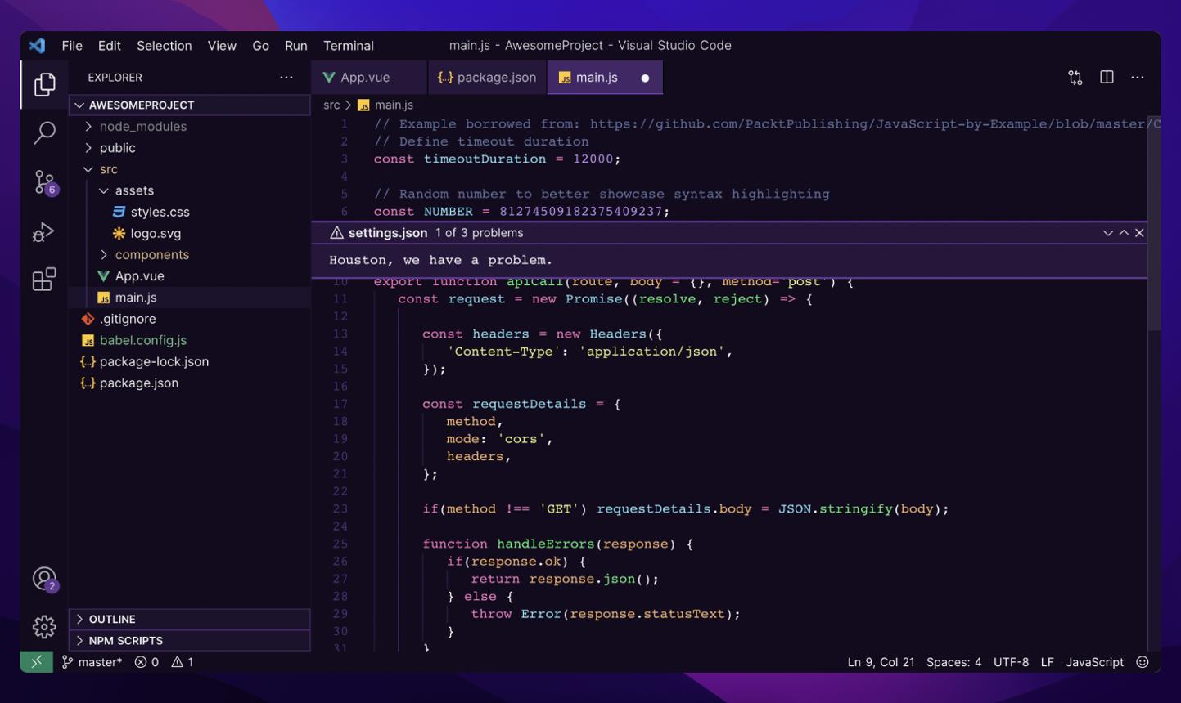
Weeks 1–2
Phase 1: JavaScript foundation
Learn before React
- let, const, data types, functions and arrow functions
- Objects, arrays, destructuring, spread/rest
- map, filter, find, reduce
- Modules, optional chaining and nullish coalescing
- Promises, async/await, try/catch
- Immutability and basic event-loop concepts
Fitness Tracker deliverable: Prepare activity and user data, transform API-like data and write asynchronous JavaScript functions.
Interview target: Closures, promises, asynchronous execution, array methods, shallow vs deep copies and object references.
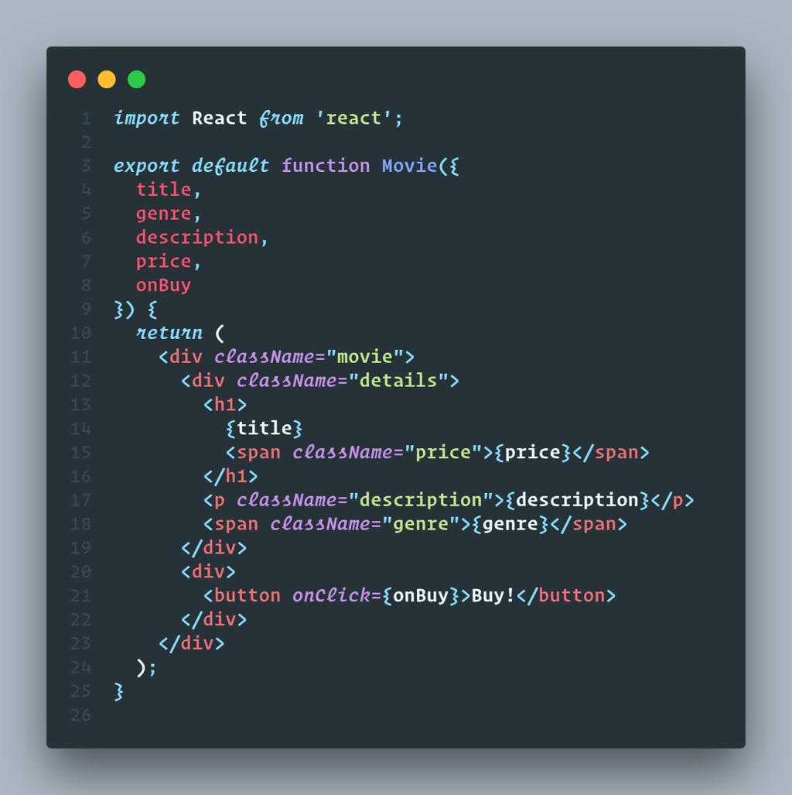
Weeks 3–4
Phase 2: React fundamentals
Understand how React works
- Create a Vite application
- JSX, components, props and composition
- useState, events and conditional rendering
- Lists, stable keys and forms
- Controlled inputs and lifting state
- Updating arrays and objects immutably
Fitness Tracker deliverable: Navbar, dashboard layout, activity cards, activity list and an add-activity form using temporary data.
Interview target: Props vs state, re-rendering, reconciliation, keys, controlled vs uncontrolled inputs and why state must be updated immutably.
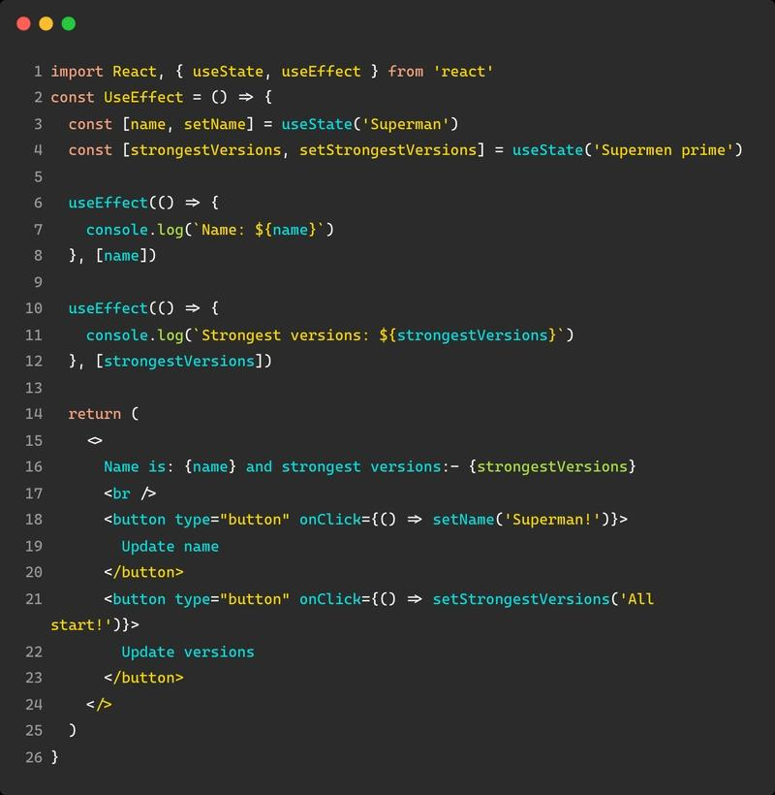
Week 5
Phase 3: Hooks and component lifecycle
Learn the rules behind React behavior
- useEffect and dependency arrays
- Cleanup functions
- useRef and useReducer
- Derived state vs duplicated state
- Stale closures, effect loops and re-render behavior
- Custom hooks introduction
Fitness Tracker deliverable: Activity filters, date selection, reusable form logic and effects with correct cleanup.
Interview target: Why an effect runs repeatedly, dependency mistakes, stale state, effect cleanup, Strict Mode behavior and when an effect is unnecessary.
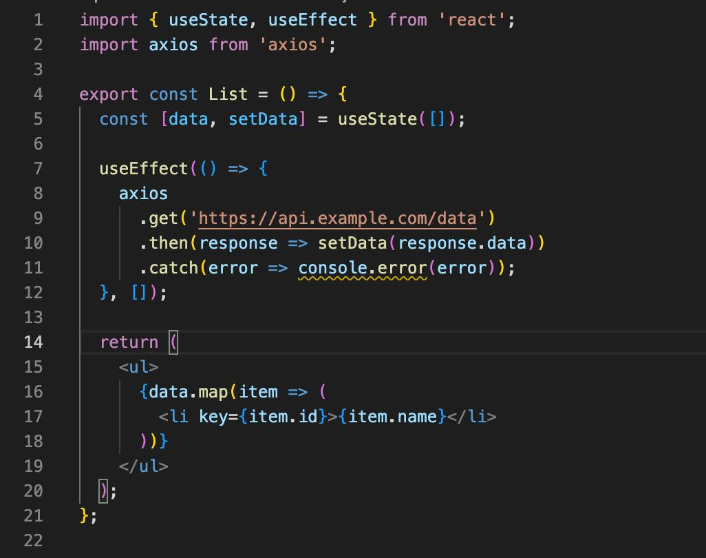
Weeks 6–7
Phase 4: REST APIs and CRUD
Connect React to Spring Boot
- HTTP methods and status codes
- fetch first, then Axios
- Centralized API client and environment variables
- GET, POST, PUT/PATCH and DELETE
- Loading, error, empty and success states
- Form validation and server-side validation errors
- CORS, network errors, timeouts and cancellation
Fitness Tracker deliverable: Create, view, edit and delete real activities through your backend. Integrate through your existing API Gateway where appropriate.
Interview target: Promise handling, request cancellation, race conditions, API error handling, CORS, retries and duplicate submissions.
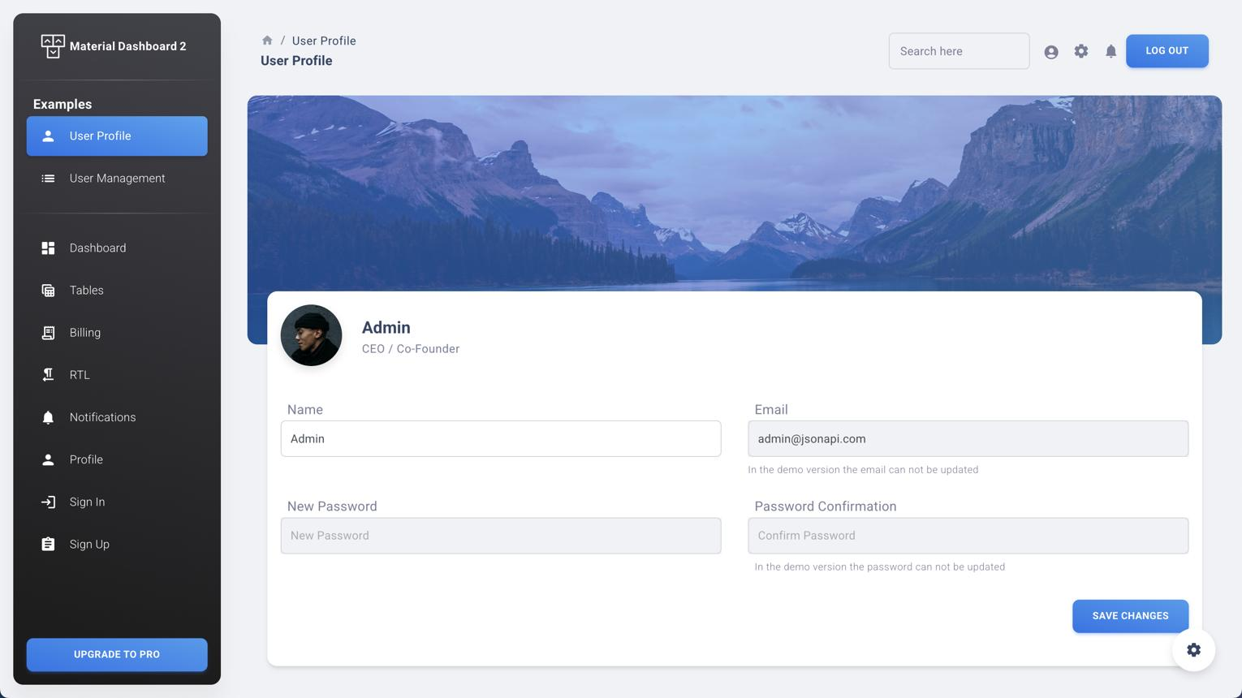
Week 8
Phase 5: Routing and layouts
Build a multi-page application
- React Router
- Nested routes and shared layouts
- URL parameters and query parameters
- Navigation and 404 pages
- Search, pagination and filters in URLs
- Route-level lazy loading
Fitness Tracker deliverable: /login, /dashboard, /activities, /activities/:id, /profile and an activity creation route.
Interview target: Nested routing, route parameters, navigation, protected-route design and code splitting.
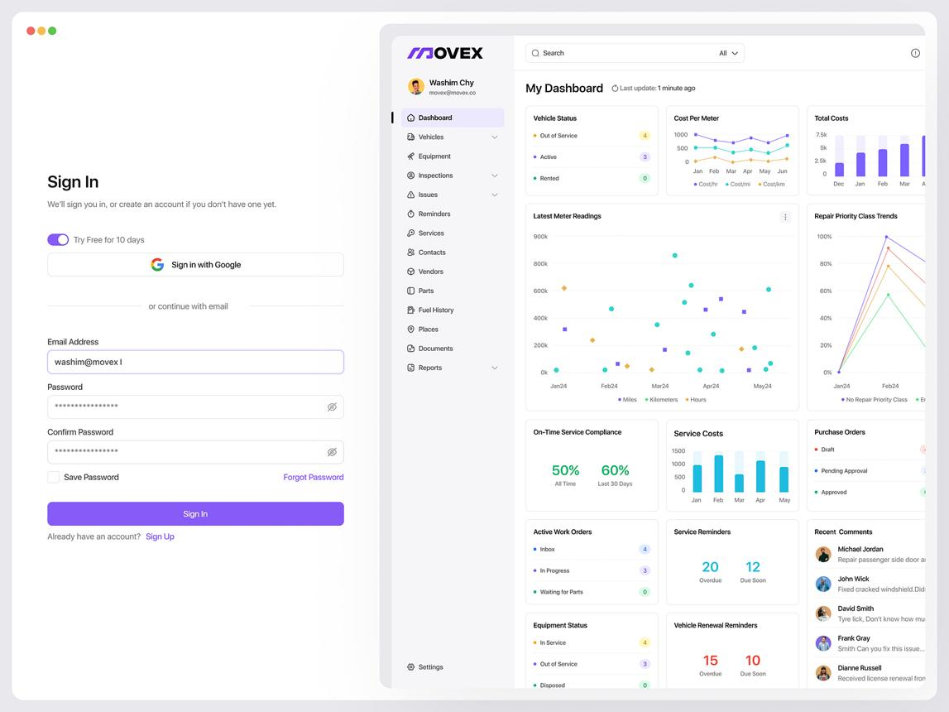
Weeks 9–10
Phase 6: Authentication and state management
Make the app work for real users
- Login, logout and user profile
- Spring Security integration and JWT flow
- Token expiry and refresh-token behavior
- Secure token storage and authentication state
- Context API and custom hooks
- Redux Toolkit fundamentals
- Server state vs client/UI state
Fitness Tracker deliverable: Login, user-specific activity views, protected navigation, logout and handling expired sessions.
Interview target: Context vs Redux, state normalization, token-storage trade-offs, refresh races, 401 vs 403, and why frontend route guards are not authorization.
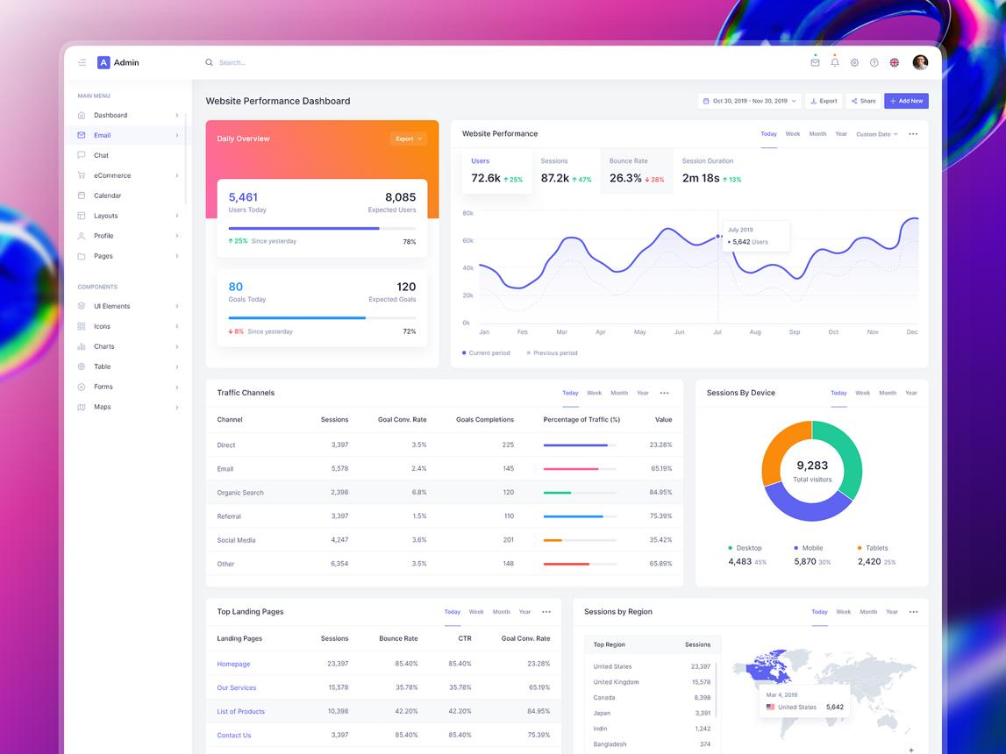
Weeks 11–12
Phase 7: Production data and advanced React
Make data fetching and rendering robust
- TanStack Query: queries, mutations and cache invalidation
- useMemo, useCallback and React.memo
- Custom hooks and reusable API logic
- Error boundaries and fallback UI
- Suspense and lazy loading concepts
- Debounced search and request cancellation
- Performance profiling and accessibility
Fitness Tracker deliverable: Activity history, cached queries, AI recommendation display, dashboard statistics, reusable notifications and resilient error states.
Interview target: Memoization trade-offs, cache invalidation, unnecessary renders, Suspense, error boundaries and client/server state separation.
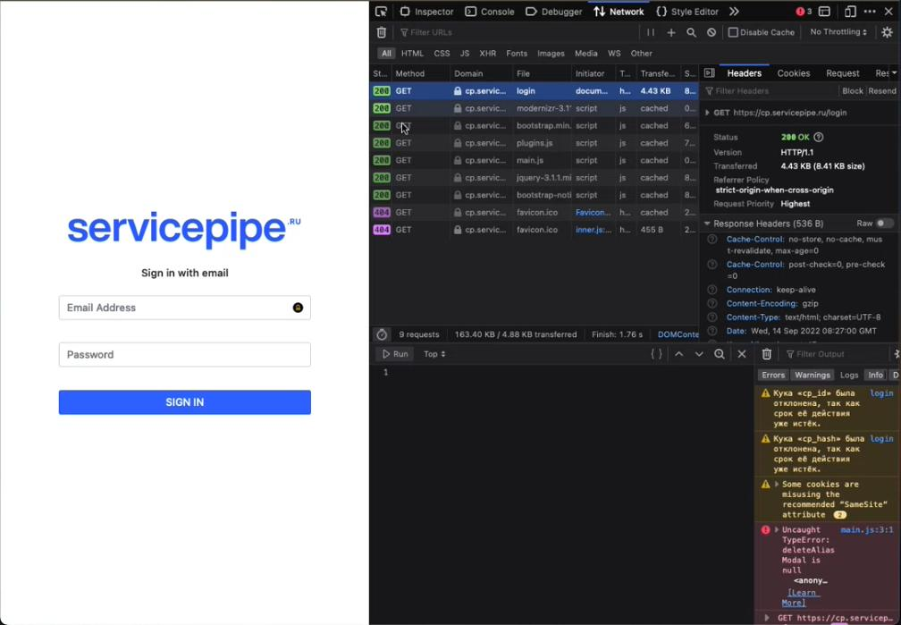
Week 13
Phase 8: Testing and debugging
Prove that your application works
- Vitest and React Testing Library
- Component and form tests
- Mocking API responses
- Success, loading and failure scenarios
- Debugging with React DevTools
- Browser Network tab and console
- Basic end-to-end testing with Playwright
Fitness Tracker deliverable: Tests for login, activity creation, API failures and protected screens.
Interview target: Unit vs integration tests, testing user behavior, mocks, flaky tests and debugging production-only issues.
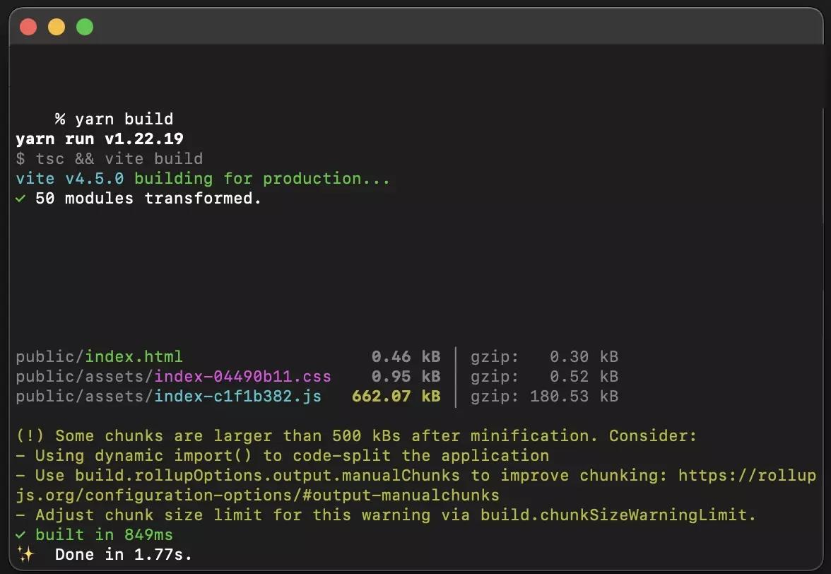
Weeks 14–15
Phase 9: Production build and deployment
Learn the path from code to release
- npm run build and production output
- Vite configuration and environment variables
- Development, staging and production API URLs
- Nginx/static hosting and Docker basics
- CI/CD basics and automated tests
- SPA route fallback and refresh issues
- HTTPS, security headers and deployment troubleshooting
- Bundle analysis and performance checks
Fitness Tracker deliverable: A production build deployed to a hosting environment, connected to your deployed backend, with configuration and deployment instructions.
Interview target: Build-time vs runtime configuration, bundle splitting, environment secrets, CORS, reverse proxies, caching and deployment rollback basics.

Week 16
Phase 10: Real-project simulation and hard interviews
Work like a developer joining an existing team
- Read an unfamiliar component and trace its data flow
- Add a feature without breaking existing behavior
- Debug an API integration bug
- Refactor duplicated components
- Write tests and review a pull request
- Explain architecture and trade-offs
- Practice timed coding and scenario-based interviews
Fitness Tracker deliverable: A feature branch, tested implementation, clean commit history, README and a short architecture explanation.
Interview target: Deep-dive questions, debugging scenarios, performance investigations, security decisions and explaining why you chose one solution over another.
3. Your weekly timetable
This is how I'd fit the roadmap around your actual work schedule.
Weekdays
Time | What to do
Office, 30 min | React theory, documentation or interview revision
9:00–10:00 PM | Reach home, dinner and rest
10:00–11:10 PM | Java/Spring Boot
11:10–11:20 PM | Break
11:20 PM–12:10 AM | React lesson and coding
12:10–12:35 AM | Practice or review mistakes
12:35–1:00 AM | Wind down and prepare for sleep
Treat this as a template, not a compulsory daily target. If work runs late, finish one small task instead of sacrificing sleep.
Saturday and Sunday
Your available windows add up to seven hours per day, so we'll use around six focused hours and leave some flexibility.
Saturday: Learn and build
10 AM–11:30 AM
React concepts and examples
90 min
11:45 AM–1 PM
Implement a Fitness Tracker feature
75 min
5 PM–6:30 PM
Java/Spring Boot, APIs or debugging
90 min
6:30–7 PM
React practice
30 min
11 PM–12:15 AM
Project integration or testing
75 min
Sunday: Consolidate
- 10 AM–1 PM: Java/Spring Boot or finish a backend dependency.
- 5 PM–7 PM: React feature development, debugging or tests.
- 11 PM–1 AM: Optional revision, interview practice or rest.
You do not have to use every window. Aim for six focused hours per weekend day at most, and reduce it when you're tired.
4. The exact Fitness Tracker project you'll build
Your project will evolve through the roadmap. Don't try to build the complete interface in Week 1.
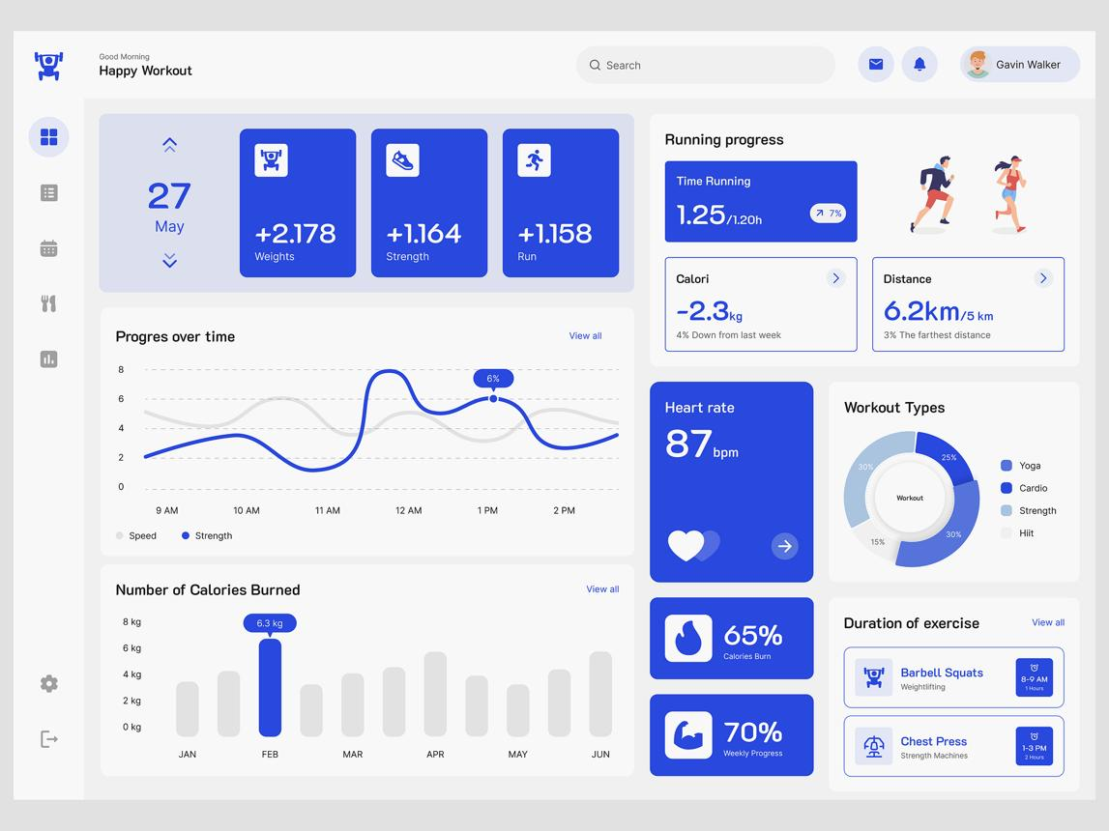
Milestone 1: Frontend foundation
Weeks 3–5
- Dashboard and activity cards
- Add-activity form
- Activity list and filters
- Reusable components
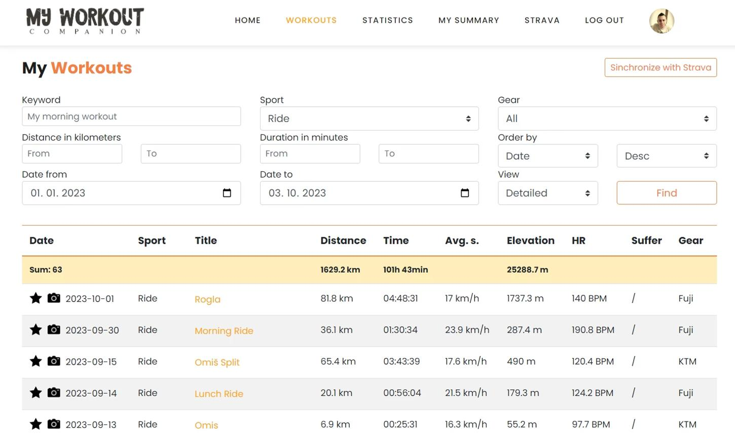
Milestone 2: Real API integration
Weeks 6–8
- Connect to your Activity Service through the Gateway
- Create, read, update and delete activities
- Add search, pagination and error handling
- Display activity details
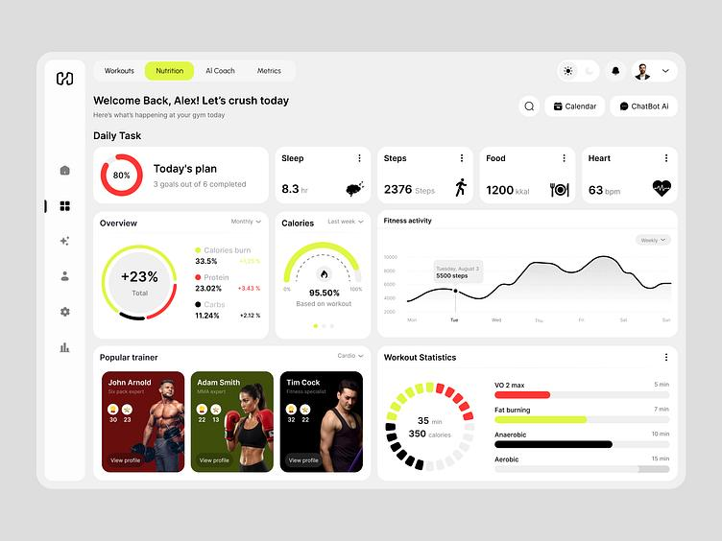
Milestone 3: Secure application
Weeks 9–10
- Integrate your existing authentication API
- Protect private screens
- Handle expired sessions
- Display only the current user's authorized data
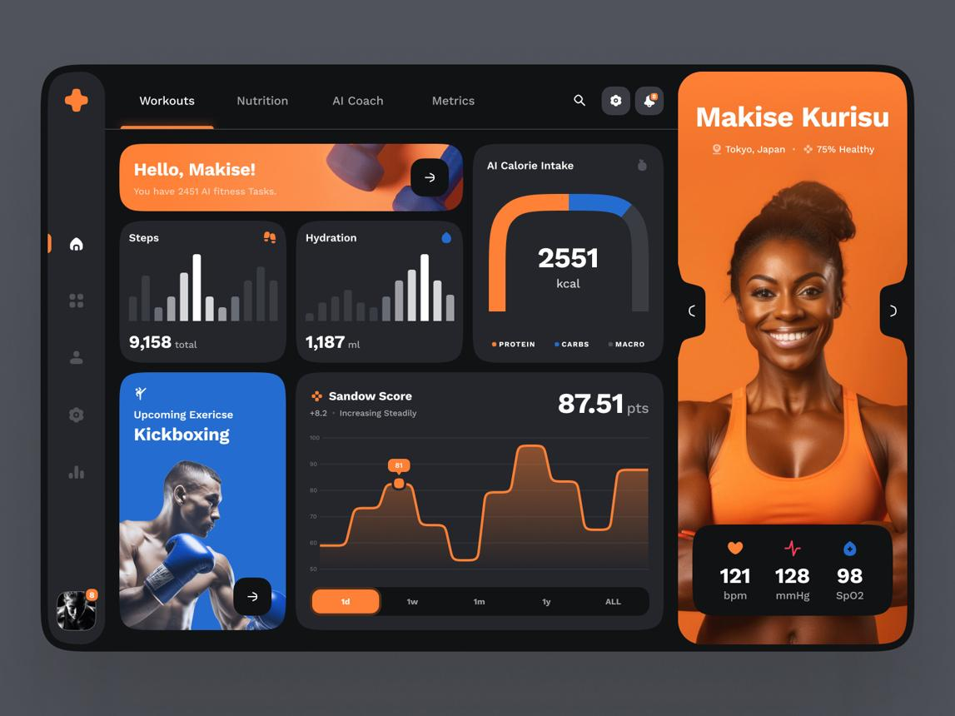
Milestone 4: Production experience
Weeks 11–16
- Cache and refresh API data
- Display AI-generated recommendations
- Test important flows
- Optimize, build and deploy
- Document setup and architecture
Your existing backend is an advantage. Do not rewrite working Spring Boot services just to learn React. Reuse the endpoints that work, document any gaps, and add backend functionality only when the frontend needs it.
5. YouTube courses and documentation
Use one main course for fundamentals and official documentation when you need to understand modern React behavior.
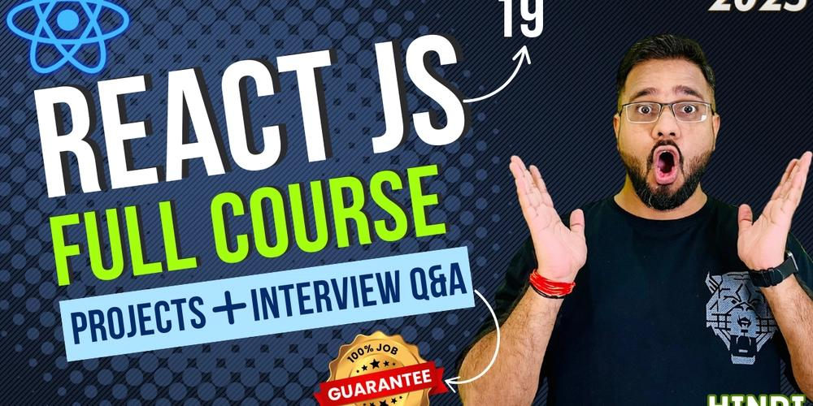
Main course: Hindi
React JS Full Tutorial in Hindi, Code Step By Step
Use for the initial concepts, components, hooks, forms, routing and basic API calls. Some material is older, so follow current setup instructions for new projects.
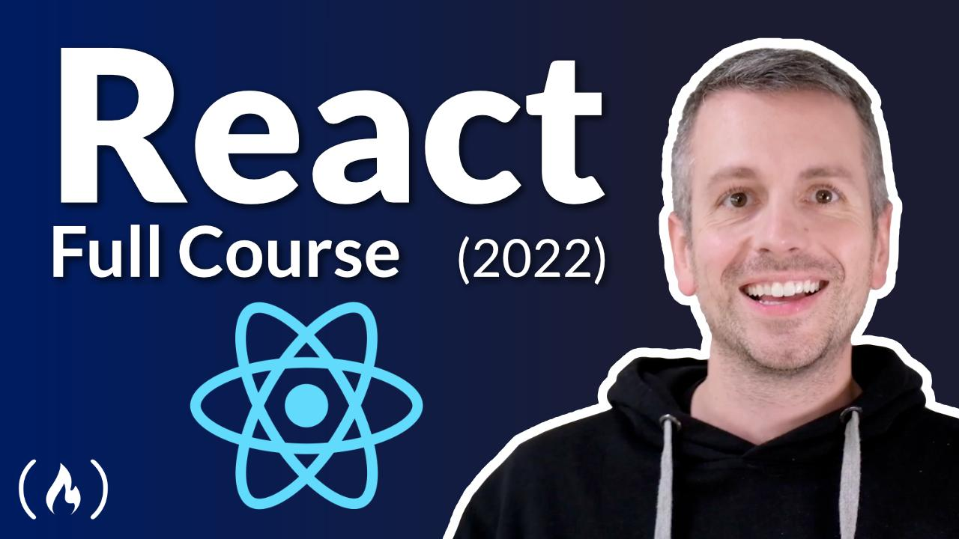
Alternative: English
freeCodeCamp React Full Course
Use as an alternative for deeper conceptual explanations. You don't need to complete both courses.
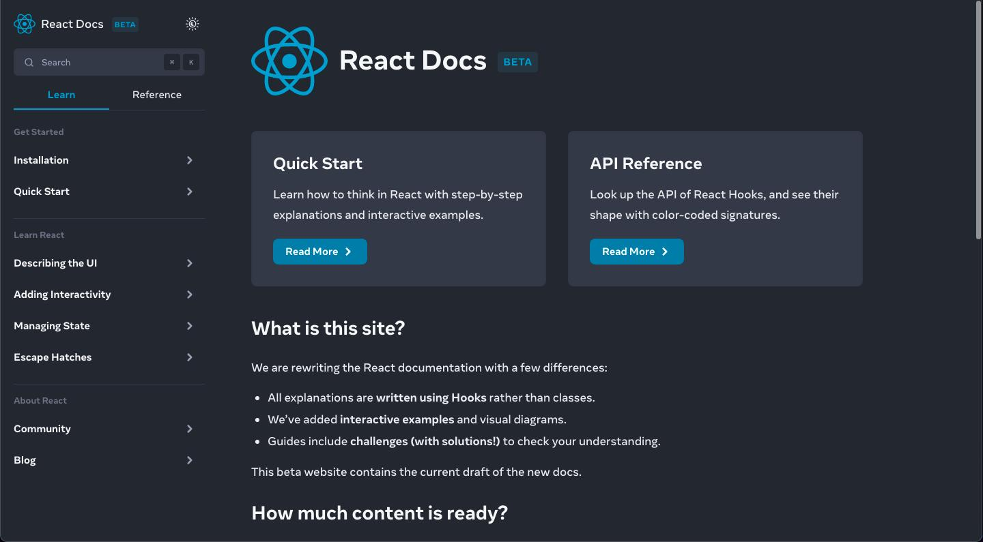
Essential reference: Official React documentation
Learn React
Use this for modern React, state management, effects, component design and understanding why code works.
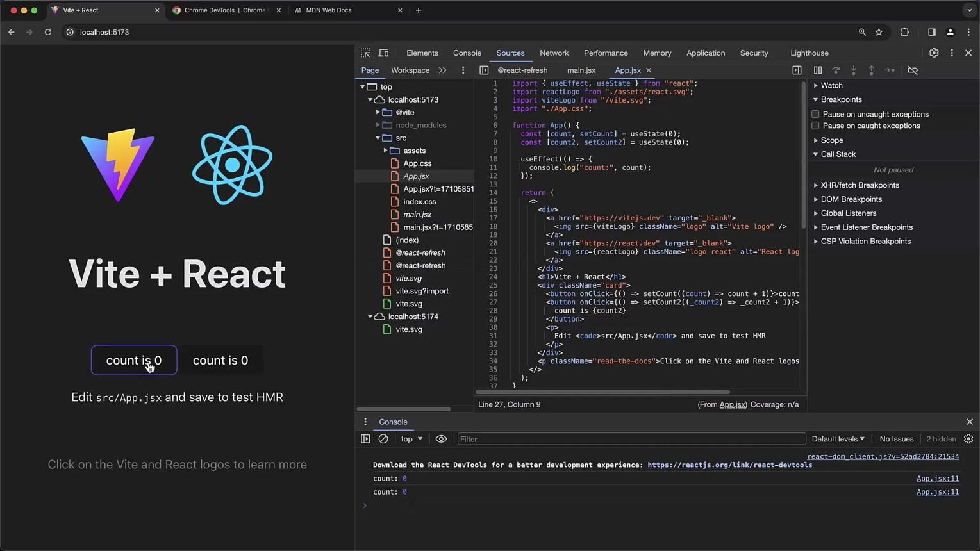
Build and production
Vite documentation
Use this for project setup, configuration, production builds and environment variables.
After the fundamentals, prefer official documentation and targeted tutorials for Axios, React Router, Redux Toolkit, TanStack Query, testing and deployment instead of starting another giant beginner course.
6. Your hard-level interview preparation
Don't leave interview preparation until Week 16. Spend 10–15 minutes a few days per week answering questions without looking at your notes.
Here is the level you should work toward.
1. JavaScript and asynchronous code
1.
Explain closures and lexical scope with a React example.
2.
Why can an async request finish after a component has unmounted or its inputs have changed?
3.
Explain the event loop, microtasks and Promise callbacks.
4.
What is a stale closure, and how can you avoid it?
2. React rendering and hooks
3. APIs and authentication
4. Architecture and performance
Your standard for a difficult interview question should be:
- Explain the concept in your own words.
- Write a small working example.
- Explain the common failure modes.
- Compare alternative solutions and their trade-offs.
- Describe where you've used it in your Fitness Tracker.
That's what moves you beyond memorized interview answers.
7. Production readiness checklist
Use this at the end of the roadmap. Check each item only when you've actually implemented and verified it.
Readiness tracker
0/15
Core React
Can create and refactor reusable components.
Can manage state, forms, effects and routing independently.
Backend integration
Can implement CRUD against real Spring Boot endpoints.
Can handle loading, empty, validation, network and server errors.
Can diagnose request failures using browser DevTools.
Security and architecture
Can integrate the existing login/session flow correctly.
Understands authorization belongs on the backend.
Can explain component boundaries and client vs server state.
Testing and delivery
Can write meaningful component and integration tests.
Can produce a successful production build.
Can deploy with the correct environment configuration.
Can debug a deployed issue and document the fix.
Interview readiness
Can solve unfamiliar React tasks without copying a tutorial.
Can explain rendering, effects, asynchronous behavior and caching.
Can defend architectural decisions and discuss alternatives.
My final recommendation
Keep Java/Spring Boot as your primary skill and let the Fitness Tracker connect it to React. At your available pace, follow the 16-week plan, but allow extra weeks if a topic is not sticking.
Your next step is Week 1: revise the JavaScript concepts that React depends on, set up your frontend with Vite, and create the first Fitness Tracker component. Don't begin with Redux or advanced optimization. Build the foundation, connect real APIs, and gradually turn the project into something you can confidently demonstrate in a technical interview.

