Foundations of Agile and Agile Frameworks

**EXERCISE WORKBOOK**

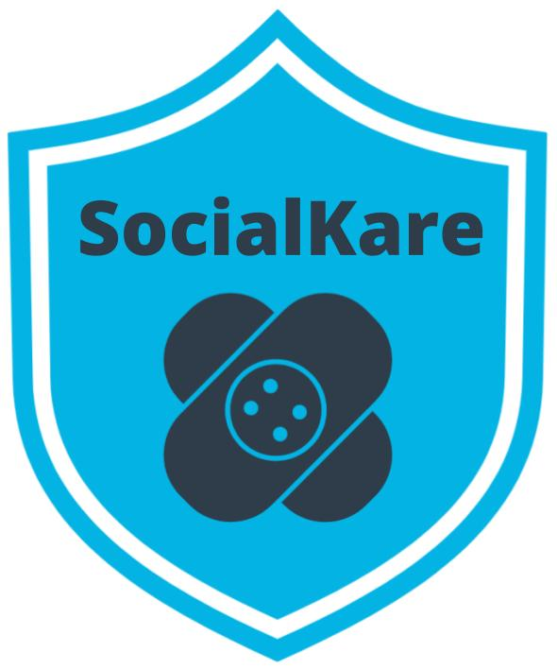



**Table of Contents**

1. SocialKare.gov Case Study

2. Why Agile Exercises

* Agile Mindset Anti-patterns
* Agile Manifesto
* Waterfall vs. Agile
* Setting an Agile Mindset

3. Agile Teams Exercises

* Three Core Roles
* High Performing Teams
* Non-Core Roles
* Agile Decision Making

 4. Agile Frameworks Exercises

* Set Up The Scrum Framework
* Kanban vs. XP
* Recommend a Framework

**Case Study: SocialKare.gov**

SocialKare.gov was launched to allow citizens of Nunamerica to enroll in Social Services provided by the government as a result of a devastating pandemic. Unfortunately, the launch of SocialKare.gov was seen as a disaster from all project management metrics, as well as by its key stakeholders’ low satisfaction ratings.

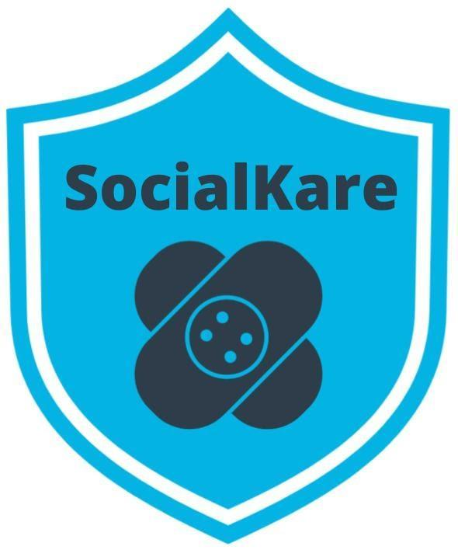

***We will be using this scenario for all of the exercises in this course***

**Independent Investigation**

An independent post-mortem investigation was launched into this project.

The investigation found a pattern of

* poor practices
* lack of clearly identified technical standards
* poor methods to identify software and coding errors.

This led to poor functionality on the website.

During the post-mortem, for virtually every error or gap, the project team claimed it had insufficient time to complete the website by the imposed deadline.

The project was a fixed fee contract with a clearly defined scope of work that was identified up front. As it eventually turned out, this was a complex website with a lot of unrealistic expectations. The multiple government agencies and stakeholders involved handed over a detailed set of inconsistent and difficult to decipher requirements up front. The expectations set for the project team was that they must deliver this content per the defined requirements and contract terms.

An anonymous survey of the team also indicated low morale, stress and employee fatigue.

**8 Key Findings from Independent Investigation**

1. The website launched across all States on the same day. With zero prior experience for citizens who had never used such a website for their important Social Services needs, there was tremendous confusion during the first few days. The system got overwhelmed with users and a multitude of performance issues were reported immediately.
2. Despite following strict government processes, the project developed the website without effective planning or oversight. The government agencies incurred significant cost increases, schedule mistakes and delayed system functionality because of changing requirements at the tail end of the project for functionality that had to go through a stringent change control review. This resulted in significant delays. More agencies were supposed to have input on the development of the website, but the project team did not have a structured approach to obtaining their input.
3. Major coding errors and insufficient capacity for scaling. An investigation identified excessive serious coding flaws in the structure of the website. The project team did not take enough steps to correct the issue until much later in the project life cycle. Some were resolved after going to production. The website was launched with insufficient visitor capacity, leading to further end user frustration. This was captured in the lessons learned session conducted after going to production. There were no Retrospectives and interim lessons learned sessions while the project was underway.
4. Majority of the eligibility requirements were never approved by SocialKare project sponsors and supporting systems integration testing was patchy. The project team claimed they were trying to develop the system in an expedited fashion to meet the deadline so steps ‘had to be missed’. Two months before the scheduled launch, integration tests on the website had not been completed. End-to-end testing, left as the last phase, was never completed before the website launched.
5. Despite thorough documentation and paper trails, oversight was inadequate. Theoretically, a number of governing committees were supposed to oversee the project through quarterly meetings with status updates. The project team spent a significant amount of time keeping up with the required project documents. However, no one raised issues of SocialKare.gov's functionality at the quarterly meetings since neither business representatives nor end user representatives had any hands-on demonstration of functionality that was being built.
6. The project team did not actively engage those business users who best understood the needs of the end users. The project team did not have a formal structure in place to ensure that everyone involved had a shared understanding of all the requirements.
7. While the project team was incentivized to deliver the requirements as specified, due to the time crunch, there was little in the way of ensuring these requirements made business sense throughout the project life cycle. The project team was overwhelmed with an excessive amount of requirements, all flagged as mandatory. What was given as detailed requirements upfront is what the project team worked diligently to deliver. The details were fuzzy in many instances, but the team did not have reliable business representatives readily available to clarify in a timely manner. So, the project team proceeded based on assumptions. It was later realized that several of these requirements were of little value to end users. Further, several key requirements were never uncovered until going to production.
8. Work was assigned by the Project Manager and her boss to the team members as the beginning of the project. Monthly status meetings were conducted by the Project Manager to check on progress based on the defined milestones upfront. Each team member worked on their own list of tasks in silos. The Project Manager monitored everyone’s technical progress individually and stepped in to troubleshoot technical problems. The developers started to depend on the Project Manager’s technical assistance.

**SocialKare.gov Employees**

*This information will be helpful for the Three Core Roles Exercise*

* **John Details**:   
  John is a detail oriented individual who likes to plan everything out in tremendous detail. He has several years of experience as a Technical Project Manager. Prior to stepping into the role of Project Manager, John was a Developer. He is known to have good communication skills.
* **Sarah Tenure**:   
  Sarah has been with the Agency responsible for launching SocialKare.gov for over 2 decades. Sarah has a lot of business knowledge and carries a certain amount of credibility due to this tenure. Sarah is strong headed and likes to make decisions based on how she sees things because she believes she has better insight than others who may have been with the organization for as long as she has.
* **Tim Devs**:   
  Tim has excellent technical skills. He prefers working as an individual contributor where he can spend time diving into the technical challenges on his own. He is well respected for his technical expertise. Tim maintains a strong focus on technical delivery and prefers the business users to stay out of his way while he is working through the development work. Tim leads a team of 5 developers with specialized vertical skills who are also on this project team
* **Jane Dollars**:   
  Jane has sponsored this project. She is a senior executive and likes to stay involved with the day to day activities of projects that she sponsors.

**Why Agile Exercises**

**Agile Mindset Anti-Patterns**

**Instructions:** Read the SocialKare.gov  case study and identify at least three anti-patterns that prevented the Agile mindset from being present. Explain why each anti-pattern is problematic.

|  |  |
| --- | --- |
| **Anti-Pattern** | **Evidence and Results** |
| Lack of communication between the team members. The anti-pattern here is not collaboration. | **Evidence:** Each team member worked on their own list of task in silos.  **Results:** Lack of understanding of the final result, and lack of accomplishing with the final goal. |
| Dependancy on the Project Manager’s Technical Assitance. The anti-pattern here is a lack of mastery and ownership. | **Evidence:** The Project Manager monitored everyone’s technical progress individually and stepped in to troubleshoot technical problems.  **Results:** A lot of consumption of time for the Project Manager, and insufficient time to complete the project. |
| Lack of control of Ambiguity. | **Evidence:** The project team proceeded based on assumptions.  **Results:** The project team was overwhelmed with an excessive amount of requirements. |
|  |  |

**Agile Manifesto**

**Instructions:** Review the SocialKare.gov case study and review the Agile Manifesto Paired Core Values and Agile Principles.  Of the four Paired Core Values, which stand out as being absent at SocialKare.gov? Which Agile Principles are missing? Identify at least two of each and explain why.

|  |  |
| --- | --- |
| **Missing Paired Core Value** | **Evidence and Results** |
| Responding to change over following a plan. | **Evidence:** Despite following strict government processes, the project developed the website without effective planning or oversight.  **Results:** This resulted in significant delays. More agencies were supposed to have input on the development of the website, but the project team did not have a structured approach to obtaining their input. |
| Customer collaboration over contract negotiations | **Evidence:** Majority of the eligibility requirements were never approved by SocialKare project sponsors and supporting systems integration testing was patchy.  **Results:** Two months before the scheduled launch, integration tests on the website had not been completed. End-to-end testing, left as the last phase, was never completed before the website launched. |
|  |  |

|  |  |
| --- | --- |
| **Missing Agile Principle** | **Evidence and Results** |
| **Business people and developers must work together daily throughout the project**. The Product Owner and the Agile Team adopt practices that ensure inclusive and joint practices. | **Evidence:** The project team did not actively engage those business users who best understood the needs of the end users.  **Result:** The project team did not have a formal structure in place to ensure that everyone involved had a shared understanding of all the requirements. |
| **Our highest priority is to satisfy the customer through early and continuous delivery of valuable software**. The goal of product development is the development of successful products. | **Evidence:** Major coding errors and insufficient capacity for scaling.  **Result:** The website was launched with insufficient visitor capacity, leading to further end user frustration. This was captured in the lessons learned session conducted after going to production. There were no Retrospectives and interim lessons learned sessions while the project was underway. |
|  |  |

**Agile vs. Waterfall**

**Instructions:** Review the SocialKare.gov case study. Where do you see weaknesses in the Waterfall approach to the SocialKare.gov project being applicable? Identify at least two weaknesses and explain why you see them as weaknesses when compared to the Agile approach for SocialKare.gov.

|  |  |
| --- | --- |
| **Weakness** | **Evidence and Results** |
| Mindset/Focus on completing the project. | **Evidence:**  The website launched across all States on the same day. With zero prior experience for citizens who had never used such a website for their important Social Services needs. This probes that the main goal in this case was to complete the project, rather than releasing a good product.  **Results:**  There was tremendous confusion during the first few days. The system got overwhelmed with users and a multitude of performance issues were reported immediately. |
| Change. Change is a challenge. | **Evidence:**  Despite following strict government processes, the project developed the website without effective planning or oversight. The government agencies incurred significant cost increases, schedule mistakes and delayed system functionality because of changing requirements at the tail end of the project for functionality that had to go through a stringent change control review.  **Results:**  This resulted in significant delays. More agencies were supposed to have input on the development of the website, but the project team did not have a structured approach to obtaining their input. |
|  |  |

**Setting An Agile Mindset**

**Instructions:** Review the SocialKare.gov case study. Outline three recommendations to set an Agile Mindset at SocialKare.gov. Consider the Agile Manifesto in your recommendation and avoid the negative pitfalls of Waterfall. Explain why your recommendation will help.

|  |  |
| --- | --- |
| **Recommendation** | **How It Will Help The Team** |
| Stablishing daily meetups to build the product iteratively based on the constant feedback of the customers, and involving the developers and other member of the team in the creation of the product, and decreasing the creation of unnecessary documentation, and eliminating the idea that the software development process can follow a pre-stablished plan that follows a traditional project management approach. | This recommendation will put into practice the Agile Mindset principle of Focusing on Delivering Value.  Putting this principle into practice would match the Agile Manifesto principle of creating working software over comprehensive documentation, and the team will avoid losing time, getting lost in useless documentation and adopting a modern approach for the software development process of the product. |
| Improving the communication between the team that is developing the product, and the business users who best understand the needs of the end users. | This recommendation will put into practice the Agile Mindset principle of Mastery and Ownership.  Putting this principle into practice would match the Agile Manifesto principle of Customer collaboration over contract negotiations.  The team will feel more engaged in the development of the product and they will come out with the feeling that they are building something that will have a real positive impact in the end users. |
| The team needs to create demos that are going to be constantly modified depending on the changing requirements of the end customers and this must to be complemented with a constant engagement of the business users. | This recommendation will put into practice the Agile Mindset principle of Adaptability to change.  Putting this principle into practice would match the Agile Manifesto principle of Responding to Change over Following a Plan.  The team will have the possibility to develop a product that can fulfill the real expectations of the end users, and a product that is open to modification if new expectations and requirements appear.  At the end the customers are going to be more satisfied and the development team will feel proud of what they are building. |

**Agile Team Exercises**

**Three Core Roles**

**Instructions:** Review the SocialKare.gov case and focus on the employees. Identify the three Agile Core roles and their responsibilities and assign a SocialKare.gov employee to each role. Explain your assignments.

|  |  |  |  |
| --- | --- | --- | --- |
| **Role** | **Responsibilities** | **Employee** | **Justification** |
| Product Owner | 1. Prioritize and manage the product Backlog. 2. Maximize value delivery. | Jane Dollars | She likes to stay involved with the day-to-day activities.  She is the sponsor of the project. |
| Facilitator | 1. Keep the Agile Team moving forward towards business objectives. 2. Agile Coach. 3. Remove technical blockages. | John Details | He is a detail-oriented individual.   He has several years of experience as a Technical Project Manager.  He was a developer and due to this fact he can really understand the Agile Team. |
| Agile Team | 1. Work after business, based on prioritization by the Product Owner. 2. Boost team’s confidence and ability to deliver. 3. Delivering a shippable product after every iteration. | Tim Devs | He has excellent technical skills.  He likes to dive into technical challenges on his own.  He is well respected for his technical experience.  He leads a team of 5 developers with specialized vertical skills. |
|  |  |  |  |

**High Performing Agile Teams**

**Instructions:** Review the SocialKare.gov case and focus on the employees. Choose three team members and identify areas where they are not following Agile best practices. Share suggestions for improvement as coaching opportunities and explain why the coaching is needed.

|  |  |  |
| --- | --- | --- |
| **Role/Team Member** | **Coaching Opportunity** | **Justification** |
| Product Owner/Sarah Tenure | She needs to learn to listen other members of the team, because listening to others is a key factor in making a Agile Team, successful.  To take too much decisions on her own can lead the team to create silos. | Sarah is strong headed and likes to make decisions based on how she sees things because she believes she has better insight than others who may have been with the organization for as long as she has. |
| Facilitator/John Details | He needs to learn to be more product centric, because although of his very useful experience as a traditional project manager, in order to be a successful part leader in a Agile Team he needs to adopt the practices of Agile Project Management. | John is a detail-oriented individual who likes to plan everything out in tremendous detail. |
| Agile Team Member/Tim Devs | He needs to improve his communication skills because he is part of a team.  His approach could contribute in a negative way, to create silos.   He needs to learn to cooperate with the people who belong to the business area. | He prefers working as an individual contributor where he can spend time diving into the technical challenges on his own.  Tim maintains a strong focus on technical delivery and prefers the business users to stay out of his way while he is working through the development work. |

**Non-Core Roles**

**Instructions:** Review the SocialKare.gov case. Identify at least three non-core roles for the Agile Team. Explain why that role is important to the team’s success.

|  |  |
| --- | --- |
| **Non-Core Role** | **Justification** |
| Stakeholder (Jane Dollars) | The involvement of the Stakeholders in the project is very important, because they have a big interest in the product being worked on.  People like Jane Dollars, the citizens, |
| Center of Excellence | This role is very important for this project, because, the project is highly regulated by multiple government agencies. |
| Domain Subject Matter Expert | This role is very important because the most of Software Developers don’t have a lot of knowledge and sometime, don’t have a lot of interest in things related to social services provided by the government. |
|  |  |

**Agile Decision Making**

**Instructions:** Review the SocialKare.gov case study. identify three types of decisions that should be centralized and three that should be decentralized at SocialKare.gov. Explain your recommendations.

|  |  |
| --- | --- |
| **Centralized Decisions** | **Justification** |
| The date of the day for launching the application. | This decision can have a wide impact in the organization, because involves the release of the application across all states, and there are many internal and external stakeholders involved in the project. |
| The configuration of the teams and the assignation of roles. | This decision is crucial and will impact the project from the beginning to the end. |
| The communication with government agencies and external stakeholders. | This decision will be crucial for the success of the project. |
| **Decentralized Decisions** | **Justification** |
| Scheduling of the meetings between members of the Agile Team. | Is up to the Agile Teams, to decide how they organize themselves |
| Setting of the milestones | This will be decided by the Agile Teams themselves, based on constant feedback and the priorities in the project’s backlog. |
| Hiring new members of the teams or reassign positions within the teams. | Is up to the Agile Teams to decide if they require new personal to help to develop the project faster or more efficiently, and to reassign tasks to different members of the teams. |

**Agile Framework Exercises**

**The Benefits of Using Agile Frameworks**

**Instructions:** Review the SocialKare.gov case study. List at least 3 specific benefits of using an Agile Framework and explain how those benefits will help SocialKare.gov achieve its goals.

|  |  |
| --- | --- |
| **Benefit from Using an Agile Framework** | **How The Benefit will Help SocialKare.gov** |
| The use of an Agile Framework can help this organization to bring structure and do adapt to the modern way of develop software in the highly competitive current industrial scenario. | SocialKare.gov will benefit being capable to deliver software iteratively, testing continuously, and making the customers more satisfied. |
| The organization would be able to organize more efficient teams. | Having the right individuals assigned to the right roles and tasks can make the development process more efficient. |
| The use of a framework can improve the communication channels. | The right level of communication is crucial to the success of the project, and the capability of understanding between team members and with external stakeholders. |
|  |  |

**Set Up the Scrum Framework**

**Instructions:** Review the SocialKare.gov case study. Set up Scrum for the SocialKare.gov team by recommending the core roles to fil and the ceremonies to be conducted. Include the schedule, duration and agenda for each recommended ceremony.

|  |  |
| --- | --- |
| **Role** | **Responsibilities** |
|  |  |
|  |  |
|  |  |

|  |  |  |  |
| --- | --- | --- | --- |
| **Scrum Ceremony** | **Purpose** | **Agenda** | **Schedule and Frequency** |
|  |  |  |  |
|  |  |  |  |
|  |  |  |  |

|  |  |  |  |
| --- | --- | --- | --- |
| **Scrum Ceremony** | **Purpose** | **Agenda** | **Schedule and Frequency** |
|  |  |  |  |
|  |  |  |  |
|  |  |  |  |

**Kanban vs. XP**

**Instructions:** Review the Kanban and XP Frameworks. Identify key differences between the two frameworks in terms of roles, ceremonies and practices.  
  
**Core Roles in Kanban**

|  |  |
| --- | --- |
| **Role** | **Responsibilities** |
|  |  |
|  |  |
|  |  |

**Core Roles in XP**

|  |  |
| --- | --- |
| **Role** | **Responsibilities** |
|  |  |
|  |  |
|  |  |
|  |  |

**Kanban Ceremonies**

|  |  |  |  |
| --- | --- | --- | --- |
| **Ceremony** | **Purpose** | **Agenda** | **Schedule and Frequency** |
|  |  |  |  |
|  |  |  |  |
|  |  |  |  |
|  |  |  |  |

**XP Ceremonies**

|  |  |  |  |
| --- | --- | --- | --- |
| **Ceremony** | **Purpose** | **Agenda** | **Schedule and Frequency** |
|  |  |  |  |
|  |  |  |  |
|  |  |  |  |
|  |  |  |  |
|  |  |  |  |
|  |  |  |  |

|  |
| --- |
| **Key Differences Between Kanban and XP** |
|  |

**Recommend a Framework**

**Instructions:** Review the SocialKare.gov case study and the Scrum, Kanban and XP frameworks. Recommend a framework or combinations of frameworks for SocialKare.gov. Justify your recommendation by listing the specific characteristics of the framework that will bring value to SocialKare.gov.

|  |
| --- |
| **Recommended Framework** |
|  |

|  |  |
| --- | --- |
| **Characteristic** | **Justification** |
|  |  |
|  |  |
|  |  |