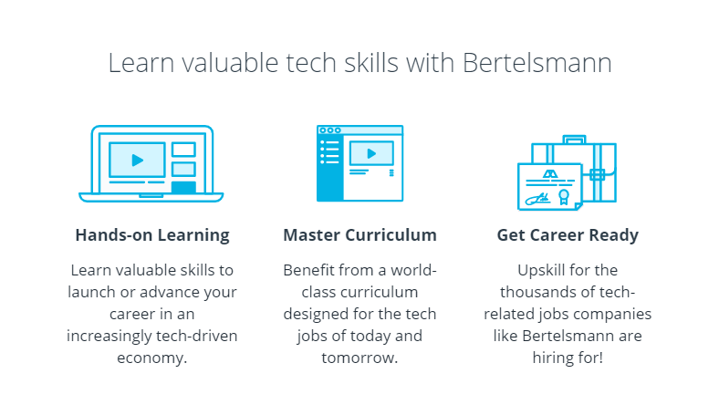

 How it Works

Bertelsmann’s media, services and educational offerings make it a leader in many areas of the digital world. Accordingly, the company wants to empower as many people as possible to be successful in the digital world. Over a three-year period Bertelsmann is funding as many as 50,000 tech scholarships for students to learn with Udacity.

The second phase of the program, starting in September 2020, consists of a two-stage scholarship that’s similar to the first phase of the program. The scholarship is open to any student, 18 years of age or older, interested in Cloud Computing, Data Science or Artificial Intelligence. Both Bertelsmann employees and the general public are encouraged to apply for one of the three tech learning paths: Cloud, Data, or AI.

When applications close on November 16, 2020, we’ll review all entries and select 15,000 recipients to participate in the Cloud, Data, or AI Challenge Courses. This is where the learning begins! Recipients will spend 3.5 months learning key components for Cloud Computing, Data Analysis, or Artificial Intelligence. Top students from this initial phase will earn a full Nanodegree program scholarship.

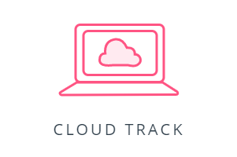

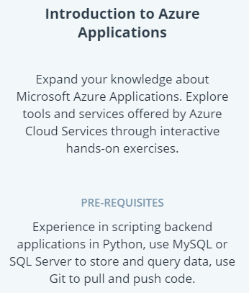

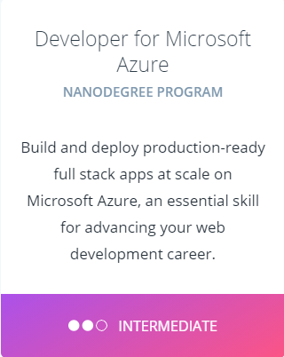

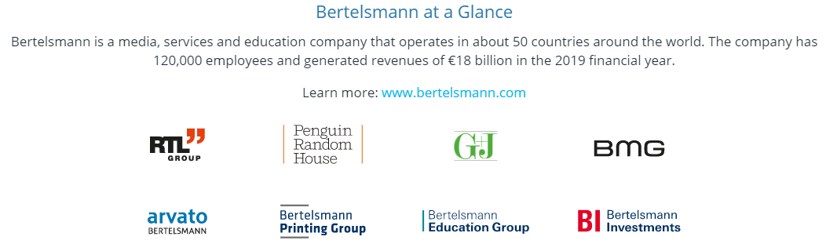

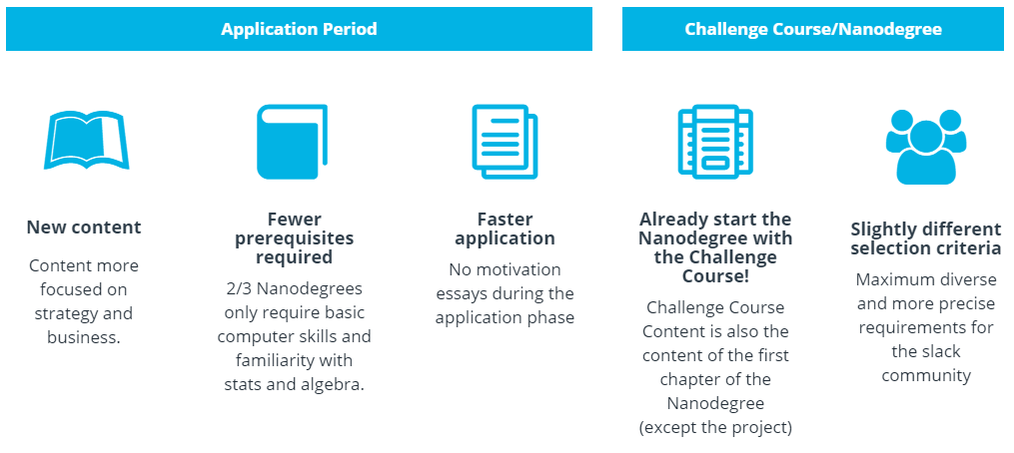

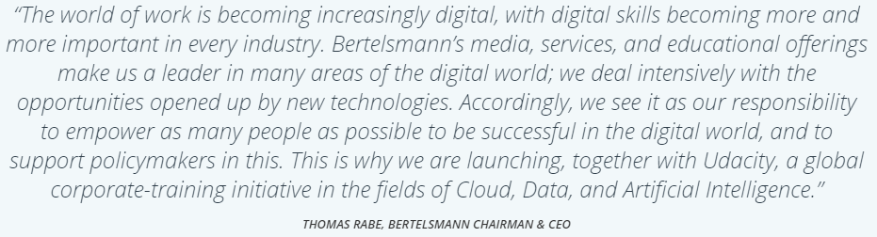

### **What is the “Bertelsmann Technology Scholarship Program”?**

Over a three-year period, Bertelsmann is investing several million euros in funding as many as 50,000 tech scholarships on the online education platform Udacity to strengthen people’s tech skills. Specifically, the Group is funding 15,000 tech scholarships annually for Challenge Courses in Cloud, Data and AI. In addition, the top ten percent of participants will receive a scholarship for a full Nanodegree in their selected subject area.

### **Who can apply?**

Anyone 18 years of age and above is encouraged to apply. This includes any Bertelsmann employee or general student, who wants to expand their AI, Data, or Cloud skillset.

Please note, there are certain prerequisites for each track. Scholarship recipients should be prepared to invest about 3-5 hours per week during the Challenge Course and about 5–10 hours per week during the Nanodegree programs.

### **What are the prerequisites?**

***Cloud Track:*** Students are advised to have 1-3 years of programming experience using Python. Students should be comfortable with using MySQL or SQL Server to store and query data, and using Git to pull and push code.

### **How does this scholarship program work?**

The scholarship program is structured in two parts:

***Phase 1: 15,000 Challenge Courses:* during the first phase of this scholarship, students work through one of the 3 initial Challenge Courses: “Introduction to Azure Applications”,  “Introduction to Problem Solving with Advanced Analytics” or “Introduction to AI in Business” for 3.5 months. Applicants should be prepared to invest about 3–5 hours per week during this period. Scholarship recipients participating in this initial phase of the program will engage with classmates in a robust, actively managed, student community.**

***Phase 2: 1,600 Full Nanodegree programs:***the top 1,600 students from the first phase will earn a follow-up scholarship to either the Cloud Developed with Azure, Predictive Analytics for Business, or AI Product Manager Nanodegree programs. Access to these Nanodegree programs includes expert project reviews, mentorship and community support. These full Nanodegree program scholarships will be awarded in March 2021. Applicants should be prepared to invest about 5–10 hours per week for the 6 months of the program.

Account:

[anudabertelsmann@hotmail.com](mailto:anudabertelsmann@hotmail.com)